**Experiment No. 05**

* 1. **Experiment Name**

s1= Low frequency signal (like 0Hz to 1Hz)

s2= High frequency signal (like 100Hz to 500Hz)

s3= Midrange frequency signal (like 5Hz to 30Hz)

s4=s1+s2+s3;

Design a digital filter (high pass/ low pass/ band pass/ band reject) using python code.

* 1. **Objectives**
* To get a better understanding of digital filter design using python
* To become acquainted with filter and it’s working criteria.
  1. **Apparatus**
* Jupyter Notebook
  1. **Python code & graph**

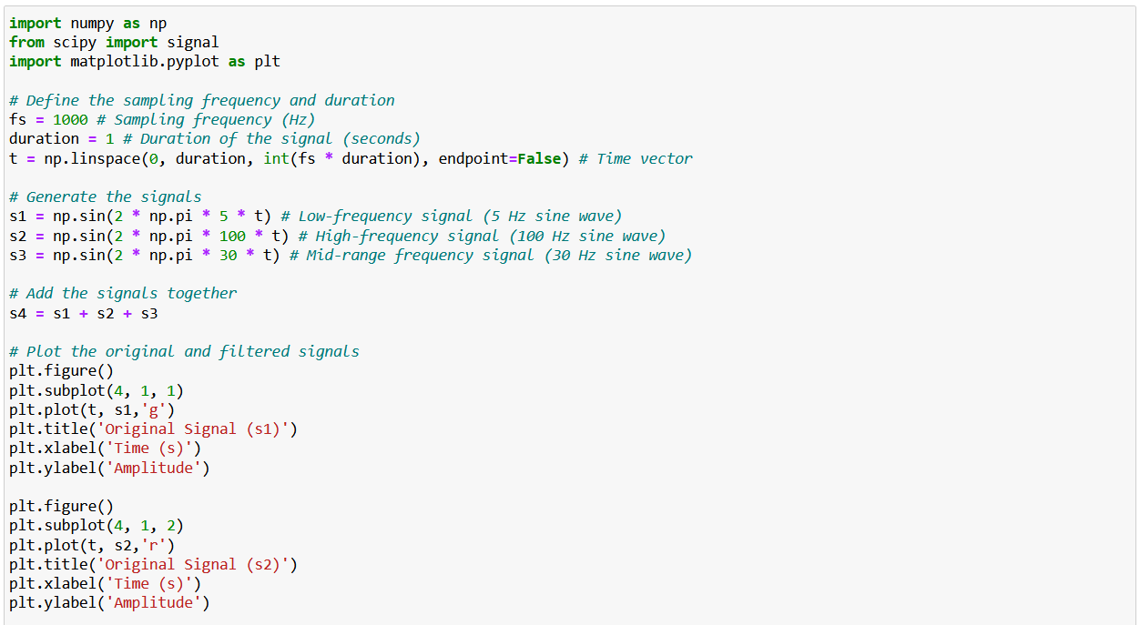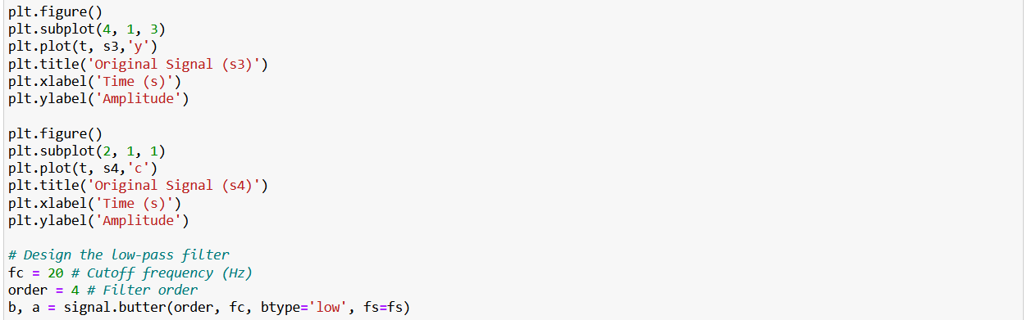

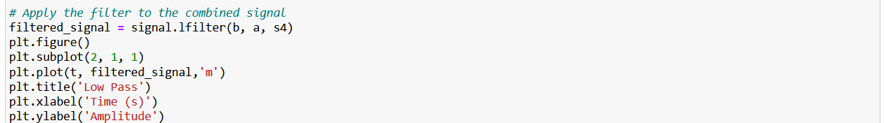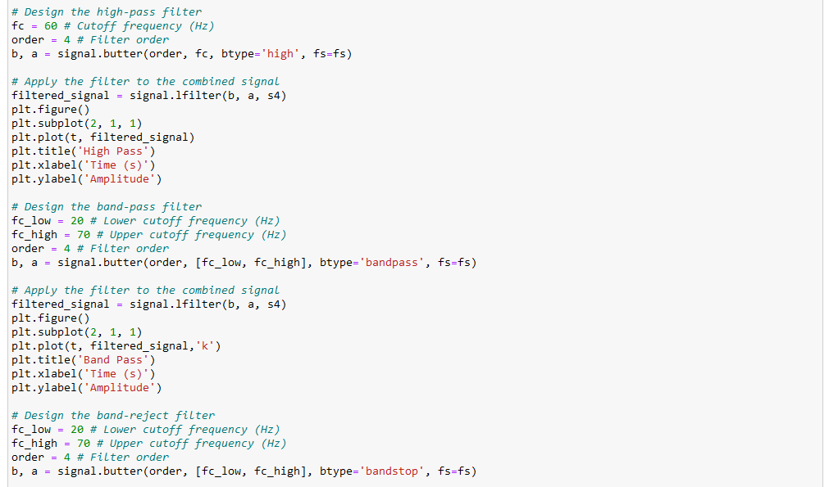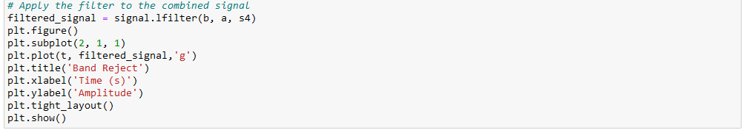

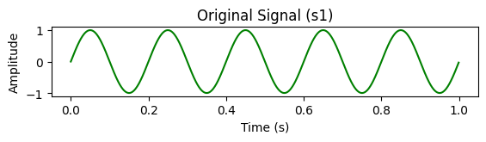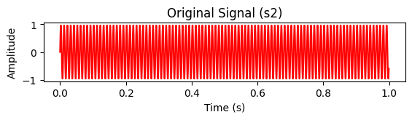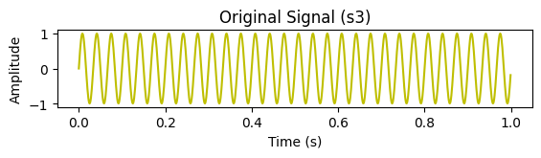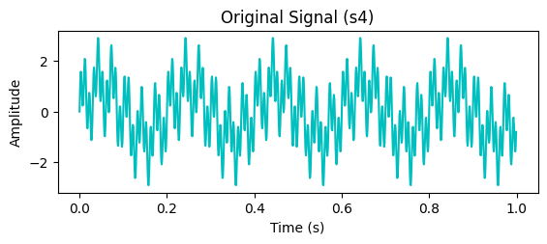

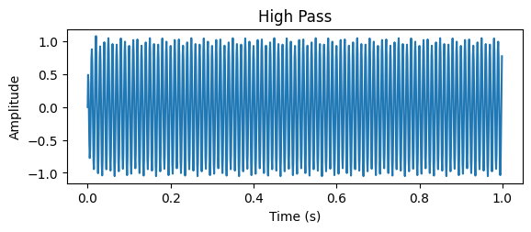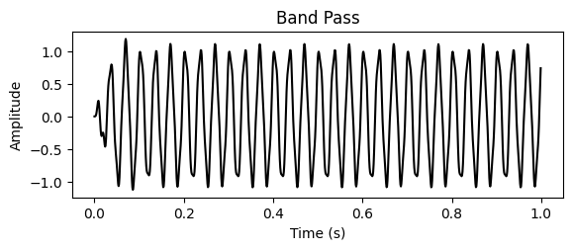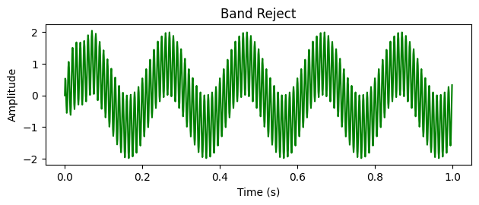

* 1. **Discussion & Conclusion**

In this experiment, we used the python to analyze different given signals and design digital filter with necessary requirements. Through this experiment, we got a better understanding of the designing process and its’ practical use and understood the scope of improvements in the regarding field. Here, we designed 4th order for all the filter i.e., band pass, band reject, high pass, low pass filters. We set the frequency range according to our study requirement and used butter function for designing.