MarketLens
Screen-by-Screen Guide
An AI investment analyst for Indian equities (NSE/BSE): it turns a news headline into a probability, historical evidence, a research memo and a price outlook.
Demo event used in every screenshot: "Infosys Stock Update: Shares Slip Amid IT Sector Headwinds - LatestLY" (ticker INFY).

Overview: how the screens fit together
The application has a Next.js frontend with a sidebar of eight views, and a FastAPI backend. Choosing a headline calls the backend once (POST /api/v1/analyze). The result is kept in the page and shared by every tab, so the tabs are different views of the same analysis.
# | Screen | Question it answers
1 | Analyst Chat | Ask anything about this event in plain English.
2 | Market Events | Which news should I look at?
3 | Stock Analysis | Will this stock beat NIFTY 50 over 3 days, and how does the news read?
4 | Price Forecast | Where might the price be in 7 trading days?
5 | Historical Evidence | What happened after similar news in the past?
6 | Technical Analysis | What was the stock doing before the news?
7 | Research Memo | Give me the whole story in written form.
8 | ML Features | Exactly what numbers did the model see?

The pipeline behind the screens
- Extraction: a local Qwen2.5-1.5B model reads the headline and returns structured JSON (company, event type, surprise, magnitude, summary). A regex rule-based extractor is the fallback.
- Sentiment: ProsusAI/FinBERT gives positive, negative and neutral probabilities.
- Technicals: momentum, volatility and volume are computed from the PostgreSQL price tables.
- Prediction: "Model C", a classifier on 21 features, outputs the probability that the 3-day abnormal return vs NIFTY 50 is above +0.5%.
- Memory: FAISS with all-MiniLM-L6-v2 embeddings finds similar past events and reports how they turned out.
- Memo: an LLM writes a four-section research memo, with a rule-based fallback.
The analysis for the demo headline is pre-computed and stored on the server (demo_cache/analysis_cache.json), so it opens instantly after a restart.

1. Analyst Chat
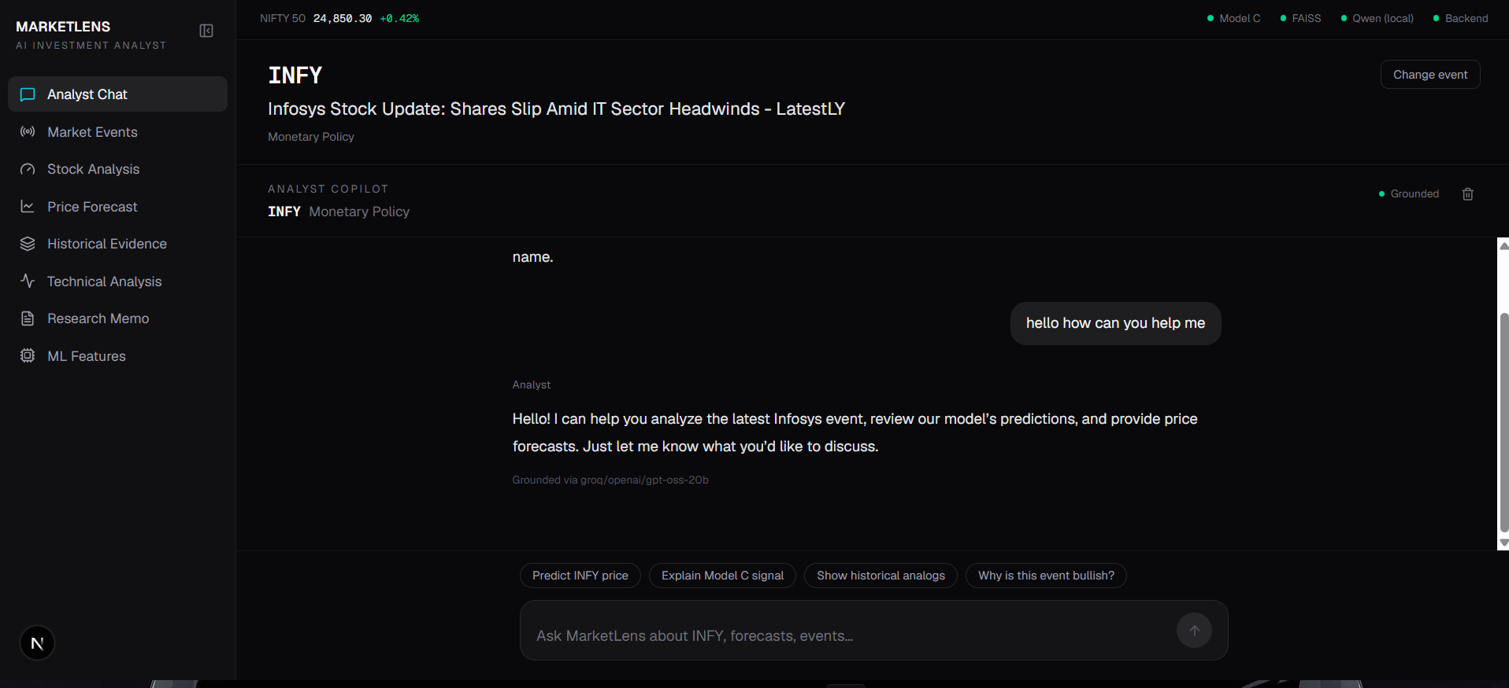

What it is
A conversational copilot for the active event. The header shows the ticker (INFY) and event type; the "Grounded" label means answers are built from the analysis numbers, not from the model's general knowledge. In the screenshot the user said hello and the analyst offered to discuss the event, Model C predictions and price forecasts. Four suggestion chips start common questions.

How it helps
- Lets a non-technical user query the analysis without learning the other tabs.
- Gives buy / hold / sell style answers for price questions, with the supporting numbers.
- The footer ("Grounded via groq/openai/gpt-oss-20b") shows which model answered, which makes answers auditable.

How it is implemented
- The React component AnalystChat.tsx keeps the conversation in state and posts the whole history plus the current analysis to POST /api/v1/chat.
- The backend builds a system prompt containing the headline, extracted event, Model C probability, FAISS win rate and median return, and the top analogs.
- If the question is about price, it first fetches a live forecast for the right ticker and adds it to the prompt.
- Models are tried in order and the first success wins: Groq, then Gemini, then Ollama, then local Qwen, then a keyword-based deterministic answer. This keeps the chat working when a service is down.

Technology behind it
Component | Technology / detail
Frontend | Next.js, React, TypeScript, Tailwind CSS
API | FastAPI endpoint POST /api/v1/chat
Primary LLM | Groq cloud (openai/gpt-oss-20b), chosen for speed
Fallbacks | Google Gemini, Ollama (qwen2.5:1.5b), local Hugging Face Qwen2.5-1.5B, deterministic templates
Grounding | System prompt built from the analysis; instruction not to invent figures

2. Market Events (Live Ingestion Feed)
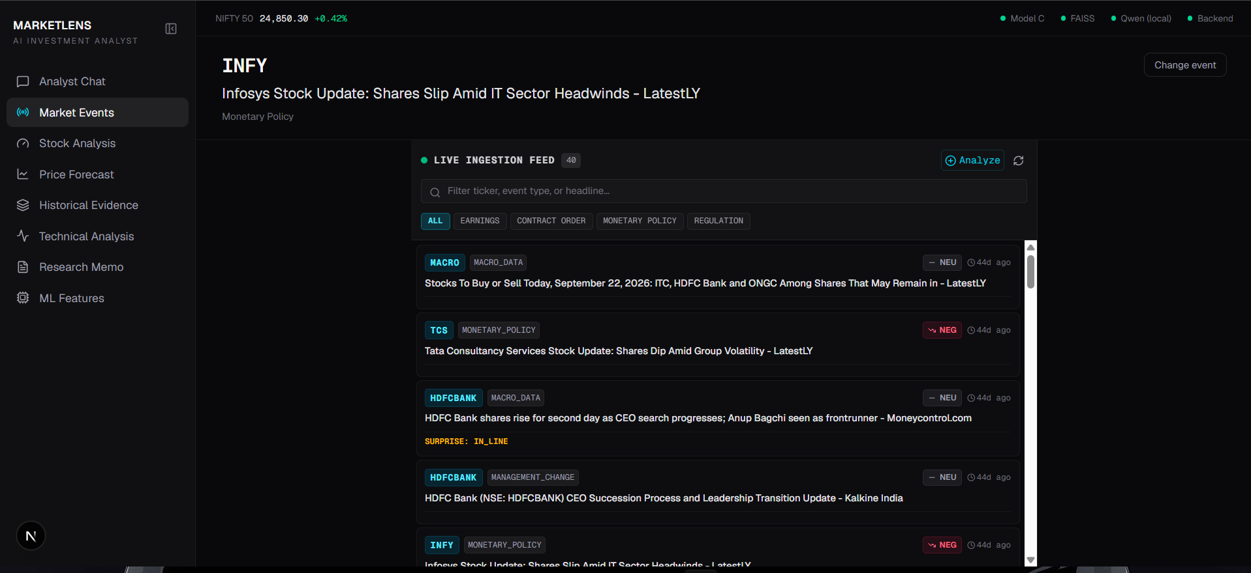

What it is
The list of recent news events that the system has already collected and processed. Each card shows the ticker, event type, sentiment tag (NEG / NEU), age, the headline and, when relevant, the surprise (for example IN_LINE). The search box and type chips (Earnings, Contract Order, Monetary Policy, Regulation) filter the list, and "+ Analyze" lets you paste any custom headline.

How it helps
- Gives the analyst a single place to scan what is happening across the market.
- Clicking a card runs the full analysis and opens the chat for that event.
- The custom-headline option means the tool works on breaking news that is not yet in the database.

How it is implemented
- News is collected from RSS feeds, and article text is extracted with trafilatura and newspaper3k. It is stored in PostgreSQL.
- A batch script (extract_events.py) runs the extraction model over stored news and writes rows to the events table.
- The feed calls GET /api/v1/events, which joins events, news and companies and returns the latest 40.
- The cards show the extractor's labels, so an imperfect classification (for example the "Monetary Policy" tag on an IT-sector story) appears here too.

Technology behind it
Component | Technology / detail
Ingestion | feedparser (RSS), trafilatura, newspaper3k, requests
Database | PostgreSQL with SQLAlchemy 2.0 models, Alembic migrations
Tables | companies, news, market_data, market_indices, events
API | GET /api/v1/events
UI | LiveEventFeed.tsx with client-side filtering

3. Stock Analysis (Overview)
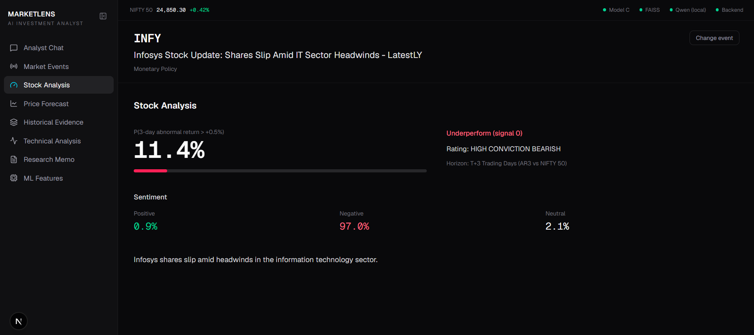

What it is
The headline result. The large number (11.4%) is the probability that INFY's 3-day return will beat NIFTY 50 by more than 0.5%. The bar shows it visually, the label "Underperform (signal 0)" is the yes/no call, and "HIGH CONVICTION BEARISH" is the confidence band. Below, the FinBERT sentiment split is 0.9% positive, 97.0% negative and 2.1% neutral, followed by a one-line summary.

How it helps
- Turns a headline into one number a person can act on.
- Shows the reason for the call (strongly negative sentiment) next to the number.
- The horizon is stated (T+3 trading days versus NIFTY 50), so the number is not mistaken for a long-term view.

How it is implemented
- POST /api/v1/analyze runs the pipeline in MarketLensAgent: extraction, FinBERT, technical features from the database, then Model C inference.
- Model C receives 21 features and returns predict_proba. The signal is 1 when the probability is at least 0.50, and the conviction label comes from probability bands (70%+ high bullish, 55-70% moderate bullish, 45-55% neutral, 30-45% moderate bearish, below 30% high bearish).
- The model was trained with a chronological train/validation/test split so it never learns from future data.

Technology behind it
Component | Technology / detail
Extraction | Qwen2.5-1.5B-Instruct (Hugging Face Transformers, PyTorch)
Sentiment | ProsusAI/FinBERT, softmax probabilities
Model C | scikit-learn / XGBoost pipeline saved with joblib (event_classifier_v1.joblib)
Target | AR3 = 3-day stock return minus NIFTY 50 return, label AR3 > +0.5%
Caching | Results stored in demo_cache/analysis_cache.json for instant reloads
Note: The "signal 0 / 1" label and the five-level conviction rating come from the same probability but use different cut-offs, so for probabilities near 50% they can appear to disagree.

4. Price Forecast
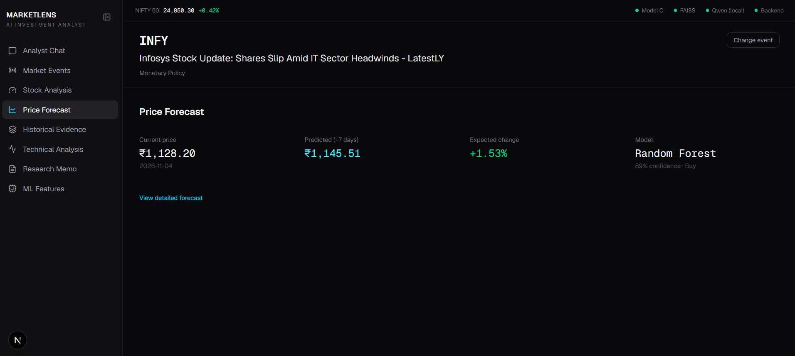

What it is
A 7-trading-day price outlook for INFY: the current price (Rs 1,128.20 as of 2026-11-04), the predicted price (Rs 1,145.51), the expected change (+1.53%) and the model used (Random Forest). The small caption shows a direction label and the model's test-set confidence. "View detailed forecast" opens the full chart.

How it helps
- Adds a second, independent view: where the price may go, not only whether it beats the index.
- Works for any NSE ticker; if no model exists yet, one is trained in the background.
- Feeds the chat, so "Predict INFY price" returns the same numbers.

How it is implemented
- price_forecast_service.py bridges a separate project (ml_genai/stock-price-prediction-ml) into the backend.
- It downloads recent prices, builds technical-indicator features, loads the saved Random Forest, XGBoost or LSTM models, and returns forecast prices, dates, a direction label and test metrics.
- Results are cached for a short time to avoid repeated downloads.
- For a new ticker, training starts on a background thread and the user is told to ask again shortly.

Technology behind it
Component | Technology / detail
Market data | yfinance (Yahoo Finance)
Models | Random Forest, XGBoost, LSTM (TensorFlow)
Indicators | ta library technical indicators, pandas, numpy
API | POST /api/v1/price-forecast
Persistence | Trained models stored in saved_models/
Note: This forecast is independent of the news model, so it can point the other way (here +1.53% while the news model is bearish). The confidence shown is the model's one-step test result, not a guarantee of multi-day accuracy, and should be presented as a directional hint.

5. Historical Evidence
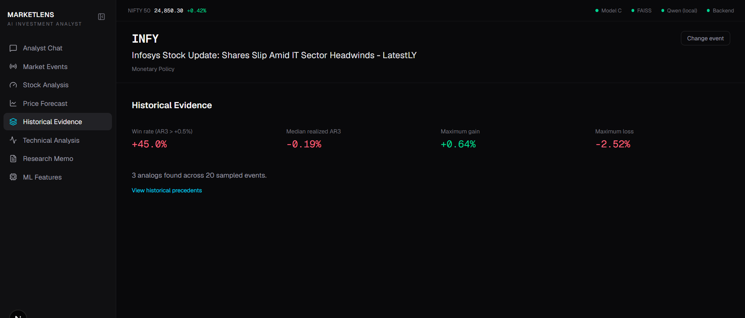

What it is
What happened after similar news in the past. For INFY the win rate (share of similar events where AR3 exceeded +0.5%) is 45.0%, the median realised AR3 is -0.19%, the best case was +0.64% and the worst case -2.52%. The text says 3 analogs were found across 20 sampled events, and "View historical precedents" lists them.

How it helps
- Checks the model against real history, so the prediction is not a black box.
- Shows the range of outcomes, including the downside, not just an average.
- Gives the chat and the memo real numbers to quote.

How it is implemented
- Each past event is turned into text such as "[INFY] MONETARY_POLICY | Surprise: ... | summary" and embedded with a sentence-transformer.
- The vectors are L2-normalised and stored in a FAISS inner-product index, so the search score is cosine similarity. Event details are kept in a Parquet file.
- For a new headline the engine retrieves the nearest events and computes win rate, median, mean, standard deviation, max gain, max loss and the top analogs.
- The index is built offline by scripts/build_vector_index.py.

Technology behind it
Component | Technology / detail
Embeddings | sentence-transformers/all-MiniLM-L6-v2
Vector search | FAISS IndexFlatIP (faiss-cpu)
Metadata | Parquet via pyarrow (data/faiss_metadata.parquet)
Statistics | pandas / numpy on the retrieved AR3 values
API | POST /api/v1/evidence, also used inside /analyze
Note: Only 20 events were sampled and 3 analogs shown, so this is a small sample. Present it as supporting context rather than proof.

6. Technical Analysis
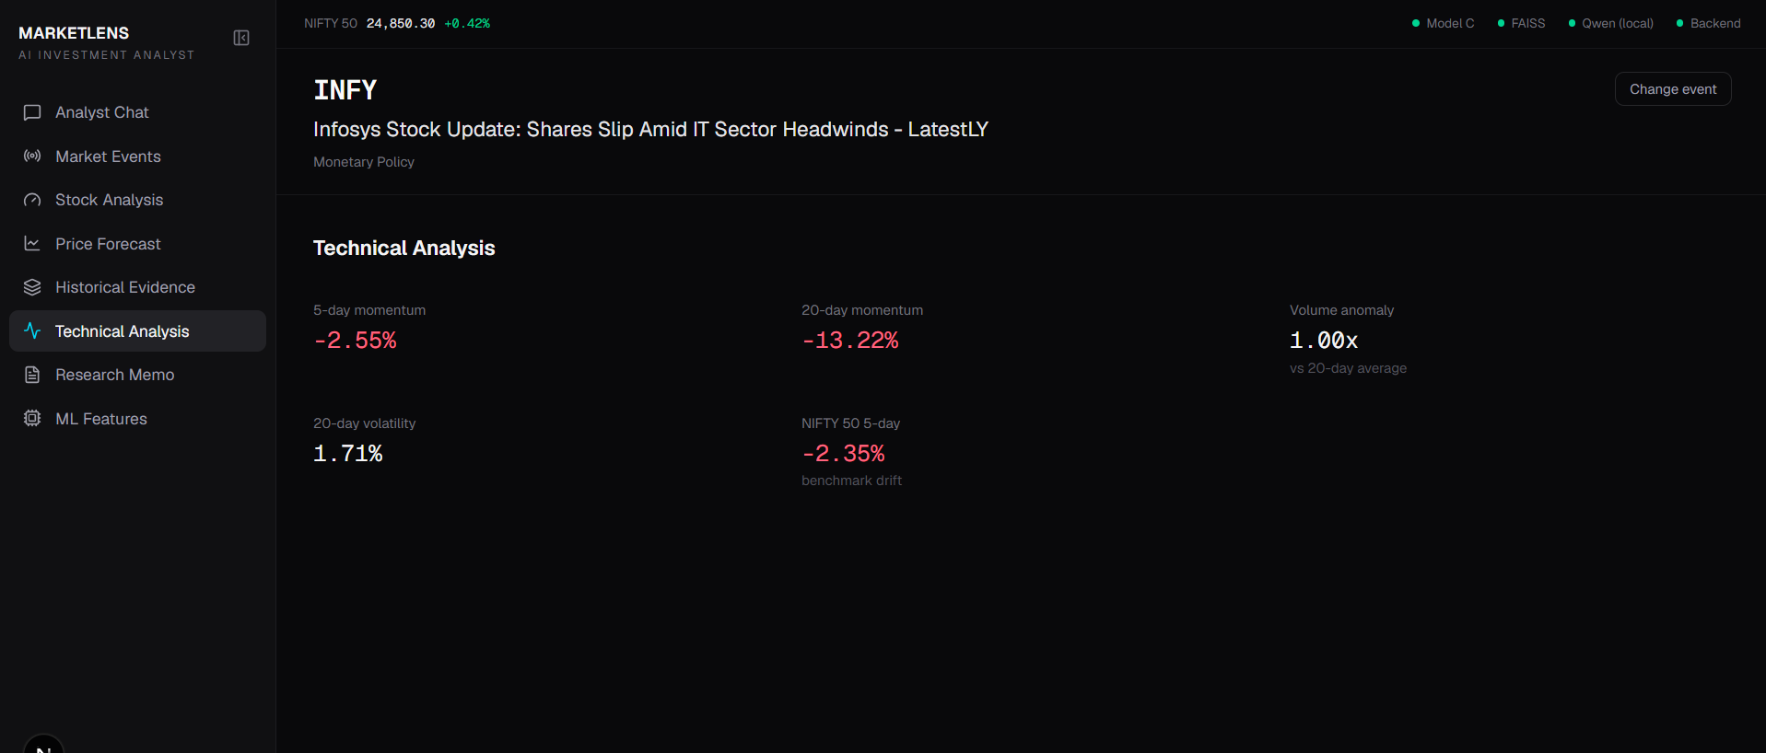

What it is
The stock's behaviour before the news. INFY's 5-day momentum is -2.55% and 20-day momentum -13.22%, volume is 1.00x its 20-day average, 20-day volatility is 1.71%, and NIFTY 50's 5-day return is -2.35% (the market backdrop).

How it helps
- Shows whether the news arrives into an already weak or strong stock.
- Separates stock-specific weakness from a falling market using the NIFTY figure.
- These are real inputs to Model C, so they explain part of the probability.

How it is implemented
- compute_technicals_from_db() queries the latest ~35 daily rows for the ticker and for the ^NSEI index.
- Momentum is the percentage change over 5 and 20 days, volatility is the standard deviation of daily returns over 20 days, and volume anomaly is the latest volume divided by the 20-day mean.
- If too little price data exists, safe defaults are used so the pipeline never fails.

Technology behind it
Component | Technology / detail
Data source | market_data and market_indices tables, filled by collect_market_data.py and collect_indices.py via yfinance
Computation | pandas and numpy
Benchmark | NIFTY 50 (^NSEI)
Use | Displayed here and passed into the 21-feature vector

7. Research Memo
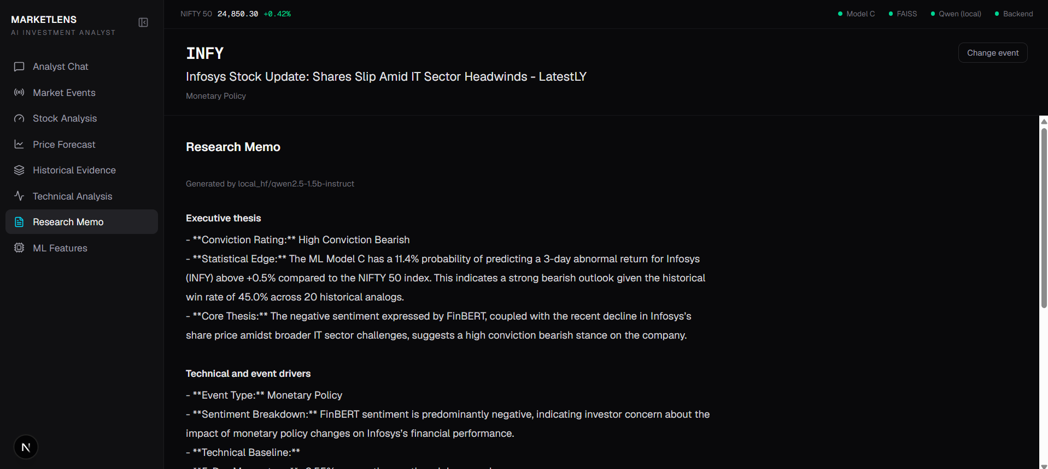

What it is
A written research note on the event, labelled with the model that wrote it (local Qwen2.5-1.5B here). It has four sections: Executive thesis (rating, statistical edge, core thesis), Technical and event drivers, Historical analog rationale, and Downside risks and invalidation.

How it helps
- Packages every number into a readable report that can be shared.
- Explains the reasoning in words for users who do not read charts.
- Always available: if no LLM responds, a deterministic template produces the same four sections.

How it is implemented
- A prompt template inserts the headline, extracted event, technicals, Model C output and FAISS evidence.
- The synthesiser tries Ollama, then local Hugging Face Qwen, then the deterministic generator, and records which one produced the memo.
- The text is split into sections by their headings, and the frontend shows each section under its own title.

Technology behind it
Component | Technology / detail
Generation | Qwen2.5-1.5B-Instruct (local) or Ollama; deterministic fallback
Prompting | prompt_templates.py with system prompt and structured user prompt
Parsing | Section splitter in synthesizer.py
Cost / speed | Local CPU generation is the slowest step, which is why the demo analysis is pre-computed
Note: Small local models can produce rough wording. Review the memo before a demo and regenerate with scripts/preanalyze_demo.py --force if needed.

8. ML Features
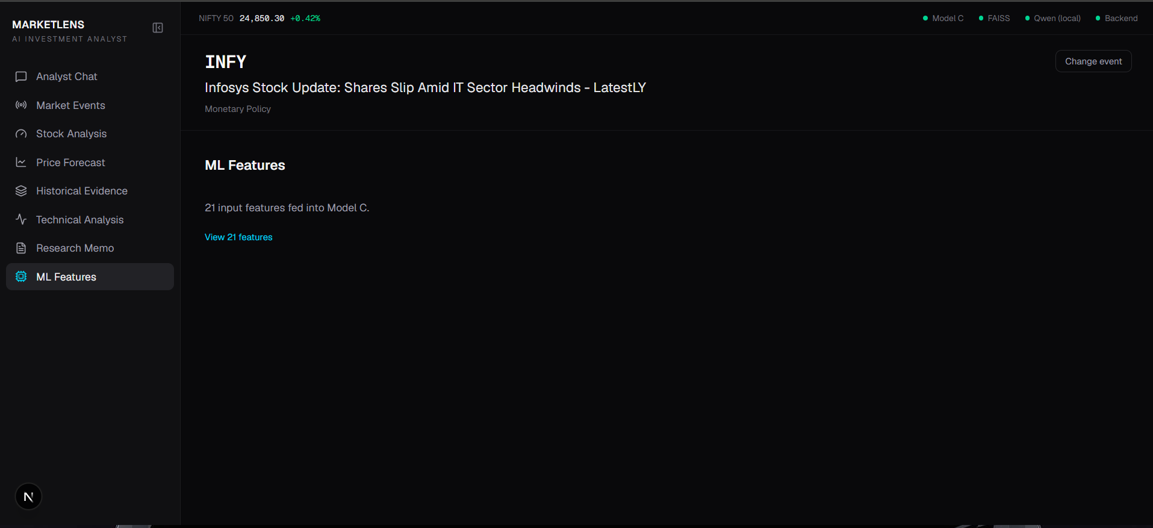

What it is
A transparency view of the exact 21 numbers Model C received for this event. The "View 21 features" link expands the full list.

How it helps
- Makes the prediction explainable: users and judges can see precisely what drove it.
- Helps debug odd results, for example a wrong event type that skews the input.
- Shows there is no hidden data: the model sees only technicals, sentiment and event details.

How it is implemented
- predict_event() builds one row of features and aligns the columns to the order the trained model expects.
- Feature groups: 5 technicals (momentum 5d and 20d, volatility, volume anomaly, market return), 3 FinBERT scores, one-hot event type, one-hot surprise, and magnitude.
- The frontend shows the same dictionary that was passed to the model.

Technology behind it
Component | Technology / detail
Feature engineering | backend/ml/features.py and dataset_builder.py
Training | scripts/run_phase3_training.py; comparison in notebooks/03_model_comparison.ipynb
Model storage | joblib artifact with pipeline and feature column list
Validation | Chronological split to avoid look-ahead bias

Technology summary
Layer | Technologies
Frontend | Next.js, React, TypeScript, Tailwind CSS, lucide-react icons
Backend API | FastAPI, Uvicorn, Pydantic
Database | PostgreSQL, SQLAlchemy 2.0, Alembic
Data collection | feedparser, trafilatura, newspaper3k, yfinance
NLP | Qwen2.5-1.5B-Instruct, ProsusAI/FinBERT (Transformers, PyTorch)
Machine learning | scikit-learn, XGBoost, joblib; TensorFlow LSTM for price forecasts
Vector memory | FAISS, sentence-transformers (all-MiniLM-L6-v2), pyarrow
Chat / memo LLMs | Groq, Google Gemini, Ollama, local Qwen, deterministic fallback

Points to be upfront about
- The news model (3-day, relative to NIFTY 50) and the price forecast (7-day, absolute price) answer different questions and can disagree.
- Historical evidence here rests on a small sample (20 events, 3 analogs).
- The price forecast has no multi-day backtest for INFY; treat it as a directional hint.
- MarketLens is a research and decision-support tool, not investment advice.

