MarketLens
Team Presentation Script (4 Speakers)
From headline to decision: an AI investment analyst for Indian equities.
Length: about 7 minutes, plus questions. A 5-minute cut is on the last pages.
Demo event: "Infosys Stock Update: Shares Slip Amid IT Sector Headwinds - LatestLY" (INFY).

Plan at a glance
Time | Speaker | Part | Screens shown
0:00 - 1:30 | Student 1 | The problem, the idea and the architecture | Market Events
1:30 - 3:15 | Student 2 | How the AI understands news and predicts | Stock Analysis, ML Features
3:15 - 5:00 | Student 3 | Evidence, market context and price forecast | Historical Evidence, Technical, Price Forecast
5:00 - 7:00 | Student 4 | Copilot, memo, reliability, impact and close | Analyst Chat, Research Memo

The story in one line
We do not just predict. We predict, then show the evidence, then let you question it, and every layer has a backup so it always answers.

The three ideas to repeat
- Evidence, not opinion. Every call is backed by retrieved history and real numbers.
- Explainable. You can see the 21 inputs, the sentiment, the analogs and the memo.
- Always available. Cloud AI for speed, local models and rule-based fallbacks for resilience.

Before you go on stage
- Start the backend and frontend, and open the app once. The INFY analysis is pre-computed and loads instantly.
- Open the Price Forecast tab once so the INFY forecast model is ready.
- Click through every tab once so nothing loads for the first time in front of the judges.
- Keep a short screen recording as a backup in case the network or a service fails.
- Do not show the .env file or the API key on screen.
- Fill in your real Model C test metric where the script says [INSERT] (see the Q&A section).

Student 1: The problem, the idea and the architecture
Time: 0:00 - 1:30 Screen: Market Events feed
Goal: make the judges feel the problem, then show that we solve it end to end.
ON SCREEN: Title slide, then the Market Events feed (live ingestion list).
Good morning everyone. Imagine it is 9:15 in the morning and this headline appears: "Infosys shares slip amid IT sector headwinds." You have seconds to decide. Is this noise, or the start of a fall?
Every day, hundreds of financial headlines hit the Indian market. Retail investors cannot read them all, and most tools either dump raw news on you or give a black-box "buy" with no reasoning.
We built MarketLens. It reads a headline and answers four questions: what happened, will the stock beat the market, has this happened before, and what should I do about it.
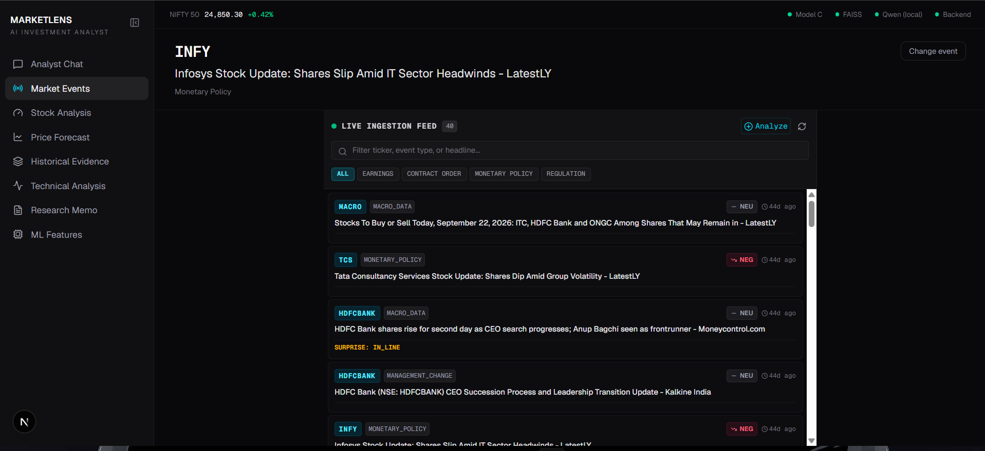
ON SCREEN: Point at the feed: tickers, event types, sentiment tags.
This is our live feed. News is collected automatically from RSS sources, stored in PostgreSQL, and every item is already tagged with the company, the event type and the sentiment. You can filter it, or paste any breaking headline of your own.
Behind it is a six-step pipeline. A local language model extracts the event. FinBERT scores the sentiment. We compute technical features from real price data. Our machine learning model predicts the outcome. A vector memory finds similar past events. And an AI writes the research memo. My teammates will take you through each step.
Hand-off: "Let me hand over to [Student 2], who will show how the AI actually understands the news and makes the prediction."

Key facts you can use
- Data tables: companies, news, market_data, market_indices, events (PostgreSQL, SQLAlchemy, Alembic migrations).
- Collection: RSS feeds with feedparser, article text with trafilatura and newspaper3k, prices with yfinance.
- Benchmark: NIFTY 50. Everything is measured relative to the index, not just up or down.

Student 2: How the AI understands and predicts
Time: 1:30 - 3:15 Screens: Stock Analysis, ML Features
Goal: show that the prediction is built on real, explainable machine learning, not a guess.
ON SCREEN: Stock Analysis tab: the 11.4% number, the signal and the sentiment split.
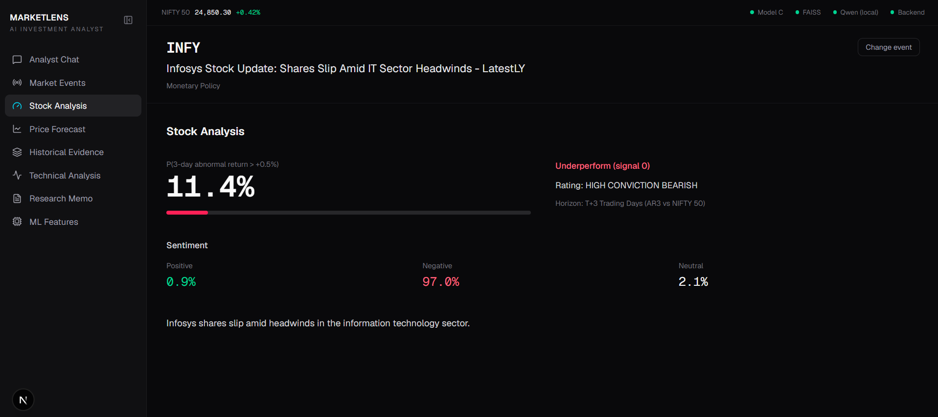
Thank you. This is the main result for our demo headline. Our model says there is only an 11.4 percent probability that Infosys will beat NIFTY 50 by more than half a percent over the next three trading days. The system labels this "High conviction bearish", and the signal is underperform.
Here is how we get that number. First, a small language model running locally, Qwen 2.5, reads the headline and turns it into structured data: the company, the type of event, whether it was a surprise and how big. If the model ever fails to return valid output, a rule-based extractor takes over, so the pipeline never breaks.
Second, FinBERT, a model trained on financial text, scores the sentiment. For this headline it is 97 percent negative. That is a continuous score, not just a label, so the machine learning model can use it directly.
ON SCREEN: Switch to the ML Features tab and click "View 21 features".
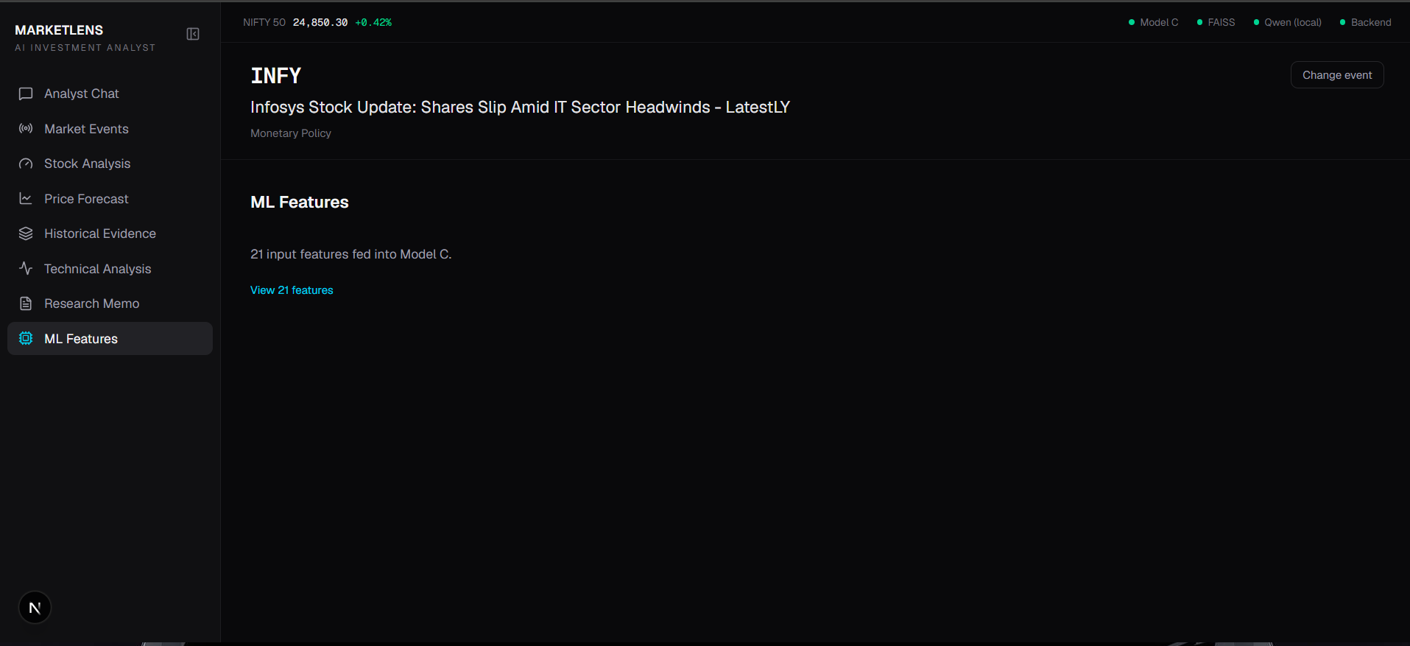
Third, all of this goes into our prediction model, which we call Model C, as 21 features: five technical indicators, the three sentiment scores, the event type, the surprise and the magnitude. You can see every one of them here, so nothing is hidden.
We trained it carefully. We used a strict chronological split, so the model is always tested on events that happened after the ones it learned from. That avoids look-ahead bias, the most common mistake in financial machine learning. The target is abnormal return: the stock's three-day return minus the NIFTY 50 return, so we measure real outperformance, not just a rising market.
Hand-off: "A prediction should never stand alone. [Student 3] will show how we check it against history and the market."

Key facts you can use
- Extraction: Qwen2.5-1.5B-Instruct (Hugging Face Transformers, PyTorch), up to 150 generated tokens, JSON output, retries then regex fallback.
- Sentiment: ProsusAI/FinBERT, softmax probabilities for positive, negative and neutral.
- Model C: scikit-learn / XGBoost pipeline saved with joblib; signal is 1 when probability is at least 0.50.
- Conviction bands: 70%+ high bullish, 55-70% moderate bullish, 45-55% neutral, 30-45% moderate bearish, below 30% high bearish.
- Model comparison and training: scripts/run_phase3_training.py and notebooks/03_model_comparison.ipynb.

Student 3: Evidence, market context and price forecast
Time: 3:15 - 5:00 Screens: Historical Evidence, Technical Analysis, Price Forecast
Goal: show that every prediction is cross-checked against real history, and add an independent price view.
ON SCREEN: Historical Evidence tab: win rate, median return, best and worst case.
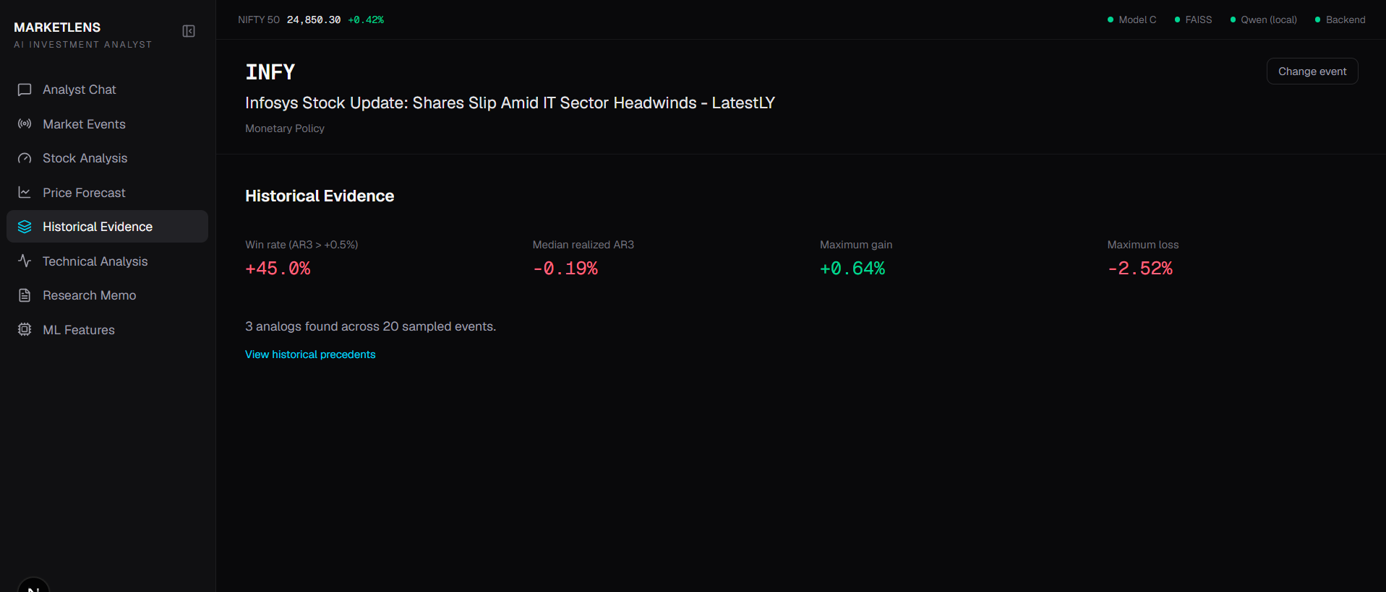
A probability is only useful if you can trust it. So we built a historical memory. Every past event in our database is converted into an embedding with a sentence-transformer and stored in a FAISS vector index. When a new headline arrives, we search for the most similar past events and look at what actually happened to those stocks.
For Infosys, similar past events had a win rate of 45 percent. The median three-day abnormal return was minus 0.19 percent. The best case was plus 0.64 percent, and the worst case was minus 2.52 percent. So history agrees with the model: this kind of news has not been a good sign. And because we show the downside as well as the average, the user sees the real range of outcomes.
ON SCREEN: Technical Analysis tab.
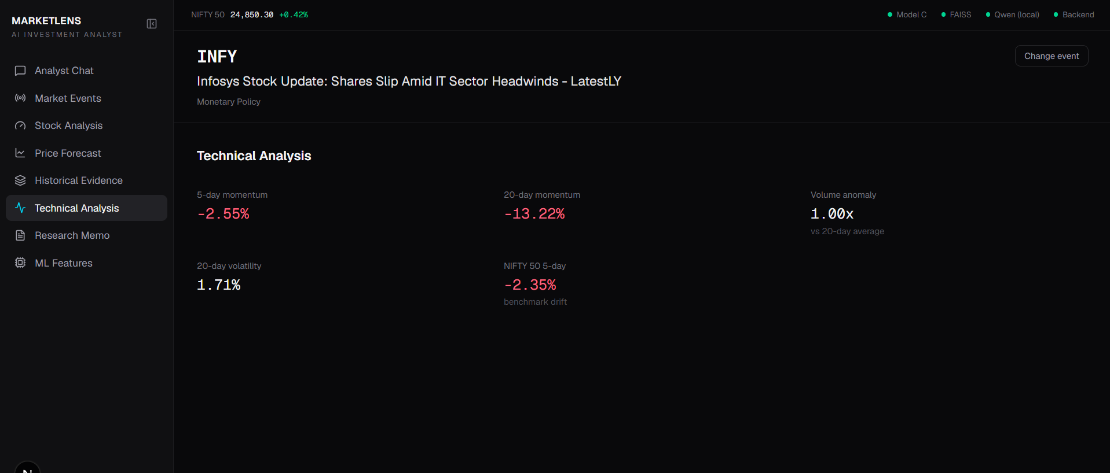
Next, the market context. Infosys had already fallen 2.55 percent over five days and 13.22 percent over twenty days, while NIFTY 50 was down 2.35 percent. So the news arrived into a weak stock in a weak market. These are real inputs to the model, computed from stored daily prices: momentum, volatility and volume against the 20-day average.
ON SCREEN: Price Forecast tab.
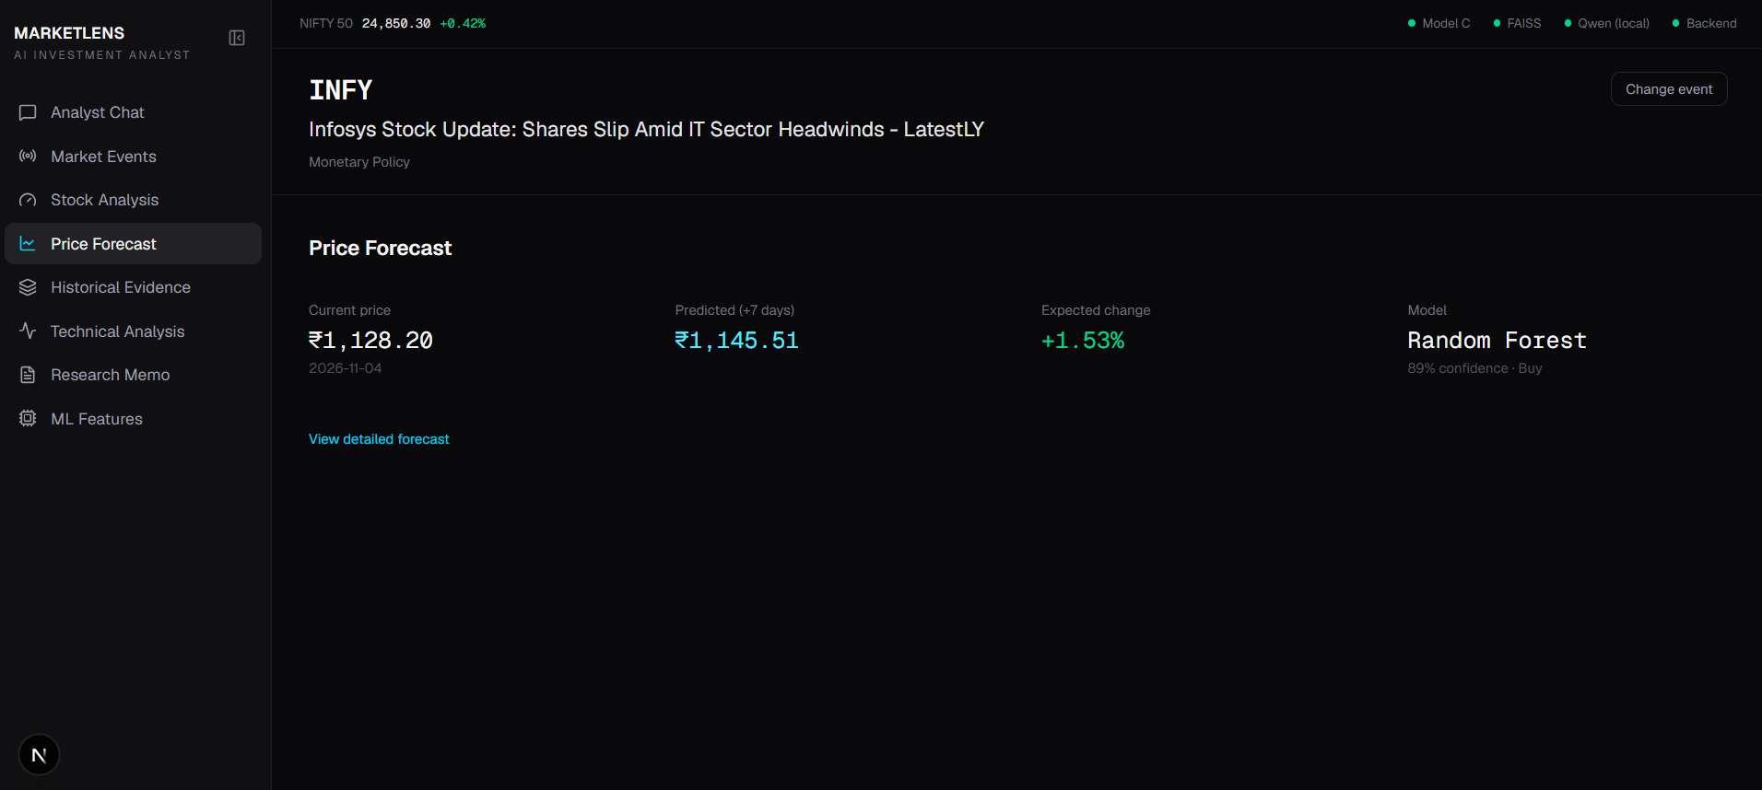
Finally, a separate price view. For any NSE ticker we run Random Forest, XGBoost and LSTM models trained on price history, and forecast seven trading days ahead. Here it projects about 1,145 rupees from 1,128, a rise of 1.5 percent. If a model does not exist for a ticker yet, the system trains one in the background.
Notice that this forecast and the news model answer different questions, one about the next three days against the index, the other about the absolute price over seven days. We show both and are open about it, because that is what honest research looks like.
Hand-off: "All of these numbers are available in plain English through our copilot. Over to [Student 4]."

Key facts you can use
- Embeddings: all-MiniLM-L6-v2; index: FAISS IndexFlatIP with normalised vectors, so scores are cosine similarity; metadata in Parquet.
- Sample for this headline: 3 analogs shown from 20 sampled events. Say so if asked; do not oversell it.
- Technicals come from the market_data and market_indices tables; defaults are used if data is missing so the pipeline never fails.
- Forecast models: Random Forest, XGBoost, LSTM (TensorFlow); data from yfinance; a short cache avoids repeated downloads.

Student 4: Copilot, memo, reliability, impact and close
Time: 5:00 - 7:00 Screens: Analyst Chat, Research Memo
Goal: show the user experience, the engineering quality, the honesty about limits, and finish strongly.
ON SCREEN: Analyst Chat tab. Type: "Explain the Model C signal" then "Predict INFY price".
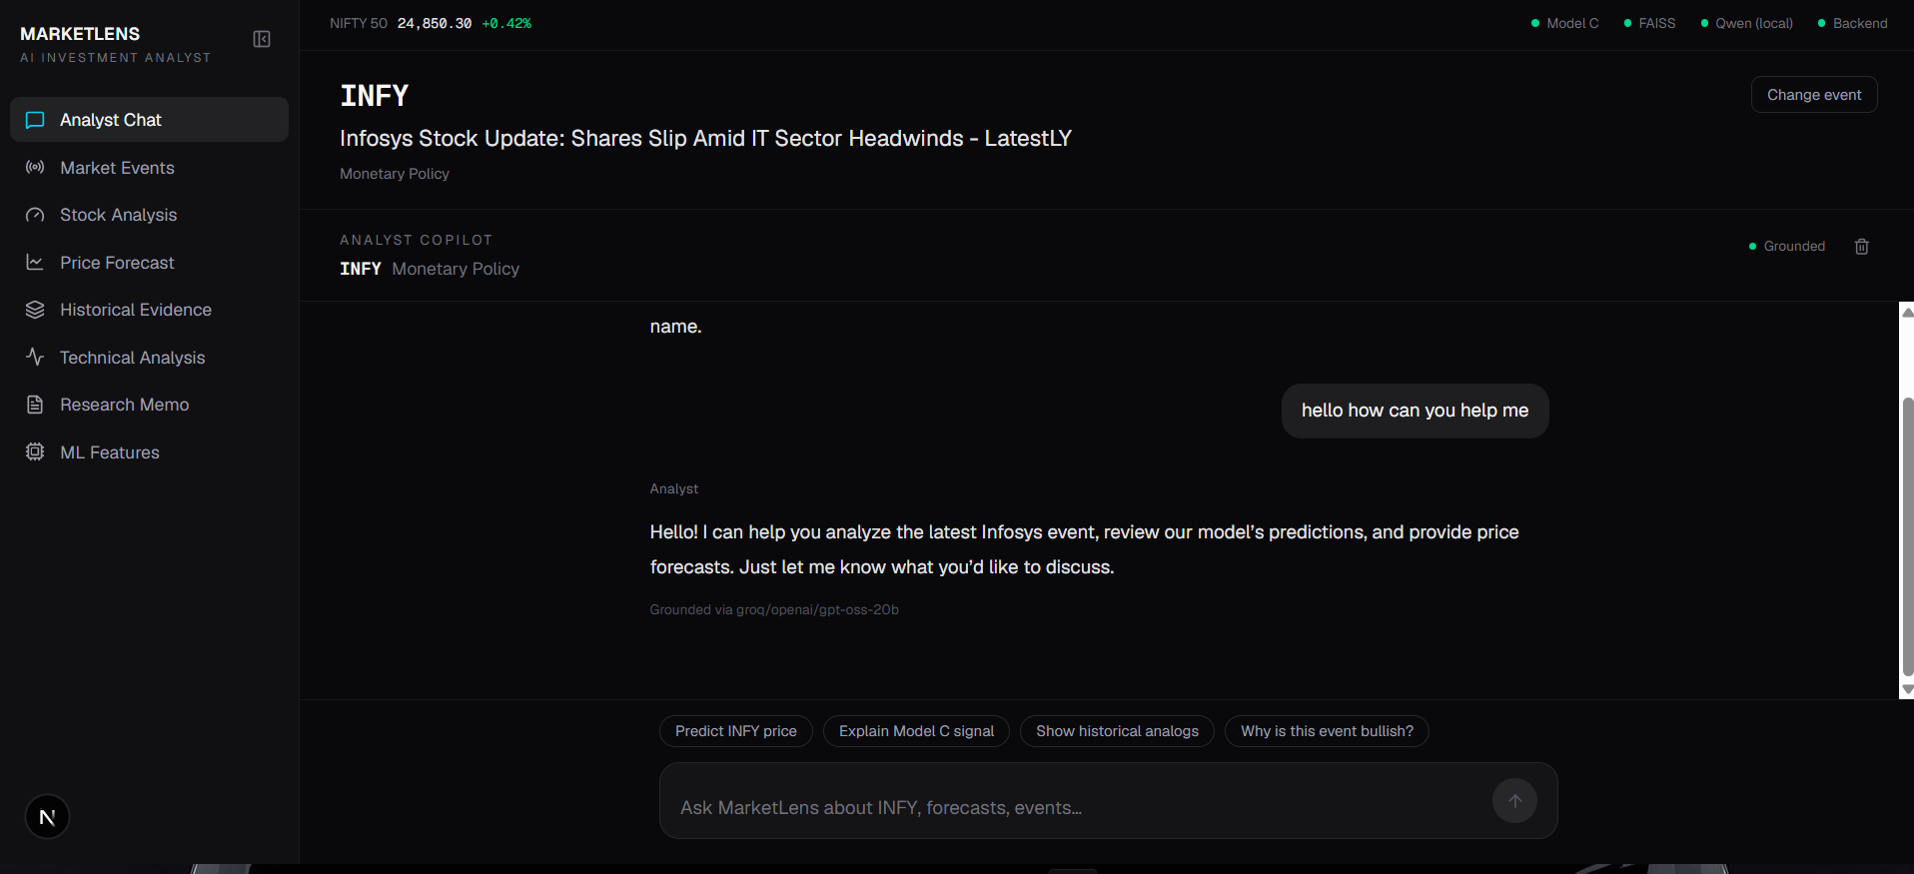
Thank you. All of this is brought together in the analyst copilot. You can simply ask in plain English: why is this bearish, what happened in similar cases, or what is the price outlook. The answers are grounded: the system gives the language model the exact probability, the historical win rate, the analogs and a live price forecast, and instructs it not to invent numbers. The footer shows which model answered, so every answer is auditable.
Speed matters, so the chat uses Groq, a fast cloud model, and replies in about a second or two. And it is built to survive failure: if Groq is down, it falls back to Gemini, then to a local Ollama model, then to a local Qwen model, and finally to a rule-based engine. The user always gets an answer, even offline.
ON SCREEN: Research Memo tab.
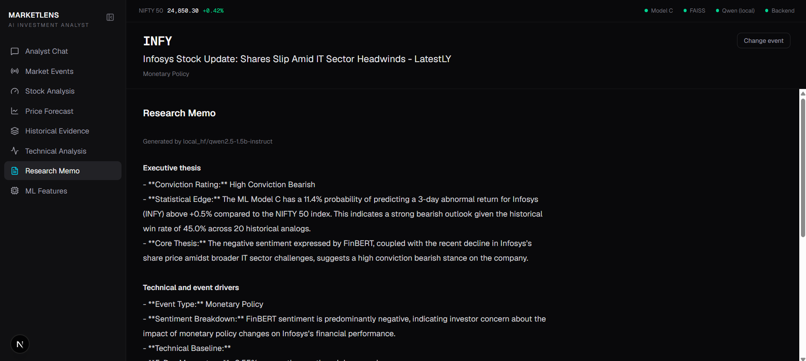
For a full written view, the memo tab produces a research note with four sections: the thesis, the technical and event drivers, the historical rationale, and the downside risks. It is generated by a local model, so the data never has to leave the machine, and it has the same rule-based fallback. Our demo analysis is pre-computed and cached on the server, so it opens instantly.
Let us be honest about the limits, because in finance trust matters. The historical sample for this event is small. Our price forecast is a directional hint, not a guarantee, and it can disagree with the news model. MarketLens is a decision-support tool, not investment advice.
Where do we go next? Live news streaming, saving every analysis and feeding the outcomes back into training, and a single reconciled buy, hold or sell verdict that combines the news signal and the price forecast with clear thresholds. Our goal is simple: do not just read the news, understand what it is worth. Thank you. We are happy to take your questions.

Key facts you can use
- Chat endpoint: POST /api/v1/chat; fallback order Groq (openai/gpt-oss-20b), Gemini, Ollama (qwen2.5:1.5b), local Qwen, deterministic templates.
- Memo: four sections generated from a structured prompt; source shown in the UI (for example local_hf/qwen2.5-1.5b-instruct).
- Caching: demo_cache/analysis_cache.json, written by scripts/preanalyze_demo.py; the first full local analysis took about 6.5 minutes, which is why it is pre-computed.

Likely questions and answers
Decide in advance who answers each question. Keep answers to two sentences.
Question | Suggested answer | Who
How accurate is Model C? | Quote the test-set result from the comparison notebook: [INSERT metric, e.g. ROC-AUC / precision]. Stress that it is a probability, not a guarantee, and that we use a chronological split. | Student 2
How do you avoid look-ahead bias? | Train/validation/test are split by time, and features use only data from before the event. | Student 2
Why use small local models? | They run offline, keep data private and cost nothing per call. Cloud models are used where speed matters, with automatic fallback. | Student 1
Is the historical sample big enough? | For this headline it is small (20 sampled events, 3 analogs), and we show that. It is supporting context next to the model, not proof on its own. | Student 3
What if the news model and price forecast disagree? | They answer different questions: 3-day outperformance against NIFTY versus 7-day absolute price. We show both. A single reconciled verdict with thresholds is our next step. | Student 3
Does the model learn from new analyses? | Not yet. Results are cached but not fed back into training. That feedback loop is on the roadmap. | Student 4
What if the internet or an API fails? | The chat falls back from Groq to Gemini to local models to a rule-based engine. Extraction and the memo also have local fallbacks. | Student 4
Is this investment advice? | No. It is a research and decision-support tool. | Student 4
Why was the event labelled "Monetary Policy"? | The small extraction model can misclassify sector news. We show the label openly; a larger model and few-shot examples would improve it. | Student 2

Delivery tips
- Rehearse with a stopwatch. Each person should finish within 15 seconds of their slot.
- Hand-offs. End with the hand-off sentence, then step aside so the next speaker owns the screen.
- One driver. Let one person (or each speaker in turn) click the tabs, and say what you click before you click.
- Numbers. Say numbers slowly and round them (about 11 percent, 45 percent).
- Do not read. Learn the order of ideas, not the words. Use your own phrasing.
- If something fails. Stay calm, say "this is exactly why we built fallbacks", and switch to the backup recording.

5-minute version
If you only get five minutes, cut as follows:
- Student 1: drop the feed description and keep the problem, the four questions and the six-step summary (1:00).
- Student 2: keep the 11.4%, the 97% negative sentiment and the chronological split; skip the extraction detail (1:15).
- Student 3: show Historical Evidence and Price Forecast only; summarise Technical Analysis in one sentence (1:15).
- Student 4: keep the chat demo, the fallback chain and the closing; skip the memo and roadmap detail (1:30).

Claims to verify before presenting
- Model C test metric: fill it in from notebooks/03_model_comparison.ipynb. This document does not state one because it was not checked.
- Chat speed ("a second or two"): time it on your network and adjust the wording.
- If you quote market size (for example the number of demat accounts in India), check a current source first.

