**RESUME OF MD ASHRAFUL AHSAN**

**Personal Information**

**Name:** MD ASHRAFUL AHSAN

**Email:** [ahsanpx@yahoo.com](mailto:ahsanpx@yahoo.com) **GitHub:**<github.com/Ashraful-Ahsan>  
**Mobile:** +880 1974 547308  
**Present Address:** Horina Gopal, Bagbati, Sirajganj, Bangladesh.

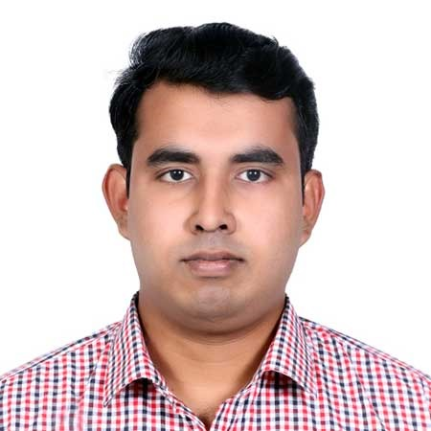

**Objective**

A Computer Science and Engineering student with a strong foundation in technical skills and management knowledge. I aim to drive innovation and contribute to technology solutions in dynamic environments, blending engineering expertise with strategic leadership. My goal is to bridge the gap between technical development and effective management, addressing real-world challenges and creating sustainable, cutting-edge solutions in the evolving tech industry. I seek continuous growth while delivering impactful results and contributing to technological advancements.

**Education**

**Bachelor of Science (Honours) in Computer Science and Engineering**  
(Expected Graduation: October 2026)

* CGPA: 3.72/4.00 (Average of results from four semesters as a current student)
* Relevant Coursework: Object-Oriented Programming, Data Structures, Algorithms, Software Engineering, Database Management Systems, Statistics, Fundamental of Business Studies, Economics  
  Jannat Ara Henry Science and Technology College (JHSTC) – Sirajganj, Bangladesh  
  Affiliated with National University, Bangladesh

**Higher Secondary Certificate (HSC)**  
Subject: Science  
Completed: 2018

* GPA: 4.17/5.00
* Board: Rajshahi Education Board  
  Islamia Government College – Sirajganj, Bangladesh

**Secondary School Certificate (SSC)**  
Subject: Science  
Completed: 2016

* GPA: 4.78/5.00
* Board: Rajshahi Education Board  
  Tarakandi High School – Kazipur, Sirajganj, Bangladesh

**Certifications and Courses**

* **Computer Office Application of National Skill Standard Basic (360 Hours)**  
  Bangladesh Technical Education Board, Dhaka | January – June 2021
* **National Skill Certificate-II in Graphic Design (NTVQF-II)**  
  Bangladesh Technical Education Board, Dhaka | January – March 2023
* **Web Development with PHP & Laravel Course**  
  Ostad (Bangladeshi Online Platform) | March – August 2024

**Technical Skills**

* **Languages:** C, C++, Python, PHP
* **Web:** HTML, CSS, JavaScript, React JS, Laravel, MySQL
* **Tools:** Git, GitHub, Postman, Visual Studio Code, PhpStorm
* **Database:** MySQL, Database Design
* **Others:** Microsoft Office (Word, Excel, PowerPoint), Google Workspace

**Projects**

**Inventory Management System**  
Technologies: PHP, MySQL, Laravel

* Developed a full inventory management system with user authentication and real-time data updates.

**E-commerce Website**  
Technologies: PHP, MySQL, Laravel, JavaScript, Axios, Bootstrap

* Built an e-commerce platform with product listings, shopping cart functionality, and user reviews.

**Awards & Honors**

* **Best Midfielder** **Award** – Inter-College Football Tournament (2023)
* **Academic Excellence Award** – Top 5% of Class (All Academic Semesters)
* **Chess Awardee** – College Tournament (2022)

**Extracurricular Activities**

* **Active Member**, Robotics Club – JHSTC
* **Volunteer**, Blood Donation Group – Sirajganj
* **Volunteer**, Plastic Waste Cleaning Group – Sirajganj
* **Private Tutor** – Teaching College Juniors in Challenging Subjects
* **Active Member**, Tree Plantation Group – Sirajganj

**References**

1. **Mahmuda Parvin**  
   Head of the Department, Computer Science and Engineering (CSE), Jannat Ara Henry Science and Technology College (JHSTC), Sirajganj, Bangladesh  
   Email: parvin.mahmuda977@gmail.com
2. **Rahat Khan**  
   Former Lecturer, Department of Computer Science and Engineering (CSE), Jannat Ara Henry Science and Technology College (JHSTC); Current Lecturer, Department of CSE, Khwaja Yunus Ali University, Sirajganj, Bangladesh  
   Email: rahatkhan.cse@gmail.com