

American International University-Bangladesh (AIUB)  
**Department of Computer Science and Engineering   
Faculty of Science &Technology (FST)  
Fall 2022-2023  
CSC4182 - HUMAN COMPUTER INTERACTION**

**Section: B**

**Project Title: Hand Gesture Controlled Car using Tangible User Interface.**

**Submitted by: B3**

|  |  |
| --- | --- |
| **Name** | **ID** |
| **ASHRAFUL HUDA RAFI** | **19-39721-1** |
| **LAMIYA RAHMAN** | **19-39771-1** |

**Submitted to:**

**Prof. Dr. Khandaker Tabin Hasan**

**Head (Graduate Program)**

Table of Contents

**** Introduction 3

**** Project Background 3

**** Methodology 4

➢ Methods & tools 4

➢ Implementation planning 6

➢ Implementation 7

**** Result 11

**** Discussion 12

➢ Findings 12

➢ Analysis 12

**** Conclusion 12

➢ Recommendations 12

➢ Conclusion 13

**Faculty of Science and Technology**

* Introduction

Effective human-computer interaction depends on a good user interface. It facilitates intuitive and comfortable user interaction with a program or app while also encouraging efficient system usage. Easy to use and comprehend, good user interfaces. They should have sufficient steps and options so that they can be fully understood, but they shouldn't be overly complicated or responsive.

Physical objects known as tangible user interfaces are capable of translating user actions into computer interface input events. By manipulating actual objects that are connected to and faithfully represent the features of the system in question, a user can interact with a digital system using a tangible user interface. An appliance, a piece of software, or a combination of both may be the physical manifestation of a tangible user interface. Appliances and software are two examples of each type discussed in this article.

Here, we will create a project for a user (**Hand Gesture Controlled Car**) that offers a tangible user interface experience.

* Project Background

Our primary goal is to gain practical driving experience. Using an MPU6050 gyro module to read the hand tilt angles, the car's purpose is to transmit data using an NRF trans-receiver. Based on these angle values, the L298N motor driver module will control the vehicle's speed and direction.

We will try to make a hand gesture-controlled car using Arduino. The idea behind this car is to read the angles of the hand using a sensor and send this data to the car. Based on these angle values car's speed and direction will be controlled. We will need Arduino Nano, nRF24l01+ module, NRF adapter, MPU6050 module, 18650 batteries (rechargeable battery) with charger, Breadboard, Double sided tape, Jumper wires, 4WD car kit, L298N driver module. After setting all the components on the breadboard, when we move our hand, the MPU6050 gyro module will read the angles. So, when we move our hand to the left angle the car will go left. And, when we move our hand at a right angle the car will go right. It will work also as same in front and backward. When no movement means no angle data is received by MPU6050. So, the car won’t move. We can stop our car at any time just by stopping movement.

Making this project with a Tangible Interface is what we aim to do. When someone operates a vehicle, they will experience driving the vehicle alone in the real world. Our primary goal is to construct the project so that children can experience real driving skills.

* Methodology
* Methods & tools

Automations are acknowledged to be helping and assisting humans daily. In this article, the reduction of human interaction in the existing scenario will be examined. The purpose of this project is to merge gesture control systems and implement them in a single autonomous vehicle, this can be applied broadly in various industries like health care, quarantine facilities, and construction. The transmitter detects hand motions, transmits signals to the receiver, and the autonomous car travels in that precise direction.

The gesture-controlled autonomous vehicle works or moves according to the movements of the user’s hand. It is because of the transmitter that was placed on the user’s hand that sends the signal for the control of the automation. There is a gyro module on the hand controller which creates analog output data according to the gestures which are further converted to digital. Then the data is sent through radio frequency through the RF transmitter part of the module. The receiving end of the module receives the data and passes the instruction through the microcontroller to the motor driver module which controls the motors of the autonomous car.

Gesture control can be divided into two divisions.

1. Transmitter
2. Receiver

**Transmitter:**

In this part, the circuit will transmit the signal part by reading the hand gestures through the gyro module and sending them to the receiving end of the circuit. This sending and receiving part is done through Radio Frequency, which is also known as RF in short. These signals are then received by the receiving part of the module and then through interpreting the signals, instructions are forwarded to the motor drivers, which control the motors of the car, making the wheels move according to the gestures.

The description of the used modules is given below:

* **Arduino Nano:**

This is like the brain of the automation of this project. The Arduino Nano like other Arduino is a microcontroller board that is based on the ATmega328P microchip. It has more or less the same functionality as other Arduinos but in a smaller form factor. It can be considered as the smaller version of an Arduino Uno. Through the help of this microcontroller, the signals from the gyro module will be relayed to the RF module which in turn will send the signals to the receiving part of the module.

* **MPU6050:**

It is an electromechanical module that is comprised of a 3-axis accelerometer and a 3-axis gyroscope. It has an I2C bus interface which is used to communicate with the microcontrollers. With the help of this sensor, the gyration/acceleration data is recorded and gives analog data which helps in moving in X, Y, Z direction or X, Y direction based on the project. In this project, the module was used to detect the hand gesture motion and send the according data to the microcontroller.

* **nRF24L01+ Trans-Receiver Module:**

To communicate wirelessly, a pair of RF transmitters and receivers are used. In this case, module nRF24L01+ is used. The nRF24L01+ module employs GFSK modulation to transmit data and is built to work in the 2.4 GHz global ISM frequency range. The module also comes with an antenna which can help to increase the range by mounting it with the module. The range can be boosted up to 1000m when the antenna is mounted. This module is the part that sends the data to the receiving end through RF.

**Receiver:**

In this part, the RF-transmitted signals are received with the help of the nRF24L01+ module’s receiving end. Then the signals are sent to the microcontrollers, which interpret the signals into commands and relay the commands to the L298N H-Bridge Motor Driver and this module helps the motor turn according to the command.

The description of the modules used is given below:

* **Arduino Nano:**

Just like before the microcontroller will be used to attach all the module components, through which all significant processes will be conducted. The nRF24L01+ module’s receiving part and the L298N H-Bridge Motor Driver are connected to the microcontroller.

* **nRF24L01+ Trans-Receiver Module:**

Just like in the transmitting part the nRF24L01 module will receive the signals and then transfer them to the microcontroller.

* **L298N H-Bridge Motor Driver:**

The featured module is an L298N Dual H-bridge, which can simultaneously control two or more DC motors as well as direction and speed. The module can drive DC motors with voltages between 5 and 35V thanks to a peak current of up to 2A. By examining the L298N module's pinout in more detail one can understand its operation. The module features a 5V pin that can be used as an input or output, two screw terminal blocks for motors A and B, a third screw terminal block for the Ground pin, the VCC for the motor, and two screw terminal blocks for motors A and B.

• Forward and Backward directions and also Stop are controlled by the "Logic Input" pins, each of which controls a motor.

• 12V power is not always 12V; it can also be 9V or powered up to 47V DC. However, one must remove the regulator jumper before utilizing higher voltages to avoid burning the device.

• Enable A/B used to control speed; if their jumpers are left in place, speed will be at its highest level (they can withstand up to 5V).

• GND pin should always be wired with Arduino.

* **DC Motors:**

This type of motor converts electrical energy into mechanical energy. Its operation is based on the idea that a current-carrying conductor will encounter a mechanical force when exposed to a magnetic field. DC motors contain a stationary field winding or permanent magnet in addition to a rotating armature but no rotating magnetic field. Different field and armature winding connections offer various speed/torque regulation characteristics. A DC motor's speed can be altered by adjusting the field current or the voltage delivered to the armature. The DC motors are connected to the motor driver module and with the help of the motor driver module, the DC motors are controlled. Batteries linked directly to the motor driver, supply the DC input power required for these motors to function.

* Implementation planning

The project can be divided into two parts.

1. Transmitter
2. Receiver

So, the first target of the project is to construct the transmitter part. To construct the transmitter part the components needed are Breadboard, Arduino nano, MPU6050 accelerometer/gyro module, nRF24L01+ Trans-Receiver module nRF adapter, and rechargeable battery. At first, on the breadboard, the Arduino nano is mounted firmly. Then the MPU6050 is mounted carefully. The nRF adapter is mounted on the board with double-sided tape. Then the connection of +5 V and GND of Arduino nano is implemented. Then the connections between the microcontroller and the MPU6050 are implemented carefully. Now the nRF adapter is to be connected to the Arduino nano. In the end, the nRF24L01+ Trans-Receiver module is mounted on the nRF adapter carefully. Then the whole breadboard can be attached to a belt for better grip. Now the code for the transmitter part needs to be created and uploaded to the Arduino nano.

Then the focus should be on the receiving end. To construct the receiving part the components needed are Wheels, vehicle chassis, breadboard, nRF24L01+ Trans-Receiver module, nRF adapter, L298N Dual H-bridge motor driver module, DC motors, and rechargeable batteries. At first, the vehicle needs to be assembled with 4 DC motors alongside the wheels. Then the breadboard and L298N motor driver needs to be placed on the top of the vehicle chassis. After that, the Arduino nano is mounted on the breadboard. Then the nRF adapter is taped on the breadboard. Then all of the parts are connected with wires accordingly. The Motor Driver is connected to the DC motors and also to Arduino nano. Then the nRF adapter is connected with the Arduino nano and then the nRF24L01+ module is connected to the nRF adapter. Then the receiving part’s code needs to be created and uploaded to the Arduino nano.

* Implementation

A hand gesture-controlled car using Arduino nano, MPU6050 module, nRF24L01, and L298N driver module works by using these components to interpret hand gestures and translate them into actions that control the movement of the car. The Arduino Nano is a microcontroller board that is used to process input from the sensors and control the motors that drive the wheels of the car. It receives input from the MPU6050 module, which is an accelerometer and gyroscope sensor that can detect the movement and orientation of the car. The nRF24L01 is a wireless communication module that is used to transmit data wirelessly between the car and a controller device. The L298N driver module is used to control the motors that drive the wheels of the car. It receives commands from the Arduino Nano and uses them to control the speed and direction of the motors. Overall, the Arduino Nano processes input from the sensors and uses it to control the movement of the car through the L298N driver module. The nRF24L01 is used to transmit data wirelessly between the car and a controller device, allowing the car to be controlled remotely.

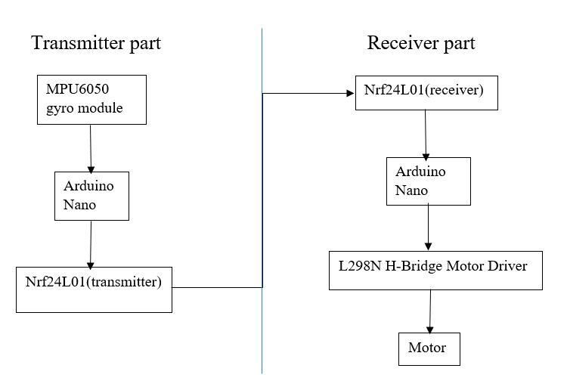

fig: Block Diagram

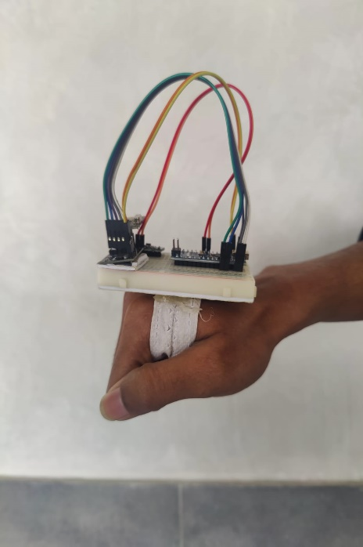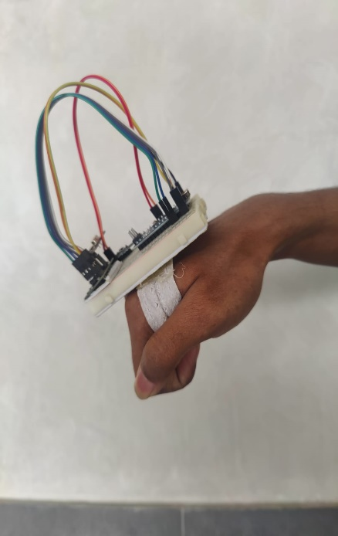

gesture to STOP gesture to move FORWARD gesture to move BACKWARD

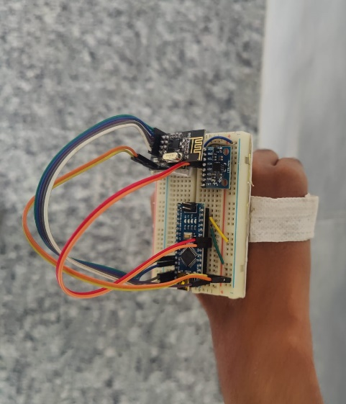

gesture to move LEFT gesture to move RIGHT

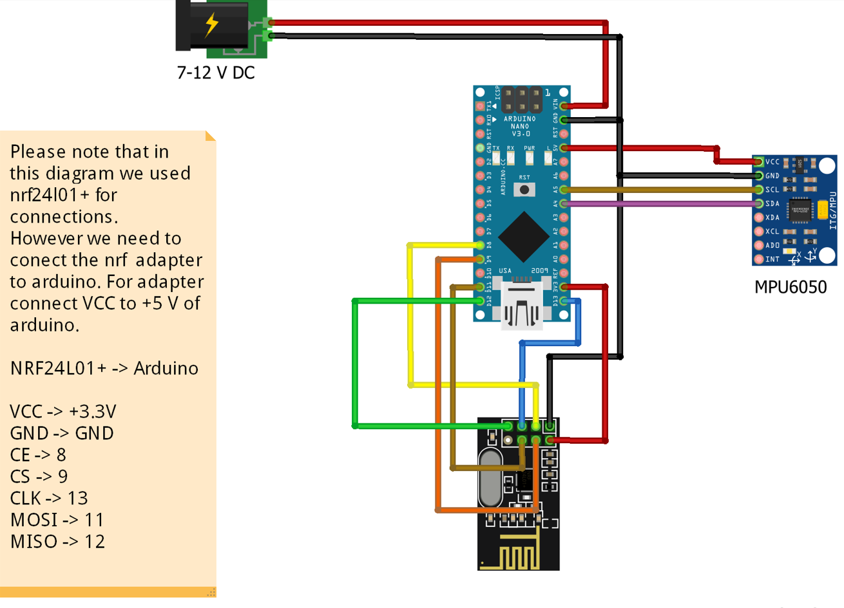

Fig: Circuit diagram of Transmitting

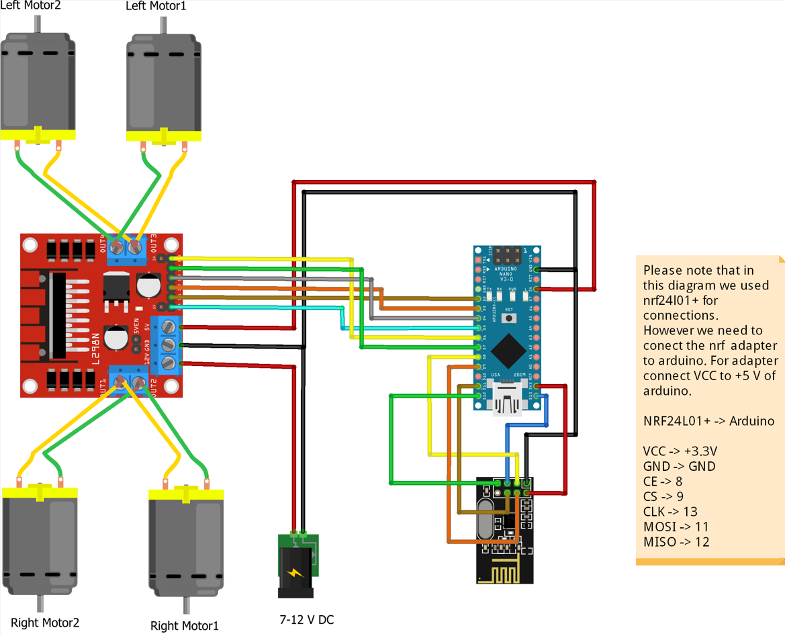

Fig: Circuit diagram of Receiving

* 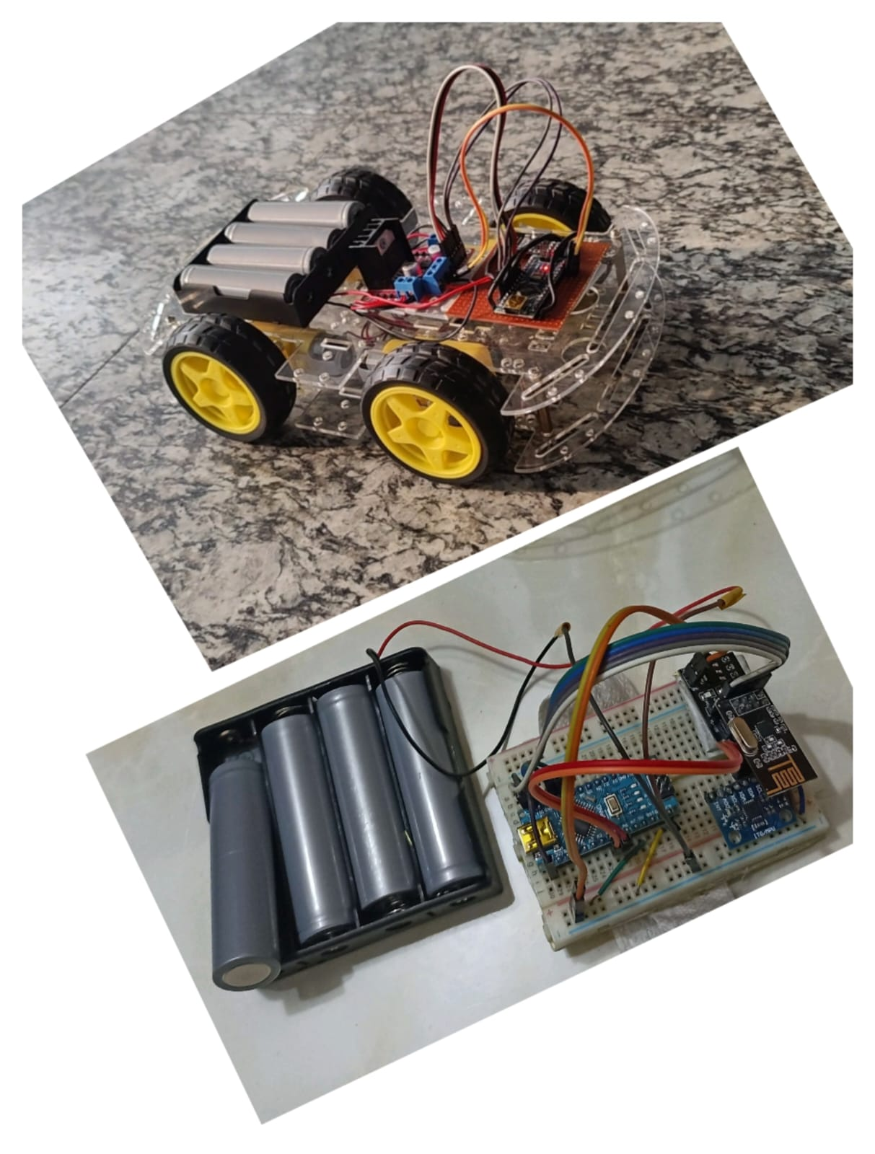Result
* Discussion
* Findings

While constructing this project some issues were faced. Some of them are minor and some of them were an integral part of this project. The major problem that was faced is the non-responsive defect of the nRF24L01+ module. Due to this even after constructing the whole project, in the trial run the vehicle was not responding. The code and connection were checked thoroughly but no issues were found. Then each component was checked individually until it was found that the nRF24L01+ module was not responding. Another problem that was faced is the loose connection of the circuit. As the vehicle is moving frequently the wired connection tends to become loose and comes out of the breadboard.

* Analysis

To address the aforementioned issue of the nRF24L01+ module not working, it is best to buy any electronic product after checking thoroughly whether it is working or not. Then to address the loose connection issue it is best to buy good cable after checking if the cable mounts on the breadboard firmly or not. The vehicle and the controller need to be further investigated to check if the mounting of the circuit is firm or not. The power consumption of the battery can be further improved by strong batteries and low-power consumption sensors.

* Conclusion
* Recommendations

Despite the project's optimism, there are still some restrictions. One of them is the amount of energy used and the weight of the batteries the vehicle is carrying for its power source. To reduce power consumption and the weight of the vehicle, a more practical power source, and power-efficient module should be used. Because the human hand can move in a wide variety of directions, not all of them are picked up by the vehicle's sensor. The project's next phase will involve the identification of additional hand movements and the resulting output from the vehicle.

In the future, the system may also include cameras and voice control, allowing the user to operate the car using voice commands and keep an eye on it from a distance. A gamer can use gesture control to use real-world gestures to fully immerse themselves in the game. It can also be used for a wide range of entertaining activities.

* Conclusion

The objective of the project is to control a toy car using sensor-equipped hand gloves. The remote control, which is typically used to operate the vehicle, is intended to be replaced by sensors. The car's throttle, forward, backward, left, and right movements can all be controlled by the same sensor using hand motions. According to the experiment's findings, about 90% of the implementation functions as intended, but the remaining 10% was caused by background noise, earning the implementation a failing grade. The hand gesture-controlled system offers a more practical method of device control. The user can direct the vehicle to move in a specific manner within the environment using hand gestures. The user can partially control the movement of the vehicle from their working station without using any external hardware support, in contrast to the previously mentioned existing approach. Nowadays, having wireless control over an object is both highly admirable and advantageous. Wireless control of an object has a vast and very practical range of applications. The project typically only touches the very beginning of using wireless control of an object.