North South University



**E commerce Website (SDS)**

**Course :** Cse327

**Section :** 05

**Submitted By:**

**Name :** Md Sazzad hossain ID : 1520693042

Md Ashraful Alam ID : 1521925642

**Submitted To:**

**Name:** Md Musfique Anwar(MMA1)

**ER Diagram**

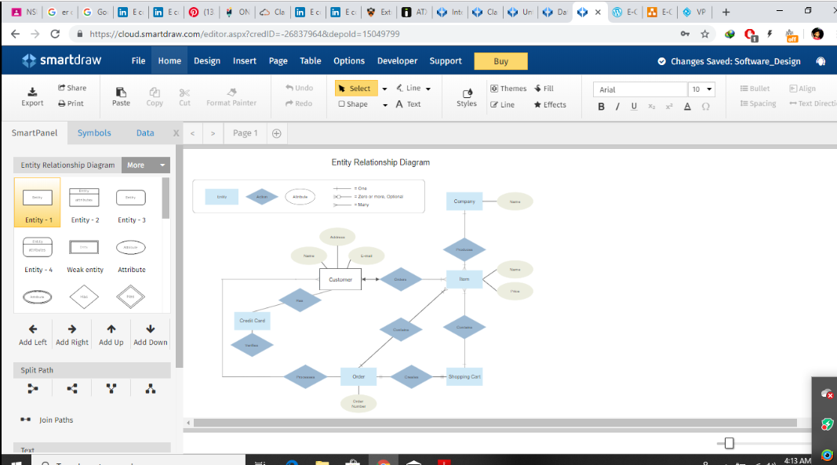

Here we are use smart Draw tools for ER Diagram . SmartDraw is a diagram tool used to make flowcharts, organization charts, mind maps, project charts, and other business visuals. SmartDraw has two versions: an online edition and a downloadable edition for Windows desktop.

Database schema

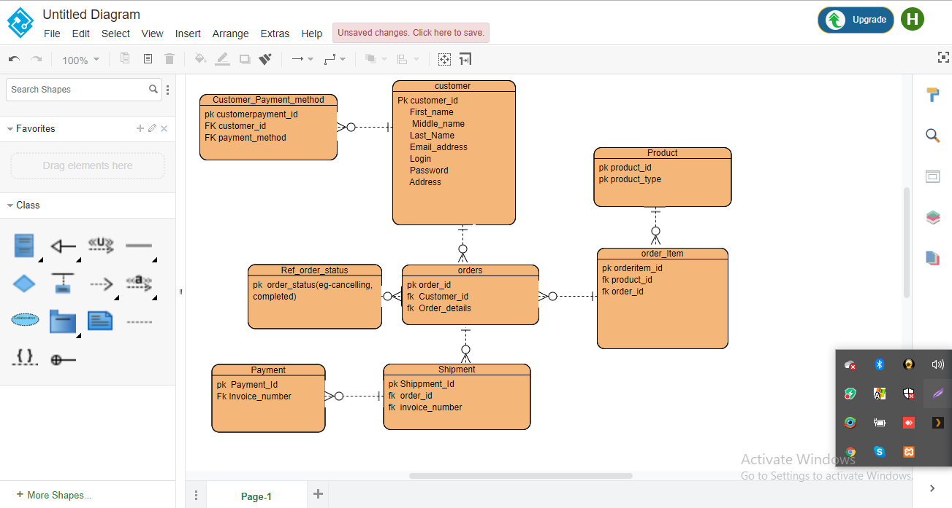

Here we are using Visual paradigm online tools for database schema. Visual Paradigm is a software tool designed for software development teams to model business information system and manage development processes. Visual Paradigm supports key industry modeling languages and standards such as Unified Modeling Language (UML), SysML, SoaML, BPMN, XMI, etc.

**UMl Diagram**

1. **Use case Diagram**

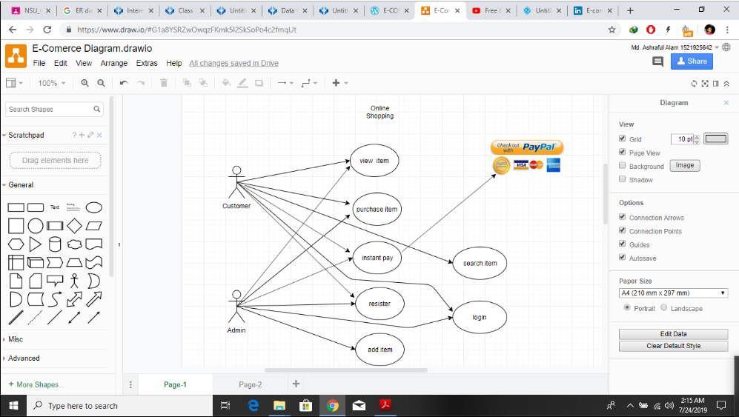

Basically we are using draw.io tools for use case diagram . Draw.io is free online diagram software for making flowcharts, process diagrams, org charts, UML, ER and network diagrams.

Anyone can view Online Shopping portal and available products, but every user must login by his/her Username and password in order to purchase or order products. Unregistered members can register by navigating to registration page. Only Admin will have access to modify roles, by default developer can only be an ‘Admin’. Once user register site, his default role will be ‘User’.

**View item**: As a customer I want to see the item so that I can compare the product is good or bad quality. Customer can also see the all categories that so that he decide the product which one is cheap cost and good quality.

**Purchases:** Customer can purchases the product and also the the details about the product.

Before purchases a item user can login his account.

**Instant Pay:** Customer also can pay instant using his/her debit card and also hand on cash.

**Resister**: Customer need to resister for buying and he can get more better experience for resistaton. Admin also see who were registered **.**

**Add Item:** Admin can Add a item so that, customer can buy a new arrival and latest products.

**Search Item :**  User can search the product Because he can see his needed product is available or not.

**Login**: Login page for both users and administrators. Admin Page: Only difference you see in this page is Role: Admin. User and Admin role will be checked once the page was login and Session [“role”] will be either Admin or User. If credentials belong to Admin then role will be Admin and if credentials belong to User then role will be User.

1. **Class Diagram**

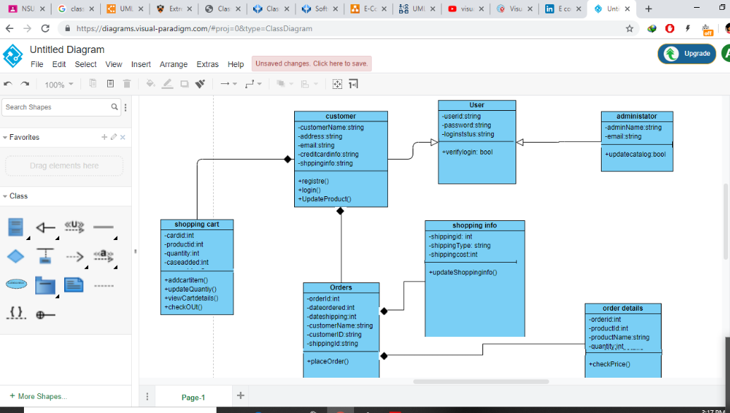

Here we are using Visual paradigm online tools for class diagram . Visual Paradigm is a software tool designed for software development teams to model business information system and manage development processes. Visual Paradigm supports key industry modeling languages and standards such as Unified Modeling Language (UML), SysML, SoaML, BPMN, XMI, etc.

1. **Sequence Diagram**

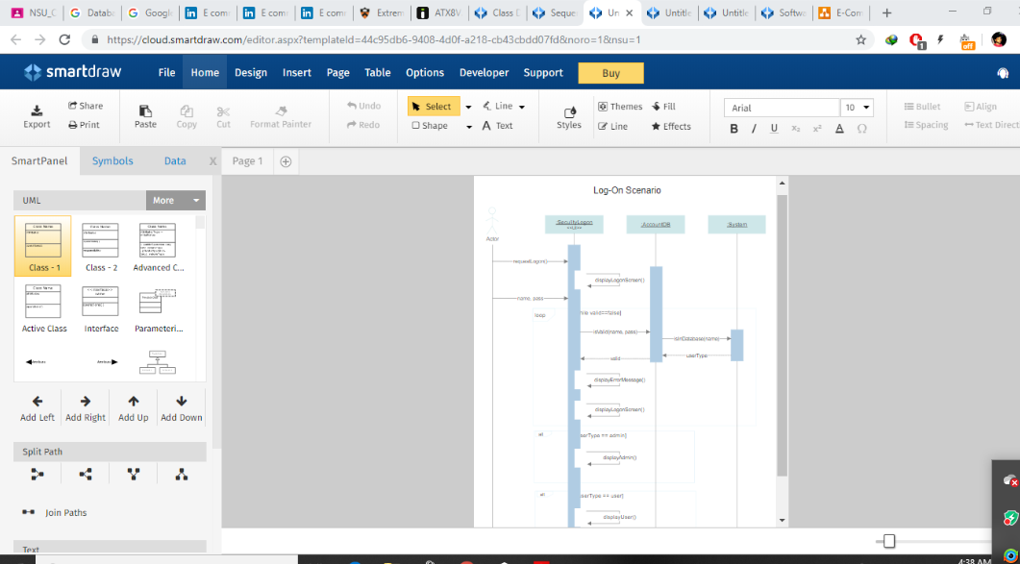 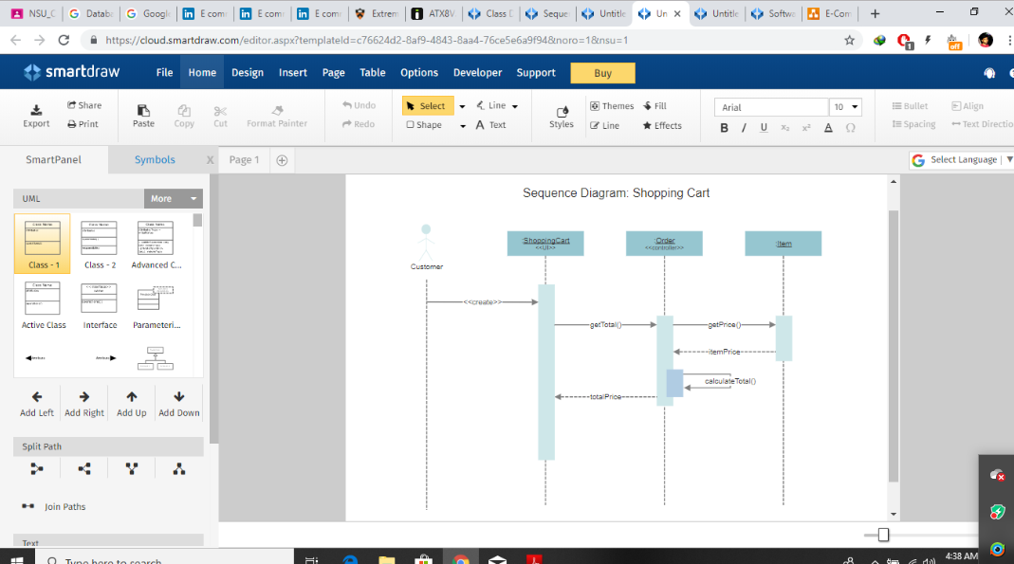

Here we are use smart Draw tools for Sequence Diagram . SmartDraw is a diagram tool used to make flowcharts, organization charts, mind maps, project charts, and other business visuals. SmartDraw has two versions: an online edition and a downloadable edition for Windows desktop