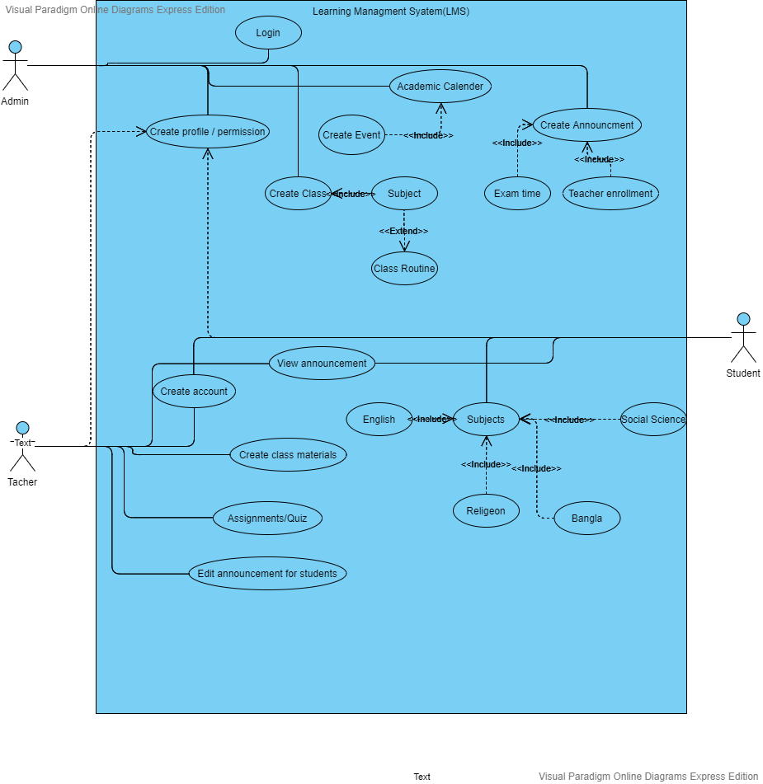

Users: there will be three types of role student, teacher, principal as SuperAdmin.

Title: Manage Dashboard

Actor: Admin

Scenario: There will be a tab dashboard tab available for SuperAdmin. In that dashboard SuperAdmin will manages teacher student, class Admin and new request for joining. By managing I meant create, edit and delete, assigning teacher and student to class.

Pre-condition: Admin need first to create a dashboard.

Post-condition: After creating the dashboard, admin need to register.

Then admin have to login the LSA.

Title: Fixed a event and class routine.

Actor: Admin

Scenario: There will be event calendar for the entire school. The principal will have the create and edit and delete event access to the event calendar &class routine only. But the entire school will able to view the event calendar and the specific class student will able to view to routine for the class.

Pre-condition: Admin need first to create a event.

Post-condition: Admin have to login the LSA and also have to permit the teachers and student so that they can get to see it.

Title: Creating Announcement and assignment.

Actor: Teachers

Scenario: Inside a certain class teacher will able create Announcement for the student of that class and also on the Assignment teacher will able to upload a file.

Pre-condition: Teacher have to post the announcement before the class and it will also be public.

Post-condition: Teacher can take any Assignment by doing a folder like assignment.

Title: Manage class material

Actor: Teachers

Scenario: Teacher will able to upload lecture video, audio, image, file etc on class lecture section on a regular basis with lecture no. student will have only view access.

Pre-condition: Teachers need to login first. After login teachers can upload any file.

Post-condition After login teacher have to put some class material

Title: Fixed a event calendar

Actor: Teachers

Scenario: There will be event calendar specific for the class which will have the teacher access for event creating. In this event calendar event will be specified for that class only.

Pre-condition: Teachers need first to create a event.

Post-condition Admin have to login the LSA and also have to permit the teachers and student so that they can get to see it.

Title: Assign Examination

Actor: Teacher

Scenario: Teacher will able to create a question as creative, multiple, short and poll question by an exam name as date. When the time comes teacher will be able to start the exam and student will able to give the exam. During starting exam teacher had to set exam end time. And on that time exam will be finished. Exam page will be reloading and student will not have access on exam.

Post-condition: Teacher need to login first. Then he/she can fix a event for the exam.

Pre-condition: Teachers have to login the LSA and student can see that what type of question is given them.

Title : Student see their marks

Actor: Students

Scenario: After the exam finished teacher will be able to view the script for the specific student and give marks. And student will able to see their marks.

Pre-condition: Student need to login first. Then he/she can see the event for the exam.

Post-condition: Students have to login the LSA and student can see that what type of question is given them.

Title: Assign for a teachers

Actor: Admin

Scenario: Principle is the admin of this site. S/he can control all of class, schedule, teachers. Admin can assign a teacher for a particular section. Admin can give a instruction for the teachers so that one teacher can take one class for a particular time.

Per-condition: Teachers must register first.

Post-condition: After login the teacher will see which section is fix for his/her