LostLink
Campus Lost & Found Management System
SECTION 1
ER Diagram
The diagram below shows all six entities and their relationships. USERS is the central entity; MATCHES bridges LOST_ITEMS and FOUND_ITEMS; CLAIMS links all three; NOTIFICATIONS feeds back to USERS.
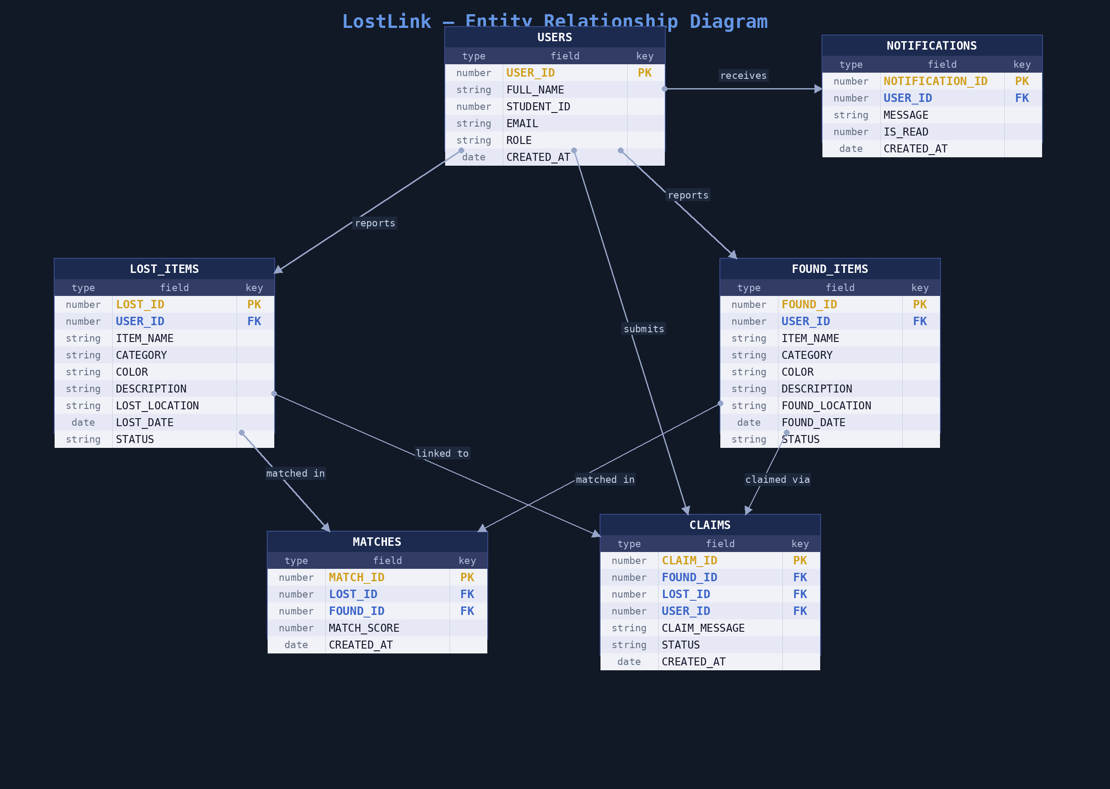
Entity Relationships
From Entity | Cardinality | To Entity | Cardinality | Relationship
USERS | 1 | LOST_ITEMS | 0..* | reports
USERS | 1 | FOUND_ITEMS | 0..* | reports
USERS | 1 | CLAIMS | 0..* | submits
USERS | 1 | NOTIFICATIONS | 0..* | receives
LOST_ITEMS | 1 | MATCHES | 0..* | matched in
FOUND_ITEMS | 1 | MATCHES | 0..* | matched in
FOUND_ITEMS | 1 | CLAIMS | 0..* | claimed via
LOST_ITEMS | 0..1 | CLAIMS | 0..* | linked to

SECTION 2
Database Schema
Six normalised Oracle tables with sequence-driven primary keys and trigger-based auto-increment. Foreign key constraints enforce referential integrity throughout.
USERS  USER_ID (PK)  FULL_NAME  STUDENT_ID  EMAIL  ROLE  CREATED_AT |  | LOST_ITEMS  LOST_ID (PK)  USER_ID (FK)  ITEM_NAME  CATEGORY  COLOR  DESCRIPTION  LOST_LOCATION  LOST_DATE  STATUS

FOUND_ITEMS  FOUND_ID (PK)  USER_ID (FK)  ITEM_NAME  CATEGORY  COLOR  DESCRIPTION  FOUND_LOCATION  FOUND_DATE  STATUS |  | MATCHES  MATCH_ID (PK)  LOST_ID (FK)  FOUND_ID (FK)  MATCH_SCORE  CREATED_AT

CLAIMS  CLAIM_ID (PK)  FOUND_ID (FK)  LOST_ID (FK)  USER_ID (FK)  CLAIM_MESSAGE  STATUS  CREATED_AT |  | NOTIFICATIONS  NOTIFICATION_ID (PK)  USER_ID (FK)  MESSAGE  IS_READ  CREATED_AT

SECTION 3
Features
User Authentication  Registration, login, and role-based access control distinguishing regular users from admins. |  | Report Lost Item  Users submit detailed lost item reports with name, category, colour, location, and date.

Report Found Item  Users log found items into the system, triggering the smart matching engine automatically. |  | Smart Match Engine  Weighted scoring: category (35%), colour (25%), location (20%), name similarity (10%), description similarity (10%). Matches above 50% are stored in MATCHES.

Claim Submission  Users claim a found item with a message; claims are queued for admin review with pending / approved / rejected status. |  | Admin Claim Management  Admins approve or reject claims via PL/SQL stored procedures that atomically update item statuses and insert notifications.

Notifications  In-app alerts for match discoveries and claim status changes (approved / rejected). |  | Dashboard & Stats  Live stat cards showing total lost, total found, recovered count, and pending claims.

Item & Profile Management
Users can edit or delete their own lost item reports and update their profile details.

