
RIZZ Leather — SEO Metadata Catalog
Pure Leather. Pure Prestige. | Chittagong, Bangladesh
Generated: 26 June 2026 | 15 Products | 58 Images

RIZZ Bini — Woven Leather Slide Sandal

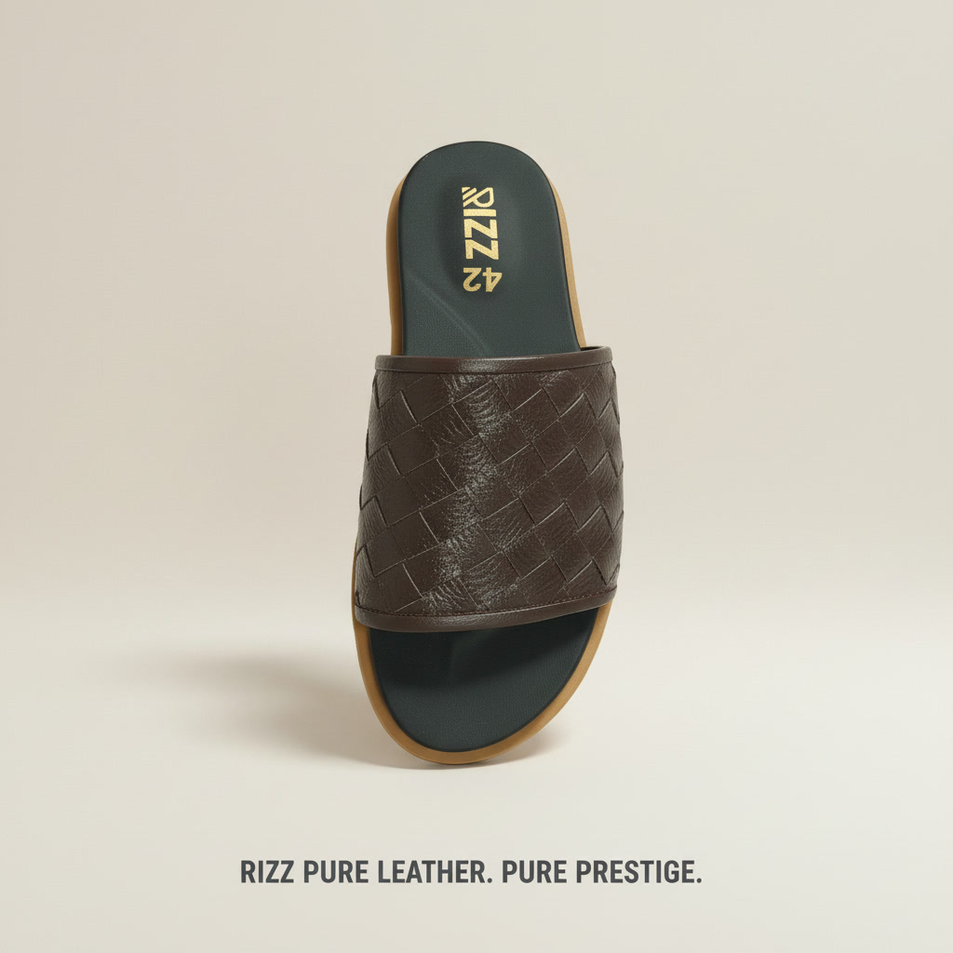  rizz_bini_sandals | SEO Title RIZZ Bini Woven Leather Slide Sandal | Handcrafted  Meta Desc Elevate your style with RIZZ Bini — a premium handcrafted woven leather slide sandal from Chittagong. Genuine leather upper, cushioned insole. Shop now.  Alt Tag RIZZ Bini dark brown woven genuine leather slide sandal — top view showing intricate basket-weave strap and teal cushioned insole  OG Title RIZZ Bini | Handcrafted Woven Leather Slide Sandal  OG Desc Pure leather. Pure prestige. The RIZZ Bini features a hand-woven genuine leather upper with cushioned teal footbed. Crafted in Chittagong.  Material Genuine Leather  Color Dark Brown  Pattern Basket Weave
Schema JSON-LD
{"@context":"https://schema.org/","@type":"Product","name":"RIZZ Bini Woven Leather Slide Sandal","brand":{"@type":"Brand","name":"RIZZ Leather"},"material":"Genuine Leather","color":"Dark Brown","category":"Sandals","offers":{"@type":"Offer","availability":"https://schema.org/InStock","priceCurrency":"BDT"}}
RIZZ Cholate — H-Strap Leather Sandal

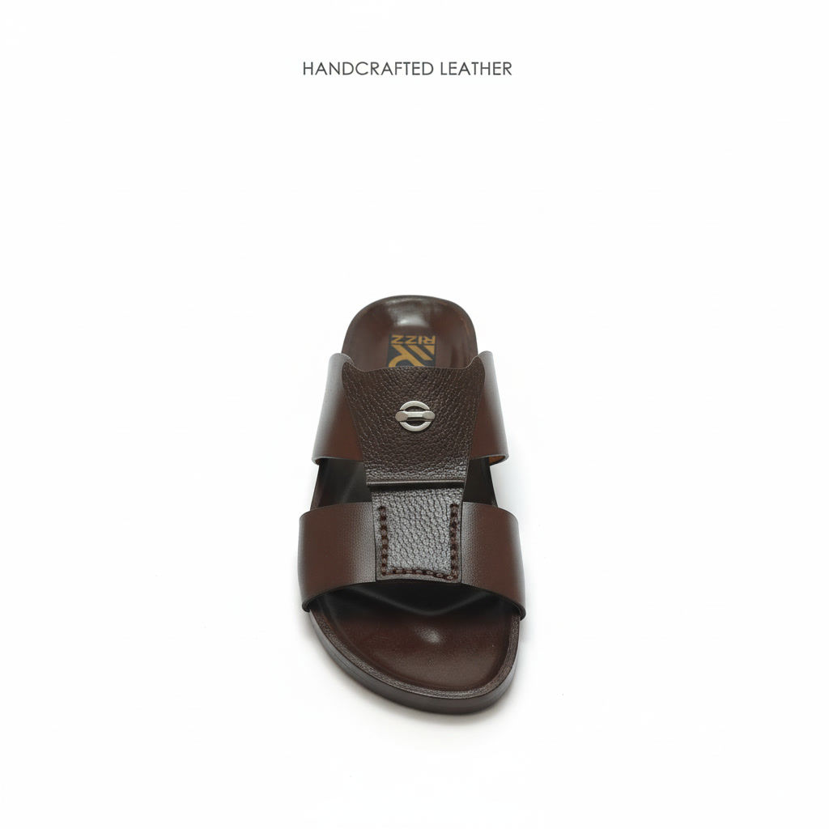  rizz_cholate_sandals | SEO Title RIZZ Cholate H-Strap Leather Sandal | Genuine Brown  Meta Desc The RIZZ Cholate — a premium handcrafted H-strap leather sandal in rich chocolate brown. Silver accent, RIZZ insole. Genuine leather. Made in Bangladesh.  Alt Tag RIZZ Cholate chocolate brown H-strap handcrafted leather sandal — front view with silver rivet button detail and RIZZ branded insole  OG Title RIZZ Cholate | Premium H-Strap Leather Sandal  OG Desc Handcrafted leather excellence. RIZZ Cholate features an H-strap design in genuine chocolate brown leather with a polished silver rivet. Pure prestige.  Material Genuine Leather  Color Chocolate Brown
Schema JSON-LD
{"@context":"https://schema.org/","@type":"Product","name":"RIZZ Cholate H-Strap Leather Sandal","brand":{"@type":"Brand","name":"RIZZ Leather"},"material":"Genuine Leather","color":"Chocolate Brown","category":"Sandals","offers":{"@type":"Offer","availability":"https://schema.org/InStock","priceCurrency":"BDT"}}
RIZZ Crocodile Slide — Cross-Strap Leather Sandal

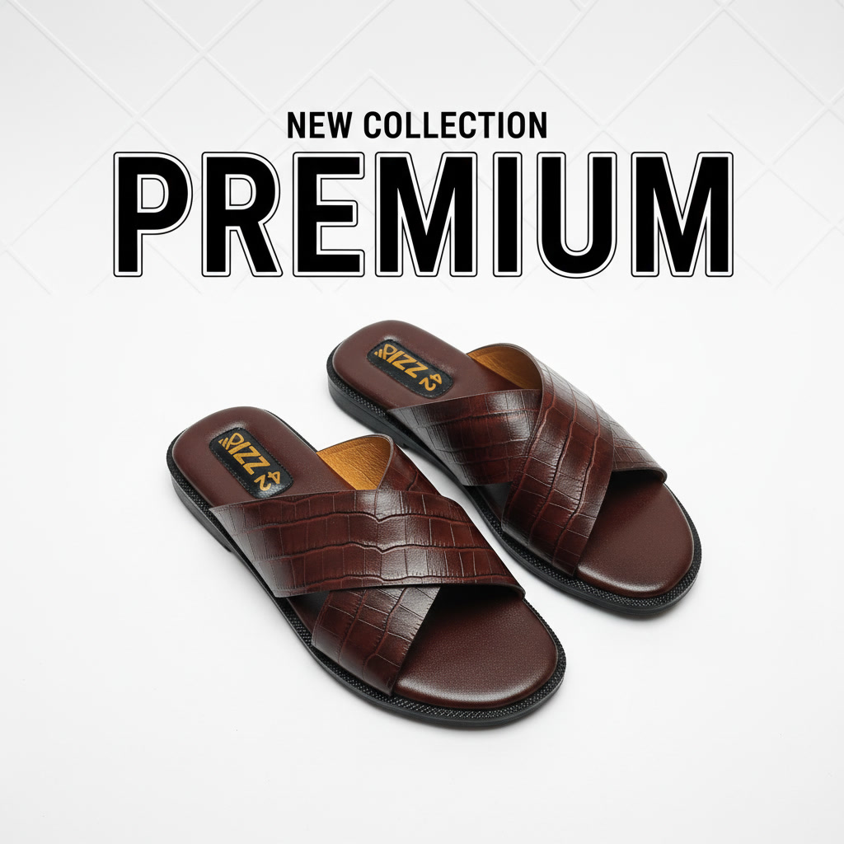  rizz_crodile_slide_sandals | SEO Title RIZZ Crocodile Slide Sandal | Cross-Strap Leather  Meta Desc Bold. Luxurious. Handcrafted. RIZZ Crocodile Slide features croco-embossed genuine leather cross-straps. Premium new collection from RIZZ Leather, Bangladesh.  Alt Tag RIZZ Crocodile cross-strap leather slide sandal pair — top front view showing dark maroon croco-embossed X-strap and RIZZ branded insole  OG Title RIZZ Crocodile Slide | New Collection Premium Leather  OG Desc New collection drop. RIZZ Crocodile Slide — croco-embossed genuine leather X-strap sandal. Handcrafted in Chittagong. Pure leather. Pure prestige.  Material Genuine Leather  Color Dark Maroon Brown  Pattern Crocodile Embossed
Schema JSON-LD
{"@context":"https://schema.org/","@type":"Product","name":"RIZZ Crocodile Slide Sandal","brand":{"@type":"Brand","name":"RIZZ Leather"},"material":"Genuine Leather","color":"Dark Maroon Brown","pattern":"Crocodile Embossed","category":"Sandals","offers":{"@type":"Offer","availability":"https://schema.org/InStock","priceCurrency":"BDT"}}
RIZZ Double Buckle — Adjustable Leather Sandal

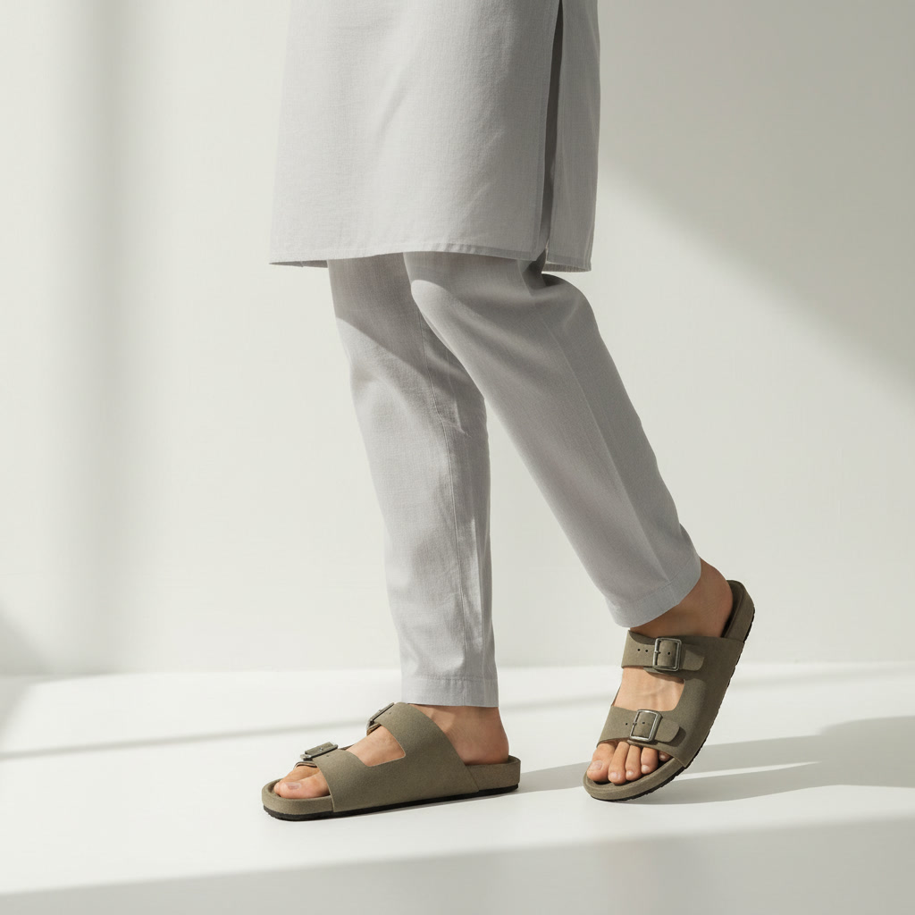  rizz_double_bockles-sandals | SEO Title RIZZ Double Buckle Leather Sandal | Adjustable Strap  Meta Desc The RIZZ Double Buckle — handcrafted genuine leather sandal with two adjustable metal buckles. Premium comfort meets elegant style. Made in Chittagong, Bangladesh.  Alt Tag RIZZ Double Buckle olive green suede leather sandal on foot — lifestyle shot worn with white panjabi showing adjustable double-buckle strap design  OG Title RIZZ Double Buckle | Adjustable Genuine Leather Sandal  OG Desc Two buckles. Endless style. RIZZ Double Buckle leather sandal — handcrafted genuine leather with adjustable metal buckle straps. Comfort and class, made in Bangladesh.  Material Genuine Leather  Color Olive Green
Schema JSON-LD
{"@context":"https://schema.org/","@type":"Product","name":"RIZZ Double Buckle Leather Sandal","brand":{"@type":"Brand","name":"RIZZ Leather"},"material":"Genuine Leather","color":"Olive Green","category":"Sandals","offers":{"@type":"Offer","availability":"https://schema.org/InStock","priceCurrency":"BDT"}}
RIZZ Dubai Golden — Black Leather Sandal with Gold Hardware

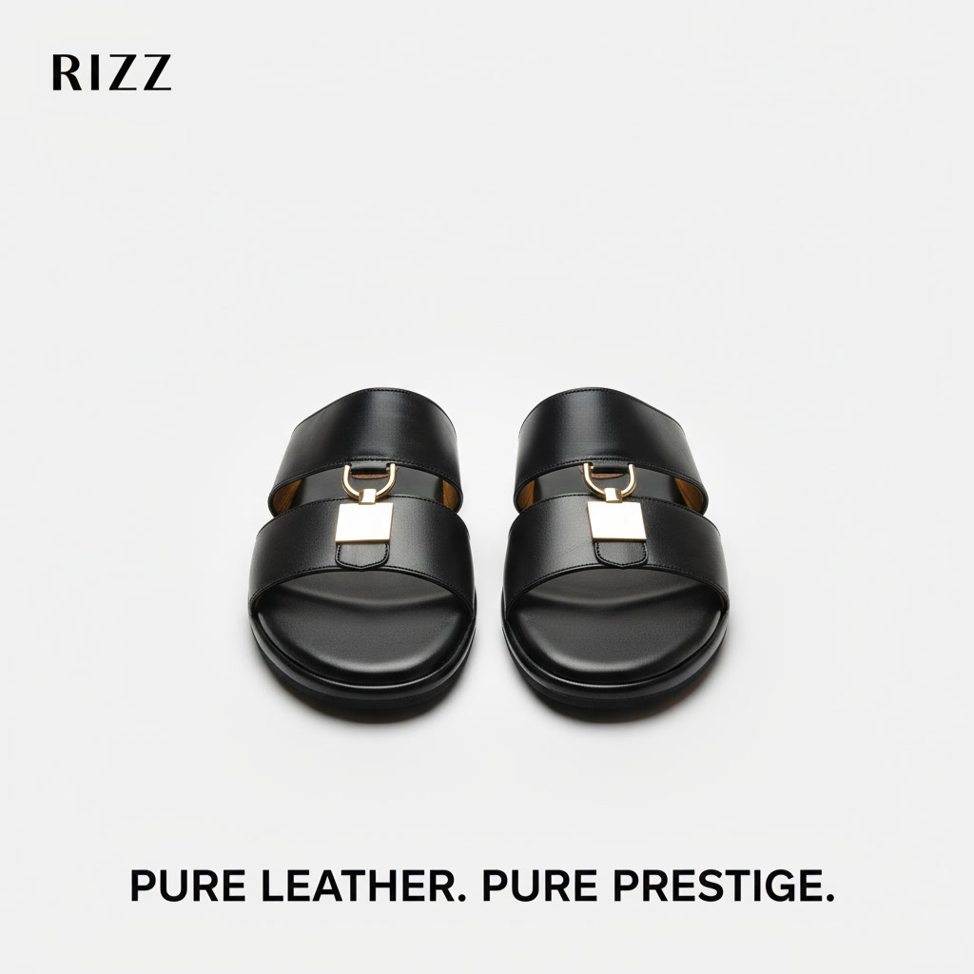  rizz_dubai_golden_sandals | SEO Title RIZZ Dubai Golden Leather Sandal | Black Gold Hardware  Meta Desc Command attention with RIZZ Dubai Golden — premium black genuine leather sandal with gold hardware accent. Handcrafted luxury from RIZZ Leather, Chittagong.  Alt Tag RIZZ Dubai Golden black genuine leather slide sandal pair — front view showing double wide straps with gold square pendant hardware charm detail  OG Title RIZZ Dubai Golden | Black Leather Sandal with Gold Accent  OG Desc Black leather meets gold hardware. RIZZ Dubai Golden — handcrafted premium leather sandal with a luxurious golden pendant accent. Pure leather. Pure prestige.  Material Genuine Leather  Color Black
Schema JSON-LD
{"@context":"https://schema.org/","@type":"Product","name":"RIZZ Dubai Golden Leather Sandal","brand":{"@type":"Brand","name":"RIZZ Leather"},"material":"Genuine Leather","color":"Black","category":"Sandals","offers":{"@type":"Offer","availability":"https://schema.org/InStock","priceCurrency":"BDT"}}
RIZZ Dubai — Arabic H-Strap Leather Sandal

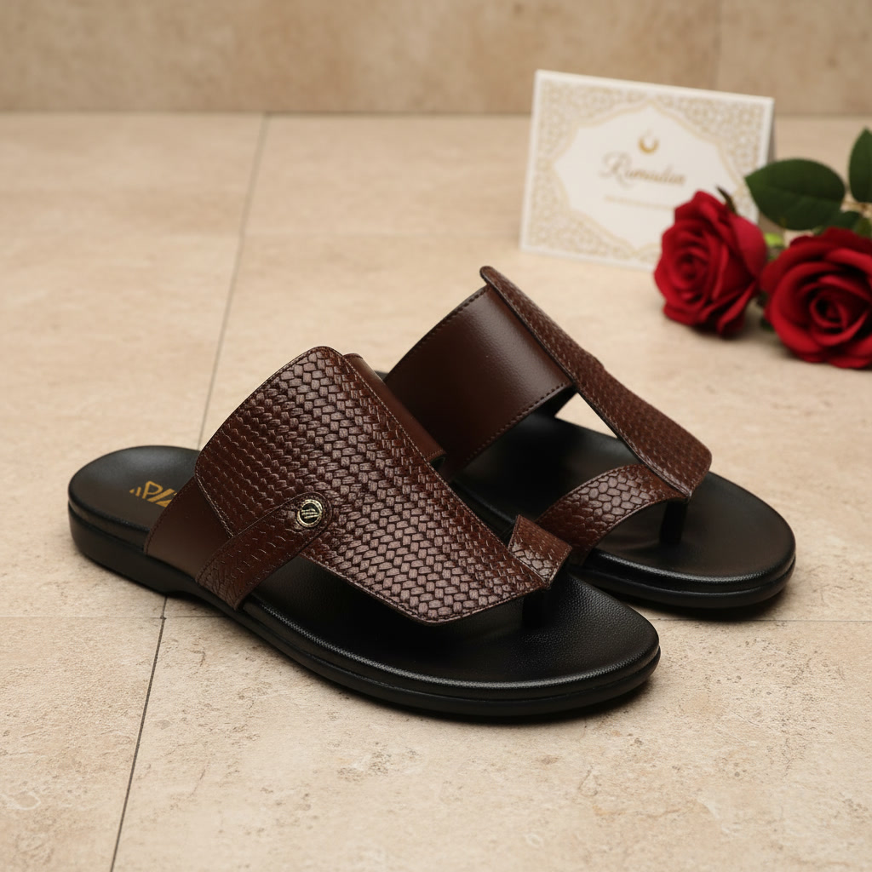  rizz_dubai_sandals | SEO Title RIZZ Dubai Leather Sandal | Arabic Style Handcrafted  Meta Desc The RIZZ Dubai — handcrafted Arabic-style H-strap leather sandal in rich brown. Woven texture, RIZZ gold emblem. Perfect for Eid and special occasions. Bangladesh.  Alt Tag RIZZ Dubai brown Arabic-style woven leather H-strap sandal pair — lifestyle shot on marble floor with Ramadan Mubarak card and red roses  OG Title RIZZ Dubai | Arabic H-Strap Woven Leather Sandal  OG Desc Crafted for elegance. RIZZ Dubai — Arabic H-strap leather sandal with woven texture and gold RIZZ emblem. Ideal for Eid. Handcrafted in Chittagong.  Material Genuine Leather  Color Brown  Pattern Woven Texture
Schema JSON-LD
{"@context":"https://schema.org/","@type":"Product","name":"RIZZ Dubai Leather Sandal","brand":{"@type":"Brand","name":"RIZZ Leather"},"material":"Genuine Leather","color":"Brown","pattern":"Woven Texture","category":"Sandals","offers":{"@type":"Offer","availability":"https://schema.org/InStock","priceCurrency":"BDT"}}
RIZZ Harmer — Black H-Strap Woven Leather Slide

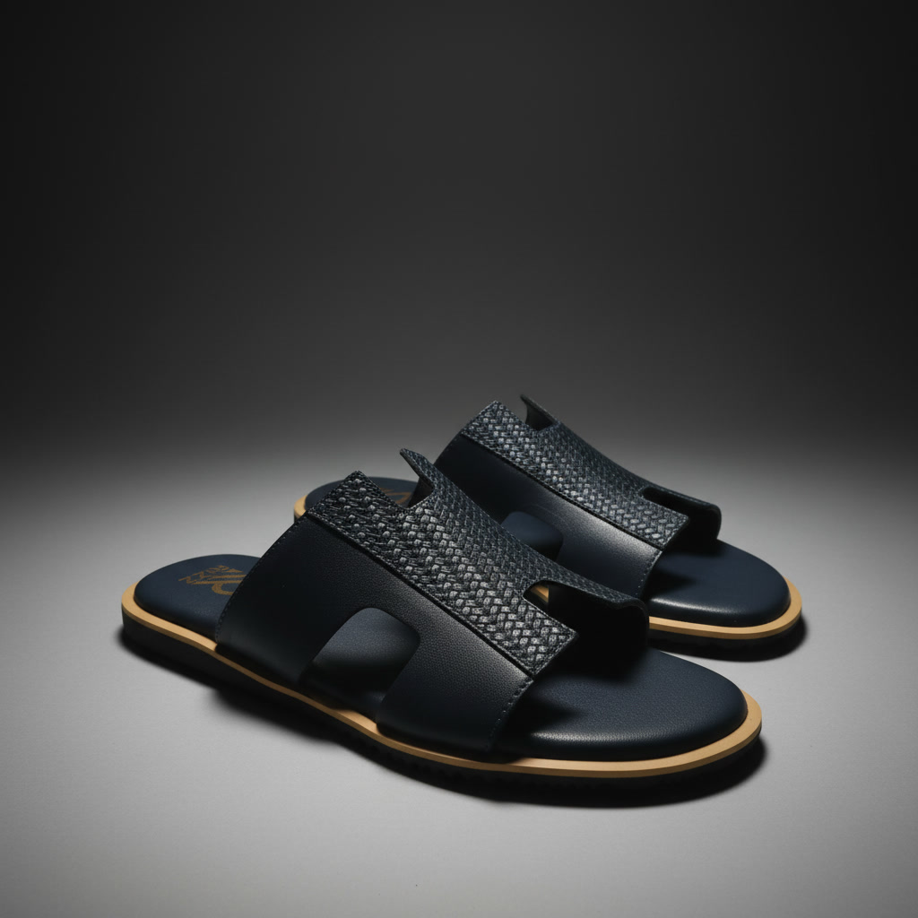  rizz_harmer_sandals | SEO Title RIZZ Harmer H-Strap Leather Slide Sandal | Black  Meta Desc Dark and bold. RIZZ Harmer features a woven H-strap genuine leather upper, navy cushioned footbed and contrast tan outsole. Handcrafted in Chittagong, Bangladesh.  Alt Tag RIZZ Harmer black H-strap woven leather slide sandal pair — dramatic studio shot showing textured strap, navy blue footbed and tan outsole edge  OG Title RIZZ Harmer | Black H-Strap Woven Leather Slide Sandal  OG Desc Bold meets refined. RIZZ Harmer — black woven leather H-strap slide sandal with navy footbed and contrast tan sole edge. Handcrafted in Chittagong.  Material Genuine Leather  Color Black  Pattern Woven H-Strap
Schema JSON-LD
{"@context":"https://schema.org/","@type":"Product","name":"RIZZ Harmer H-Strap Leather Slide Sandal","brand":{"@type":"Brand","name":"RIZZ Leather"},"material":"Genuine Leather","color":"Black","category":"Sandals","offers":{"@type":"Offer","availability":"https://schema.org/InStock","priceCurrency":"BDT"}}
RIZZ Master Color — Quilted Cross-Strap Leather Slide

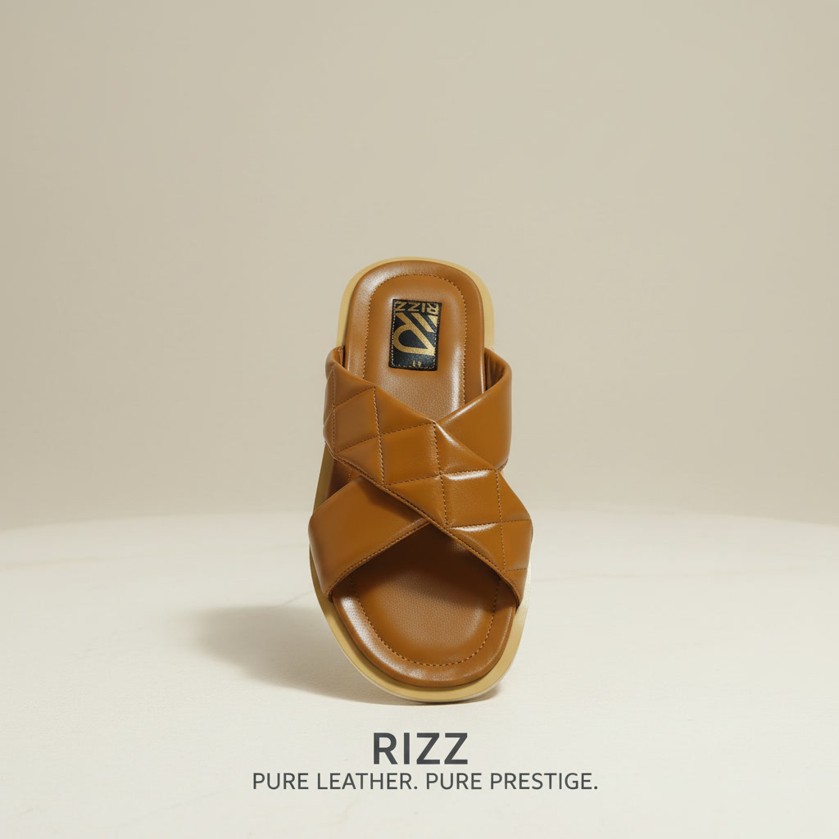  rizz_master_color_sandals | SEO Title RIZZ Master Color Quilted Leather Slide | Tan Caramel  Meta Desc Introducing RIZZ Master Color — a diamond-quilted cross-strap leather slide in warm tan. Handcrafted genuine leather, premium cushioning. RIZZ Leather, Bangladesh.  Alt Tag RIZZ Master Color tan caramel diamond-quilted cross-strap genuine leather slide sandal — top view showing quilted X-strap pattern and RIZZ branded insole  OG Title RIZZ Master Color | Quilted Cross-Strap Leather Slide  OG Desc Texture meets luxury. RIZZ Master Color — tan genuine leather slide with diamond-quilt cross-strap. Handcrafted premium cushioning. Pure leather. Pure prestige.  Material Genuine Leather  Color Tan Caramel  Pattern Diamond Quilted
Schema JSON-LD
{"@context":"https://schema.org/","@type":"Product","name":"RIZZ Master Color Quilted Leather Slide Sandal","brand":{"@type":"Brand","name":"RIZZ Leather"},"material":"Genuine Leather","color":"Tan Caramel","pattern":"Diamond Quilted","category":"Sandals","offers":{"@type":"Offer","availability":"https://schema.org/InStock","priceCurrency":"BDT"}}
RIZZ Simple — Minimalist Black Leather Thong Sandal

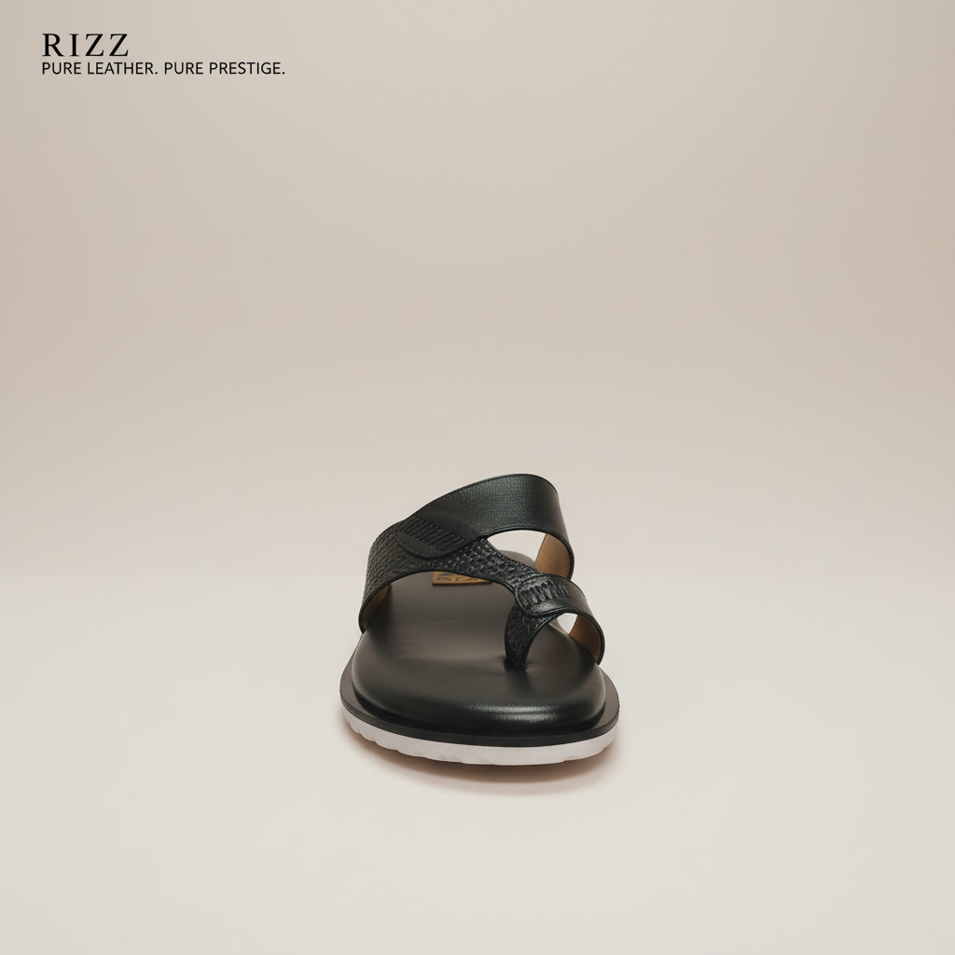  rizz_simple_sandals | SEO Title RIZZ Simple Leather Thong Sandal | Minimalist Black  Meta Desc Clean. Classic. Handcrafted. RIZZ Simple — a minimalist black genuine leather thong sandal with textured strap and white outsole. Made in Chittagong, Bangladesh.  Alt Tag RIZZ Simple black genuine leather thong sandal — front view showing textured T-strap toe-ring design with white rubber outsole  OG Title RIZZ Simple | Minimalist Black Leather Thong Sandal  OG Desc Less is more. RIZZ Simple — handcrafted minimalist black leather thong sandal. Textured strap, white sole, all-day comfort. Pure leather. Pure prestige.  Material Genuine Leather  Color Black
Schema JSON-LD
{"@context":"https://schema.org/","@type":"Product","name":"RIZZ Simple Leather Thong Sandal","brand":{"@type":"Brand","name":"RIZZ Leather"},"material":"Genuine Leather","color":"Black","category":"Sandals","offers":{"@type":"Offer","availability":"https://schema.org/InStock","priceCurrency":"BDT"}}
RIZZ Slide Multicolor — Two-Tone Woven Leather Slide

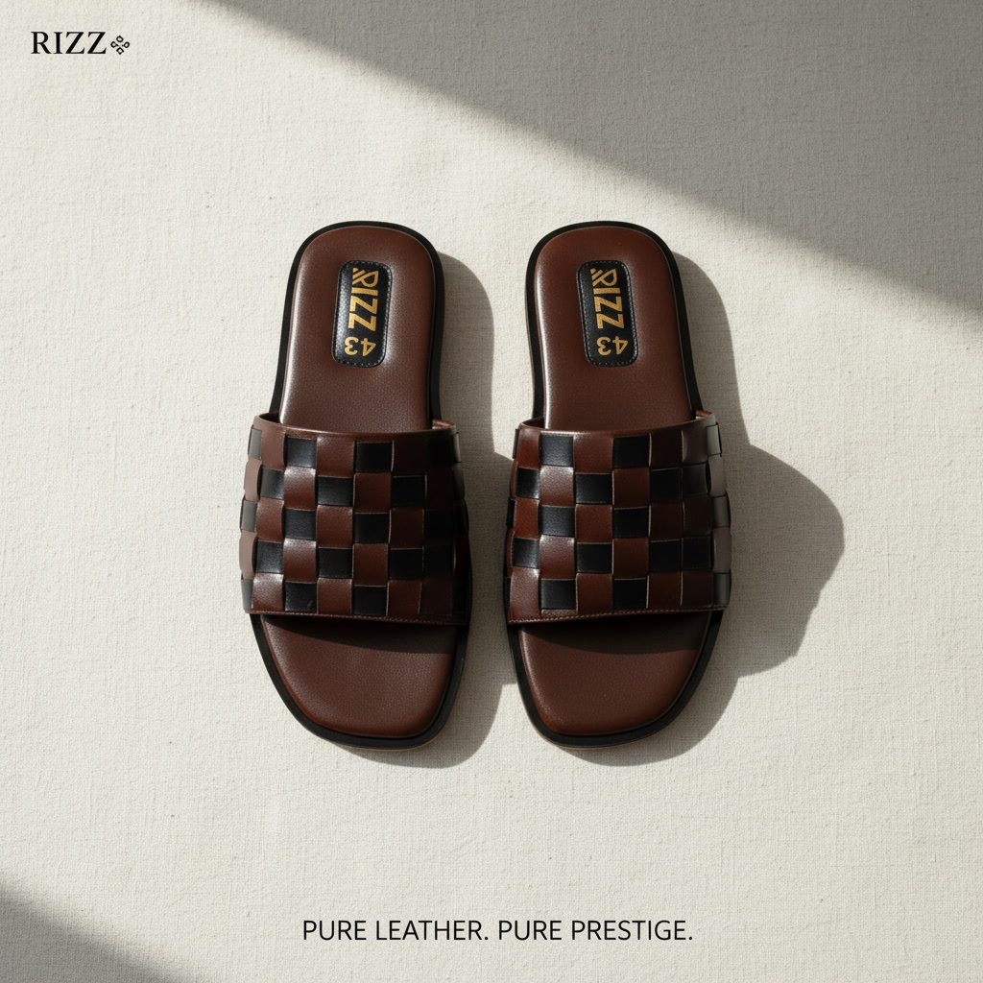  rizz_slide_multicolor_sandals | SEO Title RIZZ Slide Multicolor Woven Leather Sandal | Two-Tone  Meta Desc Stand out with RIZZ Slide Multicolor — a handcrafted two-tone woven genuine leather slide sandal. Brown and black checkered strap. RIZZ Leather, Bangladesh.  Alt Tag RIZZ Slide Multicolor brown and black two-tone checkered woven genuine leather slide sandal pair — top flat lay in natural sunlight showing RIZZ insole branding  OG Title RIZZ Slide Multicolor | Two-Tone Woven Leather Sandal  OG Desc Two tones. One statement. RIZZ Slide Multicolor — handcrafted brown and black checkered woven leather slide sandal. Pure leather craftsmanship from Bangladesh.  Material Genuine Leather  Color Brown and Black  Pattern Checkered Woven
Schema JSON-LD
{"@context":"https://schema.org/","@type":"Product","name":"RIZZ Slide Multicolor Woven Leather Sandal","brand":{"@type":"Brand","name":"RIZZ Leather"},"material":"Genuine Leather","color":"Brown and Black","pattern":"Checkered Woven","category":"Sandals","offers":{"@type":"Offer","availability":"https://schema.org/InStock","priceCurrency":"BDT"}}
RIZZ Suede Slide — Wide Band Genuine Leather Sandal

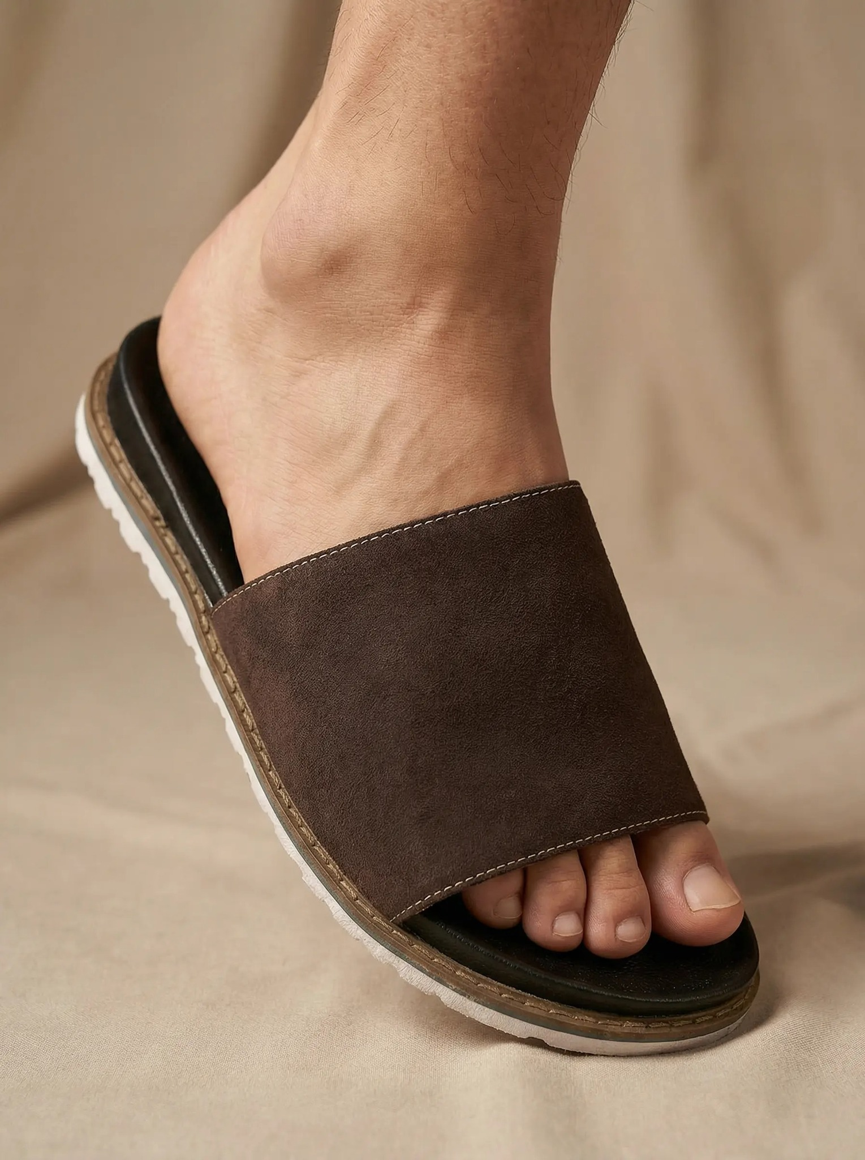  rizz_suade_slide_sandals | SEO Title RIZZ Suede Slide Sandal | Wide Band Genuine Leather  Meta Desc Effortlessly casual. RIZZ Suede Slide — wide-band genuine suede leather slide sandal in dark brown. White outsole, all-day comfort. Handcrafted in Chittagong.  Alt Tag RIZZ Suede Slide dark brown suede genuine leather wide-band sandal on foot — side profile lifestyle shot showing white outsole and stitched edge  OG Title RIZZ Suede Slide | Wide Band Brown Genuine Leather Sandal  OG Desc Simple luxury for every day. RIZZ Suede Slide — dark brown suede leather wide-band slide sandal with white sole. Handcrafted in Chittagong, Bangladesh.  Material Genuine Suede Leather  Color Dark Brown
Schema JSON-LD
{"@context":"https://schema.org/","@type":"Product","name":"RIZZ Suede Slide Sandal","brand":{"@type":"Brand","name":"RIZZ Leather"},"material":"Genuine Suede Leather","color":"Dark Brown","category":"Sandals","offers":{"@type":"Offer","availability":"https://schema.org/InStock","priceCurrency":"BDT"}}
RIZZ Three Buckle — Triple Strap Leather Sandal

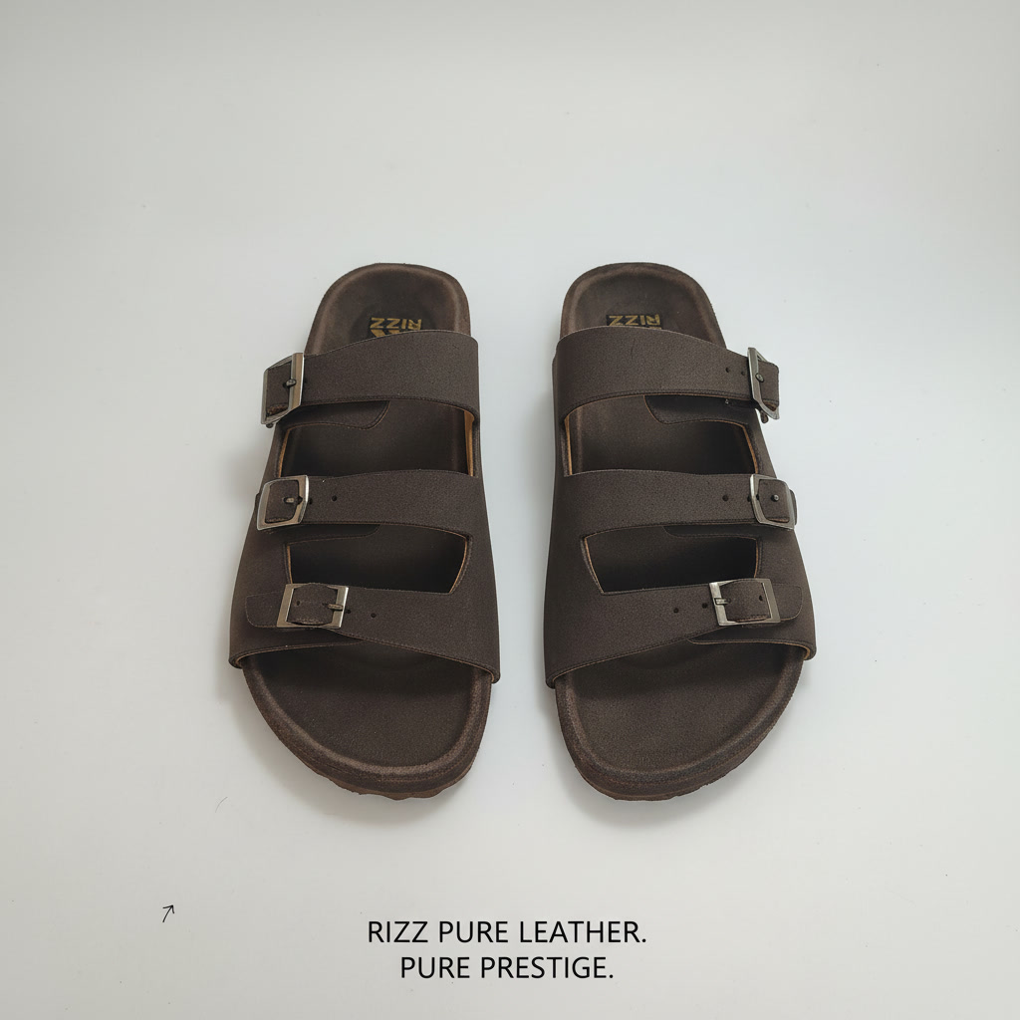  rizz_three_bocles_sandals | SEO Title RIZZ Three Buckle Leather Sandal | Triple Strap Brown  Meta Desc The RIZZ Three Buckle — handcrafted genuine leather sandal with three adjustable metal buckle straps. Premium dark brown suede finish. Made in Chittagong, Bangladesh.  Alt Tag RIZZ Three Buckle dark brown suede genuine leather sandal pair — overhead flat lay showing three metal buckle straps and RIZZ insole branding  OG Title RIZZ Three Buckle | Triple Strap Genuine Leather Sandal  OG Desc Three buckles. Maximum style. RIZZ Three Buckle — handcrafted dark brown leather sandal with three adjustable metal buckle straps. Pure leather. Pure prestige.  Material Genuine Leather  Color Dark Brown
Schema JSON-LD
{"@context":"https://schema.org/","@type":"Product","name":"RIZZ Three Buckle Leather Sandal","brand":{"@type":"Brand","name":"RIZZ Leather"},"material":"Genuine Leather","color":"Dark Brown","category":"Sandals","offers":{"@type":"Offer","availability":"https://schema.org/InStock","priceCurrency":"BDT"}}
RIZZ Two Color Strip — Navy & Tan Quilted Thong Sandal

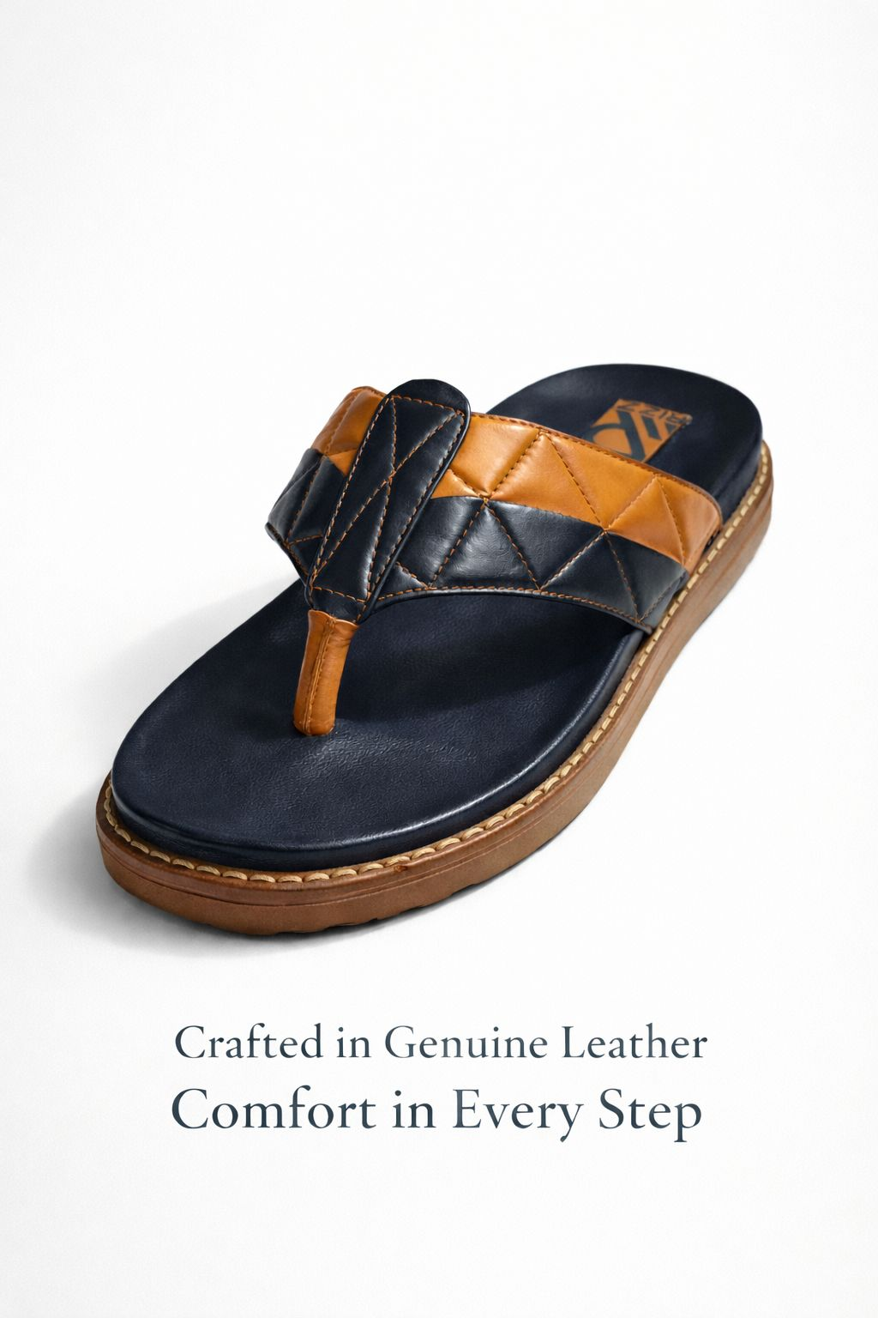  rizz_two_color_strip_sandals | SEO Title RIZZ Two Color Strip Leather Thong Sandal | Navy Tan  Meta Desc Two colors. One masterpiece. RIZZ Two Color Strip — navy and tan genuine leather thong sandal with diamond-quilted T-strap. Handcrafted in Chittagong, Bangladesh.  Alt Tag RIZZ Two Color Strip navy blue and tan caramel diamond-quilted genuine leather thong sandal — product shot showing quilted T-strap and tan rubber outsole with gold stitching  OG Title RIZZ Two Color Strip | Navy Tan Quilted Leather Thong  OG Desc Crafted in genuine leather. RIZZ Two Color Strip — navy and tan diamond-quilted thong sandal. Comfort in every step. Handcrafted in Chittagong, Bangladesh.  Material Genuine Leather  Color Navy Blue and Tan  Pattern Diamond Quilted
Schema JSON-LD
{"@context":"https://schema.org/","@type":"Product","name":"RIZZ Two Color Strip Leather Thong Sandal","brand":{"@type":"Brand","name":"RIZZ Leather"},"material":"Genuine Leather","color":"Navy Blue and Tan","pattern":"Diamond Quilted","category":"Sandals","offers":{"@type":"Offer","availability":"https://schema.org/InStock","priceCurrency":"BDT"}}
RIZZ Two Fita — Colorful Sole Leather Thong Sandal

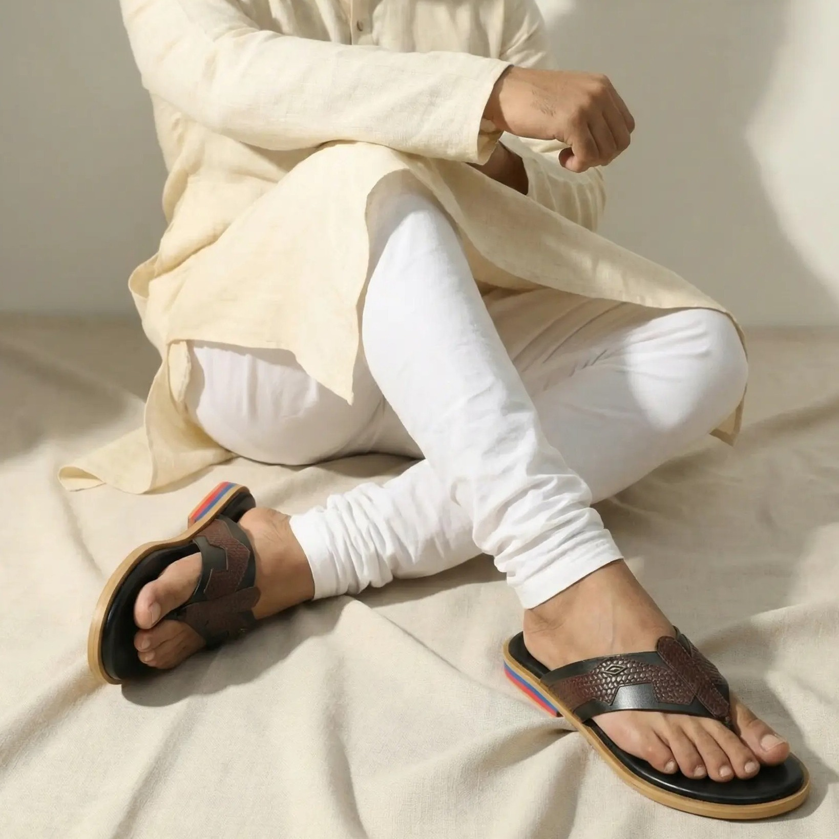  rizz_two_fita_sandals | SEO Title RIZZ Two Fita Leather Thong Sandal | Colorful Stripe Sole  Meta Desc The RIZZ Two Fita — handcrafted genuine leather thong sandal with bold multicolor stripe outsole. Perfect with panjabi. Made in Chittagong, Bangladesh.  Alt Tag RIZZ Two Fita dark brown embossed leather thong sandal on foot — lifestyle shot with white panjabi showing multicolor red blue yellow striped sole edge  OG Title RIZZ Two Fita | Genuine Leather Thong with Stripe Sole  OG Desc Traditional style, modern craft. RIZZ Two Fita — dark brown leather thong sandal with vibrant multicolor stripe sole. Handcrafted in Chittagong, Bangladesh.  Material Genuine Leather  Color Dark Brown
Schema JSON-LD
{"@context":"https://schema.org/","@type":"Product","name":"RIZZ Two Fita Leather Thong Sandal","brand":{"@type":"Brand","name":"RIZZ Leather"},"material":"Genuine Leather","color":"Dark Brown","category":"Sandals","offers":{"@type":"Offer","availability":"https://schema.org/InStock","priceCurrency":"BDT"}}
RIZZ Slide — Crocodile Embossed Cross-Strap Sandal

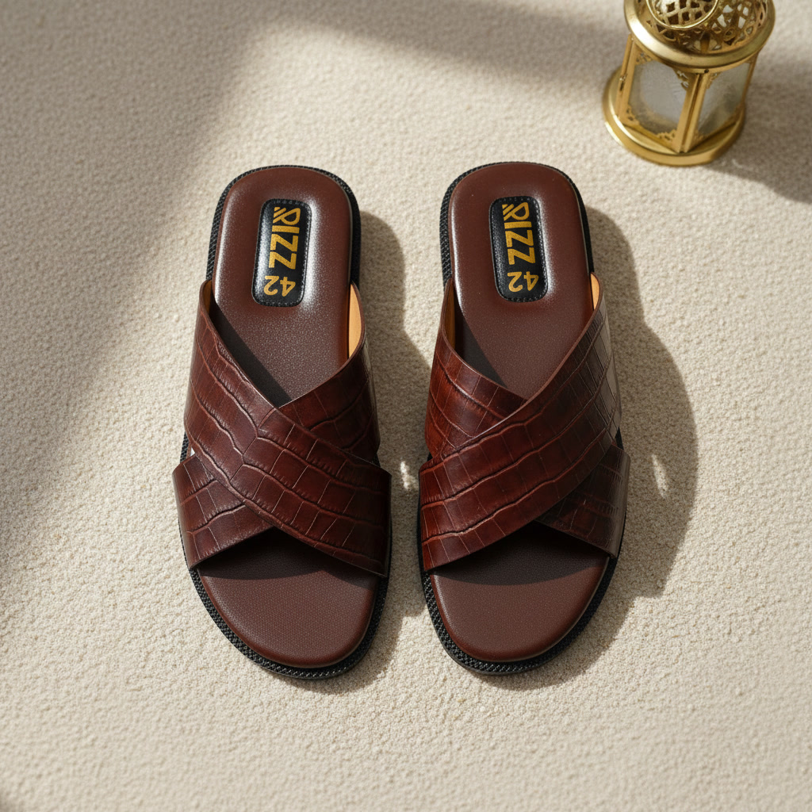  (standalone) | SEO Title RIZZ Slide Crocodile Leather Sandal | Premium Maroon  Meta Desc The RIZZ Slide — handcrafted croco-embossed genuine leather cross-strap slide in dark maroon. Premium texture, luxe comfort. RIZZ Leather, Chittagong, Bangladesh.  Alt Tag RIZZ Slide dark maroon crocodile-embossed genuine leather cross-strap slide sandal pair — overhead lifestyle shot with golden lantern and RIZZ size 42 branded insole  OG Title RIZZ Slide | Premium Crocodile Leather Cross-Strap Sandal  OG Desc Pure leather. Pure prestige. RIZZ Slide — dark maroon croco-embossed cross-strap leather sandal. Handcrafted in Chittagong, Bangladesh. Shop now.  Material Genuine Leather  Color Dark Maroon  Pattern Crocodile Embossed
Schema JSON-LD
{"@context":"https://schema.org/","@type":"Product","name":"RIZZ Slide Crocodile Leather Sandal","brand":{"@type":"Brand","name":"RIZZ Leather"},"material":"Genuine Leather","color":"Dark Maroon","pattern":"Crocodile Embossed","category":"Sandals","offers":{"@type":"Offer","availability":"https://schema.org/InStock","priceCurrency":"BDT"}}

