[Noukadubi](https://www.imdb.com/title/tt1946280/?ref_=ttfc_fc_tt) (2011)

Full Cast & Crew

*Directed by*

[Rituparno Ghosh](https://www.imdb.com/name/nm0315916/?ref_=ttfc_fc_dr1)

*Writing Credits* ***(in alphabetical order)***

|  |  |  |
| --- | --- | --- |
| [Rituparno Ghosh](https://www.imdb.com/name/nm0315916/?ref_=ttfc_fc_wr1) | ... | ( screenplay ) |
| [Gulzar](https://www.imdb.com/name/nm0347899/?ref_=ttfc_fc_wr2) | ... | (lyrics) |
| [Rabindranath Tagore](https://www.imdb.com/name/nm0007173/?ref_=ttfc_fc_wr3) | ... | (story) |

*Cast* ***(in credits order)***

|  |
| --- |
| [Jisshu Sengupta](https://www.imdb.com/name/nm1702868/?ref_=ttfc_fc_cl_t1)  ... [Rameshchandra Chaudhry](https://www.imdb.com/title/tt1946280/characters/nm1702868?ref_=ttfc_fc_cl_t1) |
| [Riya Sen](https://www.imdb.com/name/nm1116258/?ref_=ttfc_fc_cl_t2)  ... [Sushilla R. Chaudhry](https://www.imdb.com/title/tt1946280/characters/nm1116258?ref_=ttfc_fc_cl_t2) / [Kamla](https://www.imdb.com/title/tt1946280/characters/nm1116258?ref_=ttfc_fc_cl_t2) |
| [Raima Sen](https://www.imdb.com/name/nm0784025/?ref_=ttfc_fc_cl_t3)  ... [Hemnalini](https://www.imdb.com/title/tt1946280/characters/nm0784025?ref_=ttfc_fc_cl_t3) |
| [Prasenjit Chatterjee](https://www.imdb.com/name/nm0154146/?ref_=ttfc_fc_cl_t4)  ... [Nalinaksha Chattopadhyay](https://www.imdb.com/title/tt1946280/characters/nm0154146?ref_=ttfc_fc_cl_t4) (as Prosenjit Chatterjee) |
| [Dhritiman Chatterjee](https://www.imdb.com/name/nm0154122/?ref_=ttfc_fc_cl_t5) |
|

Rest of cast listed alphabetically:

*Produced by*

[e](https://www.imdb.com/name/nm1137410/?ref_=ttfc_fc_cl_t6)

[Sumanta Mukherje](https://www.imdb.com/name/nm1137410/?ref_=ttfc_fc_cl_t6)

...

[Ramesh's Fathe](https://www.imdb.com/title/tt1946280/characters/nm1137410?ref_=ttfc_fc_cl_t6)

[r](https://www.imdb.com/title/tt1946280/characters/nm1137410?ref_=ttfc_fc_cl_t6)

[r](https://www.imdb.com/name/nm0765270/?ref_=ttfc_fc_cl_t7)

[Laboni Sarka](https://www.imdb.com/name/nm0765270/?ref_=ttfc_fc_cl_t7)

...

[Sushila's Mothe](https://www.imdb.com/title/tt1946280/characters/nm0765270?ref_=ttfc_fc_cl_t7)

[r](https://www.imdb.com/title/tt1946280/characters/nm0765270?ref_=ttfc_fc_cl_t7)



|  |  |  |
| --- | --- | --- |
| [Subhash Ghai](https://www.imdb.com/name/nm0007131/?ref_=ttfc_fc_cr2) | ... | producer |
| [Sanu Roy](https://www.imdb.com/name/nm7428675/?ref_=ttfc_fc_cr3)  *Music by* | ... | line producer |
| [Sanjoy Das](https://www.imdb.com/name/nm1893765/?ref_=ttfc_fc_cr4) |  |  |

[Raja Narayan Deb](https://www.imdb.com/name/nm1892895/?ref_=ttfc_fc_cr5)

*Cinematography by* [Soumik Haldar](https://www.imdb.com/name/nm2954841/?ref_=ttfc_fc_cr6)

*Film Editing by*

[Arghakamal Mitra](https://www.imdb.com/name/nm0593942/?ref_=ttfc_fc_cr7)

*Art Direction by*

[Indranil Ghosh](https://www.imdb.com/name/nm1136226/?ref_=ttfc_fc_cr8)

*Costume Design by*

[Sabarni Das](https://www.imdb.com/name/nm1738990/?ref_=ttfc_fc_cr9)

*Second Unit Director or Assistant Director* [Debabrata Dutta](https://www.imdb.com/name/nm1911960/?ref_=ttfc_fc_cr10) ... associate director *Art Department*

[Sushanta Paul](https://www.imdb.com/name/nm1897658/?ref_=ttfc_fc_cr11) ... set designer (2010)

*Sound Department*

|  |  |  |
| --- | --- | --- |
| [Dipankar Chaki](https://www.imdb.com/name/nm3273794/?ref_=ttfc_fc_cr12) | ... | sound |
| [Sanjoy Das](https://www.imdb.com/name/nm1893765/?ref_=ttfc_fc_cr13) | ... | final sound mix |
| [Racchit](https://www.imdb.com/name/nm3663458/?ref_=ttfc_fc_cr14)  [Malhotra](https://www.imdb.com/name/nm3663458/?ref_=ttfc_fc_cr14) | ... | additional dialogue recordist (as Rachit Malhotra) / associate mixing engineer (as Rachit Malhotra) |
| [Abhijit Sarkar](https://www.imdb.com/name/nm5588813/?ref_=ttfc_fc_cr15) | ... | dialogue editor |
| [Anirban](https://www.imdb.com/name/nm3274258/?ref_=ttfc_fc_cr16)  [Sengupta](https://www.imdb.com/name/nm3274258/?ref_=ttfc_fc_cr16) | ... | sound |
| [Gunjan](https://www.imdb.com/name/nm3213134/?ref_=ttfc_fc_cr17)  [Srivastava](https://www.imdb.com/name/nm3213134/?ref_=ttfc_fc_cr17)  *Visual Effects by* | ... | adr engineer / associate mixing engineer |
| [Salil Deshpande](https://www.imdb.com/name/nm2571801/?ref_=ttfc_fc_cr18) |  | ... senior digital intermediate producer |
| [Rajiv Raghunathan](https://www.imdb.com/name/nm3008889/?ref_=ttfc_fc_cr19) | | ... digital intermediate production head |
| [Anuj Upadhyay](https://www.imdb.com/name/nm4945823/?ref_=ttfc_fc_cr20) *Music Department* | | ... digital compositor |
| [Srikanta Acharya](https://www.imdb.com/name/nm1383784/?ref_=ttfc_fc_cr21) | | ... playback singer (as Srikanto Acharya) |
| [Shreya Ghoshal](https://www.imdb.com/name/nm1304975/?ref_=ttfc_fc_cr22) | | ... playback singer |
| [Gulzar](https://www.imdb.com/name/nm0347899/?ref_=ttfc_fc_cr23) | | ... lyricist |
| [Hariharan](https://www.imdb.com/name/nm0363028/?ref_=ttfc_fc_cr24) | | ... playback singer |
| [Madhushree](https://www.imdb.com/name/nm1300807/?ref_=ttfc_fc_cr25) | | ... playback singer |
| [Rajiv Sunam](https://www.imdb.com/name/nm4492093/?ref_=ttfc_fc_cr26) | | ... playback singer |
| [Rabindranath Tagore](https://www.imdb.com/name/nm0007173/?ref_=ttfc_fc_cr27) | | ... lyricist |

*Additional Crew*

[Rolland Cabral](https://www.imdb.com/name/nm8452042/?ref_=ttfc_fc_cr28)  ... publicist

[Sarbani Mukherjee](https://www.imdb.com/name/nm8452041/?ref_=ttfc_fc_cr29) ... publicist

[Noukadubi](https://www.imdb.com/title/tt1946280/?ref_=ttco_co_tt) (2011)

Company Credits

|  |
| --- |
| Showing all 4 company credits |
| Jump to: [Production Companies](https://www.imdb.com/title/tt1946280/companycredits?ref_=ttfc_sa_3#production) (3) | [Distributors](https://www.imdb.com/title/tt1946280/companycredits?ref_=ttfc_sa_3#distributors) (1) |

*Production Companies*

* [Blue Water Pictures](https://www.imdb.com/company/co0342204?ref_=ttco_co_1)
* [Mukta Arts](https://www.imdb.com/company/co0066395?ref_=ttco_co_2)
* [Mukta Searchlight Films](https://www.imdb.com/company/co0176124?ref_=ttco_co_3)

*Distributors*

* [Mukta Arts](https://www.imdb.com/company/co0066395?ref_=ttco_co_1) (2011) (India) (all media)

[Noukadubi](https://www.imdb.com/title/tt1946280/?ref_=ttspec_spec_tt) (2011)

Technical Specifications

Showing all 3 technical specifications

Runtime

)

hr 15 min (135 min) (approx) (India

2

Sound Mix

[l](https://www.imdb.com/search/title?sound_mixes=dolby_digital&ref_=ttspec_spec_2)

[Dolby Digita](https://www.imdb.com/search/title?sound_mixes=dolby_digital&ref_=ttspec_spec_2)

Color

[Colo](https://www.imdb.com/search/title?colors=color&ref_=ttspec_spec_3)

[r](https://www.imdb.com/search/title?colors=color&ref_=ttspec_spec_3)

[Noukadub](https://www.imdb.com/title/tt1946280/?ref_=ttrel_rel_tt)

[i](https://www.imdb.com/title/tt1946280/?ref_=ttrel_rel_tt)

(2011

)

Release Info

Showing all 9 items Jump to:

* [Release Dates](https://www.imdb.com/title/tt1946280/releaseinfo?ref_=ttspec_sa_2#releases) (2)
* [Also Known As (AKA)](https://www.imdb.com/title/tt1946280/releaseinfo?ref_=ttspec_sa_2#akas) (7)

*Release Dates*

*Also Known As (AKA)*

(

original title

)

Noukadubi

Germany

Kashma Kash

-

Die fremde Ehefrau

India (Hindi title) (dubbed version)

Kashma Kash

India (Bengali title) (original script title)

Noukadubi (Boat Wreck)

India (Hindi title)

Kashmakash

India (English title)

Noukadubi

Russia

Дилемма

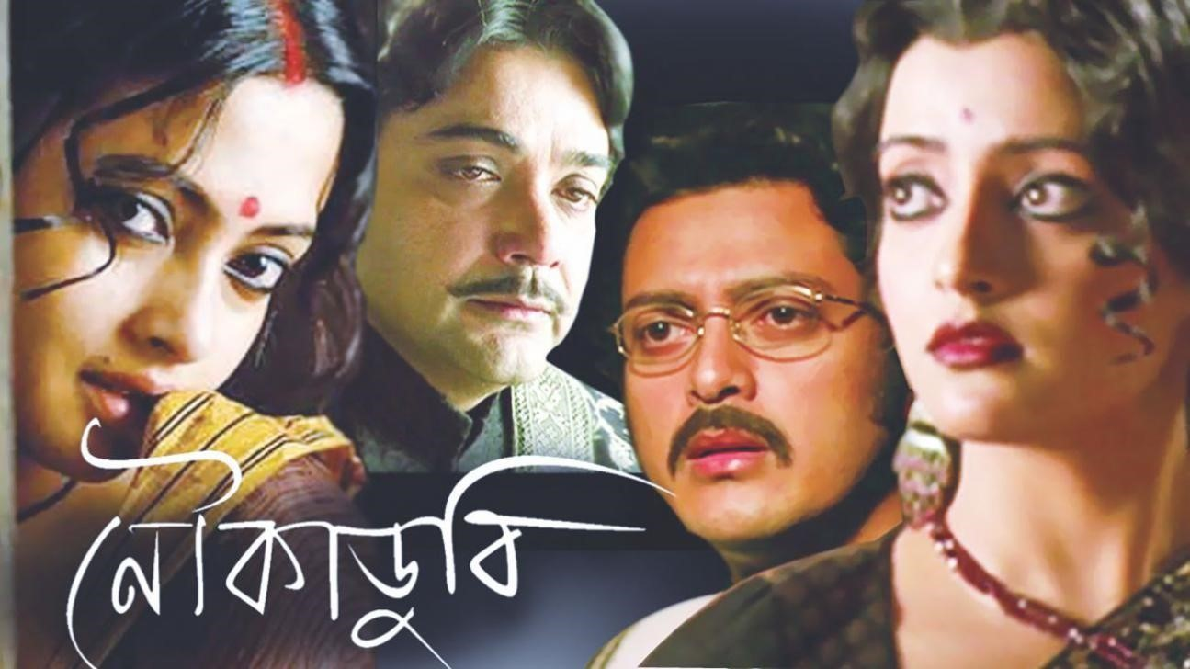

|  |  |
| --- | --- |
| [India](https://www.imdb.com/calendar/?region=in&ref_=ttrel_rel_1) | 20 May 2011 (limited) |
| [Japan](https://www.imdb.com/calendar/?region=jp&ref_=ttrel_rel_2) | 9 October 2012 (Indian Film Festival Japan) |

