
UNDERSTANDING THE NABCA DATASET JUNE 2025

What is NABCA?
NABCA (National Alcohol Beverage Control Association) is a trade organization that represents alcohol control states in the United States. It serves as a centralized data collection and reporting system for distilled spirits sales across control jurisdictions.
Dataset Purpose and Scope
- Industry Benchmarking: Provides comprehensive sales data for distilled spirits brands across control states
- Market Analysis: Enables tracking of brand performance, market share, and sales trends
- Regulatory Compliance: Supports alcohol control state reporting and regulatory requirements
- Business Intelligence: Offers insights for manufacturers, distributors, and retailers
Data Structure and Content
- Geographic Coverage: Sales data from alcohol control states (government-controlled liquor sales)
- Product Categories: All major distilled spirits categories (Vodka, Whiskey, Gin, Rum, Tequila, etc.)
- Time Periods: Monthly, year-to-date, and rolling 12-month sales data
- Metrics Tracked: Case sales, market share percentages, year-over-year changes, vendor performance

Key Data Tables Identified
- BRAND LEADERS
- CURRENT MONTH SALES
- YEAR-TO-DATE SALES
- ROLLING 12-MONTH
- BRAND SUMMARY
- VENDOR RANKINGS: Top 100
- VENDOR RANKINGS: Top 20
- CONTROL STATES
Table 1: Brand Leaders
This table shows the top spirit brands ranked by sales volume. It tracks their performance over different time windows (year-to-date, current month, rolling 12 months) with comparisons against prior year sales (pg: 3-4).
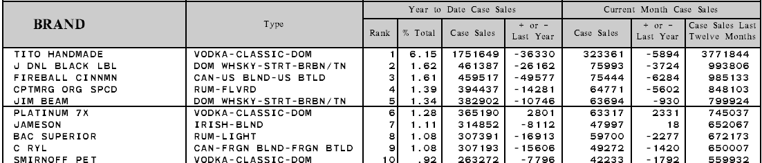
Field Breakdown:
Field | Description | Classification
Brand | The name of the spirit brand. Represents a real-world business entity. | Master Data
Type | Spirit type/category associated with the brand. (same as class) | Reference Data
Year to Date Case Sales Rank | Rank of the brand based on case sales for the year-to-date period. | Dimensional Data
Year to Date Case Sales % Total | The brand’s share (%) of total case sales year-to-date. | Dimensional Data
Year to Date Case Sales Case Sales | Total number of 9-liter cases sold year-to-date for the brand. | Fact Data
Year to Date Case Sales + or - Last Year | Difference in case sales compared to the same YTD period in the prior year. | Fact Data
Current Month Case Sales Case Sales | Total number of 9-liter cases sold in the current month. | Fact Data
Current Month Case Sales + or - Last Year | Difference in case sales compared to the same month last year. | Fact Data
Current Month Case Sales Case Sales Last Twelve Months | Rolling 12-month total of 9-liter case sales for the brand. | Fact Data

Table 2: Current Month Sales
This table provides a breakdown of total case sales by spirit class for the current month. It shows how each class contributes to the overall distilled spirits market (% of total), the class-level share (% of class), and the distribution across different bottle sizes (pg: 5-6).
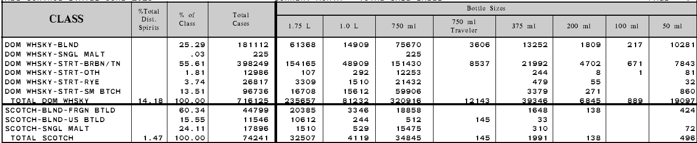
Field Breakdown:
Field | Description | Classification
Class | The spirit class/category. | Reference Data
% Total Dist. Spirits | Percentage of this class out of all distilled spirits sales. | Dimensional Data
% of Class | Share of this class relative to its parent grouping. | Dimensional Data
Total Cases | Total number of 9-liter cases sold for this class (all bottle sizes). | Fact Data
Bottle Sizes 1.75 L | Number of cases sold in 1.75L bottles for this class. | Fact Data
Bottle Sizes 1.0 L | Number of cases sold in 1.0L bottles for this class. | Fact Data
Bottle Sizes 750 ml | Number of cases sold in 750ml bottles for this class. | Fact Data
Bottle Sizes 750 ml Traveler | Number of cases sold in 750ml traveler bottles. | Fact Data
Bottle Sizes 375 ml | Number of cases sold in 375ml bottles. | Fact Data
Bottle Sizes 200 ml | Number of cases sold in 200ml bottles. | Fact Data
Bottle Sizes 100 ml | Number of cases sold in 100ml bottles. | Fact Data
Bottle Sizes 50 ml | Number of cases sold in 50ml bottles. | Fact Data

Table 3: Year to Date Sales
This table provides a breakdown of total case sales by spirit class for year to date. Shows each class’s share of total distilled spirits, share within its grouping, and distribution by bottle size (pg: 7-8)
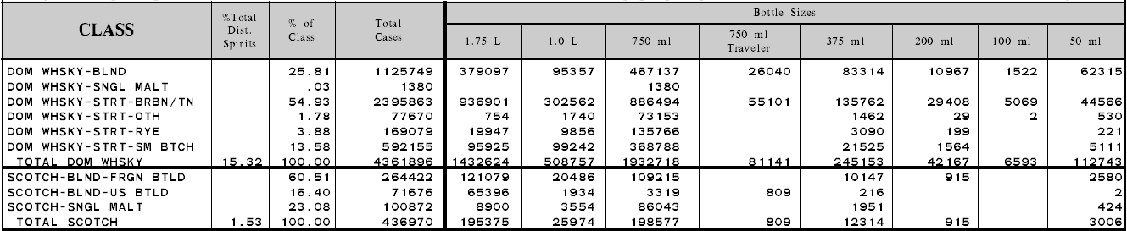
Field Breakdown:
Field | Description | Classification
Class | Spirit class/category. | Reference Data
% Total Dist. Spirits | Class share (%) of all distilled spirits for the period. | Dimensional Data
% of Class | Share within the parent grouping defined by the report. | Dimensional Data
Total Cases | Total 9L cases for the class (all bottle sizes). | Fact Data
Bottle Sizes 1.75 L | 9L cases sold in 1.75L. | Fact Data
Bottle Sizes 1.0 L | 9L cases sold in 1.0L. | Fact Data
Bottle Sizes 750 ml | 9L cases sold in 750ml. | Fact Data
Bottle Sizes 750 ml Traveler | 9L cases sold in 750ml traveler. | Fact Data
Bottle Sizes 375 ml | 9L cases sold in 375ml. | Fact Data
Bottle Sizes 200 ml | 9L cases sold in 200ml. | Fact Data
Bottle Sizes 100 ml | 9L cases sold in 100ml. | Fact Data
Bottle Sizes 50 ml | 9L cases sold in 50ml. | Fact Data

Table 4: Rolling 12-Month Sales
This table provides a breakdown of total case sales by spirit class for the last 12 months. Shows each class’s share of total distilled spirits, share within its grouping, and distribution by bottle size (pg: 9-10)
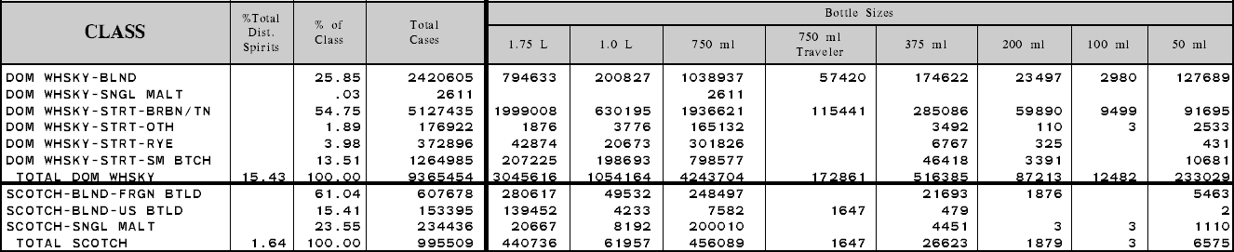
Field Breakdown:
Field | Description | Classification
Class | Spirit class/category. | Reference Data
% Total Dist. Spirits | Class share (%) of all distilled spirits for the period. | Dimensional Data
% of Class | Share within the parent grouping defined by the report. | Dimensional Data
Total Cases | Total 9L cases for the class (all bottle sizes). | Fact Data
Bottle Sizes 1.75 L | 9L cases sold in 1.75L. | Fact Data
Bottle Sizes 1.0 L | 9L cases sold in 1.0L. | Fact Data
Bottle Sizes 750 ml | 9L cases sold in 750ml. | Fact Data
Bottle Sizes 750 ml Traveler | 9L cases sold in 750ml traveler. | Fact Data
Bottle Sizes 375 ml | 9L cases sold in 375ml. | Fact Data
Bottle Sizes 200 ml | 9L cases sold in 200ml. | Fact Data
Bottle Sizes 100 ml | 9L cases sold in 100ml. | Fact Data
Bottle Sizes 50 ml | 9L cases sold in 50ml. | Fact Data

Table 5: Brand Summary
Provides a granular view of brand sales performance, broken down by Class, Brand, and Vendor. It captures sales across multiple time windows (last 12 months, YTD, current month) and includes bottle-size level breakdowns for the current month. This table is the foundation (fact table) for reconstructing other summary tables (pg: 11-346).
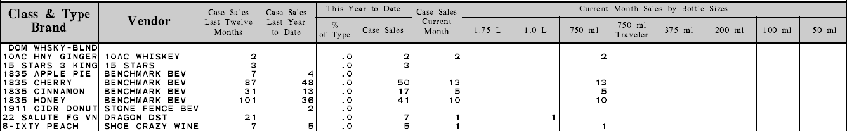
Field Breakdown:
Field | Description | Classification
Class & Type | Spirit class category. | Reference Data
Brand | The brand name of the product. | Master Data
Vendor | The supplier or producer associated with the brand. | Master Data
Case Sales Last Twelve Months | Total cases sold in the last rolling 12 months. | Fact Data
Case Sales Last Year to Date | Total cases sold in the same year-to-date period last year. | Fact Data
This Year to Date % of Type | Brand’s % share of its spirit type. | Dimensional Data
This Year to Date Case Sales | Current year-to-date total case sales. | Fact Data
Case Sales Current Month | Total case sales in the current month. | Fact Data
Current Month Sales by Bottle Sizes 1.75 L | Current month sales in 1.75L bottles. | Fact Data
Current Month Sales by Bottle Sizes 1.0 L | Current month sales in 1.0L bottles. | Fact Data
Current Month Sales by Bottle Sizes 750 ml | Current month sales in 750ml bottles. | Fact Data
Current Month Sales by Bottle Sizes 750 ml Traveler | Current month sales in 750ml “traveler” bottles. | Fact Data
Current Month Sales by Bottle Sizes 375 ml | Current month sales in 375ml bottles. | Fact Data
Current Month Sales by Bottle Sizes 200 ml | Current month sales in 200ml bottles. | Fact Data
Current Month Sales by Bottle Sizes 100 ml | Current month sales in 100ml bottles. | Fact Data
Current Month Sales by Bottle Sizes 50 ml | Current month sales in 50ml bottles. | Fact Data

Table 6: Vendor Sales Performance (Top 100)
This table provides a vendor-level view of sales performance of top 100 vendors. It shows each vendor’s market position, share of total sales, and performance trends across multiple timeframes (last 12 months, year-to-date, current month) with comparisons against prior periods (pg: 365-366).
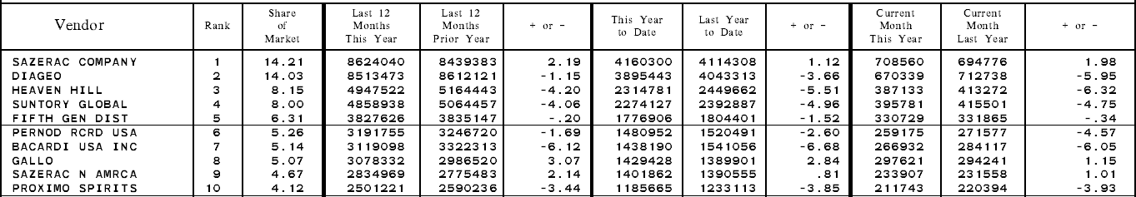

Field Breakdown:
Field | Description | Classification
Vendor | The supplier or producer. | Master Data
Rank | Position of the vendor based on sales performance. | Dimensional Data
Share of Market | Vendor’s percentage share of the overall spirits market. | Dimensional Data
Last 12 Months This Year | Total case sales for the last 12 months. | Fact Data
Last 12 Months Prior Year | Total case sales for the same 12-month period in the previous year. | Fact Data
+ or - (Last 12 Months) | Difference in sales between this year and last year’s 12-month period. | Fact Data
This Year to Date | Total case sales year-to-date for the current year. | Fact Data
Last Year to Date | Total case sales year-to-date for the prior year. | Fact Data
+ or - (YTD) | Difference in sales between this year-to-date and last year-to-date. | Fact Data
Current Month This Year | Total case sales for the current month. | Fact Data
Current Month Last Year | Total case sales for the same month last year. | Fact Data
+ or - (Current Month) | Difference in sales between this year’s and last year’s current month. | Fact Data

Table 7: Vendor Sales Performance (Top 20)
This table shows a combined view of sales performance by Class and Vendor (top 20). It highlights each vendor’s market position within a class, their share of market, and sales trends across timeframes (last 12 months, year-to-date, current month) compared with prior periods (pg: 367-373).
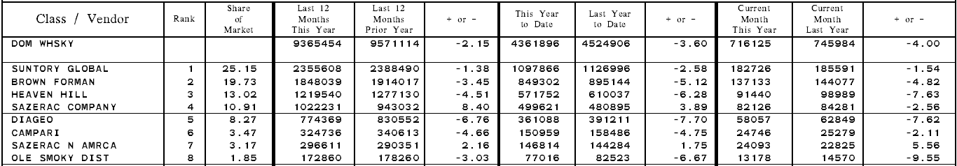
Field Breakdown:
Field | Description | Classification
Class | The spirit class category. | Reference Data
Vendor | The supplier or producer. | Master Data
Rank | Position of the vendor within the class based on sales. | Dimensional Data
Share of Market | Percentage share of the class’s total sales for the vendor. | Dimensional Data
Last 12 Months This Year | Case sales for the last 12 months (current year). | Fact Data
Last 12 Months Prior Year | Case sales for the same 12-month period in the prior year. | Fact Data
+ or - (Last 12 Months) | Difference in sales between this year and last year’s 12-month period. | Fact Data
This Year to Date | Case sales year-to-date for the current year. | Fact Data
Last Year to Date | Case sales year-to-date for the prior year. | Fact Data
+ or - (YTD) | Difference in sales between this year-to-date and last year-to-date. | Fact Data
Current Month This Year | Case sales for the current month. | Fact Data
Current Month Last Year | Case sales for the same month in the prior year. | Fact Data
+ or - (Current Month) | Difference in sales between this year’s and last year’s current month. | Fact Data

Table 8: All Control States - Vendor / Brand Sales Performance by Class
This table provides a brand-level view within each vendor, showing performance across classes. It captures sales volume over the last 12 months, year-to-date, and current month, with comparisons against prior periods and percentage changes. It enables detailed analysis of how each brand under a vendor is performing inside its class (pg: 375-754).
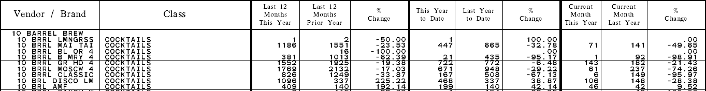
Field Breakdown:
Field | Description | Classification
Vendor | The supplier or producer. | Master Data
Brand | The brand name of the product. | Master Data
Class | Spirit class/category associated with the brand. | Reference Data
Last 12 Months This Year | Case sales for the last 12 months (current year). | Fact Data
Last 12 Months Prior Year | Case sales for the same 12-month period in the prior year. | Fact Data
% Change (Last 12 Months) | Percentage change in sales between this year and last year’s 12-month period. | Dimensional Data
This Year to Date | Case sales year-to-date for the current year. | Fact Data
Last Year to Date | Case sales year-to-date for the prior year. | Fact Data
% Change (YTD) | Percentage change in sales between this year-to-date and last year-to-date. | Dimensional Data
Current Month This Year | Case sales for the current month. | Fact Data
Current Month Last Year | Case sales for the same month in the prior year. | Fact Data
% Change (Current Month) | Percentage change in sales between this year’s and last year’s current month. | Dimensional Data

Note:
- Master Data = the entities
- Reference Data = the classifications of those entities
- Dimensional Data = the context for measuring
- Fact Data = the actual numbers we measure

Data Processing and Structure
(1) Data Extraction and Flattening
- NABCA report tables are scraped and converted into a flat file.
- The flat file is in long format: one row per Brand × Vendor × Class/Type × Bottle Size × Month.
- Each row holds a single fact value (case sales for that brand–bottle–month).
- Flattening means unpivoting bottle-size columns into a single BottleSize column with a corresponding CaseSales value.
(2) Normalization
- Vendor and Brand → Master Data (real-world business entities).
- Class/Type and Bottle Size → Reference Data (standardized categories).
- Month/Year, Rank, % Share, % Change → Dimensional Data (context for analysis).
- Case Sales and other numbers → Fact Data (measurable values).
- Separate lookup tables will be created for Vendor, Brand, Class/Type, and Bottle Size to keep the warehouse clean and consistent.
(3) Core Fact Table
- The main fact table will store:
Brand, Vendor, Class/Type, BottleSize, Month, CaseSales.
- This is the most detailed dataset (atomic grain).
- All other NABCA report tables (1–8) can be reconstructed by grouping this table and applying time-based calculations (YTD, L12M, Current Month, % Change, Rank, Market Share).
(4) Matching and Mastering
- NABCA sales data will be matched to TTB COLA products using a match and merge (mastering) process.
- Matching uses:
  - Brand + Bottle Size as the main keys.
  - Class/Type and Vendor to confirm matches and improve accuracy.
- This process links sales data to official product records, enabling richer analysis with label, origin, and alcohol content information.
(5) Product Hierarchy
- Products follow a hierarchical structure:
  - Brand → may have multiple flavors or variants.
  - Each variant → may have multiple bottle sizes (SKUs).
- NABCA data is currently at the bottle-size (SKU) level.
- TTB COLA may reveal a finer atomic level (e.g., flavor + size). If so, we will refine the structure; if not, the atomic key is Brand + Vendor + Class/Type + Bottle Size.
Summary
- Table 5 is the core table - it is the most detailed, and all other tables can be derived from it.
- All sales data is broken down by four key fields: Brand, Vendor, Class/Type, Bottle Size.
- Flattening and normalization ensure the data is consistent and ready for ingestion.
- Every brand belongs to one vendor and one class, so Vendor and Class serve as stable lookup references.
- With 18 months of data, we can compute all required reporting metrics (YTD, L12M, % Change, Ranks, Market Share).

Next:
- Deriving all tables from table 5
- ER Diagram
- How MDM can help with matching with ttb data
Note:
- Unique list of brand from table 8
- Unique list of vendors from table 5
- Unique list of class (same as type) from table 4

