



**SM6P07NI Digital Media Project**

**25% Research and Proposal**

**2022-23 Winter**

**Student Name: Ashraya Singh Khatri**

**London Met ID: 19031980**

**College ID: NP01MM4A190077**

**External Supervisor: Pooja Shrestha**

**Internal Supervisor Rakshak**

**Assignment Due Date: Wednesday, December 28, 2022**

**Assignment Submission Date: Wednesday, December 28, 2022**

**Word Count: 3430**

*I confirm that I understand my coursework needs to be submitted online via Google Classroom under the relevant module page before the deadline in order for my assignment to be accepted and marked. I am fully aware that late submissions will be treated as non-submission and a marks of zero will be awarded.*

**Abstract**

The origins of animation can be traced to ancient history. Animation has existed in many forms throughout history, from the Greek pottery of the ancient world to the visual toys of the 17th century to the computer-generated imagery (CGI) of the 21st century. This report will include my research on animation and my reasons for selecting to create an animation for my digital media project.

With the help of my supervisors, Rakshak Sir and Pooja Ma’am, I was able to finalize my concepts. My concept for DMP is to create low poly animations and models as assets to be used in-game development. This project will showcase all the research, and software to to complete the project.

Contents

Introduction 1

Literature Review 2

Polygonal modeling technique 2

What makes graphics for low-poly 3D games stand out? 6

Shading for Low Poly 7

Lightning for Low Poly 9

Principles of Animation 13

Product Review 14

Deaths Door 14

Tunic 16

Ashen 18

Summary and Conclusions 20

Section B: 21

Project Title 21

Low Poly assets for game development 21

Research Question 22

How can I model low poly assets that seems visually aesthetic for gaming? 22

Treatment 23

Resources 24

Devices and Hardware 24

Software 24

Contribution of Others 24

Evaluation and Testing 25

References 27

**Table of Figures**

Figure 1 Low Poly Models 3

Figure 2 Low Poly mesh 4

Figure 3 Triangulated low poly mesh 5

Figure 4 Lowpoly style mesh 7

Figure 5 bad shading in scene 8

Figure 6 a beautiful shading for the environment 9

Figure 7 directional light used in the environment 10

Figure 8 sky dome light used in the environment 10

Figure 9 in direct light used in the environment 11

Figure 10 rendered image with proper lightning 12

Figure 11 12 Principles of Animations 13

Figure 12 Death's Door 14

Figure 13 Tunic 16

Figure 14 Ashen 18

Figure 15 Gantt chart for my project 25

# Introduction

This project is our first proposal for Digital Media Project (DMP) for Multimedia Technologies. This project contains 20% of our total marks

under 100 for which we will be graded.

For the Digital Media Project, I have decided to create low poly animations and model assets to be used in gaming environments. I have decided to model low poly as such games are seen in the rising these days. They are easy to model and can be visually aesthetic. Additionally, rendering low-poly 3D models does not require a lot of processing resources. They are ideal for rendering for animation and gaming.

I plan to use Blender for modeling and animation, as it has tons of resources accessible. It can be used for all such as modeling, sculpting, animations, etc. It is diverse, so if you begin with Blender, you can approach more complex software, and is great for solo projects.

# Literature Review

A literature review is a piece of academic writing that explains and demonstrates knowledge of the academic literature on a particular subject. (BRITANNICA KIDS, 2017)

Game design refers to the entire process of developing an idea for a game and seeing it through to a completed playable game. Many people associate game design with video games, but it includes all types of games (board games, card games, video games, etc.) (GAMEDESIGNING, Copyright © 2022)

# Polygonal modeling technique

Most 3D game content is created using the polygonal modeling technique, which involves using polys (polygonal shapes) to create a polygonal mesh in order to create a model. 3D artists use mathematical formulas to establish the appropriate proportions for a model and then edit each poly in the models to create a natural and aesthetic model.

This popular 3D modeling technique that is primarily used in games and designs is classified into high-poly and low-poly modeling methods. Since high-poly is used to create highly detailed and often lifelike models, artists create the model with a large number of polygons. At the same, the low-poly method uses fewer polygons to model a character or any asset, involving less for modeling and rendering.

Low poly modeling has evolved into a distinctive style in recent years. Due to hardware limitations, models had to use lower polygon counts at first. However, hardware has progressed at a remarkable rate, and video games can now make use of a significant number of polygons to make amazing graphical contents with higher resolution textures and innovative shading techniques such as raytracing. Despite technological advances, there is a growing artistic movement that seeks to keep things simple.

Low poly art is a popular style in video game design, animation, and illustration. Using rough polygons, you can make beautiful and simple-looking objects. Besides it’s simple and minimal appearance, low poly designs require a high level of creativity. Several artists have adopted this technique because of its distinctive shapes and colors, along with its aesthetics.

Low poly art allows us to play with our creativity to textures, shapes and color the model. Low poly objects have very little definition and are composed with fewer polygons.  The models achieve a flat-shaded block appearance by using flat lighting. The designer uses topology, lighting, and post-process, to design in low poly. (Unity Asset Store, Copyright © 2022 Unity Technologies)

(Ramanandi, 2015)

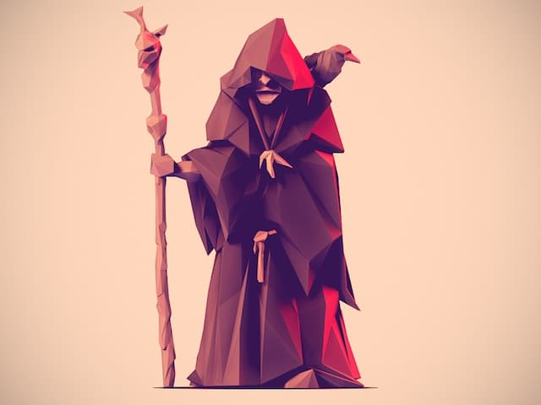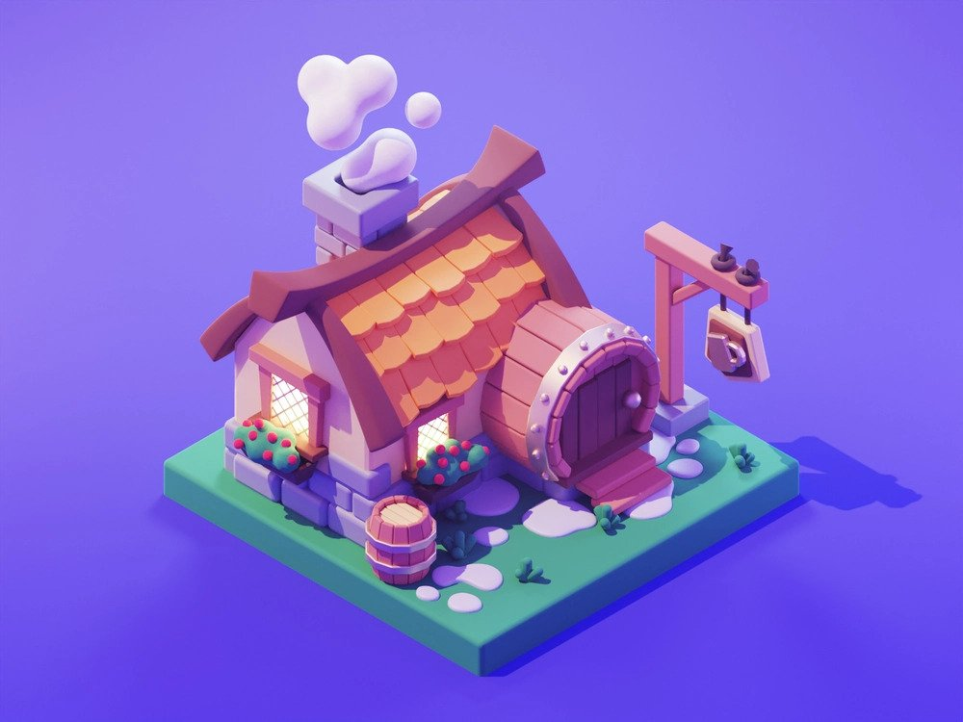

Figure Low Poly Models

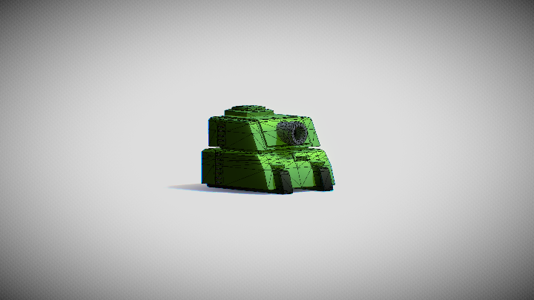

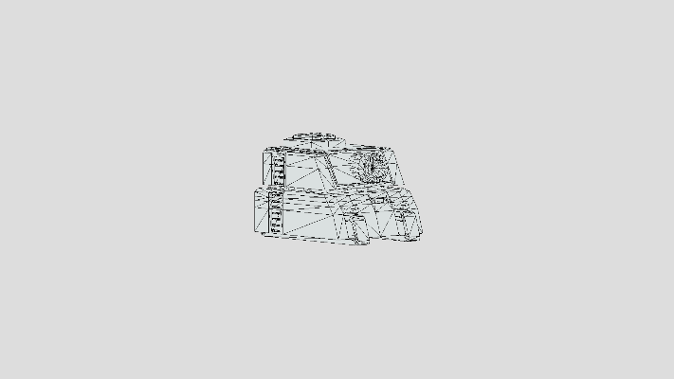

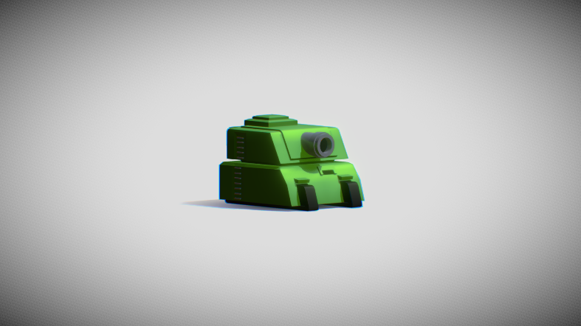

Figure Low Poly mesh

Various modeling methods can be used to create and design low poly models. We can see in the image above, that the tank was created by combining hard surface modeling techniques with post-processing effects. This produces a smooth look while keeping the actual modeling detailed to a minimum.

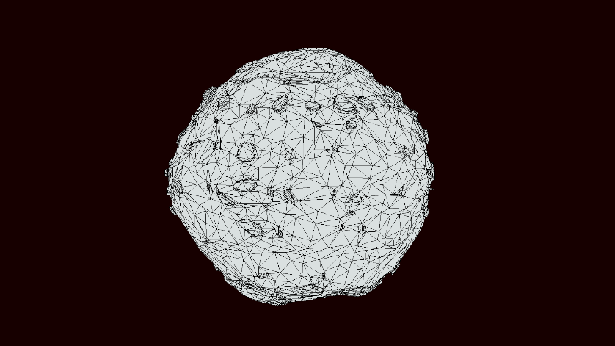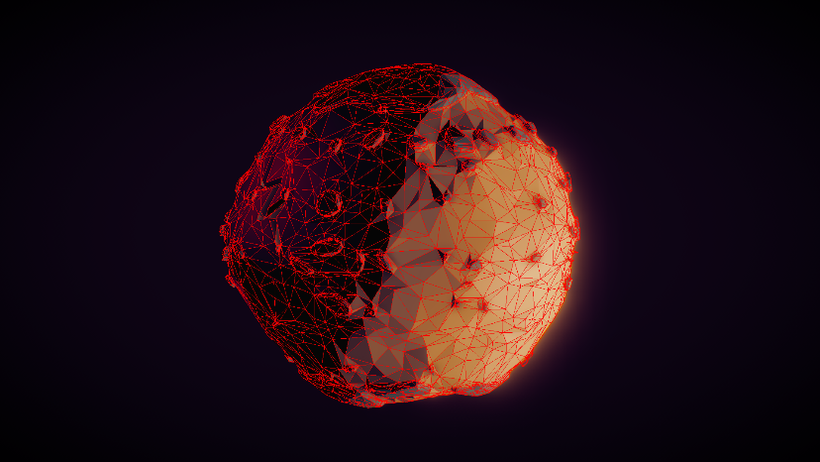

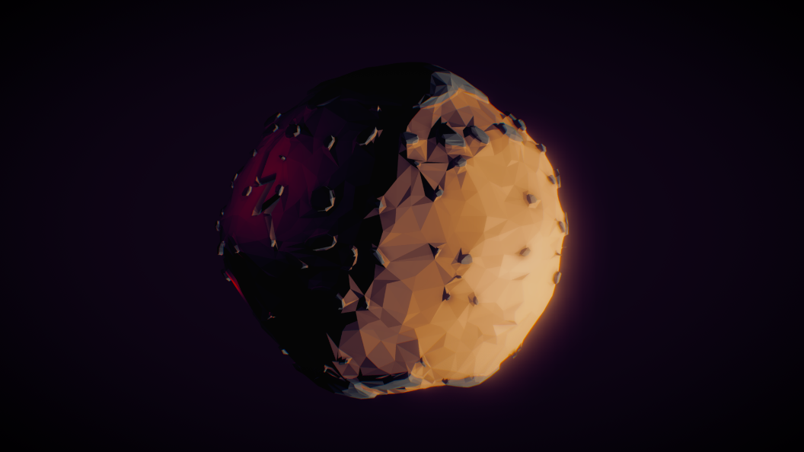

Figure Triangulated low poly mesh

Triangulated mesh is another practice while designing low poly art style. This modeling method, as shown in the image above, allows the designer to add triangulated detail, which when combined with materials and rendering capabilities results in a nice triangulated low poly look. (Theory, 2020)

## What makes graphics for low-poly 3D games stand out?

Low poly objects have less definition and are modeled with lesser polygons, spheres, cubes and cylinders. The models can achieve the desired flat-shaded boxy look by using flat lighting.

Using specific tools, we can make our model look smooth.  Most modeling   software includes a tool that uses smoothing methods to quickly reduce the number of polygons in models. Blender, for example, has a function called Shade Smooth, which also has an Auto Smooth option. By using this, users can create an angle (usually 30°) that will remove all the angles that do not fit.

When creating low-poly characters, we can give them a distinct style and unique detail. When game characters look attractive and have some distinctive characteristics that capture the attention of gamers, they don't have to be photorealistic to make the project stand out.

Artists can use any polygonal shape to create a polygonal mesh when modeling, so they can pick anything from a triangle to a pentagon.  Since quads are well-transformed into subdivision surfaces, they are more suitable for low modeling. (Gameace Creative Studio, 2021)

## Shading for Low Poly

Lowpoly style mesh normal are flattened (normal smooth-groups are removed) and may not use diffuse texture for rendering as it is baked inside vertex color. These two factors give a mesh a lowpoly appearance.

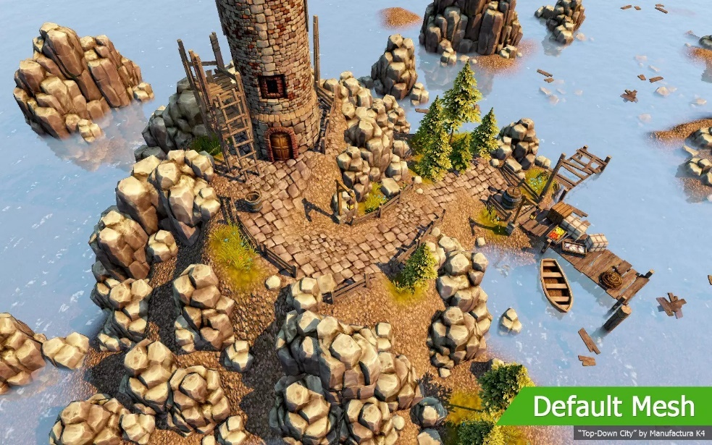

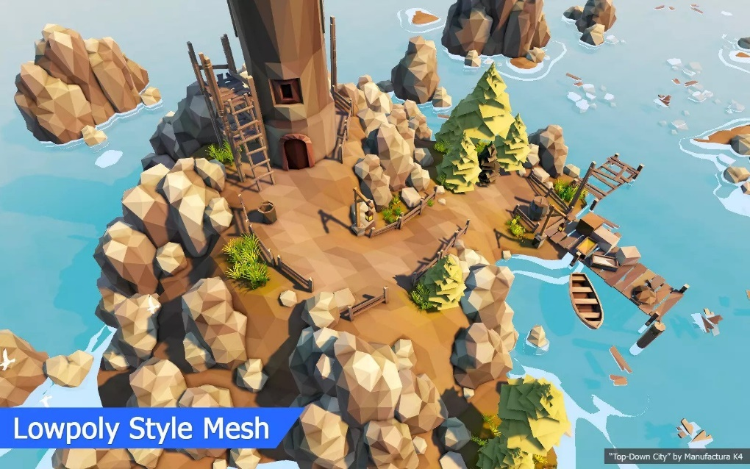

Figure Lowpoly style mesh

There should be an attempt to keep the textures to a minimum. Use only flat colors to help add complexity with lighting. This produces the cleanest and most interesting results However, it can be useful to add a slight texture to break up the surface slightly.

Making use of elements such as specularity, refraction, scatter, and so on. Using these can undoubtedly give a good, one-of-a-kind look. There should be awareness of saturation, a lot of low poly art, particularly grass, have too much saturation. Ensure to include some specular, because this will help to reduce highlights to a more pleasant, desaturated tone. Saturation can be a powerful tool for directing the viewer's attention.

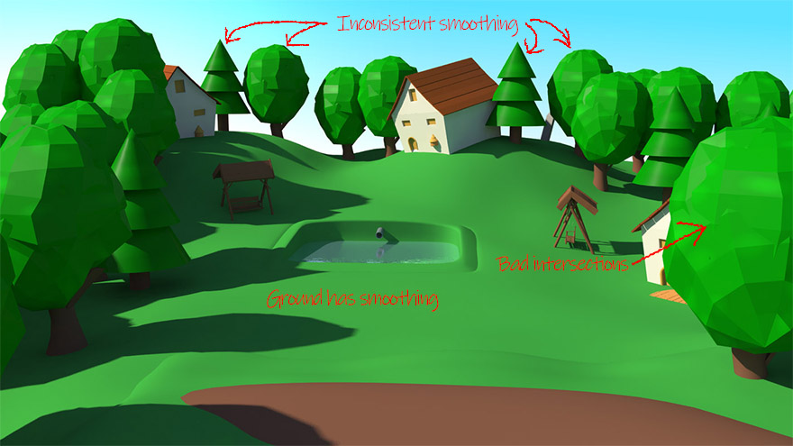

Figure bad shading in scene

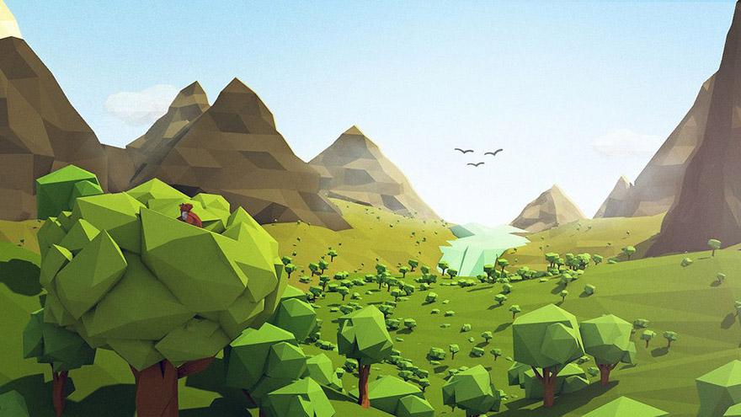

Figure a beautiful shading for the environment

## Lightning for Low Poly

One of the most important aspects of rendering your models is lighting. The lighting determines how your model will appear to the viewers.

Different types of lighting and camera angles determine how your scene will appear. There are three types of lighting. When three distinct lights are set up from three different positions. They are the key light, the fill light, and the backlight. The primary and brightest light in all three is the key light.

We can see that directional light was used in the scene. This will serve as a substitute for the sun. It can be positioned to the left of the sun, providing some nice backlight on the mountains.

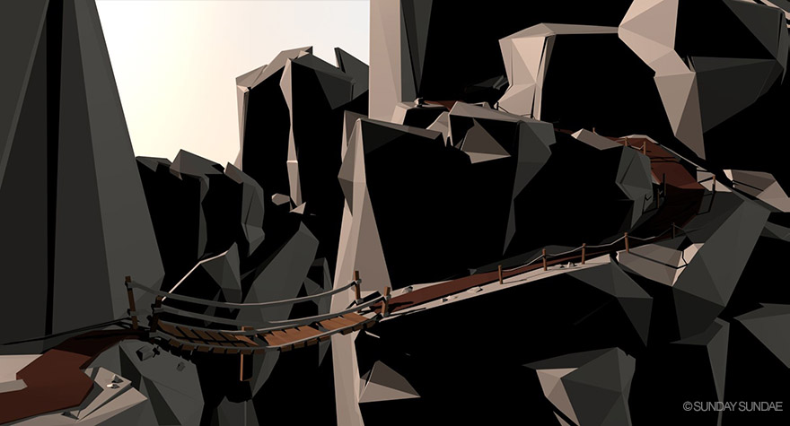

Figure directional light used in the environment

The usage of sky dome light to fill up shadow areas is visible in the following scene.

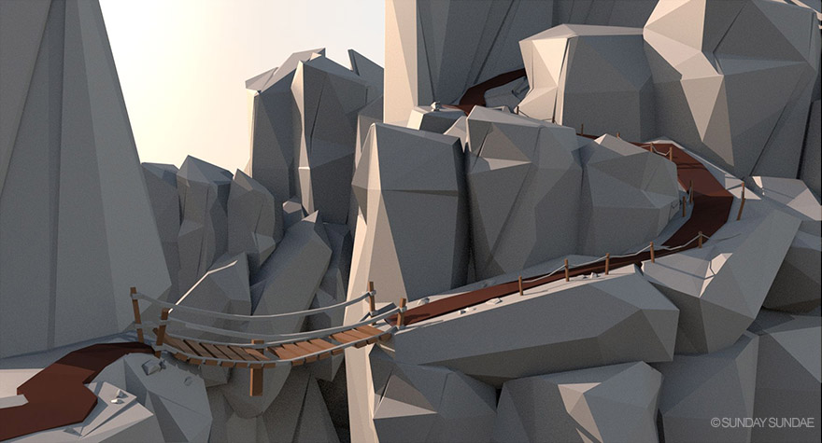

Figure sky dome light used in the environment

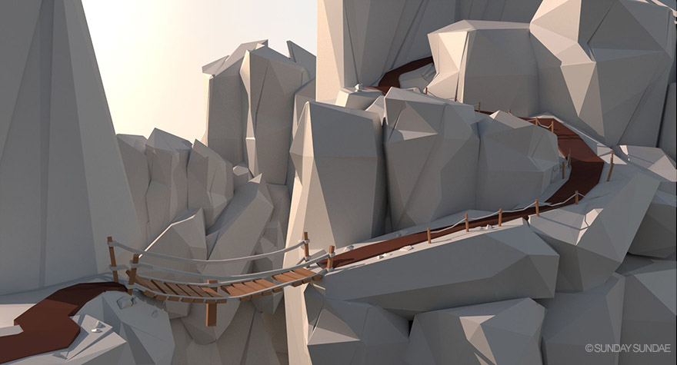In the next image, some of the darker, murky parts were helped to be smoothed out by the indirect light, giving us a clean, fresh appearance.

Figure in direct light used in the environment

Rocks typically aren't so shiny, though the shine on them is quite subtle because I've set the specularity to be rather rough. The pathway clearly reveals the primary distinction. The path seemed a little flat in early versions, so it got it quite glossy. (PONTYPANTS, 2018)

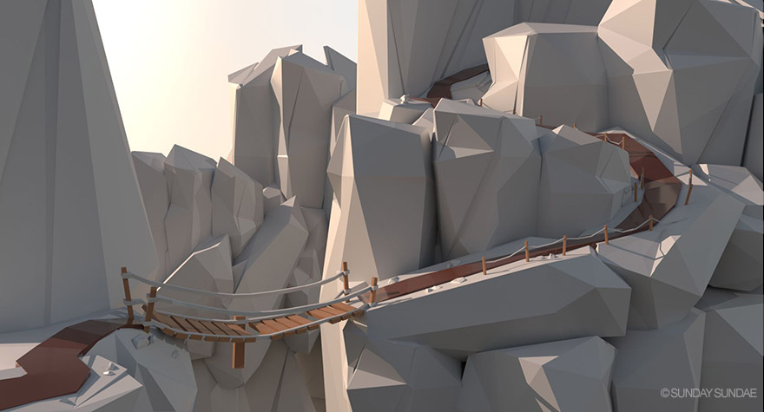

Figure rendered image with proper lightning

# Principles of Animation

A collection of fundamental guidelines for the professional animator is called the 12 Principles of Animation. In the 1981 book The Illusion of Life: Disney Animation, Ollie Johnston and Frank Thomas outlined the list, which has been helpful to Disney animators since the 1930s. Nearly 40 years later, many of these fundamental concepts are still applied in classrooms and studios all around the world. (deedeecourse, © 2022 DeeDee Animation Studio.)

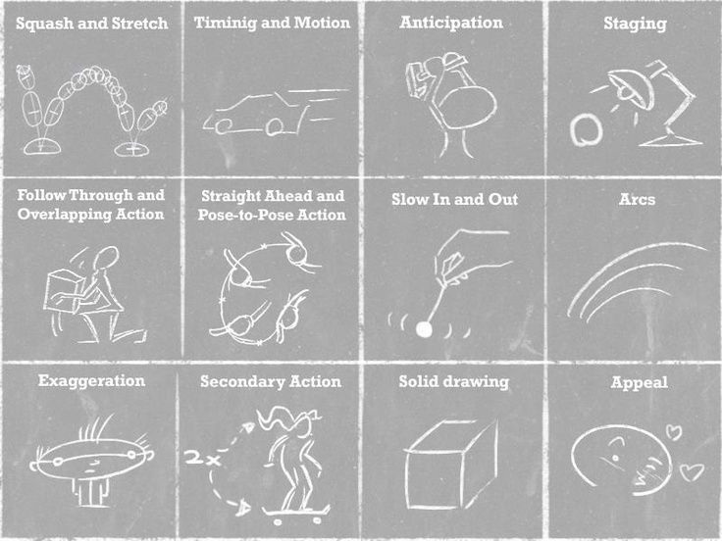

Figure 12 Principles of Animations

# Product Review

## Deaths Door

It is a low-poly style game with a rich world full of detail and vibrancy. The character designs are also creative, with some unique creatures to encounter throughout the game. (Samuel, 2021)

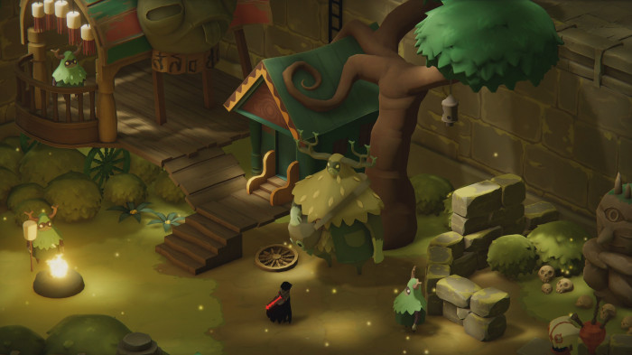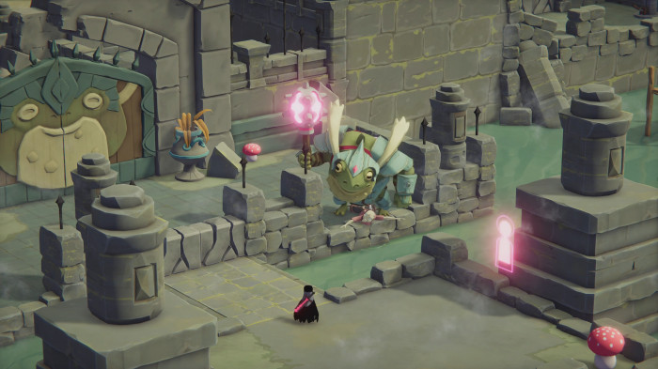The display of the world is lovely, with its mixes including almost monochrome locations and it’s burst of beautiful color palettes, along with the vast world you can visit which promises something new with every new encounter.

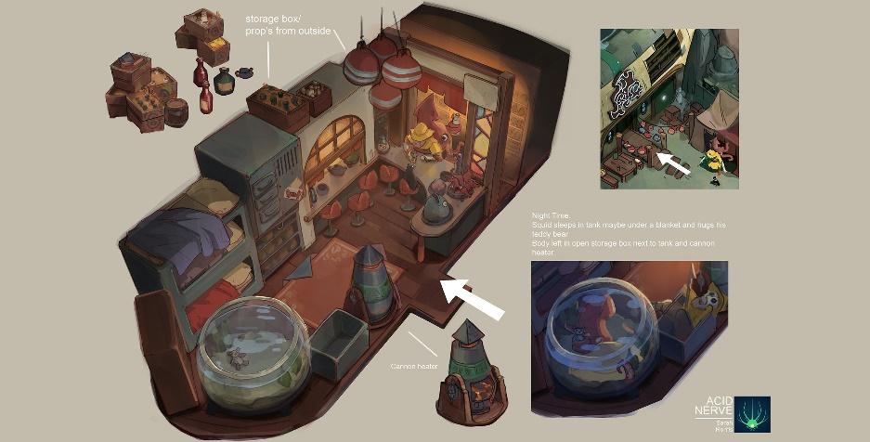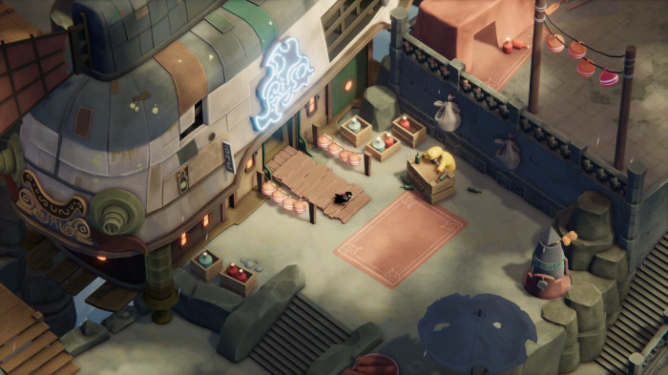

Figure Death's Door

There is a list of things that can be learnt by reviewing this game is as follows:

* It uses a simple game attraction formula that is seamlessly executed.
* There is distinct color palette that help differentiate each location from the others, in addition to the various assets that occupy them.
* It uses a particular color palette for a specific environment to indicate a mood for the story.
* The character designs are also great. For example, the enemy’s appearance changes as the story progresses, not by design but by costumes.

The following are some of the things I didn't like about this game:

* There are some visual effects problems encountered while facing a boss later on in the game.
* There are certain layering issues that can make you lose sight of your main character easily.

## Tunic

Tunic is an elegant mix of low-poly 3D models and beautifully illustrated visual elements that help to fill the gap between Zelda like adventure and the mystic elements showed later. (Donlan, 2022)

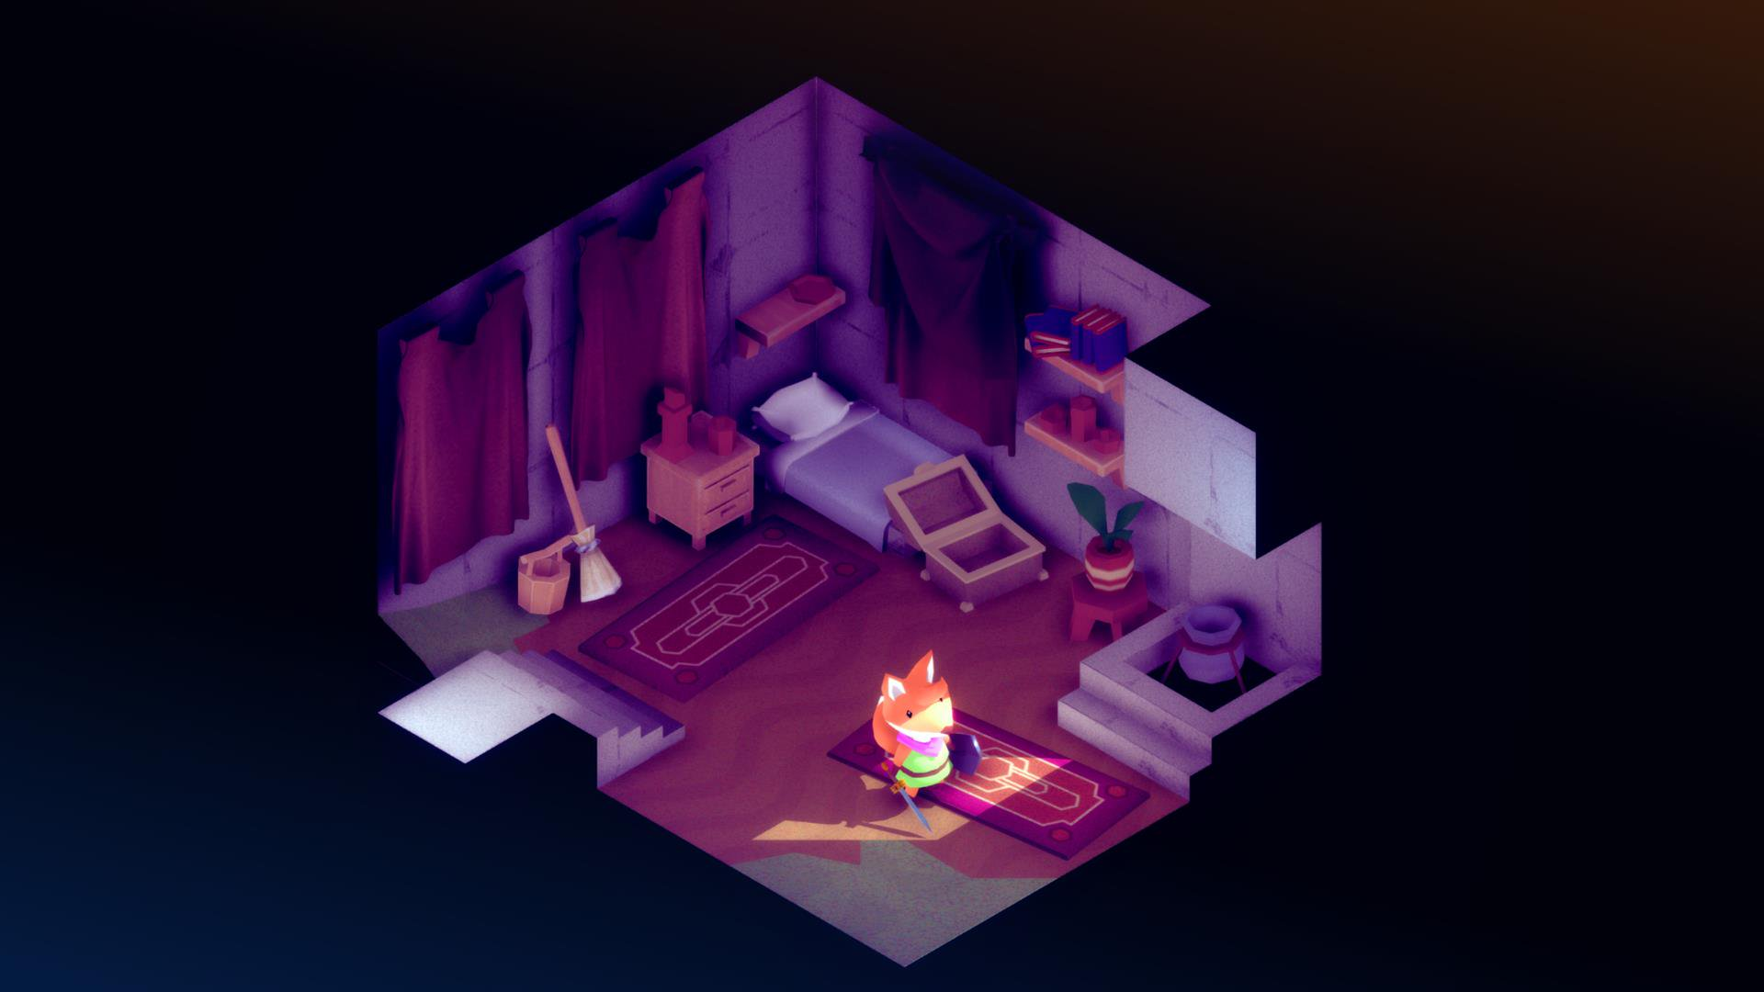

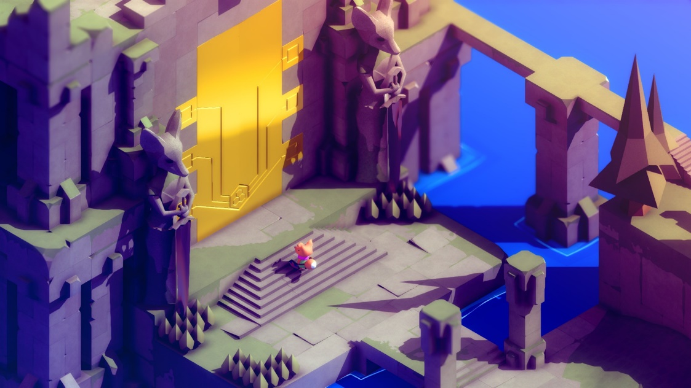

Figure Tunic

There is a list of things that can be learnt by reviewing this game is as follows:

* Tunic is an eye-catching isometric game.
* Lightning with beautiful texture enhances the visual appeal of the game.

The following are some of the things I didn't like about this game:

* The game’s camera movements somewhat hinder the gameplay.

## Ashen

Ashen is an action RPG game, which takes inspiration form the Dark soul’s franchise. It tells a story about good and evil. (Petite, 2021)

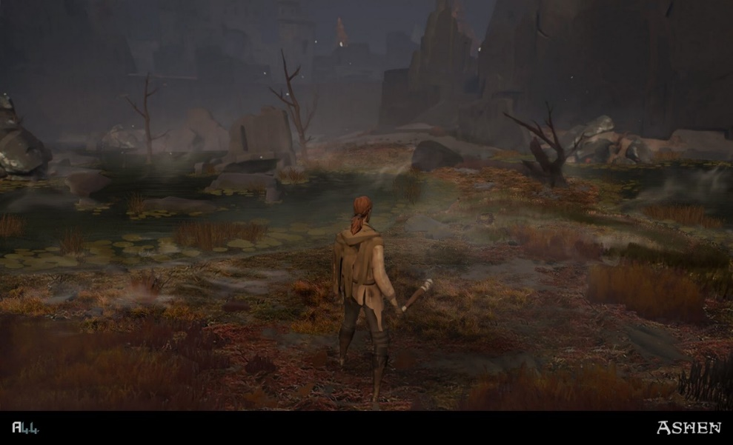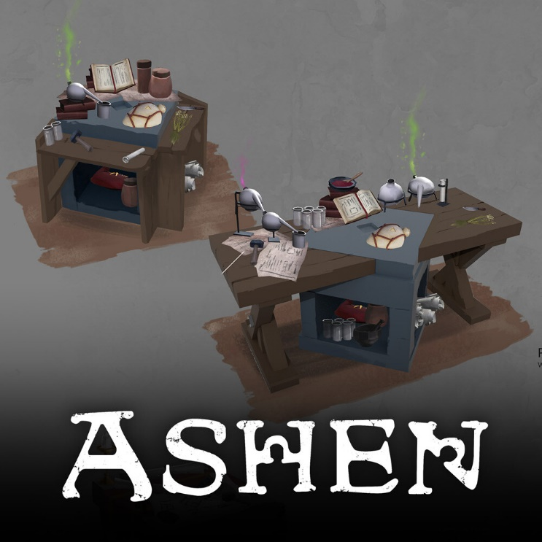

Figure Ashen

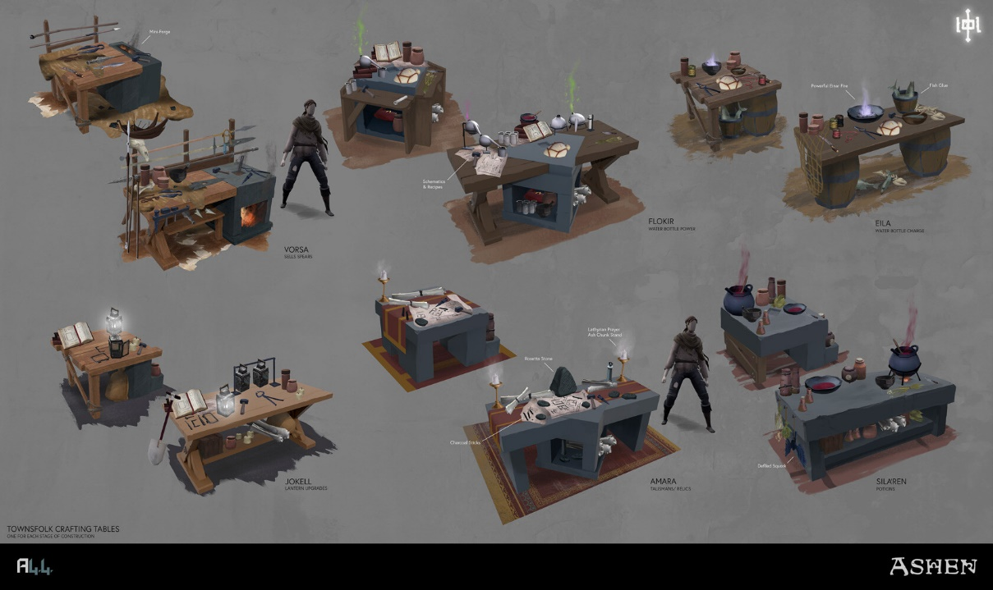

There is a list of things that can be learnt by reviewing this game is as follows:

* It’s simple yet bold design allows the players a chance to marvel and explore its diverse and perilous environments.
* The game tells us a compelling story through its design.
* The characters lack faces and fingers, and most of the artwork is untextured, but the game's mechanics make up the difference.

The following are some of the things I didn't like about this game:

* There is a problem in rendering at certain times, since it appears that the enemy’s texture only loads when you get near them.

# Summary and Conclusions

In recent years there has been a rise of low – poly art and flat designs. Its visual aesthetic texture is seemingly popular amongst indie game developers. During the early days, that popularity was almost imposed on game creators. And it had more to do with hardware limitations. Today, it is more of a visual trend, as developers and players embrace the retro aesthetic.

There are lots of advantages to using low-poly art as a game designer. For beginners, your models require fewer polygons and are smaller in size, as they load quickly and run on low-end hardware.

To model low poly requires one’s creativity. While creating complex models. We must make good use of our limited resources. However, and if when we get it right, the simplicity and style with its unique colors and shapes will find a market that believes a low poly game can still be highly enjoyable.

The majority of what I've learned will be implemented into this project. Using concepts and inspiration from similar games, I hope to create an amazing low poly art model and animation that the viewer will enjoy.

# Section B:

# 

# Project Title

### Low Poly assets for game development

My project is a showcase of low poly models for video game development. It includes both models and animations. The project will include various low poly props such as houses, castles, dungeons, characters, space shuttles, etc. and simple riggings of objects that can be used as an asset in video games. I'll use various textures and lighting effects on the models to create a mood for a suitable environment.

As for the name, I ended up choosing because it is simple and easy for people to understand what my project is about. The reason I chose to model in low - poly art is because it has always fascinated me. Its attention to detail, texture, and lightning, combined with excellent game mechanics, make it a joy to play. Its simplicity of design makes it easier to grasp more knowledge of 3D topology. Other styles may require more detail, whereas I see low-poly as a way to create clarity through simplicity.

# Research Question

## How can I model low poly assets that seems visually aesthetic for gaming?

For those who are making low-poly models or art must first regard how many models and model types they will require. There isn't a single method for modeling these assets; rather, a number of methods. Since, I am focusing on a small number of polygons, I can rule out techniques like digital sculpting and NURBS, that are best suited for high poly modeling. This leaves me mainly with box modeling and edge modeling.

A basic geometric shape is created and then broken down into many smaller shapes in box modeling. Once there are hundreds or thousands of shapes, the method is repeated. The model then acquires unique features that make it look more and more similar to the idea in mind with each modification.

I can start designing a model with a reference image. If the models appear too blocky, I can use smooth shading to make them more appealing. To begin texturing, I can first establish the model's base color. Hair, clothing, and skin can all be referenced using flat colors.

I can use textures ranging from low-poly to high-poly. Low poly textures are how we create the illusion of detail, and I can take my time modeling and animating it. The most important aspect is lighting.  However, it will never look good if the lighting is not correct. Post-production is also important because things like color correction help set the mood and adding depth haze to separate the foreground from the background. Since attention to detail is important, I will take my time with it. (Garbaj, 2021)

# Treatment

With my project, I hope that viewers will have a good understanding of what low poly design is. I hope they realize that low poly games can be as creative as high poly games. There are several factors to consider when creating low poly games, such as shading, lighting, and engaging backgrounds. I hope they recognize the artist's efforts to make their game fun and enjoyable. We can create any wonderful game with passion.

Duration: 1-2 minutes

Target Audience

* Age: 15+ year
* Gender: All
* Ethnicity: All
* Location: All

I intend to target people aged 15 and up because everyone nowadays wants to build and create their own games. Everyone enjoys playing games and wishes to create their own, but not everyone has the skill or knows where to begin when creating a 3D model as they get confused.

# Resources

In order to complete this project, I will use multiple resources that will help me in completing it. I've listed the majority of the resources I'll be using for modeling below.

## Devices and Hardware

* Laptop (Acer Predator Helios 300)

## Software

* Blender: This software will be used for all of my modeling and animation
* Adobe Photoshop: This software will be used for creating storyboard, textures, editing render images
* Adobe Illustrator: This software will be used for vector designs for the project
* Adobe After Effects: This software will be used for editing the final video
* Adobe Premiere Pro: This software will be used for compositing and color correcting the final video
* Substance Painter: This software will be used for importing and exporting textures for my models

## Distribution platform

* YouTube: I will post my final video on YouTube to showcase my assets and animation
* CGTrader: To make my assets public, I will distribute them on 3D modeling platforms such as CGTrader.

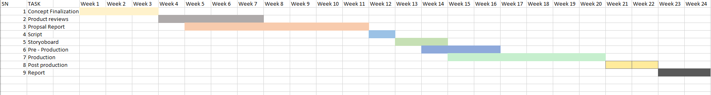

Figure 15 Gantt chart for my project

# Contribution of Others

Since this is our DMP, it is not an easy project, and I could not have completed this project by myself.

Both of my supervisors, Rakshak Sir and Pooja Ma'am, have assisted me with this project by giving me advice on what I should do and reviewing my progress so far. I'd also like to thank my friends Bibek Dhungana and Samapan Rai for giving me advice on what I should do for the project.

# Evaluation and Testing

I intend to evaluate my project by showing it to my supervisors, friends, students, and video game players for feedback. I will then improve the project based on with all of their suggestions.

Once completed, the modeling, texturing, compositing, etc. will be tested. I intend to gather responses from my supervisors, friends and through online surveys.  This will assist me in improving my 3D work by understanding what I should do to improve further.

Bibliography

BRITANNICA KIDS. (2017, 09 10). *Animation*. Retrieved 12 10, 2022, from BRITANNICA KIDS: https://kids.britannica.com/students/article/animation/604592

deedeecourse. (© 2022 DeeDee Animation Studio.). *12 Principles of Animation - Squash and Stretch*.

Retrieved 11 04, 2022,

from DeeDee Animation Studio: https://www.deedeestudio.net/en/post/principles-animation-squash-stretch#:~:text=What%20is%20%E2%80%9CSquash%20and%20Stretch,or%20stiffness%20to%20the%20motion.

Donlan, C. (2022, 09 27). *Tunic review - it's a marvel*.

Retrieved 11 09, 2022,

from EUROGAMER: https://www.eurogamer.net/tunic-review-its-a-marvel

Gameace Creative Studio. (2021, 7 19). *How to Make Low-poly Models for Games*. Retrieved 12 14, 2022,

from Gameace Creative Studio: https://game-ace.com/blog/low-poly-models/

GAMEDESIGNING. (Copyright © 2022). *Learn to Design Video Games with GameDesigning.org*.

Retrieved 12 2022,

from GAMEDESIGNING: https://www.gamedesigning.org/

Garbaj. (2021, 7 01). *How To Make Low Poly Models (That Don't Suck)*.

Retrieved 12 16, 2022,

from Youtube: https://www.youtube.com/watch?v=7s7uSx18DUc&ab_channel=Garbaj

Petite, S. (2021, 12 22). *Ashen Review*.

Retrieved 11 29, 2022,

from IGN: https://www.ign.com/articles/2018/12/12/ashen-review

PONTYPANTS. (2018, 08 18). *How To Make Low Poly Look Good*.

Retrieved 12 15, 2022,

from sundaysundae: https://sundaysundae.co/how-to-make-low-poly-look-good/

Samuel. (2021, 11 23). *DEATH’S DOOR [PLAYSTATION 5] | REVIEW*.

Retrieved 11 28, 2022,

from Use a Potion - Games Review: https://www.useapotion.com/2021/11/deaths-door-playstation-5-review/#:~:text=It%20features%20a%20low%2Dpoly,good%20way%2C%20of%20course).

Theory, G. (2020, 05 10). *What is a low poly style in video games design?*

Retrieved 12 12, 2022,

from Digitsale: https://www.digitalste.com/post/what-is-a-low-poly-style-in-video-games-design

Unity Asset Store. (Copyright © 2022 Unity Technologies). *LOw Poly mesh Generator*. Retrieved 12 11, 2022,

from Unity Asset Store: https://assetstore.unity.com/packages/tools/modeling/lowpoly-mesh-generator-196511

References

(n.d.). Retrieved from https://www.openxcell.com/blog/low-poly-game-art-trends-exemplary-games/

(n.d.). Retrieved from https://www.sessions.edu/notes-on-design/whats-the-deal-with-low-poly-art/