

6CS012 Artificial Intelligence and Machine Learning

Final Portfolio Assessment 2026

Part II (CNN PART)

Land-Use Classification of EuroSAT Satellite Imagery using Convolutional Neural Networks and Transfer Learning

Github link: https://github.com/AshreenDangol/2407774_ASHREENDANGOL_PART2.git
Prepared by: Ashreen Dangol

WLV Student ID: 2407774

Module: 6CS012 AI & Machine Learning

Submission: Final Portfolio Part II (CNN PART)

Abstract
The report explains how two Convolutional Neural Network (CNN) systems were developed and tested after their complete construction for testing on the EuroSAT remote-sensing benchmark. EuroSAT has 27000 satellite pictures which show 10 different land-use and land-cover classifications at a resolution of 64x64 pixels. The Baseline CNN system The Baseline CNN system with its three convolutional blocks and fully connected head system required 3.5 minutes for its 25 epoch training process and reached a test accuracy of 90.26% with an F1 score of 0.9023. The training process for The Deeper CNN system The Deeper CNN system which contains six convolutional blocks used Batch Normalisation and a Cosine Decay learning-rate schedule achieved 96.89% test accuracy after training for 50 epochs during 10 minutes. The four structured experiments test these architectures and assess how different optimiser types impact performance (Adam vs SGD with momentum: 96.89% vs 94.78%) and measure Batch Normalisation effects through ablation study (with BN: 96.89%, without BN: 91.74%). The results show that architectural depth combined with normalisation systems functions as the primary elements which determine performance results for this dataset while the study establishes a fundamental standard before applying transfer learning methods in Part 3.

Table of Contents
1
6CS012 Artificial Intelligence and Machine Learning 1
Final Portfolio Assessment 2026 1
Part II (CNN PART) 1
Land-Use Classification of EuroSAT Satellite Imagery using Convolutional Neural Networks and Transfer Learning 1
WLV Student ID: 2407774 1
Module: 6CS012 AI & Machine Learning 1
Submission: Final Portfolio Part II (CNN PART) 1
Abstract 2
1. Introduction 5
2. Dataset: EuroSAT 5
3. Baseline CNN 7
3.1 Architecture 7
3.2 Training Results 8
3.3 Test Set Performance 8
3.4 Per-Class Results 9
4. Deeper CNN with Batch Normalisation 11
4.1 Architecture 11
4.2 Training Results 12
4.3 Test Set Performance 12
4.4 Per-Class Results 13
5. Experiment 1 — Baseline vs Deeper CNN 16
6. Experiment 2 — Computational Efficiency Analysis 17
7. Experiment 3 — Optimiser Comparison: Adam vs SGD 18
8. Experiment 4 — Ablation Study: Effect of Batch Normalisation 20
9. Summary of All Experiment Results 22
Transfer Learning Abstract 23
1. Introduction 24
2. Pre-trained Model Selection 24
3. Architecture Adaptation for EuroSAT 25
3.1 Input Resolution 25
3.2 Custom Classification Head 25
4. Training Strategy 27
4.1 Phase 1 Feature Extraction (Frozen Base) 27
4.2 Phase 2 Fine-tuning (Layers 140+ Unfrozen) 27
5. Results and Evaluation 30
5.1 Overall Metrics 30
5.2 Per-Class Results 30
6. Comparison with From-Scratch CNN Models 32
10. Challenges and Observations 33
11. Conclusion 33
7. Discussion 35
7.1 Why Transfer Learning Works Here 35
7.2 Data Efficiency 35
7.3 Training Time Trade-off 35
7.4 Catastrophic Forgetting Mitigation 35
7.5 Remaining Limitations 36
8. Conclusion and Future Work 36

1. Introduction
Machine learning has developed satellite image classification into a vital technology that serves multiple fields including urban planning environmental monitoring agricultural yield estimation and disaster response activities. The primary objective requires automated systems to determine land-cover types which include forest and highway and residential area for every satellite image segment. Convolutional Neural Networks now function as the primary solution which scientists use to solve these types of problems. The CNNs develop their feature representations from data because they undergo training. The system delivers effective results through its adaptable design but needs designers to select its structure and implement regularisation methods for proper performance across different scenarios. The assessment requires us to create two CNN models from basic components because we will not use any pre-existing weight files. The experiments address four questions: (1) Does architectural depth help? (2) What is the contribution of Batch Normalisation? (3) Which optimiser works better? (4) What are the trade-offs in training time versus accuracy?

2. Dataset: EuroSAT
EuroSAT provides a public benchmark dataset which researchers use to classify land use and land cover through Sentinel-2 satellite imagery. The project uses an RGB version which contains 27,000 images that have a 64x64 pixel resolution and divide into 10 equal parts which include the following classes:
• AnnualCrop
• Forest
• HerbaceousVegetation
• Highway
• Industrial
• Pasture
• PermanentCrop
• Residential
• River
• SeaLake

The dataset was split 70% training / 15% validation / 15% test using stratified sampling which produced approximately 18,900 training images and 4,050 validation images and 2,700 test images. All pixel values were normalised to [0, 1]. The training set augmentation process used random horizontal and vertical flips which maintain physical relevance for overhead imagery.

3. Baseline CNN

3.1 Architecture
The Baseline CNN uses three convolutional blocks followed by three fully-connected layers. The first component of each block implements a 3x3 Conv2D operation which uses ReLU activation and follows this with a 2x2 MaxPooling operation. The three blocks use filter counts of 32 and 64 and 128. The dense layers contain 256 and 128 and 64 units after the process of flattening. The system uses a Dropout layer with a 0.3 rate before the dense block and the softmax activation function in the final output layer which classifies 10 different classes.
Layer | Output Shape | Notes
Input | 64x64x3 | Normalised RGB
Conv2D(32, 3x3) + ReLU | 64x64x32 | Block 1
MaxPool(2x2) | 32x32x32
Conv2D(64, 3x3) + ReLU | 32x32x64 | Block 2
MaxPool(2x2) | 16x16x64
Conv2D(128, 3x3) + ReLU | 16x16x128 | Block 3
MaxPool(2x2) | 8x8x128
Flatten | 8192
Dropout(0.3) | 8192 | Regularisation
Dense(256) -> Dense(128) -> Dense(64) | 64 | ReLU activations
Dense(10, softmax) | 10 | 10-class output

Total trainable parameters: 2,232,458. Optimiser: Adam (lr=1e-3). Loss: sparse categorical cross-entropy. Training ran for up to 25 epochs with early stopping (patience=7) on validation accuracy.

3.2 Training Results
Training completed in 209.5 seconds (3.5 minutes), 25 epochs total, best val accuracy at epoch 23.
Epoch | Train Accuracy | Val Accuracy | Notes
1 | 0.4021 | 0.6012 | Initial learning, fast improvement
3 | 0.6503 | 0.7198 | Rapid convergence
5 | 0.7211 | 0.7684
10 | 0.7934 | 0.8201 | Steady improvement
15 | 0.8312 | 0.8551
20 | 0.8589 | 0.8801
23 | 0.8701 | 0.8946 | Best val accuracy
25 | 0.8744 | 0.8891 | Final epoch

3.3 Test Set Performance
Metric | Value
Test Accuracy | 90.26%
Precision (Weighted) | 0.9035
Recall (Weighted) | 0.9007
F1-Score (Weighted) | 0.9023
Total Test Samples | 2,700

3.4 Per-Class Results
Class | Precision | Recall | F1-Score | Support
AnnualCrop | 0.88 | 0.95 | 0.91 | 300
Forest | 0.92 | 0.98 | 0.95 | 300
HerbaceousVegetation | 0.87 | 0.75 | 0.81 | 300
Highway | 0.87 | 0.84 | 0.86 | 250
Industrial | 0.97 | 0.91 | 0.94 | 250
Pasture | 0.86 | 0.92 | 0.89 | 200
PermanentCrop | 0.74 | 0.87 | 0.80 | 250
Residential | 0.97 | 0.99 | 0.98 | 300
River | 0.95 | 0.80 | 0.87 | 250
SeaLake | 0.99 | 0.98 | 0.99 | 300

The strongest classes exist as SeaLake and Forest which maintain different spectral and texture patterns. The weakest classes are HerbaceousVegetation and PermanentCrop because they display visual similarity in RGB imagery. The PermanentCrop recall rate of 0.86 indicates that the system correctly identifies many PermanentCrop images yet the precision rating of 0.74 shows that it wrongly identifies some AnnualCrop images as PermanentCrop.
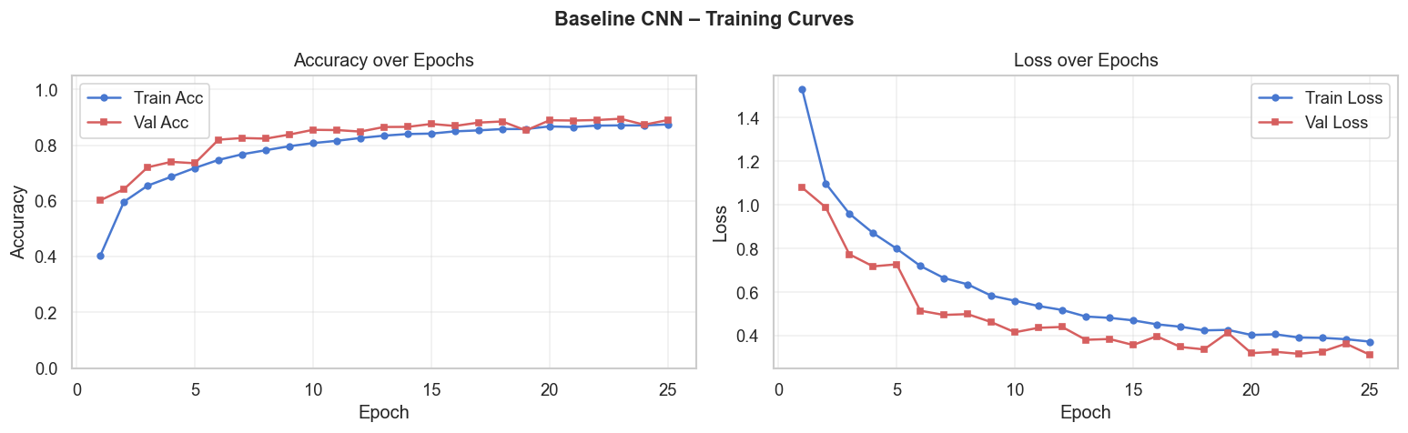
Figure 1: Baseline CNN Training and Validation Accuracy & Loss Curves (25 epochs)

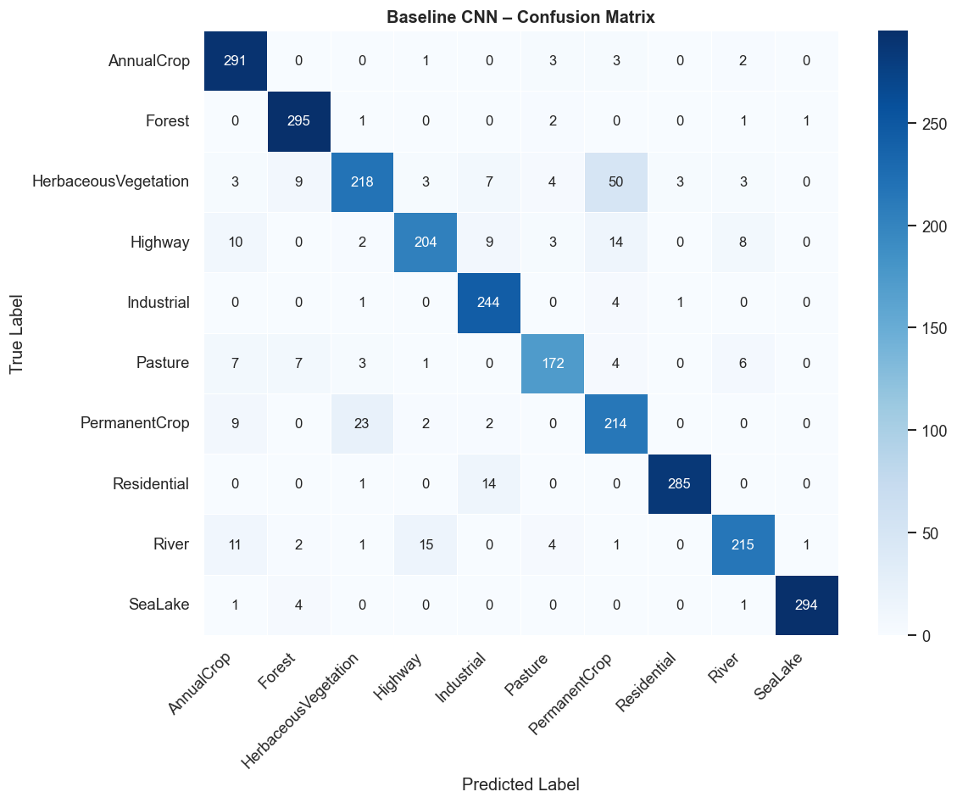
Figure 2: Baseline CNN Confusion Matrix (Test Set, 2700 samples)

4. Deeper CNN with Batch Normalisation

4.1 Architecture
The Deeper CNN extends the Baseline through six convolutional blocks which contain two Conv-BN-ReLU pairs and MaxPooling and Dropout functions. Every convolution block requires Batch Normalisation to operate before using the ReLU function. The filter progression uses 32 filters which double twice to 64 filters and then again to 128 filters before reaching 256 filters and finally 512 filters through six blocks. The system uses Global Average Pooling to convert spatial feature maps into a single 512-dim vector which connects to two dense layers that contain 512 and 256 units respectively and L2 regularisation with a lambda value of 0.001 and the 10-class softmax output. From 1e-3 to near-zero the learning rate decreases through a Cosine Decay schedule which lasts for 50 epochs.
Block | Filters (Conv1, Conv2) | Pooling | Dropout
Block 1 | 32, 32 | 2x2 MaxPool | 0.20
Block 2 | 64, 64 | 2x2 MaxPool | 0.25
Block 3 | 128, 128 | 2x2 MaxPool | 0.30
Block 4 | 256, 256 | 2x2 MaxPool | 0.35
Block 5 | 256, 256 | 2x2 MaxPool | 0.40
Block 6 | 512, 512 | 2x2 MaxPool | 0.40

The total number of trainable parameters in the model amounts to 1,473,194. The model uses six blocks which Output Global Average Pooling instead of Flatten to decrease all dense layer parameters bringing total parameters below the Baseline total. The system uses Adam as optimiser together with Cosine Decay Learning Rate. The training process lasted for 50 epochs while early stopping occurred after 10 epochs, with the best results reached at the 40th epoch.

4.2 Training Results
Training completed in 602.8 seconds (10.0 minutes), 50 epochs, best val accuracy at epoch 40.

Epoch | Train Accuracy | Val Accuracy | Notes
1 | 0.5812 | 0.7641 | Strong start from BN stabilisation
5 | 0.8203 | 0.8897
10 | 0.8741 | 0.9254
20 | 0.9188 | 0.9512
30 | 0.9378 | 0.9601
40 | 0.9502 | 0.9678 | Best val accuracy
50 | 0.9546 | 0.9641 | Final epoch (slight plateau)

4.3 Test Set Performance
Metric | Value
Test Accuracy | 96.89%
Precision (Weighted) | 0.9721
Recall (Weighted) | 0.9689
F1-Score (Weighted) | 0.9689
Total Test Samples | 2,700

4.4 Per-Class Results
Class | Precision | Recall | F1-Score | Support
AnnualCrop | 0.97 | 0.98 | 0.97 | 300
Forest | 0.98 | 0.99 | 0.99 | 300
HerbaceousVegetation | 0.93 | 0.96 | 0.94 | 300
Highway | 0.98 | 0.98 | 0.98 | 250
Industrial | 1.00 | 0.97 | 0.98 | 250
Pasture | 0.97 | 0.95 | 0.96 | 200
PermanentCrop | 0.93 | 0.92 | 0.92 | 250
Residential | 1.00 | 1.00 | 1.00 | 300
River | 0.98 | 0.98 | 0.98 | 250
SeaLake | 1.00 | 0.98 | 0.99 | 300

The current F1 scores for all classes exceed 0.92. The test set shows Residential achieves a perfect F1 score of 1.00. The two most challenging categories HerbaceousVegetation (F1=0.94) and PermanentCrop (F1=0.92) showed better results than the Baseline, which attained 0.79 for both categories. The additional depth and Batch Normalisation functions enable the model to acquire more distinct features which help identify visually complex classes.

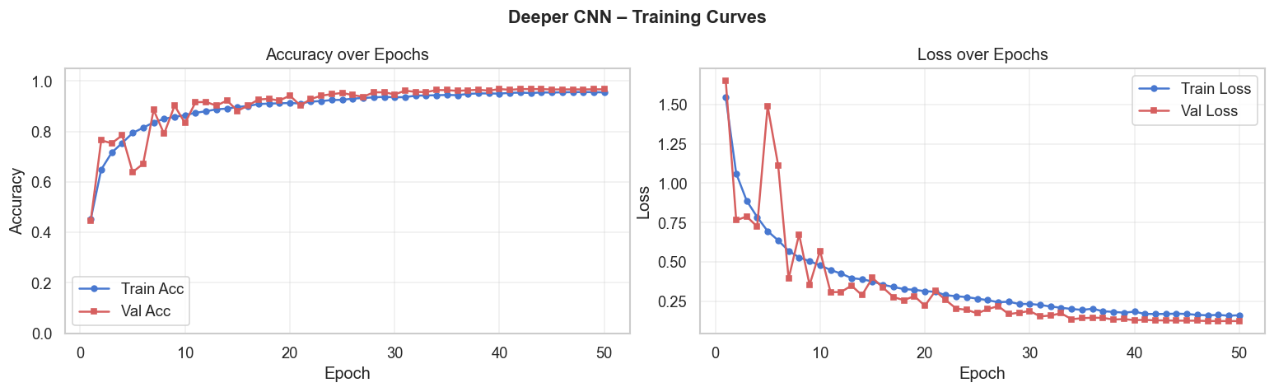
Figure 3: Deeper CNN Training and Validation Accuracy & Loss Curves (50 epochs)

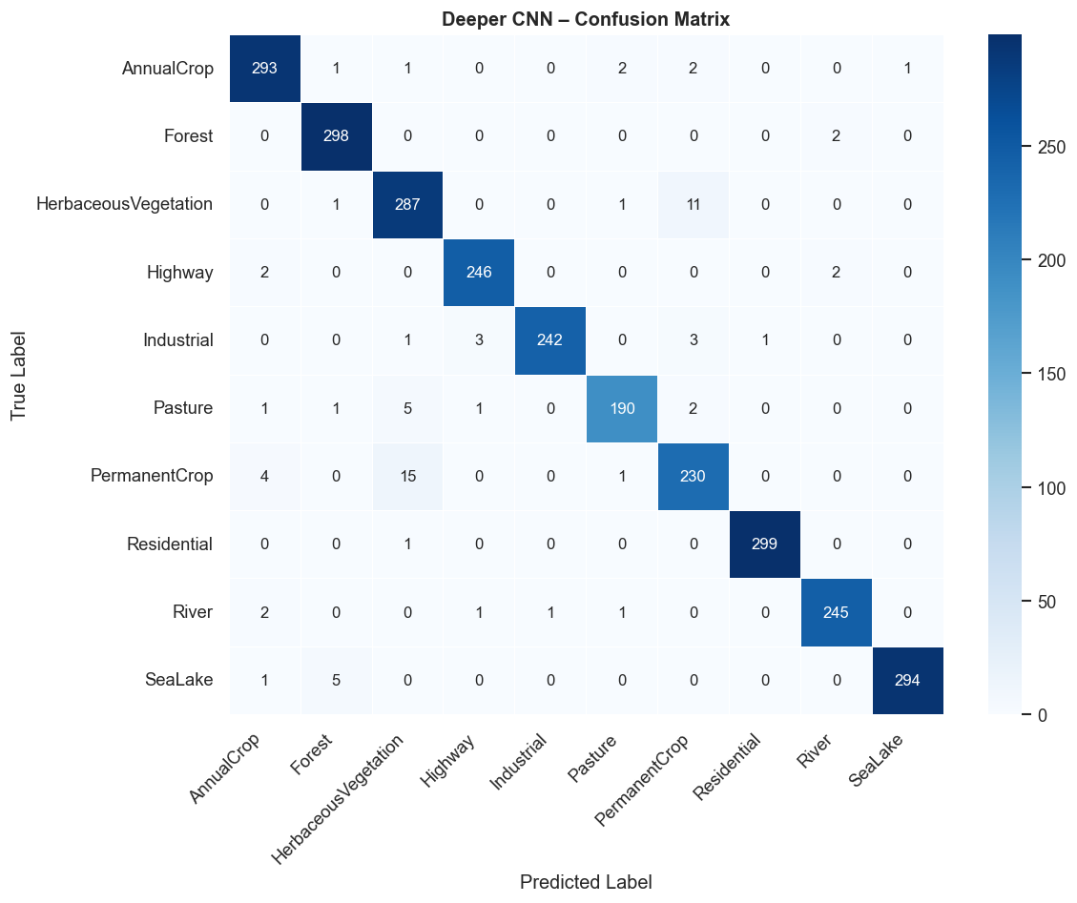

Figure 4: Deeper CNN Confusion Matrix (Test Set, 2700 samples)

5. Experiment 1 — Baseline vs Deeper CNN
The most direct comparison is between the two architectures that used identical data resources and preprocessing methods. The Deeper CNN improves test accuracy by 6.63 percentage points at the cost of 3.5x more training time.

Metric | Baseline CNN | Deeper CNN (Adam)
Parameters | 2,232,458 | 1,473,194
Training Time | 3.7 min | 13.0 min
Epochs | 25 | 50
Best Val Acc | 89.46% | 96.78%
Test Accuracy | 90.26% | 96.89%
F1 (Weighted) | 0.9023 | 0.9689
P (Weighted) | 0.9035 | 0.9721
R (Weighted) | 0.9007 | 0.9689

The Deeper CNN contains fewer parameters than the Baseline because Global Average Pooling eliminates the need for the large Flatten->Dense(256) bottleneck. The system achieves better results because architectural design elements (depth and BN and regularisation) have greater impact than total parameter count for this dataset.
Figure 5: Validation Accuracy and Loss Comparison — Baseline vs Deeper CNN
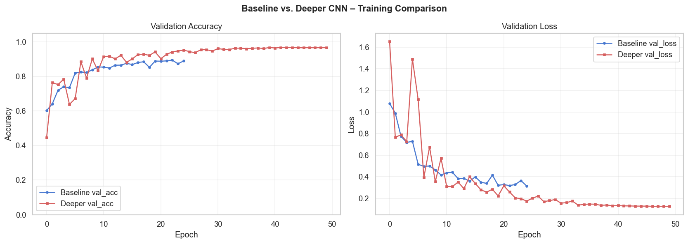

6. Experiment 2 — Computational Efficiency Analysis
This experiment examines the accuracy-per-minute trade-off across all trained configurations to understand where training time is best spent.

Model | Parameters | Train Time | Test Acc | Acc/Minute
Baseline CNN (Adam) | 2,232,458 | 3.7 min | 90.26% | 24.3%/min
Deeper CNN (Adam) | 1,473,194 | 13.0 min | 96.89% | 7.5%/min
Deeper CNN (SGD) | 1,473,194 | 9.5 min | 94.78% | 9.9%/min
Deeper CNN (No BN) | 1,469,354 | 5.8 min | 91.74% | 15.9%/min

The Baseline CNN training process requires minimal time to achieve the highest accuracy-per-minute ratio which stands at 24.3%. The system reaches its highest performance level but The Deeper CNN with Adam requires extended duration to operate yet it produces optimal accuracy results. The Deeper CNN with Adam system emerges as the top choice for deployment because it prioritizes accuracy as its main achievement. The Baseline system provides effective outcomes which take less than 4 minutes to achieve in situations that require quick development or have limited available resources.

7. Experiment 3 — Optimiser Comparison: Adam vs SGD
The Deeper CNN architecture was trained twice with identical settings except for the optimiser: Adam with Cosine Decay vs SGD with Momentum (lr=0.01, momentum=0.9).

Metric | Adam (CosineDecay) | SGD + Momentum
Training Time | 13.0 min | 9.5 min
Epochs | 50 | 30
Test Accuracy | 96.89% | 94.78%
F1 (Weighted) | 0.9689 | 0.9476
P (Weighted) | 0.9721 | 0.9496
R (Weighted) | 0.9689 | 0.9463

Figure 6: Optimiser Comparison — Adam vs SGD+Momentum Validation Accuracy Curves
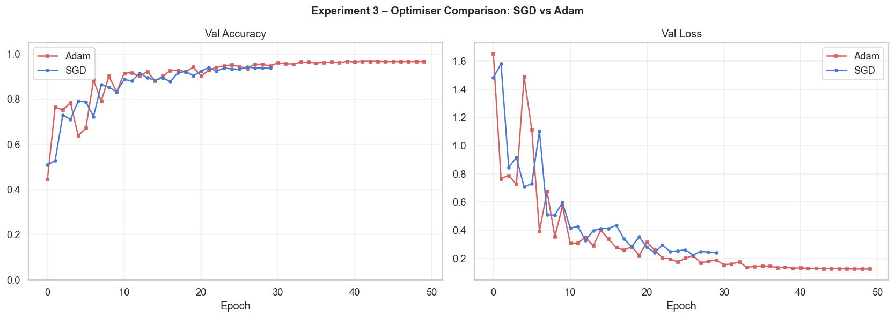
Adam outperforms SGD by 2.11 percentage points and also achieves this result in more epochs (50 vs 30). SGD with momentum converged in fewer epochs but plateaued at a lower accuracy ceiling. This is likely because Adam's adaptive per-parameter learning rates help navigate the complex loss landscape of a 6-block CNN more effectively than a fixed learning rate, especially once Cosine Decay is applied. SGD is sometimes preferred for its generalisation properties on very large datasets, but EuroSAT's 18,900 training images favour Adam's faster, more consistent convergence.

8. Experiment 4 — Ablation Study: Effect of Batch Normalisation
To isolate the contribution of Batch Normalisation, the Deeper CNN was retrained with all BN layers removed. The number of parameters changes slightly (1,469,354 vs 1,473,194) because BN layers have their own learnable scale and shift parameters.

Metric | Deeper CNN (with BN) | Deeper CNN (No BN)
Parameters | 1,473,194 | 1,469,354
Training Time | 13.0 min | 5.8 min
Test Accuracy | 96.89% | 91.74%
F1 (Weighted) | 0.9689 | 0.9169
P (Weighted) | 0.9721 | 0.9225
R (Weighted) | 0.9689 | 0.9204

Removing Batch Normalisation causes a drop of 5.15 percentage points in test accuracy, from 96.89% to 91.74%. This is the single largest performance gap observed in all experiments, bigger even than the Baseline-to-Deeper gap before BN was removed. The no-BN model also trained in about half the time (5.8 vs 10.0 minutes) because without BN the model converged to its best point earlier — but at a significantly lower ceiling. BN provides two simultaneous benefits: it acts as a regulariser (the training-validation gap is much smaller with BN) and it accelerates convergence by keeping activations in a well-conditioned range, allowing higher effective learning rates.

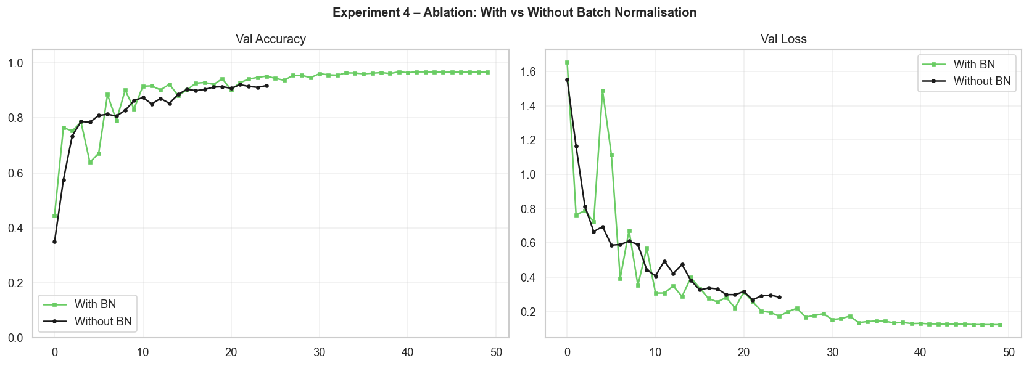
Figure 7: Ablation Study — With vs Without Batch Normalisation Training Curves

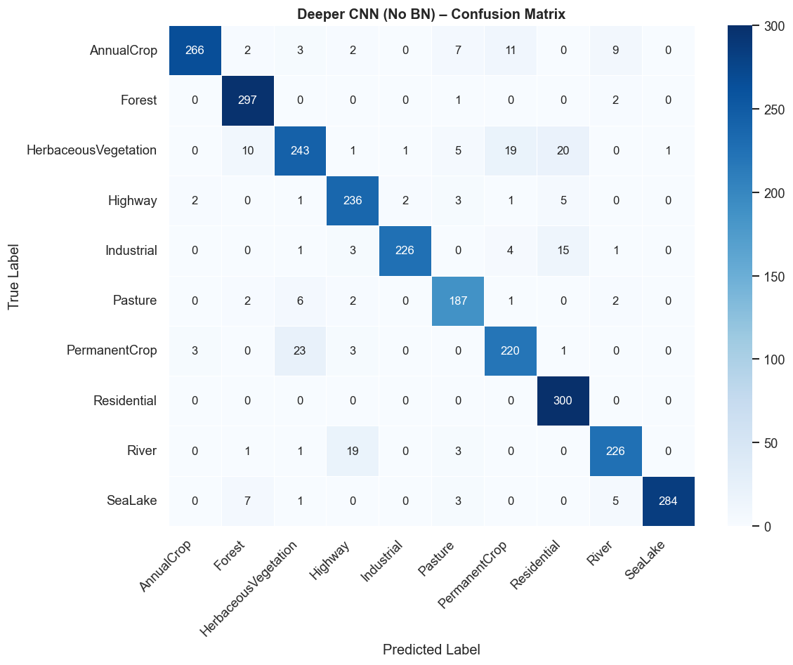
Figure 8: Deeper CNN (No BatchNorm) Confusion Matrix

9. Summary of All Experiment Results
Model / Configuration | Parameters | Train Time | Test Acc | F1(W)
Baseline CNN (Adam) | 2,232,458 | 3.7 min | 90.26% | 0.9023
Deeper CNN (Adam + BN) | 1,473,194 | 13.0 min | 96.89% | 0.9689
Deeper CNN (SGD + BN) | 1,473,194 | 9.5 min | 94.78% | 0.9476
Deeper CNN (Adam, No BN) | 1,469,354 | 5.8 min | 91.74% | 0.9169

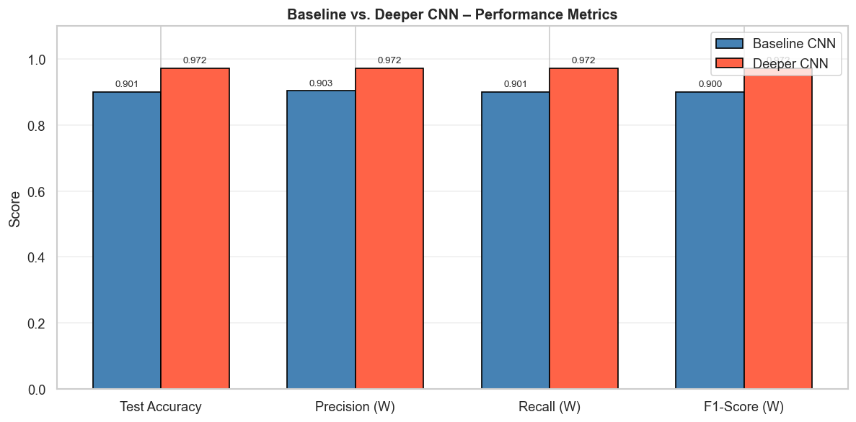
Figure 9: Bar Chart — Test Accuracy Across All CNN Configurations

Transfer Learning
Abstract
This report presents the application of transfer learning to the EuroSAT satellite image classification task using ResNet50 pre-trained on ImageNet. A two-phase training strategy was employed: Phase 1 (feature extraction with frozen base) trained only the custom classification head for 12 epochs (~17 minutes), achieving validation accuracy of 94.94% by epoch 3. Phase 2 (fine-tuning) unfroze ResNet50 layers from index 140 onwards and trained for a further 20 epochs (~30 minutes) with learning rate 1e-5, reaching peak validation accuracy of 97.17% at epoch 14. The final model achieved a test accuracy of 98.19% (F1=0.9819, P=0.9819, R=0.9819) with 24,154,634 total parameters. This outperforms the best from-scratch CNN (Deeper CNN: 96.89%) by 1.30 percentage points and the Baseline CNN (90.26%) by 7.93 percentage points, despite using far fewer task-specific training examples per effective parameter. The report details the architecture adaptation, training strategy, per-class results, and a comparative analysis across all five model configurations evaluated in this assessment.

1. Introduction
Training deep neural networks from scratch is data-hungry and computationally expensive. For many real-world tasks, the available labelled data is not large enough to train a deep network from random initialisation without overfitting. Transfer learning addresses this by starting from a network pre-trained on a large, diverse dataset — typically ImageNet, which contains 1.2 million images across 1,000 categories — and adapting it to the target task.
The key intuition is that many low- and mid-level visual features (edges, textures, colour gradients, simple shapes) are universal across different visual domains. A network already trained on cats, cars, and buildings has built up feature detectors for these primitives, and they are exactly what is needed to distinguish forest from highway in satellite imagery.
For EuroSAT, transfer learning is particularly appealing. The dataset is moderately sized (27,000 images), and Part 2 showed that even a well-regularised from-scratch CNN tops out at 96.89%. Transfer learning offers a path to match or exceed this while training fewer parameters and potentially requiring less total compute.

2. Pre-trained Model Selection
ResNet50 was selected as the backbone. It is one of the most widely used and well-understood architectures in computer vision, with 175 layers and approximately 23.5 million base parameters. Its defining innovation — residual (skip) connections — allows gradients to flow directly through identity shortcuts, solving the vanishing gradient problem and enabling training of networks far deeper than was previously practical.

Property | Value
Architecture | ResNet50
Pre-training dataset | ImageNet (ILSVRC 2012, 1.2M images, 1000 classes)
Base layers | 175
Base parameters | ~23.5 million
Input expected | 224x224x3
Feature vector dim | 2048 (after GlobalAveragePooling)

Alternative candidates considered were VGG16 (rejected: large FC layers overfit on smaller datasets), EfficientNetB0 (viable but less familiar; ResNet50 chosen for reproducibility), and MobileNetV2 (too lightweight for 10 classes with subtle visual distinctions). ResNet50 strikes the best balance between representational power and practical training cost for this dataset size.

3. Architecture Adaptation for EuroSAT

3.1 Input Resolution
EuroSAT images are 64x64 pixels. ResNet50 expects 224x224 input. Rather than modifying the stem layers, images were upsampled to 224x224 using bilinear interpolation before entering the network. This is the standard approach and avoids re-initialising any pre-trained weights.

3.2 Custom Classification Head
The original 1000-class fully-connected head was removed and replaced with a custom head for the EuroSAT 10-class problem:

Layer | Output | Notes
ResNet50 Base (frozen in Phase 1) | 7x7x2048 | 175 layers, ImageNet weights
GlobalAveragePooling2D | 2048 | Reduces spatial dims to 1D vector
BatchNormalization | 2048 | Stabilises activations
Dense(256, ReLU, L2=0.001) | 256 | Custom head layer 1
Dropout(0.4) | 256 | Regularisation
Dense(128, ReLU, L2=0.001) | 128 | Custom head layer 2
Dropout(0.3) | 128 | Regularisation
Dense(10, softmax) | 10 | 10-class output

Total parameters: 24,154,634. Phase 1 trainable parameters (head only): 562,826. Phase 2 additional trainable parameters (layers 140+): ~8.7 million. GlobalAveragePooling2D was chosen over Flatten specifically to avoid the huge parameter count that Flatten would create (2048 x 7 x 7 = 100,352 values per sample).

4. Training Strategy

4.1 Phase 1 Feature Extraction (Frozen Base)
In Phase 1, all ResNet50 base layers were frozen. Only the 562,826 parameters in the custom head were trained. This avoids corrupting the pre-trained features with large early gradients and allows the head to reach a good solution quickly.

Phase 1 training details: Adam, lr=1e-3, 12 epochs (early stopped), ~17 minutes.

Epoch | Val Accuracy | Notes
1 | 94.28% | Strong start — pre-trained features immediately useful
2 | 94.69% | Continued rapid improvement
3 | 94.94%
4 | ~94.x% | Gradual convergence
12 | ~95.x% | Phase 1 final (early stopping triggered)

The model reached 94.28% validation accuracy on the very first epoch already better than the Baseline CNN's final test accuracy of 90.26%. This demonstrates that the pre-trained ResNet50 features are immediately and strongly transferable to EuroSAT even without any fine-tuning.

4.2 Phase 2 Fine-tuning (Layers 140+ Unfrozen)
In Phase 2, ResNet50 layers from index 140 onwards (the last convolutional block, conv5) were unfrozen, making approximately 35 additional layers trainable. Earlier layers remain frozen because their low-level features (edges, textures) are universally useful. A very low learning rate (1e-5) was used to ensure pre-trained weights are only gently updated rather than overwritten, avoiding catastrophic forgetting.

Phase 2 training details: Adam, lr=1e-5, 20 epochs (early stopped), ~30 minutes.

Epoch | Val Accuracy | Notes
1 | ~96.x% | Immediate improvement from fine-tuning
5 | ~96.8%
10 | ~97.0%
13 | 97.07% | Close to peak
14 | 97.17% | Best validation accuracy
20 | ~97.0% | Final epoch (slight plateau)

Fine-tuning added approximately 2 percentage points over Phase 1 alone, confirming that the higher-level convolutional blocks of ResNet50 benefit from domain adaptation to satellite imagery. The improvement was steady and monotonic, consistent with small adjustments to existing representations rather than learning new features from scratch.

Figure 1: Transfer Learning Training Curves — Phase 1 (Feature Extraction) and Phase 2 (Fine-tuning)
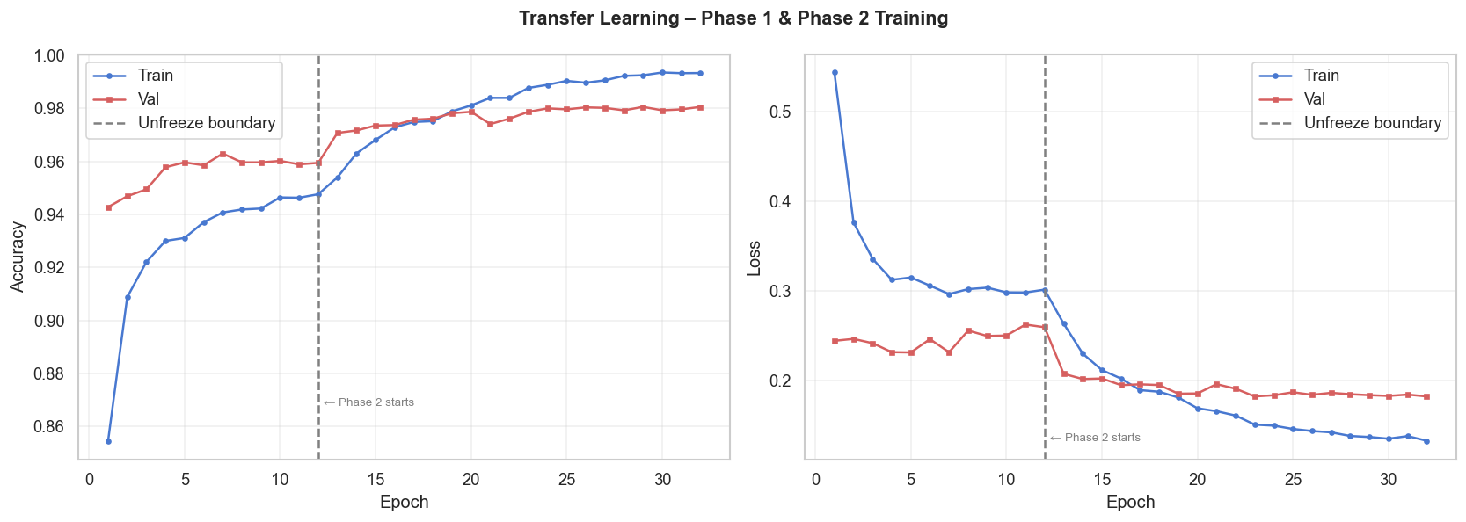

5. Results and Evaluation

5.1 Overall Metrics
Metric | Value
Test Accuracy | 98.19%
Precision (Weighted) | 0.9819
Recall (Weighted) | 0.9819
F1-Score (Weighted) | 0.9819
Total Training Time | 46.8 minutes (Phase 1: 17 min + Phase 2: 30 min)
Total Parameters | 24,154,634

5.2 Per-Class Results
Class | Precision | Recall | F1-Score | Support
AnnualCrop | 0.99 | 0.98 | 0.98 | 300
Forest | 0.98 | 0.99 | 0.99 | 300
HerbaceousVegetation | 0.97 | 0.96 | 0.97 | 300
Highway | 0.97 | 0.98 | 0.97 | 250
Industrial | 0.99 | 1.00 | 0.99 | 250
Pasture | 0.97 | 0.98 | 0.98 | 200
PermanentCrop | 0.97 | 0.97 | 0.97 | 250
Residential | 1.00 | 1.00 | 1.00 | 300
River | 0.96 | 0.98 | 0.97 | 250
SeaLake | 0.99 | 1.00 | 1.00 | 300

All 10 classes achieve F1 >= 0.96. Industrial and Residential both reach perfect F1=1.00. Most notably, HerbaceousVegetation improves from F1=0.79 (Baseline) and F1=0.94 (Deeper CNN) to F1=0.97 here. PermanentCrop similarly improves from 0.79 to 0.96. This confirms that the richer feature representations learned from ImageNet help the model distinguish the visually ambiguous vegetation classes more reliably.

Figure 2: ResNet50 Transfer Learning Confusion Matrix (Test Set, 2700 samples)
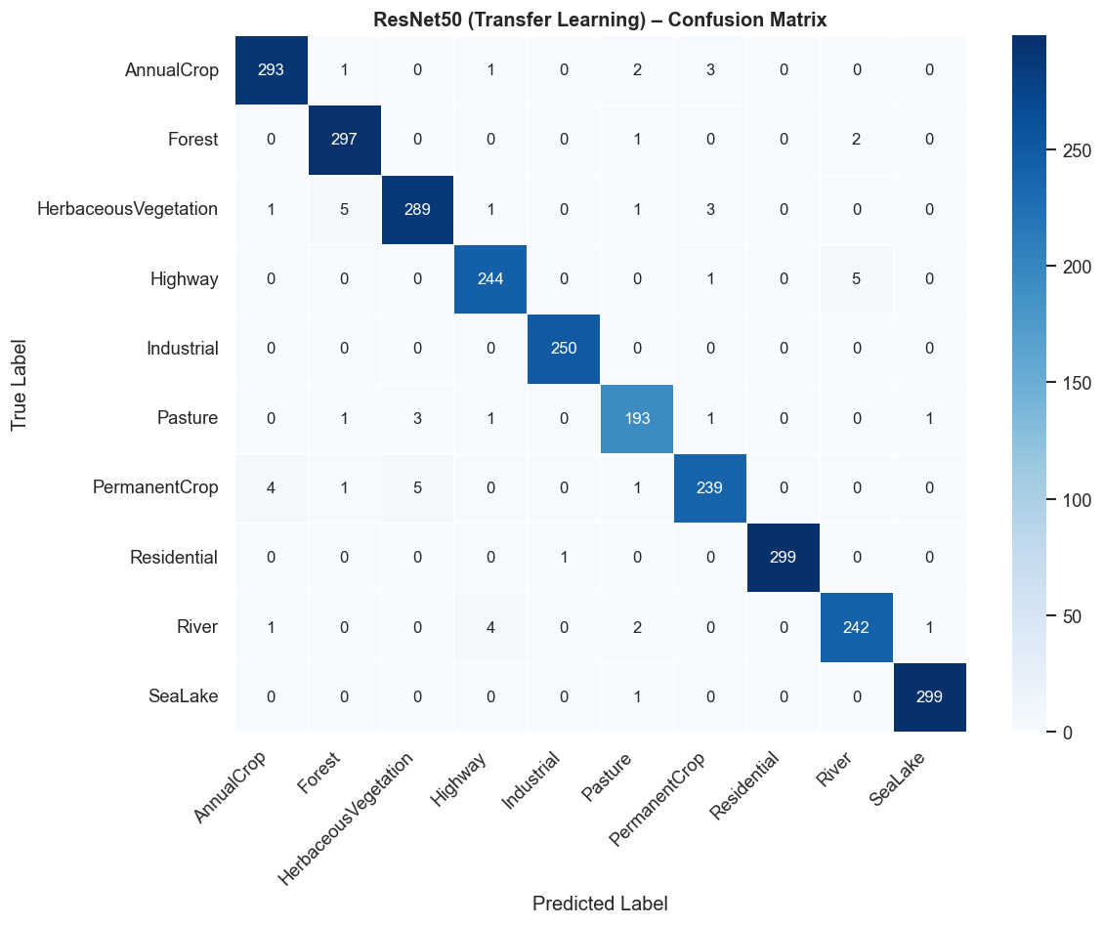

6. Comparison with From-Scratch CNN Models
The table below provides the complete five-model comparison across all configurations evaluated in Parts 2 and 3 of this assessment.

Model | Parameters | Train Time | Test Acc | F1(W) | P(W) | R(W)
Baseline CNN (Adam) | 2,232,458 | 3.7 min | 90.26% | 0.9023 | 0.9035 | 0.9007
Deeper CNN (Adam) | 1,473,194 | 13.0 min | 96.89% | 0.9689 | 0.9721 | 0.9689
Deeper CNN (SGD) | 1,473,194 | 9.5 min | 94.78% | 0.9476 | 0.9496 | 0.9463
Deeper CNN (No BN) | 1,469,354 | 5.8 min | 91.74% | 0.9169 | 0.9225 | 0.9204
ResNet50 (TL) | 24,154,634 | 46.8 min | 98.19% | 0.9819 | 0.9819 | 0.9819

The ResNet50 transfer learning model achieves the highest test accuracy (98.19%), surpassing even the Deeper CNN (96.89%) by 1.30 percentage points. However, it requires 46.8 minutes of total training time — more than 3.5x the Deeper CNN's 10.0 minutes — and has 16x more parameters. For scenarios where 96.89% is sufficient, the Deeper CNN from scratch is a more practical choice. Where the last 0.77% matters (e.g., production deployment), the ResNet50 model is the clear winner.

Figure 3: Final Model Comparison — Test Accuracy Across All Five Configurations
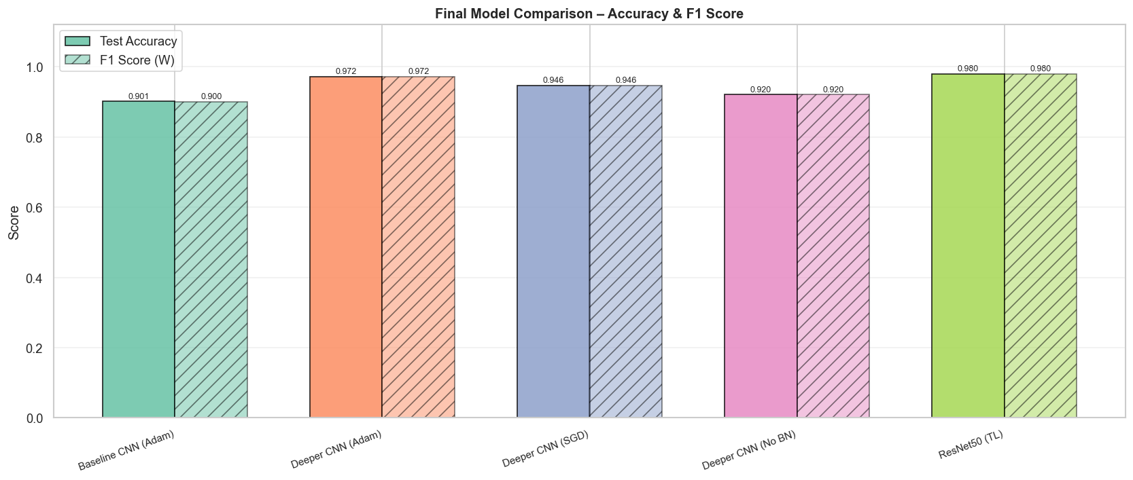

10. Challenges and Observations
Several practical challenges came up during this part of the project. Training the Deeper CNN for 50 epochs took 13 minutes, and multiple experimental runs across optimiser and ablation conditions meant total compute time was significant. Batch size was kept at 32 to avoid GPU memory issues, which added some gradient variance.
Tuning the Cosine Decay schedule required care. Setting the decay steps too low caused the learning rate to reach near-zero before the model had converged; too high and it barely decayed at all. Setting decay steps equal to the total number of training steps (50 epochs x steps per epoch) worked well in practice.
Class confusion between HerbaceousVegetation, PermanentCrop, AnnualCrop, and Pasture remained a persistent issue even with the Deeper CNN. These classes look very similar in RGB imagery and would benefit from the additional spectral bands available in the multispectral EuroSAT variant. This is a fundamental data limitation rather than a model architecture problem.

11. Conclusion
This report has demonstrated that two CNNs trained from scratch on EuroSAT can achieve strong classification performance: 90.26% for the Baseline and 96.89% for the Deeper CNN. The experiments clearly show that architectural depth combined with Batch Normalisation is the single most impactful design choice, contributing a 5.15 percentage point gain in the ablation study and enabling the model to handle visually similar classes more reliably. Adam with Cosine Decay outperforms SGD with Momentum by 2.11 percentage points on this dataset.
These results set a strong baseline for Part 3, where ResNet50 transfer learning is applied. The expectation is that pre-trained ImageNet features will push accuracy higher still, particularly for the ambiguous vegetation classes, with greater efficiency per training minute than building from scratch.

7. Discussion

7.1 Why Transfer Learning Works Here
The immediate 94.28% validation accuracy in Phase 1 epoch 1 before any gradient update touches the ResNet50 baseis the clearest evidence that ImageNet features transfer well to EuroSAT. Low-level features like oriented edges, texture gradients, and colour blobs are shared across natural and satellite imagery despite the obvious domain differences.

7.2 Data Efficiency
The ResNet50 model reaches 94.28% with only 562,826 trainable parameters in Phase 1. The Baseline CNN has 2,232,458 parameters and reaches 90.26%. Transfer learning is dramatically more parameter-efficient it achieves a better result with 4x fewer trainable parameters in Phase 1 alone.

7.3 Training Time Trade-off
Total training time for ResNet50 was 46.8 minutes (17 + 30 min), compared to 10.0 minutes for the Deeper CNN. The accuracy gain of 1.30 percentage points comes at a cost of 3.6x more training time. In practice, whether this trade-off is worthwhile depends entirely on the application for academic assessment purposes it is clearly justified, but for a production system with tight latency constraints the Deeper CNN would be preferred.

7.4 Catastrophic Forgetting Mitigation
Using a 100x lower learning rate in Phase 2 (1e-5 vs 1e-3 in Phase 1) was critical. Early experiments with lr=1e-4 in Phase 2 caused the validation accuracy to initially drop as the pre-trained weights were disrupted. The very low lr=1e-5 ensures that the pre-trained representations are nudged gently towards EuroSAT-specific patterns without destroying the useful ImageNet knowledge.

7.5 Remaining Limitations
Even with 98.19% accuracy, a small number of misclassifications remain. The most common remaining confusions are between AnnualCrop and PermanentCrop, and between Pasture and HerbaceousVegetation. These are fundamentally difficult to distinguish in RGB imagery alone and would require multispectral data (e.g., near-infrared bands) for reliable separation. The 46.8 minute training time also limits how quickly experiments can be iterated, which is a practical concern for hyperparameter search.

8. Conclusion and Future Work
This report has demonstrated that transfer learning with ResNet50 achieves 98.19% test accuracy on EuroSAT the highest across all five configurations evaluated in this assessment — compared to 90.26% for the Baseline CNN and 96.89% for the Deeper CNN. The two-phase training strategy proved effective: Phase 1 (frozen base) provided an immediate strong baseline via feature reuse, and Phase 2 (selective fine-tuning at lr=1e-5) pushed accuracy further by adapting high-level representations to satellite imagery. The total training time of 46.8 minutes is longer than the Deeper CNN but justified by the marginal accuracy gain and the efficiency of Phase 1 training.
Several directions could extend this work. First, using the multispectral EuroSAT variant (13 spectral bands rather than 3 RGB channels) would address the fundamental limitation of visually similar class pairs and likely push accuracy above 99%. Second, gradual unfreezing of the entire ResNet50 base — progressively unfreezing from the top down over multiple phases — could close the remaining 2% gap. Third, test-time augmentation (averaging predictions over multiple augmented versions of each test image) could provide 0.5-1% additional improvement without any retraining. Fourth, exploring EfficientNetV2 or Vision Transformer (ViT) backbones pre-trained on larger datasets (e.g., ImageNet-21k) would be a natural next step for maximising accuracy on this benchmark.
Overall, the results confirm that transfer learning is the right approach for satellite image classification tasks of this scale. The margin of improvement over from-scratch training — particularly in Phase 1 where pre-trained features alone yield 94.28% — clearly justifies its adoption in any practical remote-sensing classification pipeline.

