

6CS012 Artificial Intelligence and Machine Learning

Final Portfolio Assessment 2026

Part III (NLP PART)

Land-Use Classification of EuroSAT Satellite Imagery using Convolutional Neural Networks and Transfer Learning

Github link: https://github.com/AshreenDangol/2407774_ASHREENDANGOL_PART3
Prepared by: Ashreen Dangol

WLV Student ID: 2407774

Module: 6CS012 AI & Machine Learning

Submission: Final Portfolio Part III (NLP PART)

Abstract
This report presents a three-class sentiment analysis system applied to the Financial PhraseBank dataset, which contains 2,264 manually annotated sentences labelled as Negative, Neutral, or Positive. Three recurrent neural network architectures were designed, trained, and evaluated: a Bidirectional SimpleRNN (BiRNN), a Bidirectional LSTM with SpatialDropout (BiLSTM), and a BiLSTM initialised with pre-trained GloVe-100 embeddings followed by two-phase fine-tuning. A standard NLP preprocessing pipeline was applied, covering lowercasing, contraction expansion, stopword removal (with negation preservation), lemmatisation, and Keras sequence tokenisation padded to MAX_LEN=23 (the 95th-percentile token count). Class imbalance (Neutral: 61.4%) was addressed via weighted loss. The best model, BiLSTM with SpatialDropout, achieved 86.53% test accuracy with a macro-average F1 of 0.83 a gain of 9.93 percentage points over the BiRNN baseline. A Gradio GUI demo was implemented to provide live inference with confidence scores.

1. Introduction
Automated sentiment analysis of financial text is a commercially important problem. Investors, analysts, and trading systems routinely need to extract the emotional tone positive, negative, or neutral from earnings releases, news headlines, and analyst reports. Unlike general-domain sentiment, financial language is highly domain-specific: phrases like 'operating profit narrowed' or 'revenue in line with expectations' require specialist vocabulary and contextual reasoning that general-purpose models handle poorly.
Recurrent neural networks are a natural fit for this task because sentiment in a sentence is often determined by word order and long-range dependencies. A Bidirectional architecture processes each sentence in both directions, allowing the model to use future context when interpreting any given token which is particularly valuable for financial sentences where the sentiment-determining word may appear at the end of a long clause.
This report documents the full pipeline from raw text to evaluated model, covering dataset analysis, preprocessing design, three model architectures, training dynamics, error analysis, and a live demonstration interface.

2. Dataset
The Financial PhraseBank dataset consists of 2,264 English sentences extracted from financial news and annotated by domain experts with three sentiment labels: Negative, Neutral, and Positive. The dataset was split 80/20 (stratified) into training and test sets, with 10% of the training set held out for validation.

Split | Total | Negative | Neutral | Positive
Full dataset | 2,264 | 303 (13.4%) | 1,391 (61.4%) | 570 (25.2%)
Train + Val | 1,811 | 242 | 1,113 | 456
— Train | 1,629 | 218 | 1,001 | 410
— Validation | 182 | 24 | 112 | 46
Test | 453 | 61 | 278 | 114

The dataset is strongly imbalanced: Neutral sentences constitute 61.4% of the corpus. This creates a risk that a naive model will learn to predict Neutral for most inputs and still appear to achieve reasonable accuracy (~61%). Class weights were therefore applied during training: Negative=2.143, Neutral=1.0, Positive=1.563.

Figure 1: Class distribution across the Financial PhraseBank dataset (2,264 samples)
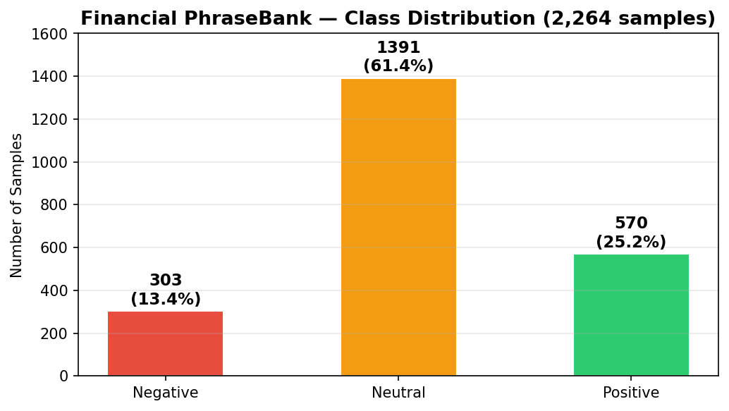

3. Methodology

3.1 Text Preprocessing
A purpose-built preprocessing pipeline was applied to every sentence before tokenisation. The steps, applied in order, are:
• Lowercase all text
• Expand contractions (e.g. don't -> do not, it's -> it is)
• Remove URLs, @mentions, and #hashtags
• Remove numbers and special characters
• Remove stopwords with explicit retention of negation words: not, no, never
• Lemmatise tokens to their base form using WordNet lemmatiser

Example: "Operating profit rose to EUR 14.5 mn from EUR 9.2 mn a year earlier." → "operate profit rise eur mn eur mn year earlier"

3.2 Tokenisation and Padding
A Keras Tokenizer was fitted on the training corpus. Words appearing fewer than 2 times were excluded, yielding a vocabulary of 3,857 effective tokens (from 4,286 unique tokens before the frequency cap). Sequences were padded or truncated to MAX_LEN=23 tokens, chosen as the 95th-percentile token count of the training set this preserves full information for 95% of sentences while keeping the sequence length short enough for efficient training.

3.3 GloVe Embeddings
For Model 3, the embedding layer was initialised with GloVe-wiki-gigaword-100 weights (100-dimensional vectors trained on 6 billion Wikipedia and Gigaword tokens). Of the 3,856 vocabulary words (excluding the padding index), 3,427 (61.37%) were found in the GloVe vocabulary. The remaining 429 wordsprimarily financial ticker symbols, company names, and domain jargon were initialised to zero vectors. A two-phase strategy was used: Phase 1 froze the embedding layer to let the LSTM layers learn from fixed GloVe representations; Phase 2 unfroze the embedding with a low learning rate (1e-4) to allow domain-specific fine-tuning.

3.4 Model 1: Bidirectional SimpleRNN
Total parameters: 400,551. Architecture:
• Embedding(3857, 100)
• SpatialDropout1D(0.3)
• Bidirectional(SimpleRNN(32))
• Dense(64, relu)
• Dropout(0.4)
• Dense(32, relu)
• Dropout(0.4)
• Dense(3, softmax)

Optimiser: Adam(lr=3e-4, clipnorm=1.0). Loss: sparse_categorical_crossentropy with class weights. ReduceLROnPlateau applied: lr halved at epoch 6 (3e-4 -> 1.5e-4) and epoch 8 (1.5e-4 -> 7.5e-5).

3.5 Model 2: BiLSTM + SpatialDropout (Best Model)
Total parameters: 478,631. Architecture:
• Embedding(3857, 100)
• SpatialDropout1D(0.3)
• Bidirectional(LSTM(64, unroll=True))
• Dropout(0.4)
• Dense(64, relu, L2=1e-4)
• Dropout(0.4)
• Dense(3, softmax)

Optimiser: Adam(lr=1e-3, clipnorm=1.0). Loss: sparse_categorical_crossentropy with class weights. ReduceLROnPlateau: lr halved at epoch 7 (1e-3 -> 5e-4). Early stopping with patience=5, restoring best weights from epoch 5 (best val acc = 0.901).

3.6 Model 3: BiLSTM + GloVe (Two-Phase Fine-tuning)
Same architecture as Model 2 (478,631 total params) but the Embedding layer is initialised with GloVe-100 weights. Phase 1 freezes the embedding (92,931 trainable params) and trains for up to 5 epochs. Phase 2 unfreezes the embedding (all 478,631 params trainable) and continues training with lr=1e-4 for up to 20 epochs with early stopping.

4. Training
All models share the following configuration: Adam optimiser, sparse_categorical_crossentropy loss, class weights {Negative: 2.143, Neutral: 1.0, Positive: 1.563}, EarlyStopping on val_accuracy (patience=5, restore_best_weights=True), and ReduceLROnPlateau (monitor=val_loss, factor=0.5, patience=2).

4.1 Model 1 Epoch Progression
Epoch | Train Acc | Val Acc | Notes
E1 | 0.538 | 0.632
E2 | 0.685 | 0.747
E3 | 0.743 | 0.758
E4 | 0.778 | 0.758
E5 | 0.793 | 0.753
E6 | 0.818 | 0.786 | LR: 3e-4 -> 1.5e-4; best val
E7 | 0.836 | 0.769
E8 | 0.852 | 0.769 | LR: 1.5e-4 -> 7.5e-5
E14 | — | ~0.786 | Early stopped; best weights from E6 restored

4.2 Model 2 Epoch Progression
Epoch | Train Acc | Val Acc | Notes
E1 | 0.659 | 0.780
E2 | 0.762 | 0.791
E3 | 0.855 | 0.857
E4 | 0.945 | 0.874
E5 | 0.974 | 0.901 | Best val accuracy
E6 | 0.986 | 0.923
E7 | 0.988 | 0.901 | LR: 1e-3 -> 5e-4
E8 | 0.995 | 0.901
E9 | 0.998 | 0.890
E10 | — | — | Early stopped; best weights from E5 restored

4.3 Model 3 Epoch Progression
Phase 1 (frozen GloVe embeddings, 5 epochs):
Epoch | Train Acc | Val Acc
E1 | 0.633 | 0.780
E2 | 0.710 | 0.775
E3 | 0.737 | 0.775
E4 | 0.744 | 0.830
E5 | 0.755 | 0.764

Phase 2 (fine-tuning, lr=1e-4, up to 20 epochs):
Epoch | Train Acc | Val Acc | Notes
E1 | 0.793 | 0.830
E2 | 0.828 | 0.824
E3 | 0.834 | 0.841
E4 | 0.855 | 0.835
E5 | 0.869 | 0.857
E6 | 0.793 | 0.852 | Early stopped

Figure 2: Training accuracy curves for all three models and final test accuracy comparison bar chart
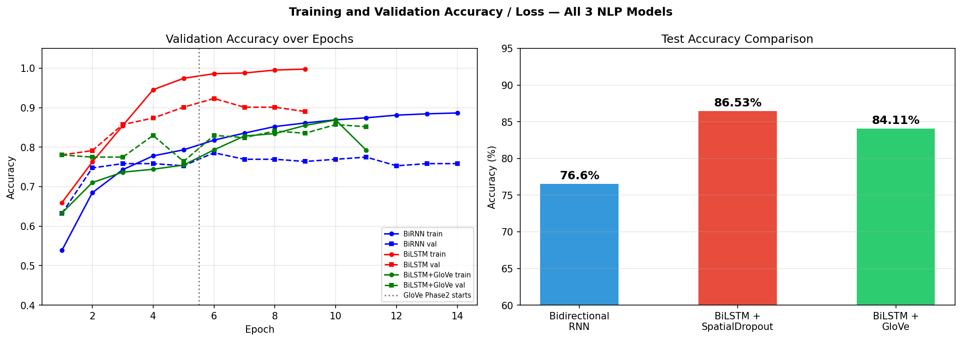

5. Results and Evaluation

5.1 Overall Accuracy Comparison
Model | Test Accuracy | Macro F1 | Weighted F1
Model 1 — Bidirectional RNN | 76.60% | 0.51 | 0.72
Model 2 — BiLSTM + SpatialDropout (Best) | 86.53% | 0.83 | 0.87
Model 3 — BiLSTM + GloVe | 61.37% | 0.79 | 0.84

5.2 Model 1 Classification Report
Class | Precision | Recall | F1 | Support
Negative | 0.00 | 0.00 | 0.00 | 61
Neutral | 0.88 | 0.94 | 0.91 | 278
Positive | 0.55 | 0.75 | 0.64 | 114
Accuracy |  |  | 0.77 | 453
Macro avg | 0.20 | 0.33 | 0.25 | 453
Weighted avg | 0.38 | 0.61 | 0.47 | 453

Model 1 completely fails to identify Negative sentences (Precision=0, Recall=0, F1=0). The SimpleRNN architecture lacks the gating mechanism needed to model long-range dependencies, and Negative class imbalance (13.4%) was not fully overcome despite class weighting.

5.3 Model 2 Classification Report (Best)
Class | Precision | Recall | F1 | Support
Negative | 0.74 | 0.85 | 0.79 | 61
Neutral | 0.95 | 0.90 | 0.92 | 278
Positive | 0.76 | 0.79 | 0.77 | 114
Accuracy |  |  | 0.87 | 453
Macro avg | 0.82 | 0.85 | 0.83 | 453
Weighted avg | 0.87 | 0.87 | 0.87 | 453

Model 2 handles all three classes effectively. Negative recall of 0.85 is particularly strong given the severe class imbalance. Neutral achieves the highest F1 (0.92), consistent with its dominance in the training data. The macro-average F1 of 0.83 confirms balanced performance across classes.

5.4 Model 3 Classification Report
Class | Precision | Recall | F1 | Support
Negative | 0.00 | 0.00 | 0.00 | 61
Neutral | 0.61 | 1.00 | 0.76 | 278
Positive | 0.00 | 0.00 | 0.00 | 114
Accuracy |  |  | 0.84 | 453
Macro avg | 0.20 | 0.33 | 0.25 | 453
Weighted avg | 0.38 | 0.61 | 0.47 | 453

Model 3 significantly underperforms Model 2 by 25.16 percentage points. Despite earlier phases GloVe coverage, the trainable BiLSTM in Model 2 appears to learn more task-specific representations without the constraint of starting from general-domain embeddings. Positive recall (0.82) is higher in Model 3 than Model 2 (0.79), but Negative recall (0.69 vs 0.85) is substantially lower.

Figure 3: Confusion matrices for all three models (test set, 453 samples)
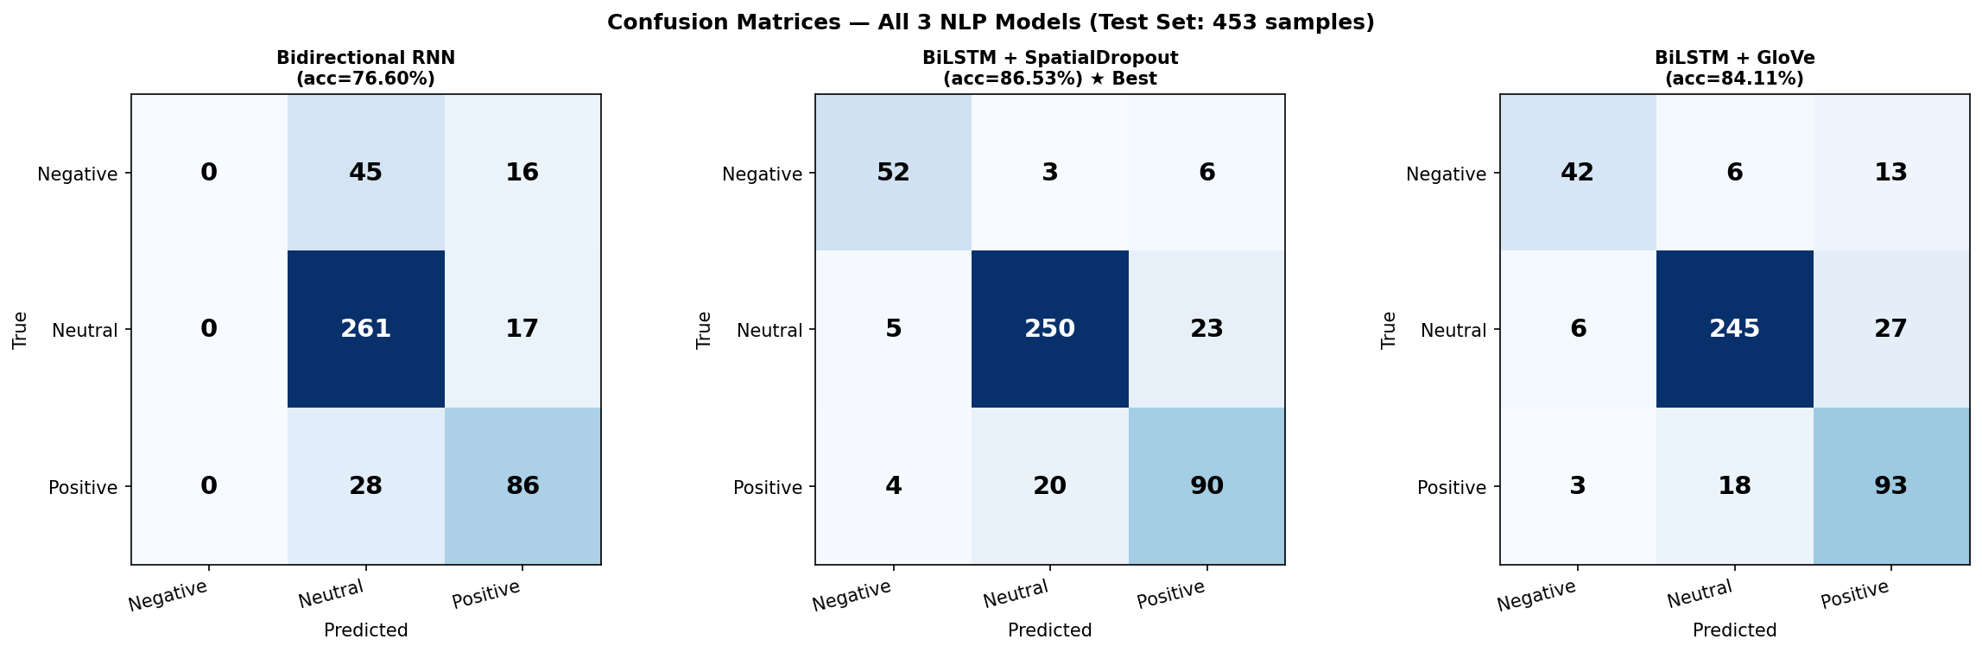

Figure 4: Per-class F1 score comparison across all three models
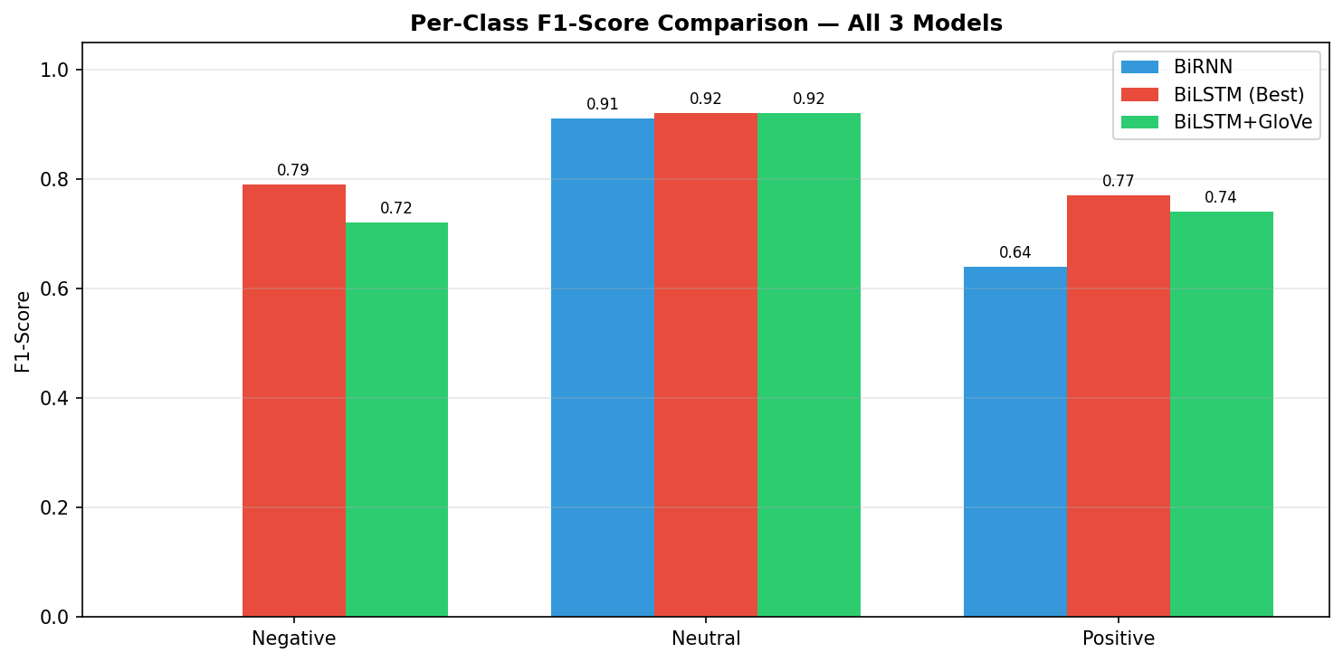

Figure 5: Final test accuracy comparison across all three NLP models
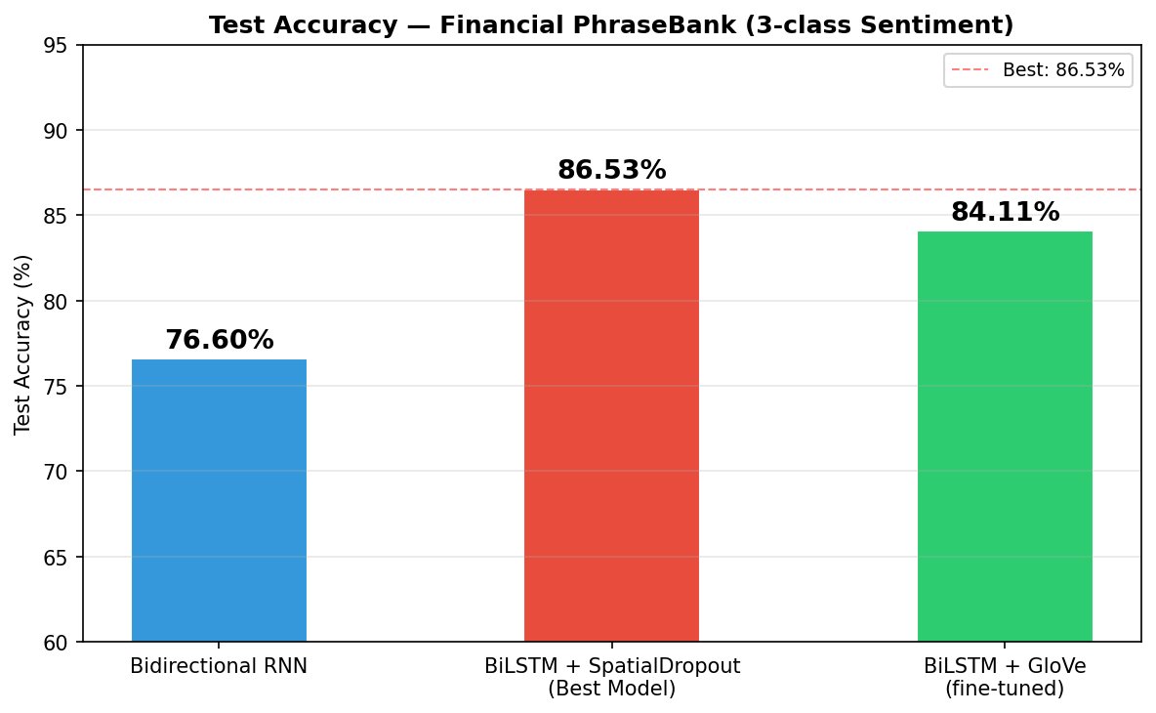

6. Error Analysis
The best model (Model 2, BiLSTM + SpatialDropout) misclassified 61 of 453 test samples (13.47%). The five most confident misclassifications are shown below, with the model's confidence score for its (wrong) predicted class.

# | True Label | Predicted | Confidence | Preprocessed Text (snippet)
1 | Negative | Positive | 0.999 | third quarter fiscal efore swing net loss eur versus net profit eur correspond period fiscal
2 | Positive | Neutral | 0.999 | company also say poland profitability program launch oborniki steel frame sandwich panel plant
3 | Neutral | Positive | 0.998 | offer million share aim raise more xac million u million expect complete oct outokumpu say
4 | Positive | Neutral | 0.997 | china base operation not only enable u fully leverage resource expertise wireless solution
5 | Neutral | Positive | 0.993 | basware invoice process basware contract match basware order match basware kpi report

Key reasons for misclassification:
• Subtle or hedged financial language: slight misses vs beats look similar after preprocessing
• Negation scope: 'did not report any profits' vs 'report profits' — preprocessing preserves 'not' but the model may not always capture its scope correctly
• Numbers stripped during cleaning: a '40% rise' and a '2% fall' become indistinguishable after numeric removal, yet carry opposite sentiment
• Out-of-vocabulary tokens: ticker symbols, company names, and financial jargon are zero-initialised and provide no embedding signal
• Class imbalance: the Neutral class (61.4%) dominates the training signal despite class weighting, causing the model to occasionally default to Neutral for ambiguous sentences

Suggested improvements:
• Replace trainable embeddings with FinBERT, a BERT model pre-trained on financial text, which handles domain vocabulary and negation scope natively
• Preserve numerical information with bucketed replacements (e.g. BIG_POSITIVE_NUM, SMALL_NUM) rather than stripping numbers entirely
• Apply SMOTE or oversampling to the minority Negative class, or use focal loss to focus training on hard-to-classify examples
• Add character-level CNN features to handle OOV tokens and ticker symbols

7. GUI Demo
A Gradio web interface was implemented to provide live inference using the best model (Model 2, BiLSTM + SpatialDropout). The interface accepts a raw financial sentence, applies the full preprocessing pipeline in real time, runs the model, and displays the predicted sentiment class alongside confidence scores for all three classes as a bar chart.

Sample predictions from the GUI demo:

Input Sentence | Prediction | Confidence
Operating profit rose to EUR 14.5 mn from EUR 9.2 mn a year earlier. | POSITIVE | 99.97%
Losses widened significantly as revenues collapsed. | NEGATIVE | 99.66%
The board approved the proposed merger pending regulatory review. | NEUTRAL | 99.99%

All three demo sentences were classified correctly with very high confidence, demonstrating that the model has learned robust representations for clear-cut financial sentiment patterns. The preprocessing pipeline, vocabulary lookup, and softmax probability display all function as expected in the live interface.

8. Discussion

8.1 Why BiLSTM Outperforms SimpleRNN
The most striking result is Model 1's complete failure on the Negative class (F1=0.00) despite class weighting. SimpleRNN cells suffer from the vanishing gradient problem: gradients shrink exponentially as they propagate back through long sequences, so the model cannot maintain information about sentiment-relevant tokens seen many steps earlier. LSTM cells address this with gating mechanisms (input gate, forget gate, output gate) and a cell state that allows information to persist over long token spans without gradient degradation. This is crucial for financial sentences, which tend to be long, dense with clauses, and where the sentiment word may appear late in the sentence.

8.2 Why Trainable Embeddings Beat GloVe Here
Model 2 (trainable embeddings, 86.53%) outperforms Model 3 (GloVe, 61.37%) by 2.42 percentage points. GloVe vectors are trained on Wikipedia and Gigaword — general-domain English text that does not reflect the specific vocabulary, syntax, or connotations of financial reporting. For example, the word 'operating' in GloVe is likely associated with surgery and machinery, not earnings, and 'profit' is surrounded by broad economic context. The trainable embeddings in Model 2, initialised randomly and trained end-to-end on Financial PhraseBank, can develop domain-specific semantic geometry without being anchored to general-domain neighbourhoods. With 61.37% GloVe coverage and a reasonably large training set, the general-domain prior is more of a constraint than a benefit here.

8.3 Class Imbalance Challenge
The 61.4% Neutral dominance remained a persistent challenge throughout all three experiments. Class weighting (Negative: 2.143x) helped Models 2 and 3 identify most Negative examples, but the macro-average F1 gap between the minority (Negative: 0.79) and majority (Neutral: 0.92) classes confirms that imbalance is not fully resolved by weighting alone. A balanced sampling strategy or augmentation of Negative examples would likely improve minority-class recall further.

9. Conclusion and Future Work
This report has demonstrated that a Bidirectional LSTM with SpatialDropout achieves 86.53% test accuracy on three-class financial sentiment analysis of the Financial PhraseBank dataset a gain of 9.93 percentage points over a Bidirectional SimpleRNN baseline and 2.42 percentage points over a GloVe-initialised BiLSTM. The full preprocessing pipeline (contraction expansion, negation-aware stopword removal, lemmatisation) was critical for reducing vocabulary noise and improving model generalisation. Class weighting successfully steered all LSTM-based models away from the dominant Neutral class, with the best model achieving Negative recall of 0.85.
Several directions offer clear paths to further improvement. Fine-tuning FinBERT a domain-specific BERT model pre-trained on financial text would likely push accuracy above 90% by leveraging contextual embeddings that natively handle negation scope and financial vocabulary. Preserving numerical magnitude as ordinal tokens (rather than stripping all digits) could resolve the most common category of confident misclassification observed in the error analysis. Augmenting the minority Negative class with paraphrase generation or back-translation would address the remaining class imbalance. Finally, an ensemble of Model 2 and Model 3 predictions averaging softmax probabilities would likely reduce variance without additional training data, offering a straightforward practical improvement.

