

**THE STATE UNIVERSITY OF ZANZIBAR**

**DEPARTMENT OF COMPUTER SCIENCE AND INFORMATION**

**TECHNOLOGY**

|  |  |
| --- | --- |
| **REG NO** | **NAME** |
| BCS/18/23/011/TZ | ASHURA SALUM KHAMIS |

**Github Username:**Ashrey1234

**Github link:**https://github.com/Ashrey1234/AshuraaProject.git

**1.Project Title:**Loan Cycle System for Women Group Lending

**2. Introduction**

The Loan Cycle System is a web-based platform developed to simplify loan issuance to women organized in groups in Zanzibar. Many women face challenges accessing traditional financial services. This system enables administrators to manage groups and members while allowing women to apply for loans digitally.

**3. Objectives**

* Develop a platform for group-based loan issuance.
* Provide secure login for admins and members.
* Enable members to apply for loans online.
* Allow administrators to manage users and groups efficiently.
* Promote financial inclusion for women.

**4. Technologies Used**

|  |  |
| --- | --- |
| **Component** | **Technology** |
| Frontend | React.js (Vite) |
| Backend | Spring Boot (Java) |
| Database | PostgreSQL |
| Tools | Postman, GitHub |

**5. Key Features**

* Secure login for Admins and Members.
* Group creation and management by Admin.
* Loan application by Members with amount, reason, and duration fields.
* Admin dashboard to view all users and loan applications.

**6. System Flow**

* Admin logs in and creates groups.
* Admin registers members into groups.
* Members submit loan applications.
* Admin views loan applications in the dashboard.

1. **System**

Login Page

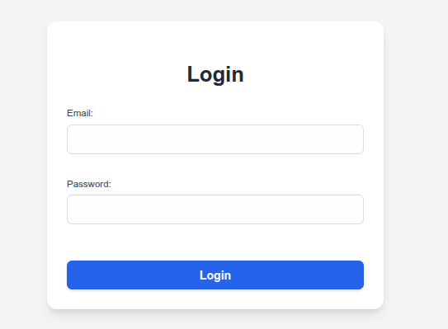

Apply loan

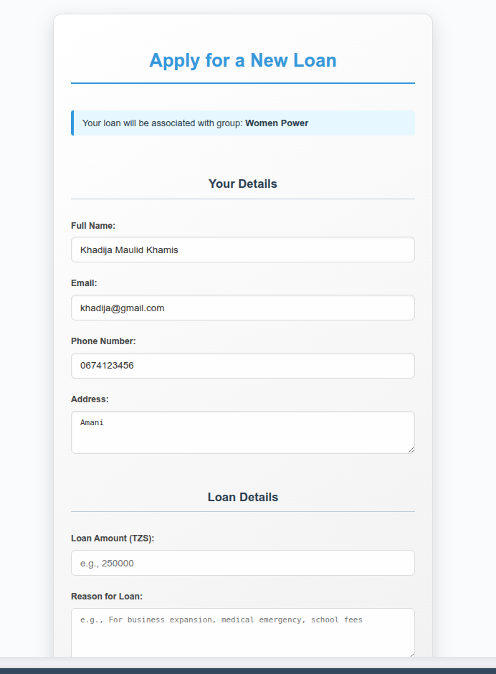

Admin Dashboard

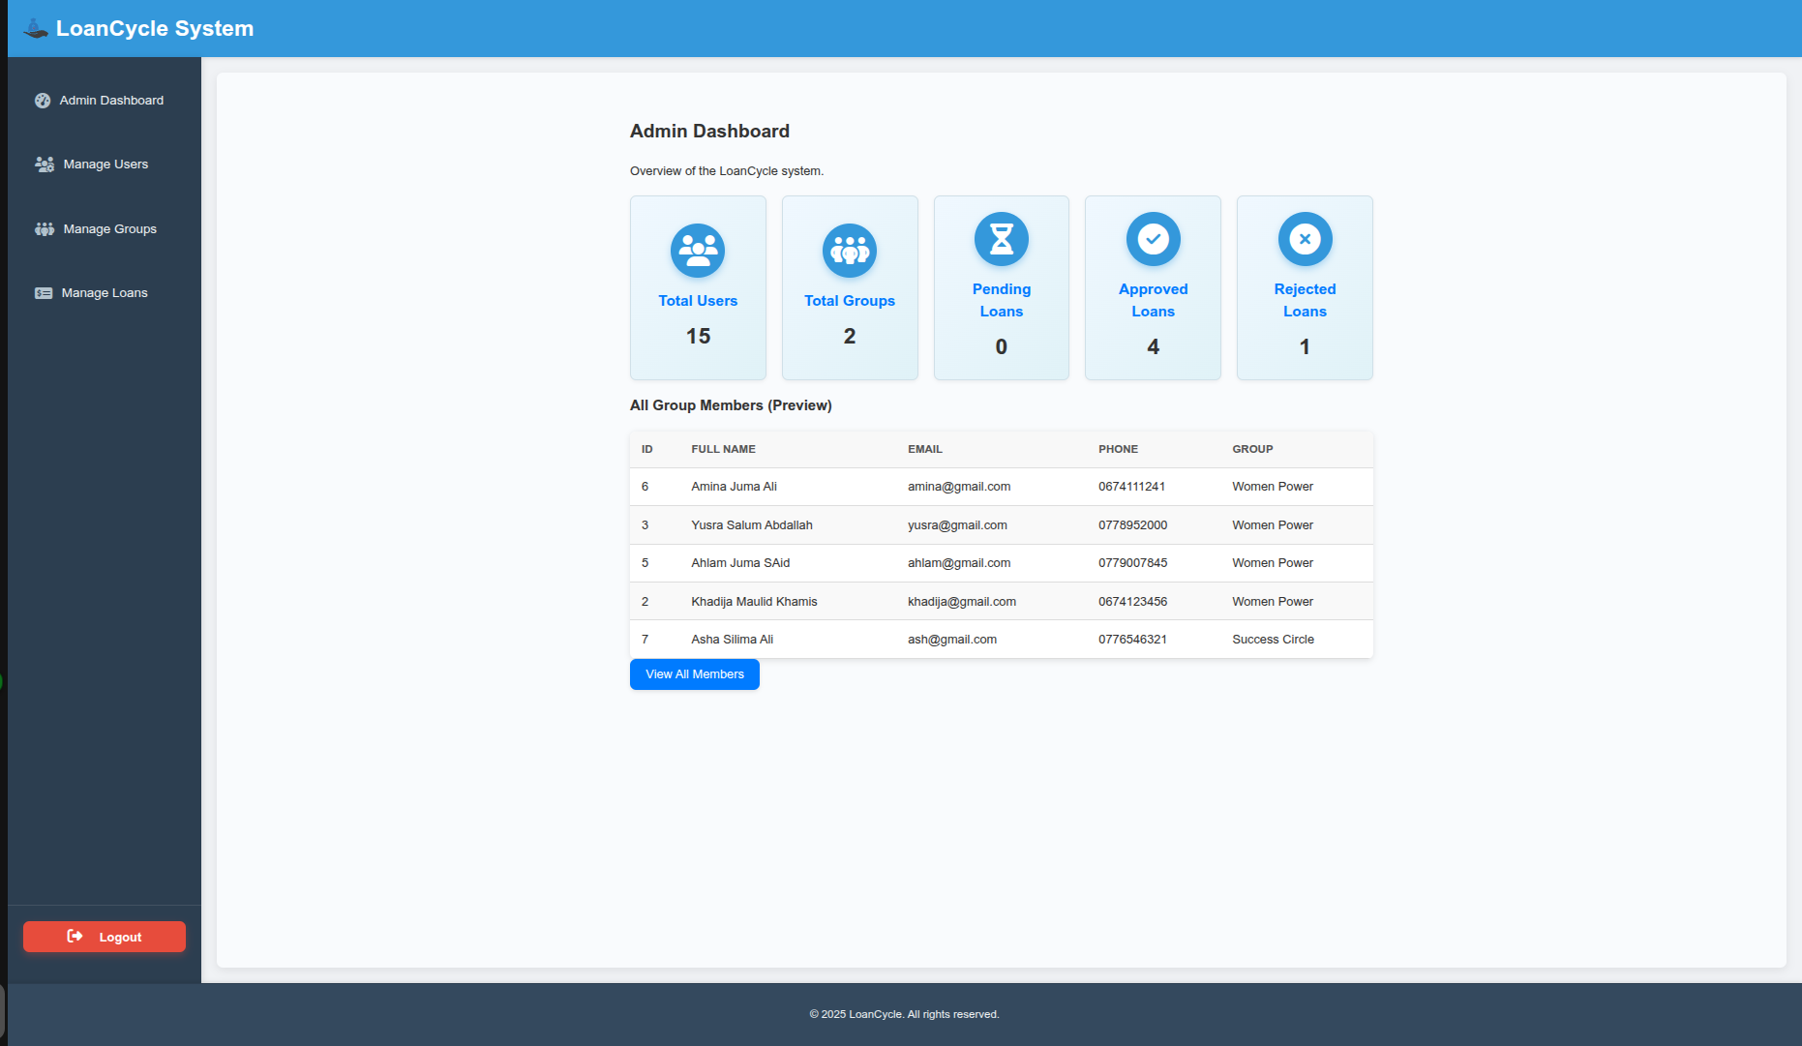

Group Management Page

