Experiment 1.1 – Design and Analysis of a Butterworth IIR Low-Pass Filter Using MATLAB
MATLAB Program
clc; clear; close all;
Fs=10000; Fp=1000; Fst=1500;
[N,Wn]=buttord(Fp/(Fs/2),Fst/(Fs/2),1,60);
[b,a]=butter(N,Wn);
freqz(b,a)
figure
[h,n]=impz(b,a,50);
stem(n,h), grid on
title('Impulse Response')
figure
stepz(b,a)
title('Step Response')
figure
grpdelay(b,a)
title('Group Delay')
figure
zplane(b,a)
title('Pole-Zero Plot')
fprintf('Minimum Filter Order (N) = %d\n',N);
fprintf('Cutoff Frequency (Wn) = %.4f\n',Wn);
OUTPUT
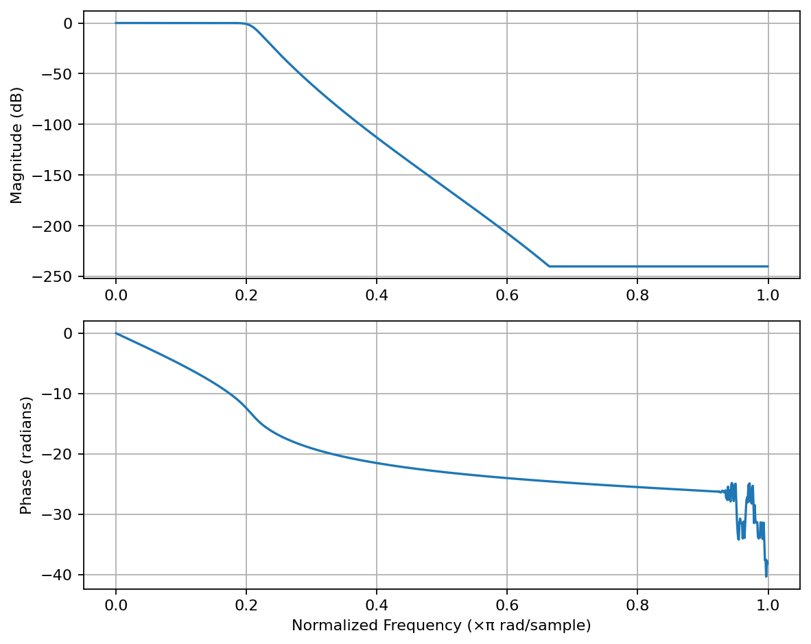
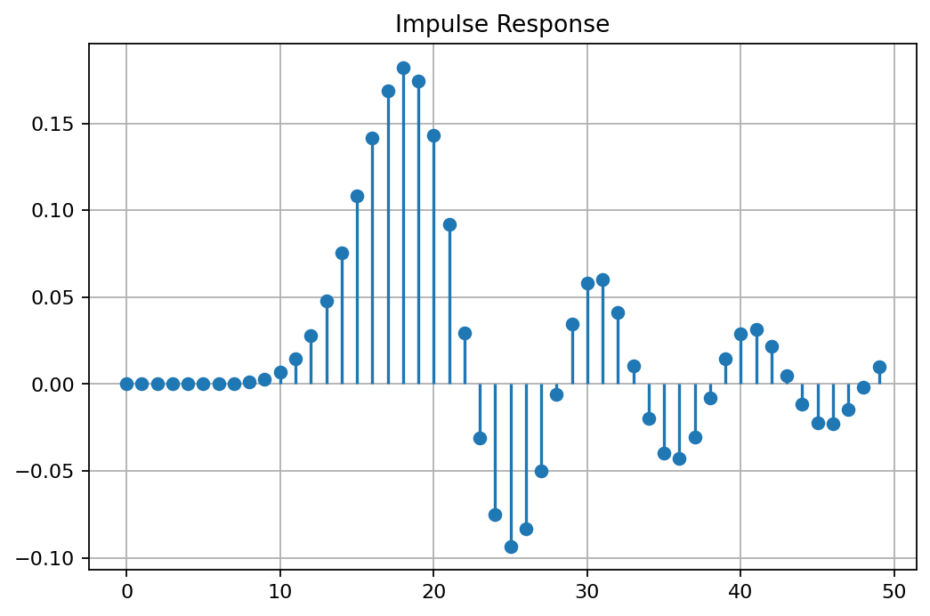
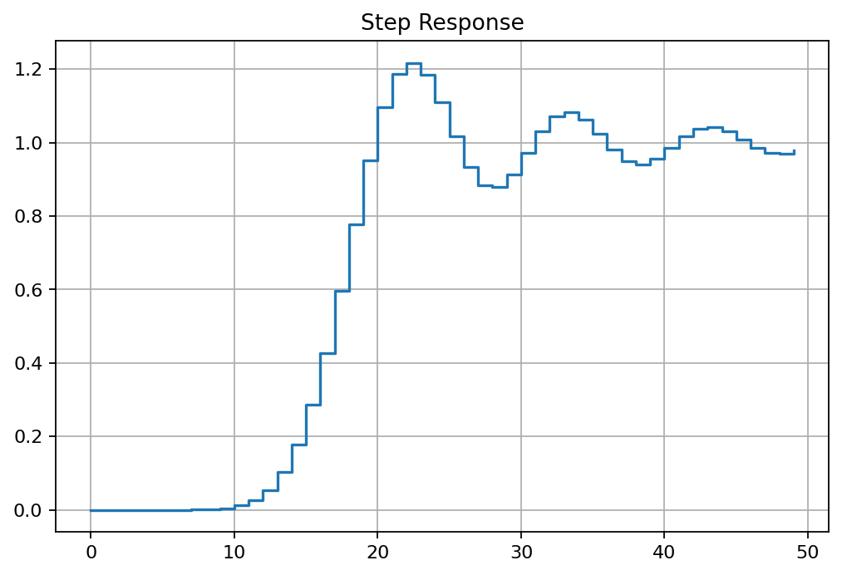
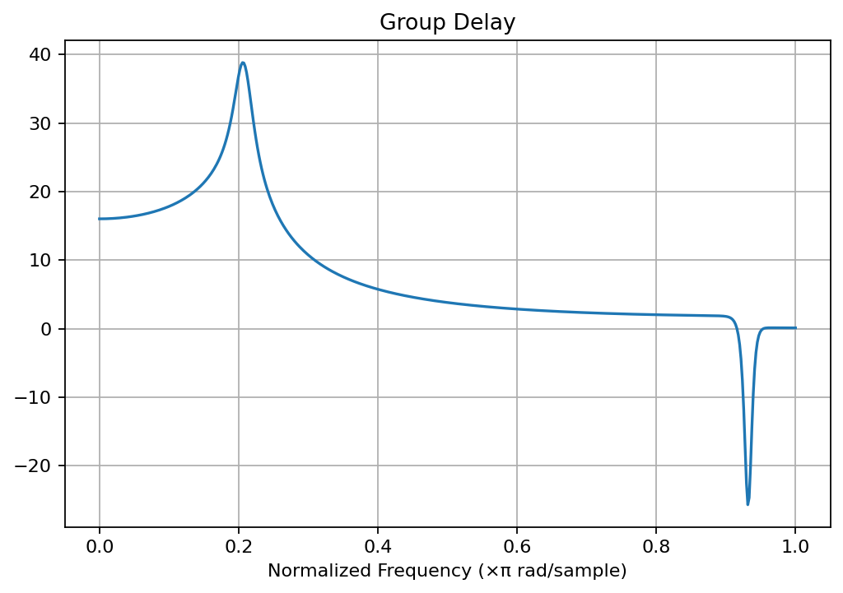
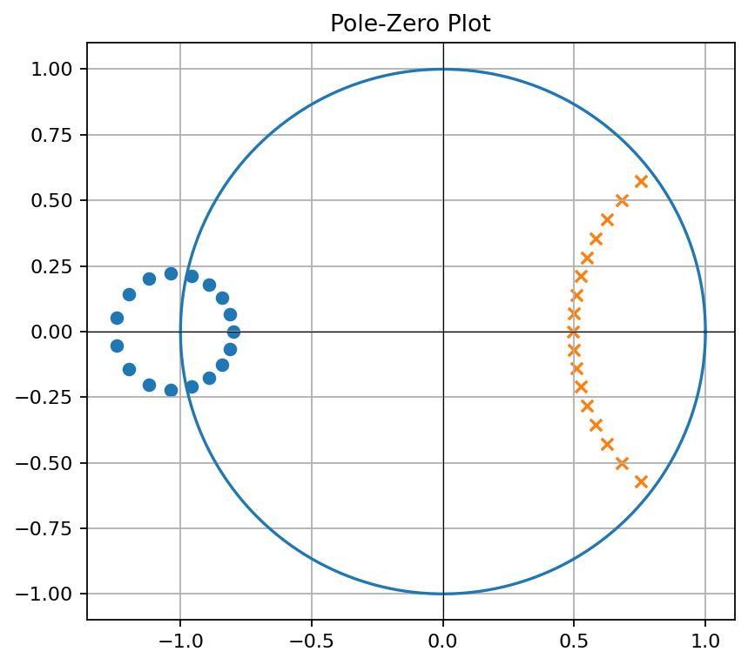

Experiment 1.2 – Design and Analysis of a Butterworth IIR High-Pass Filter Using MATLAB
MATLAB Program
clc; clear; close all;
Fs=10000; Fp=3000; Fst=2000;
[N,Wn]=buttord(Fp/(Fs/2),Fst/(Fs/2),1,60);
[b,a]=butter(N,Wn,'high');
freqz(b,a)
figure
[h,n]=impz(b,a,50);
stem(n,h), grid on
title('Impulse Response')
figure
stepz(b,a)
title('Step Response')
figure
grpdelay(b,a)
title('Group Delay')
figure
zplane(b,a)
title('Pole-Zero Plot')
fprintf('Minimum Filter Order (N) = %d\n',N);
fprintf('Cutoff Frequency (Wn) = %.4f\n',Wn);
OUTPUT
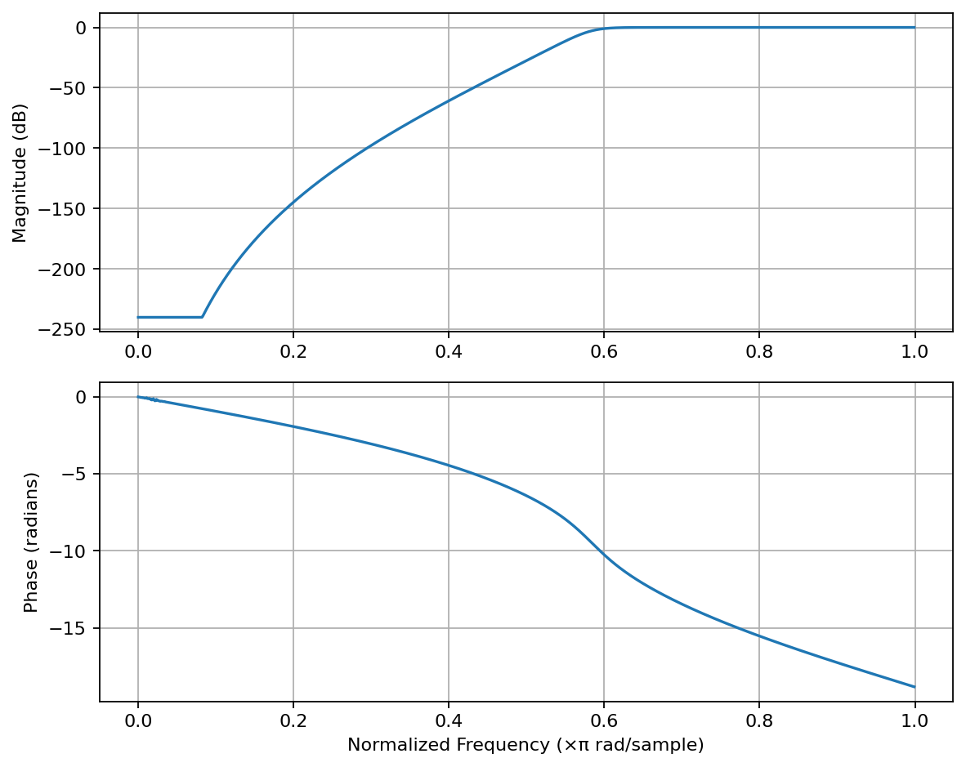
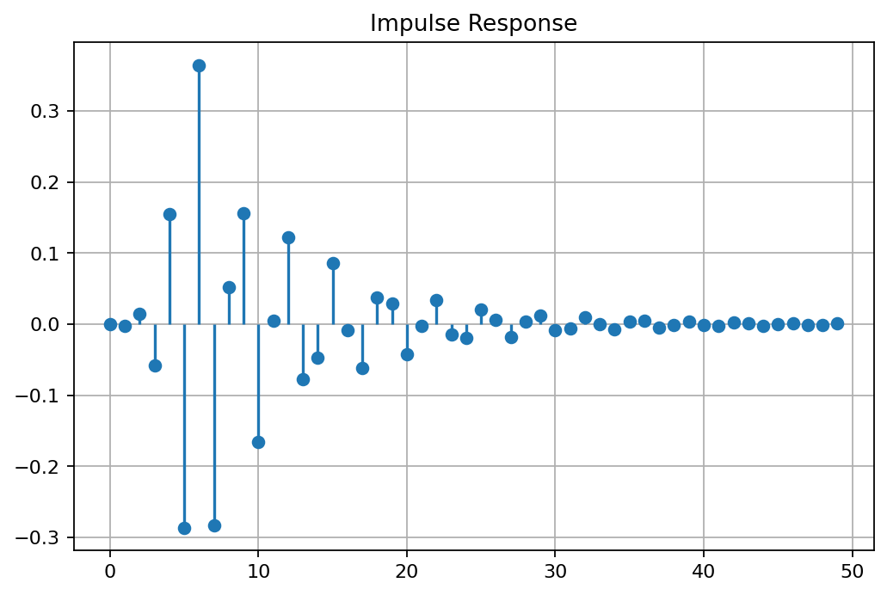
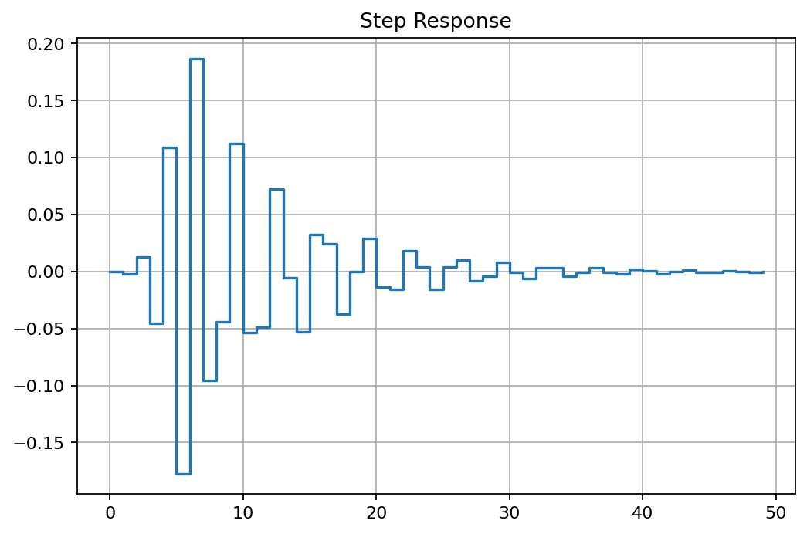
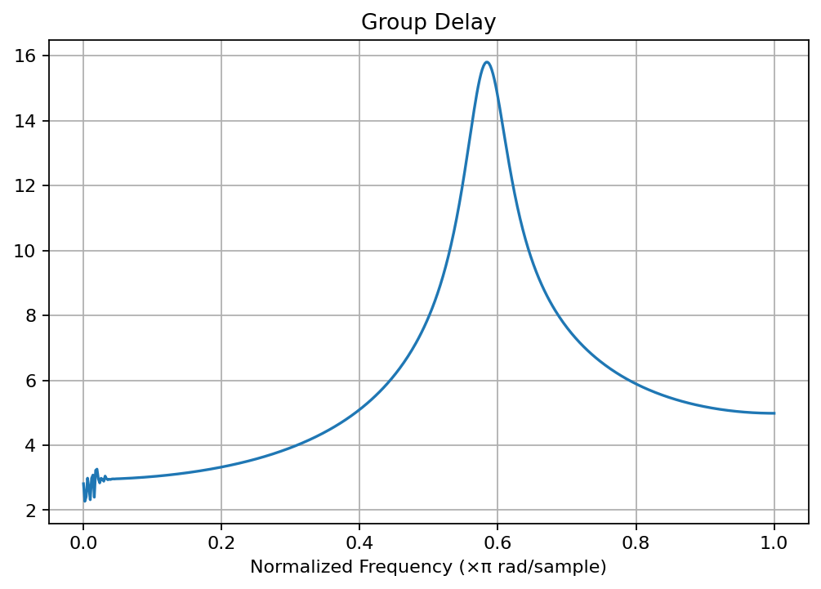
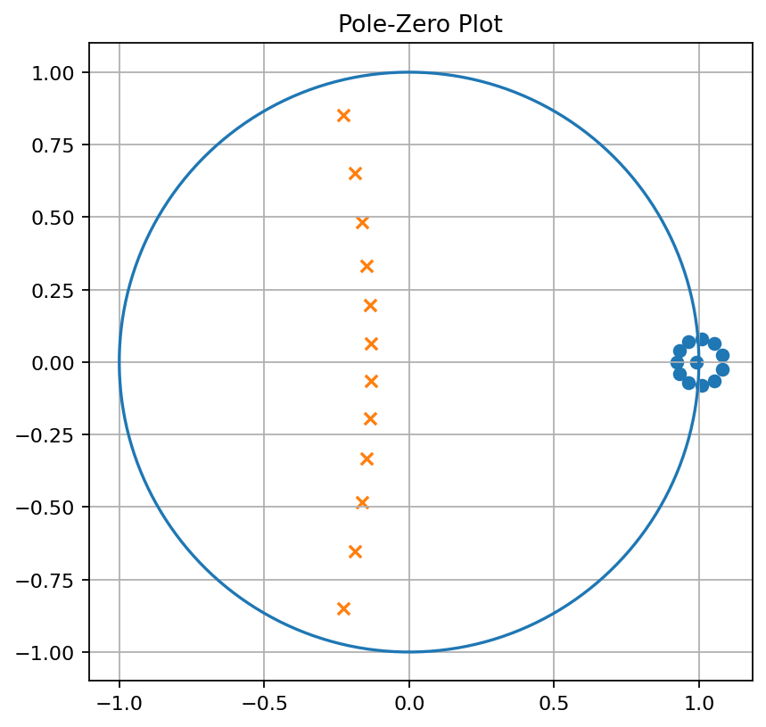

Experiment 2.1 – Design and Performance Evaluation of a Chebyshev Type-I IIR Low-Pass Filter Using MATLAB
MATLAB Program
clc; clear; close all;
Wp=0.4; Ws=0.55; Rp=1; As=40;
[N,Wn]=cheb1ord(Wp,Ws,Rp,As);
[b,a]=cheby1(N,Rp,Wn);
fprintf('Filter Order = %d\n',N);
fprintf('Cutoff Frequency = %.2f * pi rad/sample\n',Wn);
if all(abs(roots(a))<1)
disp('System is STABLE');
else
disp('System is UNSTABLE');
end
figure; freqz(b,a);
figure; impz(b,a);
figure; grpdelay(b,a);
figure; zplane(b,a);
OUTPUT
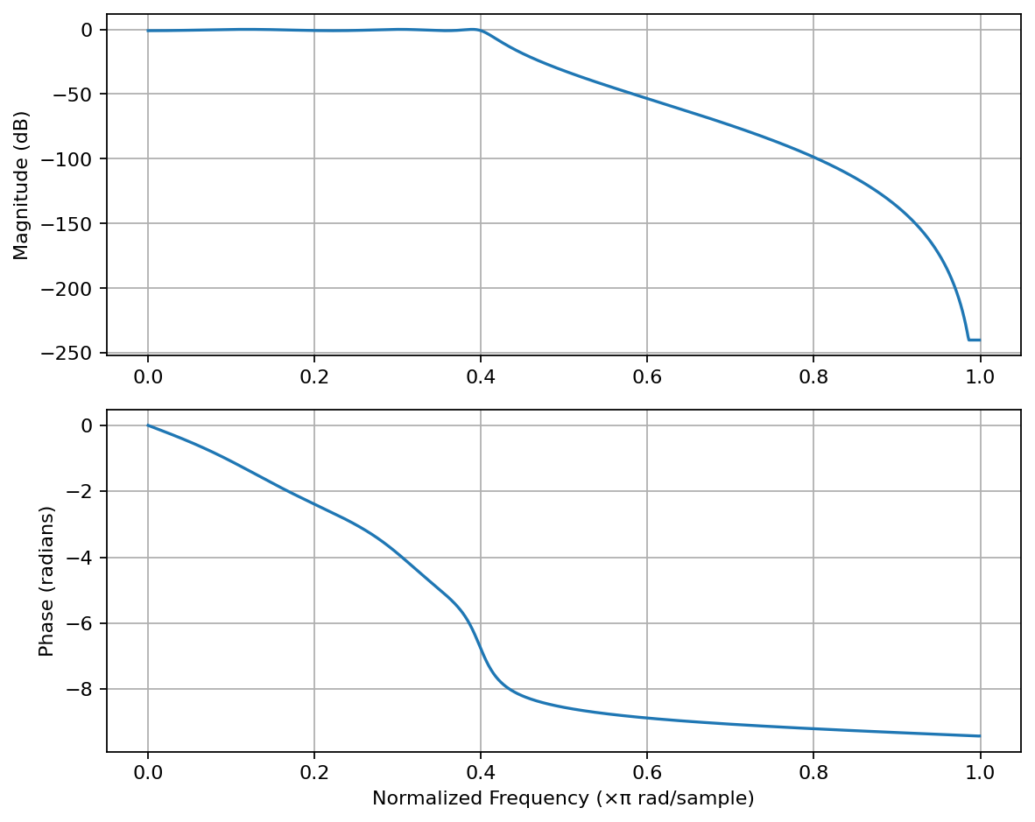
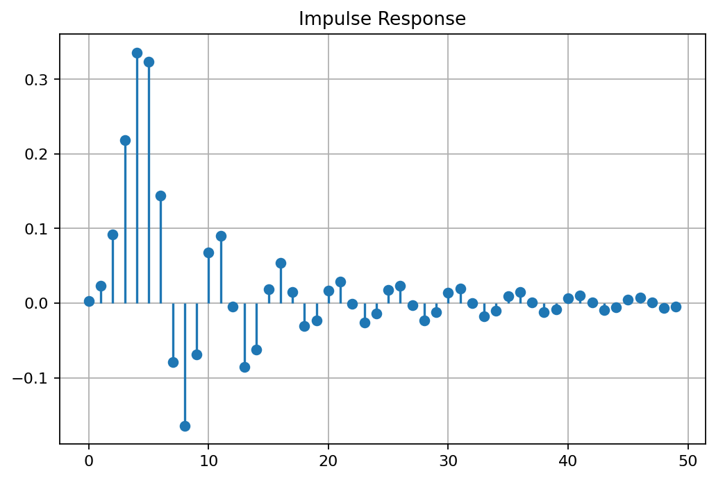
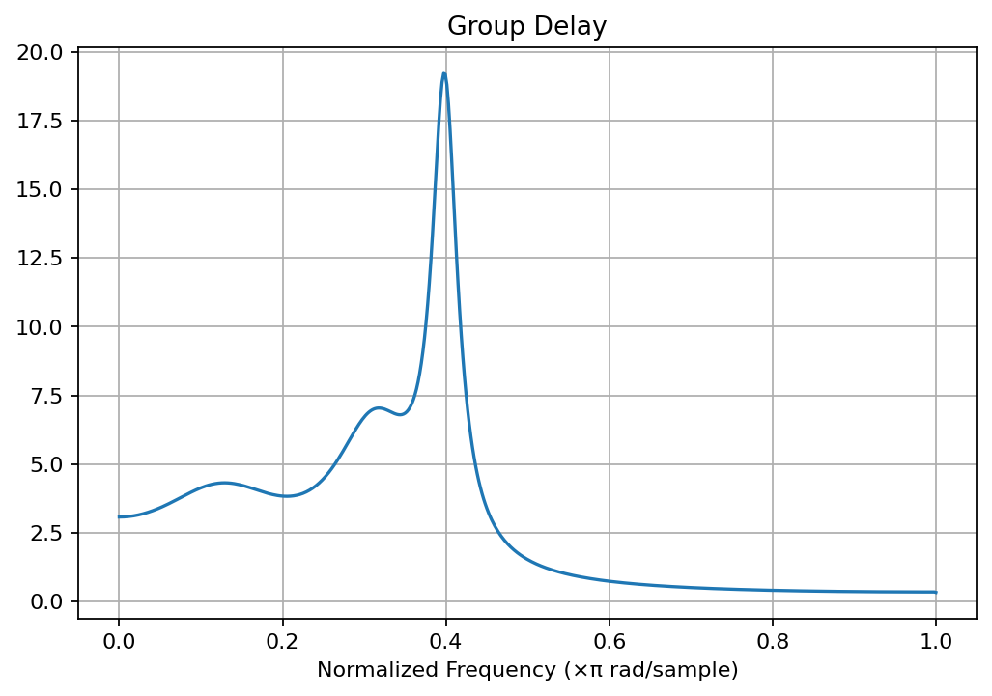
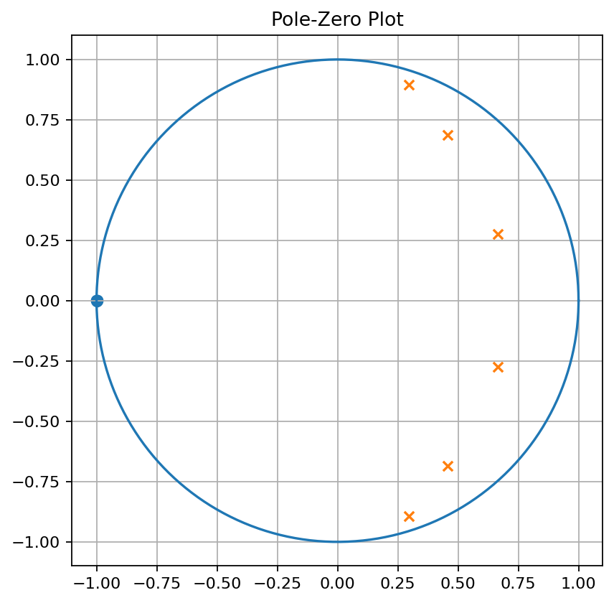

Experiment 2.2 – Design and Performance Evaluation of a Chebyshev Type-I IIR High-Pass Filter Using MATLAB
MATLAB Program
clc; clear; close all;
Rp=1; Rs=40; Wp=0.5; Ws=0.35;
[n,Wn]=cheb1ord(Wp,Ws,Rp,Rs);
[b,a]=cheby1(n,Rp,Wn,'high');
figure; freqz(b,a); title('Frequency Response');
figure; impz(b,a); title('Impulse Response');
figure; grpdelay(b,a); title('Group Delay');
figure; zplane(b,a); title('Pole-Zero Plot');
fprintf('Filter Order = %d\n',n);
fprintf('Cutoff Frequency = %.4f\n',Wn);
OUTPUT
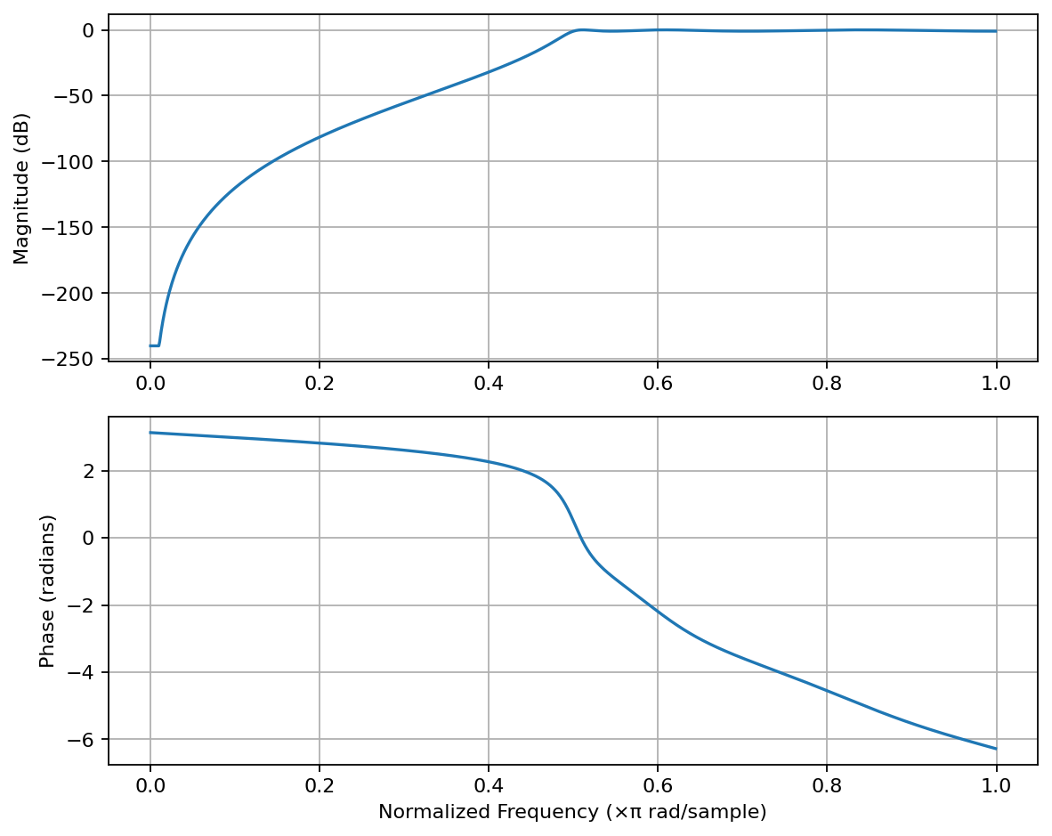
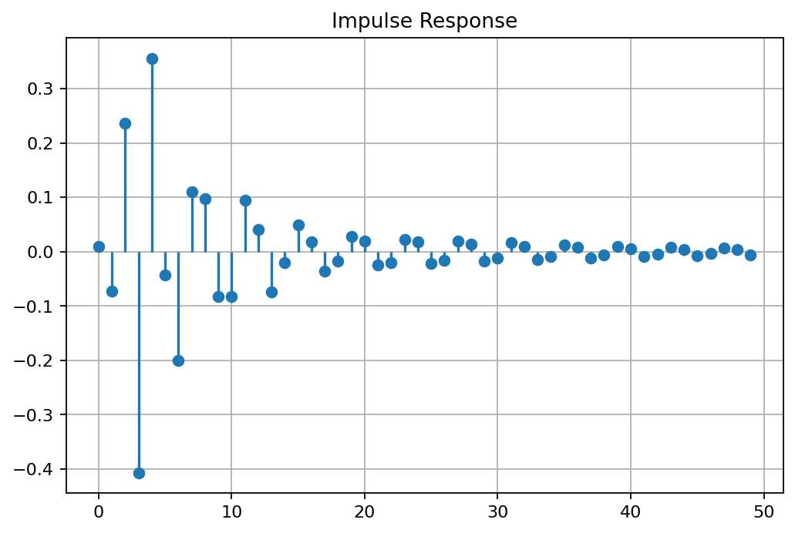
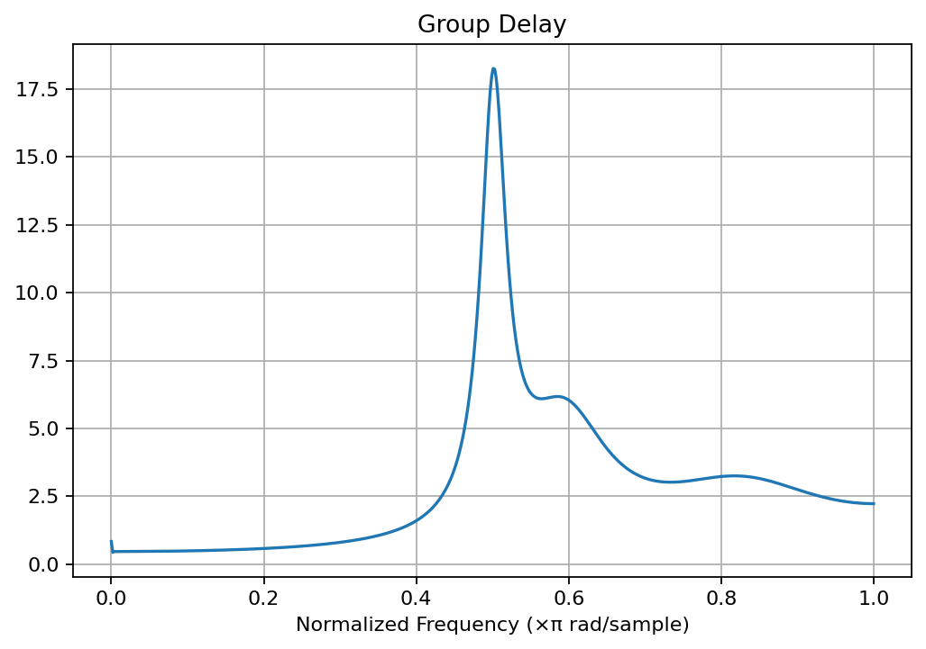
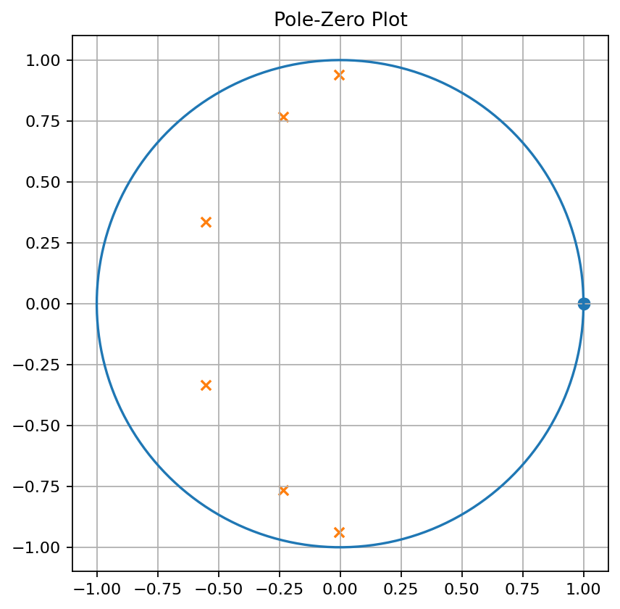

Experiment 3.1 – Design and Comparative Analysis of Butterworth and Chebyshev Type-I IIR Band-Pass Filters Using MATLAB
MATLAB Program
clc; clear; close all;
Fs=2000; Rp=1; Rs=40;
Wp=[300 600]/(Fs/2); Ws=[200 700]/(Fs/2);
[n1,W1]=buttord(Wp,Ws,Rp,Rs);
[b1,a1]=butter(n1,W1,'bandpass');
[n2,W2]=cheb1ord(Wp,Ws,Rp,Rs);
[b2,a2]=cheby1(n2,Rp,W2,'bandpass');
figure; freqz(b1,a1); title('Butterworth Filter');
figure; freqz(b2,a2); title('Chebyshev Type-I Filter');
figure; grpdelay(b1,a1); hold on; grpdelay(b2,a2);
legend('Butterworth','Chebyshev-I');
figure; subplot(121),zplane(b1,a1),title('Butterworth')
subplot(122),zplane(b2,a2),title('Chebyshev-I')
figure; subplot(211),impz(b1,a1),title('Butterworth Impulse')
subplot(212),impz(b2,a2),title('Chebyshev Impulse')
figure; subplot(121),stem(abs(roots(a1)),'filled'),title('Butterworth Pole Magnitude')
subplot(122),stem(abs(roots(a2)),'filled'),title('Chebyshev Pole Magnitude')
disp(['Butterworth Order = ',num2str(n1)])
disp(['Chebyshev Order = ',num2str(n2)])
OUTPUT
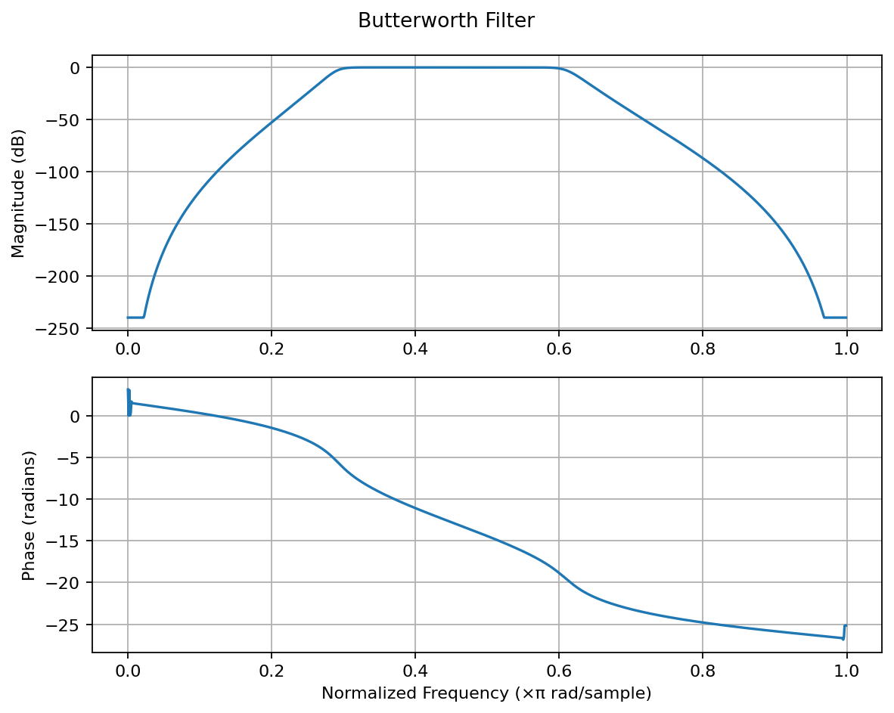
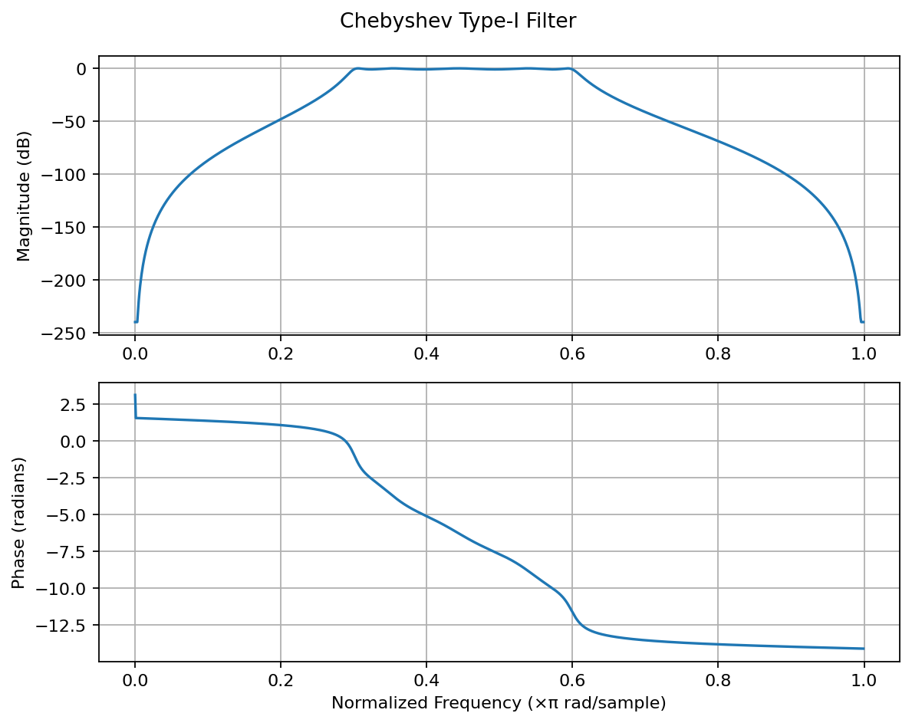
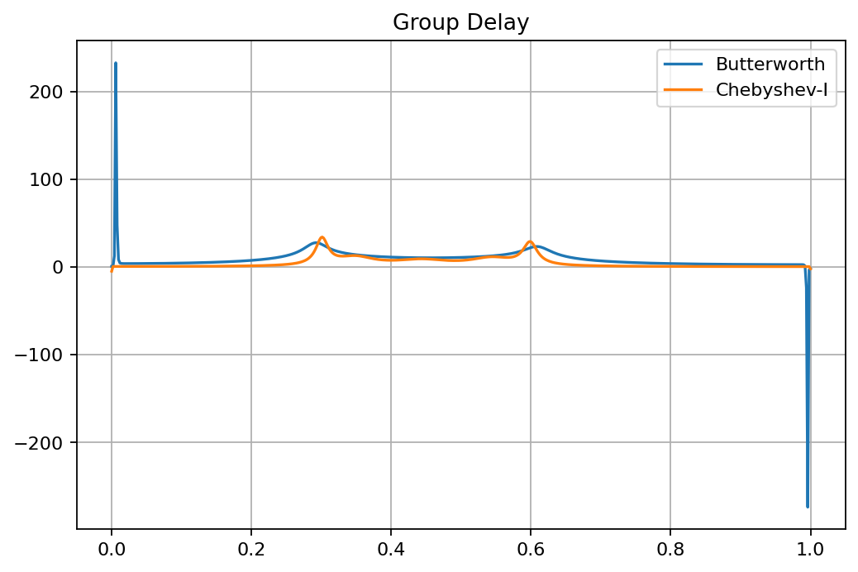
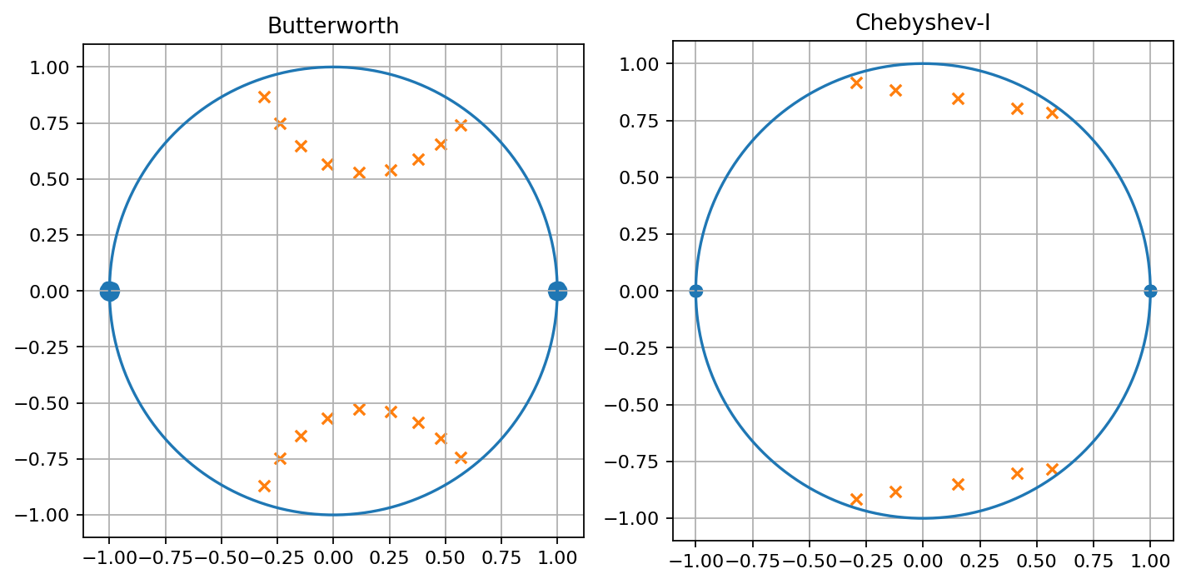
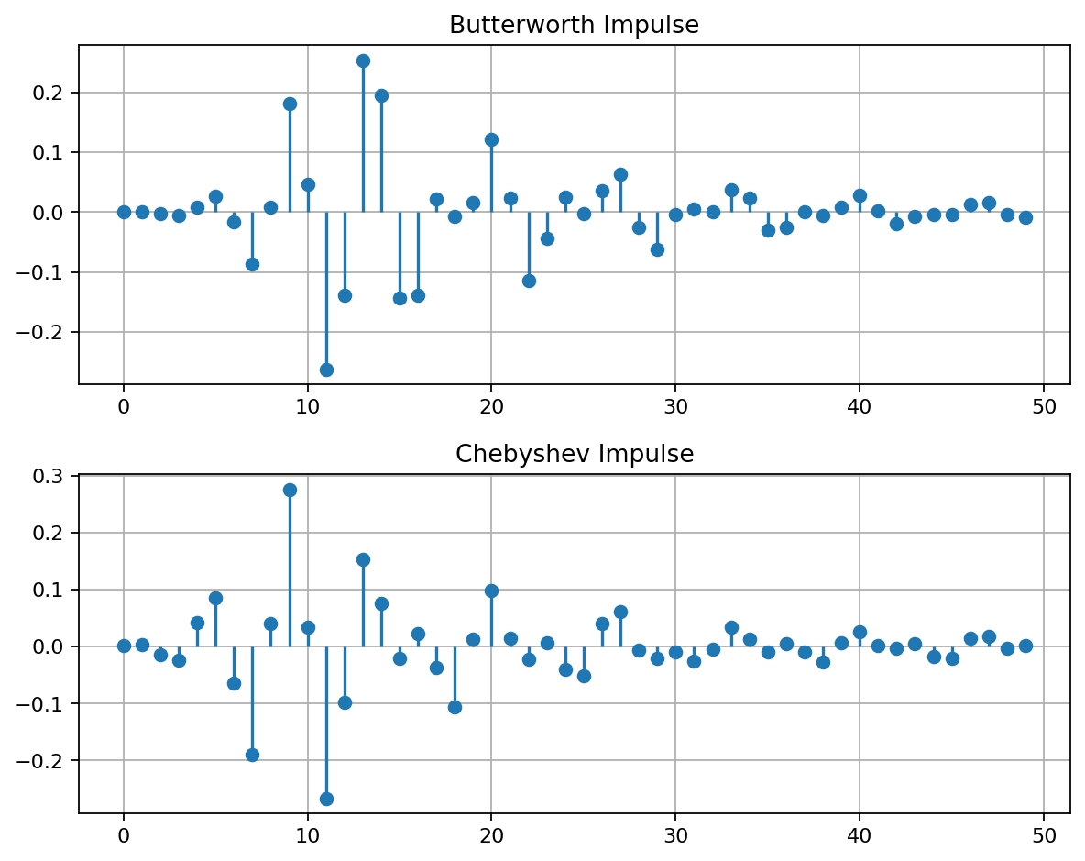
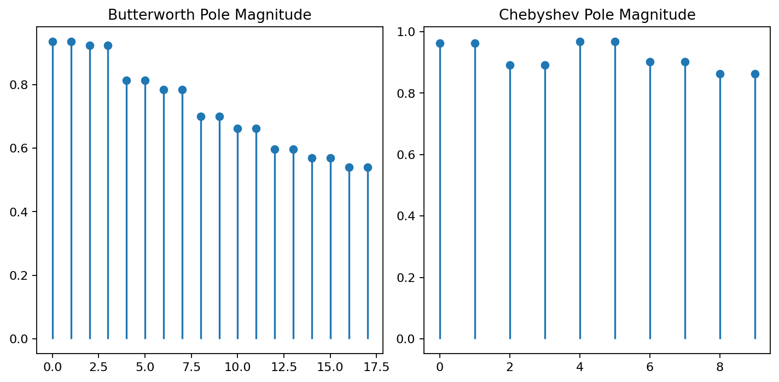

Experiment 4.1 – Design and Analysis of an FIR Low-Pass Filter Using the Rectangular Window Technique in MATLAB
MATLAB Program
clc; clear; close all;
fp=1000; fs=4000; N=50;
wc=fp/(fs/2);
b_rect=fir1(N,wc,'low',rectwin(N+1));
disp('--- Rectangular Window Coefficients ---');
disp(b_rect');
figure; freqz(b_rect,1);
title('Low-pass FIR using Rectangular Window');
OUTPUT
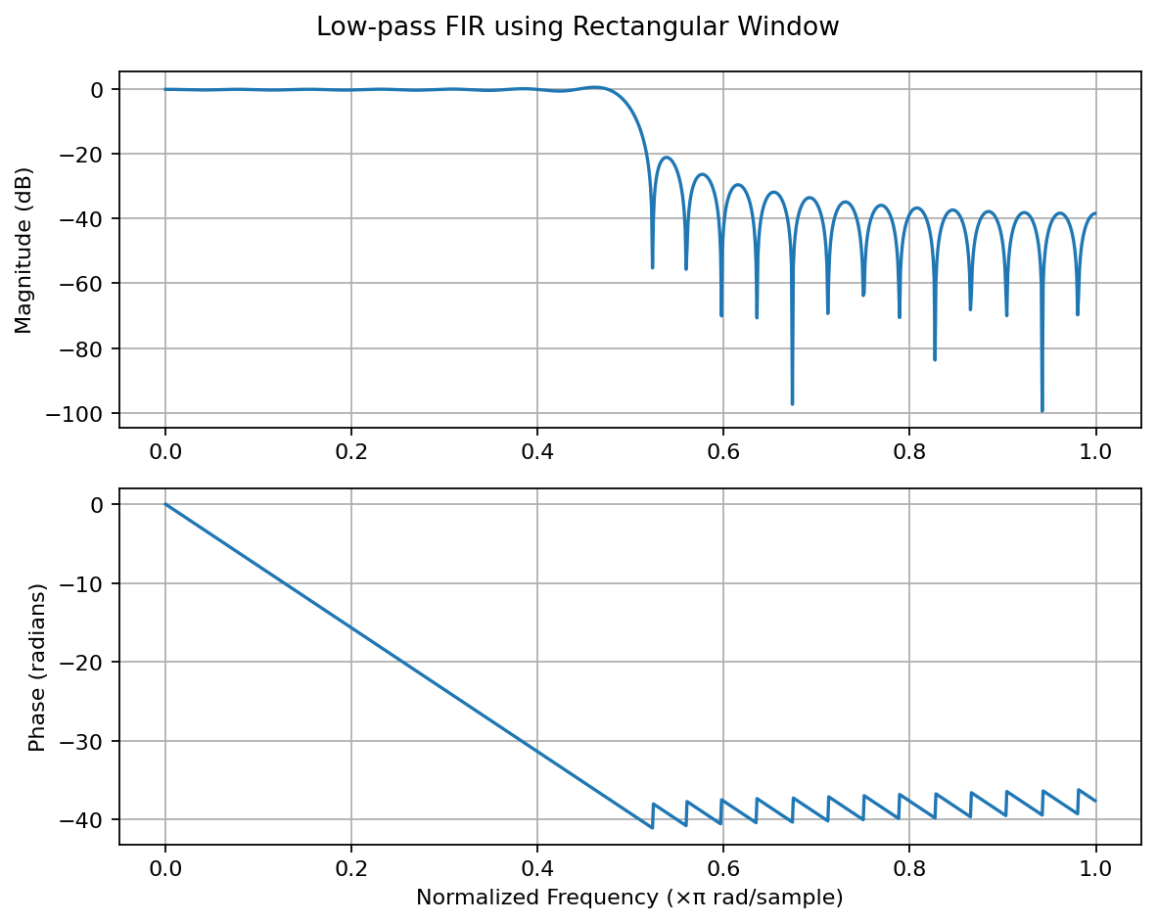

Experiment 4.2 – Design and Analysis of an FIR Low-Pass Filter Using the Hamming Window Technique in MATLAB
MATLAB Program
clc; clear; close all;
fp=1000; fs=4000; N=50;
wc=fp/(fs/2);
b_hamm=fir1(N,wc,'low',hamming(N+1));
disp('--- Hamming Window Coefficients ---');
disp(b_hamm');
figure; freqz(b_hamm,1);
title('Low-pass FIR using Hamming Window');
OUTPUT
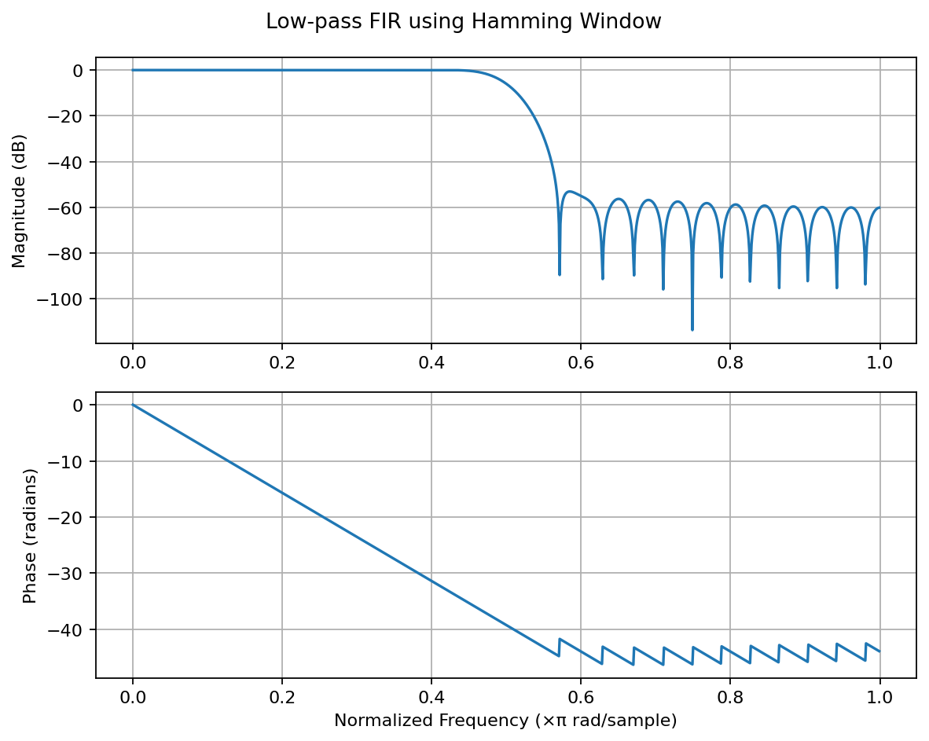

Experiment 4.3 – Design and Analysis of an FIR Low-Pass Filter Using the Hanning Window Technique in MATLAB
MATLAB Program
clc; clear; close all;
fp=1000; fs=4000; N=50;
wc=fp/(fs/2);
b_hann=fir1(N,wc,'low',hanning(N+1));
disp('--- Hanning Window Coefficients ---');
disp(b_hann');
figure; freqz(b_hann,1);
title('Low-pass FIR using Hanning Window');
OUTPUT
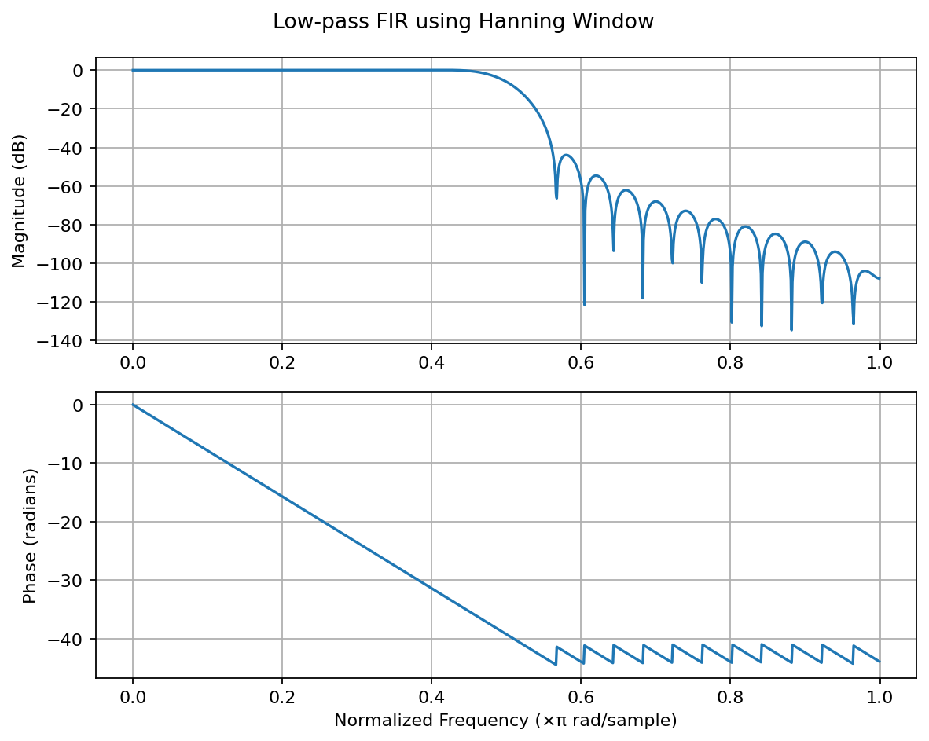

Experiment 5.1 – Design and Analysis of an FIR High-Pass Filter Using the Rectangular Window Technique in MATLAB
MATLAB Program
clc; clear; close all;
fp=1000; fs=8000; N=50;
wc=fp/(fs/2);
b_rect=fir1(N,wc,'high',rectwin(N+1));
disp('--- High-Pass Coefficients (Rectangular Window) ---');
disp(b_rect');
figure; freqz(b_rect,1);
title('High-pass FIR using Rectangular Window');
OUTPUT
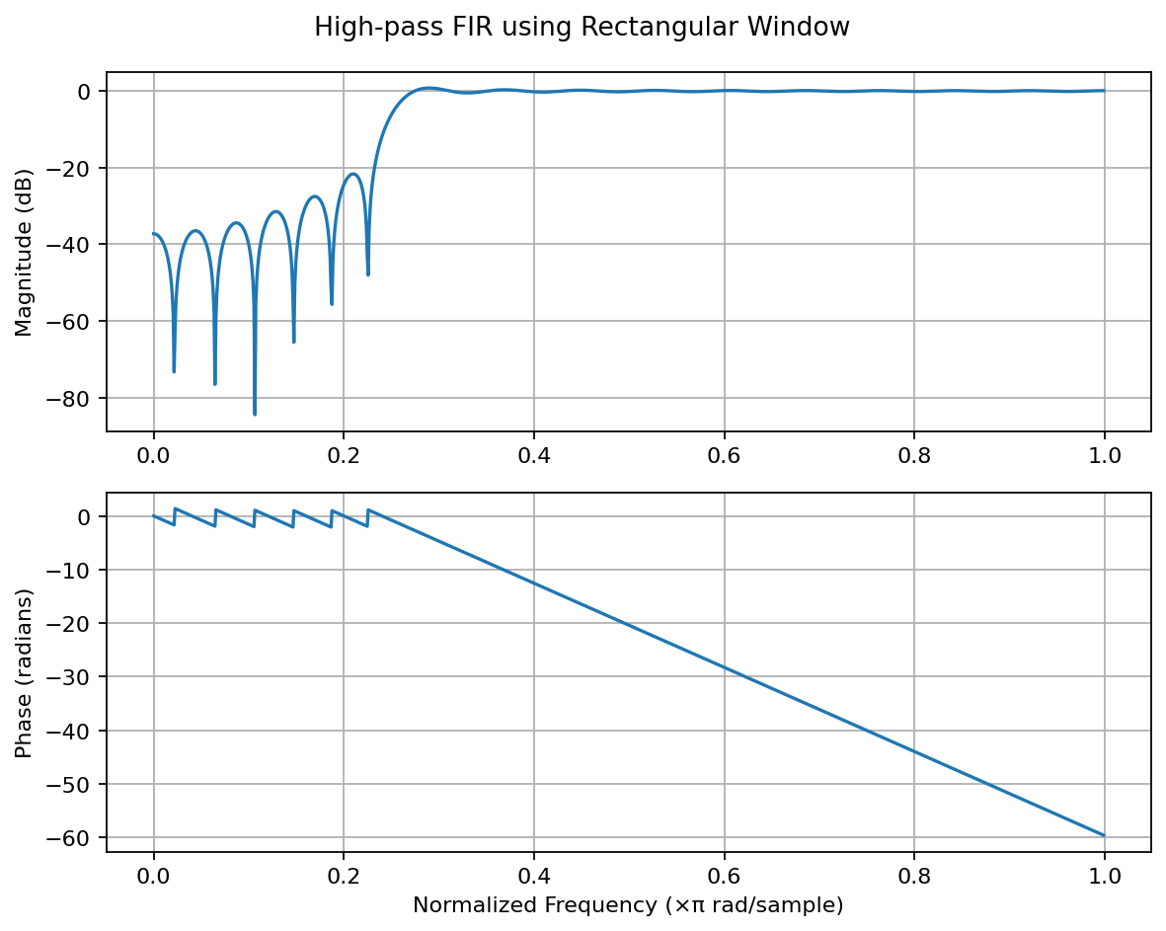

Experiment 5.2 – Design and Analysis of an FIR High-Pass Filter Using the Hamming Window Technique in MATLAB
MATLAB Program
clc; clear; close all;
fp=1000; fs=8000; N=50;
wc=fp/(fs/2);
b_hamm=fir1(N,wc,'high',hamming(N+1));
disp('--- High-Pass Coefficients (Hamming Window) ---');
disp(b_hamm');
figure; freqz(b_hamm,1);
title('High-pass FIR using Hamming Window');
OUTPUT
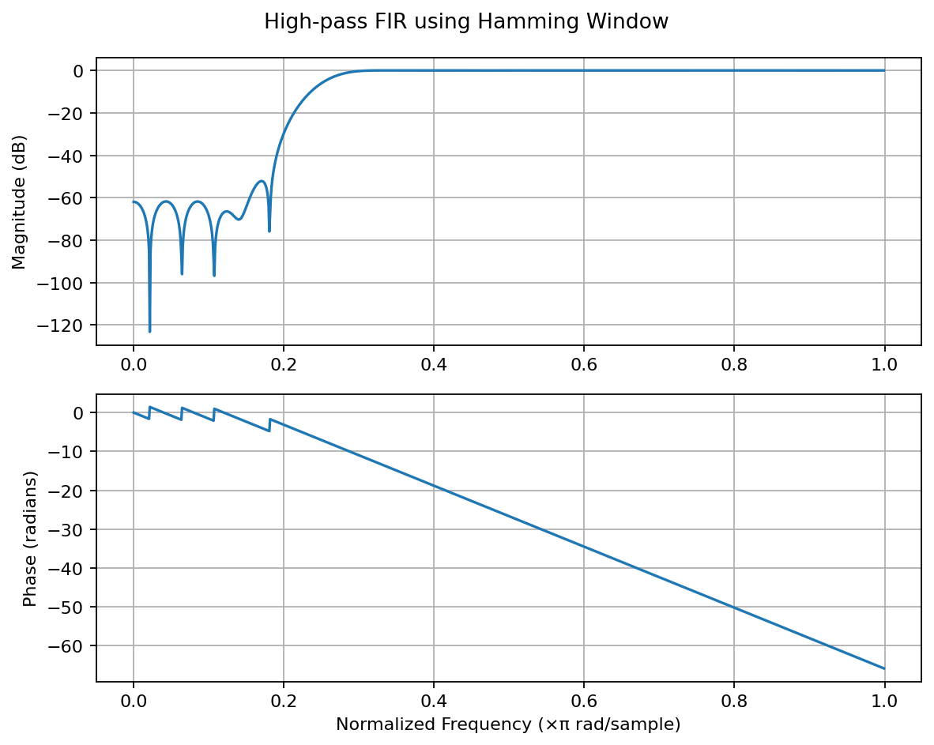

Experiment 5.3 – Design and Analysis of an FIR High-Pass Filter Using the Hanning Window Technique in MATLAB
MATLAB Program
clc; clear; close all;
fp=1000; fs=8000; N=50;
wc=fp/(fs/2);
b_hann=fir1(N,wc,'high',hanning(N+1));
disp('--- High-Pass Coefficients (Hanning Window) ---');
disp(b_hann');
figure; freqz(b_hann,1);
title('High-pass FIR using Hanning Window');
OUTPUT
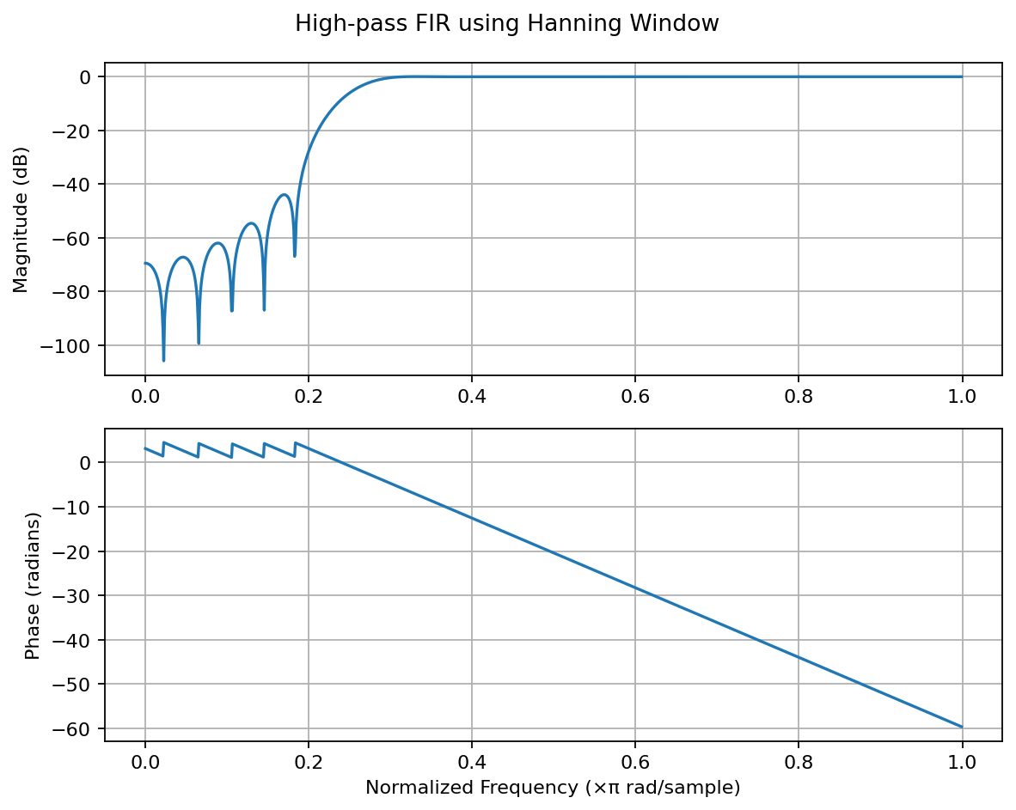

Experiment 6.1 – Uniform Quantization and Quantization Error Analysis of a Discrete-Time Sinusoidal Signal Using MATLAB
MATLAB Program
clc; clear; close all;
fs=1000; f=50; t=0:1/fs:0.1;
x=sin(2*pi*f*t); L=[8 16 32];
colors={'r','g','m'}; figure;
for i=1:length(L)
xq{i}=round((x+1)*(L(i)-1)/2)*(2/(L(i)-1))-1;
e{i}=x-xq{i}; mse(i)=mean(e{i}.^2);
subplot(4,1,i+1); stairs(t,xq{i},colors{i},'LineWidth',1.2);
title(['Quantized Signal (' num2str(L(i)) ' Levels)']); grid on;
end
subplot(4,1,1); plot(t,x,'LineWidth',1.5); title('Original Signal'); grid on;
fprintf('MSE for 8 Levels = %f\n',mse(1));
fprintf('MSE for 16 Levels = %f\n',mse(2));
fprintf('MSE for 32 Levels = %f\n',mse(3));
figure;
for i=1:3
subplot(3,1,i); plot(t,e{i});
title(['Error (' num2str(L(i)) ' Levels)']); grid on;
end
OUTPUT
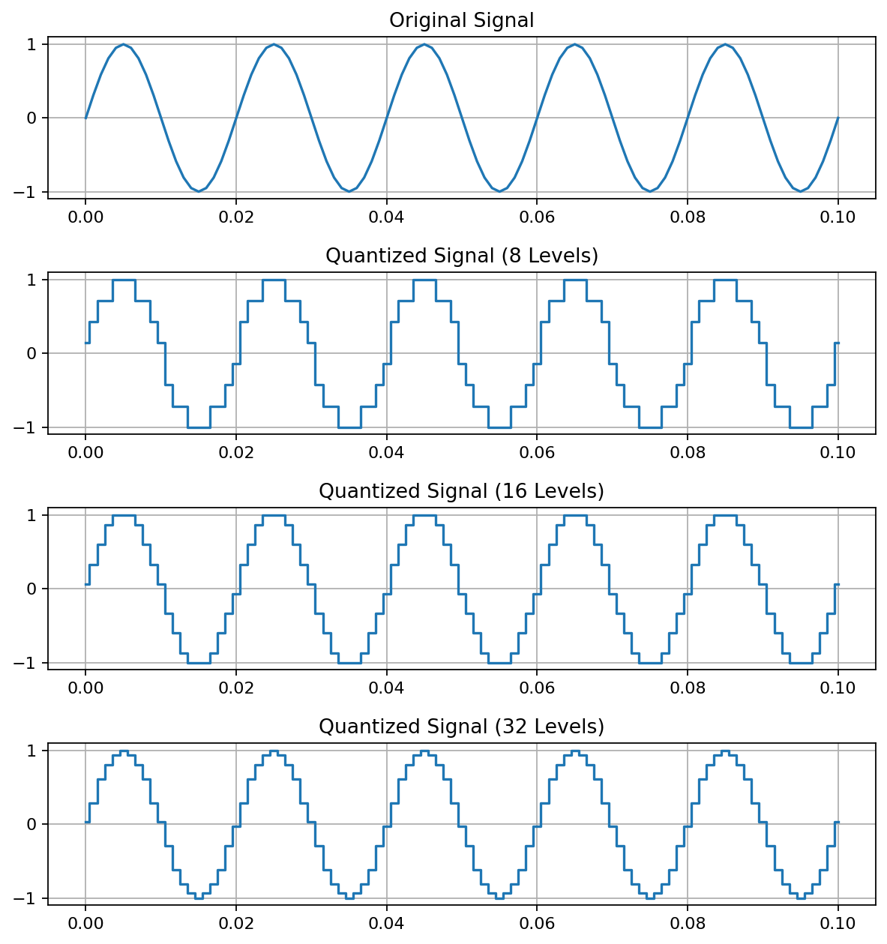
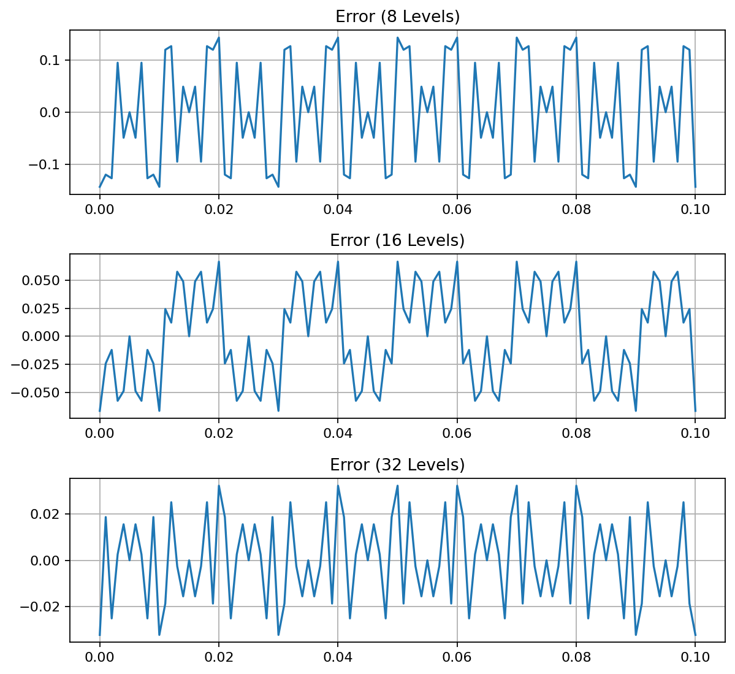

Experiment 6.2 – Analysis of Finite Word Length Effects in Digital Signal Representation Using Truncation and Rounding Techniques in MATLAB
MATLAB Program
clc; clear; close all;
n=0:79; x=sin(2*pi*n/40); q=8;
xt=floor(x*q)/q; xr=round(x*q)/q;
et=x-xt; er=x-xr;
figure; plot(n,x,'b',n,xr,'r','LineWidth',1.5); grid on;
title('Original vs Quantized'); legend('Original','Quantized');
figure; plot(n,x,'b',n,xt,'r',n,xr,'g','LineWidth',1.5); grid on;
title('Truncation vs Rounding'); legend('Original','Truncated','Rounded');
figure; stem(n,et,'r'); hold on; stem(n,er,'g'); grid on;
title('Quantization Error'); legend('Truncation','Rounding');
figure; bar([mean(et.^2) mean(er.^2)]);
set(gca,'XTickLabel',{'Truncation','Rounding'}); grid on;
title('MSE Comparison'); ylabel('MSE');
OUTPUT
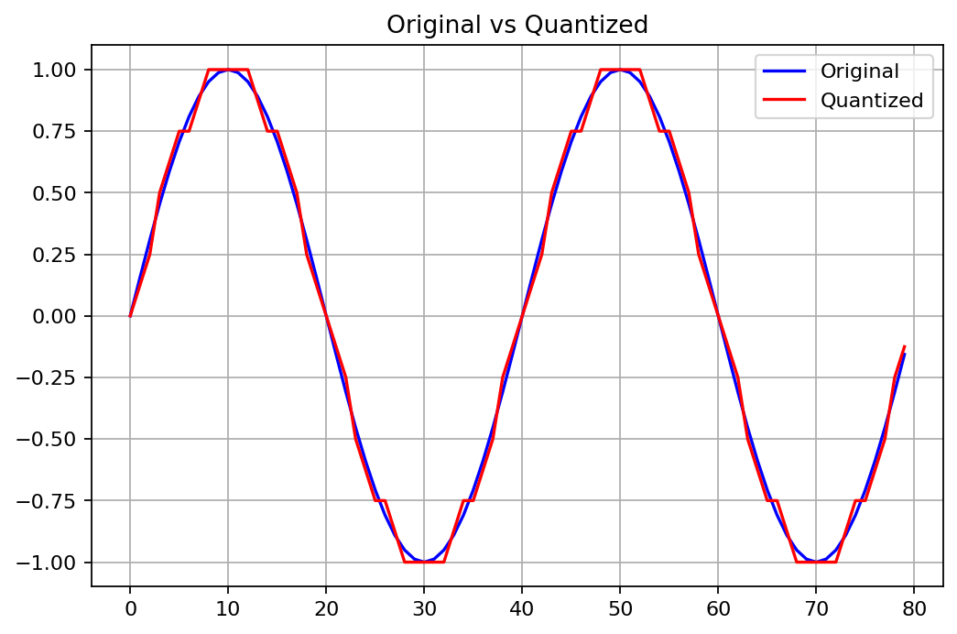
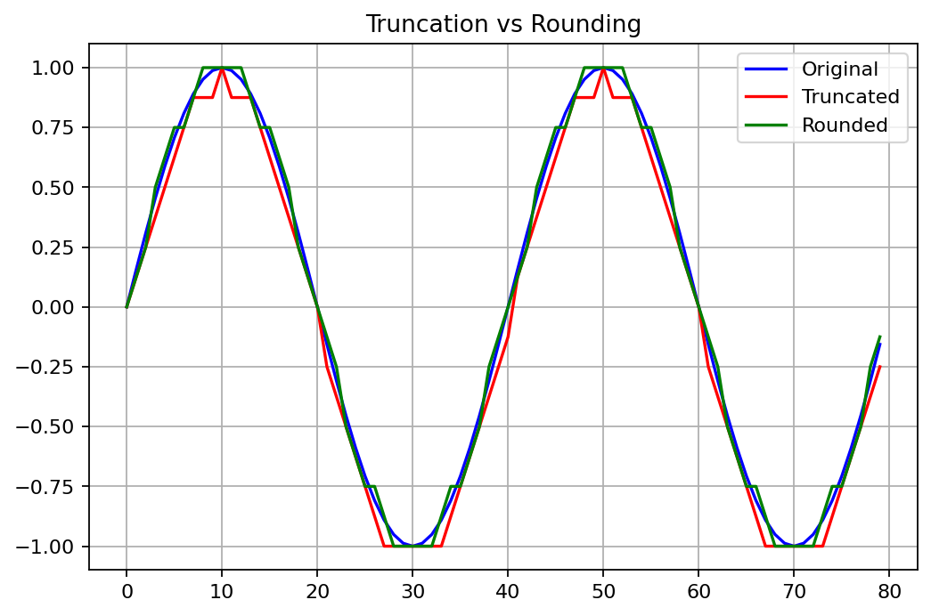
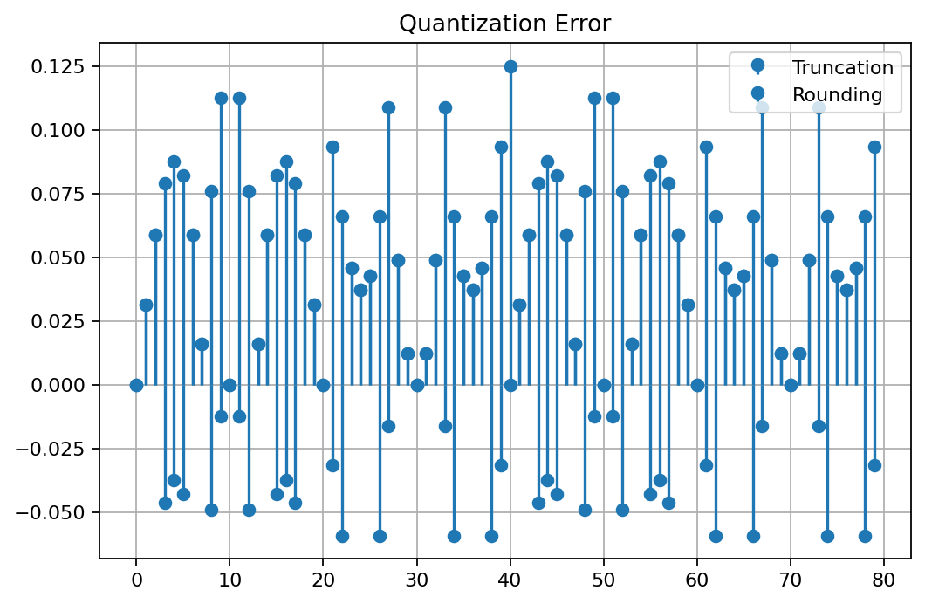
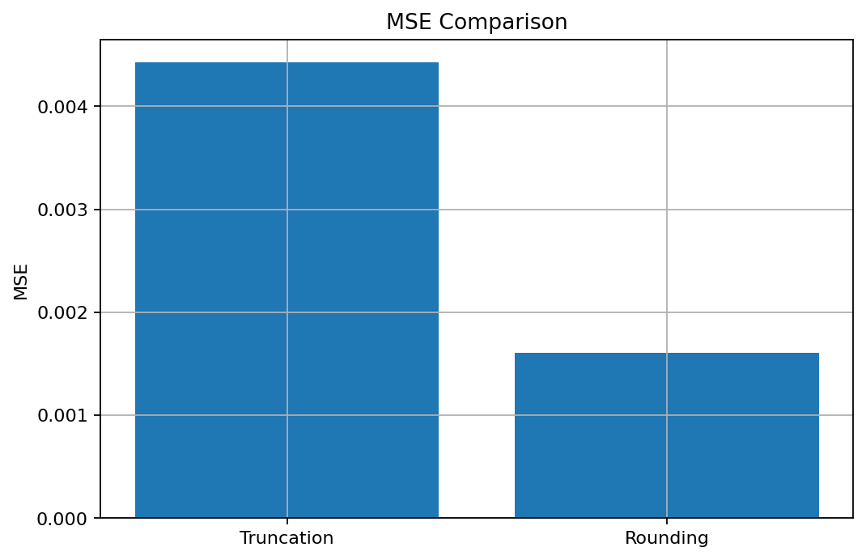

Experiment 7.1 – Power Spectral Density Estimation and Spectral Analysis of Noisy Sinusoidal Signals Using Periodogram Method in MATLAB
MATLAB Program
clc; clear; close all;
fs=1000; t=(0:999)/fs;
s=sin(2*pi*100*t)+0.5*sin(2*pi*200*t);
n=0.3*randn(size(t)); x=s+n;
figure; plot(x); grid on; title('Signal with Noise');
figure; periodogram(x,[],[],fs); title('PSD using Periodogram');
figure; X=abs(fft(x)); f=(0:length(X)-1)*fs/length(X);
plot(f(1:500),X(1:500)); grid on; title('Magnitude Spectrum');
figure; bar([mean(s.^2) var(n)]);
set(gca,'XTickLabel',{'Signal','Noise'}); title('Power Comparison'); grid on;
OUTPUT
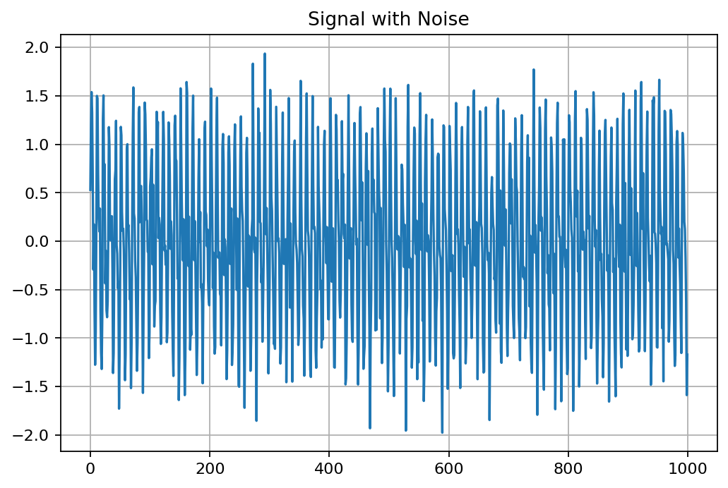
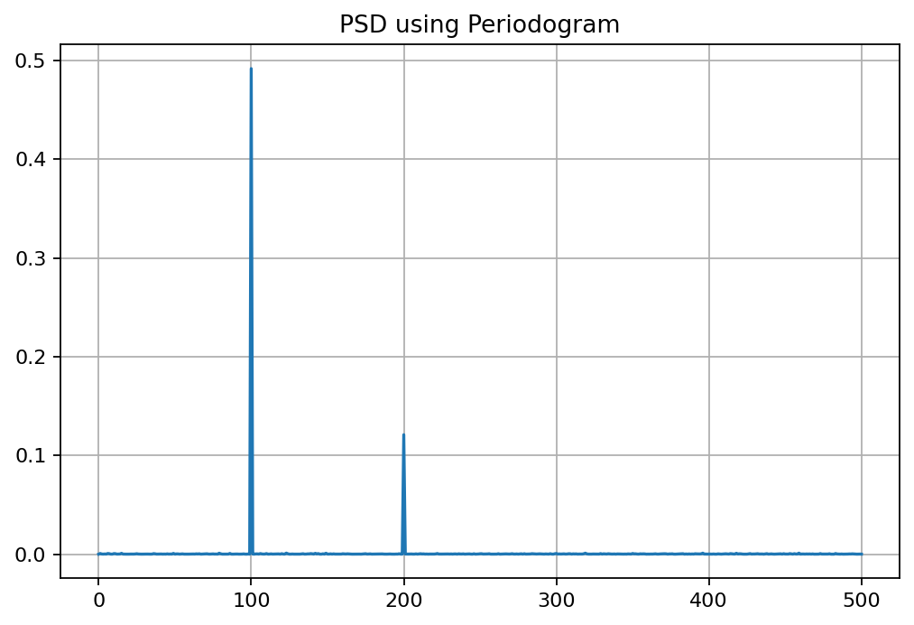
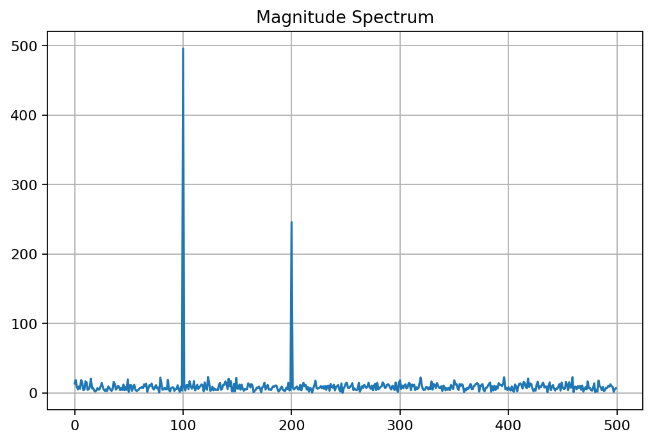
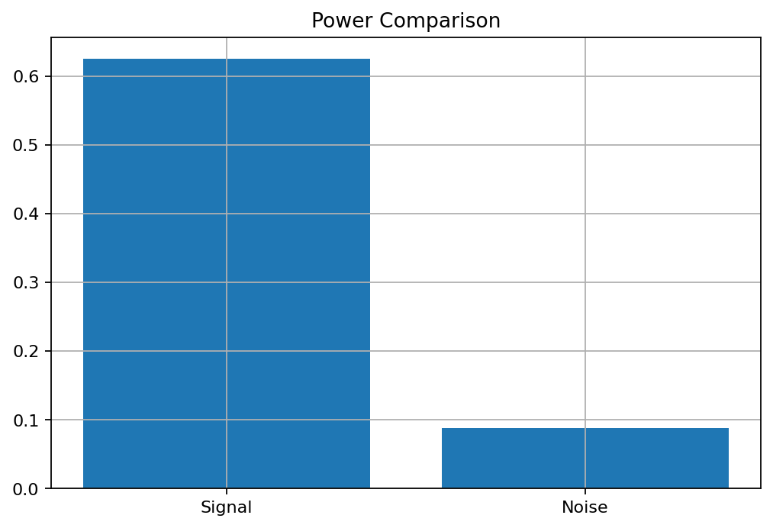

Experiment 7.2 – Analysis of Windowing Effects on Spectral Estimation Using Rectangular, Hamming, and Hanning Windows in MATLAB
MATLAB Program
clc; clear; close all;
fs=1000; N=256; t=(0:N-1)/fs;
x=sin(2*pi*100*t)+0.8*sin(2*pi*110*t);
NFFT=2048; f=(0:NFFT/2-1)*(fs/NFFT);
w={rectwin(N),hamming(N),hann(N)};
names={'Rectangular','Hamming','Hanning'};
for i=1:3
xw=x(:).*w{i}; X=fft(xw,NFFT); P{i}=abs(X(1:NFFT/2)); P{i}=P{i}/max(P{i});
end
figure;
for i=1:3
subplot(3,1,i); plot(f,20*log10(P{i}),'LineWidth',1.5);
title(['Spectrum using ' names{i} ' Window']); xlim([0 250]); grid on;
end
figure; plot(f,20*log10(P{1}),f,20*log10(P{2}),f,20*log10(P{3}),'LineWidth',1.5);
legend(names); title('Window Comparison'); xlim([50 170]); grid on;
figure;
for i=1:3
subplot(3,1,i); plot(w{i},'LineWidth',1.5); title([names{i} ' Window']); grid on;
end
OUTPUT
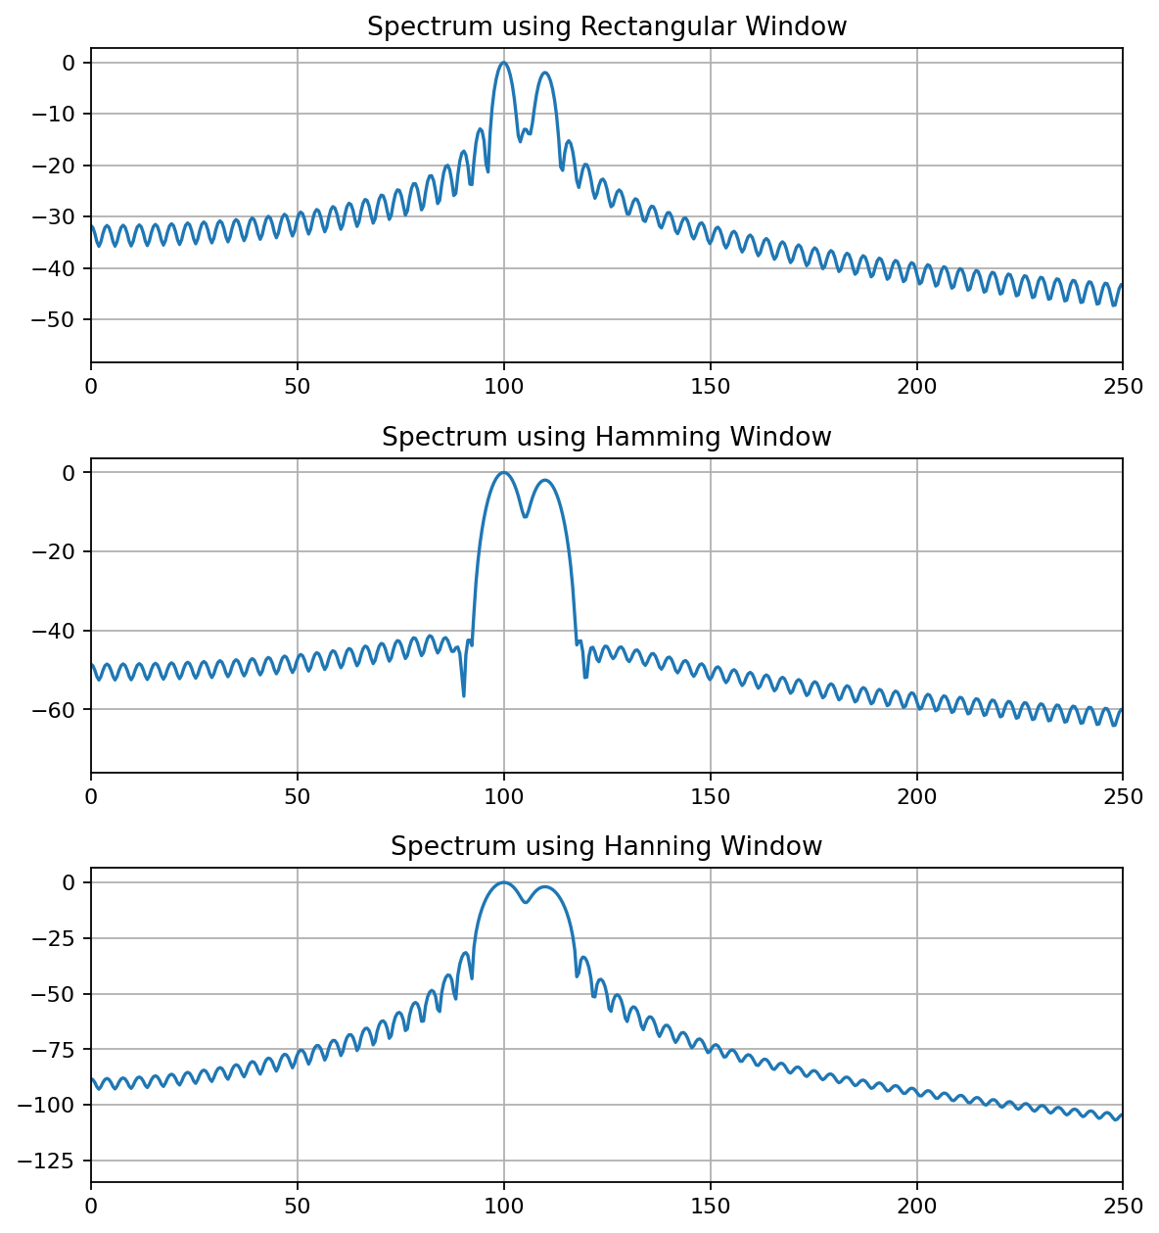
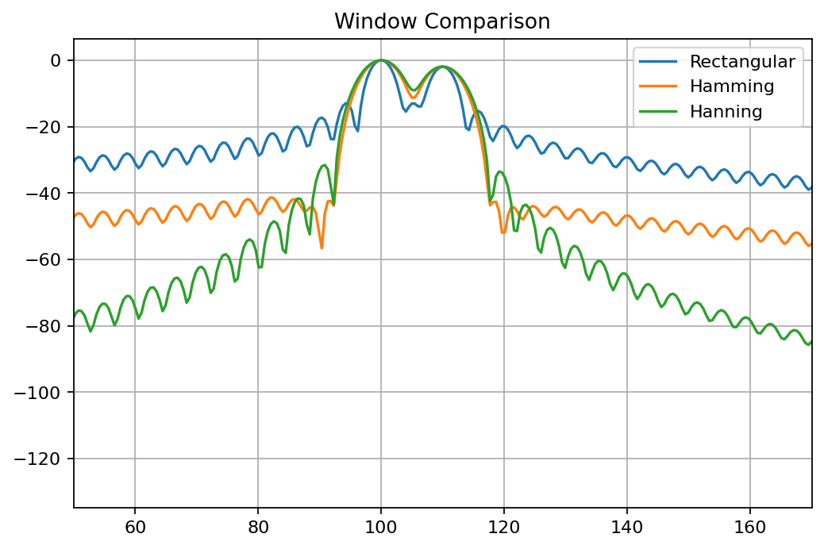
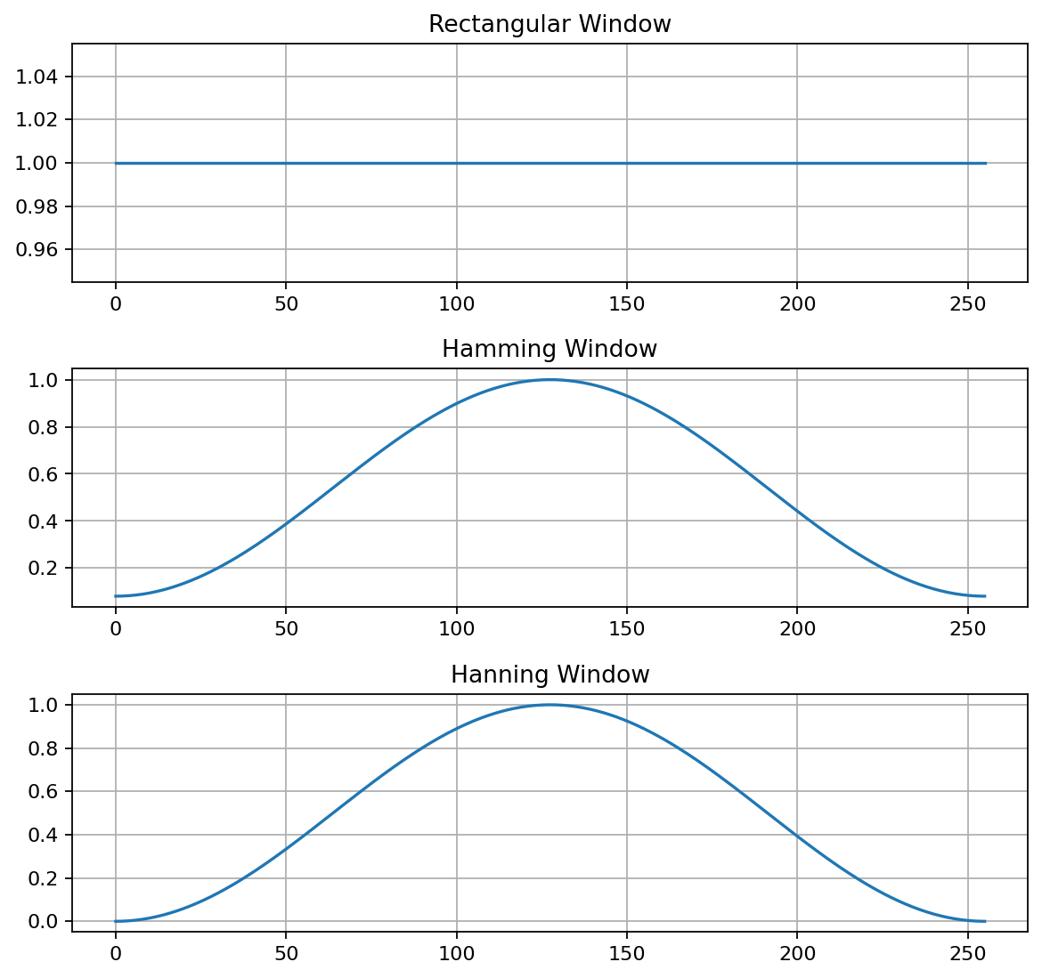
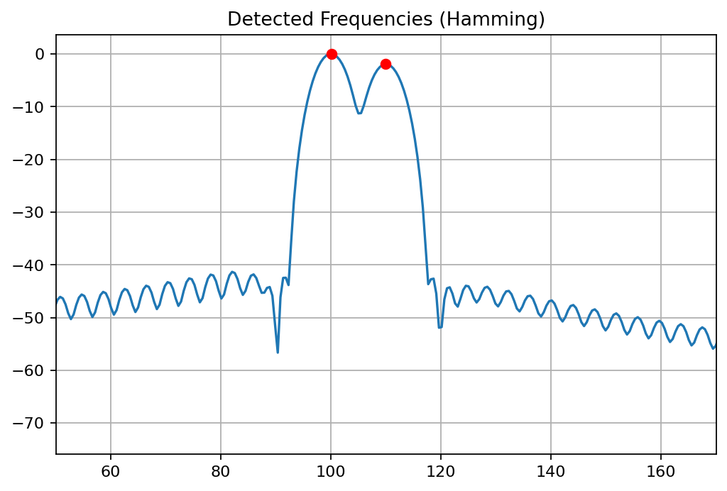

Experiment 8.1 – Implementation and Analysis of Decimation and Interpolation in Multirate Signal Processing Using MATLAB
MATLAB Program
clc; clear; close all;
n=0:40; x=sin(0.3*pi*n);
y=x(1:2:end); nd=0:length(y)-1;
v=zeros(1,2*length(x)); v(1:2:end)=x; ni=0:length(v)-1;
figure; stem(n,x,'filled'); grid on; title('Original Sequence x[n]'); xlabel('n'); ylabel('Amplitude');
figure; stem(nd,y,'filled'); grid on; title('Decimated Sequence by 2'); xlabel('n'); ylabel('Amplitude');
figure; stem(ni,v,'filled'); grid on; title('Interpolated Sequence by 2'); xlabel('n'); ylabel('Amplitude');
figure; stem(n,x,'b'); hold on; stem(0:2:length(v)-2,v(1:2:end),'r');
legend('Original x[n]','Interpolated Samples'); grid on; title('Comparison of Sequences'); xlabel('n'); ylabel('Amplitude');
OUTPUT
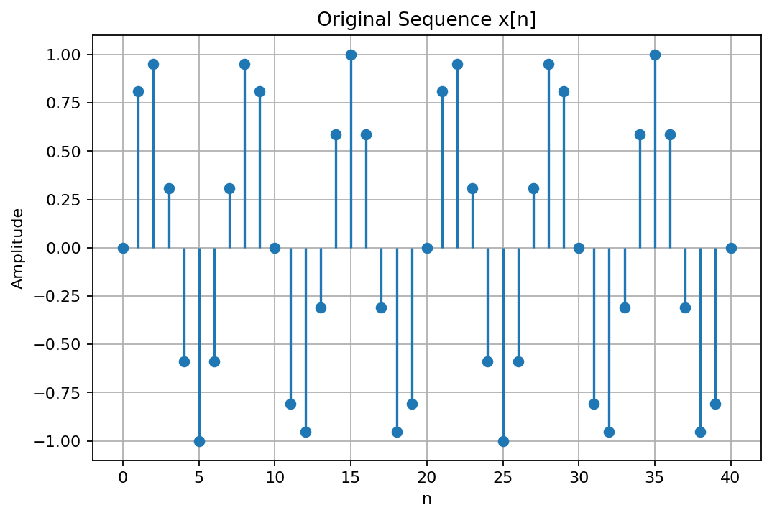
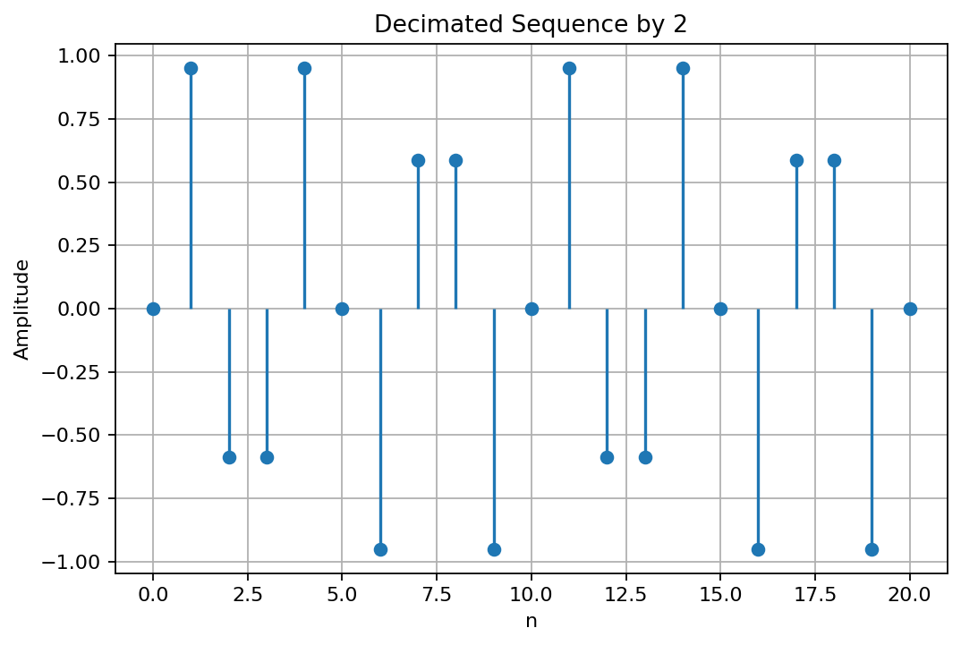
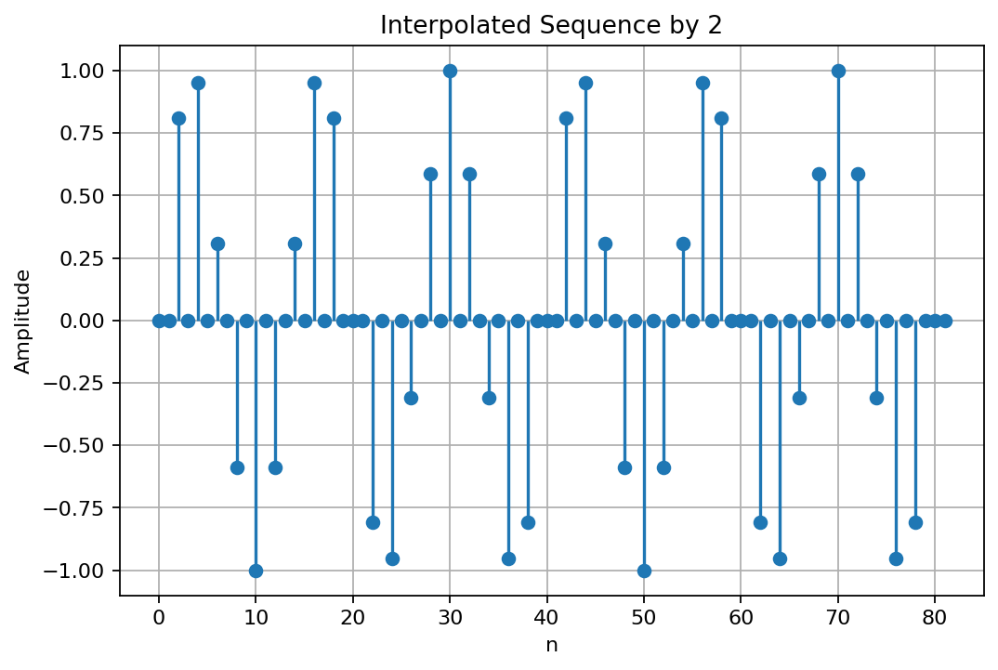
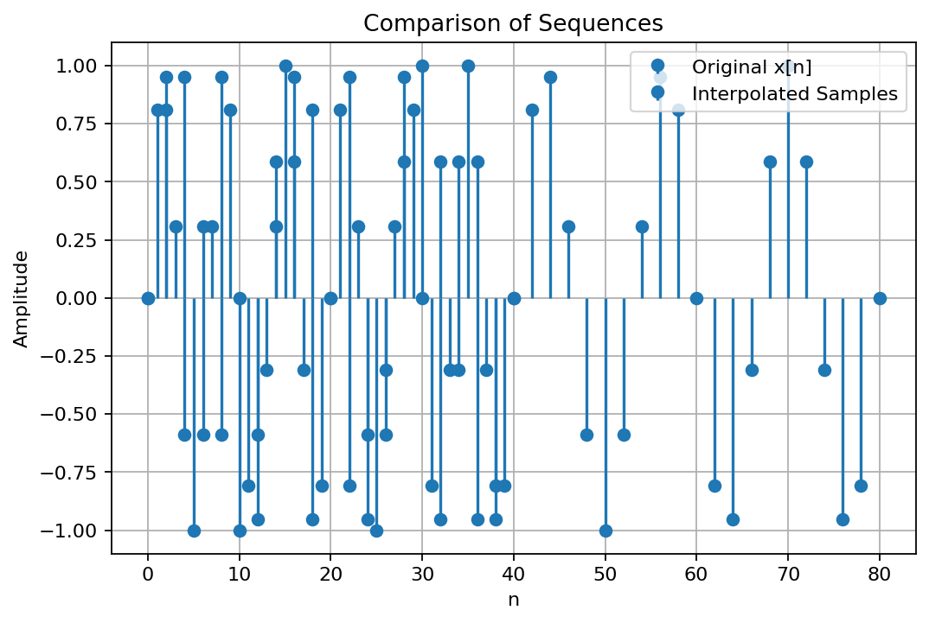

Experiment 8.2 – Polyphase Implementation of Decimation and Interpolation Filters Using MATLAB
MATLAB Program
clc; clear; close all;
Fs=1000; t=0:1/Fs:1;
x=sin(2*pi*50*t)+0.5*sin(2*pi*120*t);
N=20; Fc=0.4; h=fir1(N,Fc,hamming(N+1));
M=2; y_dec=upfirdn(x,h,1,M);
L=2; y_int=upfirdn(y_dec,h,L,1);
if length(y_int)>length(x), y_int=y_int(1:length(x));
elseif length(y_int)<length(x), x=x(1:length(y_int)); end
t1=(0:length(x)-1)/Fs; t2=(0:length(y_dec)-1)/(Fs/M); t3=(0:length(y_int)-1)/Fs;
figure('Name','Polyphase Decimation and Interpolation','NumberTitle','off');
subplot(4,1,1); plot(t1,x,'LineWidth',1.5); title('Original Input Signal'); xlabel('Time (s)'); ylabel('Amplitude'); grid on;
subplot(4,1,2); stem(t2,y_dec,'filled'); title('Decimated Signal (M = 2)'); xlabel('Time (s)'); ylabel('Amplitude'); grid on;
subplot(4,1,3); plot(t3,y_int,'LineWidth',1.5); title('Interpolated/Reconstructed Signal (L = 2)'); xlabel('Time (s)'); ylabel('Amplitude'); grid on;
subplot(4,1,4); plot(t1,x,'LineWidth',1.5); hold on; plot(t3,y_int,'--','LineWidth',1.5);
title('Comparison of Original and Reconstructed Signals'); xlabel('Time (s)'); ylabel('Amplitude'); legend('Original Signal','Reconstructed Signal'); grid on;
figure; freqz(h,1); title('FIR Low-Pass Filter Frequency Response');
OUTPUT
