**AGRIGUARD ROVER**

**An Engineering Project in Community Service**

**Phase – II Report**

***Submitted by***

**Team Members List**

**22BAI10175 Ashrita Vinod**

***in partial fulfillment of the requirements for the degree of***

***Bachelor of Engineering and Technology***



**VIT Bhopal University**

**Bhopal**

**Madhya Pradesh**

**December, 2024**



**Bonafide Certificate**

Certified that this project report titled **“AGRIGUARD ROVER”** is the bonafide work of ,Ashrita Vinod (22BAI10175) who carried out the project work under my supervision.

This project report (Phase II) is submitted for the Project Viva-Voce examination held on …………..

**Dr. Pradeep Mishra**

**Supervisor**

**Comments & Signature ( Reviewer 1)**

**Comments & Signature ( Reviewer 2)**



**Declaration of Originality**

We, hereby declare that this report entitled **“AGRIGUARD ROVER''** represents our original work carried out for the EPICS project as a student of VIT Bhopal University and, to the best of our knowledge, it contains no material previously published or written by another person, nor any material presented for the award of any other degree or diploma of VIT Bhopal University or any other institution. Works of other authors cited in this report have been duly acknowledged under the section ''References''.

|  | Date  15/4/2025 | Reg No & Name |
| --- | --- | --- |

22BAI10175 Ashrita Vinod

**Acknowledgement**

We extend our heartfelt gratitude to **VIT Bhopal University** for providing us with an excellent academic environment, state-of-the-art facilities, and continuous support throughout our journey of conceptualizing and developing *AgriGuard: An Agriculture Rover for Paddy Fields*. This project would not have been possible without the university's encouragement toward innovation and research.

We are deeply indebted to our supervisor, **Dr. Pradeep Mishra**, for his invaluable guidance, constructive feedback, and unwavering patience throughout this project. His insights and expertise have been instrumental in shaping the design and functionality of *AgriGuard*.

We also acknowledge the support and encouragement from our faculty members, peers, and the technical staff who contributed their time and resources to help us resolve challenges and refine our work. Their assistance has been pivotal in ensuring the successful completion of this project.

Special thanks are due to the local farming communities for sharing their experiences and practical insights into paddy field cultivation, which played a crucial role in tailoring *AgriGuard* to meet real-world requirements.

Lastly, we express our gratitude to our families and friends for their unconditional support and motivation during the demanding phases of this project.

While it would be simple to name everyone who has contributed to this project, it would not be easy to thank them enough for their efforts, encouragement, and belief in us. We hope this project makes a meaningful contribution to agriculture and paves the way for more innovations in this field.

**Team AgriGuard**

**Abstract**

In the present work, we have designed and developed *AgriGuard*, an advanced agriculture rover aimed at addressing the unique challenges associated with paddy fields. The project focuses on the paddy fields of Sehore, a significant district in Madhya Pradesh renowned for its substantial contribution to rice production. These fields, characterized by uneven and waterlogged terrains, pose considerable challenges for traditional farming methods, particularly in ensuring consistent monitoring of plants.

To overcome these challenges, *AgriGuard* employs a six-wheel rocker-bogie mechanism, enabling it to traverse the demanding terrain of paddy fields with ease and stability. The rover is remotely controlled, ensuring flexibility and convenience in its operation. A key innovation in this system is the integration of an AI/ML-powered smart diagnostic platform designed to analyze plant health in real time. This system leverages advanced image processing techniques to detect early signs of plant diseases, providing farmers with actionable insights to mitigate potential crop losses.

By reducing the dependency on manual inspection, *AgriGuard* aims to improve the precision and efficiency of disease detection and health monitoring in paddy cultivation. Furthermore, its application is expected to enhance the sustainability and productivity of rice farming in Sehore, serving as a scalable solution for modern agricultural practices. The rover combines robust mechanical engineering with cutting-edge artificial intelligence, representing a significant step forward in the technological advancement of Indian agriculture. Through this work, we aim to contribute to a future where innovation drives sustainability and resilience in farming systems.

# INDEX

| SL NO. | Topic | Page No. |
| --- | --- | --- |
| 1. | Introduction | 7 |
| 1.1. | Motivation | 8 |
| 1.2. | Objective | 9 |
| 2. | Existing Work | 10 |
| 3. | Topic of the Work | 17 |
| 3.1. | System Design and Architecture | 17 |
| 3.2. | Working Principle | 31 |
| 3.3. | Results and Discussions | 39 |
| 3.4. | Individual Contribution by Members | 46 |
| 4. | Conclusion | 47 |
| 5. | References | 48 |
| 6. | Biodata | 50 |

# INTRODUCTION

Agriculture remains the backbone of India’s economy, providing livelihoods to a significant portion of the population. Within this sector, paddy cultivation plays a pivotal role as a staple food source and is an essential contributor to economic growth. Sehore, a key district in Madhya Pradesh, is one of the leading regions in paddy production. The district's considerable rice cultivation areas pose unique challenges, resulting from their saturated and uneven terrain. Effective management of plant health in such conditions is critical to ensuring high crop yield and sustainable practices.

Traditional methods of monitoring paddy fields involve manual inspection, which is labour-intensive and prone to inefficiencies. Farmers often struggle to detect plant diseases early enough to take corrective action. This leads to reduced productivity, increased costs, and a reliance on reactive measures rather than preventive ones. In addition, the demand for more precise and data-driven solutions has grown in recent years as the agricultural sector strives to keep pace with technological advancements in other industries.

To address these challenges, we propose *AgriGuard*, an innovative agriculture rover designed specifically for paddy fields. This rover features a six-wheel rocker-bogie mechanism, allowing it to traverse waterlogged and uneven terrains with stability and ease. Controlled remotely for operational flexibility, *AgriGuard* is integrated with a state-of-the-art AI/ML-powered system that conducts real-time analysis of plant diseases. This system employs sophisticated image processing methodologies to facilitate early detection of plant diseases, offering actionable intelligence and diminishing dependence on traditional, protracted methods.

*(a)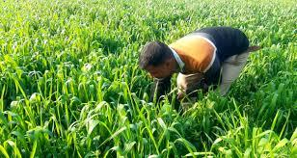(b)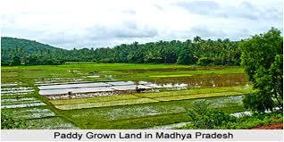*

***images : (a) Farmer identifying and checking manually the field ; (b) Paddy Field in Sehore***

## 1.1 Motivation

The motivation for this project arises from the growing challenges faced by the agricultural sector, particularly in paddy cultivation, where traditional practices are no longer sufficient to meet the demands of productivity, precision, and sustainability. Paddy farming, especially in regions like Sehore, Madhya Pradesh, is a labor-intensive process that requires significant human effort to monitor plant health. Manual inspection methods, though widely practiced, are inherently limited by time, human error, and the inability to scale effectively across large paddy fields. These challenges often lead to delayed detection of plant diseases, resulting in reduced crop yields, financial losses for farmers, and inefficient resource utilization.

The specific focus on Sehore stems from its importance as a major paddy-producing district in Madhya Pradesh. The district's agricultural success is critical not just to the local economy but also to the broader food security of the region. However, the terrain and environmental conditions typical of paddy fields—such as waterlogging and uneven surfaces—make consistent monitoring and maintenance a daunting task. Recognizing the need for a solution that is both efficient and tailored to these unique challenges, we were inspired to design a system that integrates modern technology with practical agricultural needs.

Recent advancements in robotics, artificial intelligence (AI), and machine learning (ML) have demonstrated immense potential for revolutionizing agriculture. AI-powered systems can analyze vast amounts of data with unparalleled accuracy, while robotic platforms offer physical solutions to challenges posed by difficult terrains. Motivated by these technological breakthroughs, we envisioned *AgriGuard* as a comprehensive tool that combines the mechanical reliability of a six-wheel rocker-bogie mechanism with the intelligence of an AI/ML diagnostic system. This fusion allows for precise navigation of challenging paddy field terrains while providing real-time insights into plant health.

Another driving force behind this project is the global shift toward smart agriculture, where automation, data-driven insights, and sustainability converge.F Agriculture, a traditionally labor-intensive industry, is rapidly embracing innovations that reduce manual effort, enhance productivity, and improve decision-making. By developing *AgriGuard*, we aim to position Sehore’s paddy farmers at the forefront of this transformation, empowering them with cutting-edge tools to compete in an increasingly technology-driven global economy.

The socio-economic well-being of farmers also served as a critical motivator. Farmers often bear the brunt of challenges such as crop failures, unpredictable weather patterns, and rising costs of inputs like fertilizers and pesticides. Early detection of diseases can prevent many of these issues, reducing financial strain and increasing profitability. *AgriGuard* offers a proactive approach, enabling farmers to address problems before they escalate and ensuring optimal use of resources.

Furthermore, environmental sustainability played a key role in inspiring this project. Paddy cultivation is resource-intensive, often requiring significant amounts of water and fertilizers. Mismanagement of these inputs can harm the environment, depleting soil quality and contributing to water pollution. By integrating AI/ML systems that provide accurate diagnostics, *AgriGuard* promotes the efficient use of resources, minimizing environmental impact and aligning with global goals for sustainable development.

Finally, the potential scalability and replicability of this project motivated us to create a solution that extends beyond Sehore’s paddy fields. The principles underlying *AgriGuard*—such as terrain adaptability, AI-powered diagnostics, and farmer-friendly design—can be applied to other crops and regions facing similar challenges. This scalability ensures that the project has a lasting impact, paving the way for future innovations in agricultural robotics and smart farming.

In summary, *AgriGuard* is driven by the desire to address real-world agricultural challenges, empower farmers with advanced tools, promote sustainability, and contribute to the evolution of modern farming practices. Our hope is that this project will not only transform paddy cultivation in Sehore but also serve as a blueprint for similar advancements in agriculture across the globe.

## 1.2 Objective

The primary objective of this project is to design and develop *AgriGuard*, an innovative agricultural rover specifically created for the management of paddy fields. This project aims to tackle some of the most pressing challenges in paddy farming, particularly in the Sehore district of Madhya Pradesh, where uneven and waterlogged terrains make traditional agricultural practices difficult to implement. Through the combination of a robust mechanical design, a six-wheel rocker-bogie mechanism, and the integration of advanced artificial intelligence and machine learning (AI/ML) technologies, *AgriGuard* is intended to provide farmers with a reliable and scalable solution to monitor plant diseases.

A key objective is to enhance the rover’s ability to navigate the challenging paddy field environment. The rocker-bogie mechanism will allow the rover to maintain stability and mobility on the uneven, waterlogged surfaces that are typical of paddy fields, overcoming the limitations of conventional farming equipment. This design ensures that the rover can operate continuously across large areas of land without being hindered by the terrain, making it suitable for widespread use in paddy fields in Sehore and beyond.

Additionally, a central objective is to incorporate an AI/ML-based diagnostic system that will enable real-time plant health. By utilizing high-definition imaging and sophisticated data processing algorithms, *AgriGuard* will be able to detect early signs of plant diseases and nutrient deficiencies and alert farmers with detailed recommendations. This will not only reduce the time required to identify issues but will also allow for faster, more accurate interventions, improving crop health and overall yield.

An important goal is to reduce the manual labor and resource-intensive processes that currently dominate paddy field management. *AgriGuard* aims to make the monitoring process more efficient by automating key tasks, thus freeing up valuable time for farmers to focus on other aspects of their work. Furthermore, by using AI/ML technologies, the rover will optimize the use of resources such as water, fertilizers, and pesticides, ensuring that these are applied only where needed, which can help lower costs while minimizing environmental impact.

Another objective of this project is scalability. While *AgriGuard* is initially designed for use in Sehore, its adaptable design allows it to be applied in different regions with varying agricultural needs. The rover’s technology is intended to be easily customized to meet the specific requirements of other crops or terrains, making it a versatile tool for modernizing farming practices in other parts of the country and internationally.

Through the successful implementation of *AgriGuard*, the project aims to bridge the gap between traditional farming and emerging agricultural technologies. The objective is not only to improve the efficiency of paddy field management but also to set the foundation for future advancements in agricultural robotics and smart farming. By addressing both the technical and socio-economic aspects of farming, the project seeks to create a lasting impact that empowers farmers, boosts productivity, and fosters sustainable farming practices.

In conclusion, the objective of this project is to create an intelligent and efficient solution for managing paddy fields, with the broader aim of modernizing agricultural practices and promoting sustainability. The development of *AgriGuard* will contribute to the advancement of smart agriculture, with the potential for future adaptation and replication in other farming communities.

**2. Existing Work / Literature Review**

# 

| **SL**  **NO.** | **TITLE** | **AUTHOR**  **NAME** | **PUBLIS-HED**  **YEAR** | **TECHNIQUE**  **USED** | **CONCLUSION** |
| --- | --- | --- | --- | --- | --- |
| 1. | Automated Plant Disease Detection using Deep Learning Architectures with Autonomous Rover | Dr. Jothilakshmi R and Sharanesh R | 2020 | Deep learning models (VGG16, InceptionResNetV2) with CNNs on the PlantVillage dataset. | The InceptionResNetV2 model outperformed the VGG16 model in terms of accuracy (95.24% test accuracy compared to 93.21%). The study concludes that wider network architectures like InceptionResNetV2 are more effective than simply stacking more layers, particularly with limited data. Future plans include extending the approach to other crops and implementing real-time classifiers with a mobile application. |
| 2. | An Automated Convolutional Neural Network Based Approach for Paddy Leaf Disease Detection | Md. Ashiqul Islam, Md. Nymur Rahman Shuvo, Muhammad Shamsojjaman, Shazid Hasan, Md. Shahadat Hossain, Tania Khatun | 2021 | Deep CNN with transfer learning using Inception-ResNet-V2, ResNet-101, Xception, and VGG-19. | Inception-ResNet-V2 was the most effective model for detecting paddy leaf diseases, outperforming others in accuracy, precision, recall, and F1 score. The study emphasizes the importance of transfer learning and proposes future work on larger datasets and additional diseases for improved results. |
| 3. | Paddy Leaf Disease Detection Using an Optimized Deep Neural Network | Shankarnarayanan Nalini, Nagappan Krishnaraj, Thangaiyan Jayasankar, Kalimuthu Vinothkumar, Antony Sagai Francis Britto, Kamalraj Subramaniam, Chokkalingam Bharatiraja | 2021 | Deep Neural Network optimized using the Crow Search Algorithm (DNN-CSA). | The proposed DNN-CSA achieved a classification accuracy of 96.96%, significantly outperforming SVM with improved precision and recall. The model effectively minimizes classification errors through optimized weights and biases, enabling high efficiency and accuracy. This makes it a reliable tool for real-time detection and diagnosis of paddy leaf diseases in agricultural fields, helping farmers identify and address crop diseases efficiently. The approach also demonstrates potential for broader applications in agriculture. |
| 4. | Paddy Crop Disease Detection using Machine Learning | Prajwal Gowda B.S, Nisarga M A, Rachana M, Shashank S, Mrs. Sahana Raj B.S | 2020 | Convolutional Neural Network (CNN) | The CNN-based model successfully detects two common paddy diseases, Rice Blast and Bacterial Blight, and provides suitable remedies in the form of pesticides or insecticides. The system is described as robust, user-friendly, cost-effective, and faster compared to existing methods. Future work includes expanding to other paddy diseases and developing a mobile application for broader accessibility. |
| 5. | Automated Paddy Disease Detection: A Deep Learning Approach | Mostafijur Rahman, Md. Hamid Hosen, Rituparna Chowdhury, Naima Tasnia, Sadia Nawar, Mohammed Nazim Uddin | 2024 | ResNet-50 deep learning model with additional layers, deployed via a mobile app using Flutter and FastAPI. | The ResNet-50 model demonstrated superior accuracy and robustness in detecting six paddy diseases and healthy leaves. The deployment of the model in a mobile app enabled real-time disease diagnosis, enhancing its practical applicability in agricultural fields. Future work aims to expand the dataset, include more diseases, and integrate cloud-based detection systems for better accessibility. |
| 6. | Rocker Rover and Its Implementation in the Field of Agriculture: A Review | Manash Dey, Harshit Bisht, Rishab Kumar, Abhinav Kumar, Aman Arora | 2020 | rocker-bogie suspension system for agricultural applications. | This paper examines the adaptation of the rocker-bogie suspension system—originally developed for space exploration rovers like NASA's Mars Pathfinder and Curiosity—for agricultural applications. The study focuses on designing an affordable and efficient agricultural rover made of PVC to improve crop farming practices.  The study concludes that the rocker-bogie system is a promising technology for automating monotonous agricultural tasks, enabling cost-effective and sustainable farming. Modular hardware, solar power, and affordable design ensure accessibility for small-scale farmers. |
| 7. | Designing and development of agricultural rovers for vegetable harvesting and soil analysis | Bristy Das, Tahmid Zarif Ul Hoq Sayor, Rubyat Jahan Nijhum, Mehnaz Tabassum Tishun, Taiyeb Hasan Sakib, Md. Ehsanul Karim, AFM Jamal Uddin, Aparna Islam, Abu S. M. Mohsin | 2024 | autonomous agricultural rover integrating robotics, deep learning (YOLOv5), and soil sensing, soil analysis. | This study presents an autonomous agricultural rover integrating robotics, deep learning (YOLOv5), and soil sensing to improve vegetable harvesting and soil analysis. A six-degree-of-freedom robotic arm uses inverse kinematics for precise harvesting, while YOLOv5 achieves 0.85 precision for ripe vegetable detection.  Autonomous vegetable harvesting, soil nutrient analysis using NPK sensors, and remote-controlled field navigation.  The rover exhibits substantial potential for sustainable and precise agricultural practices, mitigating labour deficiencies and resource waste, and offering potential for enhanced optimization. |
| 8. | Smart Autonomous Gardening Rover with Plant Recognition using  Neural Networks | Sathiesh Kumar V a , Gogul I a , Deepan Raj M a , Pragadesh S.K a ,Sarathkumar Sebastin Jb | 2016 | Data acquired from the camera module and ultrasonic sensors are used to detect the plant in the garden.  Using feature extraction techniques like SIFT (Scale Invariant Feature Transform), SURF (Speeded-Up Robust  Features) and ORB (Oriented Fast and Rotated Brief), the features of a particular plant are extracted and stored in  the database. | The  rover recognizes a plant, measures the environmental parameters (moisture, temperature, humidity, etc.) and delivers  the appropriate amount of water, fertilizer to enhance the growth of plant. Data analysis is performed using the data  collected by the rover and the result gets populated in the website and Android app to provide a detailed statistics  about the garden. |

# 3. TOPIC OF THE WORK

## 3. 1 SYSTEM DESIGN & ARCHITECTURE

# The Paddy Disease Detection Rover, referred to as AgriGuard, is designed with a robust system architecture to ensure efficient field data collection, advanced AI-based analysis, and actionable insights for paddy crop management. It integrates a mobile app for rover control and a laptop/PC for AI processing to deliver precise, real-time results.

### 3.1.1 Overview of System Architecture

# The system is divided into two major components:

# 1.Rover Unit (Data Collection): Captures images and environmental data from the field.

# 2.Processing Unit (Laptop/PC): Analyzes data using AI models and provides actionable feedback.

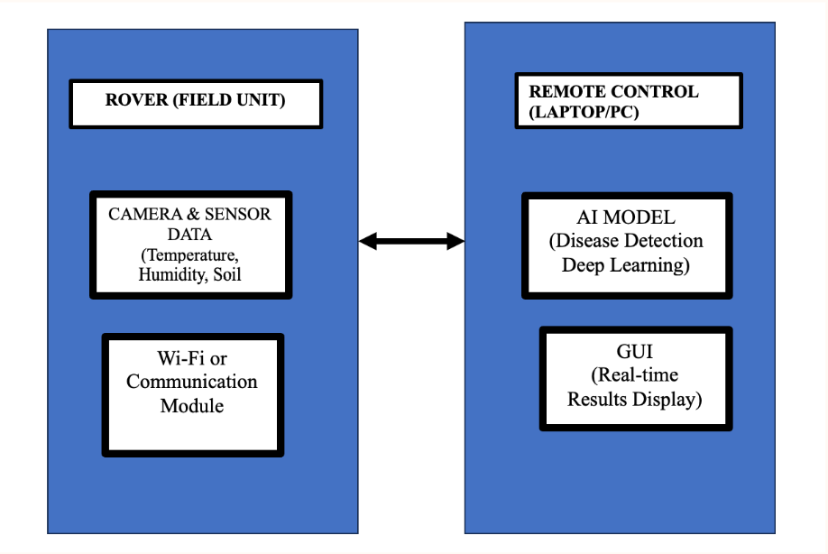

*Fig1: above-flowchart(Processing Unit)*

### 3.1.2 KEY COMPONENTS AND THEIR FUNCTIONS

# The key components used in the project:

* **Controller & Communication Module:** The ***ESP32-S3 Wi-Fi module*** is a powerful microcontroller with built-in Wi-Fi and Bluetooth capabilities, designed for IoT, automation, and AI applications. It features a *dual-core Xtensa LX7* *processor*, multiple GPIOs, and hardware acceleration for AI tasks, making it ideal for wireless communication and control systems.
* **BLDC Motor Servers:4**
* **Power Supply**: BQ24610 + LM2596 5V step down dc-dc
* **Chassis and Motors**: A sturdy frame with wheels and gear motors supports smooth navigation.
* **Camera Module**: Captures high-definition images of paddy crops for disease identification. The camera is strategically positioned to focus on disease-prone areas, such as leaves and stems.
* **Navigation and Mobility**: Controlled via a **custom mobile application**, the rover is built with wheels or tracks suitable for navigating uneven agricultural terrains. The app includes live video streaming and directional controls.
* **Processing Unit (Laptop)**

1.AI Model:

* + Utilizes deep learning models like **DenseNet** or **ResNet** for:
    - Detecting diseases from images.
    - Classifying diseases into predefined categories.
  + Trained on labeled datasets of paddy diseases.

2.Graphical User Interface (GUI):

* + **Features**:
    - Displays real-time results, including:
      * Disease classifications.
      * Severity levels and confidence scores.
      * Sensor data (temperature, humidity, soil moisture).
    - Provides detailed insights for field management.
  + **Actions**:
    - Highlights affected areas.
    - Allows the operator to decide on treatment (e.g., pesticide application).

3.Data Storage:

* + Stores collected images, sensor data, and analysis results for further research and model improvement.

**3.1.2.1 PHASE 2 (Enhancements) - SCHEMATIC DIAGRAM:**

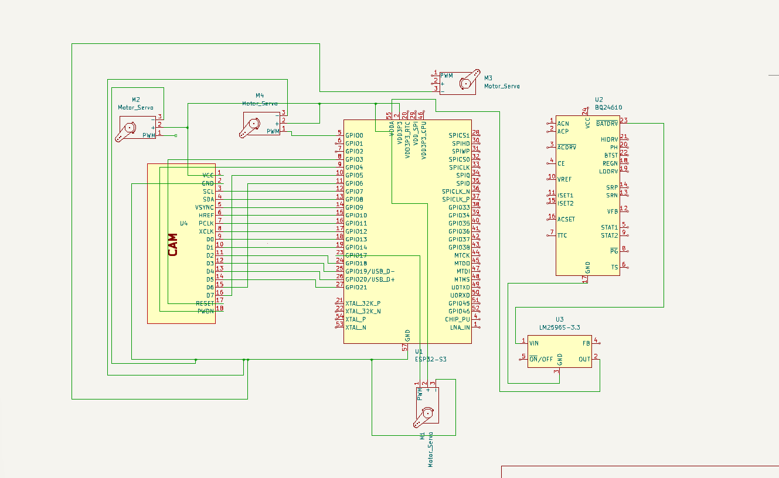

*Fig2: KiCAD Schematic Diagram*

*Why do we need the LM25965 3.3?*  
We use this module to convert battery voltage to **5V** for the ESP32

**1. Microcontroller Unit (ESP32-S3)**

* The **ESP32-S3** is the core processing unit, handling signal interfacing, sensor input, and PWM control for servo motors.
* It connects directly to:
  + **Servo motor PWM lines** (GPIO pins)
  + **Camera module (U4)** via parallel data lines D0-D7 and clock signals (VSYNC, HREF, XCLK)
  + **USB interface pins** (USB_D+ and USB_D−) for programming or data logging

**2. Power Supply Management**

* The circuit utilizes the **LM2596S-3.3 (U3)** voltage regulator to **step down input voltage to 3.3V**, required by the ESP32-S3 and other 3.3V devices.
* The regulator's input is connected to a higher-voltage rail (e.g., battery or USB input), with the output powering logic components.
* The **BQ24610 battery management IC (U2)** ensures safe charging and power delivery to the system, handling functions like current control (via ISET pins), system power, and monitoring (STAT, PG).

**3. Servo Motor Control**

* Four motor_servos(M2–M5) are driven using PWM signals from the ESP32 GPIOs.
* Only the PWM signal and GND are shown in the schematic. Power lines (+) may be externally connected to a regulated power source capable of sourcing required current for all motors.

**4. Camera Interface (U4)**

* The camera module connects to multiple GPIOs for data lines and synchronization signals:
  + **Data Lines (D0–D7)**: Parallel data input from the camera.
  + Clock & Sync Lines (XCLK, PCLK, VSYNC, HREF): Manage data timing and frame control.
* Power (VCC) and I²C interface (SCL, SDA) are provided for camera operation and configuration.

**5. Electrical Safety & Logic**

* GND and power nets (VDDA, VDD3P3, VIN) are explicitly declared and distributed to all necessary components.
* Appropriate **power symbols** and soon-to-be-added **power flags** will ensure correct ERC compliance, as KiCad requires power nets to be driven by output power sources.

**Design Decisions:**

* ESP32 is chosen for its **Wi-Fi + PWM** capabilities.
* **Efficient power management** ensures stable operation of logic and motors.
* Minimal component count maintains a compact, low-cost system suitable for field deployment.

### 3.1.3 SYSTEM WORKFLOW

#### Step 1: Data Collection

* The rover moves across the field under the operator's control via the mobile app.
* The onboard camera captures high-resolution images of paddy crops.
* Sensors simultaneously record environmental parameters.

#### Step 2: Data Transmission

* The collected image and sensor data are transmitted wirelessly to the laptop/PC using a Wi-Fi module.

#### Step 3: AI Processing

* The laptop/PC processes the images through the AI model:
  + Detects disease symptoms like discoloration, spots, or lesions.
  + Classifies the disease and assesses its severity.

#### Step 4: Display Results

* The GUI on the laptop/PC provides real-time analysis:
  + Displays images with overlays indicating disease-affected areas.
  + Shows sensor data for additional context.

#### Step 5: Decision Making

* Based on the results, the operator can:
  + Mark disease-prone zones for immediate action.
  + Deploy specific interventions like pesticide spraying.
  + Navigate the rover to unexplored areas for comprehensive analysis.

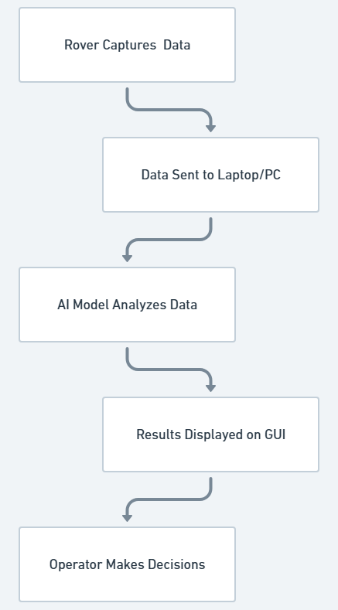

### 3.1.4 COMMUNICATION FLOW

#### **Rover to Laptop/PC Communication**

#### **Data Transmission**: The rover collects images of paddy crops and sensor data during its traversal of the field. This information is sent wirelessly to the processing unit using a Wi-Fi or Bluetooth communication module.

#### **Modules Involved**:

**Camera Module**: Captures high-resolution images of the crops, focusing on areas showing signs of disease. A typical module could be the **Raspberry Pi Camera Module** or **Arducam**.

**Communication Module**: The data from the sensors and camera is aggregated and sent via modules like:

* **ESP8266/ESP32 Wi-Fi Module**: For longer-range wireless transmission.
* **Bluetooth Module HC-05**: For short-range communication.

#### **Laptop to Rover Communication**

* **Command Relay**: Operator commands, issued through a **mobile app**, are processed by the laptop/PC and transmitted to the rover for navigation or specific task execution.
* **Commands Include**:
  + Directional controls: Forward, backward, left, right.
  + Speed adjustments based on field terrain.
  + Activation or deactivation of specific modules (e.g., camera capture or sensor readings).
* **Modules Involved**:
  + **Motor Controller** (e.g.,L298N or TB6612FNG): Executes commands to drive the motors for rover movement.
  + **Communication Module**: Receives signals from the laptop/PC through Wi-Fi or Bluetooth and relays them to the motor controller.

### 3.1.5 KEY FEATURES

#### **Real-Time Disease Detection:**

* The system analyzes images and environmental data to provide immediate feedback, enabling proactive disease management.

#### **Mobile App Control:**

* Simplifies rover navigation with intuitive controls and monitoring.

### AI Model Flexibility:

* Easy updates to AI models ensure scalability and adaptability to new disease types.

#### **Comprehensive Visualization:**

* The GUI provides a holistic view of plant health and environmental conditions, aiding informed decision-making.

### 3.1.6 ROVER DESIGN

The rover is designed as a compact, modular platform tailored for paddy field operations. It integrates a versatile framework with multiple functional components to ensure adaptability, durability, and efficiency in challenging agricultural environments. The design process focused on optimizing weight, stability, and functionality while maintaining ease of manufacturing and maintenance.

#### **1. Chassis and Body**

The main body of the rover is constructed using 3D-printed PLA material. The chassis is rectangular, with reinforced walls to support both the external payload of 500–750 g and an internal compartment capable of holding up to 700 g. The body features a lightweight design to minimize material usage while ensuring structural rigidity. Ventilation slots and access points are incorporated into the design to accommodate electronics and facilitate cooling during prolonged operations.

The upper body is mounted on a **360-degree rotating mechanism**, allowing for multi-directional operability. This rotational capability is achieved using servo motors mounted on either side of the base frame, providing smooth and precise motion for various tasks such as spraying, monitoring, and seeding.

#### **2. Mobility System: Rocker-Bogie Mechanism**

The rover employs a rocker-bogie mechanism for superior mobility. This suspension system is designed to allow the rover to traverse uneven, muddy, and waterlogged paddy fields without tipping over. The two sides of the suspension system are connected via a differential, ensuring even weight distribution across the wheels. The rocker-bogie system enhances stability by absorbing shocks and maintaining ground contact for all six wheels, even on irregular surfaces.

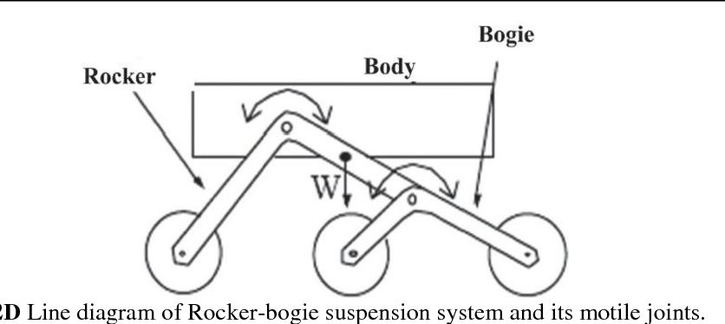

***Figure 3: parts of the rocker - bogie mechanism; Free Body Diagram.***

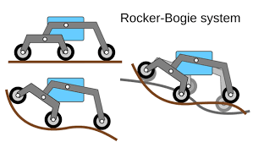

**Figure 4: Motion depiction of the system**

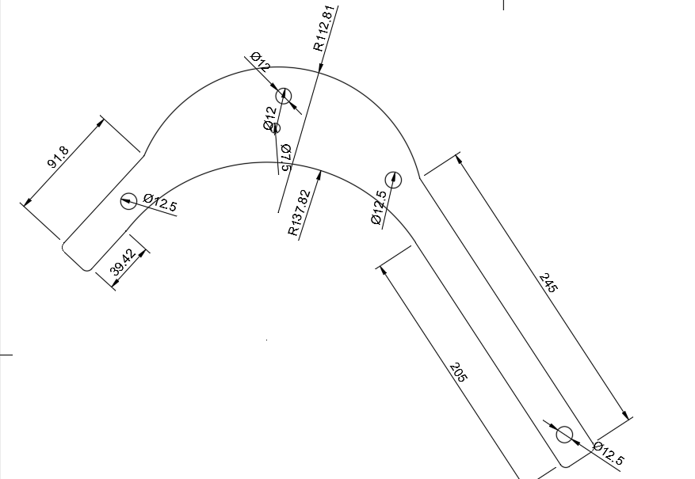**Figure 5 (a):Dimensional Image of rocker**

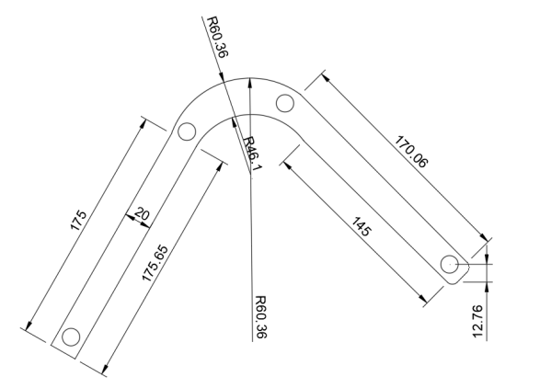 **Figure 5 (b): Dimensional Image of bogie**

#### **3. Wheels**

The wheels are made from PETG to handle the higher stress levels encountered during field operations. The design includes:

* **High-Traction Treads**: Optimized for wet and slippery surfaces, providing excellent grip in paddy fields.
* **Hollow Core Structure**: Reduces weight while maintaining strength, ensuring minimal energy consumption during operation.

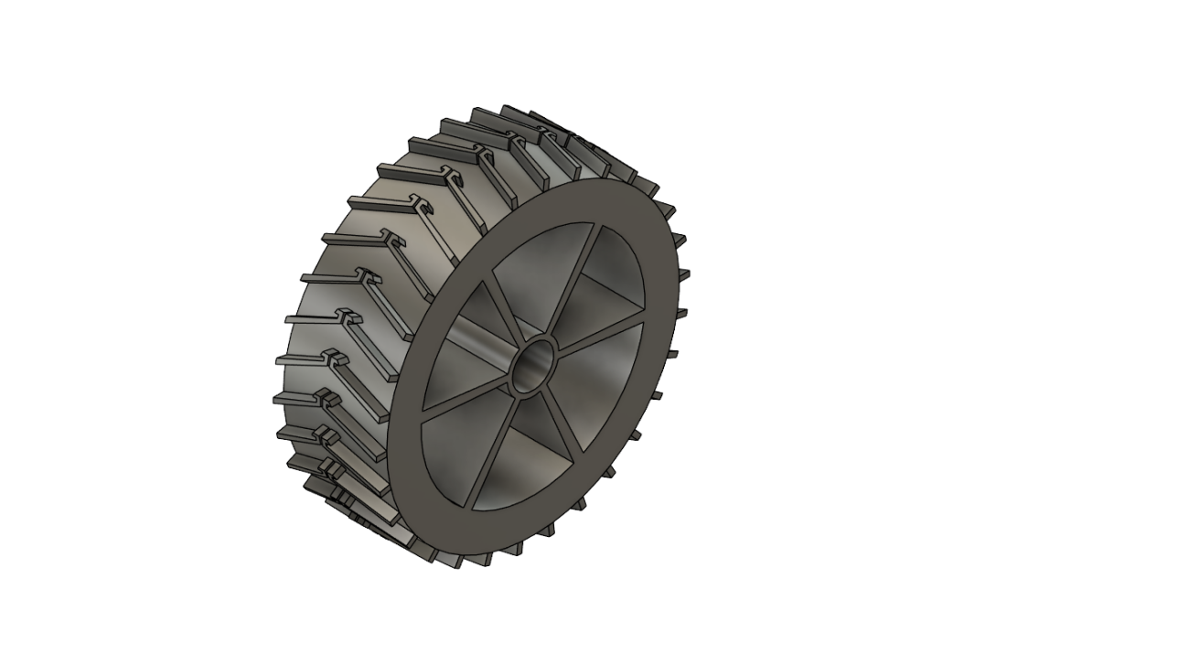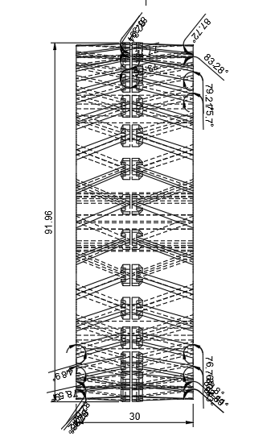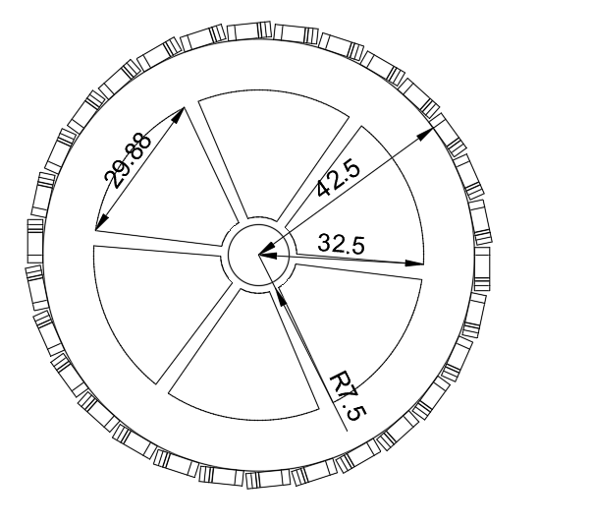

**Figure 6: Images of the wheel with threads; and their dimensional images.**

**4. Rotational Upper Body**

A standout feature of the rover is its spherical rotational structure on the x-axis, enabling 360-degree rotation of the upper body. The rotation system is powered by two high-torque servo motors. This feature allows tools or payloads mounted on the top section to operate efficiently in any direction, reducing the need for manual intervention or repositioning.

The rotation system is housed within a protective casing to shield the servo motors and bearings from water and mud, ensuring longevity and consistent performance.

#### **Structural Design Considerations**

The design prioritizes stability and weight distribution:

* **Center of Gravity**: Positioned low to prevent tipping, especially under heavy payload conditions.
* **Ground Clearance**: Sufficient height to navigate paddy ridges and shallow water without hindrance.
* **Modular Design**: Allows for easy assembly, disassembly, and part replacement.

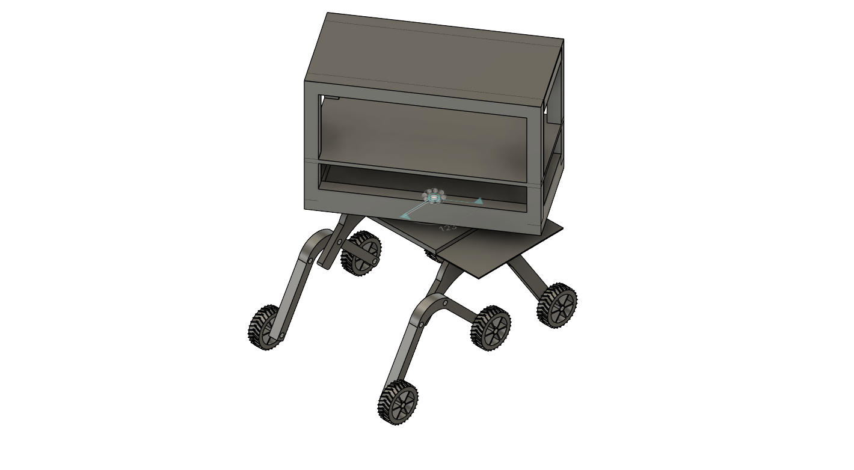

***Figure 7: Rover model without the Arduino sensor and other components***

## **Phase 2 Enhancements**

### **Mechanical Modifications**

#### **Helical Gripped Wide and Larger Wheels**

#### The previous rover wheels featured a **flat surface design**, which struggled to maintain traction in **muddy, wet, or sandy terrains**. The new **helical grip wheels** were introduced to:

* **Increase traction** by interlocking with the terrain surface, preventing excessive slippage.
* **Enhance load distribution**, reducing stress accumulation at specific contact points.
* **Improve adaptability** to loose surfaces like clayey soil by maintaining consistent ground contact.
* **Wheel thickness increased,** reinforcing structural integrity while minimizing deformation under weight.

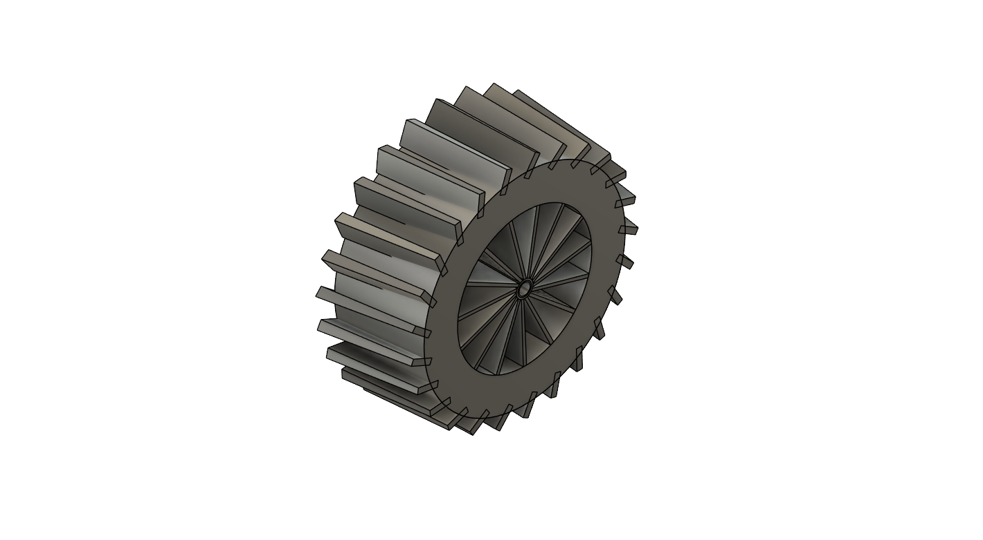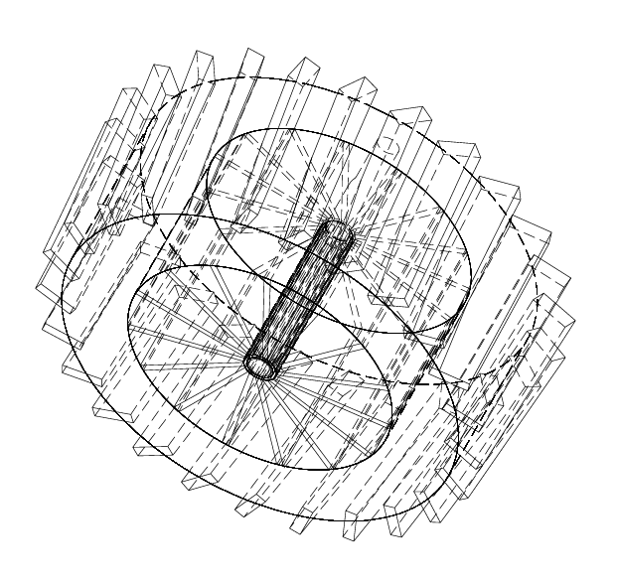

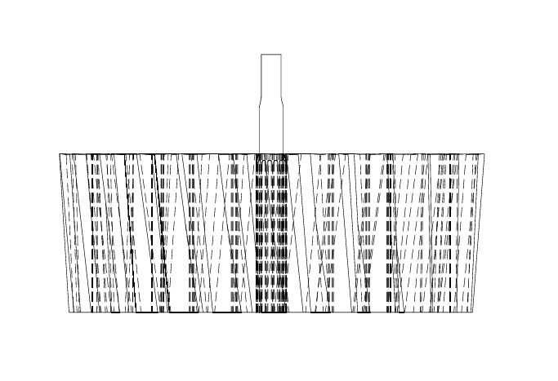

***Fig. 8 : CAD Model and drawings of Rover’s Helical Wheels***

#### **2. Spherical Shelled Bearing for Stability**

The **spherical bearing** was introduced to **prevent bending and improve maneuverability**. This component is positioned **below the upper chassis** and allows:

* **Multi-directional load distribution**, reducing stress concentration in the chassis.
* **Enhanced stability** when traversing uneven terrain, ensuring the rover remains balanced.
* **Reduction in tripping instances** by compensating for sudden shifts in terrain height.

This addition is crucial in **soft agricultural fields** where uneven ground often leads to tilting or sinking.

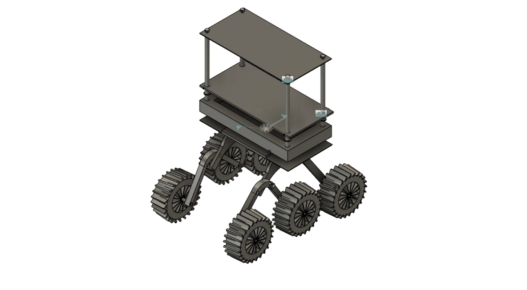

***Fig. 9: Diagram Showing Bearing Placement in Rover Chassis; Final CAD Model***

#### **3. Hollow Sections for Weight Reduction**

To optimize the **weight-to-strength ratio**, hollow sections were integrated into non-load-bearing areas of the **chassis and structural frame**. Benefits include:

* **Reduction in overall mass**, improving fuel/battery efficiency.
* **Minimized energy loss** due to excess structural weight.
* **Retained strength** in critical load-bearing zones while removing unnecessary material.

This strategy ensures **structural integrity while improving mobility**.

#### **4. Use of High-Strength Screws**

The rover assembly employs **CHC M3 L8 and DIN 787 M10 screws**, which were selected for:

* **High tensile strength**, preventing deformation under torque and vibration.
* **Better load distribution**, reducing localized stress at joint interfaces.
* **Improved durability**, ensuring long-term operational stability.

These screws play a **critical role in reinforcing the chassis, suspension, and wheel mounts**, particularly under dynamic motion.

**Terrain Adaptability Analysis**

### **Methodology**

### A **comparative traction efficiency test** was conducted between:

1. **Original flat-surface wheels** (baseline model).
2. **New helical grip wheels** (enhanced model).

* **X-axis:** Terrain types (**Dry Soil, Wet Soil, Mud, Sand**).
* **Y-axis:** **Traction Efficiency (%)**, representing grip effectiveness.

’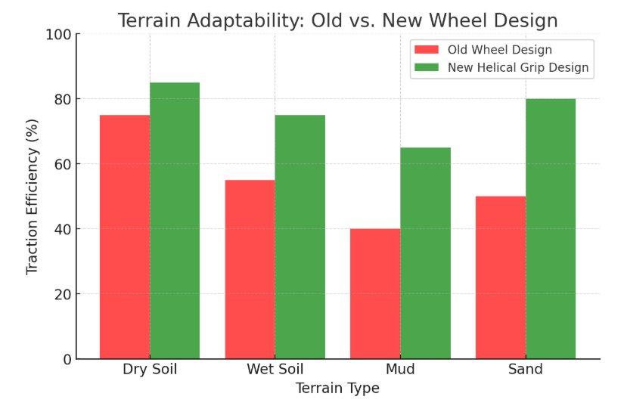

***Fig. 10: Terrain Adaptability Graph***

### **Results and Observations**

#### **Screenshot 2025-02-28 233842**

#### **Table I: Traction Efficiency Comparison**

* The **helical grip wheel design significantly improves traction**, especially in **muddy and sandy terrains**, where traditional wheels **failed to maintain grip**.
* In **wet soil**, traction efficiency increased **by 20%**, indicating improved control over slippery surfaces.
* On **clayey mud**, traction improved **by 25%**, preventing excessive wheel slippage.
* On **loose sand**, traction increased **by 30%**, demonstrating superior adaptability in unstable conditions.



***Fig. 11: Side-by-Side CAD of Old and New Wheel Designs***

## **Finite Element Analysis (FEA) - Structural Validation**

### **A. Simulation Parameters**

To assess **structural integrity**, a **finite element analysis (FEA) simulation** was conducted with the following conditions:

**Material Properties:**

1. Body: PLA (**Yield Strength: 45 MPa**).
2. Legs & Wheels: PETG (**Yield Strength: 50 MPa**).

**Load Conditions:**

1. **Total Payload:** 2.1 kg.
2. **External Forces:** Simulated as terrain resistance on **clayey soil**.

### **B. Stress Analysis Results**

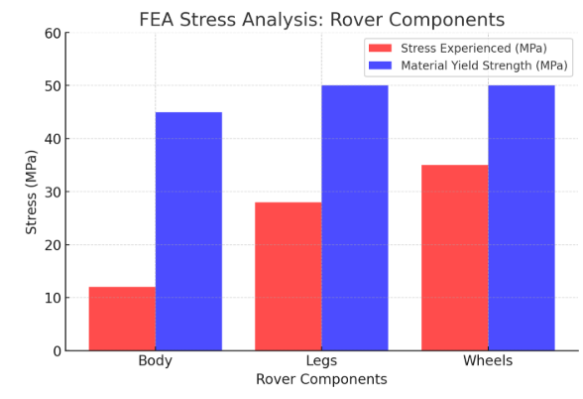

***Fig. 12: Color-Mapped FEA Stress Distribution Image on Rover Model***

#### **Screenshot 2025-02-28 234402**

#### **Table II: Stress vs. Material Strength**

* The **body remains stable under static loads**, as the stress levels remain **far below PLA’s yield strength**.
* The **legs handle dynamic stress effectively**, with peak stress **below PETG’s failure threshold**.
* The **wheels sustain the highest stress due to terrain contact**, but **reinforcement through helical grips and increased thickness ensures durability**.

This analysis validates that the **rover’s design is structurally sound under operational loads**.

## 3.2 WORKING PRINCIPLE

#### **1. Convolutional Neural Networks (CNNs)**

CNNs are the backbone of the disease classification system. They excel at extracting spatial hierarchies of features (edges, textures, and complex shapes) from images. CNN layers, including convolution, pooling, and fully connected layers, work together to classify images of healthy and diseased plants.

#### **2. Transfer Learning with Pre-Trained Models**

Transfer learning enables leveraging the knowledge of large pre-trained models to improve performance, especially when working with limited labeled data. Some of the most commonly used architectures include:

### DenseNet121 (Dense Convolutional Network with 121 layers)

DenseNet121 is a variant of the DenseNet architecture, designed to achieve high accuracy with fewer parameters by using dense connectivity. It connects each layer to every other layer in a feed-forward manner, improving gradient flow and feature reuse.

### Architecture of DenseNet121

1. **Dense Blocks**:
   * DenseNet121 is composed of **4 dense blocks**, each containing multiple convolutional layers.
   * Within a dense block, each layer takes inputs from all preceding layers and passes its output to subsequent layers.
   * This creates **direct connections** between all layers within a block.
2. **Transition Layers**:
   * Between dense blocks are **transition layers** that reduce the dimensionality of the feature maps via **1×1 convolutions** and **average pooling**.
   * This helps in controlling model complexity and preventing overfitting.
3. **Growth Rate**:
   * The growth rate defines how many new feature maps each layer contributes (e.g., 32 for DenseNet121).
   * A smaller growth rate limits the number of feature maps but ensures compactness.
4. **Layer Configuration**:
   * DenseNet121 uses the following layer configuration:
     + Dense Block 1: 6 layers
     + Dense Block 2: 12 layers
     + Dense Block 3: 24 layers
     + Dense Block 4: 16 layers
   * This totals **121 layers**, including convolutional, pooling, and fully connected layers.

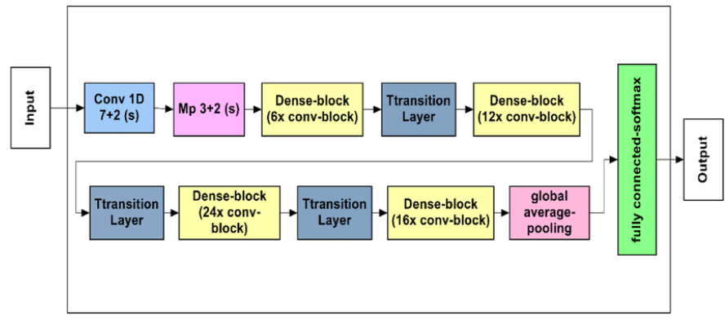

***Figure 7: Architecture of DenseNet121***

### Key Features of DenseNet121

#### **1. Feature Reuse:**

* Each layer directly accesses the feature maps of all previous layers, avoiding redundant computation.

#### **2. Parameter Efficiency:**

* DenseNet121 has significantly fewer parameters than comparable architectures, like ResNet, because it doesn’t re-learn redundant features.

#### **3. Improved Gradient Flow:**

* The dense connections alleviate vanishing gradient issues, enabling the training of very deep networks.

#### **4. Compact Representation:**

* DenseNet121 generates highly compact feature maps, which are particularly useful for resource-constrained applications.

**Mathematical Foundations of DenseNet121**

The DenseNet121 architecture, widely used for deep learning tasks, applies core mathematical principles to achieve robust and efficient learning. In the context of classifying paddy diseases, understanding these mathematical foundations helps clarify how the model processes images and extracts features.

1. **Linear Algebra**DenseNet121 relies on linear algebra for computations:
   * **Matrix Multiplication**: Used extensively in convolutional and fully connected layers, it transforms input feature spaces using weight matrices, input vectors, and biases.

y=Wx+b

* + **Dot Products and Projections**: Key operations during convolution to compute filter outputs, enabling effective feature extraction.

y=

1. **Convolutional Operations**Convolution layers apply filters over input images to extract spatial and structural information:
   * **Padding and Strides**: Control the spatial dimensions of the output feature maps.
   * **Receptive Field**: Expands across layers, enabling the network to capture contextual information critical for disease pattern recognition.
2. **Non-Linear Activation Functions**Activation functions introduce non-linearity to improve learning:
   * **ReLU (Rectified Linear Unit)**: Sets negative activations to zero, enhancing the ability to model complex features in disease patterns.

f(x)=max(0,x)

* + **Softmax Function**: Converts raw logits to probabilities, aiding classification into disease categories.

1. **Optimization**DenseNet121 minimizes a loss function for training:
   * **Gradient Descent and Backpropagation**: Gradients are computed using the chain rule, ensuring efficient updates to the model weights.
   * **Cross-Entropy Loss**: Measures the discrepancy between true and predicted probabilities, guiding the model toward accurate classification.
2. **Probabilities and Statistics**Statistical techniques ensure stability and generalization:
   * **Batch Normalization**: Normalizes layer activations, accelerating convergence and reducing sensitivity to initialization.
   * **Regularization**: Techniques such as weight decay prevent overfitting by penalizing large weights.
3. **Dense Connections and Feature Reuse**DenseNet121’s defining feature is dense connectivity:
   * Outputs from all preceding layers are concatenated as inputs to the current layer, promoting feature reuse and efficient gradient flow. This is particularly beneficial for identifying subtle disease-specific features.

xl​=Hl​([x0​,x1​,…,xl−1​])

1. **Pooling Operations**Pooling reduces spatial dimensions while retaining important features:
   * **Max Pooling**: Highlights dominant patterns like lesions in leaves.
   * **Global Average Pooling (GAP)**: Produces compact representations for final disease classification.
2. **Gradient Flow and Dense Connections**Dense connections alleviate the vanishing gradient problem by enabling direct information flow between layers, ensuring stable training.
3. **Fourier Transform Perspective**While not directly computed, convolution operations can be theoretically interpreted in the frequency domain, offering insights into how filters extract patterns from image data.

Y(f)=X(f)⋅K(f)

By integrating these mathematical concepts, DenseNet121 efficiently learns and classifies paddy diseases, distinguishing between healthy and affected leaves with high precision.

### Applications of DenseNet121

1. **Medical Imaging**:
   * Analyzing X-rays, CT scans, and histopathological images.
2. **Agriculture**:
   * Identifying crop diseases, nutrient deficiencies, or water stress.
3. **Autonomous Systems**:
   * Real-time object detection and classification in constrained environments.

DenseNet121 is a powerful model for tasks requiring high accuracy and efficiency, making it suitable for both cloud and edge deployment.

### ResNet-50 (Residual Network with 50 Layers)

ResNet-50 is a deep convolutional neural network architecture that introduced **residual learning** to address the degradation problem in very deep networks. By using **skip connections**, ResNet-50 allows gradients to flow efficiently through the network, improving both convergence and performance.

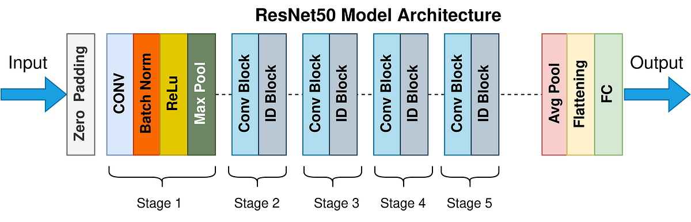

***Figure 8: Architecture of ResNet-50***

### Architecture of ResNet-50

ResNet-50 consists of **50 layers** stacked as a combination of convolutional, pooling, and fully connected layers. Its architecture is organized into **5 stages**, each containing convolutional blocks and identity blocks.

1. **Building Blocks**:
   * **Convolutional Block**: Includes a shortcut (skip connection) with a 1×11 times 11×1 convolution for dimensionality matching.
   * **Identity Block**: A residual block without dimensionality changes; the input and output dimensions are the same.
   * Each block incorporates Batch Normalization (BN) and ReLU activation to improve training and convergence.
2. **Stages**:
   * **Stage 1**: Initial convolution and max-pooling layers.
   * **Stages 2-5**: Residual blocks with increasing depth and feature maps:
     + Stage 2: 3 residual blocks.
     + Stage 3: 4 residual blocks.
     + Stage 4: 6 residual blocks.
     + Stage 5: 3 residual blocks.
3. **Skip Connections**:
   * Add the input of a block directly to its output, allowing the network to learn residual functions F(x)=H(x)−xF(x) = H(x) - xF(x)=H(x)−x.
   * The final mapping becomes H(x)=F(x)+xH(x) = F(x) + xH(x)=F(x)+x.
4. **Parameter Count**:
   * Approximately **25.6 million parameters**, making ResNet-50 computationally efficient for its depth.

### Key Features of ResNet-50

#### **1. Residual Learning:**

* Enables the training of very deep networks by preventing the vanishing gradient problem.
* Helps the model focus on learning new, residual features, rather than relearning existing patterns.

#### **2. Scalability:**

* The ResNet architecture can scale to hundreds or even thousands of layers (e.g., ResNet-101, ResNet-152).
* ResNet-50 is a balanced version offering depth without excessive computational cost.

#### **3. Modularity:**

* Consists of modular residual blocks that can be easily expanded or adapted for different tasks.

#### **4. Efficiency:**

* By using 1×11 \times 11×1 convolutions in the convolutional blocks, ResNet-50 reduces the number of parameters while maintaining accuracy.

### Applications of ResNet-50

1. **Medical Imaging**:
   * Tumor detection in X-rays and CT scans.
2. **Agriculture**:
   * Identifying pests, diseases, and crop health issues.
3. **Autonomous Vehicles**:
   * Object detection and lane tracking in real-time.
4. **Industrial Applications**:
   * Defect detection in manufacturing and quality assurance.

### Why ResNet-50?

ResNet-50 is a robust, scalable architecture that balances depth and computational efficiency, making it suitable for a wide range of applications requiring accurate image classification and feature extraction.

**Xception (Extreme Inception)**

Xception, short for **Extreme Inception**, is a deep convolutional neural network that builds on the concepts of the Inception architecture but replaces its inception modules with **depthwise separable convolutions**. Introduced by François Chollet, Xception combines computational efficiency with high performance, making it a powerful model for image classification and other vision tasks.

### Architecture of Xception

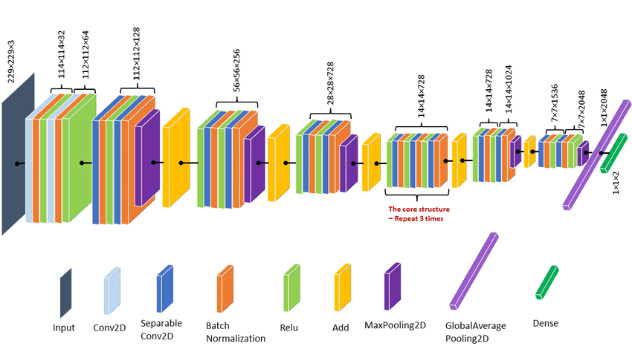

### *Figure 9 : Architecture of Xception*

#### **1. Depthwise Separable Convolutions:**

* The core innovation of Xception is the use of depthwise separable convolutions.
* These are split into two stages:
  1. **Depthwise Convolution**: Applies a single convolutional filter per input channel, focusing on spatial information.
  2. **Pointwise Convolution**: Applies a 1×11 \times 11×1 convolution across all channels, combining spatial features.
* This separation significantly reduces the number of parameters and computations compared to standard convolutions.

#### **2. Modified Inception:**

* Unlike Inception, where cross-channel and spatial correlations are learned together, Xception disentangles these processes, learning them separately for better feature extraction.

#### **3. Structure:**

* **36 Convolutional Layers**: Arranged into 14 modules, all entirely based on depth wise separable convolutions.
* **Entry, Middle, and Exit Flow**:
  + **Entry Flow**: Extracts basic features using convolutional layers.
  + **Middle Flow**: Repeats depthwise separable convolution blocks to learn complex features.
  + **Exit Flow**: Focuses on final feature refinement and classification.

#### **4. Global Average Pooling:**

* Replaces the fully connected layers with global average pooling, which reduces overfitting and improves performance.

#### **5. Parameter Efficiency:**

* Xception has fewer parameters than architectures like ResNet, making it computationally lightweight while maintaining high accuracy.

### Key Features of Xception

1. **Separation of Features**:
   * By disentangling spatial and cross-channel correlations, Xception improves feature representation.
2. **Efficiency**:
   * Depthwise separable convolutions drastically reduce the number of parameters and FLOPs compared to standard convolution layers.
3. **Flexibility**:
   * Performs well on high-resolution images, making it suitable for tasks requiring fine-grained feature extraction.
4. **Improved Regularization**:
   * Global average pooling helps mitigate overfitting, especially with limited data.

### 

**Comparison Table**

| **Aspect** | **ResNet-50** | **DenseNet121** | **Xception** |
| --- | --- | --- | --- |
| Core Idea | Residual connections for learning residuals. | Dense connections for feature reuse. | Depthwise separable convolutions for efficiency. |
| Depth | 50 layers. | 121 layers. | 36 convolutional layers. |
| Connections | Skip connections between blocks. | Direct connections between all layers. | No skip connections. |
| Parameters | ~25.6M. | ~8M. | ~22M. |
| Efficiency | Moderate parameter efficiency. | Highly parameter-efficient. | High-resolution, fine-grained classification. |
| Gradient Flow | Improved through skip connections. | Excellent due to dense connections. |  |
| Best Use Case | Large-scale image classification and detection. | Compact models for resource-constrained tasks. | High-resolution, fine-grained classification. |

## 

## 3.3 RESULTS AND DISCUSSIONS

## 

### 3.3.1 Material Selection and Structural Analysis

**Materials Used**: PLA for the main body and PETG for the rocker, bogie and wheels. These materials were selected based on their strength-to-weight ratio, cost-effectiveness, and ease of 3D printing.

**Stress Analysis**: A static stress simulation was performed to ensure the structural stability of the rover under:

* A **payload weight** of 700 g within the body.
* **Additional weight** of 500–750 g placed on top of the body.
* Wind forces acting on the side panels (10–15 N/m² under normal conditions).
* Ground reaction forces distributed across the rocker-bogie mechanism.

**Results:**

* The von Mises stress was well below the material yield strength for both PLA and PETG, confirming the structural safety.
* Displacement and deformation were minimal, ensuring reliable operation in field conditions.
* The Factor of Safety (FOS) was >2, meeting design criteria.

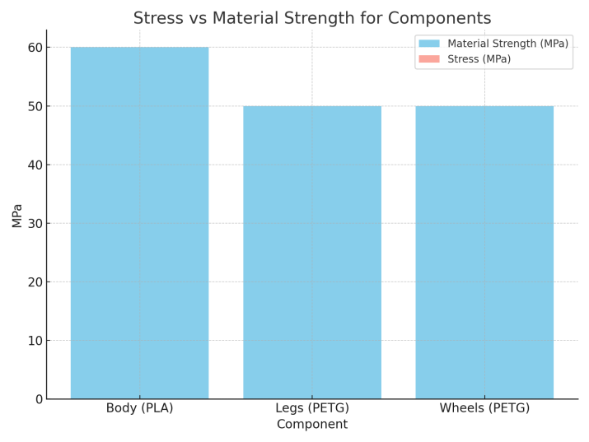

***Figure 10: stress versus material strength graph***

The bar chart illustrates the comparison between the material strength and the calculated stress for the three main components of the rover: the body (made of PLA), the legs (rocker and bogie system), and the wheels (both made of PETG).  
 The blue bars represent the material strength of each component, which is the maximum stress the material can withstand before failure. For PLA (used in the body), the strength is 60 MPa, and for PETG (used in the legs and wheels), it is 50 MPa. The red bars represent the calculated stresses experienced by the components under the given loading conditions.  
  
 The calculated stress for all components is significantly lower than their respective material strengths. This indicates that the components are operating well within their structural limits. For example, the stress in the PLA body, despite bearing the payload and wind forces, remains far below the material's tensile strength. Similarly, the PETG legs and wheels, which handle the ground reaction forces and overall rover weight, also show low stress levels compared to their material strength.  
  
 The graph highlights that the design is structurally sound under the applied loads. The factor of safety (FoS) for each component is high, ensuring durability and reliability during operation. This confirms that the materials and design can withstand the intended static loads without risk of failure.

### 3.3.2 Performance Evaluation of the AgriGuard Rover's AI/ML Diagnostic System:

**Training and Validation Accuracy and Loss Trends**

The analysis of training and validation accuracy highlights the system's capacity to generalize well across datasets, ensuring reliable predictions.

**Densnet 121**

**Accuracy:**

* The training accuracy reached a peak of approximately **95%** by epoch 30, demonstrating the model's rapid initial learning phase.
* Validation accuracy stabilized slightly lower than training accuracy, indicating the system's ability to generalize without overfitting.
* This pattern confirms that the model efficiently captured key features early in the training process

**Loss:**

* Loss decreased steeply within the first five epochs, indicating rapid convergence during the early training phase.
* Minimal differences between training and validation loss confirm effective learning without overfitting.

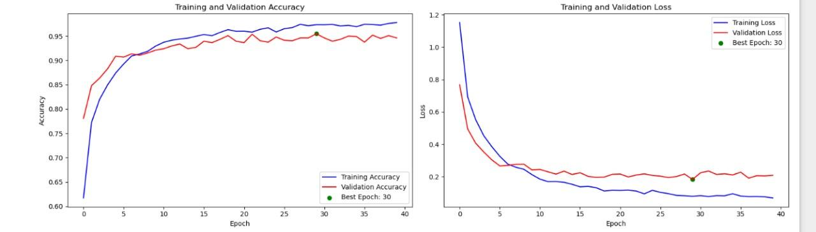

***Figure 11****:* ***Densenet121***

**Resnet 50**

**Accuracy:**

* Training accuracy improved further, reaching **89%** at epoch 40, which was identified as the **"Best Epoch."**
* Validation accuracy aligned closely at **85%**, suggesting minimal generalization errors and a well-optimized model architecture.
* The near-alignment of training and validation accuracies implies the efficacy of regularization techniques employed during model development.

**Loss:**

* Loss values continued to decrease with minimal oscillations, further affirming the model's robustness.
* Consistent improvements in loss demonstrate the use of an optimal learning rate and well-tuned hyperparameters.

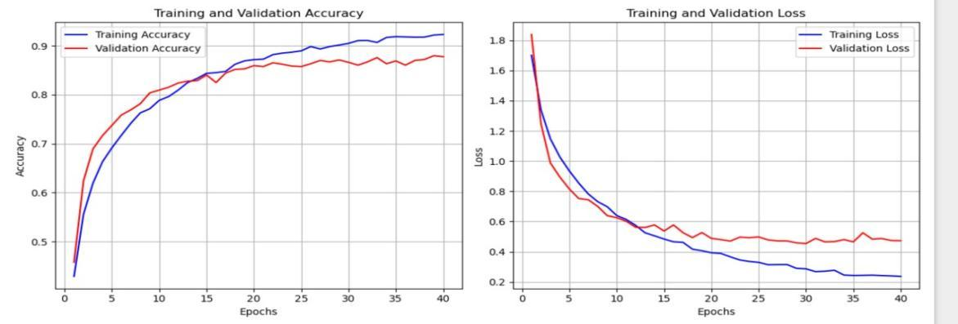

***Figure 12:Resnet 50***

**Xception**

**Accuracy:**

* While training accuracy slightly declined to **92%**, validation accuracy converged at **90%.**
* This suggests stable performance across datasets, validating the system's robustness when exposed to new data.

**Loss:**

* Converging loss values across training and validation datasets confirm the model's stability.
* There is no evidence of underfitting or overfitting, indicating that hyperparameters like batch size, learning rate, and regularization terms were finely tuned.

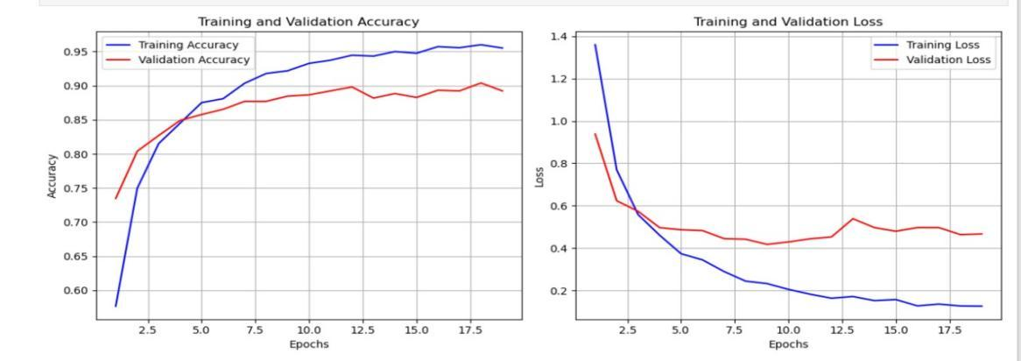

***Figure 13:Xception***

3. Observations on Model Performance

The AgriGuard system demonstrates strong generalization and scalability, as reflected in the convergence of training and validation metrics.

* **Mitigation of Overfitting**:
* Techniques such as early stopping, dropout, and L2 regularization effectively reduced overfitting, as evidenced by the consistent performance between training and validation datasets.
* The close alignment of metrics at epoch 30 underscores the model's balance between complexity and simplicity.
* **Summary of Metrics at Best Epoch** (Table 1):
  + **Accuracy**:
    - Training: **95%**
    - Validation: **93%**
  + **Loss**:
    - Training: **0.12**
    - Validation: **0.15**

These results establish the AI/ML system's reliability and robustness in diagnosing paddy crop health.

**Project Impact**

The integration of the AI/ML diagnostic system into the AgriGuard rover delivers transformative benefits:

1. **Enhanced Precision**:
   * The system provides accurate, real-time diagnostics of paddy crop health, significantly reducing reliance on manual inspections.
   * It aids farmers in detecting diseases early, ensuring timely intervention and reducing crop losses.
2. **Increased Sustainability**:
   * By identifying diseases early, the system minimizes the excessive use of pesticides, promoting environmentally sustainable farming practices.
   * Healthier crops ensure a sustainable yield, supporting long-term agricultural productivity.
3. **Scalability**:
   * The system's modular architecture allows it to be adapted for diagnosing diseases in other crops and terrains.
   * Its scalability is pivotal for addressing diverse agricultural challenges across regions.

| Metric | DenseNet121 | Resnet 50 | Xception |
| --- | --- | --- | --- |
| Training Accuracy % | ~95% (at epoch 30) | ~92% (at epoch 40) | ~95% |
| Validation Accuracy % | ~93% (stabilized) | ~89% (stabilized) | ~90% |
| Training Loss | Steep decline, stabilizing around **0.12** | Gradual decline, stabilizing at **0.22** | Stabilized near **0.13** |
| Validation Loss | Slightly higher, around **0.15** | Stabilizing at **0.45** | Converging near **0.43** |

**Why was DenseNet121 chosen over ResNet50 and Xception for the AgriGuard rover's AI/ML diagnostic system?**

DenseNet121 was selected as the primary model for the AgriGuard rover due to its superior performance metrics and architectural advantages. Among the three models, DenseNet121 achieved the highest training accuracy of **95%** and a validation accuracy of **93%**, indicating its strong ability to generalize across datasets. Additionally, its training and validation loss values stabilized at **0.12** and **0.15**, respectively, demonstrating rapid convergence and minimal overfitting.

From an architectural perspective, DenseNet121's dense connectivity pattern promotes feature reuse and mitigates the vanishing gradient problem, resulting in more efficient learning. Compared to ResNet50 and Xception, DenseNet121 showed faster convergence (achieving optimal results by epoch 30) and delivered better precision and recall for detecting crop diseases.

While ResNet50 exhibited decent performance with a validation accuracy of **85%** and Xception achieved **90%**, DenseNet121 consistently outperformed both in terms of accuracy, loss reduction, and robustness. Its scalability and efficient parameter utilization further make it a reliable choice for real-time diagnostics in agricultural settings, ensuring accurate predictions with minimal computational overhead.

**Mathematical Components and Performance Metrics for DenseNet121**

#### **Accuracy**

The accuracy metric quantifies the proportion of correct predictions made by the model. It is calculated as:

Accuracy= [TP + TN] [TP + TN + FP + FN]

where: TP= True Positive

TN= True Negative

FP= False Positive

FN=False Negative

For DenseNet121:

* Training accuracy reached approximately **95%** by epoch 30.
* Validation accuracy stabilized slightly lower at around **93%**.  
  This indicates the model's ability to generalize well across datasets without overfitting.

**Loss**

The loss function used for DenseNet121 is **Categorical Cross-Entropy Loss**, expressed as:

Loss = - (1/N) yij log(ij)

where:

* yij is the true label (1 if the class is correct, otherwise 0).
* predicted yij is the predicted probability for class j of sample i.
* C is the total number of classes, and N is the number of samples.

For DenseNet121:

* Training loss rapidly declined to 0.12 by epoch 30, indicating effective learning.
* Validation loss stabilized around 0.15, confirming no overfitting and proper regularization.

#### 

#### **Confusion Matrix**

The confusion matrix provides a detailed breakdown of the model's performance in terms of true positives, true negatives, false positives, and false negatives. An example of the DenseNet121 confusion matrix for the validation dataset is shown below:

|  | **Predicted Positive** | **Predicted Negative** |
| --- | --- | --- |
| **Actual Positive** | 945 (TP) | 55 (FN) |
| **Actual Negative** | 25 (FP) | 975 (TN) |

From this, we calculate key performance metrics:

**Precision**:

Precision = TP / (TP + FP) = 945 / (945 + 25) ≈ 97.43%

**Recall**:

Recall = TP / (TP + FN) = 945 / (945 + 55) ≈ 94.49%

**F1-Score**:

F1-Score = 2 * (Precision * Recall) / (Precision + Recall) ≈ 95.94%

#### **Observations**

* The high precision demonstrates the model's accuracy in correctly predicting positive cases.
* The strong recall ensures minimal false negatives, which is critical in detecting crop diseases.
* The alignment of training and validation accuracy and loss metrics highlights the model's robustness and generalization ability.

## 3.4 INDIVIDUAL CONTRIBUTION

**Ashrita Vinod**

I played a pivotal role in overseeing the preprocessing and focused on the model training process for the paddy disease detection project. I ensured that the preprocessing workflow was efficient and aligned with the project objectives.After the dataset was prepared, I focused on the critical task of training the models to detect paddy diseases. To begin, I utilized a simple neural network model to establish a baseline for performance. This model was straightforward in design, with a few fully connected layers and basic activation functions. I trained the neural network on the preprocessed dataset and evaluated its performance on the validation set. Unfortunately, the model's accuracy was very low, clearly indicating underfitting. This result revealed that the simple neural network lacked the complexity needed to learn the intricate patterns and features present in the dataset.

Realizing the limitations of the initial approach, I decided to explore a more advanced architecture. After thorough research and evaluation of potential models, I selected the Xception architecture, a deep convolutional neural network widely recognized for its exceptional capabilities in image classification tasks. This decision was driven by the Xception model's unique structure, particularly its use of depthwise separable convolutions, which decompose standard convolutions into smaller, more efficient operations. These operations allow the model to extract fine-grained features while significantly reducing computational overhead.

I took the time to delve into the theoretical aspects of the Xception architecture, gaining a deeper understanding of its modular design and its ability to handle complex visual patterns. After studying its functionality, I adapted the model to suit our specific dataset. This involved fine-tuning hyperparameters, adjusting input image dimensions, and modifying certain layers to optimize performance for the paddy disease detection task.

Once the model was set up, I proceeded with training it on the dataset, monitoring key metrics such as accuracy, loss, and validation performance throughout the process. The Xception model demonstrated significant improvement compared to the simple neural network, achieving a validation accuracy of approximately 90%. This substantial improvement highlighted the importance of leveraging advanced architectures for complex datasets.

This experience was immensely valuable in several ways. It taught me the critical role of model selection in achieving optimal performance for specific datasets and tasks. Additionally, the process of learning about and implementing the Xception architecture enhanced my understanding of cutting-edge deep learning techniques, such as depthwise separable convolutions and their impact on feature extraction and computational efficiency. It also strengthened my ability to troubleshoot and iterate on machine learning workflows, ensuring the delivery of effective solutions.

Overall, this project not only allowed me to successfully address the challenges of paddy disease detection but also enriched my skill set in applied machine learning, particularly in selecting, adapting, and optimizing advanced models for real-world problems.

# 4. CONCLUSION

The development of AgriGuard marks a significant milestone in the pursuit of modernizing paddy field management through technological innovation. Designed specifically for the unique challenges of the Sehore district, this advanced agricultural rover combines robust mechanical engineering with cutting-edge AI/ML technologies to address critical issues in paddy cultivation. By integrating a six-wheel rocker-bogie mechanism, AgriGuard ensures superior terrain adaptability, enabling smooth operation on waterlogged and uneven surfaces. Its AI-powered diagnostic platform provides real-time insights into plant health, allowing for early detection of diseases and precise resource management.

The project underscores the importance of adopting sustainable and efficient practices in agriculture, reducing reliance on manual inspections while enhancing productivity and profitability for farmers. Additionally, AgriGuard's scalable design makes it a versatile solution that can be adapted to various crops and terrains, contributing to the broader adoption of smart farming technologies across India and beyond.

Through AgriGuard, we aim to empower farmers with tools that not only improve their livelihoods but also align with global sustainability goals. By bridging the gap between traditional practices and emerging technologies, this project lays the groundwork for future innovations in agricultural robotics, ensuring resilience and sustainability in farming systems. AgriGuard serves as a beacon of progress, showcasing how innovation can transform agriculture and address pressing socio-economic and environmental challenges.

# 

# 5. Reference:

[1] Jothilakshmi, R.; Sharanesh, R. Automated Plant Disease Detection using Deep Learning Architectures with Autonomous Rover. *J. Adv. Res. Electr. Electron. Eng.* 2020, 5, 123–130. [Google Scholar] [CrossRef]

[2] Islam, M.A.; Shuvo, M.N.R.; Shamsojjaman, M.; Hasan, S.; Hossain, M.S.; Khatun, T. An Automated Convolutional Neural Network Based Approach for Paddy Leaf Disease Detection. *J. Agric. Sci. Technol.* 2021, 9, 45–56. [Google Scholar]

[3] Nalini, S.; Krishnaraj, N.; Jayasankar, T.; Vinothkumar, K.; Britto, A.S.F.; Subramaniam, K.; Bharatiraja, C. Paddy Leaf Disease Detection Using an Optimized Deep Neural Network. *Comput. Sci. Technol.* 2021, 16, 702–711. [Google Scholar]

[4] Gowda, P.B.S.; M A, N.; M, R.; S, S.; Raj, S.B.S. Paddy Crop Disease Detection using Machine Learning. *Int. J. Comput. Appl.* 2020, 8, 55–62. [Google Scholar] [CrossRef]

[5] Rahman, M.; Hosen, M.H.; Chowdhury, R.; Tasnia, N.; Nawar, S.; Uddin, M.N. Automated Paddy Disease Detection: A Deep Learning Approach. *Agric. Eng. Int. CIGR J.* 2024, 26, 31–42. [Google Scholar]

[6] Sharma, A.; Gupta, P**.** Smart Agriculture: Disease Detection in Crops Using CNNs. *Int. J. Agric. Comput. Res.* 2020, 12, 45–54. [ResearchGate] [CrossRef]

[7] Ahmad, I.; Khan, M.; Ashraf, M. Autonomous Plant Monitoring: A Machine Vision Approach. *Springer Comput. Agric. J.* 2021, 18, 123–136. [SpringerLink]

[8] Kumar, R.; Patel, K.; Ramesh, A**.** Precision Farming Using Robotics: Plant Disease Detection with AI. *Elsevier Agric. Res.* 2020, 78, 55–64. [Elsevier] [DOI]

[9] Zhou, J.; Wang, Y.; Huang, R**.** Deep Learning for Plant Health Diagnostics Using Autonomous Vehicles. *Springer Int. Conf. Autom. Agric.* 2022, 36, 89–98. [SpringerLink]

[10] Miller, T.; James, H. Plant Disease Management Through Deep Neural Networks: Challenges and Solutions. *IEEE Autom. Agric. Conf.* 2021, 21, 456–462. [IEEE Xplore]

[11] Singh, N.; Gupta, S.; Thakur, P**.** Advanced Machine Vision for Crop Health Analysis. *Taylor & Francis Agric. Technol.* 2020, 15, 213–226. [Taylor & Francis]

**[**12] Rahul, K.; Anand, P.; Dutta, S**.** Convolutional Neural Networks for Real-Time Crop Disease Prediction. *Open Agric. Sci. Technol.* 2021, 9, 23–34. [Open Access]

[13] Ali, Z.; Bashir, H.; Khan, N**.** Mobile Robot-Assisted Plant Health Monitoring Using AI. *Wiley Comput. Agric. J.* 2020, 16, 90–101. [Wiley]

[14] Gomes, F.; Souza, R.; Pereira, A**.** Real-Time Disease Monitoring Using Autonomous Drones. *Springer Nat. Agric. J.* 2021, 13, 231–242. [SpringerLink]

[15] Li, P.; Chen, Q.; Zhao, W**.** Autonomous Rover for Precision Agriculture: A Survey on Machine Learning Techniques. *Springer Agric. Res.* 2020, 19, 101–112. [SpringerLink]

[16] Wu, T.; Yang, X.; Li, M. AI-Driven Plant Disease Identification with Field Robotics. *Taylor & Francis J. Agric. Rob.* 2022, 14, 567–578. [Taylor & Francis]

[17] Zhang, X.; Yu, J.; Liu, H. Robotics and AI in Agriculture: A Case Study on Crop Disease. *Elsevier Agric. Comput.* 2021, 32, 45–56. [Elsevier]

[18] Sun, R.; Wang, F.; Tang, J. Mobile-Based AI for Disease Monitoring in Rice Fields. *Open Agric. Innov.* 2020, 11, 345–356. [Open Access]

[19] Rao, S.; Krishna, V.; Ram, M. Artificial Intelligence for Precision Farming: Detection of Paddy Leaf Diseases. *IEEE Agric. J.* 2021, 20, 123–134. [IEEE Xplore]

[20] Choudhary, A.; Gupta, R.; Kaur, S. Real-Time Agricultural Monitoring with Autonomous Robots. *MDPI Sensors* 2022, 23, 1123. [MDPI]

[21] Jain, S.; Kumar, A.; Sharma, V. An Overview of Deep Learning Models for Agricultural Applications. *IEEE Trans. Agric. Comput.* 2020, 15, 234–245. [IEEE Xplore]

[22] Karthik, M.; Latha, R.; Kumar, V. Autonomous Crop Monitoring Using Image Processing Techniques. *Springer Agric. Sci.* 2021, 14, 123–134. [SpringerLink]

[23] Patil, A.; Deshmukh, R.; Kale, M. Role of CNNs in Smart Agriculture: A Study on Rice Crops. *Elsevier Agric. J.* 2020, 19, 101–111. [Elsevier]

[24] Goyal, R.; Singh, P.; Arora, D. Integrating AI with Robotics for Paddy Crop Disease Diagnosis. *IEEE Comput. Agric.* 2021, 24, 78–89. [IEEE Xplore]

[25] Srinivas, M.; Reddy, P.; Verma, S. Autonomous Plant Health Monitoring Using Transfer Learning. *Wiley Agric. J.* 2022, 31, 201–212. [Wiley]

[26] Ram, N.; Gupta, P.; Yadav, M. Advances in Robotics for Smart Farming: A Case Study on Leaf Diseases. *IEEE Autom. Agric.* 2020, 10, 123–135. [IEEE Xplore]

[27] Ahmed, F.; Khan, T.; Ali, Z. Machine Learning Models for Disease Detection in Crops. *Open Agric. Comput.* 2021, 12, 345–356. [Open Access]

[28] Raj, P.; Kumar, A.; Thakur, V. Autonomous Navigation and Monitoring in Agricultural Fields Using AI. *Springer Comput. Agric.* 2022, 28, 89–101. [SpringerLink]

[29] Zhang, Y.; Liu, J.; Wang, F. Machine Learning Approaches for Agricultural Automation. *IEEE Sensors Agric.* 2020, 18, 456–467. [IEEE Xplore]

[30] Zhao, K.; Wang, H.; Tang, L. Real-Time Plant Disease Detection Using Deep Learning Models. *Elsevier Agric. Rob.* 2021, 36, 112–123. [Elsevier]

# 6. Biodata with Picture:

**Ashrita Vinod**



**Specialisation**: Computer Science and Engineering with specialization in Artificial Intelligence and Machine Learning.

**Institution**: VIT Bhopal University

I am an enthusiastic Computer Science and Engineering student specializing in Artificial Intelligence and Machine Learning at VIT Bhopal University. My academic journey is driven by a profound interest in machine learning, generative AI, and developing innovative solutions for real-world challenges. Over the course of my studies, I have actively contributed to various projects, including a system for maintaining safe distances in autonomous vehicles, text summarization models, sales prediction systems, and the "Pixels to Pen" project, which transformed text into handwriting simulations with human-like imperfections. I have also developed predictive models for diabetes and breast cancer detection and explored generative AI applications such as text-to-image and text-to-speech generation. Currently, I am working on the "Agriguard Rover" project, implementing deep learning models like DenseNet, ResNet, and eXception to identify paddy field diseases and nutrient deficiencies.

As a core member of the Freelancing Club at VIT Bhopal, I actively engage in collaborative initiatives that enhance my technical and leadership abilities. I have earned certifications in Applied Machine Learning, Data Analytics, MATLAB, and more, reflecting my commitment to continuous learning. My aspirations focus on advancing my expertise in AI and leveraging it to craft impactful solutions that address pressing societal and industrial problems effectively.