AI-Based Personal Finance Manager
In propose work we have utilize AI algorithms such as LSTM and ML algorithms like KMEANS clustering to planned user income, expenses and investment recommendation.
In propose work KMEANS clustering is utilizing to group or cluster user behaviour expenses on different categories. LSTM was utilize to train on user historical expenses data and then trained model can be utilize to predict future expenses. Based on expenses and income application will suggest or recommend investment plans.
User allowed to give feedback on which sentiment will be detected to know about user satisfaction level.
To train LSTM algorithm and KMEANS algorithms we have used Budget dataset which can be downloaded from below URL
https://github.com/Ismat-Samadov/Budget_Prediction/blob/main/1.0.0/budget.csv
To implement this project we have designed following modules
- New User Signup: using this module user can sign up with the application and all user passwords will be encrypted to make user data secured
- User Login: user can login to system and need to validate account access using Email OTP validation so given valid email Id to receive OTP
- Load & Process Dataset: using this module user can load and process dataset by removing missing value and then normalized all dataset values
- K-means Clustering: this module will cluster using expenses behaviour and then plot clustering graph which indicate total expenses on different categories
- LSTM Spending: this module will trained LSTM algorithm on user historical expenses data which will split into 80% training and 20% test data. 20% test data will be input to LSTM trained model to calculate prediction Accuracy and MSE score. MSE refers to difference between predicted and true values so the lower the MSE the better is the model
- Recommend Budget: using this module user can select date and then LSTM will predict expenses and then recommend investment plan.
- Feedback: user can input his experience on the application and then system will calculate sentiment to know about user satisfaction level;
SCREEN SHOTS
To run project install python 3.7.2 and then install all packages given in requirements.txt file. Install MYSQL database and then copy content from ‘DB.txt’ file and paste in MYSQL console to create database.
Now double click on ‘runServer.bat’ file to start python server and then will get below page
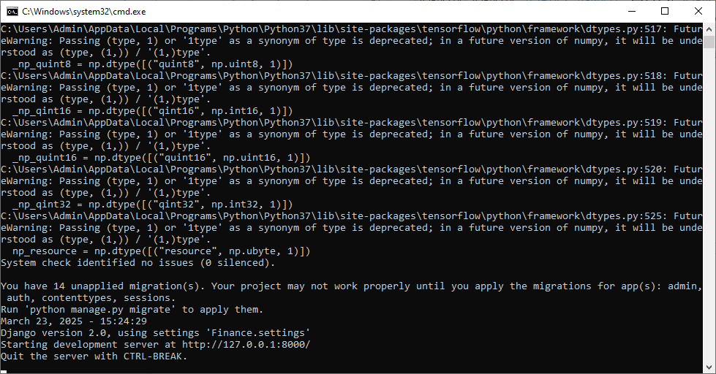
In above screen python server started and now open browser and enter URL as http://127.0.0.1:8000/index.html and then press enter key to get below page
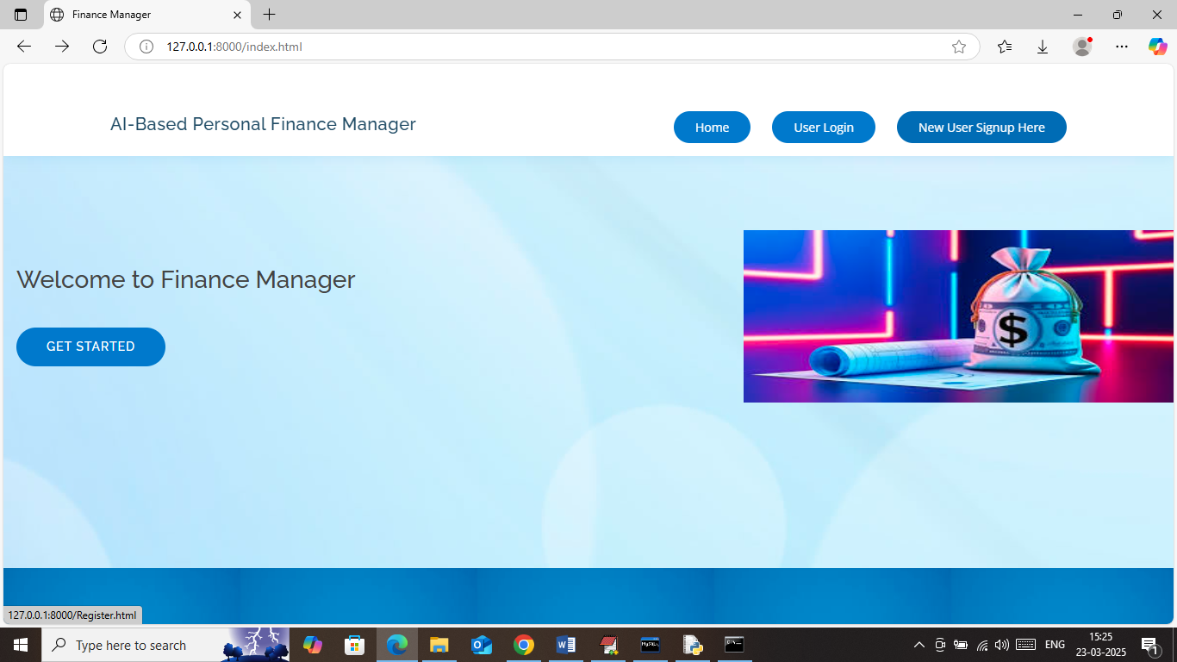
In above screen click on ‘New User Sign up’ button to get below page
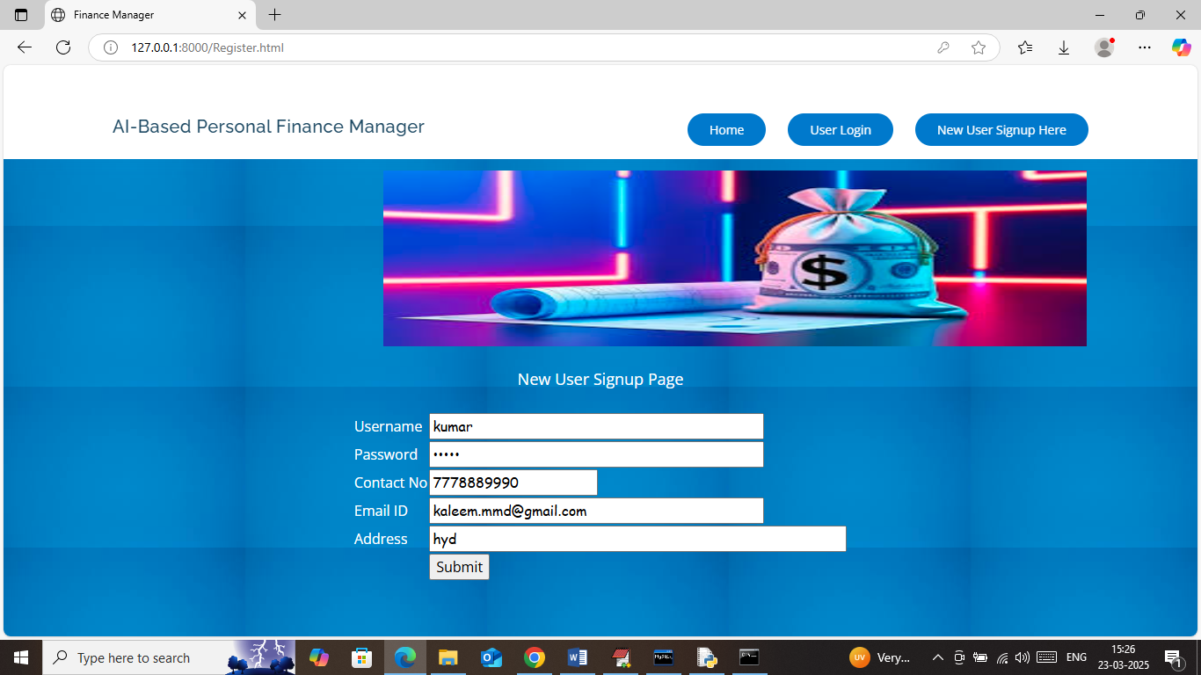
In above screen user is entering sign up details and then press button to get below page
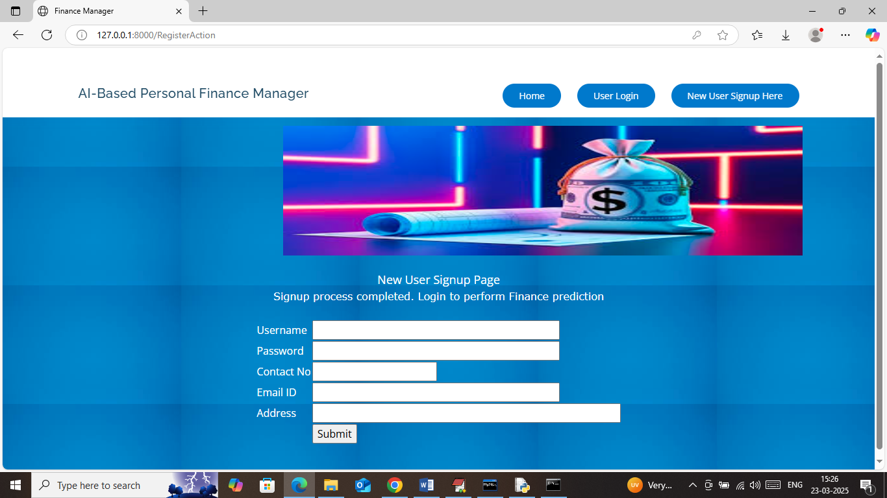
In above screen user sign up completed and now click on ‘User Login’ link to get below page
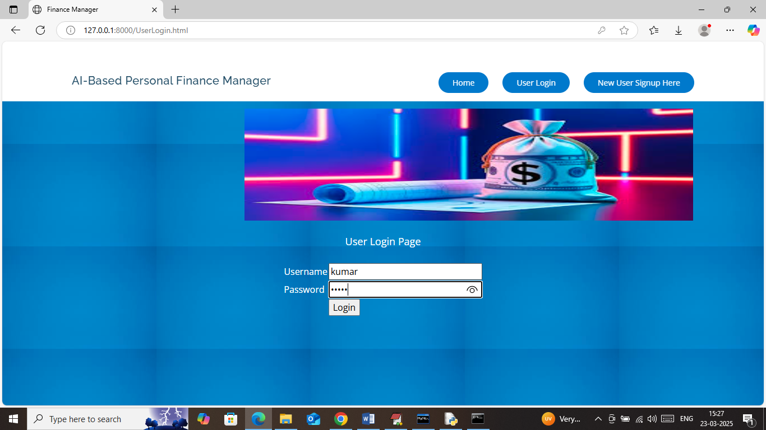
In above screen user is login and after login will get OTP to email like below page
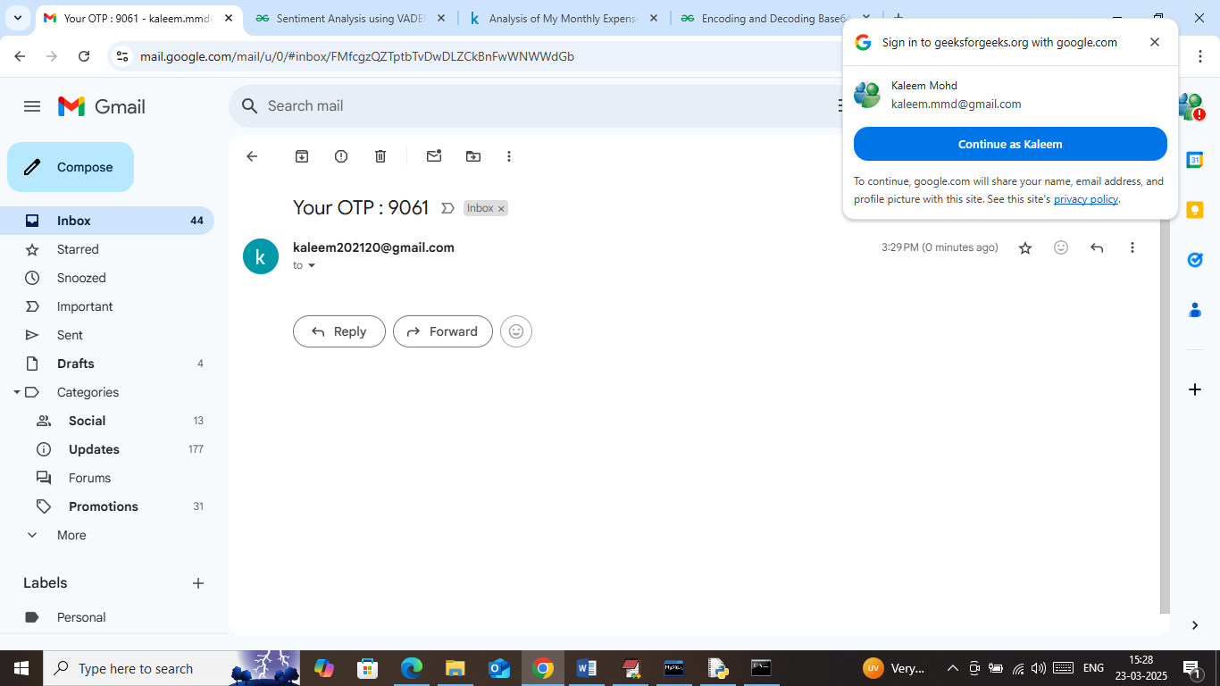
In above screen OTP is received and now enter is application to continue login
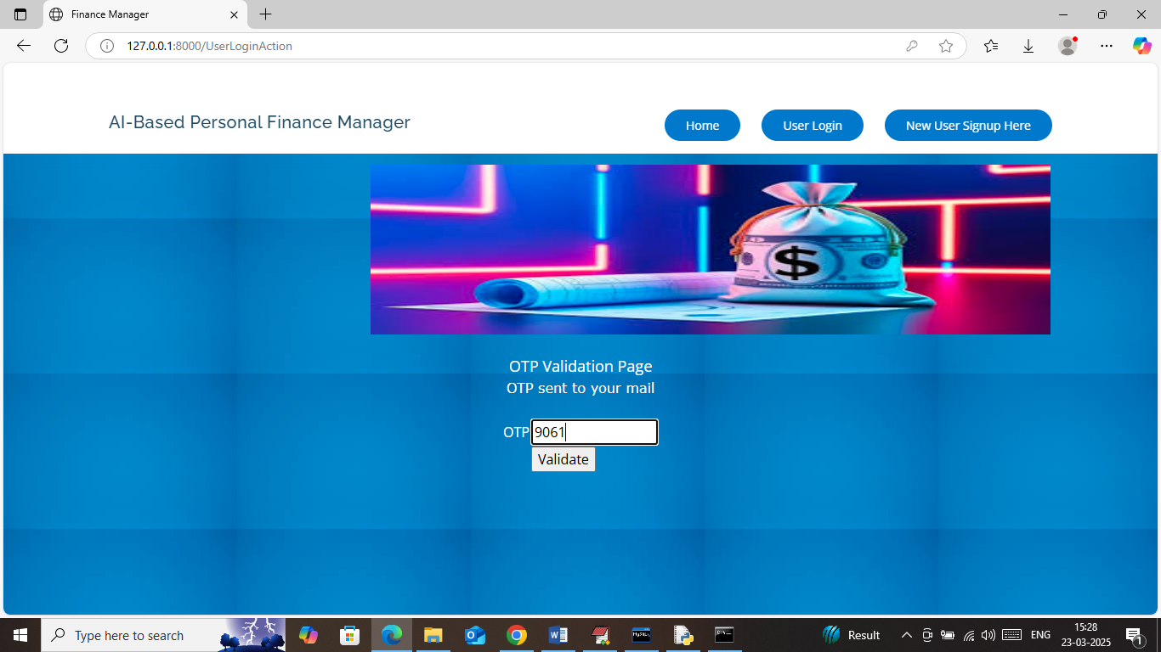
In above screen enter OTP and then press button to get below page
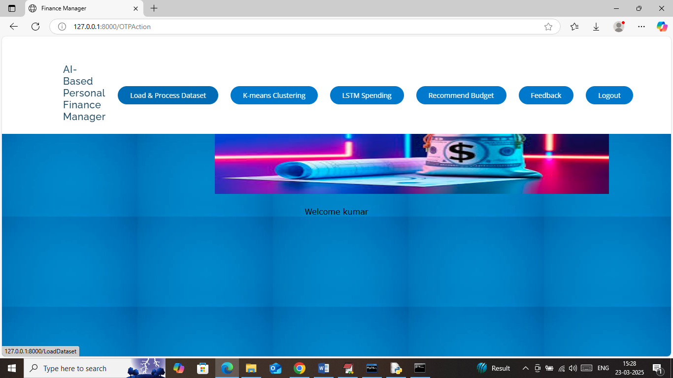
In above screen click on ‘Load & Process Dataset’ link to load dataset and then will get below page
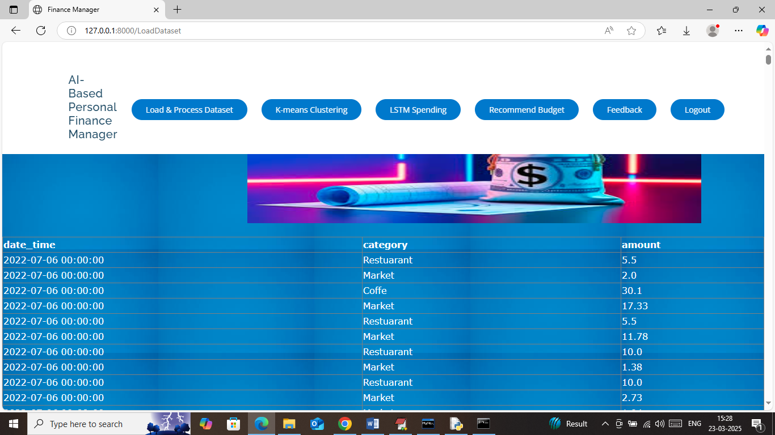
In above screen dataset loaded and now click on ‘K-means clustering’ link to cluster user expenses behaviour and then will get below page
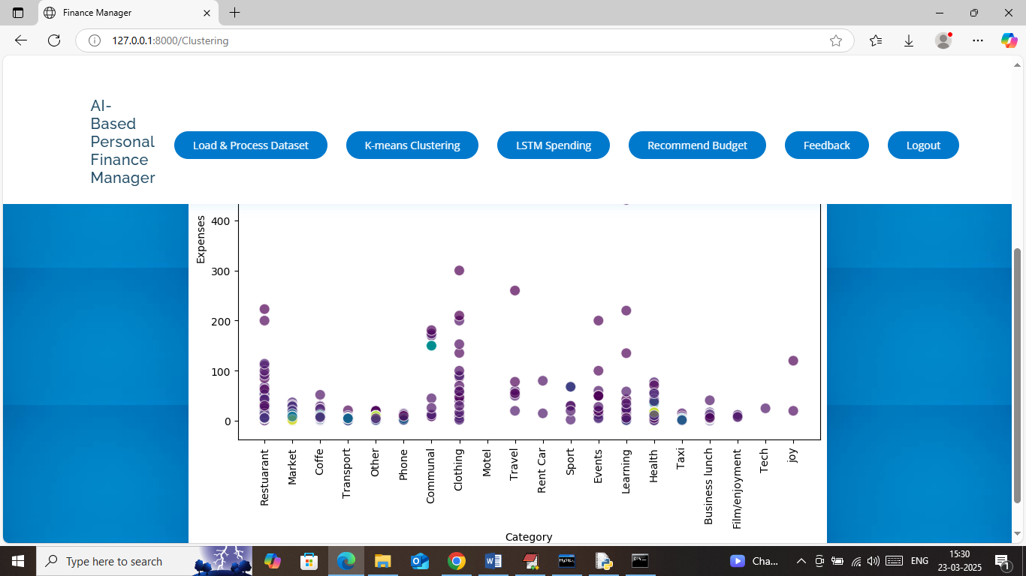
In above graph x-axis represents categories and y-axis represents expenses amount and then each different colour circle represents one cluster which indicate total amount spends on different categories. Now click on ‘LSTM Spending’ link to train LSTM algorithm to predict expenses and then will get below page
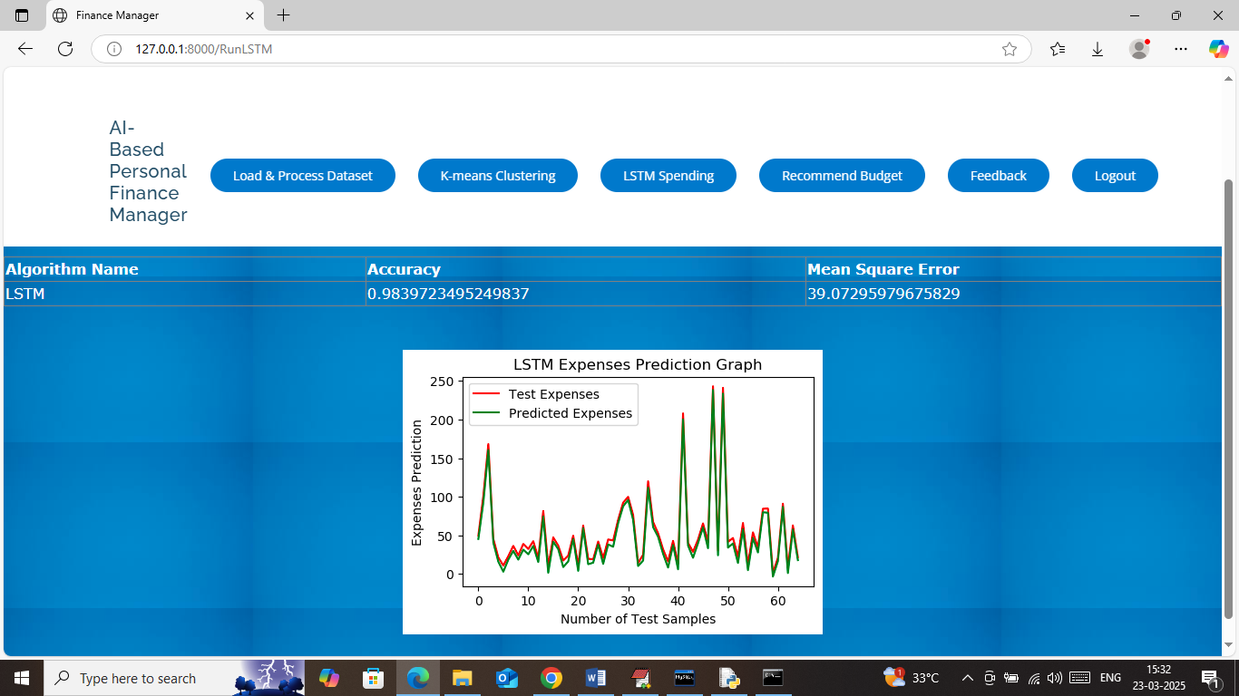
In above screen in white table format can see LSTM accuracy on test data prediction is 98% and MSE error rate is 39. In prediction graph x-axis represents ‘Number of Test Data’ and y-axis represents ‘Expenses Amount’ and then red line represents ‘True Expenses’ and green line represents ‘Predicted Expenses’ and in above graph can see both lines are fully overlapping with minor gap so we can say LSTM prediction is accurate. Now click on ‘Recommend Budget’ link to predict future expenses like below page
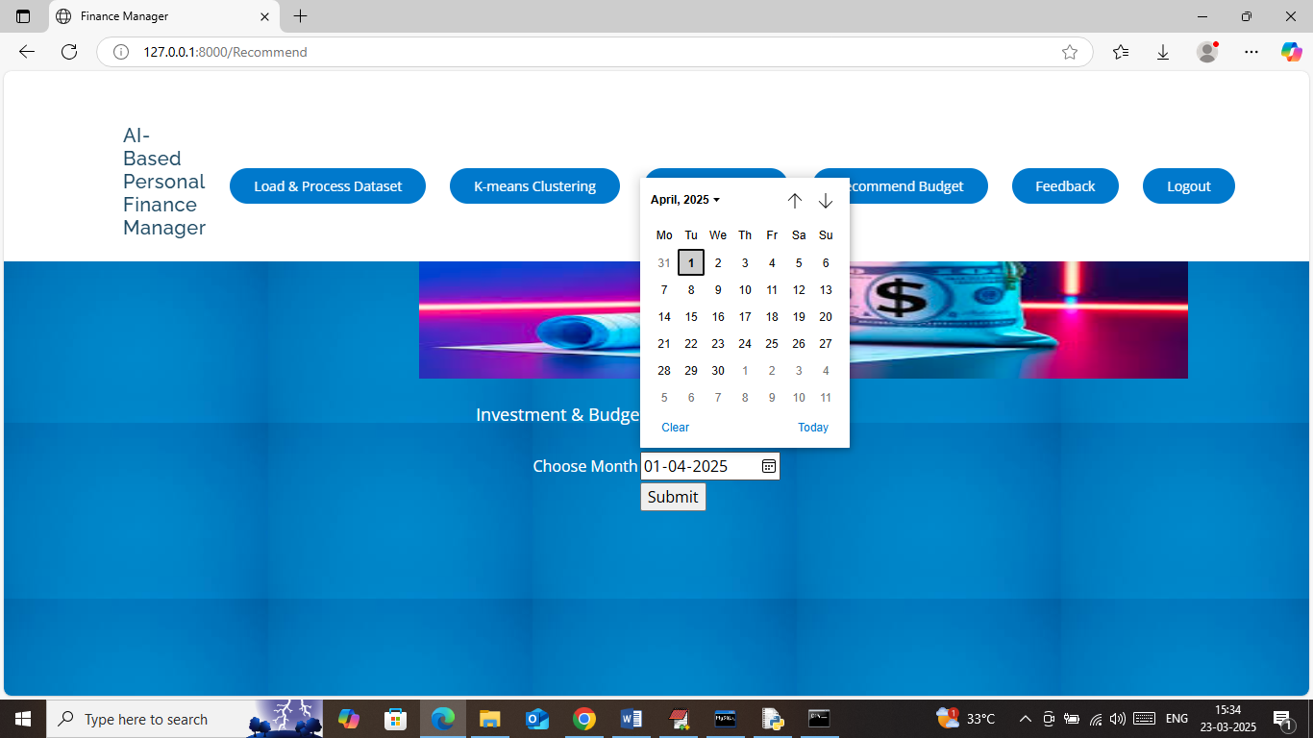
In above screen I am selecting 1st of April 2025 and then press button to get below page
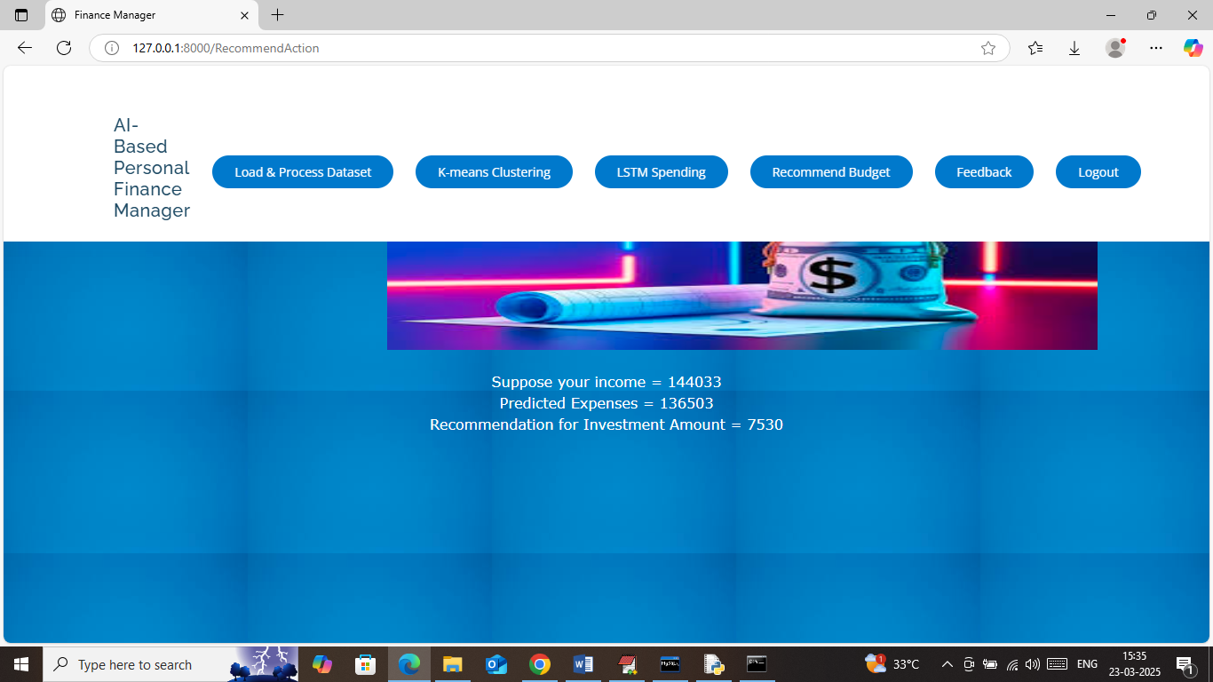
In above screen can see income amount along with predicted Expenses and then can see recommended amount for investment. Similarly by selecting date you can make prediction for any future month. Now click on ‘Feedback’ link to get below page
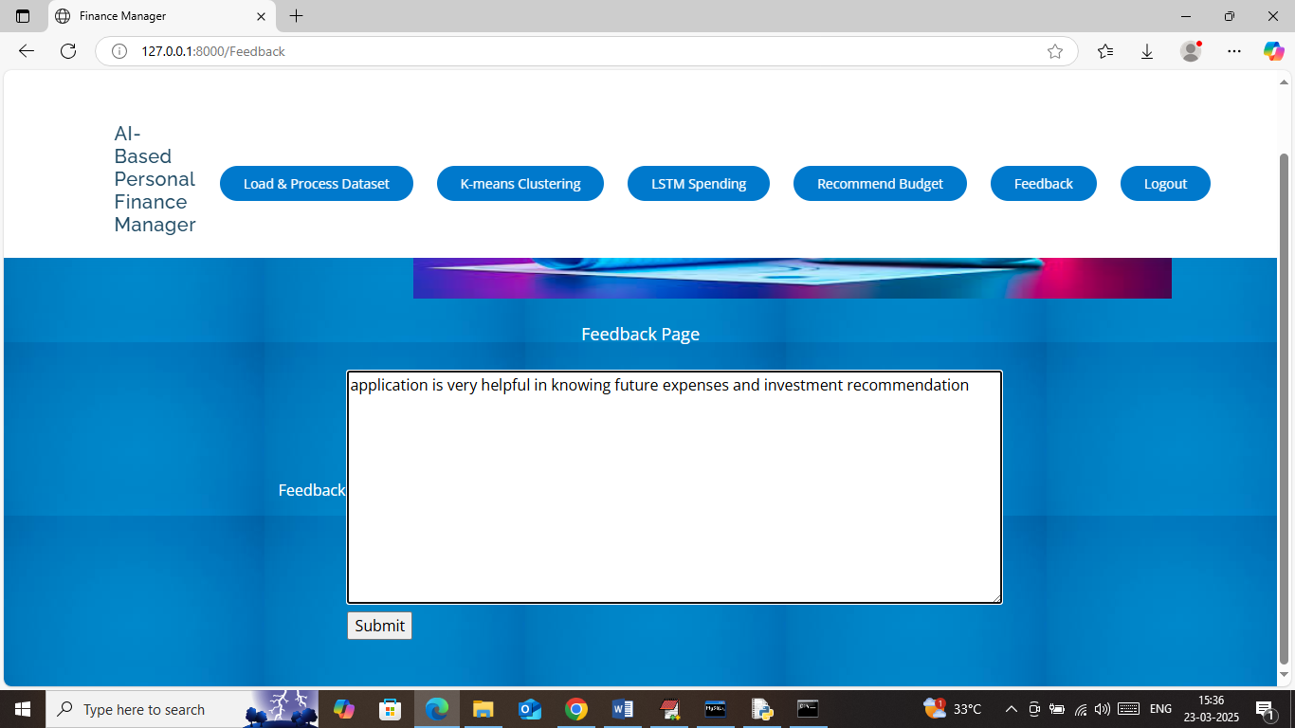
In above screen user will write some feedback and then press button to get below page
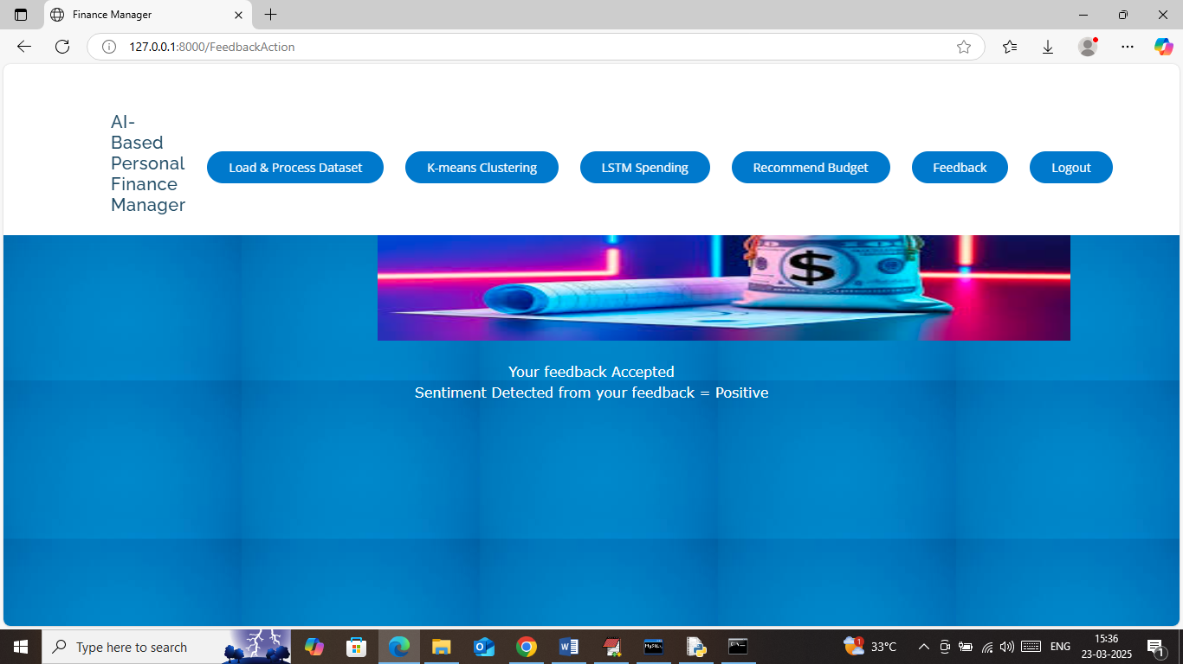
In above screen can see ‘user feedback accepted’ and detected sentiment is ‘Positive’. Similarly application will calculate sentiments for all feedbacks.
So above are the modules implemented as per given requirements

