**Experiment 12:Speeding up website with CloudFront**

1. Give Bucket Name
2. ACL should be abledpublic
3. **Uncheck** Block all access
4. **Check** the box for ***I acknowledge that the current settings ….***
5. **Create Bucket**
6. Amazon S3 🡪 Buckets 🡪 ***bucket name*** *(give your bucket name here)*
7. Choose Properties 🡪 Edit Static website hosting
8. **Enable static website hosting**
9. Enter index.html for Name of Index Document
10. Save Changes

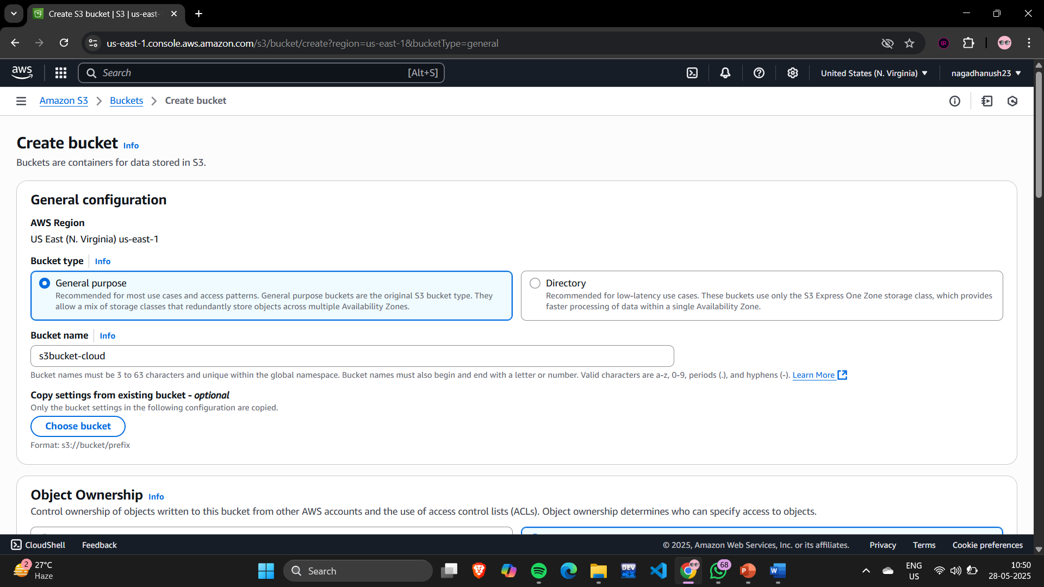

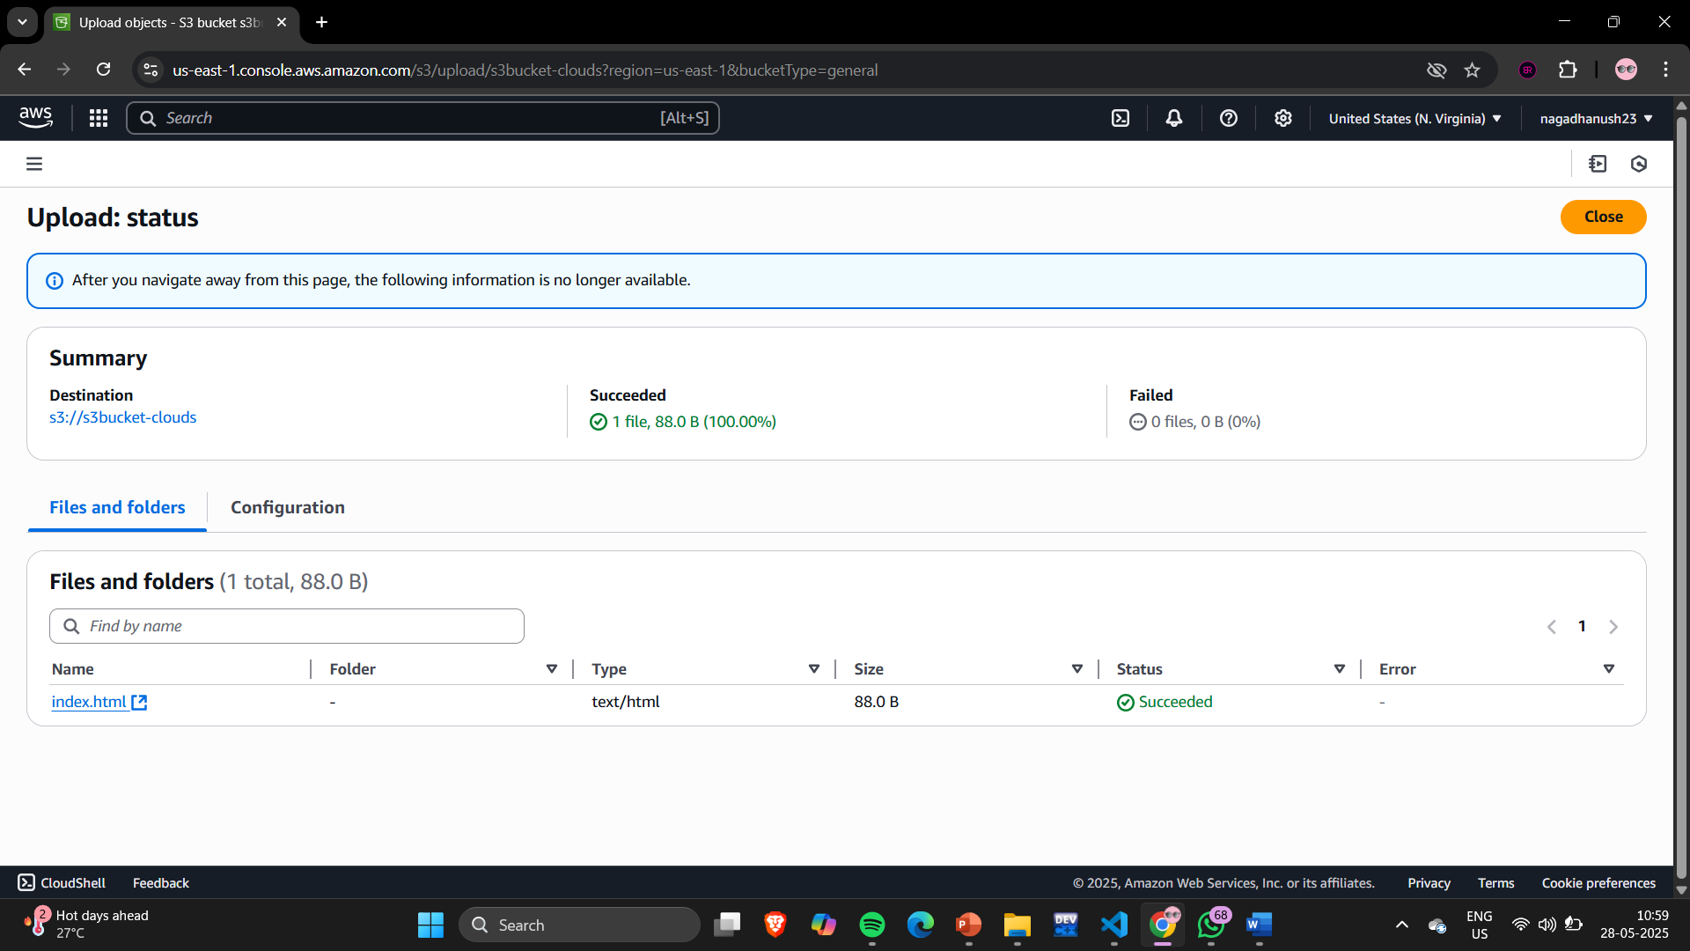

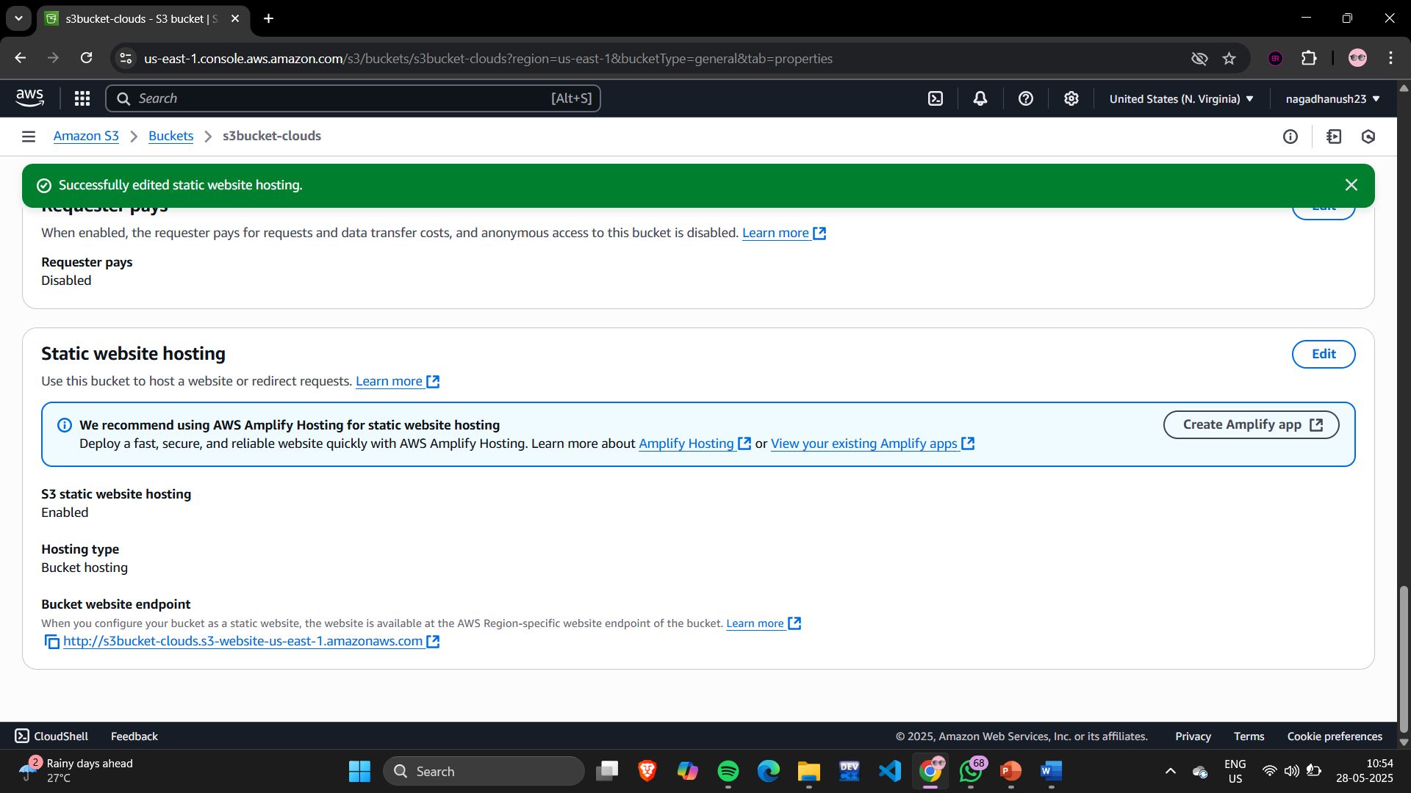

Index.html code:

<html>

    <head>demo</head>

    <body>

        welcome to kmit

    </body>

</html>

These are the object present in s3 bucket

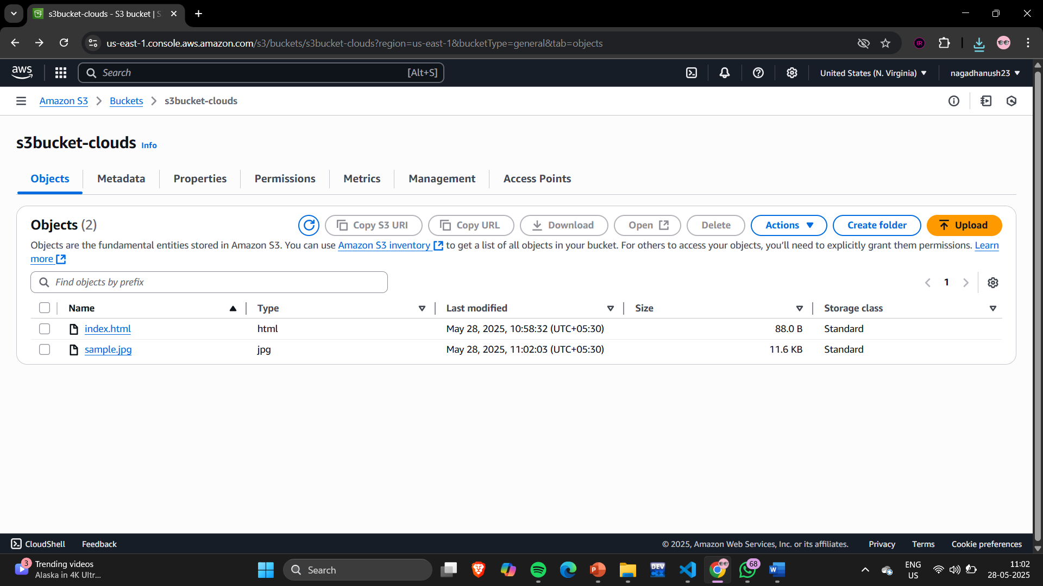

Open cloud front

Create a cloudfront distribution

