**Experiment 16:Design and implement an Amazon chatbot using natural language processing (NLP) or conversational AI techniques by using Amazon LEX**.

Open amazon lex to create bot:

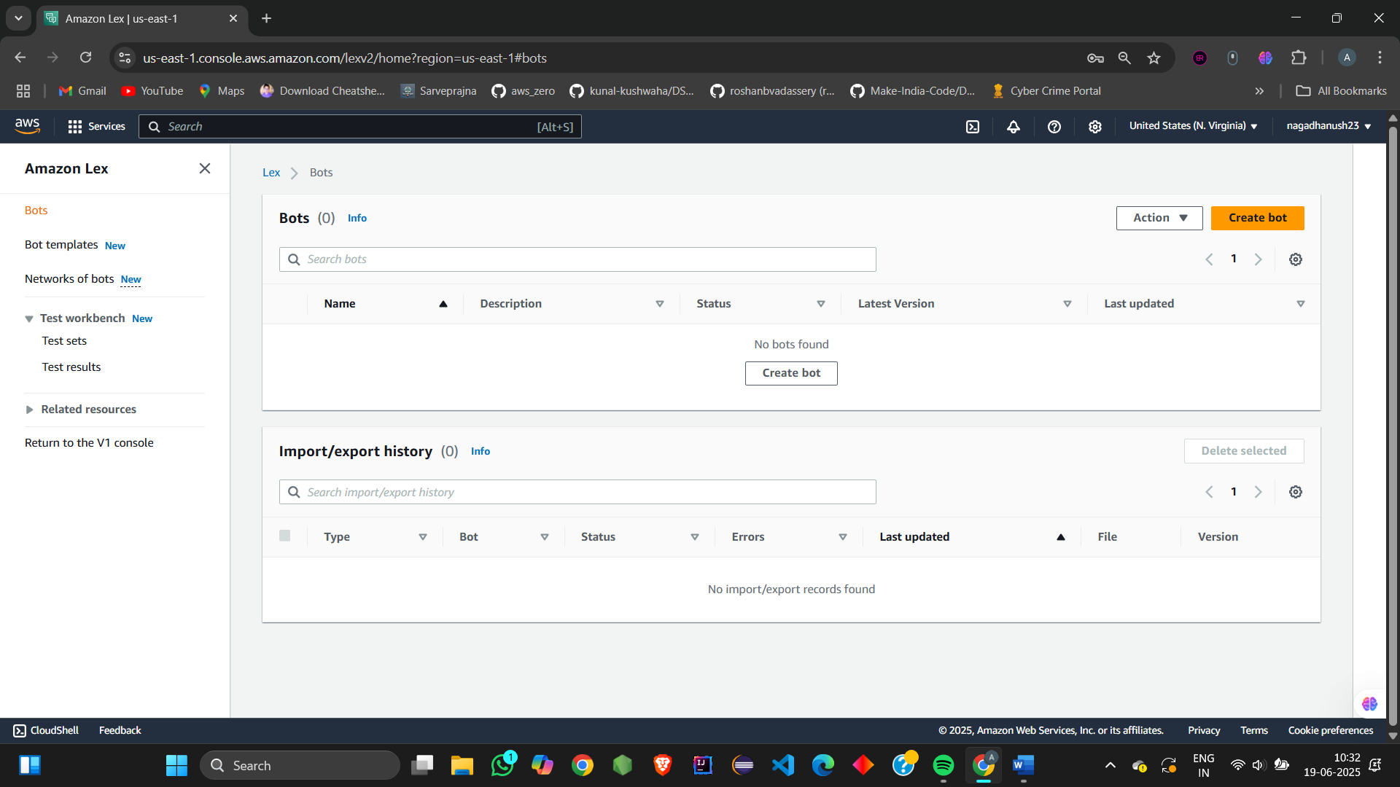

Name the bot: TheatreAssistantBot

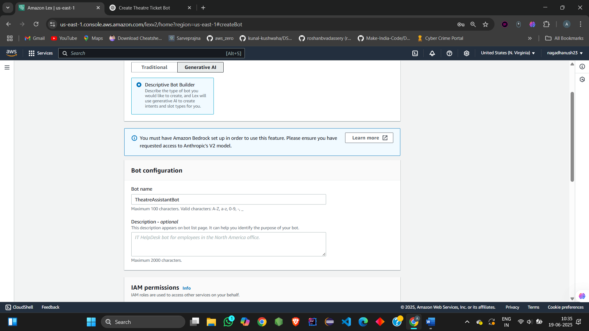

Add language to the bot

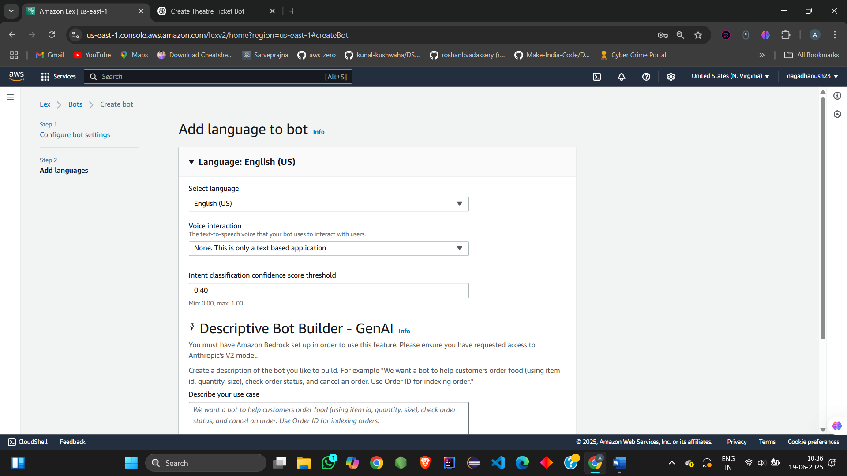

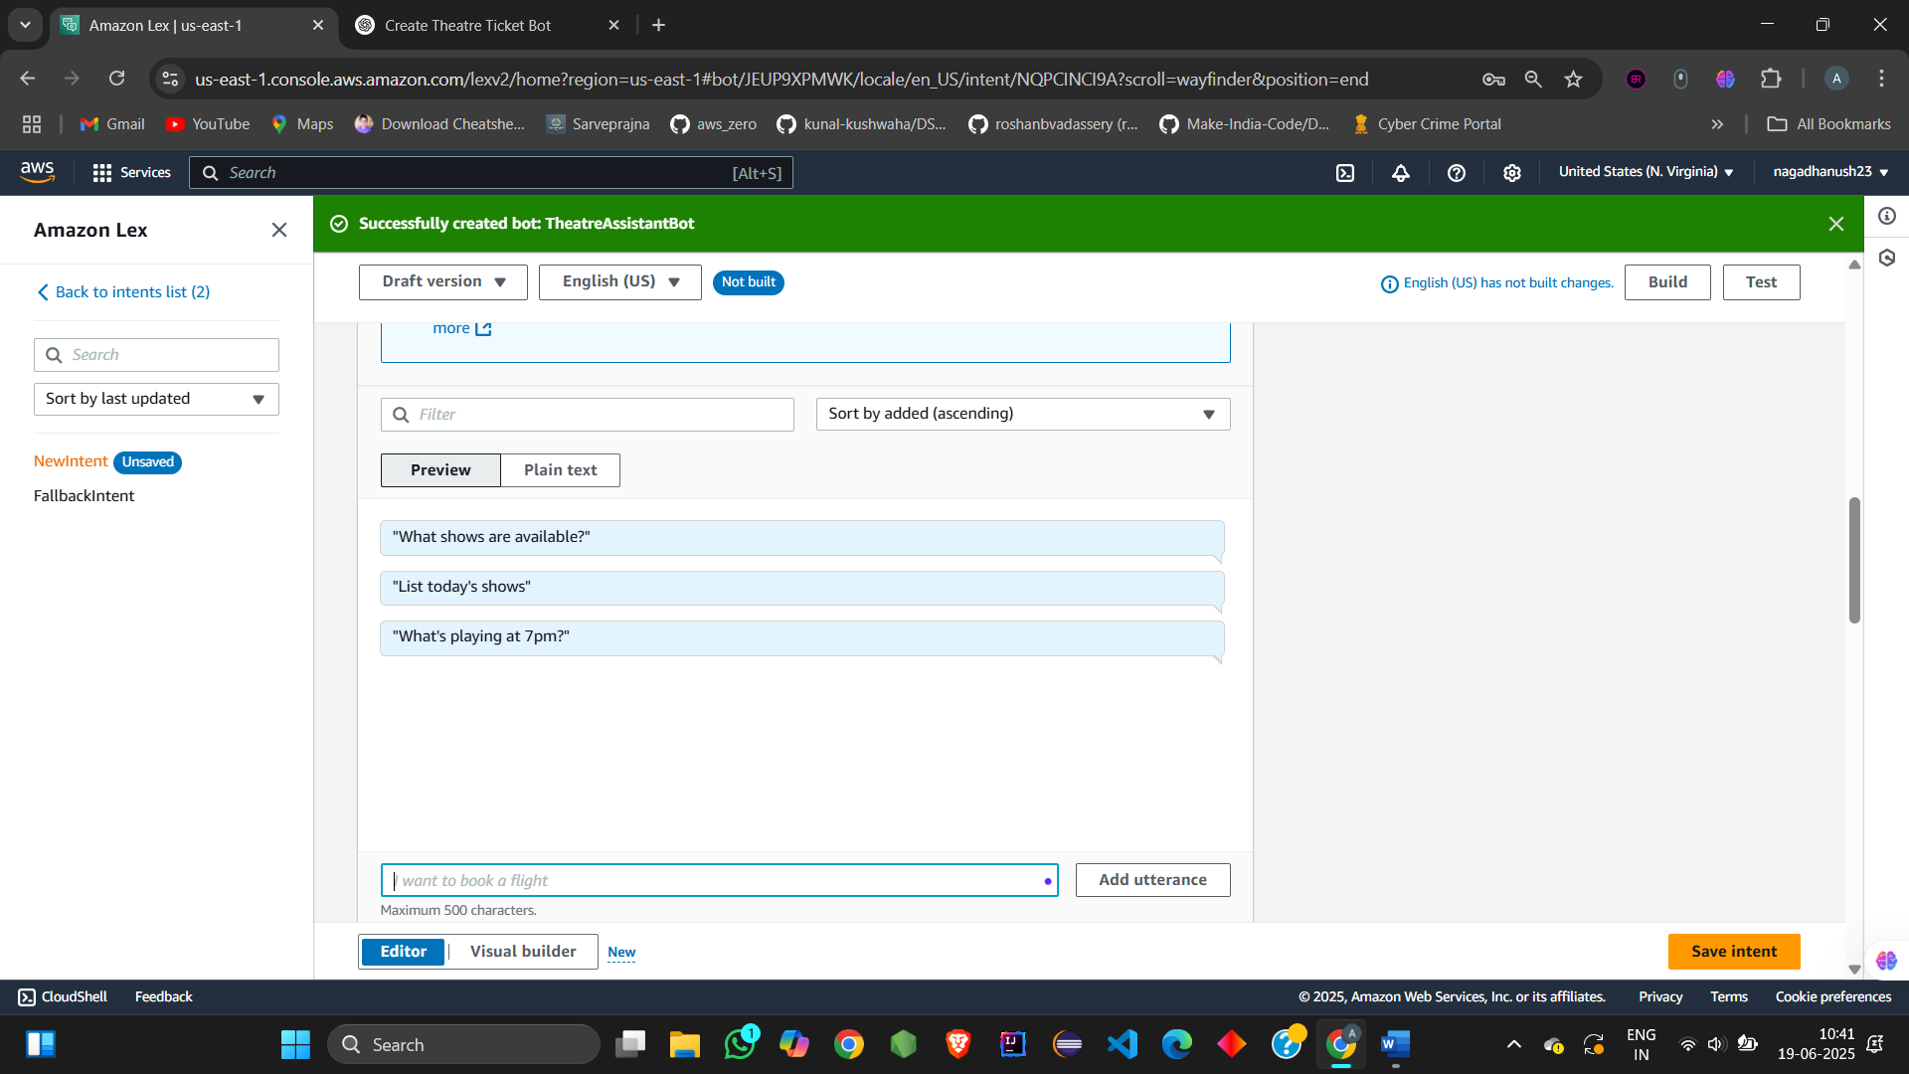

Initial response:

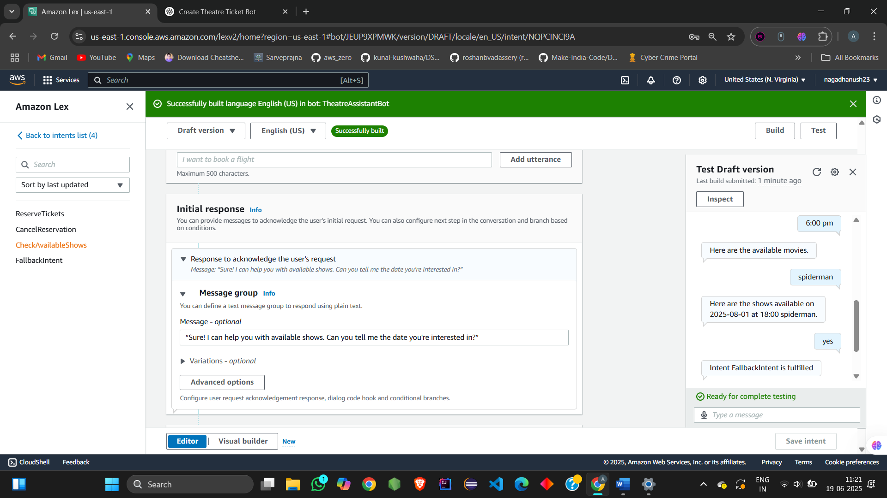

Slots : vaiorus prompts

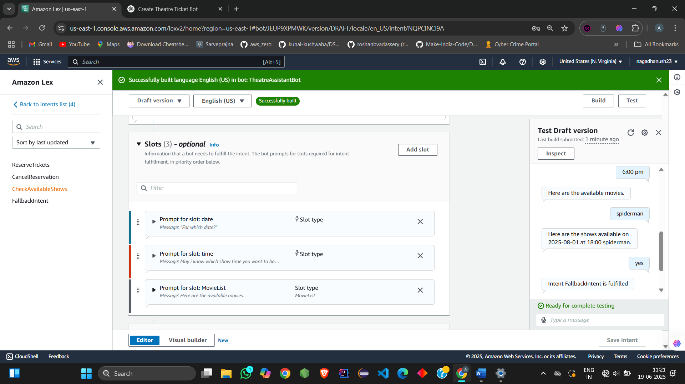

CONFIRMATION SLOT:

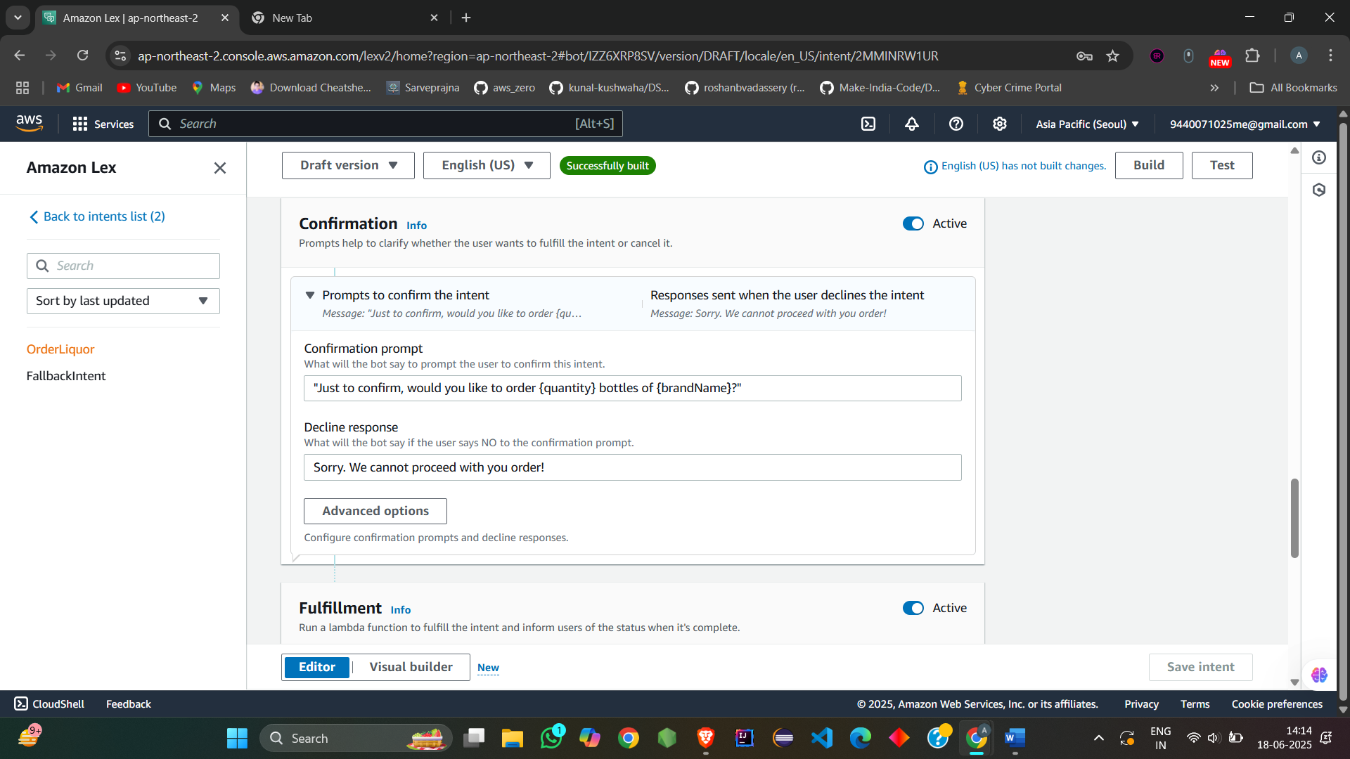

On fulfilment:

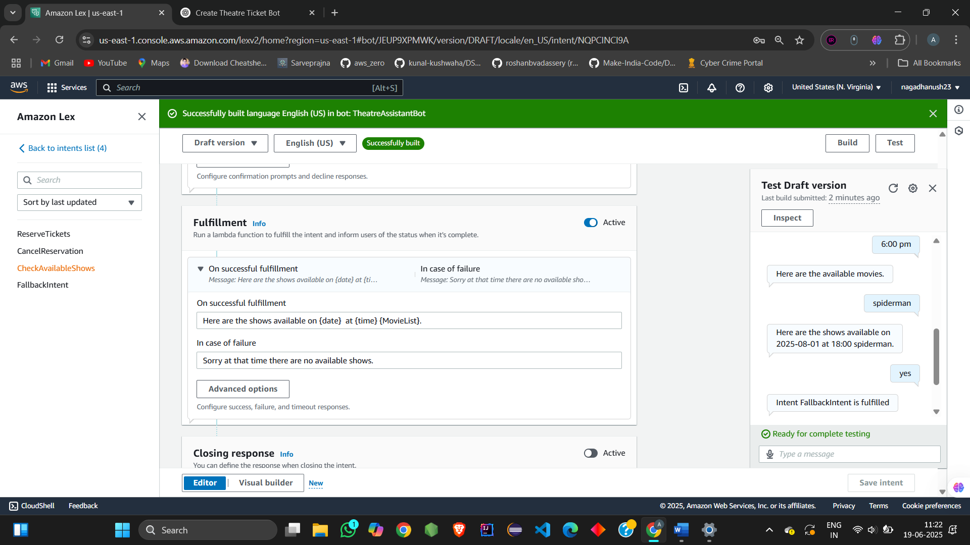

Closing response:

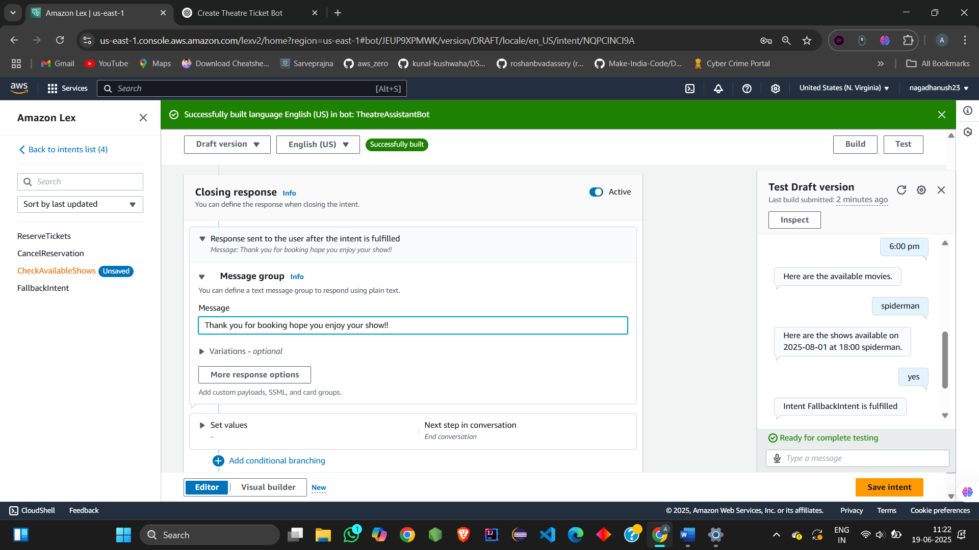

This is how I created various custom slot:

Bot🡪Slot types🡪ADD slot type🡪 blank slot

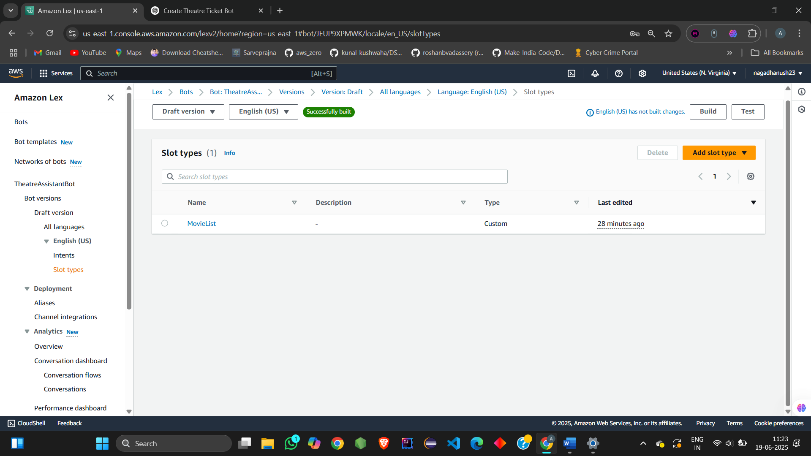

This is how I created button and images:

Slot in intents🡪Adavanced options🡪slot prompts🡪add card groups🡪buttons

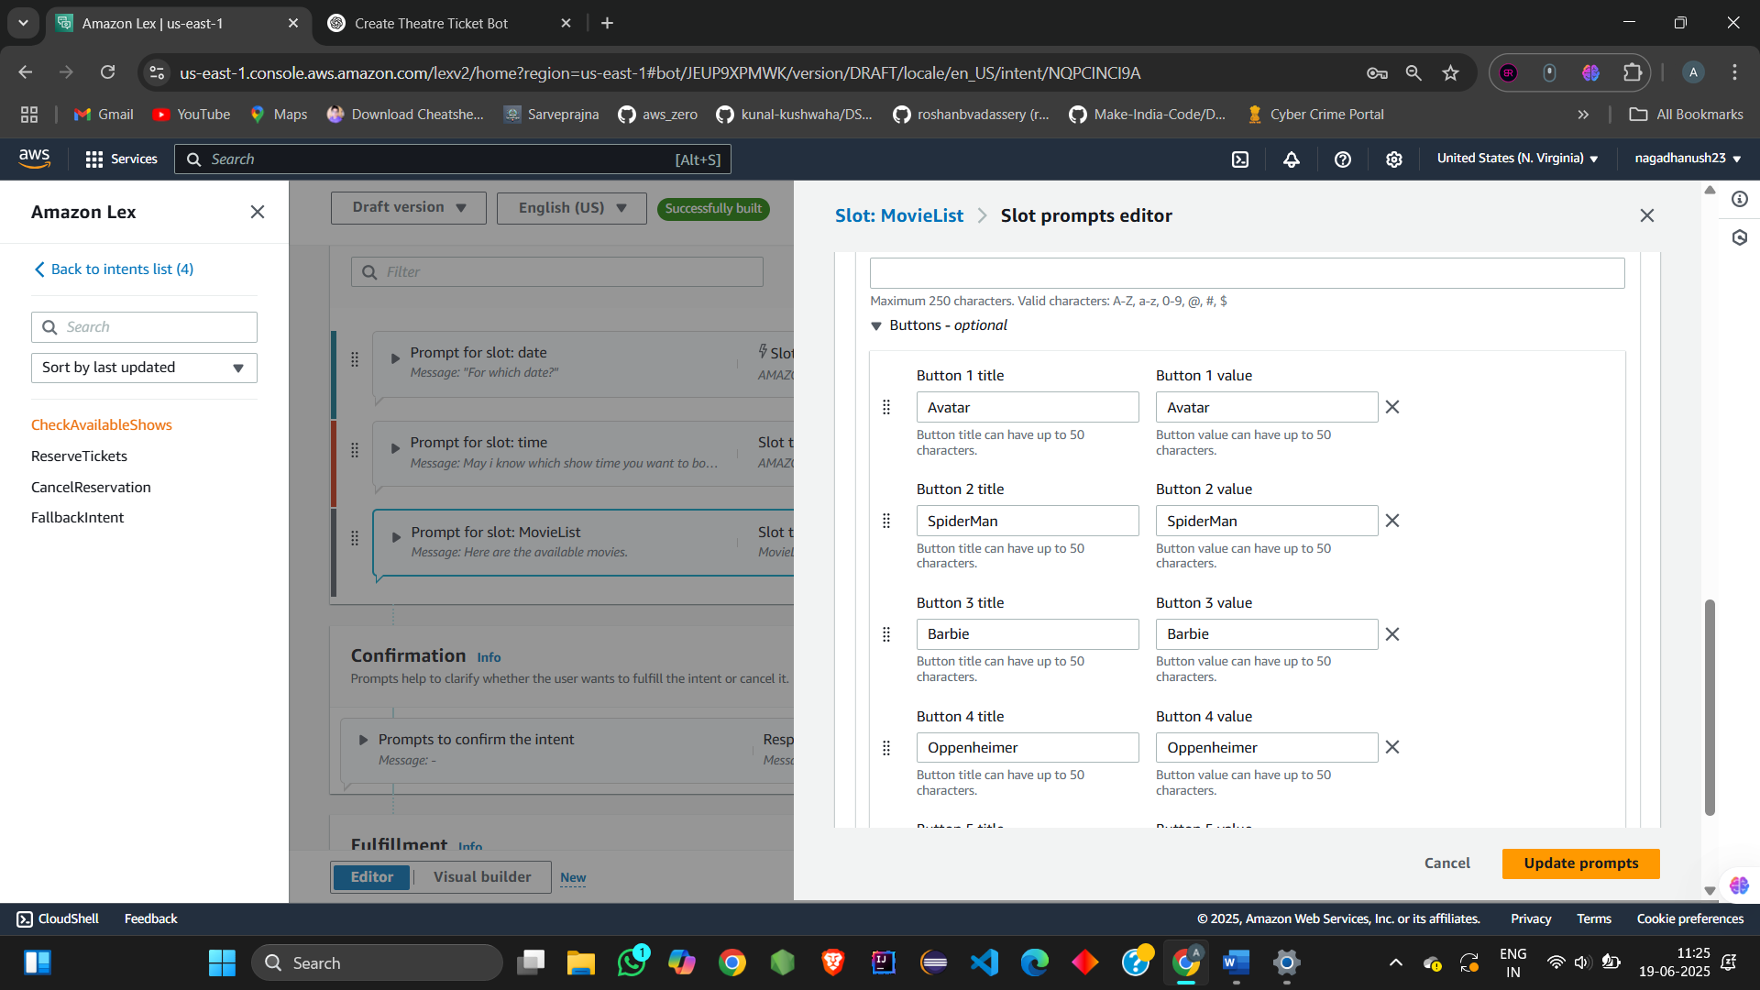

After all these Save the intent and build and test:

Output:

