**EXPERIMENT 17:INTEGRATION OF AMAZON LEX WITH TWILIO**



login to twilio and verify your phone number

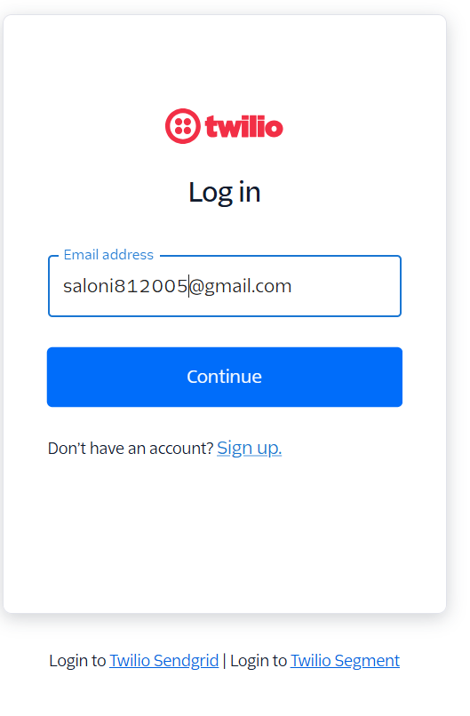

[Ashrithbunny13@gmail.com](mailto:Ashrithbunny13@gmail.com)

->go to messaging ->overview ->connect to whatsapp Sandbox

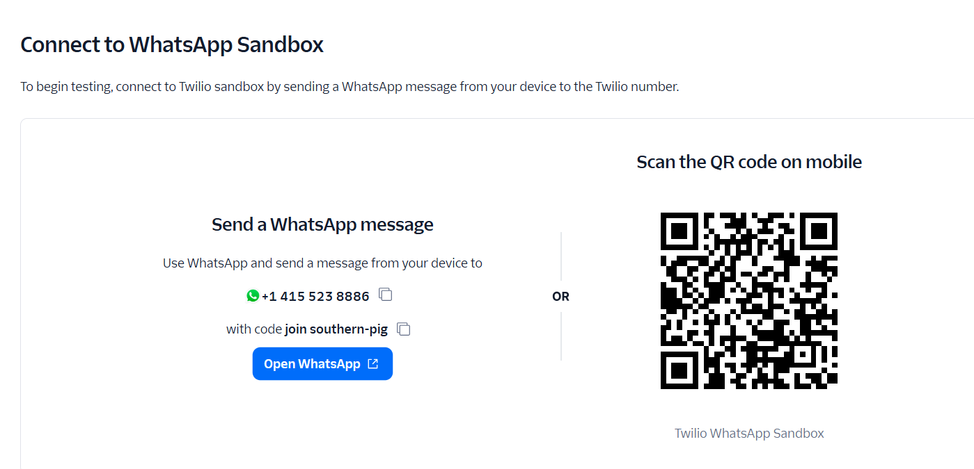

**Create Version and Alias**

* Go to Lex → Bot → **Create Version**

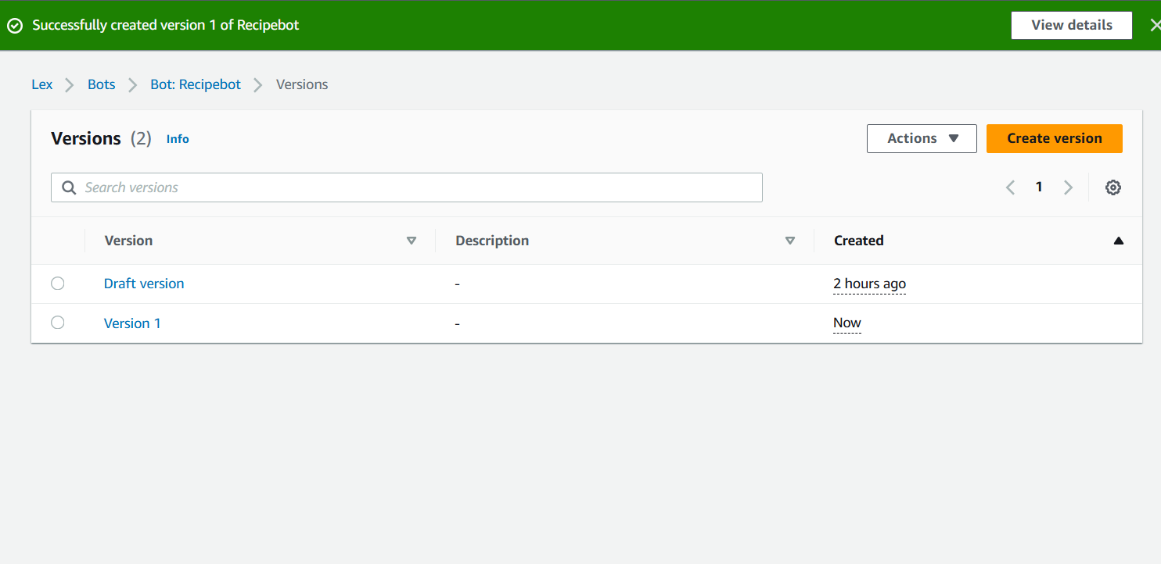

Create an **Alias** pointing to the version

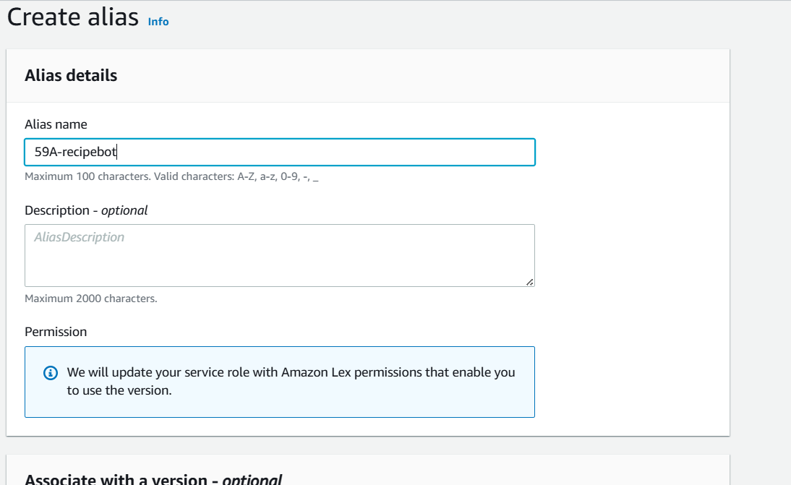

58a-receipt

Associate the version to alias

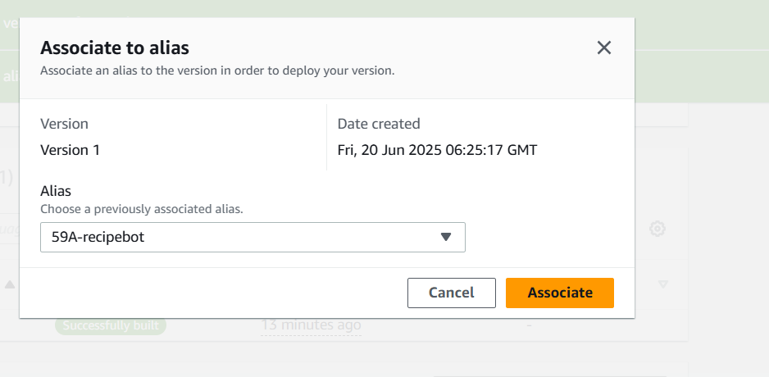

58a-receipt

**Create Lex-Twilio Channel**

Go to Lex → Channels → Create Channel

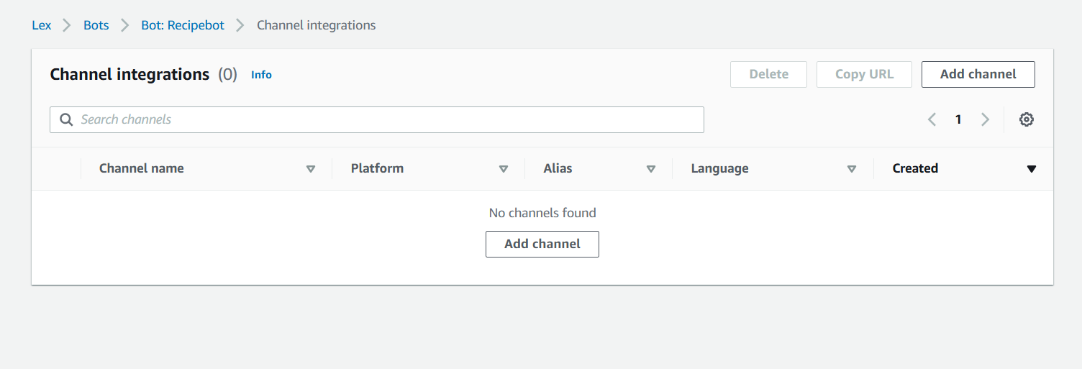

Channel Type: **Twilio SMS**

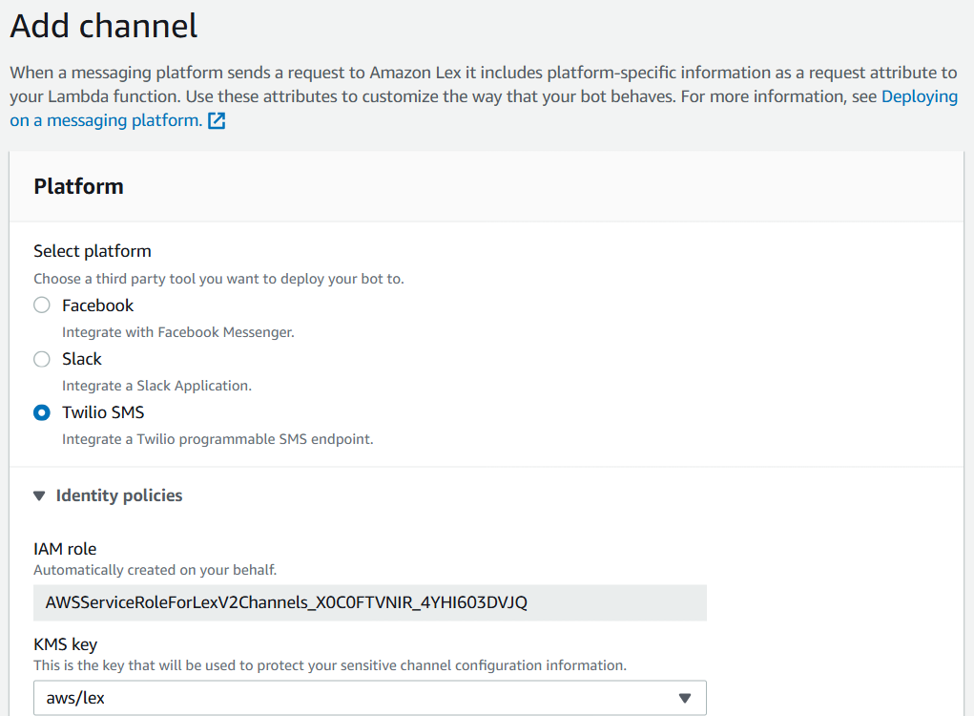

Alias: Select your **production alias**

Fill:

* **Twilio Account SID**
* **Twilio Auth Token**

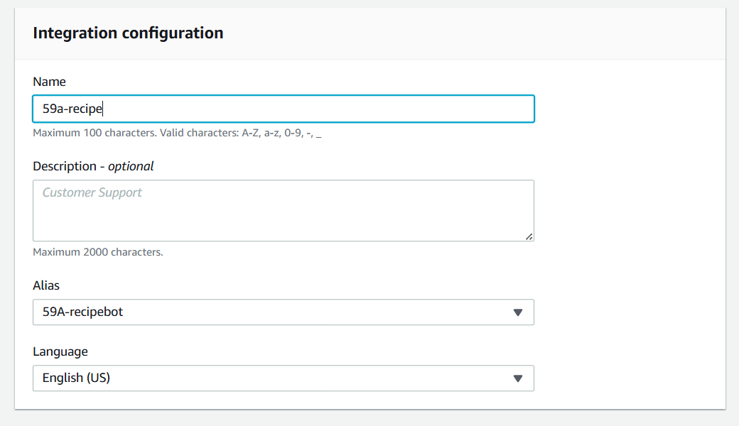

58a-receipe

58a-receipt

**Twilio Sandbox Configuration for WhatsApp**

**Access Twilio WhatsApp Sandbox**

* Go to: Twilio Console → Messaging → WhatsApp Sandbox

**Join the Sandbox**

* You’ll see:
  + Sandbox Number: +14155238886
  + Join code: e.g., join bright-lake
* From your own WhatsApp, send the join code to the sandbox number.

