**School: SCOPE Semester: WIN 2022-23**

**Subject: Computer Graphics (Lab) Subject Code: CSE2006**

**Assignment 1**

1. **Write programs to demonstrate the use of basic graphics 2D primitives: point, line, circle, arc, ellipse, rect, square, quad, triangle, etc.**

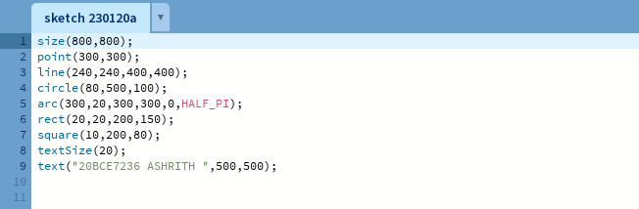

**Output:**

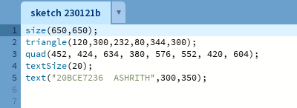

**Output:**

1. **Draw alphabets ‘S’ and ‘G’ using 2D primitives.**

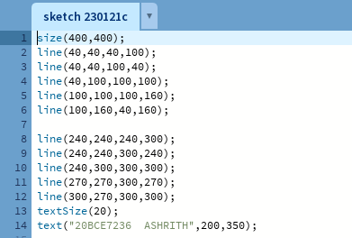

**Output:  
**