School: SCOPE Semester: FALL 2020-21

Subject: Computer Graphics (Lab) Subject Code: CSE2006

**Assignment 10**

**NAME: S.B.Ashrith**

**Registration No: 20BCE7236**

**Write any two of the following:**

1. Write programs to illustrate Lighting (ambient light, directional light, point light and spotlight).

**Ambient Light:**

void setup() {

size(400, 400, P3D);

}

void draw() {

background(0);

// Set ambient light

ambientLight(100, 100, 100);

// Draw a cube

translate(width/2, height/2, 0);

rotateX(frameCount * 0.01);

rotateY(frameCount * 0.01);

box(100);

text("S.B.ASHRITH", 100, 100);

text("20BCE7236", 110, 110);}

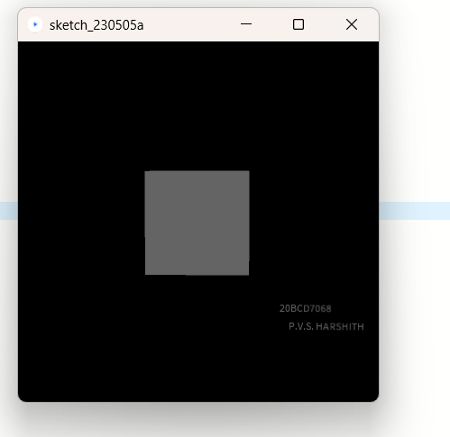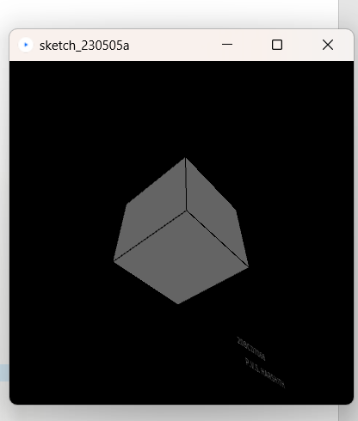

**Directional Light:**

void setup() {

size(400, 400, P3D);

}

void draw() {

background(0);

// Set directional light

directionalLight(200, 200, 200, 0, 0, -1);

// Draw a sphere

translate(width/2, height/2, 0);

rotateX(frameCount * 0.01);

rotateY(frameCount * 0.01);

sphere(100);

text("S.B.ASHRITH", 100, 100);

text("20BCE7236", 110, 110);

}

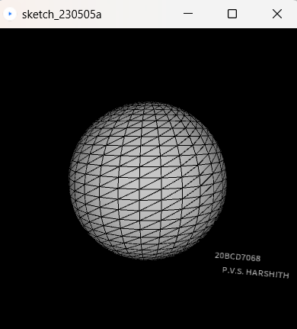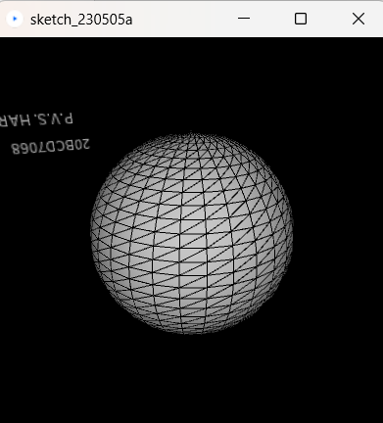

**Point Light:**

float angle = 0;

float radius = 100;

float tubeRadius = 30;

void setup() {

size(400, 400, P3D);

noStroke();

}

void draw() {

background(0);

// Set point light

pointLight(255, 255, 255, mouseX, mouseY, 200);

// Set spotlight

spotLight(0, 255, 0, mouseX, mouseY, 200, 0, 0, -1, PI/3, 2);

// Draw torus

translate(width/2, height/2);

rotateX(frameCount * 0.01);

rotateY(frameCount * 0.01);

int numSteps = 60;

float angleStep = TWO_PI / numSteps;

for (int i = 0; i < numSteps; i++) {

float theta = i * angleStep;

float nextTheta = (i + 1) * angleStep;

beginShape(QUAD_STRIP);

for (int j = 0; j <= numSteps; j++) {

float phi = j * angleStep;

float x1 = (radius + tubeRadius * cos(theta)) * cos(phi);

float y1 = (radius + tubeRadius * cos(theta)) * sin(phi);

float z1 = tubeRadius * sin(theta);

float x2 = (radius + tubeRadius * cos(nextTheta)) * cos(phi);

float y2 = (radius + tubeRadius * cos(nextTheta)) * sin(phi);

float z2 = tubeRadius * sin(nextTheta);

vertex(x1, y1, z1);

vertex(x2, y2, z2);

}

endShape();

}

text("S.B.ASHRITH", 100, 100);

text("20BCE7236", 110, 110);

}

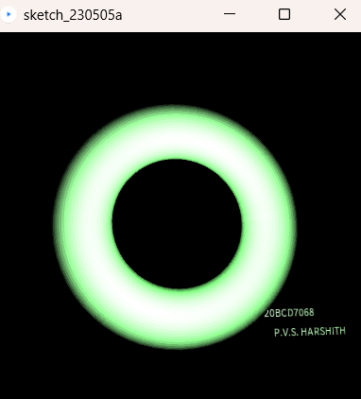 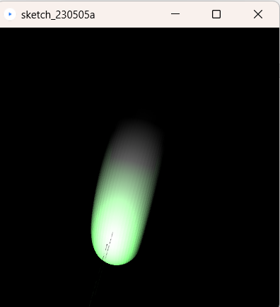

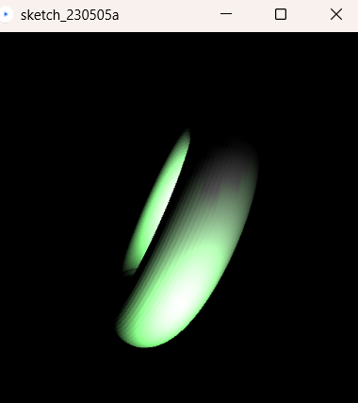

**Spot light:**

void setup() {

size(400, 400, P3D);

}

void draw() {

background(0);

// Set spotlight

spotLight(255, 255, 255, width/2, height/2, 200, 0, 0, -1, PI/3, 2);

// Draw a cube

translate(width/2, height/2, 0);

rotateX(frameCount * 0.01);

rotateY(frameCount * 0.01);

box(100);

text("S.B.ASHRITH", 100, 100);

text("20BCE7236", 110, 110);

}

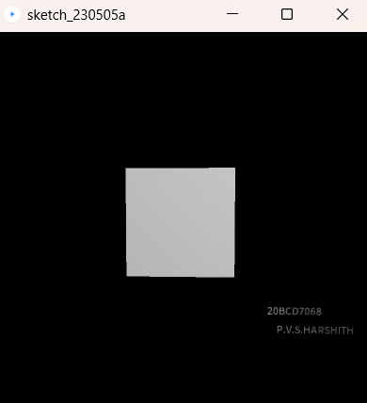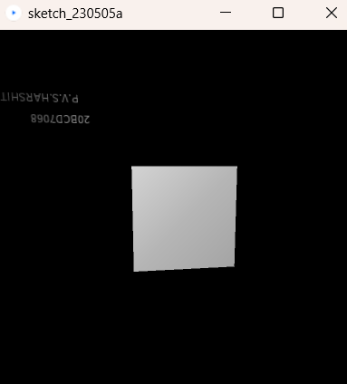

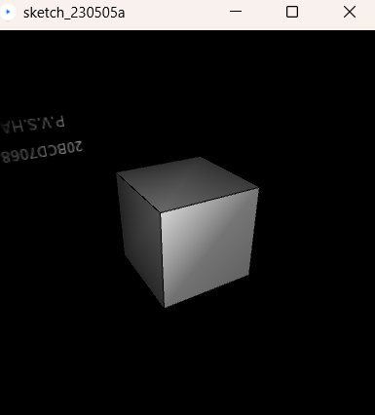

1. 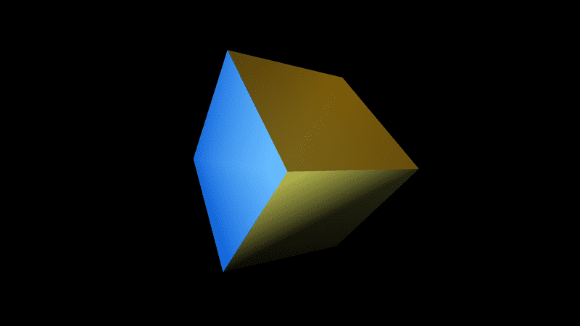Write a program to display a box with all the three different kinds of lights.

Expected Output:

void setup() {

size(600,600,P3D);

noStroke();

}

void draw() {

background(0);

translate(width / 2, height / 2);

pointLight(255,0,0,200,-150, 0);

directionalLight(0,255,0,0,1,0);

spotLight(0,0,255,0,40,200,0,-0.5,-0.5,PI / 2, 2);

rotateY(map(mouseX, 0, width, 0, PI));

rotateX(map(mouseY, 0, height, 0, PI));

box(150);

text("S.B.ASHRITH", 100, 100);

text("20BCE7236", 110, 110);

}

Output:

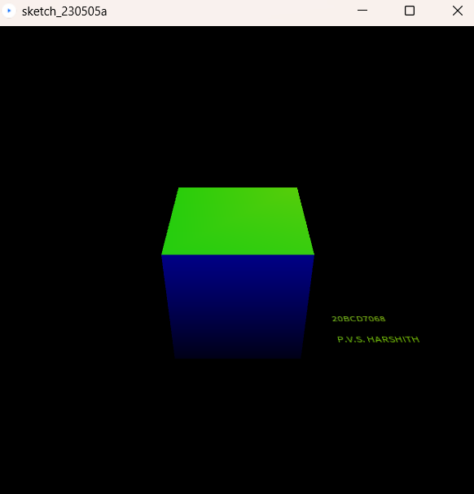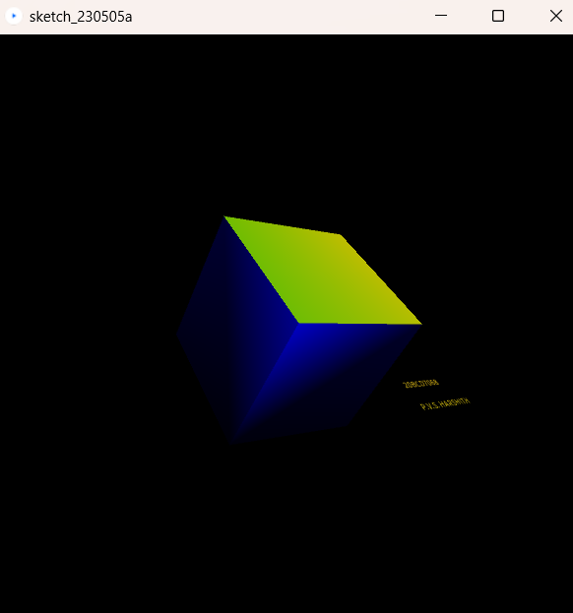

1. Write programs to illustrate spot light with two different colour (Orange and Green) on a 3D cube. Move the mouse to change the position of a Green spot light.

float greenLightX;

float greenLightY;

void setup() {

size(400, 400, P3D);

greenLightX = width / 2;

greenLightY = height / 2;

}

void draw() {

background(0);

// Set orange spotlight

spotLight(255, 165, 0, width / 2, height / 2, 200, 0, 0, -1, PI/3, 2);

// Set green spotlight

spotLight(0, 255, 0, greenLightX, greenLightY, 200, 0, 0, -1, PI/3, 2);

// Draw a cube

translate(width/2, height/2, 0);

rotateX(frameCount * 0.01);

rotateY(frameCount * 0.01);

box(100);

text("S.B.ASHRITH", 100, 100);

text("20BCE7236", 110, 110);

}

void mouseMoved() {

greenLightX = mouseX;

greenLightY = mouseY;

}

