EXPERIMENT - 2

EXERCISE – 3

* B4A6 TIMES 5624 IS 3CC92B58

INPUT

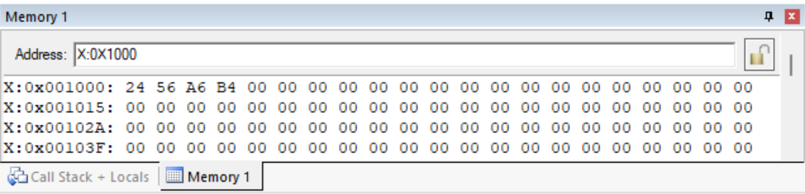

OUTPUT

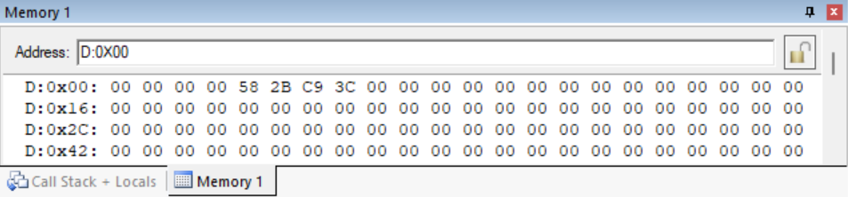

CODE

; Multiply two 16-bit hex numbers and store the product.

; ASSUME THE NUMBERS ARE STORED IN EXTERNAL LOCATION 1000H TO 1003H

; WILL STORE THE PRODUCT IN R4, R5, R6, R7

ORG 0000H ; ORIGINATE

AJMP START ; JUMP TO THE LABEL START

START:

CLR C ; CLEAR CARRY

MOV R3, #00H ; CLEAR R3

MOV R4, #00H ; CLEAR R4

MOV R5, #00H ; CLEAR R5

MOV R6, #00H ; CLEAR R6

MOV R7, #00H ; CLEAR R7

MOV DPTR, #1000H ; LSB_1

MOVX A, @DPTR ; GET EXTERNAL DATA

MOV 0F0H, A ; COPY IN B

MOV DPTR, #1002H ; LSB_2

MOVX A, @DPTR ; GET EXTERNAL DATA

MUL AB ; LSB_1 TIMES LSB_2

MOV R4, A ; LSB OF CURRENT PRODUCT

MOV A, B ; COPY TO A

MOV R5, A ; MSB OF CURRENT PRODUCT

MOV DPTR, #1001H ; MSB_1

MOVX A, @DPTR ; GET EXTERNAL DATA

MOV 0F0H, A ; COPY IN B

MOV DPTR, #1002H ; LSB_2

MOVX A, @DPTR ; GET EXTERNAL DATA

MUL AB ; MSB_1 TIMES LSB_2

ADD A, R5 ; LSB OF CURRENT PRODUCT

MOV R5, A ; STORE THE PRODUCT

MOV A, B ; COPT TO A

ADDC A, R6 ; MSB OF CURRENT PRODUCT. R6 IS 00H

MOV R6, A ; STORE THE PRODUCT

MOV DPTR, #1000H ; LSB_1

MOVX A, @DPTR ; GET EXTERNAL DATA

MOV 0F0H, A ; COPY IN B

MOV DPTR, #1003H ; MSB_2

MOVX A, @DPTR ; GET EXTERNAL DATA

MUL AB ; LSB_1 TIMES MSB_2

ADD A, R5 ; LSB OF CURRENT PRODUCT

MOV R5, A ; STORE THE PRODUCT

MOV A, B ; COPY TO A

ADDC A, R6 ; MSB OF CURRENT PRODUCT

MOV R6, A ; STORE THE PRODUCT

JNC NOCARR

INC R3 ; INCREMENT IF CARRY

NOCARR:

MOV DPTR, #1001H ; MSB_1

MOVX A, @DPTR ; GET EXTERNAL DATA

MOV 0F0H, A ; COPY IN B

MOV DPTR, #1003H ; MSB_2

MOVX A, @DPTR ; GET EXTERNAL DATA

MUL AB ; MSB_1 TIMES MSB_2

ADD A, R6 ; LSB OF CURRENT PRODUCT

MOV R6, A ; STORE THE PRODUCT

MOV A, B ; COPY TO A

ADDC A, R7 ; MSB OF CURRENT PRODUCT. R7 IS 00H

ADD A, R3 ; ADD CARRY FROM PREVIOUS STEP, IN CASE

MOV R7, A ; STORE THE PRODUCT

END