Project Report: Healthcare Patient Data Dashboard

Problem Statement
Develop a Patient Health Tracking application that allows healthcare providers to monitor and analyze patient records. The system should handle structured data containing vital statistics such as weight, blood pressure, heart rate, temperature, diagnosis, and medication details. The solution should be able to compute trends, handle missing data, and generate weekly summaries using pivot tables. Additionally, the application should provide both population-level insights and individual patient tracking through an interactive web dashboard.

Tools and Technologies
1. Pandas & NumPy: Used for data manipulation, cleaning, statistical analysis, and handling missing values.
2. Plotly Express: For interactive visualizations such as bar charts, line graphs, and pie charts.
3. Streamlit: Open-source Python framework to build an interactive web application.
4. Python (OOP): Classes were used to model patients and the health tracking system, ensuring modularity and scalability.

About the Dataset
The dataset is a CSV file named 'AI_in_HealthCare_Dataset_with_Timestamps.csv'. It contains patient information with time-series health records. The key columns include:
- Patient_ID: Unique identifier for each patient
- Age: Age of the patient
- Gender: Gender of the patient
- Blood_Pressure: Recorded blood pressure values
- Heart_Rate: Recorded heart rate values
- Temperature: Recorded body temperature
- Diagnosis: Medical condition diagnosed
- Medication: Medication prescribed
- Timestamp: The date and time of record collection

Methodology

1. Data Loading and Cleaning
The application begins by reading the dataset using Pandas. Missing values in numeric columns are filled with their column-wise means to ensure completeness. The 'Timestamp' column is converted into a datetime object to enable time-based analysis such as weekly resampling.

2. Class-Based Design
Two classes were implemented:
- Patient: Represents individual patient records and provides a summary method.
- HealthTracker: Manages the entire dataset, performing cleaning, aggregation, and analytical operations. It includes methods to compute averages by gender, age group, weekly summaries, and patient-specific data extraction.

3. Data Analysis and Summaries
The HealthTracker class computes insights at both the population and patient levels. Key analyses include:
- Average metrics by gender
- Average metrics by age group
- Top 5 most common diagnoses
- Weekly summaries of vital statistics
- Patient-specific trends with comparison to population averages

4. Data Visualization
Interactive charts were built using Plotly Express:
- Bar Charts: To show comparisons across genders and age groups
- Pie Chart: To represent the distribution of diagnoses
- Line Charts: To illustrate weekly summaries and patient-level time-series trends
These visualizations make it easier for healthcare providers to understand patterns and track changes over time.

5. Application Interface
The Streamlit framework was used to build an interactive dashboard. It provides:
- Sidebar for patient lookup using Patient ID
- JSON summary of patient demographics and current status
- Tabs and sections for population-level and patient-level analyses
- Dataframe display for recent patient records

Results and Analysis
The application successfully delivers both macro-level and micro-level insights:
- Population-level trends show differences across gender and age groups.
- Weekly summaries highlight overall changes in vital signs.
- The most common diagnoses provide quick insights into prevalent conditions.
- Patient-level analysis allows healthcare providers to compare individual health metrics against population averages, making it easier to detect anomalies or irregularities in patient health.

Conclusion
This project demonstrates the effectiveness of combining data science with interactive visualization tools to improve healthcare analytics. The modular design using object-oriented programming ensures scalability and maintainability. The use of Streamlit provides an intuitive interface that can be easily extended for real-world healthcare applications. In conclusion, the system serves as an analytical decision-support tool that can help healthcare professionals monitor, analyze, and act upon patient health data efficiently.

Figures
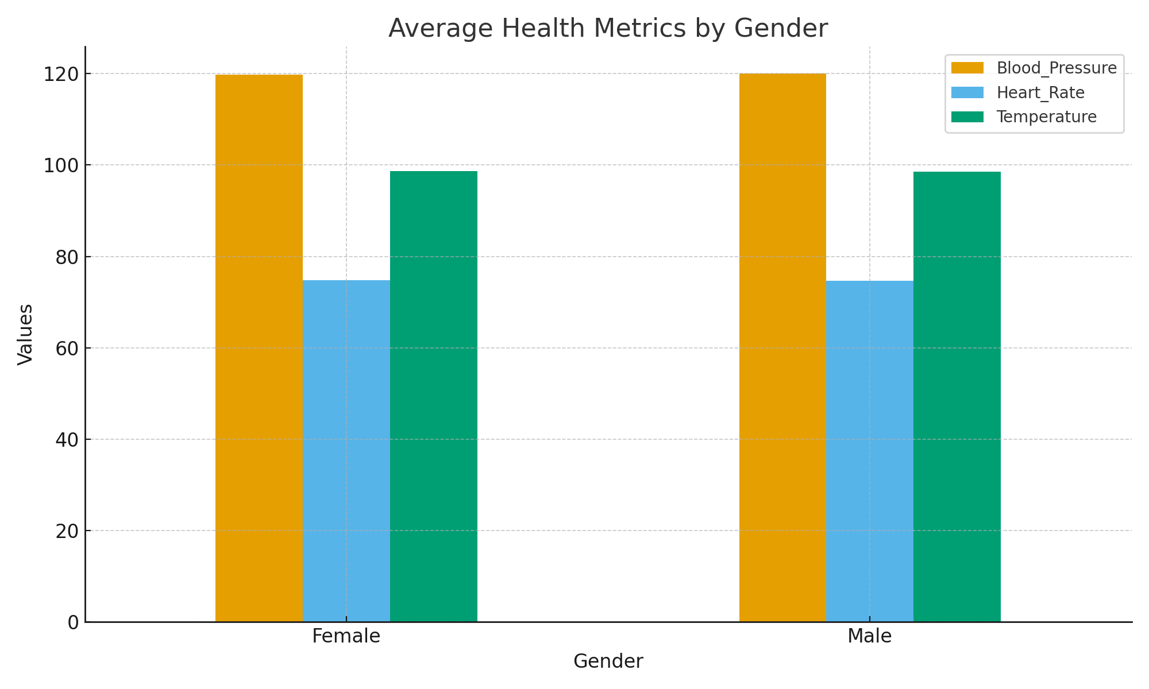
Fig 1: Average Health Metrics by Gender
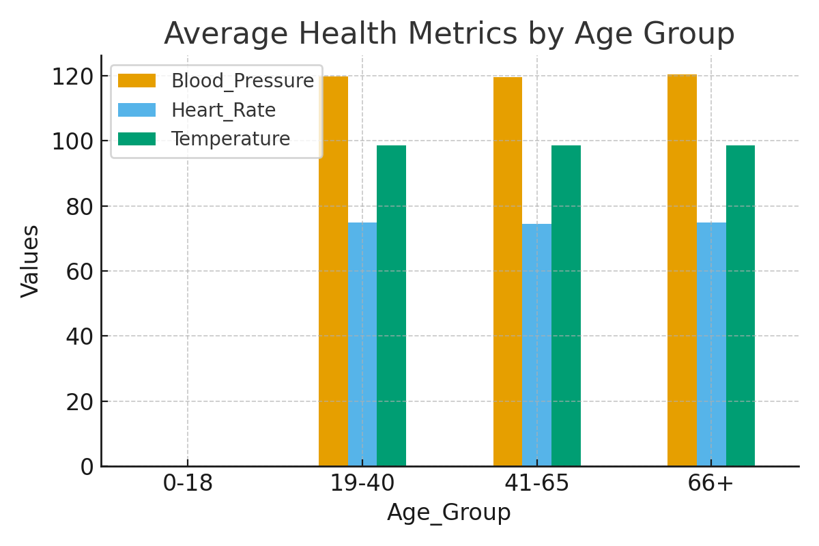
Fig 2: Average Health Metrics by Age Group
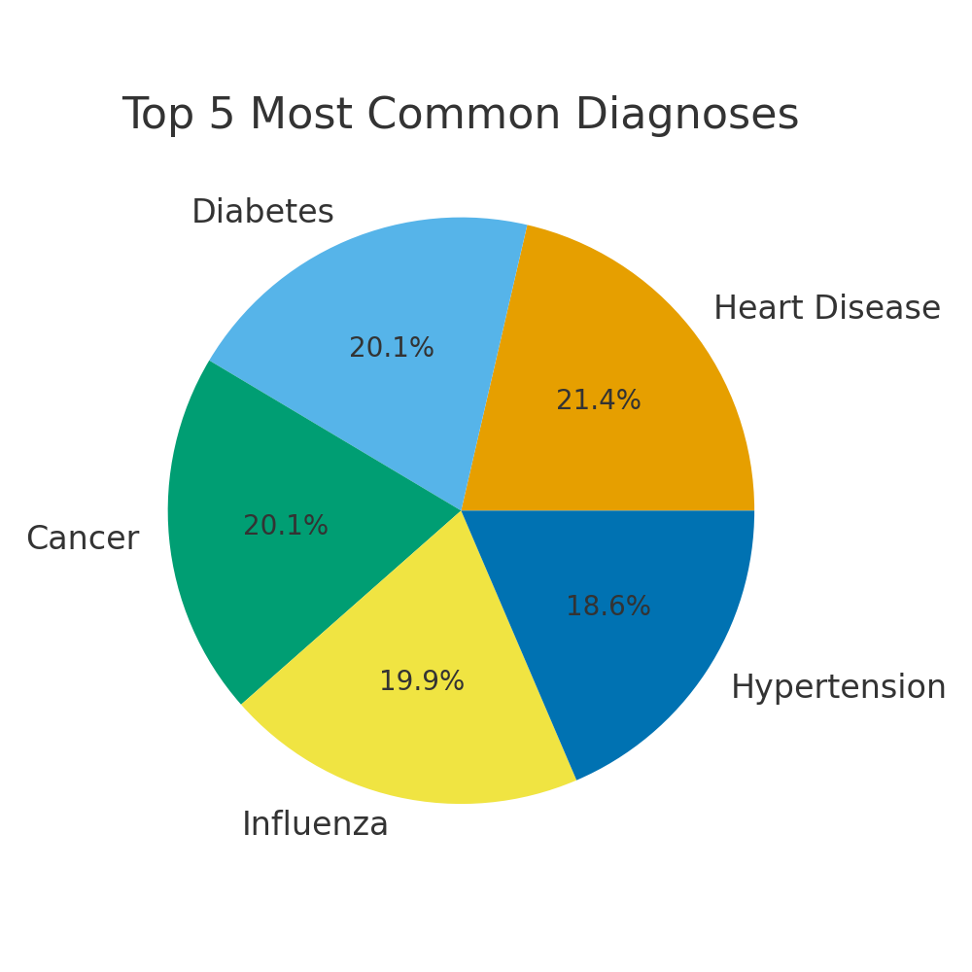Fig 3: Top 5 Most Common Diagnoses
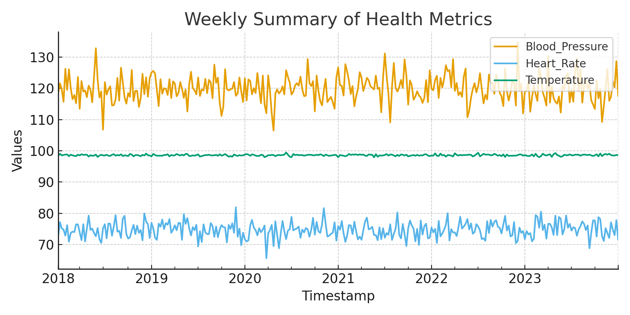
Fig 4: Weekly Summary of Health Metrics

Patient-Specific Visualizations
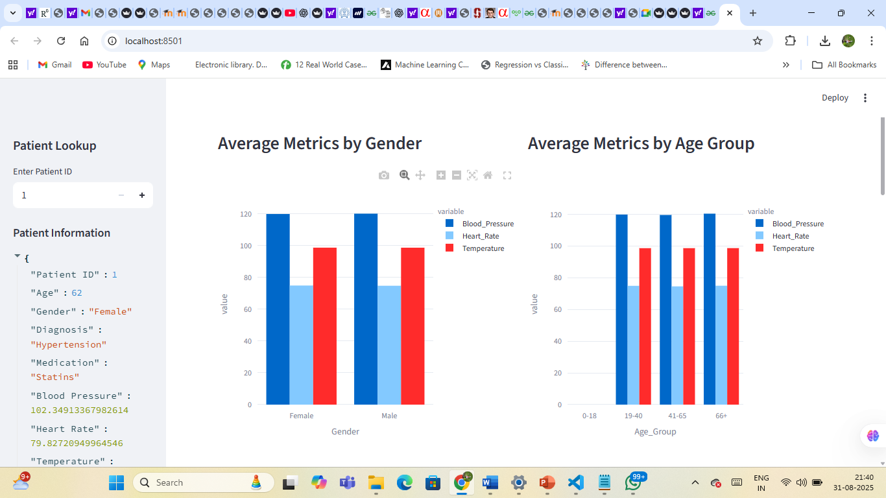
Fig 5: Dashboard view - Average Metrics by Gender and Age Group
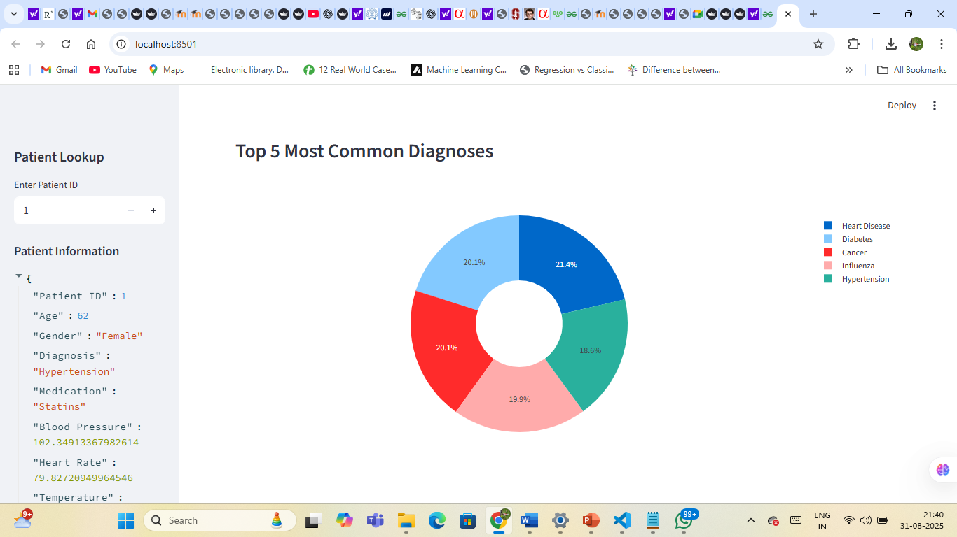
Fig 6: Dashboard view - Top 5 Most Common Diagnoses
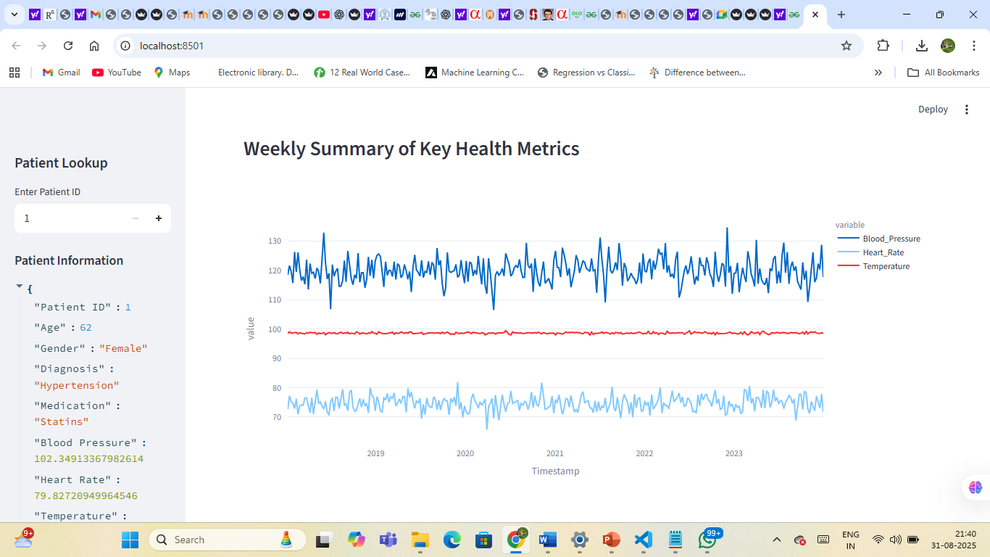
Fig 7: Dashboard view - Weekly Summary of Key Health Metrics
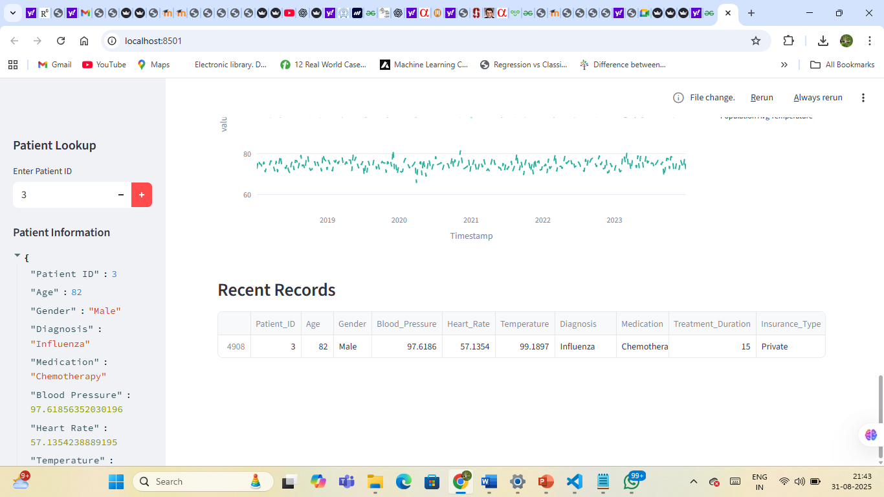
Fig 8: Dashboard view - Patient-Specific Trends and Recent Records

