SET 1
Q1: Design a database schema for a Library Management System using AI assistance.
- Use AI tools to generate SQL commands for creating tables: Books, Members, and Loans and execute in VS code
- Insert at least 3 records in each table
- Write a query to display all books currently issued to members.
PROMPT:
Design a database schema for a Library Management System using AI assistance.
• Use AI tools to generate SQL commands for creating tables: Books, Members, and Loans
and execute in VS code
• Insert at least 3 records in each table
• Write a query to display all books currently issued to members
CODE:

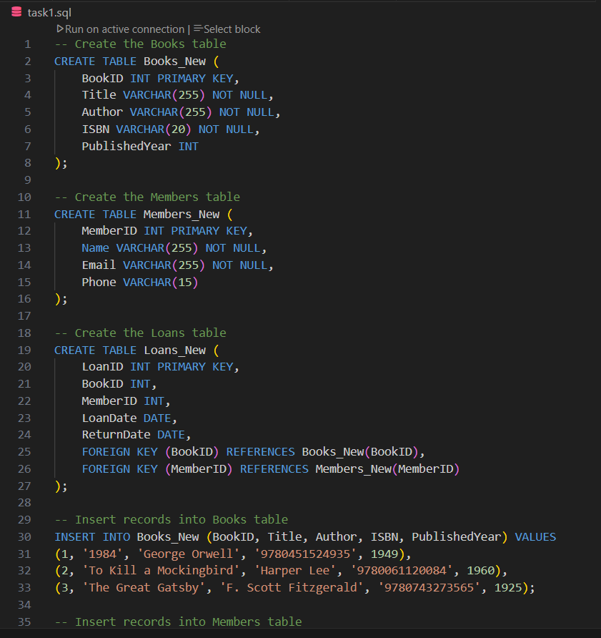
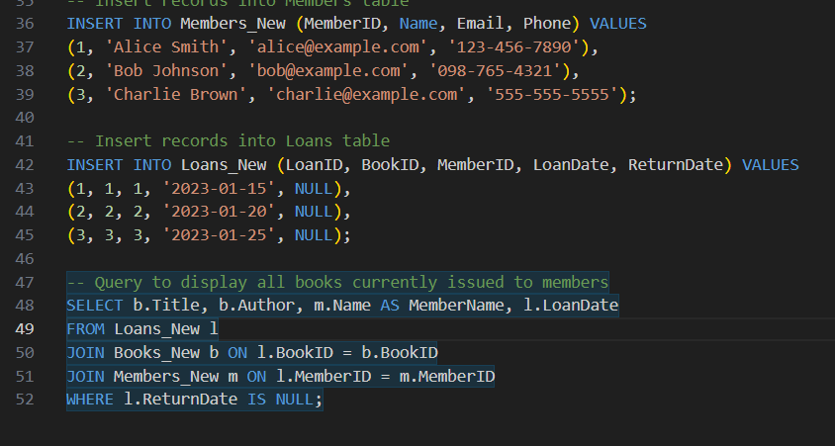
OUTPUT:
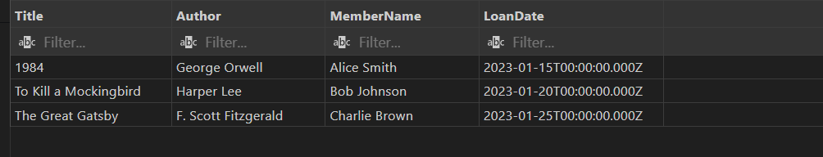
Q2. Using AI, generate a Python script to clean a sales dataset by handling missing values and normalizing the “transaction_amount” column using Min-Max scaling and standard scalar method. Use VS Code with Github copilot or cursor AI
- Generate dataset using ChatGPT that helps to complete the below two taks
- Handle missing values
- Normalize “transaction_amount”
PROMPT:
Using AI, generate a Python script to clean a sales dataset by handling missing values and normalizing the “transaction_amount” column using Min-Max scaling and standard scalar method. Use VS Code with Github copilot or cursor AI
- Generate dataset using ChatGPT that helps to complete the below two taks
- Handle missing values
- Normalize “transaction_amount”
CODE:
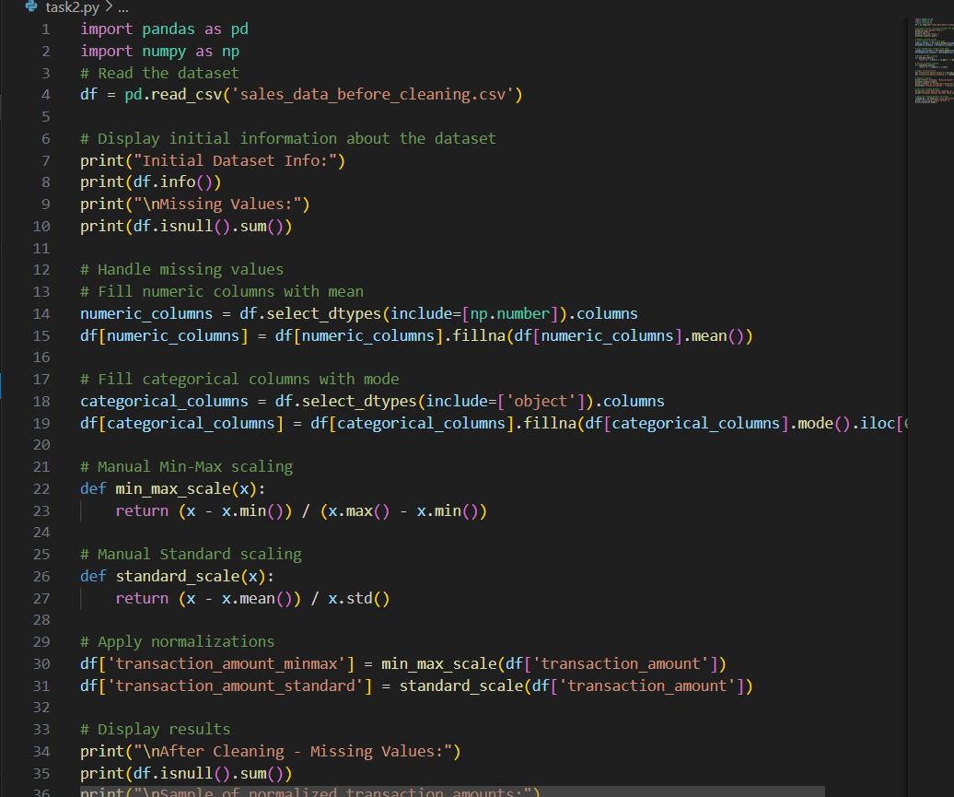

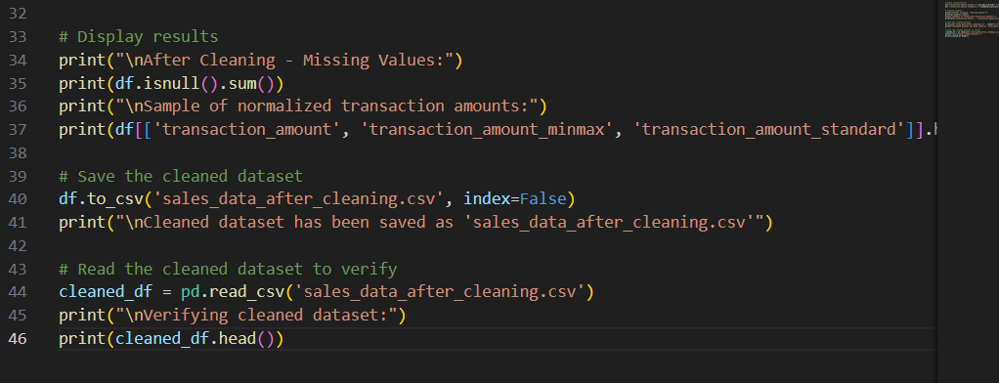
OUTPUT:
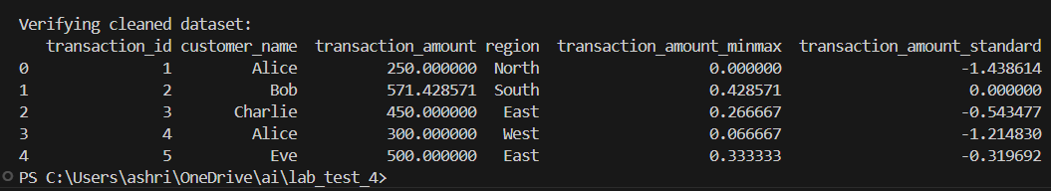
FILE BEFORE CLEANING:
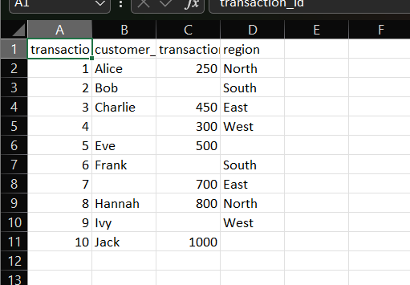
FILE AFTER CLEANING:
