SET 1

Q1. (Data Structures – 5 Marks)
Using AI assistance, write a Python program to implement a Stack using a list.
Perform the following operations:
- Push 5 elements
- Pop 2 elements
- Display the remaining stack
Explain how AI helped generate or optimize your structure.
PROMPT: write a Python program to implement a Stack using a list.
Perform the following operations:
- Push 5 elements
- Pop 2 elements
- Display the remaining stack
Explain how AI helped generate or optimize your structure.
CODE:
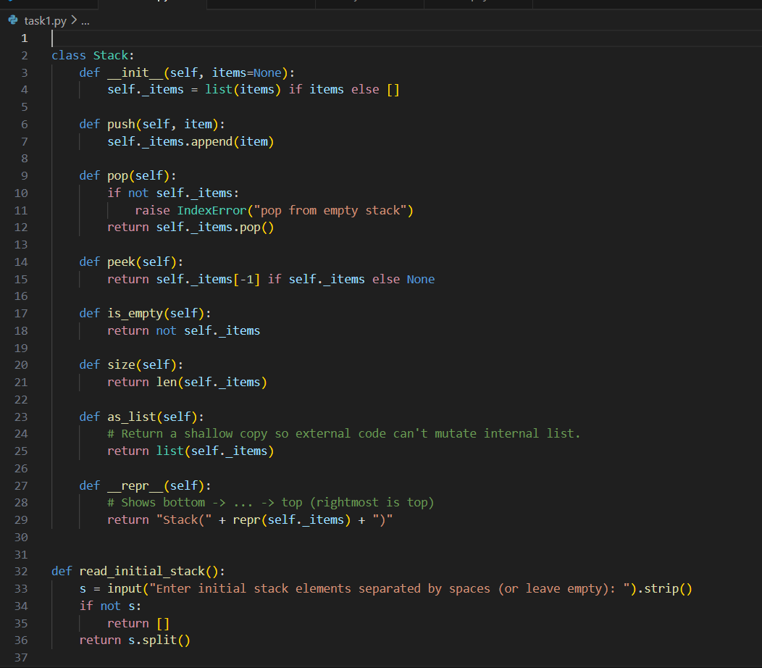

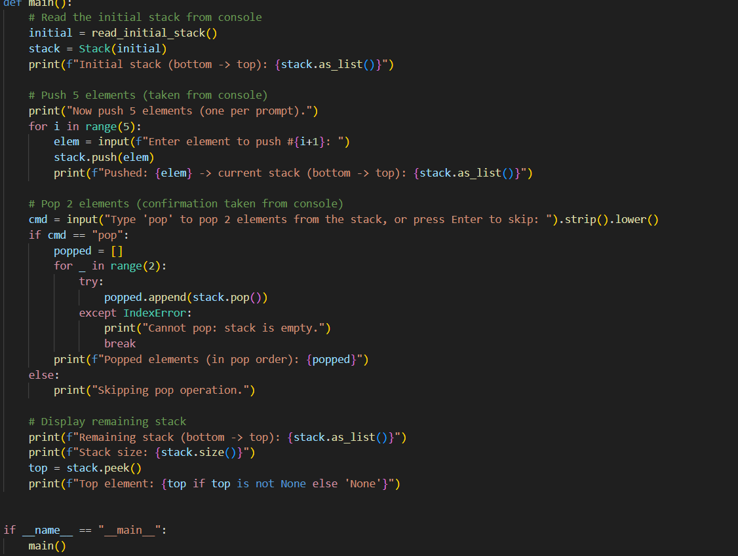

OUTPUT:

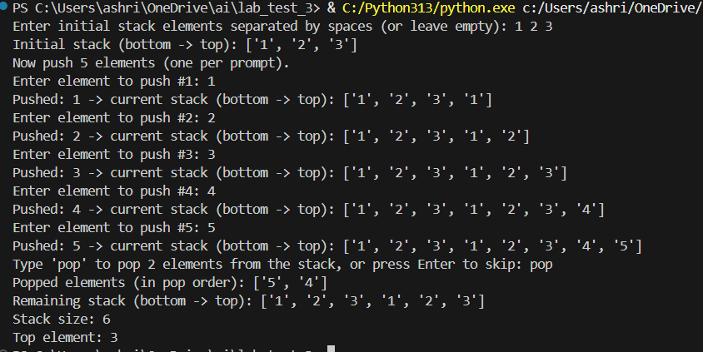

Q2. (Web Frontend – 5 Marks)
With AI tools, develop an interactive To-Do List App using HTML, CSS, and JavaScript.
Include features:
- Add task
- Delete task
- Mark as completed
PROMPT: develop an interactive To-Do List App using HTML, CSS, and JavaScript.
Include features:
- Add task
- Delete task
- Mark as completed
CODE:
INDEX.html
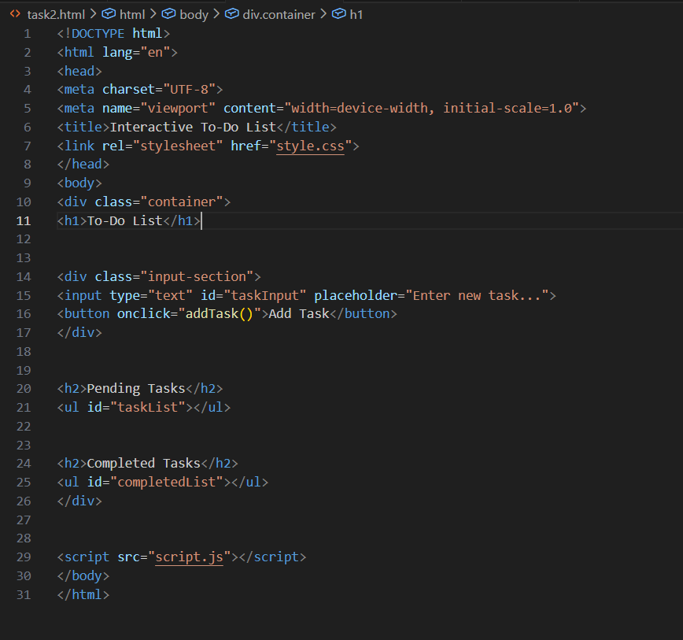
STYLE.css
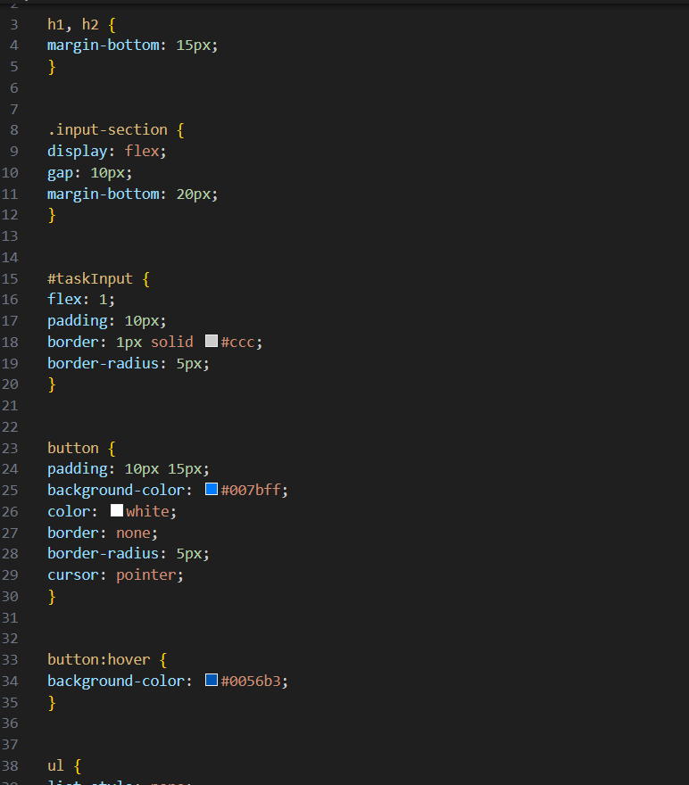
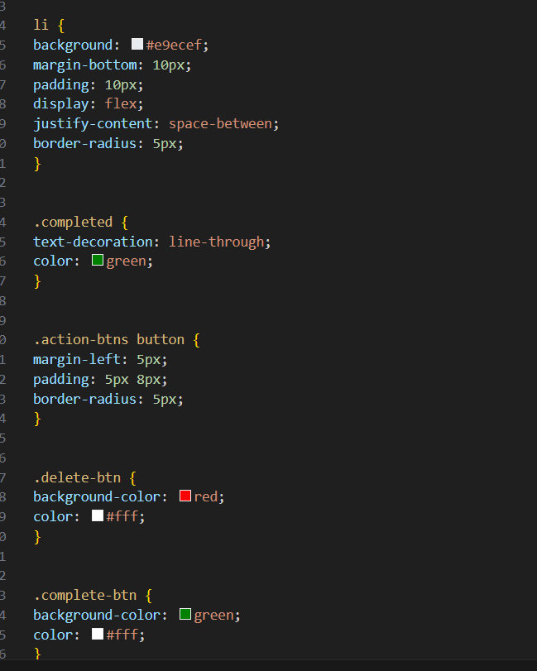
App.js
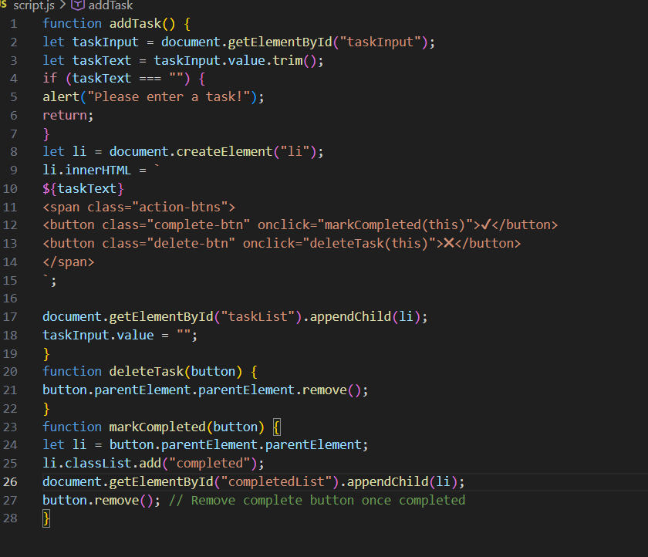
OUTPUT:
