AI ASSISTED CODING

ASSIGMENT 2.2

PROGRAM: B.TECH/CSE

SPECIALIZATION :AIML

NAME :KURAPATI ASHRITHA

ENROLLMENT NO:2403A52023

COURSE : AI ASSISTED CODE

DATE:19-08-2025

BATCH :02

#TASK DESCRIPTION 1:

Use Gemini in Colab to write a function that filters out all negative numbers from a given list

PROMPT:

Develop a code of function that filters out all negative numbers from a given list

EXPECTED OUTPUT 1:

Functional code with before/after input and output shown in Colab, plus a screenshot

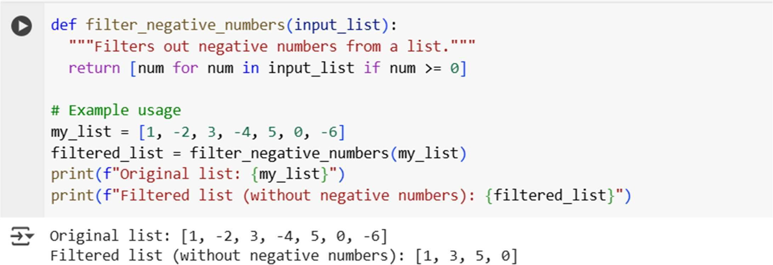

EXPLANATION 1:

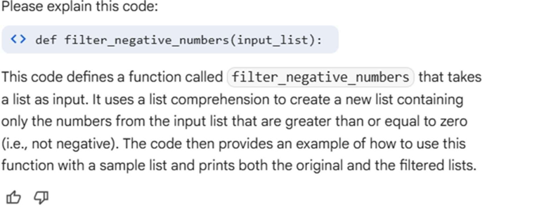

#TASK DESCRIPTION 2:

Ask Gemini to generate code that reads a text file and counts the frequency of each word. Then ask it to explain the code

PROMPT:

Develop a code to generate a text file and counts the frequency of each word

EXPECTED OUTPUT 2:

Working code and Gemini’s explanation side-by-side

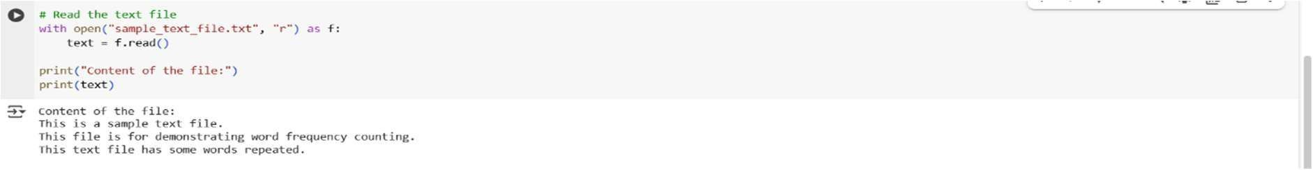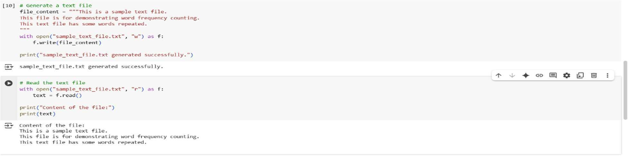

EXPLANATION 2:

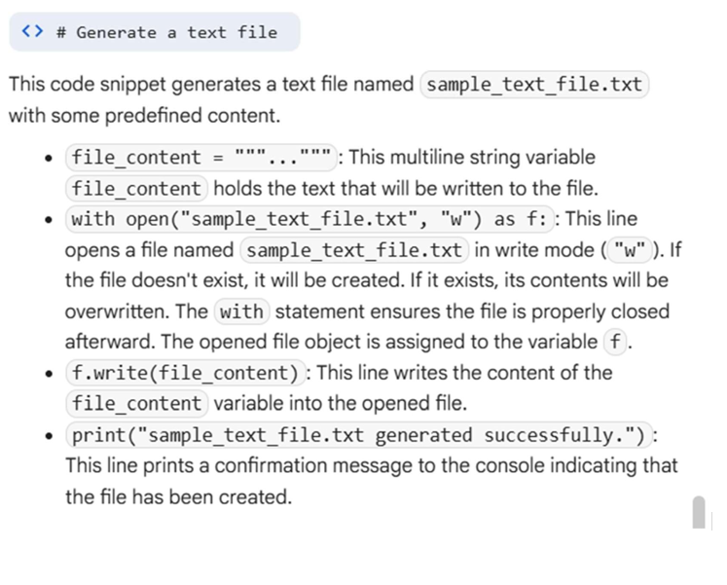

#TASK DESCRIPTION 3:

Use Cursor AI to generate a Python class called Book with attributes title, author, and a method summary() that prints the details

PROMPT:

Develop a code cursor AI to generate python class called book with attributes title,author and method summary() that prints the details

EXPECTED OUTPUT 3:

Screenshot comparisons and student commentary on code clarity and performance

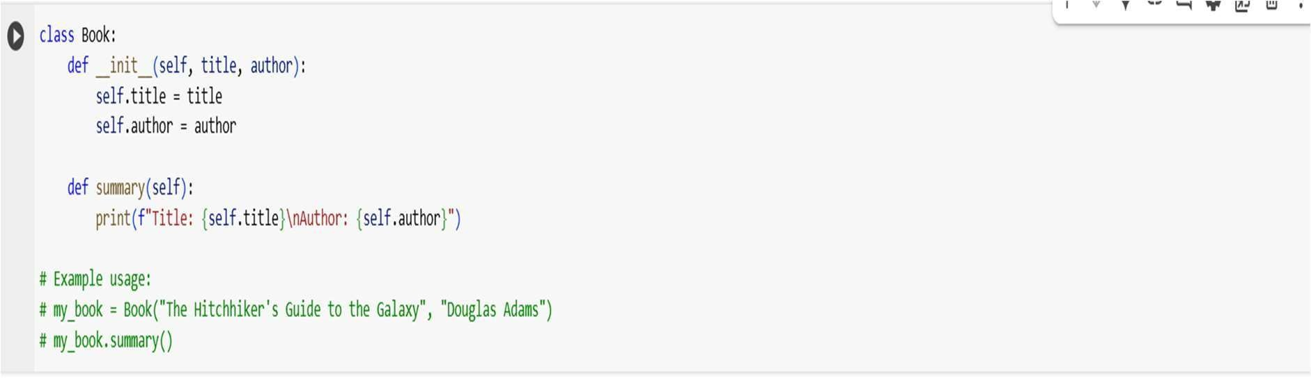

EXPLANATION 3:

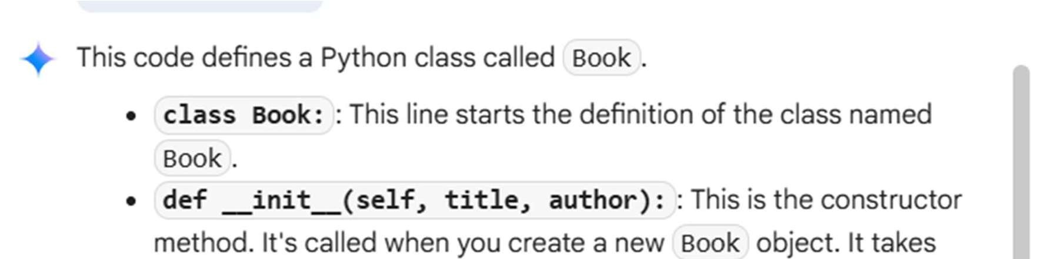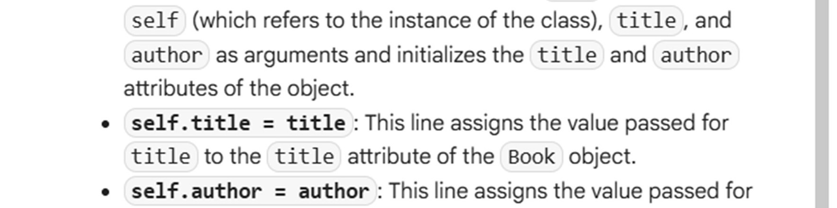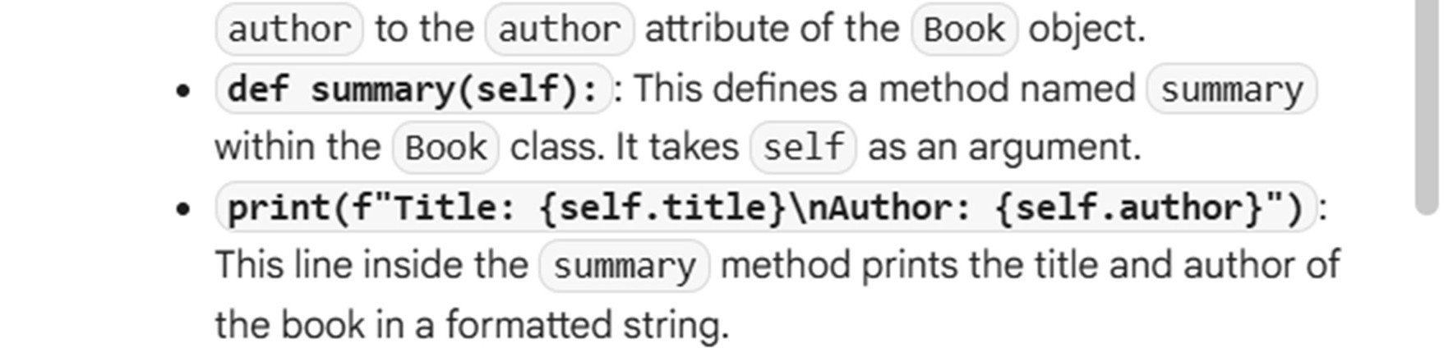

#TASK DESCRIPTION 4:

Ask Gemini to write a program that checks whether a number is an Armstrong number, and then modify it using Cursor AI to improve performance or structure

PROMPT:

Develop a code to generate program that checks whether a

number is an Armstrong number, and then modify it using Cursor AI to improve performance or structure

EXPECTED OUTPUT 4:

Two versions of the code with screenshots, and a summary of what changes were made by Cursor

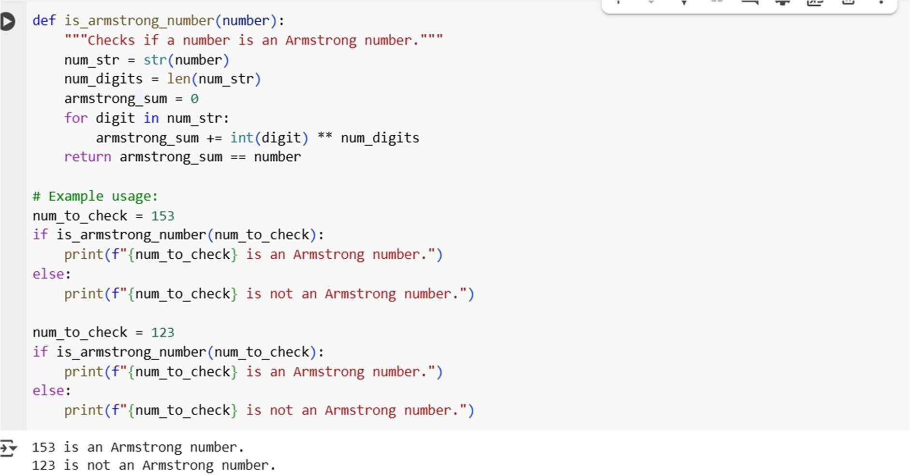

EXPLANATION 4:

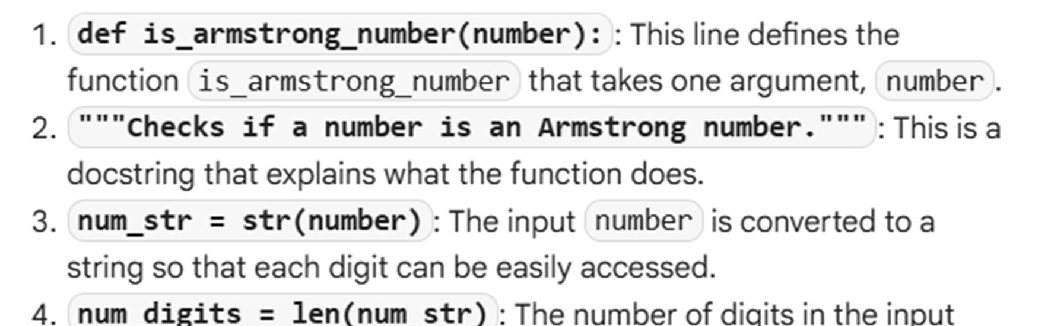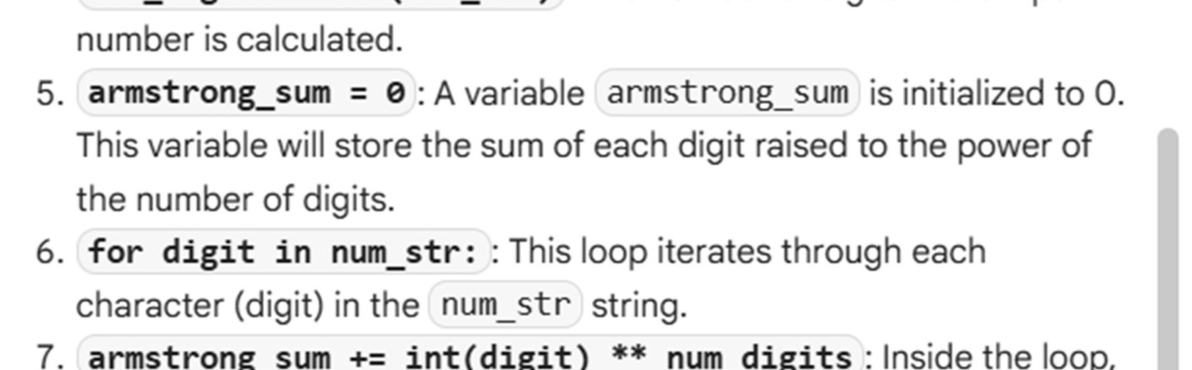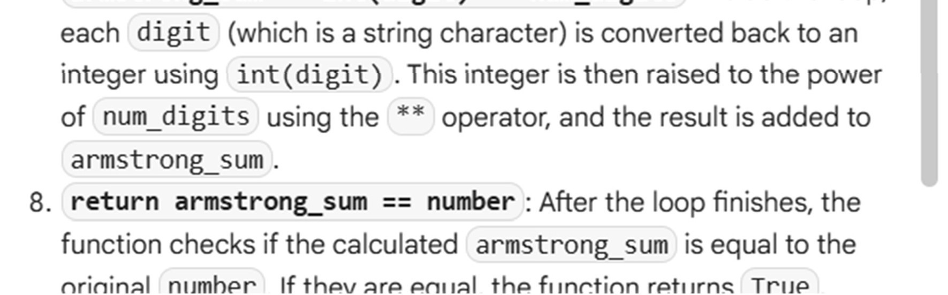

#TASK DESCRIPTION 5:

Use both Gemini and Cursor AI to generate code for sorting a list of dictionaries by a specific key (e.g., age)

PROMPT:

Develop a code to generate a code Use both Gemini and Cursor AI to generate code for sorting a list of dictionaries by a specific key (e.g., age)

EXPECTED OUTPUT 5:

Screenshot comparisons and student commentary on code clarity and performance

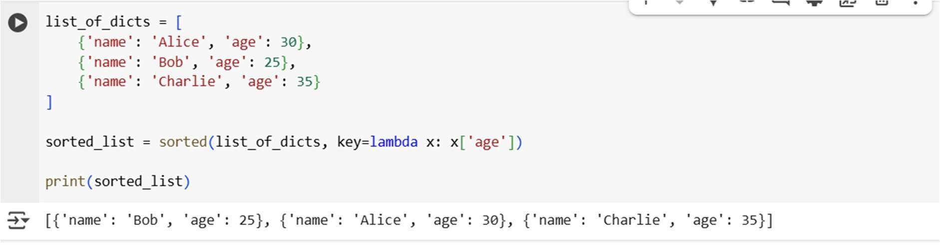

EXPLANATION OF CODE

