
Program :B.tech(CSE)
Specialization :AIML
Course Title :AI Assisted Coding
Course Code :24CS002PC215
Semester :3rd semester
Academic Session :2025-2026
Name of Student :Kurapati Ashritha
Enrollment No. :2403A52023
Batch No. :02
Date :22/10/2025
#LAB ASSIGNMENT-12.3
#TASK DESCRIPTION-1:
Linear Search implementation
Task: Write python code for linear_search() function to search a value in a list and extract it’s index.
#PROMPT:
Write a Python program to implement a function linear_search() that searches for a value in a list and returns its index with dynamic input.
#CODE:
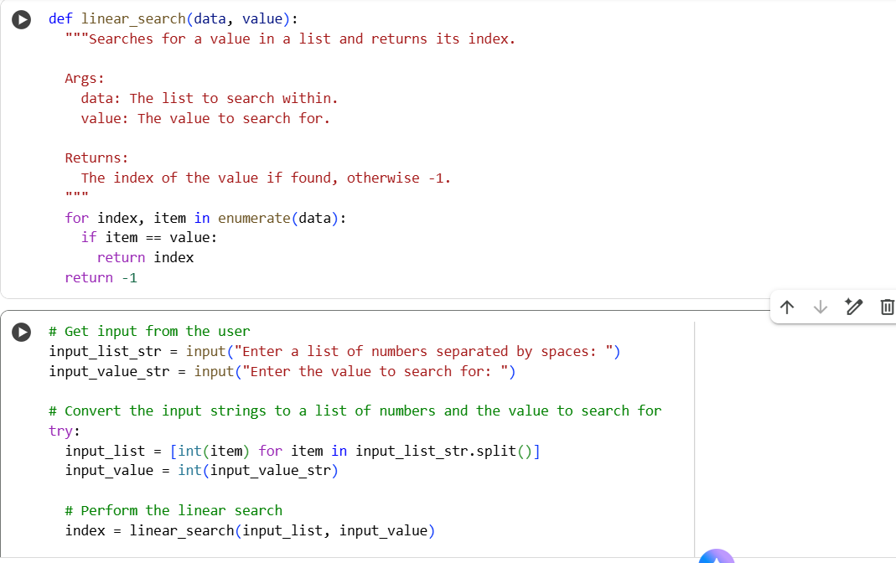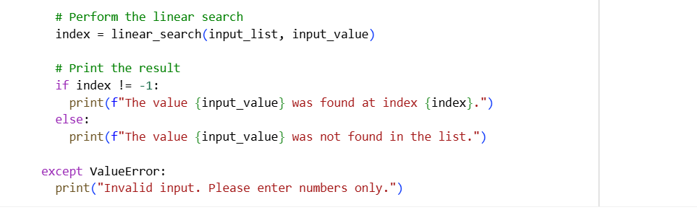
# OUTPUT:
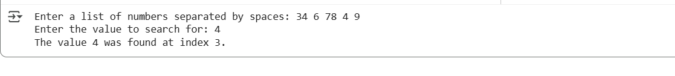

#TASK DESCRIPTION-2:
Sorting Algorithms
Task: Ask AI to implement Bubble Sort and check sorted output
#PROMPT:
Write a Python program to implement the Bubble Sort algorithm to sort a list in ascending order and display the sorted output with dynamic input.
#CODE:
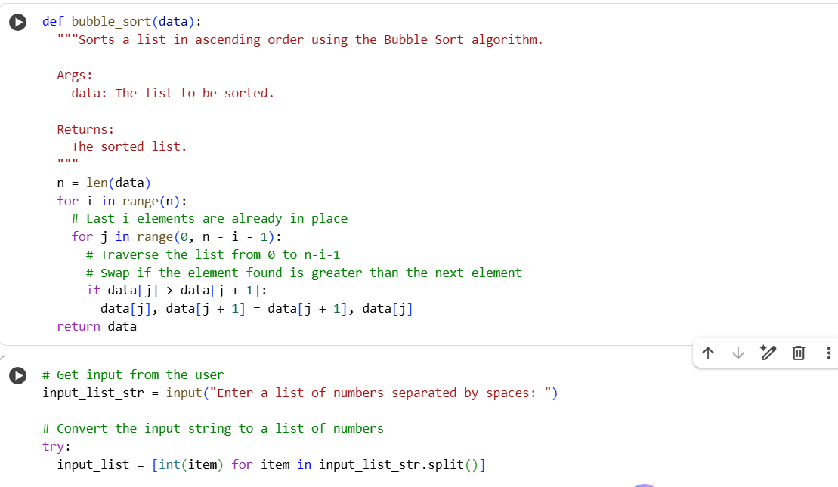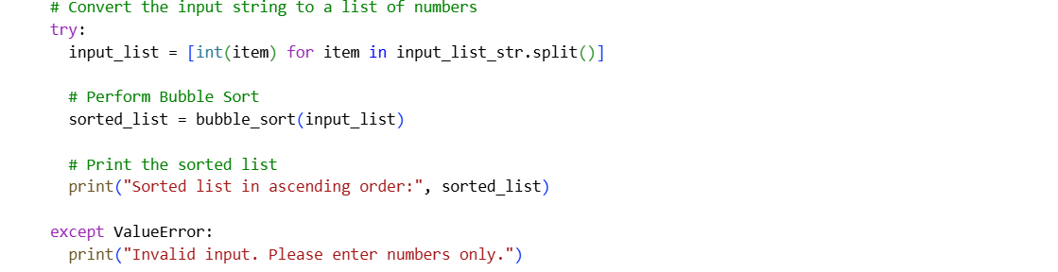
#OUTPUT:
#TASK DESCRIPTION-3:
Optimization
Task: Write python code to solve below case study using linear
optimization. 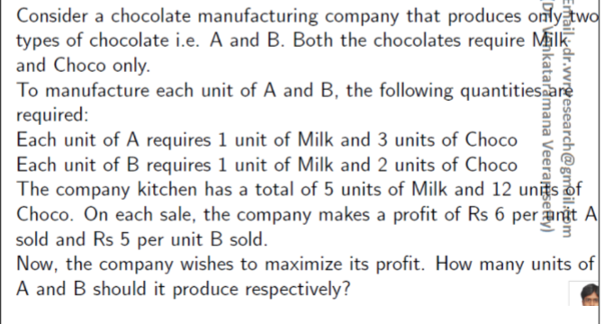

#PROMPT:
Write a python code to calculate the company makes two chocolates A and B. Each unit of A requires 1 unit of Milk and 3 units of Choco. Each unit of B requires 1 unit of Milk and 2 units of Choco. The company has a total of 5 units of Milk and 12 units of Choco. Profit is Rs 6 per unit of A and Rs 5 per unit of B. Formulate and solve the LP to maximize total profit. Return the optimal values of A and B and the maximum profit with the dynamic input.
#CODE: 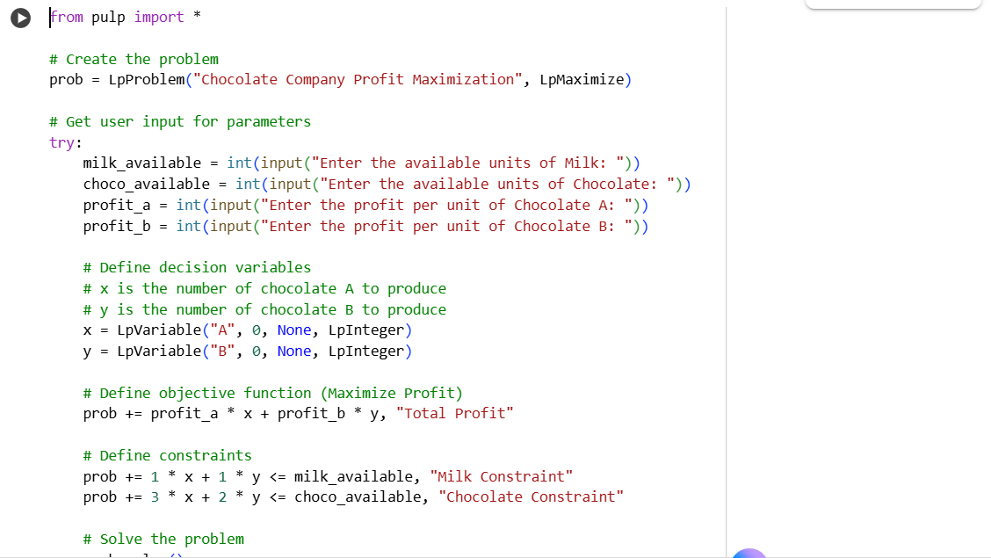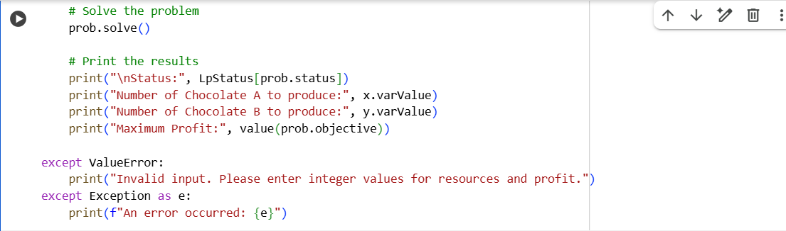

#OUTPUT:
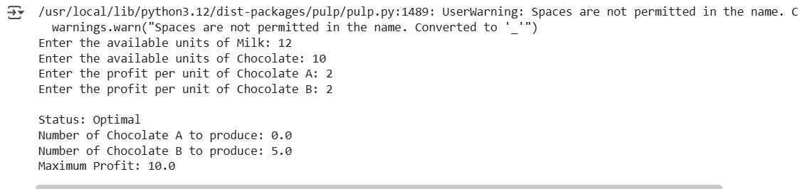
# TASK DISCRIPTION-4:
Gradient Descent Optimization
Task: Write python code to find value of x at which the function
f(x)=2X3+4x+5 will be minimum
#PROMPT:
Write Python code using Gradient Descent to find the value of x at which f(x) = 2x³ + 4x + 5 is minimum with user input.
#CODE:
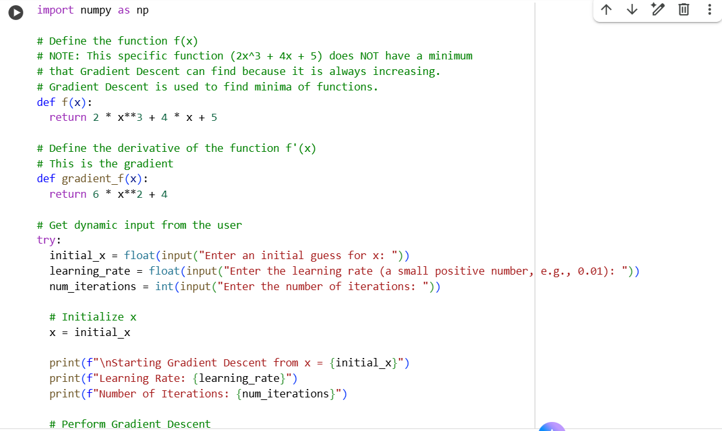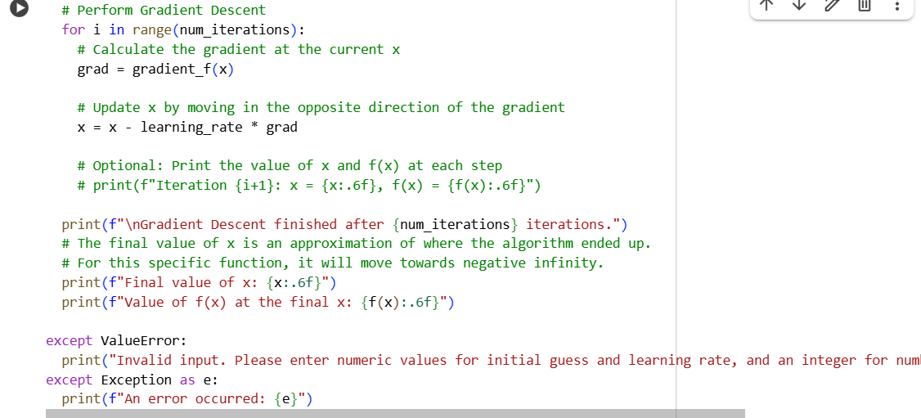
#OUTPUT:
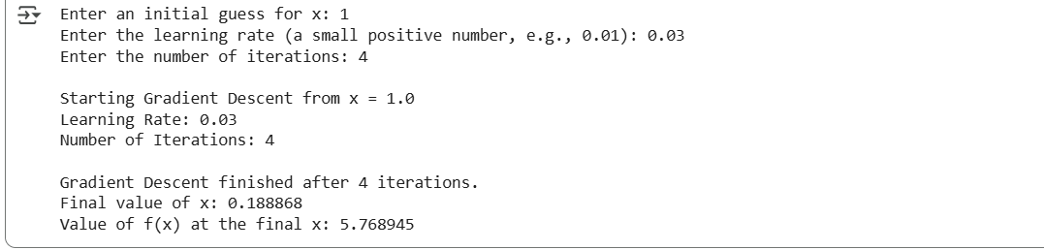
Thank You

