
Program :B.tech(CSE)
Specialization :AIML
Course Title :AI Assisted Coding
Course Code :24CS002PC215
Semester :3rd semester
Academic Session :2025-2026
Name of Student :Kurapati Ashritha
Enrollment No. :2403A52023
Batch No. :02
Date :7/10/2025
#LAB ASSIGNMENT-10.2
#TASK DESCRIPTION-1: 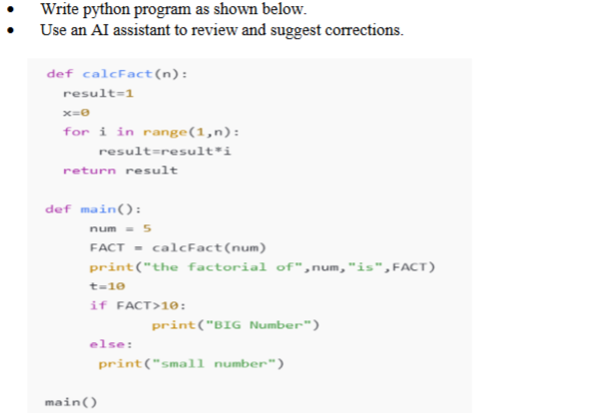
#Prompt:
def calcFact(n):
result=1
x=0
for i in range(1,n):
result=result*i
return result

def main():
num = 5
FACT = calcFact(num)
print("the factorial of",num,"is",FACT)
t=10
if FACT>10:
print("BIG Number")
else:
print("small number")

main()
Correct this Python code fix any basic errors and add comments explaining each step.
# OUTPUT:
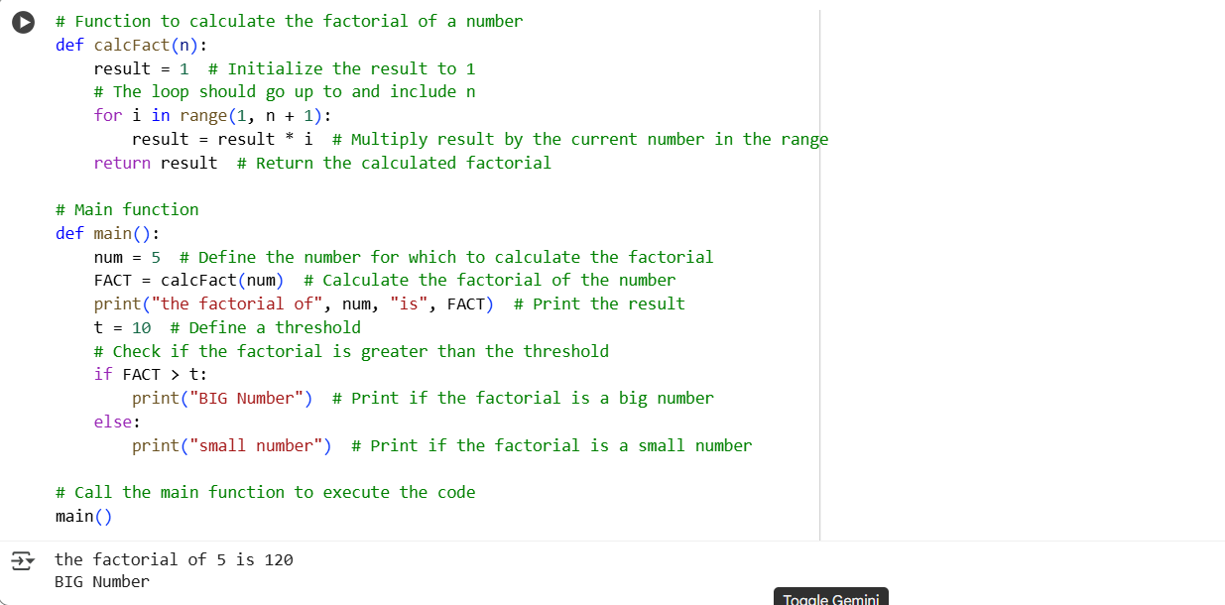

#TASK DESCRIPTION-2:
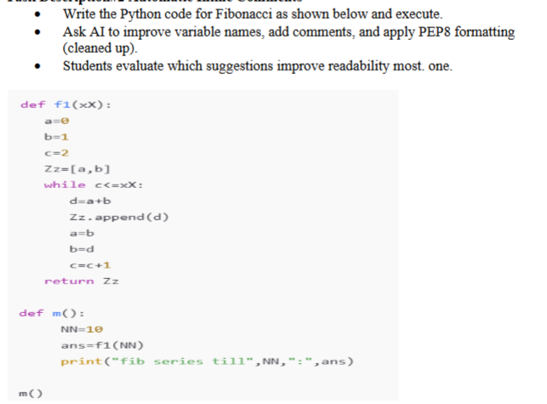
#Prompt:
def f1(XX):
a=0
b=1
c=2
Zz=[a,b]
while c<=XX:
d=a+b
Zz.append(d)
a=b
b=d
c=c+1
return Zz

def m():
NN=10
ans=f1(NN)
print("fib series till",NN,":",ans)

m()
Give me a corrected code with improving variable name , including comments, and apply PEP8 Formatting
#OUTPUT:
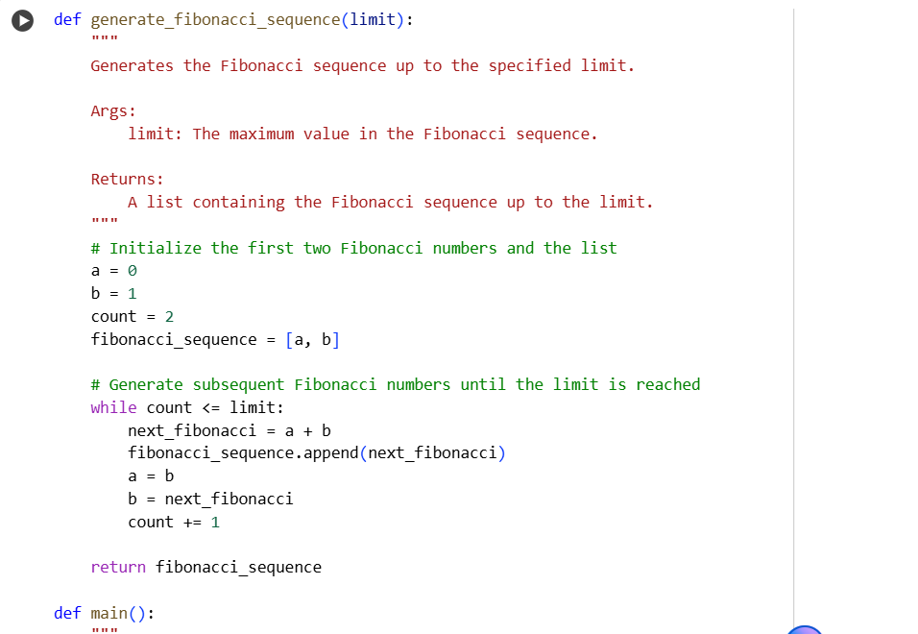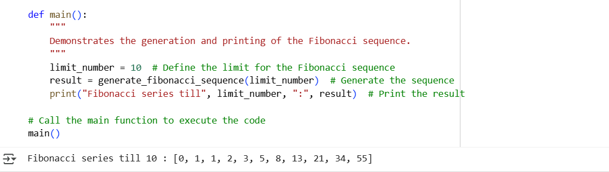
#TASK DESCRIPTION-3:
Write a Python script with 3–4 functions (e.g., calculator: add, subtract, multiply,
divide).
• Incorporate manual docstring in code with NumPy Style
• Use AI assistance to generate a module-level docstring + individual function
docstrings.
• Compare the AI-generated docstring with your manually written one.
Common Examples of Code Smells
• Long Function – A single function tries to do too many things.
• Duplicate Code – Copy-pasted logic in multiple places.
• Poor Naming – Variables or functions with confusing names (x1, foo, data123).
• Unused Variables – Declaring variables but never using them.
• Magic Numbers – Using unexplained constants (3.14159 instead of PI).
• Deep Nesting – Too many if/else levels, making code hard to read.
• Large Class – A single class handling too many responsibilities.
Why Detecting Code Smells is Important
• Makes code easier to read and maintain.
• Reduces chance of bugs in future updates.
• Helps in refactoring (improving structure without changing behavior).
• Encourages clean coding practices
Dead Code – Code that is never executed
#MANUAL CODE:
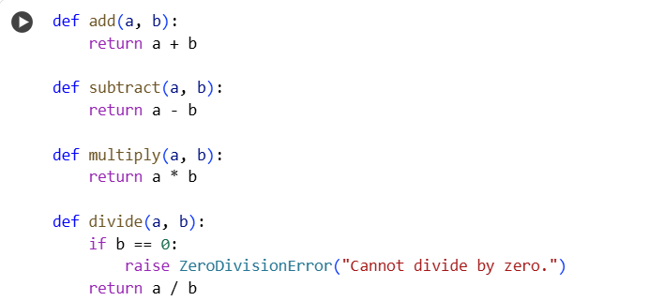
# CODE GENERATED BY AI:
Prompt:
Give me a python code to generate a model level docstring+ individual function docstrings with 3-4 functions(calculator: add, subtract, multiply, divide)
CODE:

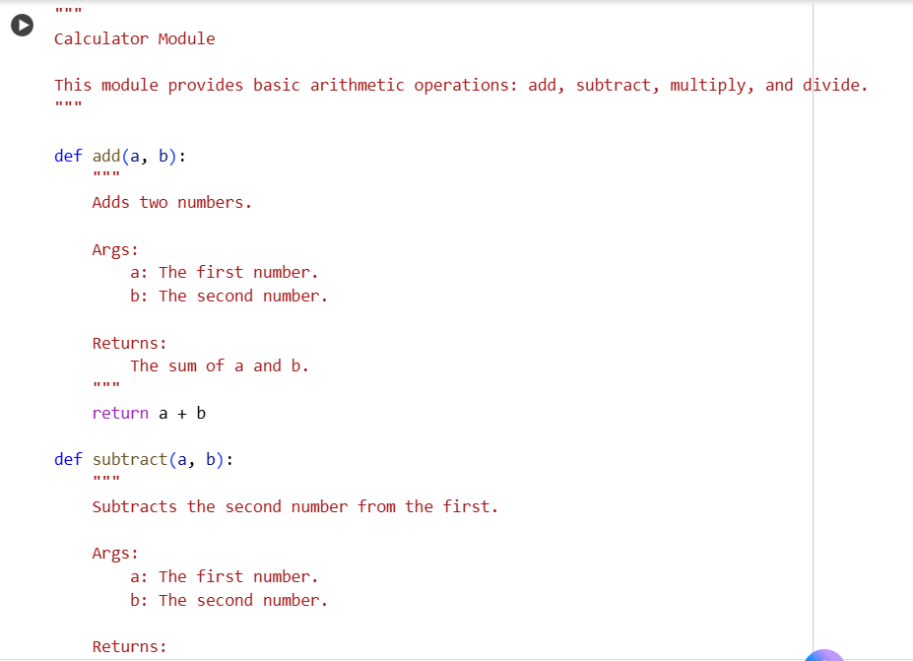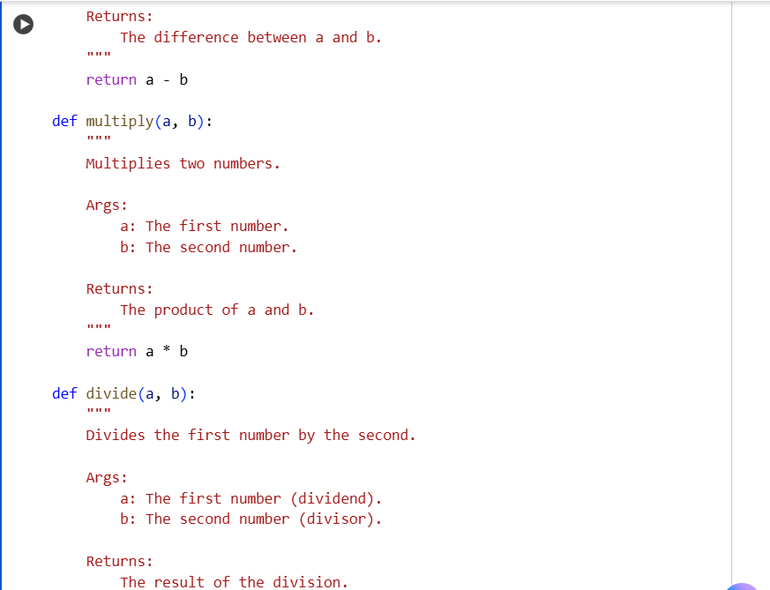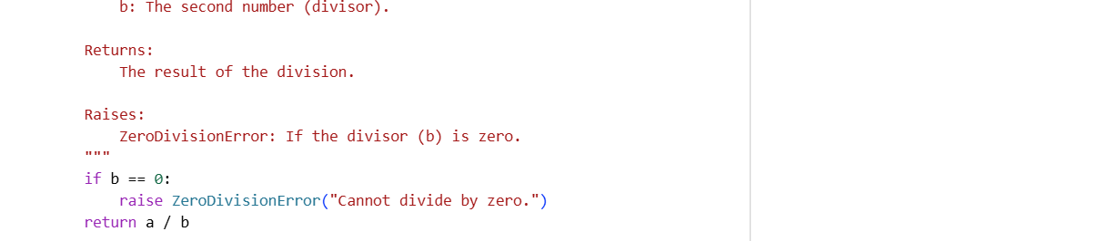
#OUTPUT:
Comparing both manual code and ai-generated code:
Manual Code:
This code provides the basic functionality for a calculator with add, subtract, multiply, and divide functions. It includes a check for division by zero in the divide function.
AI-Generated Code:
This code provides the same basic functionality as the manual code but with significant improvements:
- Model-level Docstring: It includes a docstring at the beginning of the module explaining its purpose.
- Function Docstrings: Each function has a detailed docstring explaining what it does, its arguments (Args), what it returns (Returns), and any potential errors it might raise (Raises).
- PEP 8 Formatting: The code adheres to PEP 8 guidelines for better readability and consistency (e.g., consistent spacing).
In summary, while both codes perform the same calculations, the AI-generated code is more comprehensive and follows best practices for code documentation and style, making it easier to understand and maintain.
Thank You

