**ASSIGNMENT:-**

**Development of a Secure E-**

**Commerce Platform with Microservice**

**Architecture using MERN Stack**

**Name:-**

**Table of Contents**

* [1. Project Overview](https://chat.openai.com/c/311b785c-c36b-4bff-bb5c-8727d17285e6#1-project-overview)
* [2. System Architecture](https://chat.openai.com/c/311b785c-c36b-4bff-bb5c-8727d17285e6#2-system-architecture)
  + [2.1 Microservices Architecture](https://chat.openai.com/c/311b785c-c36b-4bff-bb5c-8727d17285e6#21-microservices-architecture)
  + [2.2 Security Measures](https://chat.openai.com/c/311b785c-c36b-4bff-bb5c-8727d17285e6#22-security-measures)
* [3. Technology Stack](https://chat.openai.com/c/311b785c-c36b-4bff-bb5c-8727d17285e6#3-technology-stack)
* [4. Microservices Design](https://chat.openai.com/c/311b785c-c36b-4bff-bb5c-8727d17285e6#4-microservices-design)
  + [4.1 User Service](https://chat.openai.com/c/311b785c-c36b-4bff-bb5c-8727d17285e6#41-user-service)
  + [4.2 Product Service](https://chat.openai.com/c/311b785c-c36b-4bff-bb5c-8727d17285e6#42-product-service)
  + [4.3 Order Service](https://chat.openai.com/c/311b785c-c36b-4bff-bb5c-8727d17285e6#43-order-service)
  + [4.4 Payment Service](https://chat.openai.com/c/311b785c-c36b-4bff-bb5c-8727d17285e6#44-payment-service)
* [5. Frontend Development](https://chat.openai.com/c/311b785c-c36b-4bff-bb5c-8727d17285e6#5-frontend-development)
* [6. Security Considerations](https://chat.openai.com/c/311b785c-c36b-4bff-bb5c-8727d17285e6#6-security-considerations)
* [7. Deployment](https://chat.openai.com/c/311b785c-c36b-4bff-bb5c-8727d17285e6#7-deployment)
* [8. Testing Strategy](https://chat.openai.com/c/311b785c-c36b-4bff-bb5c-8727d17285e6#8-testing-strategy)
* [9. Conclusion](https://chat.openai.com/c/311b785c-c36b-4bff-bb5c-8727d17285e6#9-conclusion)

## 1. Project Overview

The project aims to develop a secure and scalable e-commerce platform using a microservice architecture. This approach enables independent deployment and scalability of each service, improved fault isolation, and a flexible, maintainable codebase. The MERN stack provides a full-stack JavaScript environment, facilitating rapid development and performance efficiency.

## 2. System Architecture

### 2.1 Microservices Architecture

The platform is built on a microservice architecture, where each core functionality (User Management, Product Management, Order Processing, and Payment Processing) is developed as a separate, independently deployable service. These services communicate over a lightweight protocol (HTTP/REST or message queues for asynchronous communication).

### 2.2 Security Measures

Security is integrated into the architecture from the ground up, with measures including API gateway for secure access, JWT for authentication and authorization, HTTPS for secure data transmission, and MongoDB encryption for data at rest.

## 3. Technology Stack

* **Frontend:** React.js
* **Backend:** Node.js, Express.js
* **Database:** MongoDB
* **Security:** JWT, HTTPS, OAuth
* **Communication:** REST API, RabbitMQ (for asynchronous tasks)
* **Containerization:** Docker
* **Orchestration:** Kubernetes

## 4. Microservices Design

### 4.1 User Service

Handles user registration, authentication, and profile management. It uses JWT for secure authentication and integrates OAuth for third-party logins.

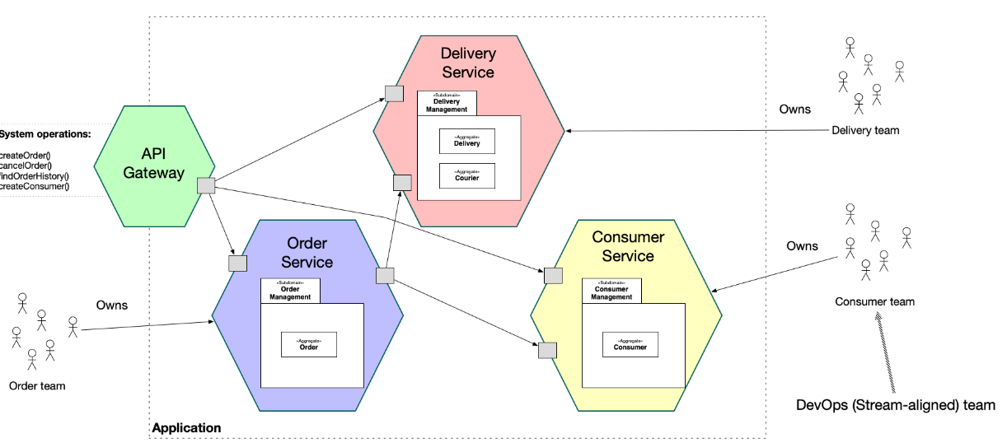

### 4.2 Product Service

Manages product inventory, including product creation, update, and deletion. It supports advanced features like category management, search, and reviews/ratings.

### 4.3 Order Service

Responsible for order management, including order creation, tracking, and history. It interacts with the Product Service to update inventory and the Payment Service to process payments.

### 4.4 Payment Service

Processes payments and integrates with external payment gateways (e.g., PayPal, Stripe). It handles payment confirmations and triggers order status updates.

## 5. Frontend Development

The frontend is developed using React, providing a dynamic and responsive user interface. It communicates with the backend services through a secure API Gateway, ensuring a seamless and secure user experience.

## 6. Security Considerations

Security is paramount, with measures including:

* **Authentication and Authorization:** Using JWT and OAuth.
* **Data Security:** HTTPS for data in transit, encryption for data at rest.
* **API Security:** Rate limiting, CORS, API gateways.
* **Regular Security Audits:** To identify and mitigate vulnerabilities.

## 7. Deployment

The services are containerized using Docker, making them easy to deploy and scale. Kubernetes is used for orchestration, managing the deployment, scaling, and operation of application containers across clusters of hosts.

## 8. Testing Strategy

Testing includes unit testing for individual services, integration testing for service interaction, and end-to-end testing for the entire application. Automated testing ensures code quality and functionality.

## 9. Conclusion

This document provides a roadmap for building a secure, scalable e-commerce platform using microservice architecture and the MERN stack. By following these guidelines, developers can create a robust platform that offers a seamless, secure shopping experience to users.

This architecture not only ensures the application's scalability and maintainability but also addresses crucial security concerns, making it a solid foundation for developing comprehensive e-commerce solutions in today's digital marketplace.