5.1

The main difference between the two is when they are called and what they are used for.

Awake() is called when the script instance is being loaded, regardless of whether the script is enabled or not. On the other hand, Start() is called just before any of the Update methods are called for the first time, only if the script is enabled.

5.2

OnCollisionStay()

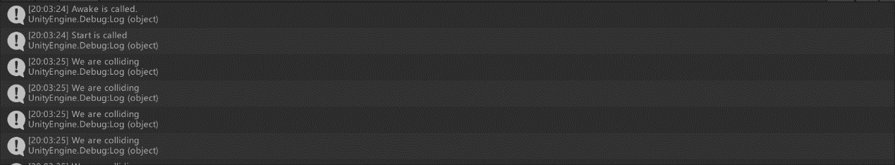

OnCollisionExit()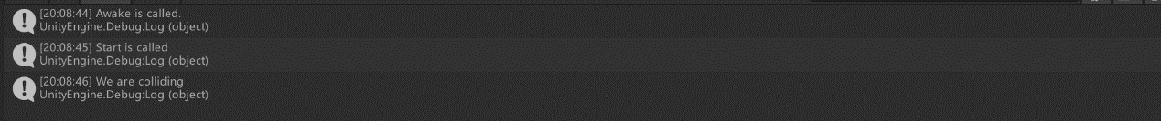

with all there method

5.3

