32

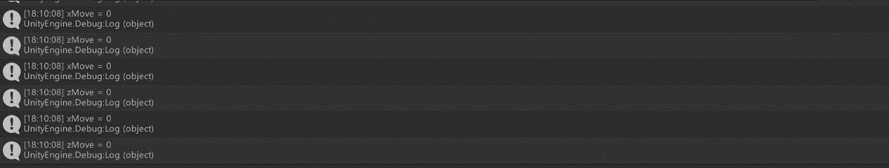

33

void ControlByArrowKeys(float speed)  
{  
 */*  
 float xMove = Input.GetAxis("Horizontal") * speed;  
 float zMove = Input.GetAxis("Vertical") * speed;  
  
 rb.AddForce(xMove, 0.0f, zMove);  
 */  
   
 //Use mouse to transform (move or rotate) the ‘Cube’* float xMove = Input.GetAxis("Mouse X") * speed;  
 float zMove = Input.GetAxis("Mouse Y") * speed;  
 transform.Translate(xMove, 0.0f, zMove);  
   
}

34

void ControlByOtherKeys()  
{  
 if (Input.GetKey(KeyCode.**UpArrow**))  
 {  
 speed += 0.01f;  
 }  
 else if (Input.GetKey(KeyCode.**DownArrow**))  
 {  
 speed -= 0.01f;  
 }  
}