ANSIBLE : LEARNING:

Ansible is simple open source IT engine which automates application deployment, intra service orchestration, cloud provisioning and many other IT tools.

Ansible kind of ek configuration automation tool hai jo different nodes or system ko automatically configure or update kr leta hai !!!!  
Ansible mai jo process use hoti hai that is PUSH (lazy process but beneficial as it reduces overhead)

## Some common words related to Ansible.

**Service/Server** − A process on the machine that provides the service.

**Machine** − A physical server, vm(virtual machine) or a container.

**Target machine** − A machine we are about to configure with Ansible.

**Task** − An action(run this, delete that) etc managed by Ansible.

**Playbook** − The yml file where Ansible commands are written and yml is executed on a machine.

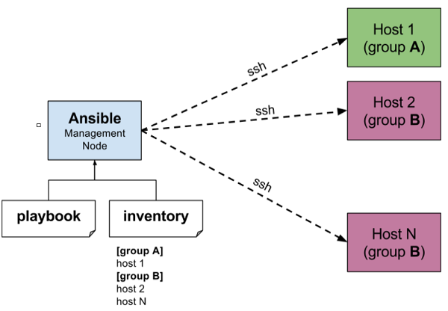

The management node in the above picture is the controlling node (managing node) which controls the entire execution of the playbook. It’s the node from which you are running the installation. The inventory file provides the list of hosts where the Ansible modules needs to be run and the management node does a SSH connection and executes the small modules on the hosts machine and installs the product/software.

**Beauty** of Ansible is that it removes the modules once those are installed so effectively it connects to host machine , executes the instructions and if it’s successfully installed removes the code which was copied on the host machine which was executed.

ANSIBLE competitor : CHEF and PUPPET

Chef mai PULL process use hota hai that is much costly and overhead count increase ho jata hai because every time it needs to go and ask every node to pull the changes.

Ansible is easy to deploy because it does not use any agents or custom security infrastructure.

Installation through Apt on Ubuntu Machine

For installing Ansible you have to configure PPA on your machine. For this, you have to run the following line of code −

$ sudo apt-get update

$ sudo apt-get install software-properties-common

$ sudo apt-add-repository ppa:ansible/ansible $ sudo apt-get update

$ sudo apt-get install ansible

After running the above line of code, you are ready to manage remote machines through Ansible. Just run Ansible–version to check the version and just to check whether Ansible was installed properly or not.