

project

Internet of things 271



October 2, 2023

Table of Contents

Team Members 3

Technical Report on Smoke Detection System 4

Abstract 4

Background 4

Objective 4

Hardware Components 4

MQ-2 Gas Sensor 4

Red LED Indicator 4

Piezo Buzzer 5

16x2 LCD Display 5

Normally Open Pushbutton 5

Resistors 5

System Setup 6

Pin Configuration 6

Alarm Threshold 6

Software Implementation 6

Setup Function 6

Loop Function 6

Display Function 6

Reset Mechanism 6

Operation 7

Smoke Detection 7

Alarm Activation 7

System Reset 7

Expanding for Market Readiness 7

Conclusion 7

Additional Information 7

Pin Definitions: 7

Global Variables: 7

Setup Function (void setup()): 7

Loop Function (void loop()): 7

Diagrams 9

# Team Members

1. Ashle Olivier 578325
2. Albert Wolfaardt 575709
3. Andre Scholtz 577552
4. Michael Coenraad Maritz 577506

# Technical Report on Smoke Detection System

## Abstract

This technical report presents the design and implementation of a Smoke Detection System equipped with an MQ-2 gas sensor for detecting dangerous levels of smoke. The system incorporates a red LED indicator, a piezo buzzer for audio alerts, a 16x2 LCD for real-time status display, and a reset mechanism via a normally open pushbutton. The report outlines the system's components, the code used for its operation, and suggestions for expanding the system to make it market ready.

## Background

Fire and smoke detection systems are vital for safeguarding lives and property (HSE Study Guide, 2023). This report outlines the development of a Smoke Detection System equipped with an MQ-2 gas sensor, designed to detect dangerous levels of smoke. The system provides real-time alerts through visual and audio indicators while maintaining a clear status display on an LCD screen.

## Objective

The primary objective of this project is to create an efficient, reliable, and market-ready smoke detection system using readily available components and open-source programming. The system must be capable of immediate smoke detection, alarm activation, and user-friendly reset functionality.

## Hardware Components

### MQ-2 Gas Sensor

The MQ-2 gas sensor employs a semiconductor gas-sensing material primarily composed of tin dioxide (Makeblock education, 2022). It operates within a temperature range of 200 to 300 °C (Makeblock education, 2022). In this configuration, tin dioxide molecules adsorb oxygen molecules present in the surrounding air. This interaction leads to a reduction in the electron density within the semiconductor, resulting in an increase in its resistance (Makeblock education, 2022).

When the MQ-2 sensor encounters smoke, the presence of smoke particles can alter the structure of the grain boundaries within the semiconductor material (Makeblock education, 2022). Therefore, this structural change on the surface of the sensor corresponds to a shift in its conductivity (Makeblock education, 2022). This change in conductivity allows the sensor to effectively detect the presence of smoke (Makeblock education, 2022).

### Red LED Indicator

The selection of a red LED in this context is driven by its inherent association with warnings and critical notifications (Home of LED, 2023). A red LED is chosen as the indicator due to its established role as a warning signal. When the system detects dangerous levels of smoke, the activation of the red LED serves as an unmistakable visual alert, indicating a potentially hazardous situation that requires immediate attention. Just as a solid red LED on a device warns of overheating, battery issues, or malfunction, the red LED in our smoke detection system is employed to communicate a critical alert to users, ensuring they are promptly informed and can take appropriate action to address the detected smoke levels. This choice aligns with the objective of providing a clear and universally understood visual warning, contributing to the system's effectiveness in enhancing safety and security (Home of LED, 2023).

## Piezo Buzzer

A piezo buzzer is an electrical device designed for generating audible tones (APC , 2020). These buzzers are characterized by their simplicity and lightweight construction, making them both cost-effective and dependable (APC , 2020). They are available in various sizes and frequencies, catering to a wide range of applications (APC , 2020)..

The distinctive feature that sets piezo buzzers apart is their utilization of piezoelectric components (APC , 2020). These components are crafted from specialized materials known for their ability to exhibit the piezoelectric effect, whereby they can convert a portion of mechanical strain energy into an electric charge (APC , 2020). Additionally, these materials demonstrate the reverse piezoelectric effect, causing them to deform when subjected to an applied electric charge (APC , 2020).

### 16x2 LCD Display

A 16x2 LCD display is used to convey the system's state and alert messages in real-time.

An LCD 16x2 display is an electronic device used for the presentation of data and messages (WatElectronics, 2021). Its name, "LCD 16x2," provides insight into its configuration: it comprises 16 columns and 2 rows, allowing it to exhibit a total of 32 characters (16x2=32). Each character displayed on this screen is constructed using a 5x8 pixel dot matrix (WatElectronics, 2021). Therefore, within the LCD, there are a total of 32 characters, each composed of 40 individual pixels( WatElectronics, 2021).

### Normally Open Pushbutton

A normally open pushbutton is included for user-initiated system reset functionality.

"Normally open" refers to the state of a switch or contact when it is in its default or resting position (Mcwilliams, 2022). In this state, the switch or contact is not compressed or activated, and it does not allow the flow of electric current to pass through it (Mcwilliams, 2022). In other words, when a component is described as "normally open," it implies that it acts as a break in the electrical circuit when it is in its typical, unaltered condition. It is only when this component is physically pressed or activated that it allows the flow of current, closing the electrical circuit and enabling the passage of electricity.

### Resistors

Various resistors are used for signal conditioning and interfacing components with the Arduino board.

A resistor is an essential electrical component designed to impede and regulate the flow of electrical current within an electric circuit (DAS, 2023). It operates as a passive device, resisting the passage of electric current, which in turn leads to the creation of a voltage drop across the resistor (DAS, 2023).

In the context of electrical circuits, resistors serve a critical purpose (DAS, 2023). They act as control mechanisms, ensuring that the flow of current from a voltage source, such as a battery, remains within safe and manageable levels (DAS, 2023). This prevents scenarios where excessive current could potentially lead to the overheating of wires or even the catastrophic failure of batteries (DAS, 2023).

## System Setup

### Pin Configuration

The system's pin configuration includes connections to the following:

- MQ-2 Gas Sensor

- Red LED Indicator

- Piezo Buzzer

- 16x2 LCD Display

- Normally Open Pushbutton

### Alarm Threshold

The "Alarm Threshold" assumes significance as a pivotal parameter within the smoke detection system. It pertains specifically to the operational characteristics of the MQ-2 gas sensor. This threshold represents a pre-established and meticulously selected level of smoke concentration. When this threshold is exceeded, it triggers the activation of the system's alarm components, comprising the LED indicator and the buzzer.

In essence, the alarm threshold operates as a safety boundary or limit, determining the point at which the system should initiate an alert. While the MQ-2 gas sensor continuously monitors the concentration of smoke particles or potentially hazardous gases in the surrounding environment, it remains inert until the detected smoke levels reach or surpass the predetermined alarm threshold. Once this threshold is exceeded, the system interprets it as a potentially perilous situation and promptly responds by initiating the alarm. This activation serves as a pivotal facet of the smoke detection system, offering immediate warnings to users and affording them the opportunity to undertake appropriate actions in response to elevated smoke levels. The predefined threshold plays a pivotal role in ensuring that the system reacts promptly and effectively to potentially hazardous conditions, thereby augmenting safety and security within the monitored environment.

## Software Implementation

### Setup Function

The `setup()` function initializes the system's components, including pins, the LCD display, and serial communication.

### Loop Function

The `loop()` function continuously monitors the MQ-2 sensor for smoke detection. Upon detection, it activates the LED indicator and sounds the buzzer, while also displaying the alarm message on the LCD screen.

### Display Function

A dedicated display function updates the LCD screen with the system's current state and alert messages.

### Reset Mechanism

The system incorporates a reset mechanism via the normally open pushbutton. When pressed, it resets the system, silencing the alarm and returning the system to standby mode.

## Operation

### Smoke Detection

The MQ-2 gas sensor continuously monitors the environment for smoke and potentially harmful gases. When smoke levels exceed the configured threshold, the sensor triggers the alarm.

### Alarm Activation

Upon smoke detection, the system activates the red LED indicator and sounds the piezo buzzer, providing visual and audible alerts to users.

### System Reset

To reset the system and silence the alarm, users can press the normally open pushbutton, returning the system to standby mode.

## Expanding for Market Readiness

1. Integration with a wireless communication module for remote monitoring and notifications.
2. Incorporating a backup power source, such as a rechargeable battery, for uninterrupted operation during power outages.
3. Implementing a data logging feature to record smoke detection events and alarms for analysis.
4. Developing a user-friendly mobile application for remote control and system management.

## Conclusion

This technical report has described the design and implementation of a Smoke Detection System equipped with an MQ-2 gas sensor. The system effectively detects dangerous levels of smoke, triggers visual and audio alarms, and provides user-friendly reset functionality. With further enhancements, it can be tailored for market readiness in various applications.

## Additional Information

### Pin Definitions:

1. LED_PIN is set to 10: This pin controls the red LED.
2. ALARM_PIN is set to 11: This pin manages the speaker responsible for generating the alarm.
3. SENSOR_PIN is set to A0: This pin is linked to the analog output of the gas detector sensor.
4. SENSOR_THRESH is set to 600: This predefined threshold value indicates when gas detection is considered "triggered."

### Global Variables:

detectState is an integer variable initialized to 0, and it is employed to track the detection state.

### Setup Function (void setup()):

1. It configures LED_PIN and ALARM_PIN as OUTPUT pins, designating them for signal output (for the LED and the speaker).
2. It configures SENSOR_PIN as an INPUT pin, designating it for analog input.
3. It initiates serial communication at a baud rate of 9600 for debugging and monitoring purposes.

### Loop Function (void loop()):

1. In the loop() function, the Arduino repetitively executes the following tasks:
   1. Reads the analog value from the gas detector sensor and stores it in the sensorReading variable.
   2. Assesses the detectState value to ascertain the current state:
      1. If detectState is 0 and sensorReading exceeds the SENSOR_THRESH, it signifies that the gas level has crossed the threshold, indicating detection:
      2. It activates the red LED by setting LED_PIN to HIGH.
      3. It generates a 1 kHz tone on the ALARM_PIN using the tone() function to activate the speaker.
      4. It updates detectState to 1, signifying detection.
   3. If detectState is 1 and sensorReading is less than or equal to the SENSOR_THRESH, it indicates that the gas level has fallen below the threshold:
      1. It turns off the red LED by setting `LED_PIN

## Diagrams

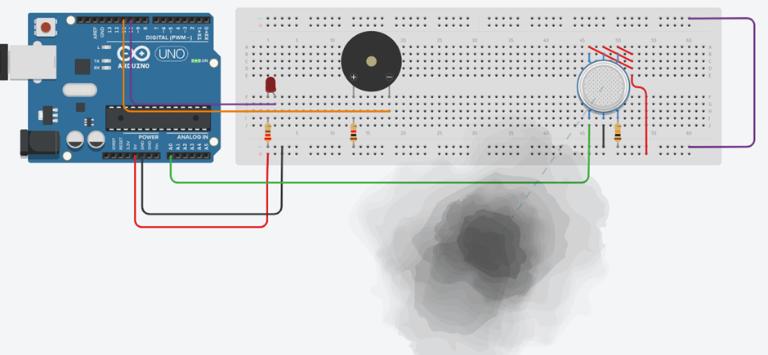

References

APC , 2020. *Piezo Buzzers vs. Magnetic Buzzers — What’s the Difference?.* [Online]   
Available at: https://www.americanpiezo.com/blog/piezo-buzzers-vs-magnetic-buzzers/  
[Accessed 2 October 2023].

DAS, S., 2023. *What is a Resistor: Types of Resistor, Function, Color Code, Symbol.* [Online]   
Available at: https://www.electronicsandyou.com/what-is-a-resistor-types-of-resistor-function-color-code-symbol.html  
[Accessed 2 October 2023].

Home of LED, 2023. *What Does a Red LED Light Mean?.* [Online]   
Available at: https://home-of-led.com/what-does-a-red-led-light-mean/  
[Accessed 2 October 2023].

HSE Study Guide, 2023. *Fire Detection System.* [Online]   
Available at: https://www.hsestudyguide.com/fire-detection-system/  
[Accessed 2 October 2023].

Makeblock education, 2022. *MQ2 Gas Sensor.* [Online]   
Available at: https://education.makeblock.com/help/mbuild-mq2-gas-sensor/  
[Accessed 2 October 2023].

Mcwilliams, S., 2022. *Normally Open vs Closed Switch.* [Online]   
Available at: https://plashlights.com/blogs/news/normally-open-vs-closed-switch  
[Accessed 2 October 2023].

WatElectronics, 2021. *What is LCD 16X2 : Pin Configuration & Its Working.* [Online]   
Available at: https://www.watelectronics.com/lcd-16x2/  
[Accessed 2 October 2023].