Part 2(a)
For NVDA and the S&P 500, we calculate monthly return volatility using an expanding window and a 12-month rolling window.
Series | Expanding Volatility | 12-Month Rolling Volatility
NVDA | 0.1278 | 0.0785
S&P 500 | 0.0415 | 0.0383

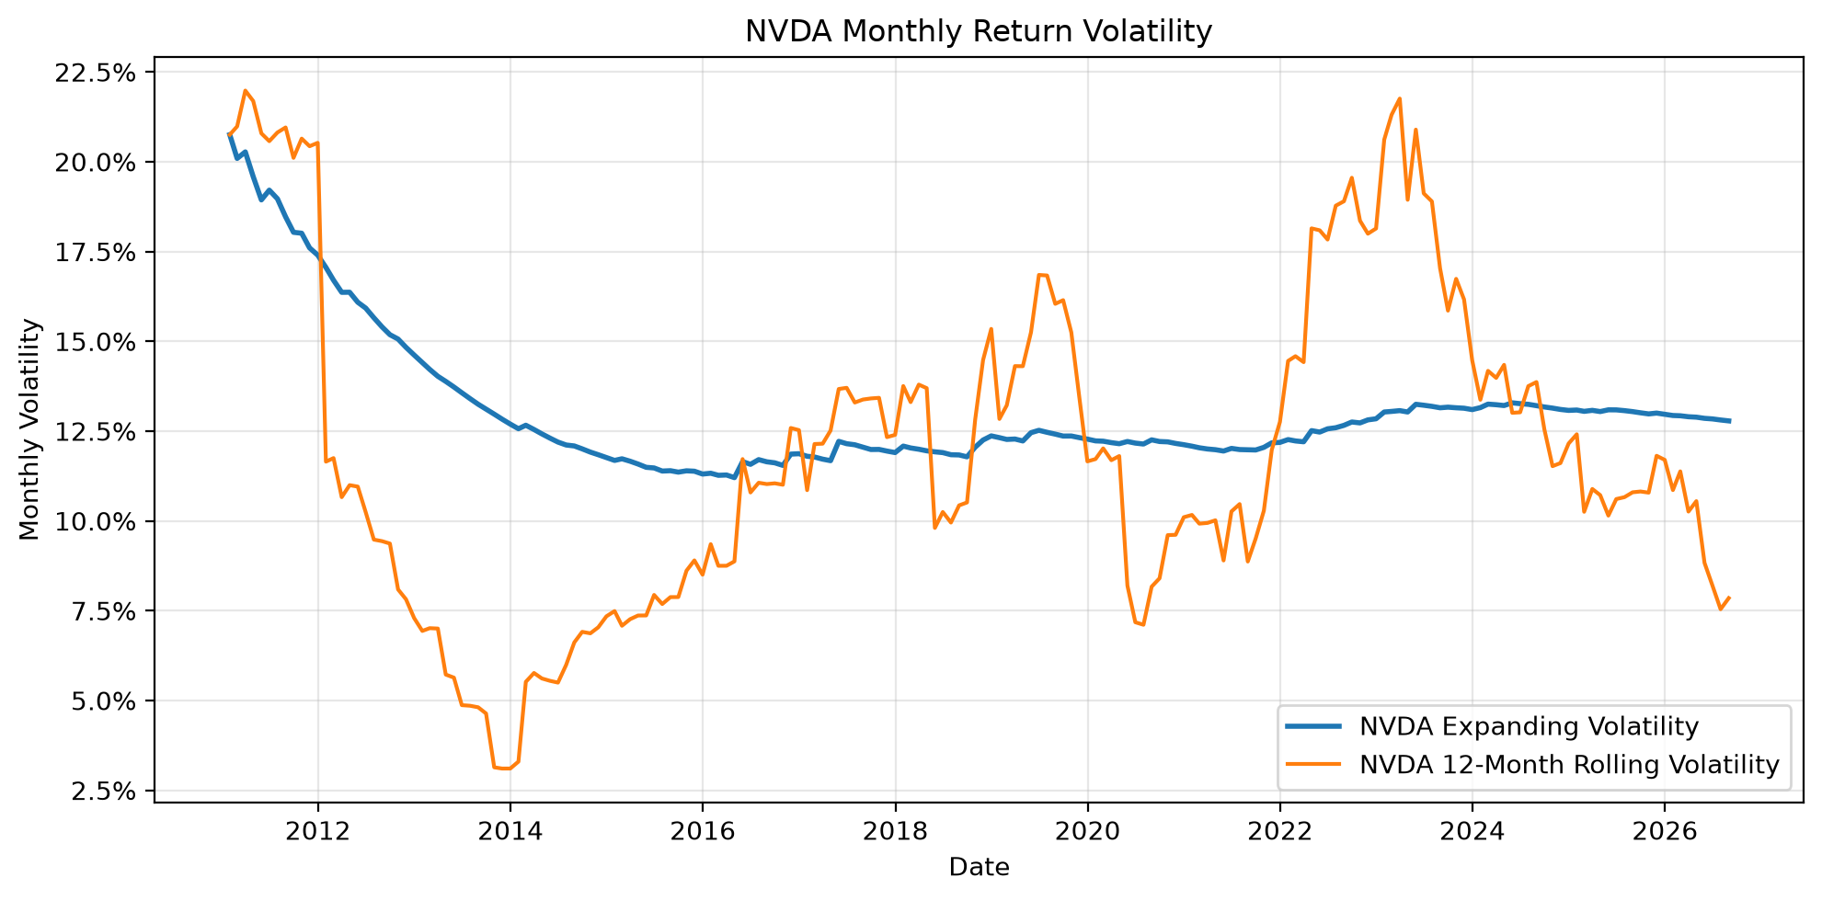
Figure 1. Expanding and 12-month rolling monthly volatility for NVDA.
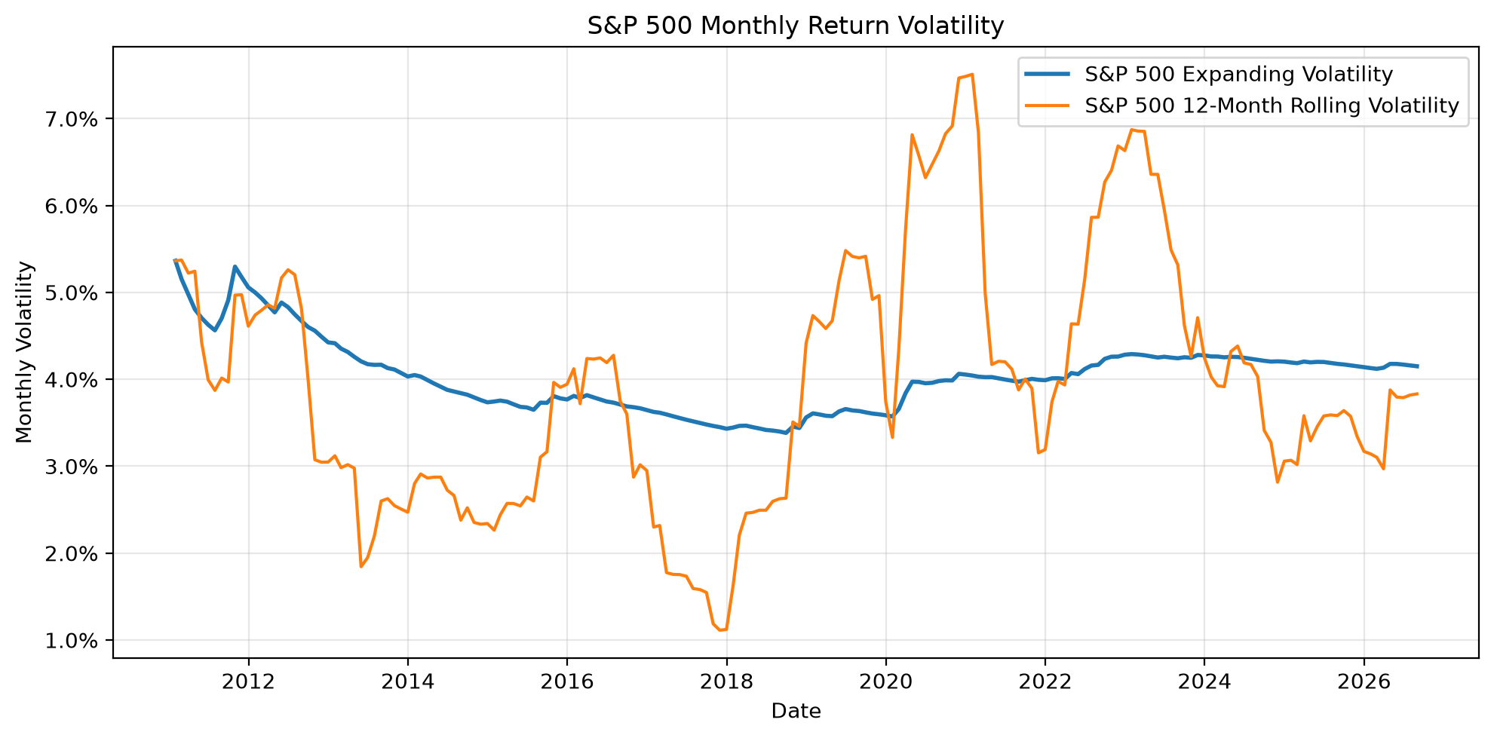
Figure 2. Expanding and 12-month rolling monthly volatility for the S&P 500.
Interpretation
For NVDA and the S&P 500 Index, the 12-month rolling volatility estimates fluctuate much more widely than the expanding-window estimates. NVDA's rolling volatility changes particularly strongly over the sample, while its expanding-window volatility gradually stabilizes as more observations are incorporated. The S&P 500 shows the same general pattern, although its volatility is lower than NVDA's.
There are two reasons why the rolling estimates fluctuate more. First, each rolling estimate uses only 12 monthly observations, making it more susceptible to sampling error and individual extreme returns. Second, the rolling window continuously adds the most recent observation and removes the oldest observation, so it reacts rapidly to changes in the recent volatility environment. In contrast, the expanding estimate uses all available observations up to each date, so the influence of any single observation declines as the sample becomes larger.
Part 2(b)
We estimate NVDA's OLS beta relative to the S&P 500 using both an expanding window and a 12-month rolling window. The chart also reports 95% confidence intervals for each beta estimate.
Measure | Estimate | Date / Interval
Full-sample beta | 1.7144 | 95% CI: [1.3549, 2.0739]
Minimum rolling beta | -2.0985 | 2017-11-30
Maximum rolling beta | 3.1190 | 2026-02-28

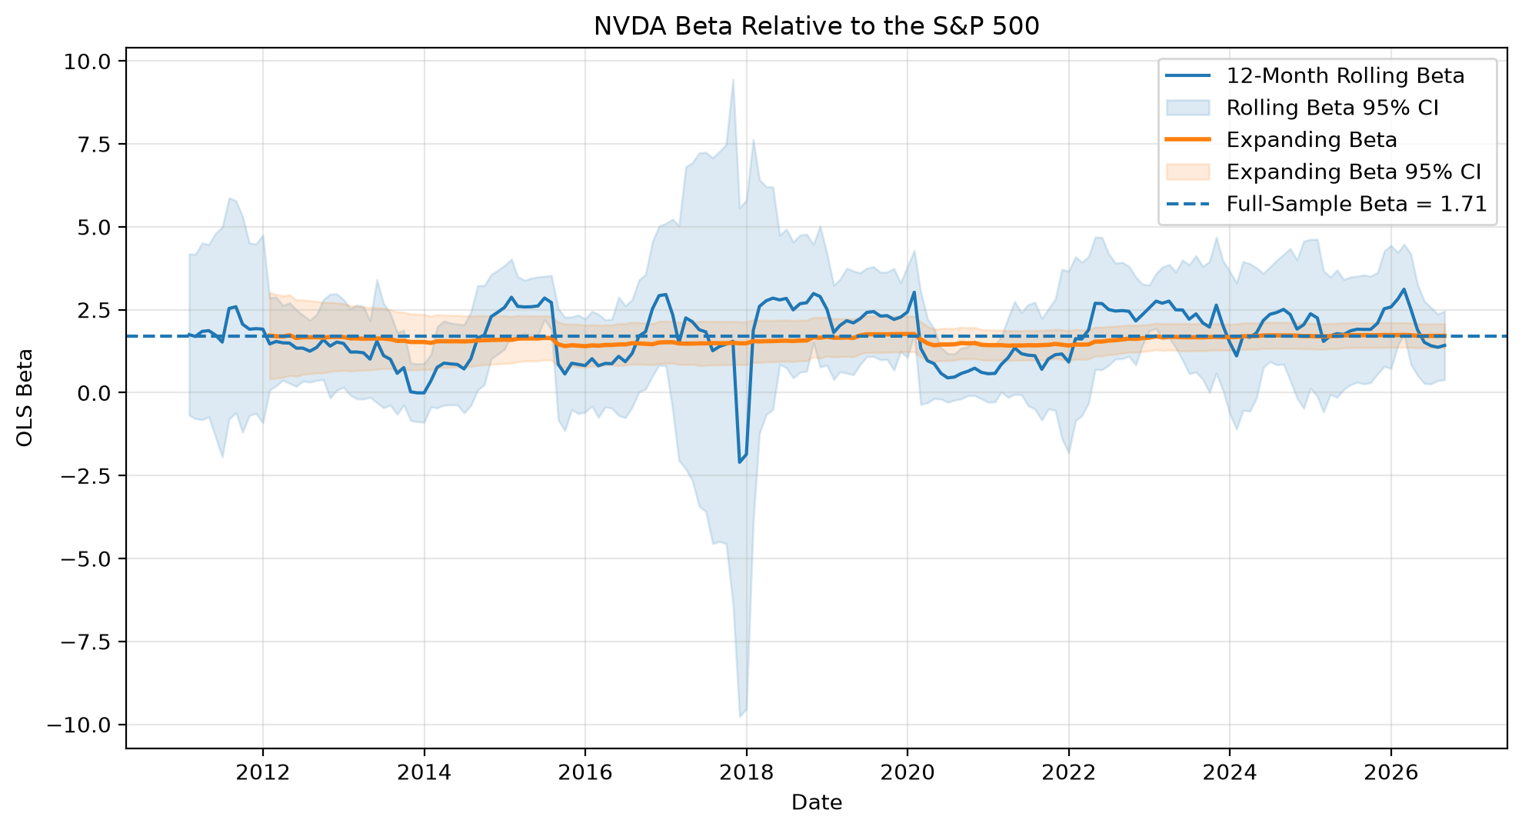
Figure 3. NVDA expanding and 12-month rolling beta relative to the S&P 500, with 95% confidence intervals.
Interpretation
NVDA's 12-month rolling beta varies substantially over time, ranging from approximately -2.10 to 3.12, compared with a full-sample beta of 1.71 and a 95% confidence interval of [1.35, 2.07]. However, this does not necessarily mean that NVDA's true beta varies dramatically over time. Each rolling regression uses only 12 monthly observations and therefore has only 10 residual degrees of freedom, making the estimates noisy and producing wide confidence intervals. The chart may therefore reflect both genuine changes in market-risk exposure and substantial short-window estimation error.
AI Integration — Rolling Beta
Prompt: My one-year rolling OLS beta for NVDA fluctuates between -2.0985 and 3.1190 over the sample, while the full-sample estimate is 1.7144 with a 95% confidence interval of [1.3549, 2.0739]. Does this imply that true beta is time-varying, or is sampling error a more plausible explanation?
Answer from LLM
The wide range of one-year rolling beta estimates does not by itself imply that NVIDIA's true beta is time-varying. Because each rolling regression uses only 12 observations and estimates both an intercept and slope, it has only 10 residual degrees of freedom, so sampling uncertainty can be substantial. Wide confidence intervals around many of the rolling estimates would indicate that these estimates are imprecise and that large apparent changes may arise even if the underlying beta were relatively stable. Genuine time variation is still possible, particularly if NVIDIA's business exposure or sensitivity to market-wide shocks changed, but stronger evidence than the movement of the point estimates alone would be needed to distinguish structural change from estimation noise.
Evaluation
The LLM's answer is mostly correct. It correctly distinguishes possible genuine time variation in beta from estimation uncertainty caused by the short 12-month window. It also correctly explains that wide confidence intervals indicate that the beta estimates are imprecise; they do not by themselves prove that the true beta changed. However, the response is somewhat general because it does not discuss NVDA's actual behavior during an identifiable episode such as the 2020 COVID crash.
COVID-19 Episode
During 2020, NVDA's 12-month rolling beta fell substantially. The minimum rolling beta during the March–December 2020 period was 0.45 on 2020-06-30, compared with NVDA's full-sample beta of 1.71. This indicates that NVDA's returns during that particular 12-month window exhibited less estimated sensitivity to contemporaneous S&P 500 returns than its long-run beta would suggest. One possible economic explanation is that NVDA's business exposure during the COVID shock differed from that of many firms in the broader market.
At the same time, the 95% confidence interval around the 2020-06-30 rolling-beta estimate is approximately [-0.29, 1.18]. Because this interval is wide, the decline should not be treated as conclusive evidence of a structural change in NVDA's true beta. Substantial sampling uncertainty remains because the regression contains only 12 monthly observations.

