Housing Price Prediction in New Haven
Problem Set 1 Part 2
In this report, sales prices of single-family homes have been predicted using the assessed values. The year 2008 dataset reveals that the manually assigned rule is not as efficient as the OLS rule. Furthermore, annual predictions tend to vary over time, making the current model better at predicting prices for 2023.

Sample | Observations | Intercept | Slope | RMSE
2008 manual rule | 279 | 0.000 | 0.800 | 55.619
2008 OLS | 279 | -51.403 | 1.009 | 52.869
Class 2020 OLS | Not reported | -4.690 | 1.370 | Not reported

All dollar amounts are expressed in thousands of dollars.

2.1 Data Preparation
The conversion of the Connecticut property data set to our sample analysis was done in four stages.
First, we divided the tax-assessed value by 0.70 in order to retrieve the assessor’s estimated true market value.
Second, we divided the assessed value and the sales figure by 1,000.
Third, the data sample was limited to single family homes located in New Haven whose true assessed value was less than $250,000.
After going through the 2008 restriction, there are 279 cases for Problems 2.2 through 2.7.
ct$assessedvalue_true <- ct$assessedvalue / 0.7 / 1000
ct$saleamount <- ct$saleamount / 1000
ct_filtered <- ct[ct$residentialtype == "Single Family" &
ct$town == "New Haven" & ct$listyear == 2008 &
ct$assessedvalue_true < 250, ]

2.2 Manual Prediction Rule
The manual prediction rule is:
Predicted sale amount = 0.8 × true assessed value
We chose a slope of 0.8 because the true assessed value represents the tax assessor’s estimate of a house’s market value, while the actual transaction price may be lower when housing-market conditions weaken. Because the observations are from 2008, during a time where major housing-market downturn, assessments may have adjusted more slowly than sale prices. We therefore use 80% of the assessed value as a simple initial prediction.
The intercept is set to zero because the rule assumes that sale price changes in direct proportion to assessed value. This rule is based on economic reasoning rather than estimated from the 2008 sample, so the later residual and OLS analyses can show how it should be improved.

2.3 Residuals and Model Improvement
A residual is calculated by deducting the estimated value from the actual value of sales. If the residual is positive, the house sells at a higher price than predicted manually. Otherwise, it sells for a lower price than was predicted.
Residual = actual sale amount − predicted sale amount
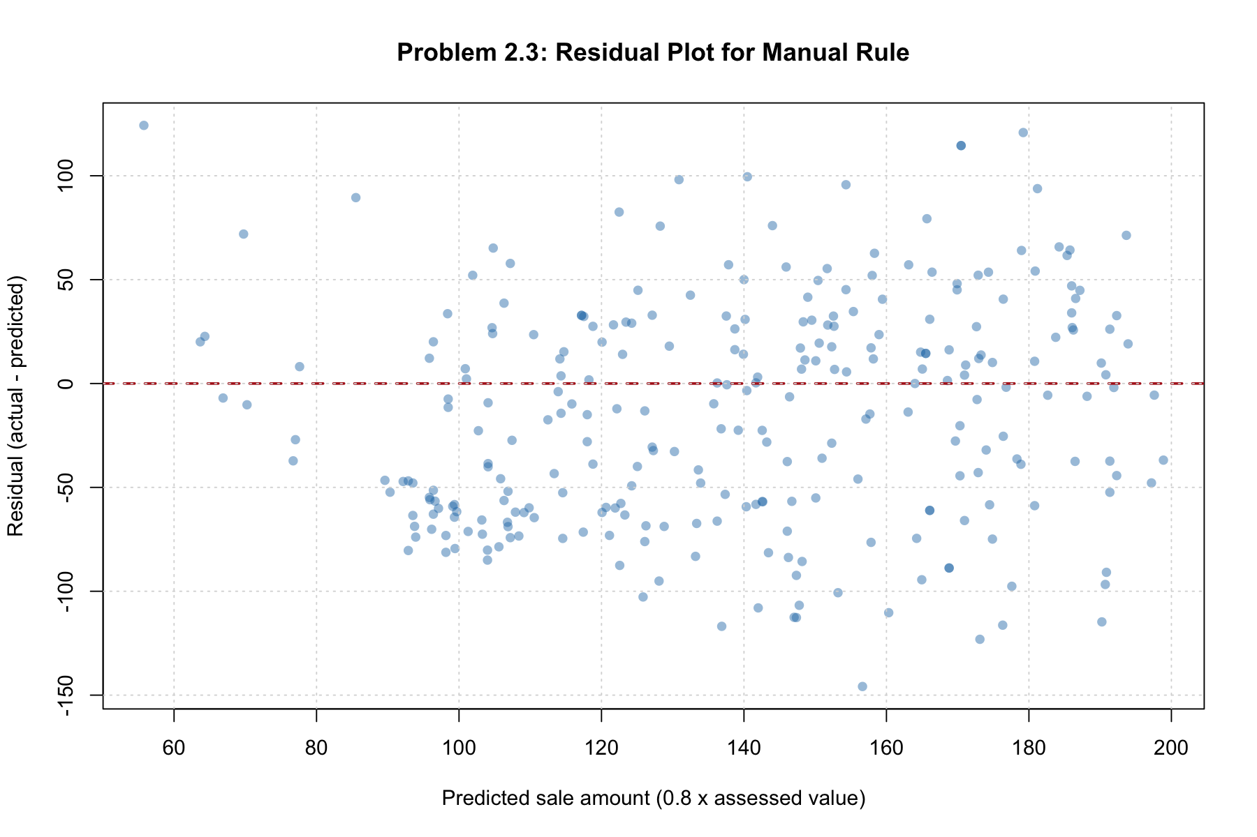
Figure 1. Residuals from the manual prediction rule for the 2008 sample
The residual plot exhibits an identifiable pattern, instead of being randomly distributed around zero. There are a lot of negative residuals among those houses which have lower to medium level of assessment value, meaning that the manual rule tends to overestimate their price. On the other hand, as the assessment value increases, the residuals are becoming increasingly positive, and hence the manual rule underestimates their prices.
In order to make the manual prediction rules better, my suggestion would be to decrease the intercept and increase the slope.

2.4 Manual OLS Estimates
OLS slope is equal to the sample covariance between the assessed value and sales amount divided by the sample variance of the assessed value. The intercept will shift the line to pass through the means of the samples.
β̂₁ = Cov(x, y) / Var(x) and β̂₀ = ȳ − β̂₁x̄
Quantity | Estimate
Mean true assessed value | 173.767993
Mean sale amount | 123.961767
Covariance of x and y | 1,657.481376
Variance of x | 1,642.393594
OLS intercept | -51.402538
OLS slope | 1.009186

The resulting prediction rule is sale amount = -51.402538 + 1.009186 × assessed value. Relative to the manual rule, OLS uses a lower intercept and a steeper slope.

2.5 Numerical Optimization
The numerical optimization was used to find the OLS estimates. The algorithm had a normal convergence and returned a code of 0. The coefficient values are within 4.01×10⁻⁸ of the manually calculated OLS values.
sse <- function(parameters) {
sum((y - parameters[1] - parameters[2] * x)^2)
}
optimization <- optim(par = c(0, 0.8), fn = sse, method = "BFGS")
Method | Intercept | Slope | SSE
Manual rule | 0.000000 | 0.800000 | 863,077.094
Manual OLS | -51.402538 | 1.009186 | 779,881.121
optim | -51.402539 | 1.009186 | 779,881.121

2.6 Manual and OLS Prediction Rules
This scatter plot shows the two regression equations in comparison with the observed values of sale prices. The regression equation using OLS estimates gives the smallest squared error of predictions and reduces the SSE to 83,195.973 and RMSE from 55.619 to 52.869. The lines intersect at higher assessment values but diverge at lower values due to negative intercept.
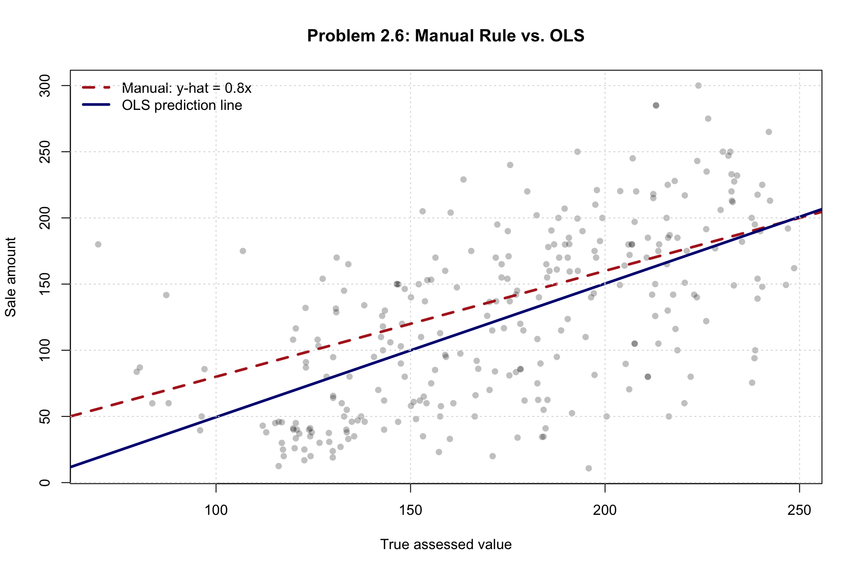
Figure 2. Sale amounts with the manual and 2008 OLS prediction lines

2.7 Prediction Rule for 2023
Of the three options that we have, I will use the OLS class rule from 2020 for forecasting in 2023, which can be given by the equation Sale amount = -4.69 + 1.37 * Assessed Value. The sample from 2020 is more recent compared to 2023 and is less likely to be outdated than the 2008 OLS class rule or the manual rule. This is based on the assumption that the value of the assessed value was relatively stable from 2020 to 2023.

2.8 Annual OLS Estimates
For this yearly sample, the same property, town, and assessed value limitations have been applied, however the limitation for 2008 has been discarded. The obtained sample is represented by 3,819 transactions within 14 years of listings, which occurred between 2007 and 2021. There are no observations related to 2016 year in the source file according to the sample definition criteria.
Listing year | Observations | Intercept | Slope
2007 | 316 | 5.697 | 0.900
2008 | 279 | -51.403 | 1.009
2009 | 289 | 2.984 | 0.728
2010 | 167 | -69.866 | 1.091
2011 | 224 | -8.620 | 0.990
2012 | 250 | -22.542 | 1.025
2013 | 233 | -31.225 | 1.128
2014 | 248 | -19.699 | 1.009
2015 | 264 | -26.429 | 1.095
2017 | 277 | -17.426 | 1.114
2018 | 262 | -21.175 | 1.156
2019 | 317 | 11.804 | 1.048
2020 | 381 | 20.877 | 1.216
2021 | 312 | 29.437 | 1.136

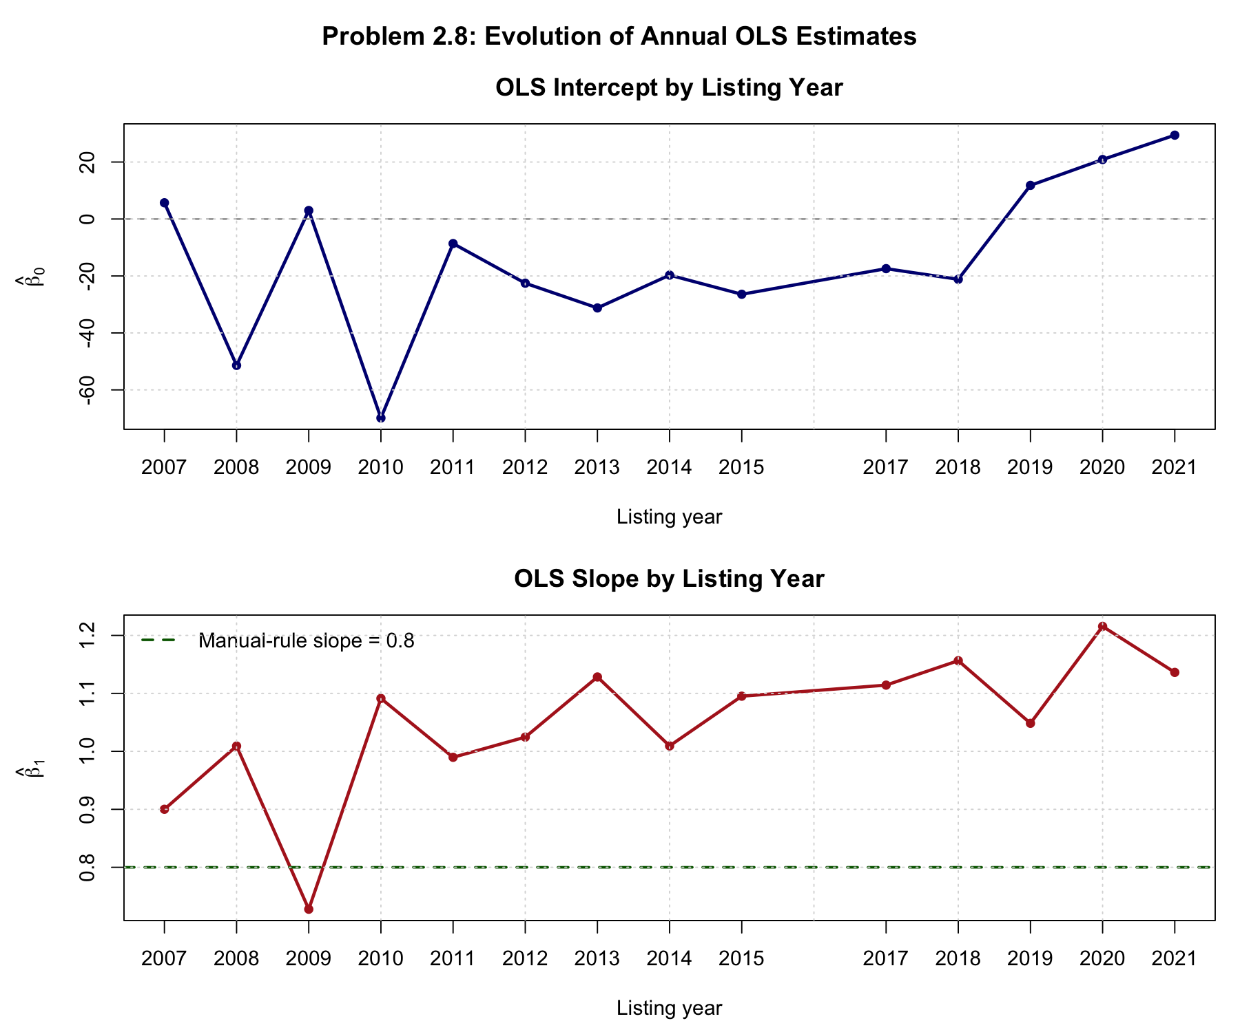
Figure 3. Annual OLS intercepts and slopes for the all-years sample
Both variables are dynamic. The slope starts at 0.728 in 2009 and increases up to 1.216 in 2020, whereas the intercept decreases from -69.866 in 2010 to 29.437 in 2021. This indicates that the connection between the variables is dynamic and that there is no static pattern linking the values of assessed property and sale prices by year of listing.

Conclusion
The 2008 OLS model is better than the manual model since it matches the data and reduces the total error sum. The numerical and equation OLS models give similar answers. The annual data show that the regression relationship varies with time, making the 2020 classroom model more sensible among the given models to predict 2023.

Code and Output Files
All reproducible analyses are saved in Problem2_2_6.R and Problem2_7_8.R. Supporting CSV files include all of the complete summary statistics and annual coefficients. All R code reads data and writes only to the person2 folder.

