
Indian Sign Language Detector

A Report submitted in partial fulfillment of the requirement for the degree of


B. Tech. In
Computer Science and Engineering

By

1803310004: Aayushi Pandey
1803310068: Bhagatpreet Singh Nagi

Raj Kumar Goel Institute of Technology Ghaziabad
5th KM. STONE, DELHI-MEERUT ROAD, GHAZIABAD (U.P)-201003

Department of Computer Science & Engineering
Session: - 2020-2021

DECLARATION

This is to certify that the Report Entitled “Indian Sign Language Detector” which is being submitted in partial fulfillment of the requirement for the award of degree B. Tech in Computer Science and Engineering to RKGIT, Ghaziabad (Dr. A.P.J. Abdul Kalam Technical University, Lucknow) comprises only original work and studies carried out by the students themselves. The matter embodied in this work has not been submitted for the award of any other degree.

Date: 23/03/2021 | 1803310004- Aayushi Pandey  1803310068- Bhagatpreet Singh Nagi

TABLE OF CONTENT

- Abstract 7
- Introduction 8
- Problem Statement 9
- Theory 10
- Conclusions and Further Work 14
- Real World Application 15
- References 16

VISION OF THE INSTITUTE

To continually develop excellent professionals capable of providing sustainable solutions to challenging problems in their fields and prove responsible global citizens.

MISSION OF THE INSTITUTE
We wish to serve the nation by becoming a reputed deemed university for providing value based professional education.

VISION OF THE DEPARTMENT
To be recognized globally for delivering high quality education in the ever changing field of computer science & engineering, both of value & relevance to the communities we serve.

MISSION OF THE DEPARTMENT
- To provide quality education in both the theoretical and applied foundations of Computer Science and train students to effectively apply this education to solve real world problems.
- To amplify their potential for lifelong high quality careers and give them a competitive advantage in the challenging global work environment.

PROGRAM EDUCATIONAL OUTCOMES (PEOs)

PEO 1: Learning: Our graduates to be competent with sound knowledge in field of Computer Science & Engineering.
PEO 2: Employable: To develop the ability among students to synthesize data and technical concepts for application to software product design for successful careers that meet the needs of Indian and multinational companies.
PEO 3: Innovative: To develop research oriented analytical ability among students to prepare them for making technical contribution to the society.
PEO 4: Entrepreneur / Contribution: To develop excellent leadership quality among students which they can use at different levels according to their experience and contribute for progress and development in the society.

PROGRAM OUTCOMES (POs)

Engineering Graduates will be able to:
PO1: Engineering knowledge: Apply the knowledge of mathematics, science, engineering fundamentals, and an engineering specialization to the solution of complex engineering problems.
PO2: Problem analysis: Identify, formulate, review research literature, and analyze complex engineering problems reaching substantiated conclusions using first principles of mathematics, natural sciences, and engineering sciences.
PO3: Design/development of solutions: Design solutions for complex engineering problems and design system components or processes that meet the specified needs with appropriate consideration for the public health and safety, and the cultural, societal, and environmental considerations.
PO4: Conduct investigations of complex problems: Use research-based knowledge and research methods including design of experiments, analysis and interpretation of data, and synthesis of the information to provide valid conclusions.
PO5: Modern tool usage: Create, select, and apply appropriate techniques, resources, a n d modern engineering and IT tools including prediction and modeling to complex engineering activities with an understanding of the limitations.
PO6: The engineer and society: Apply reasoning informed by the contextual knowledge to assess societal, health, safety, legal and cultural issues and the consequent responsibilities relevant to the professional engineering practice.
PO7: Environment and sustainability: Understand the impact of the professional engineering solutions in societal and environmental contexts, and demonstrate the knowledge of, and need for sustainable development.
PO8: Ethics: Apply ethical principles and commit to professional ethics and responsibilities and norms of the engineering practice.
PO9: Individual and team work: Function effectively as an individual, and as a member or leader in diverse teams, and in multidisciplinary settings.
PO10: Communication: Communicate effectively on complex engineering activities with the engineering community and with society at large, such as, being able to comprehend and write effective reports and design documentation, make effective
presentations, and give and receive clear instructions.
PO11: Project management and finance: Demonstrate knowledge and understanding of the engineering and management principles and apply these to one’s own work, as a member and leader in a team, to manage projects and in multidisciplinary environments.
PO12: Life-long learning: Recognize the need for, and have the preparation and ability to engage in independent and life-long learning in the broadest context of technological change.

PROGRAM SPECIFIC OUTCOMES (PSOs)
PSO1: The ability to use standard practices and suitable programming environment to develop software solutions.

PSO2: The ability to employ latest computer languages and platforms in creating innovative career opportunities.
CO1 | Relate to the 'real' working environment and get acquainted with the organization structure, business operations and administrative functions.
CO2 | Practice hands-on experience in the computer related fields so that they can relate and reinforce what has been taught.
CO3 | Develop synergetic collaboration with industry and the university in promoting a knowledgeable society.
CO4 | Set up the stage for future recruitment by potential employers.

CO | PO1 | PO2 | PO3 | PO4 | PO5 | PO6 | PO7 | PO8 | PO9 | PO10 | PO11 | PO12 | PSO1 | PSO2
CO1 | 3 | 3 | 2 | 1 | 1 | 1 | 1 | 1 | 2 | 1 | 2 | 2 | 3 | 2
CO2 | 3 | 3 | 2 | 1 | 2 | 1 | 1 | 1 | 2 | 1 | 1 | 2 | 3 | 3
CO3 | 3 | 3 | 1 | 1 | 2 | 1 | 1 | 1 | 2 | 1 | 1 | 2 | 2 | 1
CO4 | 3 | 3 | 1 | 1 | 2 | 1 | 1 | 1 | 1 | 1 | 1 | 2 | 2 | 1
CO | 3 | 3 | 1.5 | 1 | 1.75 | 1 | 1 | 1 | 1.75 | 1 | 1.25 | 2 | 2.5 | 1.75
ABSTRACT

Sign Language is a common way of communication among deaf and dumb people. There are many dialects of sign languages based on the location and culture of the origin. Some of them are British, French, and American Sign Languages and more. Amidst the growing usage of all these languages via technology, work on Indian Sign Language seems to be more or less dormant. Through the project the authors hope to support the Indian Sign Language community. The purpose of this project is to convert sign languages to text in real time through the use of live video. It will promote the usage of mobile and web application for communication.
In this method, the basics of CNN (Convolutional Neural Networks) are used. It captures and reads the sign outlined by the user’s hands and then tries to categorize it based on its training. The gesture is first passed through a filter and after that it goes through a classifier which predicts the hand gesture. The machine can be trained to classify and save new letters and gestures manually. Through the filters, the input video feed experiences color conversion from RGB to Greyscale and differences in adaptive thresholds. Noise reduction, removal of shadows and Gaussian Blur operations are performed to detect the outlines of the sign. This makes it easy to be detected by the machine. Finally it is passed through the classifier that puts the given image in one of twenty six categorise of alphabets.

While doing research and study about this topic, the authors found that Indian Sign language is widely used by many people across the country, but the usage is mostly limited to a small fraction of the population. Sometimes it gets hard to understand and interpret it to others. Since most people don’t know how to use ISL and interpreters are very difficult to come by at every situation, the authors have come up with this application. It is a fast, reliable and real-time interpreter which is intuitive and can be used without anyone’s guidance.
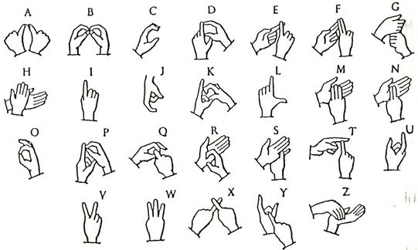
Fig. 1.1

INTRODUCTION

Technology is used in various aspects of our life. With the increased use of technology to make our life more sedentary, introduction of an application in the field of specialized communication is a big break. As the only disability faced by D&M people are communication barriers and that they cannot use the spoken languages, it is essential to make a break through real time translator for easy communication.
Deaf and Dumb people make use of hand gestures to represent letters and words. This way of non-verbal communication is known as sign language. Other ways D&M (deaf and dumb) people communicate is via their behavior, personality, expressions and signals.
Sign languages mostly contain 3 major components. These are the categories all the sign languages are roughly divided into.
1. Fingerspelling
It is used to spell words letter by letter. This is mostly used to teach as basics of learning a sign language. It is not commonly used to communicate because of its time taking and confusing structure. This helps out in situations where you don’t know the sign gesture of a word.
2. Word Level Sign Vocabulary
It is used in majority of communications. It is used in day to day communication with others. All the people wanting to use sign language have to learn this visual communication aid.
3. Non-Manual Features
These are facial expressions and visual signals. It uses tongue, mouth and body positions to indicate your idea.
All of the above are used to communicate while talking.
In the project the authors will mainly be focussing on finger gestures.
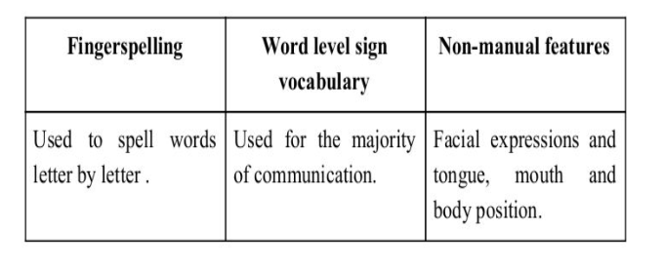
Table 1.1

PROBLEM STATEMENT

Statement- To make an application which converts sign language into text in real time.
Explanation- This web application will identify gestures and produce output with its intended meaning.

Researching the Problem
Gesture classification with the help of machine language has been a very highly researched topic in the past few years. With the understanding of power underlying with this technique humans have started investing time in researching more about this latest technology even more.
While studying the previous researches and studies regarding this field, it was found that in order to reach the goal the following steps need to be performed-
- Data collection
- Preprocessing the Data
- Classification of gestures

Data Acquisition

As the vision based approach is being used to observe the signs, the other ways to identify hand signs shall not be discussed. The gestures might be included later with the help of a sensory device or motion based learning. This sensory device can be used to figure out the gesture by wearing a glove attached with wires. These wires are connected to an output system which will in turn give the shape formed by the user’s hand.
On the other hand, the visual method of gesture identification includes identifying the shadowed part of the image captures by the camera. These places with higher contrast than that of the range of our skin color are eliminated. By the angles our fingers make with the hand and feature extraction the hand sign can be recognized by the machine. As for this method only a computer machine with a camera is required, it becomes easier to use this approach for real life translation of sign language without the need for additional hardware.

Theory

Artificial Neural Networks-

Neural networks form the base of deep learning, a sub field of machine learning where the algorithms are inspired by the structure of the human brain. Neural networks take in data train themselves to recognize the patterns in this data and then predict the outputs for a new set of similar data.

They are made up of layers of neurons. They are the core processing units of the ANN. First there is an input layer, to receive the input. The output layer predicts our final output. In between, exists the hidden layers which perform most of the computations required by our network. It is now used to recognize handwriting, automate driving and predict future market inclinations as its usage.

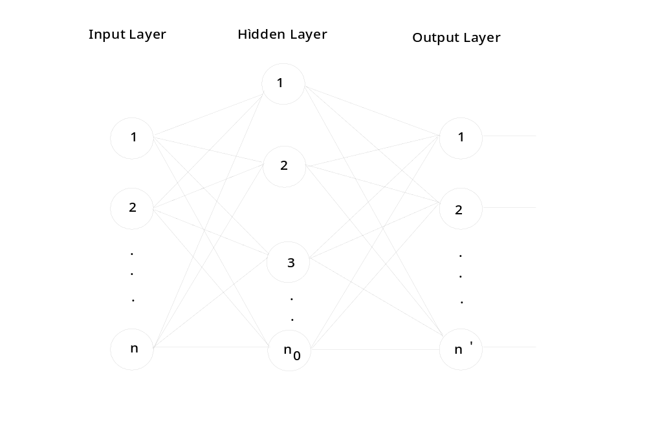
Fig.1.2

Convolutional Neural Networks-
It is a kind of neural network which is most often applied in image processing. When a computer identifies an object, handwriting or any image, CNN is in action. They are important because CNN is used in such fast growing areas.

Convolutional Neural Networks work differently with data as they treat it as spatial. Instead of neurons to be connected to every neuron in the previous layer, they are instead only connected to neurons close to it and all have the same way. It consists of different layers such as a convolutional layer, a pooling layer followed by a ReLu layer and lastly a fully connected layer.

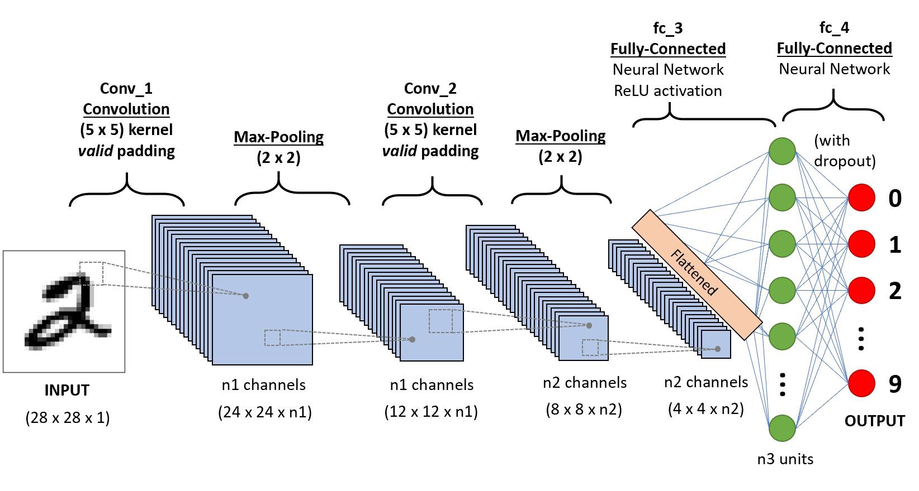
Fig. 1.3

FACILITIES REQUIRED FOR THIS METHOD

Method-

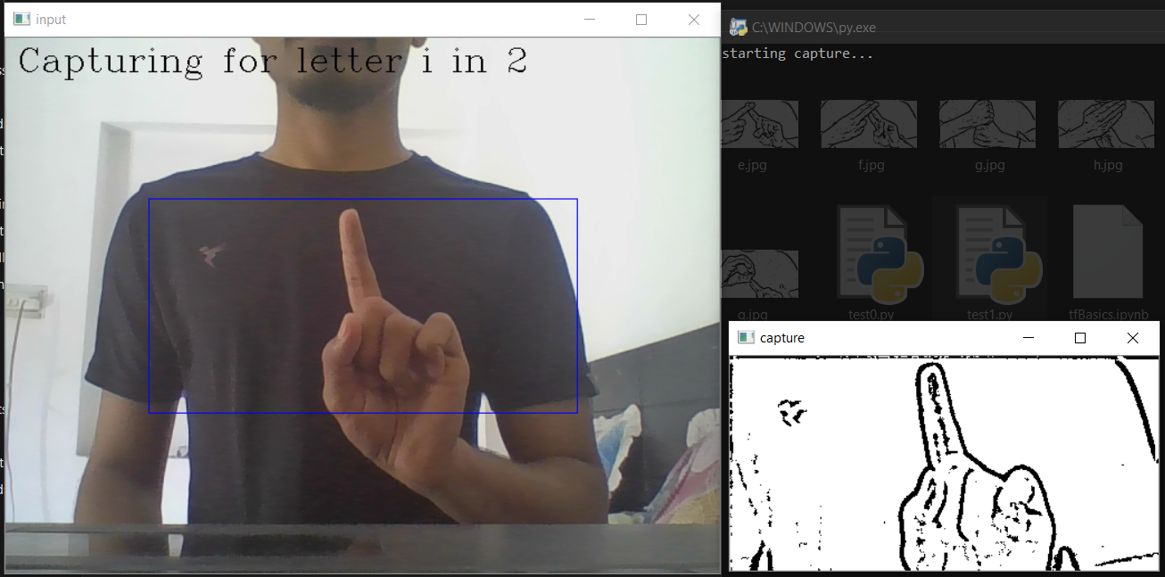
Data Collection- Initially an image is captured by the machine camera as the input of the whole process. As soon as the user clicks a key on the keyboard for a given alphabet, a timer of 5 seconds is triggered. The user needs to form the hand sign in that allotted time as shown in Fig 1.4. Once the input image is captured, the picture is allowed to be read by the training program.
Fig 1.4
This is followed by the simplification of the image for the machine. Primarily, the image is converted to a gray scaled image to get rid of features that won’t matter in our prediction. With the help of Gaussian blur, the image is blurred down so that all the noise from the image is removed. This static noise may hinder with the prediction later. Adaptive threshold limits are set to detect the edges of the shapes. The image after all this processing is stored as a file in a designated folder with the correct label.
Training- After the collection of data is completed, the collected images are read by the training program. This program uses the Tensor Flow library to generate and train the CNN. The CNN consists of an input layer, two hidden layers and a final output layer with twenty six slots, each for an alphabet.

Materials-
The following are the materials used for this project-
Python- It is the fastest growing language in terms of its applications and diversity in the range of places it can be used. It is used mostly with machine learning because of its easy to use nature and loads of libraries to make our work easier.

Libraries- In this project, python libraries such as Tensorflow, Numpy, CV2 and Matplotlib are used. Tensorflow is used for the creation, training and predictions of the CNN. Numpy is a library which is extensively used in application and calculation of machine learning algorithms. CV2 is used the for the data collection, including image capturing, feature extraction and saving to disk. Matplotlib is used for visualization of the data for training and testing purposes.

Dataset- A dataset of different signs with varied features such as lighting, position, hand size and skin color is provided to the machine for training purpose. These hand signs indicate different letters of English alphabets.

Training and Testing- The dataset which is captured by the camera can be stored in the database of this program. Hence we can retain the images clicked by us and train the model based on them. However, we have collected more than 150 samples of each image to train the model on from the internet.

Tensor Flow- It is popular for implementing machine learning algorithms, in this case, neural networks. It is an open source platform hence making it easier for the developers to use it to its full potential. It takes input as a multidimensional array or tensors.

Keras- Keras is an interface that allows us to easily access and customize the machine learning frameworks including tensorflow, CNTK and Theano. This high level API makes it easy to use such complicated backend frameworks.

Open CV- It is an open source library which is aimed at real time computer vision. It is cross platform library hence making it easy to use. It is one of the widely used packages for implementing video detection, motion detection and other such activities.
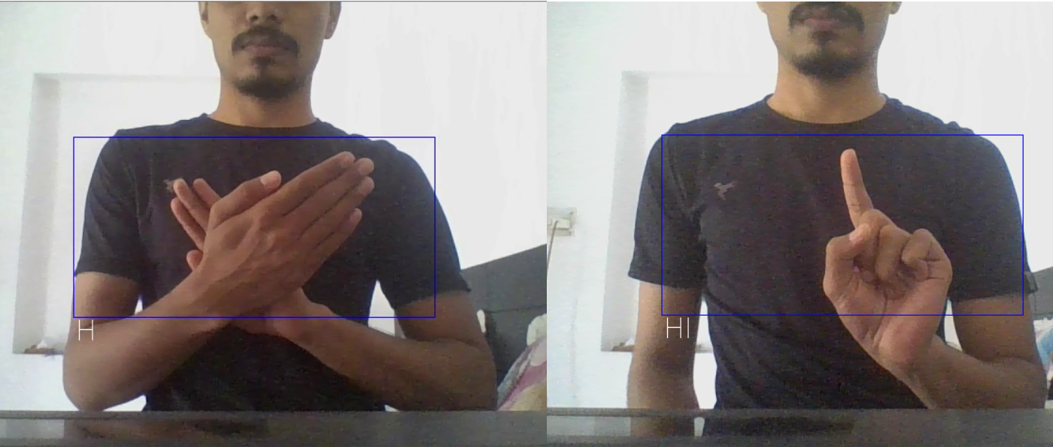

Fig 1.5

Conclusions and Further Work

This project concludes that even with such advancements in technology and our hold of various methodologies in this field, implementation of such applications have not been optimized.

This research outputs the power of training data and it accuracy after testing it with a huge range of dataset.
For further work under this project, a speech generator can be accompanied by the application. This speech generation will be synced with the actions of the users in real time. The D&M people can choose their voice to be by the options provided (of a girl or of a boy). This will further give the listeners a more humanly feel and the usage of this application will be more lifelike. The purpose of an intuitive user interface is to ease the efforts in communication and make it more like the way we do it normally.

Hence, the main objective to improve this version of application is to give that ease at communication and ultimately make the conversation more convenient. Additionally, with a 3D explanatory video tutorial tab, the non- deaf and mute people can learn this language while conversing in an easier way. The database with prior vocabulary can be updated as per user’s own comfort as well giving a dictionary which is customized as per individual use. Such personalized expressions will make the communication even tranquil.

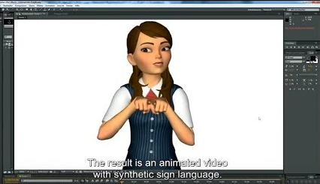
Fig 1.6

REAL WORLD APPLICATION

In the real world, this application can be a revolution in the field of apps for differently abled people. This will give the D&M (Deaf and Mute) people a way to communicate more effectively. It promises to provide easy and intuitive usage of application which does not need any specification. This will help them to involve more with the community and provide them with their insights.
The application for Indian Sign Language would come to be very useful given the lack of a proper mainstream implementation of such a concept. Even the existing applications use 2D imaging to show the hand signs. This makes it difficult to understand complex letters such as E, Q, and Z etc. in Indian Sign Language. Some of the features that yet need to be finished more are slow motion teaching ability of the application. This will lessen the work of the learner of sign language as they will not have to go anywhere else to learn this language. An already existing database of all the words and letters can give insights while learning the language.

With frequent usage of this application, not only the deaf and mute community will be profited, but even the people who have to use it on a daily basis with these people can learn a lot from it. With short and lucid tutorials it will be easy for the users to learn the sign language. Also with 3D, real life animation the users can be benefited by learning by using the signs.

REFERENCES

[1] https://opencv.org/
[2] https://en.wikipedia.org/wiki/TensorFlow
[3] https://en.wikipedia.org/wiki/Convolutional_neural_network

Project Repository-
https://github.com/Bhgt/IndianSignLanguageInterpreter (Private repository, needs permission to access)

