**Assignment 1 output**

**Question 1**

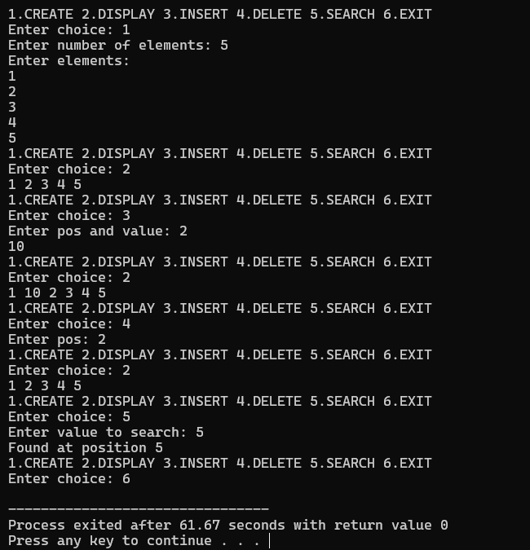

**Question 2**

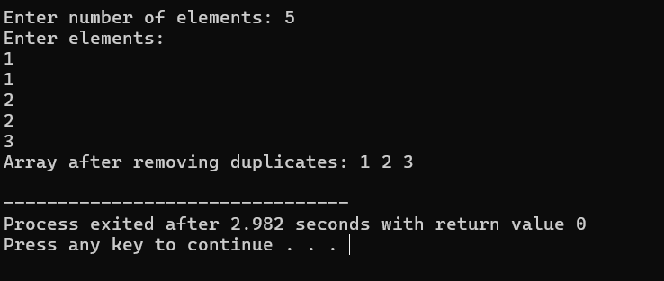

**3)Predict the Output of the following program**

**int main()**

**{**

**int i;**

**int arr[5] = {1};**

**for (i = 0; i < 5; i++)**

**printf("%d",arr[i]);**

**return 0;**

**}**

**Ans :**

**10000**

**Question 4**

**a)**

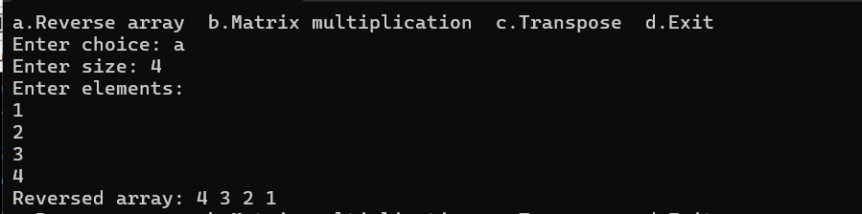

**b)**

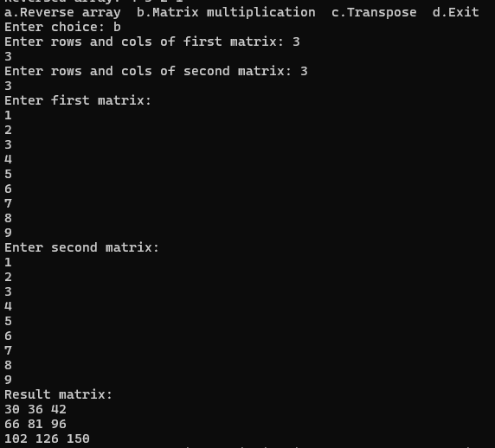

**c)**

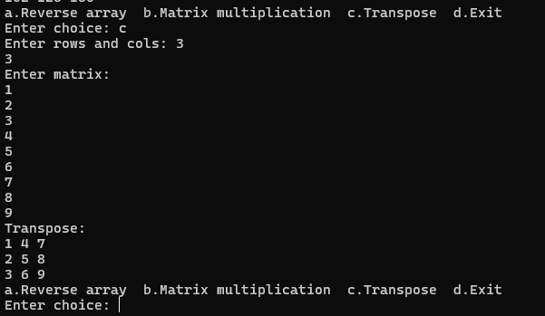

**Question 5)**

