Assignment 8
Ashish Kumar

Q-1
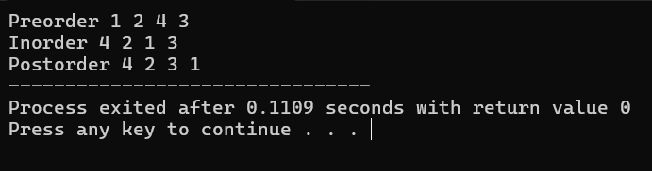

Q-2
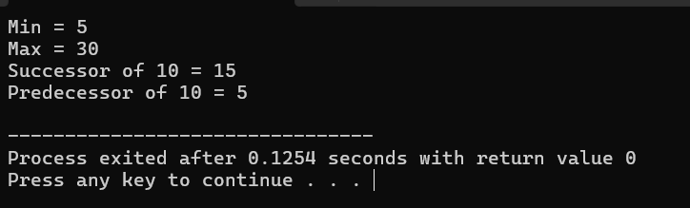

Q-3
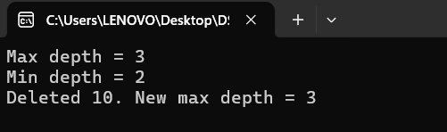

Q – 4


Q – 5
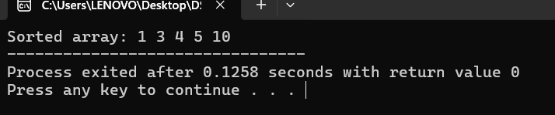

Q – 6
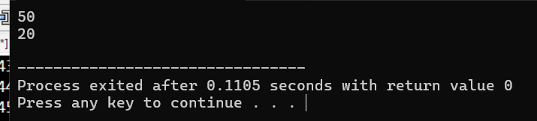s

