Assignment 9
Ashish Kumar
BFS
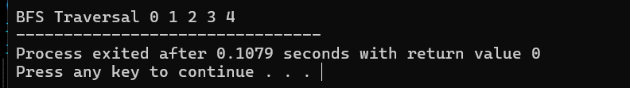

DFS
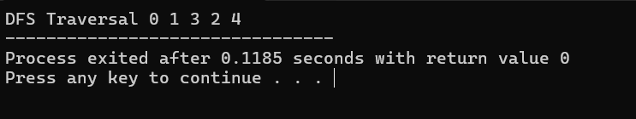

MST
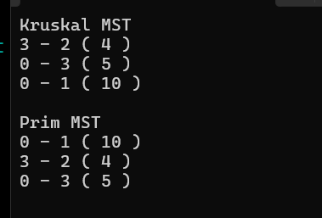

Dijkstra
