Smart Power Monitor and Optimizer System

Ashutosh Kumar *Department of Computer Science and Engineering, Sharda School of*

*Computer Science & Engineering*

*Sharda University*

Greater Noida, Uttar Pradesh. [infoashu5173@gmail.com](mailto:infoashu5173@gmail.com)

Harshit

*Department of Computer Science and Engineering, Sharda School of*

*Computer Science & Engineering*

Sharda University Greater Noida, Uttar Pradesh.

[Rohillaharshit04@gmail.com](mailto:Rohillaharshit04@gmail.com)

Keshav Gupta

Department of Computer Science & Engineering, Sharda School of Computer Science & Engineering ,Sharda University ,

Greater Noida, Uttar Pradesh

Keshav.gupta@sharda.ac.in

*Abstract***—** With the increasing demand for electricity, efficient power consumption monitoring has become essential for reducing energy waste and lowering electricity bills. This project proposes an IoT-based power monitoring and optimization system that provides real-time insights into energy usage in a building and suggests energy-saving measures. The system integrates PZEM-004T (AC energy meter) and SCT-013 (current sensor) to measure voltage, current, power, and energy consumption. These sensors are connected to a microcontroller (ESP32/ESP8266/Arduino), which collects the data and transmits it to a cloud-based IoT platform (Blynk, Firebase, or ThingSpeak). Users can access real-time and historical energy consumption data via a mobile or web application. To enhance efficiency, a machine learning model analyzes past power usage patterns to detect anomalies and predict high-energy consumption trends. The system also generates real-time alerts when usage exceeds a set threshold and provides recommendations to optimize electricity consumption. By implementing this smart power monitoring system, users can gain better control over their energy usage, improve efficiency, reduce electricity costs, and contribute to environmental sustainability.

Keywords— IoT, Smart Energy Monitoring, Power Optimization, ESP32, PZEM-004T, SCT-013, Machine Learning, Energy Efficiency.

## INTRODUCTION

## The IoT-based power monitoring system alongside optimization features transforms how companies handle their energy usage through immediate data analysis and recommended actions. The PZEM-004T and SCT-013 advanced sensors together with ESP32 or Arduino microcontrollers allow the system to track precise measurements of voltage and current and power and total energy consumption. Users benefit from transmitted data that displays on Blynk or ThingSpeak cloud platforms for mobile or web-based application monitoring of their energy consumption.

## Sugar Loaf City improves its operation by implementing machine learning algorithms to evaluate past energy statistics thereby generating energy consumption forecasts and detecting irregular patterns. The system sends immediate alert notifications to users about excessive energy use which helps them take prompt actions. The system features allow users to maximize their energy efficiency along with lowering their electricity bills while supporting environmentally friendly practices.

## The system's broader functionality can result from adding temperature and humidity sensors to achieve complete knowledge of consumption patterns. The accuracy of predictions increases when using LSTM neural networks combined with edge computing because this approach enhances both prediction accuracy and cloud-independent performance. Users show more energy efficiency-related behavior because of selective alerts together with gamification features.The system keeps its design flexible by offering capabilities for expansive growth and flexible adjustments along with features for multiple user access and universal platform functionality and third-party service incorporation. Its broad range of features makes this system operational in homes alongside offices and factories and other facilities.

## As a future upgrade the system requires integration of AI-controlled load automation and blockchain trading methods with 5G networks to enable secure fast data transmission. The project could achieve widespread acceptance through open-sourcing and collaborations between the project developers and utility companies and environmental associations.

## The intelligent energy monitoring system surpasses basic electricity cost reduction because it serves environmental purposes also. The system tracks energy consumption immediately and predicts results through simple user interfaces which provides users complete control over their power usage and helps global conservation work. This advancement brings us closer to developing better environmentally friendly energy technology solutions which benefit the entire population.

# LITERATURE REVIEW

During recent years smart energy monitoring continues to gain popularity as an important focus for residential residential and industrial applications. The development of IoT technology has driven researchers and developers to create systems which enable better power usage observation and informed decision making for people. Projects require Arduino microcontrollers together with ESP32 devices that obtain live sensor information from ACS712 current sensors and ZMPT101B voltage sensors. The setups link to platforms Blynk and ThingSpeak which enable viewers to track their energy consumption through mobile devices and laptops. Experiments have progressed to employ automation through relays that allow automatic device control for energy conservation. Tools called LSTM models together with machine learning have emerged as the new generation of usage pattern forecasting that detects abnormal energy readings. Most systems work only with data while paying insufficient attention to user experience needs. Our platform aims to distinguish itself through an energy monitoring system that handles usage control and provides a smooth user experience for regular users.Here are some paper that gives more information about power management in resent years.

* 1. *Automatic Control Station for Power Grid*

The article describes progressive advancement towards creating an automatic control station for power grid management. The NI LabVIEW Synchronization Tool serves as a configuration tool for smart meters through the implementation of PTP protocol. Through the control station panel all operations for sensor network control and inspection are accessible. The power grid network allows seamless addition of additional smart meters per requirements. The control panel supports complete meter management that includes simultaneous timing verification in addition to data reading and saving operations as well as fault detection. The control station has two capabilities which include device localization and map visualization of connected network devices. The network functionality and accuracy of synchronization were successfully tested through performed tests

* 1. *Wireless Sensor Networks (WSN) for Power*

These projects present valuable direction for establishing an all-encompassing power industry sensing network extending across production, management, marketing and service domains. On the one hand, the ubiquitous perception of the WSN has achieved the coverage of more nodes, which can signiﬁcantly improve the comprehensive perception, data collection, and service interaction capabilities of power grid operation, services, and management; on the other hand, the construction of the WSN for power system and the development of sensors, terminals, and systems for the massive deployment provide a convenient means for data collection, greatly reducing the cost to sense various types of data. With the continuous growth of the power WSN network scale and the increase amount of data accumulation

* 1. *Packet-Based Communication in Smart Grids*

The impact of integrating a packet-based communication network into the control loops of a power system has been thoroughly examined using a generalized model of a networked-controlled smart grid. The random packet loss during data transmission was modeled as a stochastic process. By applying advanced linear matrix inequalities, the minimum required probability of successful packet delivery was calculated to ensure specific damping performance. The study revealed that the networked control system for smart grids (NCSG) maintained robust performance even under varying operational conditions. A key contribution of this research is the development of a networked control framework for power systems, along with a systematic method to determine the minimum network requirements—such as packet delivery quality—needed to guarantee stability and damping margins across all operating scenarios. The findings highlight the potential of the NCSG framework to enhance oscillatory stability in modern smart grid networks, which are critical for the 21st-century electricity infrastructure

* 1. *Microgrids, Smart Grids, and VPPs*

Looking ahead, microgrids, smart grids, and virtual power plants (VPPs) are poised to shape the future of power systems. These three pillars of the energy framework play a vital role in advancing energy sustainability, and their significance cannot be overstated. To achieve sustainable energy solutions, it is essential to consider technological advancements across all domains. This work provides a concise overview of the role and potential of control algorithms in promoting sustainability. The discussion begins with an in-depth analysis of the current state of modern grids, focusing on the technological progress in their various functions. It then delves into the integration of renewable energy resources (RERs), such as wind and solar power generation, electric vehicles, and energy storage systems. The study explores their contributions to energy sustainability, the challenges associated with their implementation, and the diverse control strategies used in microgrids, smart grids, and VPPs. By addressing these aspects, the research underscores the importance of innovative control techniques in building a sustainable energy future.

* 1. *IoT-Based Smart Energy Management (SEMS)*

Advanced smart systems adoption for smart cities will trigger multiple direct consequences as well as multiple indirect requirements that affect all social economic and technical structures across operations. Understanding this impact remains vital for guiding the related decision-making processes as well as governance activities. Significant investments by all actors in the city function as both catalysts and requirements for this extensive change process.all actors in the city, from the authorities to the citizens. The chosen solutions and their schedule of deployment need to recognize and align with the local societal values and concerns and reflect their interests

* 1. *Hybrid Communication Network for Microgrids*

Research demonstrates that the technical possibility of this shift depends on the CPPS testbed because it enables thorough study of power and information interactions between physical and cyber layers. This article adds value to the field by developing a research implementation method which depends on a real-time virtual test environment for CPPSs built from co-simulation methods along with standardized communication protocols. integrated with standardised communication protocols. The research develops an advanced optimization power flow approach using objective-based modifications of operating costs and power losses. This work delivers useful methods and findings which assist researchers and scholars working on future power and energy system development at large scale

* 1. *Data-Driven Approaches in ICPS*

The proposed scheme obtains its SPS initiation ability from local monitoring while benefitting from μ-PMU measurement speed and precision which represent its main advantages. The VSI derivation from local phasor readings takes into consideration the complete influence of both local power network components and generatating power system elements.The equivalent source and impedance model contains complete information about both the local network and all power system elements which are beyond the considered node. The calculated load participation factors from system modal analysis allow proper selection of load curtailment approaches.

* 1. *Blockchain-Based Smart Grid (DS2)*

This research provides a comprehensive overview of developing a power monitoring system enhanced by IoT and Neuro-Fuzzy techniques. The smart grid employs an Adaptive Neuro-Fuzzy Inference System (ANFIS) as its primary controller to manage hybrid solar and wind power plants. By leveraging ANFIS for power management, the system significantly improves the output efficiency of these renewable energy sources. The IoT-based Neuro-Fuzzy concept is implemented using Simulink software, which utilizes power, current, and voltage measurements as key parameters. This design offers an affordable and user-friendly solution for power monitoring, making it easy to integrate into various user environments.

* 1. *Big Data Management in Smart Grids*

The study also explores the challenges faced by smart grids (SGs) from the perspective of Cyber-Physical Systems (CPS). It outlines how CPS contributes to SGs and the challenges SGs pose for CPS. The paper delves into the impact of cutting-edge technologies like big data, cloud computing, the Internet of Things (IoT), and network science on SGs. It also addresses regulatory hurdles and raises important questions for future research in SGs, CPS, and energy systems.

* 1. *LoRa-Based Water and Energy Monitoring*

An adaptive parent selection process for RPL smart meters in Advanced Metering Infrastructure (AMI) networks is introduced in this article. This method evaluates neighboring nodes' residual energy and queue capacity to prevent inconsistencies and routing loops. The system's performance is assessed under both optimal and suboptimal channel conditions, with RX levels set at 40% and 80%. Network congestion is mitigated by considering queue loads of adjacent nodes. The proposed scheme outperforms the recently developed ELPS scheme, demonstrating superior performance in terms of average power consumption and Packet Delivery Ratio (PDR) under various channel conditions.

* 1. *Bidirectional Building-to-Grid (B2G)*

The model serves as a testing environment to validate the research approach, contrasting with traditional power meter systems. This experimental design addresses the limitations of standard power meter platforms by simplifying connections between power users and network providers. It ensures accurate meter readings, prevents payment errors, and allows homeowners to monitor their energy usage. The system also provides grid suppliers with insights into peak usage times, enabling proactive planning. Traffic control and predictive algorithms reduce cloud service usage and power consumption. Extensive testing and simulations confirm the system's accuracy, with the SDN meter achieving 97.75% accuracy and the deep learning traffic optimizer reaching 98.79% accuracy. This system shows promise in managing high power demand and controlling power consumption efficiently, enhancing network reliability by separating the core communication network from the primary network, thus reducing equipment failures and maintenance efforts

* 1. *Active Learning for Energy Theft Detection*

An active learning-based system for detecting energy theft demonstrates strong potential in power grid applications. By combining active learning, data preprocessing, and machine learning modeling, the system improves generalization and reduces false detection errors. Future research should expand the model to detect more smart grid scenarios, integrate diverse datasets, and enable continuous monitoring. These advancements will strengthen the system's ability to detect and prevent energy theft in modern electricity networks

* 1. *IoT in Smart Energy Management (SEMS)*

This paper explores the role of Demand-Side Management (DSM) in Smart Grids (SG), with a focus on an IoT-based Smart Energy Management System (SEMS). DSM aims to reduce energy loss by adjusting customer energy demand through reliable monitoring and efficient strategies. SEMS collects and analyzes electrical demand data to provide real-time load predictions (LPs) to both users and suppliers. This allows suppliers to manage power generation effectively and enables customers to adjust consumption to minimize waste. The system leverages Smart Meters (SMs) and communication platforms within the SG. The paper details the design, deployment, and real-time performance evaluation of SEMS, which integrates an IoT middleware module for data management. By providing consumers with detailed energy consumption statistics and remote load predictions through IoT protocols, the system offers a practical solution for real-time energy monitoring. Tested in four locations, SEMS is well-suited for facilities requiring real-time energy consumption tracking

* 1. *Power Quality Solutions in Smart Grids*

The paper also presents an overview of smart distribution architecture with networked microgrids, emphasizing the need for a hybrid communication network to facilitate data exchange within the microgrid. A cost-optimal model is proposed to enable real-time spatio-temporal data transfer between power grid components. The model analyzes the combination of intermediate devices from source to destination, minimizing costs while considering Quality of Service (QoS) metrics such as latency, bandwidth, link reliability, packet drops, and communication range. The Recursive Algorithm for Cost Optimal Combination of Communication Technology (RACOCCT) is introduced to determine the optimal solution for a given power grid topology. Simulations using Solver, with ZigBee, Wi-Fi, and Cellular technologies, demonstrate RACOCCT’s ability to efficiently select the best combination of devices under varying link unreliability probabilities.

TABLE 1. Pros and Cons of these Literature Review

|  |  |  |
| --- | --- | --- |
| **Paper** | **Pros** | **Cons** |
| Automatic Control Station for Power Grid | Supports synchronization and fault detection | Limited scalability and no predictive analytics |
| Wireless Sensor Networks (WSN) for Power | Broad node coverage and low-cost sensing | Complex deployment and data overload management |
| Packet-Based Communication in Smart Grids | Ensures system damping under packet loss | High technical complexity and dependency on communication reliability |
| Microgrids, Smart Grids, and VPPs | Promotes sustainability and RER integration | Challenges in real-time integration and control |
| IoT-Based SEMS | City-wide energy insights and participatory governance | Lacks personalization and adaptive learning |
| Hybrid Communication Network | Real-time virtual testbed and optimization methods | High setup cost and complexity |
| Data-Driven ICPS | Accurate local load impact analysis | Requires detailed phasor and modal data |
| Blockchain-Based Smart Grid (DS2) | ANFIS-based hybrid power optimization | Cost of implementation and complexity |
| Big Data in Smart Grids | Addresses big data and cloud integration | Regulatory and CPS integration issues |
| LoRa Water & Energy Monitoring | Energy-efficient routing and better PDR | Performance highly dependent on channel conditions |

TABLE 2. Key drawbacks of the reviewed papers and the corresponding advantages of your project:

|  |  |
| --- | --- |
| **Reviewed Papers – Drawbacks** | **Your Project – Advantages** |
| Limited real-time optimization features | Real-time monitoring and optimization using ML algorithms |
| Lack of integrated mobile/web user interface | Cross-platform user access via Blynk or ThingSpeak |
| High dependency on traditional grid infrastructure | IoT-enabled, flexible for smart homes, offices, and industries |
| Minimal predictive analytics implementation | Predictive consumption trends using LSTM models |
| No focus on user engagement or gamification | Includes user alerts, gamification, and multi-user accessibility |

1. METHODOLOGY

The project utilizes a system design followed by hardware integration as its methodology. The project design combined essential components including an ESP32 microcontroller together with ZMPT101B voltage sensor and ACS712 current sensor and a relay module that constituted an assembly for active power monitoring and management. An analysis platform located in the cloud receives sensor data from the ESP32 controller which uses Wi-Fi links for the data transmission process. The system calculates power values from measured voltage and current data while the developed relay management activates smart device control for optimal energy consumption. The system delivers uniform performance because data synchronization works with a user interface that allows remote monitoring access. The research approach maintains equal concern for hardware dependability together with software reaction speed for the development of an efficient Smart Power Monitor and Optimizer.

## *Research Design*

The project research design includes four systematic phases beginning with hardware production followed by software combination and data accumulation and further machine learning application The system development uses exploratory and descriptive and experimental research methods to create and evaluate the proposed IoT platform for power monitoring and optimization.

## *Data Collection Instruments*

The research data collection involved three components including hardware sensors, software platforms along with user feedback tools. The implementation of the project relied on hardware components consisting of PZEM-004T and SCT-013 sensors for real-time measurement of voltage and current as well as power and energy usage. The ESP32 microcontroller received data from these sensors before sending them to cloud visualization platforms and storage systems Blynk and ThingSpeak through wireless transmission. The optional DHT11 sensors monitored environmental parameters by measuring temperature and humidity data for the monitoring process. Users received structured feedback to the system through post-usage surveys in combination with observation logs while the system performed automated data collection. System performance and user satisfaction could be evaluated thoroughly because these instruments gave both quantitative energy usage data and qualitative user experience information.

Table 3. Specification of Components

|  |  |  |
| --- | --- | --- |
| **Component** | **Parameter Measured** | **Range** |
| **ZMPT101B** | Voltage | 0V to250V |
| **ACS712** | Current | -30A to +30A |
| **Relay 1** | Switch | 5V |
| **ESP32** | Microcontroller | 5V to 12V |

## *Data Analysis*

The research data underwent mixed qualitative and quantitative analysis to assess system operation and user input as well as energy consumption patterns. Blynk and ThingSpeak platforms received sensor data which enabled us to extract and study maximum usage periods and normal energy consumption levels as well as detect anomalous energy use spikes. A time-series analysis studied period trends during the testing phase whereas simple statistical indicators comprising mean and variance and percentage change measured usage differences before and after implementation. A predictive analysis was attained through the implementation of basic machine learning models such as LSTM which operated to produce future consumption predictions alongside anomaly detection. A parallel effort used user survey data to group similar user behaviors and their encountered difficulties as well as suggested solutions. A combination of analytical methods generated an extensive understanding about both the system's functionality and user-friendly capabilities.

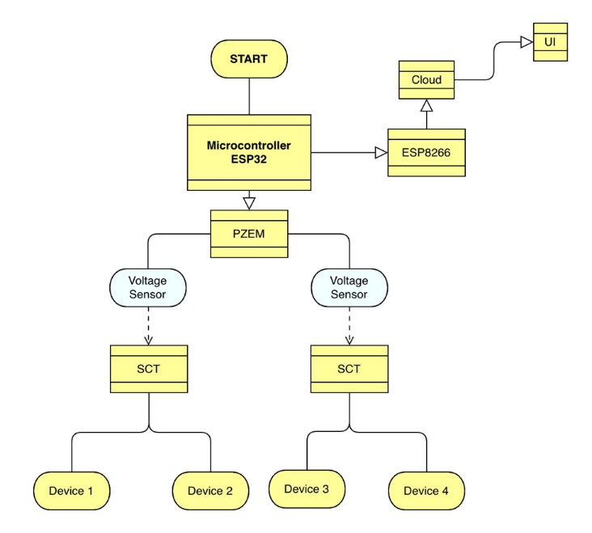

Fig.1.System Diagram of Smart Power Monitor and Optimizer System

# TECHNICAL IMPLEMENTATION OF NOTE- TAKING FEATURES

The ESP32 microcontroller stands as the foundation of the architecture because of its Wi-Fi features and low power usage together with its several I/O ports. Real-time electrical parameter measurement occurred through PZEM-004T and SCT-013 sensors with optional DHT11 sensor use for environmental parameters monitoring.

## *Architectural Considerations*

The microcontroller uses its local processing abilities to convert the acquired data into wireless signals which are transmitted to cloud services including Blynk and ThingSpeak for remote monitoring purposes and visual display. The data processing functions in clouds allow users to view real-time data through web applications and mobile interfaces. The system supports predictive analytics and anomaly detection through integrated machine learning models which run either on cloud-based scripts or mind latency when used with edge computing. The system architecture enables its capability to integrate future upgrades including multi-sensor expansion as well as AI-driven automation and third-party API integration for residential and commercial and industrial deployment.

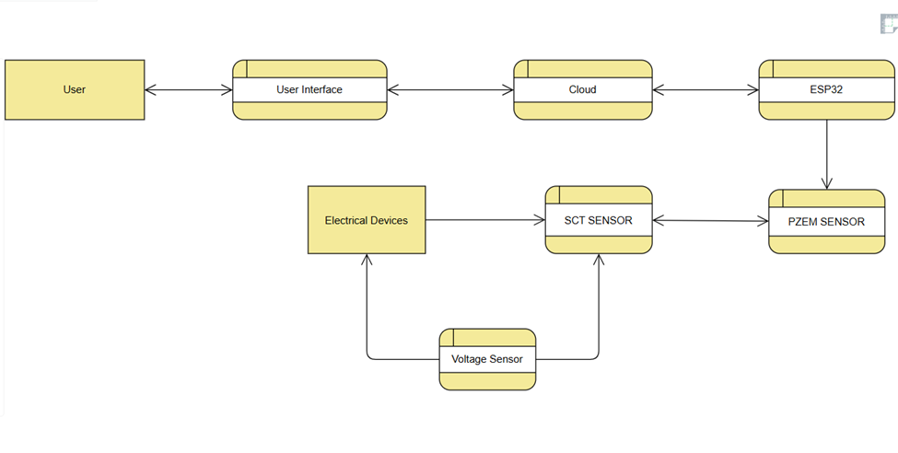  
 Fig.2. Data Flow Diagram of Smart Monitor and Optimizer System

*B. User Interface Design Patterns*

IoT-based power monitoring and optimization system focuses its user interface (UI) design on straightforwardness and clearness alongside user interface involvement. The application utilizes standard design aspects that maintain consistent user convenience for mobile and web interfaces. The dashboard design of the main interface shows energy usage overview together with real-time voltage and current and power readings presented through visual elements including graphs and gauges and numerical displays. The user interface displays sensors and data through cards which enable users to conveniently examine and interact with separate metrics. The navigation drawer enables hassle-free access to additional features that cover historical data analysis as well as customizable alerts together with settingsuminum. The application features progress indicators and notifications which supply users with quick alerts about energy thresholds and predictive analysis information. A responsive design capability in the application enables it to automatically adapt well between mobile phones and tablets and desktops. The application integrates gamification elements along with badges and achievement notifications to motivate users regarding energy conservation goals and also enables users to make personalized settings through a modal interface.

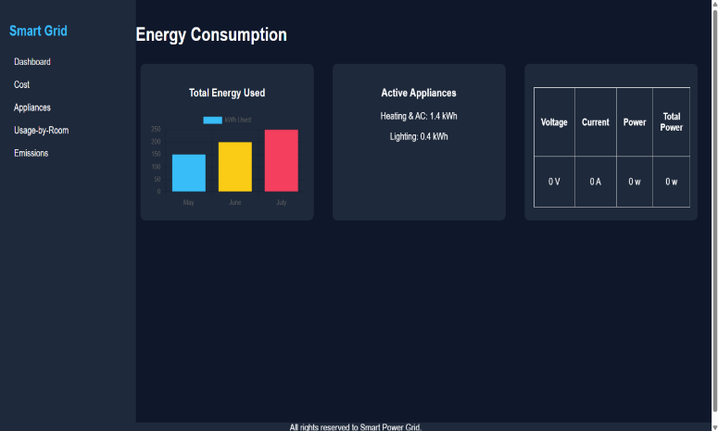

Fig 3.. Front page of Smart Power Monitor and Optimizer System

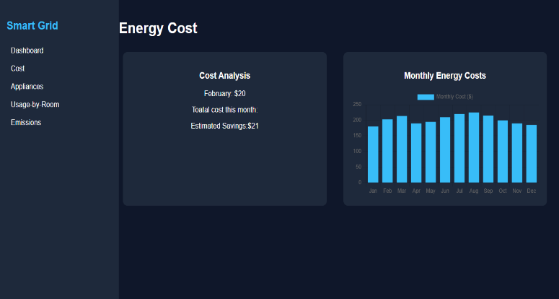

Fig.4.Web page of the cost Section of dashboard

1. *Data Synchronization and Persistence*

The system achieves both data synchronization and storage reliability by implementing immediate transmission with protected cloud storage methods. Female sensor data points consisting of voltage current power and energy readings reach the ESP32 microcontroller through wireless Wi-Fi communication protocols for real-time cloud synchronization at Blynk and ThingSpeak platforms. The microcontroller contains built-in memory buffers that temporarily store collected data to prevent loss when network interruptions occur before completing the upload process. After successful synchronization the data remains stored permanently in cloud databases so users can utilize it for historical evaluation alongsidepredictive estimations and detection of anomalous patterns. There is an automated system that maintains chronological arrangement for all data records to support smooth interpretation of trends and analytical metrics. System responsiveness and forecasting accuracy become improvedthrough regular model training by using synchronized datasets when machine learning models are applied. The system architecture provides the option to transfer data into external storage formats including CSV or JSON for both off-line research purposes along with third-party platform integration capability. The robust system design for data synchronization and persistence leads to reliable operation and protected data quality and enables users to access their data easily between several connected devices.

1. *Privacy and Data Security Considerations*

The essentiality of privacy and data security emerges due to continuous sensitive usage data acquisition and transmission within IoT-based power monitoring systems. The system protects user data through two encryption protocols: HTTPS and MQTT over TLS for secure transmission between the microcontroller and Blynk or ThingSpeak cloud platforms. The system protects user data through two security methods consisting of API keys and user login credentials which authorize specific personnel to gain access. The cloud storage provides secure access-controlled data centers which regularly back up user data to avoid loss. Physical and wireless access to temporary data stored on the ESP32 is restricted to protect its information. An additional feature of the system protects privacy by both stripping identifiable characteristics from data and restricting information acquisition to essential requirements for energy monitoring along with optimization purposes. The system's potential upgrades will consist of multiple authentication mechanisms in addition to different access permissions for various users within large installation areas combined with data protection standards fulfillment including GDPR requirements. Through these security measures the system protects user data from unauthorized access by maintaining confidentiality and ensuring integrity as well as availability from the data's lifetime inception through termination.

V. HIGH AND LOW LEVEL ARCHITECTURE

IoT-based power monitoring and optimization systems possess an architecture at the high level which unites hardware components and communication protocols while connecting cloud services with user interfaces.

## *High-Level Architecture*

The device layer incorporates the PZEM-004T and SCT-013 sensors to measure instantaneous electrical values (power, energy, voltage, current) as well as optional use of DHT11 sensors for environmental monitoring. The ESP32 microcontroller runs data acquisition tasks while performing initial filtering functions because it connects to these sensors. Wi-Fi enables secure transmission of data from the system to Blynk and ThingSpeak cloud platforms through the communication layer. Data undergoes storage and visualization and data analysis through dashboards that application users reach through web or mobile platform interfaces in the cloud system. The system enables computing by machine learning models in this layer to carry out trend prediction functions and identify anomalous data patterns. The application layer enables system users to easily access dashboards and receive alerts in real-time and manage custom thresholds as well as settings. Completing the architecture with modular elements makes it possible to scale in the future by adding sensors and APIs as well as implementing blockchain and AI features for innovative energy trading automation. Multiple levels of system structure provide adaptable and dependable operation together with optimized processing performance when serving residential and commercial domains.

TABLE 4.Data Security Consideration table

|  |  |  |
| --- | --- | --- |
| **Alert Type** | **Trigger Condition** | **Action Taken** |
| Overvoltage Alert | Voltage > 260V | Push Notification |
| High Current Alert | Current > 20A | Email + App Alert |
| Power Spike Alert | Power increases > 20% in 1 minute | Visual Warning on App |

* 1. *Low-Level Architecture*

The internal functionality of IoT-based power monitoring system components and their interactions are the subject of low-level architecture specifications. The ESP32 microcontroller acts as the principal unit by connecting to both energy monitoring sensors such as PZEM-004T through UART and SCT-013 through analog input pins. The ESP32 acquires sensor readings in a scheduled manner before processing the data using embedded C/C++ code developed inside the Arduino IDE. When implementing the DHT11 environmental sensor it must connect through digital I/O pins to simultaneously capture temperature and humidity data. Data from the microcontroller gets packaged by its built-in WiFi module for transmission to cloud platforms through HTTP POST or MQTT protocols. Buffer logic provides temporary storage of readings within local memory which serves as backup when network delays or failures occur. The firmware contains interrupt-based functions that achieve real-time data acquisition and watchdog timers for system stability. Power management functions within the ESP32 system help decrease energy usage when the device is idle. A system with error handling capabilities enables the identification of malfunctioning sensor data while providing the option to flag for monitoring or filter out the readings. Real-time debugging takes place through serial connections. A detailed low-level design creates the base that enables proper data acquisition while offering efficient processing and stable connectivity to obtain reliable system operation.

**P=V×I**

Where:

* PPP = Power (in Watts, W)
* VVV = Voltage (in Volts, V)
* III = Current (in Amperes, A)

Equation 1.

VI. BENEFIT OF SMART POWER MONITOR AND OPTIMIZER SYSTEM

The Smart Power Monitor and Optimizer System stands as a key component to change how modern facilities handle their energy resources. The system provides users with immediate access to measurements involving electrical parameters including voltage along with current and power which lets them track their energy use precisely. The system provides clear visibility that allows users to identify abnormal behavior along with high-power appliances which enables them to reduce their energy waste effectively.

The main advantage lies in substantial monetary reductions. The system monitors how power is used then generates specific actions to help people schedule their appliances better while making them use energy during less busy times and automatically turning off unutilized equipment. The system uses accumulated insights to cut down electricity expenses efficiently while keeping performance at its peak which leads to practical along with economic energy savings.

The system delivers improved safety measures apart from preventive maintenance protocols. User alerts function within seconds to notify about dangerous power utilization together with any abnormal usage patterns. The system protects important devices and controls circuit overloads through this vital security feature. The system performs predictive maintenance by detecting failure patterns that enable operators to intervene in time within industrial environments.

The system gains additional functionality through its remote capabilities coupled with automatic control systems. Users can monitor and control their energy usage from smartphones. The system advances operational efficiency through smooth integration with smart automation systems as users can execute time-dependent device operations or use AI-controlled adjustments for increased convenience. By creating an an environmentally-focused system which enhances energy awareness the system works to decrease carbon emission while also fostering more sustainable power utilization patterns through solar energy participation.

Graph 1. Comparisons of Energy Usage Before and After Optimization.

## FUTURE SCOPE AND CONCLUSION

## Future development opportunities exist extensively for the IoT-based power monitoring system that optimizes energy utilization. The addition of LSTM models as advanced technology will enable the system to make better predictions regarding energy usage. Edge computing operations should supplant cloud-based operations because it shortens delays when internet reception is limited. The system can produce smarter responses by including additional environmental sensors which measure room temperature together with humidity and check for room occupancy status. The implementation of blockchain technology enables residents of small communities to develop power exchange capabilities for their shared local network. Integrating entertaining dashboard interfaces and voice ordering systems and interactive video games lets users actively handle their power consumption more easily. Soaring 5G network availability and increased energy provider-user partnerships can advance this system from residential use toward business applications.

## The main objective of this project involved developing an IoT solution which enables users to monitor their electricity consumption and discover cost-effective power utilization techniques. Users could access real-time power consumption updates through mobile and web applications because the system incorporated ESP32 microcontrollers with PZEM-004T and SCT-013 sensors. The system notified users with alerts whenever the electricity usage exceeded regular levels. Users accessed knowledge about upcoming usage patterns because of the machine learning component. The system displayed reliability along with affordability despite minor installation issues and minor latencies. The system connects basic hardware elements together with intelligent software to provide users an effective method to monitor energy consumption while establishing better power management routines.

# REFERENCES

[1] Time Synchronised Power Meters for Advanced Smart Distribution of Energy in Smart Grids (Morello et al., 2024) IEEE Sensors Journal (2024)

[2] Research and application of wireless sensor network technology in power transmission and distribution system (Liu et al., 2020)Intelligent and

Converged Networks (2020) 1(2) 199-220

[3] Stability analysis of networked control in smart grids(Singh et al., 2015)IEEE Transactions on Smart Grid (2015) 6(1) 381-390

[4] Energy Sustainability-Survey on Technology and Control of Microgrid, Smart Grid and Virtual Power Plant (Khan et al., 2021) IEEE Access

[5] Smart (Electricity) Grids for Smart Cities: Assessing Roles and Societal Impacts (Masera et al., 2018)Proceedings of the IEEE

[6] Real-Time Cyber-Physical Power System Testbed for Optimal Power Flow Study Using Co-Simulation Framework (Nam Hai Pham et al., 2024)IEEE Access (2024) 12 150914-150929

[7] Micro-synchrophasor based special protection scheme for distribution system automation in a smart city (Kumar et al., 2020)Protection and Control of Modern Power Systems (2020) 5(1)

[8] Neuro-Fuzzy-Based IoT Assisted Power Monitoring System for Smart Grid (Ghosh, 2021)IEEE Access (2021) 9 168587-168599

[9] Smart Grids: A Cyber-Physical Systems Perspective (Yu & Xue, 2016)Proceedings of the IEEE

[10] Energy and congestion-aware routing metric for smart grid ami networks in smart city (Ullah et al., 2017)IEEE Access (2017) 5 13799-13810

[11] Micro Software Defined Control (μSDC): Empowering Smart Grids With Enhanced Control and Optimization (Al Mhdawi et al., 2024)IEEE Access (2024) 12 95750-95761

[12].Experimental Analysis using IoT based Smart Power Quality Analyser System with Remote Data Access and GSM Alerting Mechanism (Mallala et al., 2025)IEEE Access (2025)

[13] Improving Smart Grids Security: An Active Learning Approach for Smart Grid-Based Energy Theft Detection (Abbas et al., 2024)IEEE Access (2024) 12 1706-1717

[14] Distributed Anomaly Detection in Smart Grids: A Federated Learning-Based Approach (Jithish et al., 2023)IEEE Access (2023) 11 7157-7179

[15] Load Oscillating Attacks of Smart Grids: Vulnerability Analysis (Alanazi et al., 2023)IEEE Access (2023) 11 36538-36549

[16] Evaluation of Smart Grid Technologies Employed for System Reliability Improvement: Pacific Northwest Smart Grid Demonstration Experience (Agalgaonkar & Hammerstrom, 2017)IEEE Power and Energy Technology Systems Journal (2017) 4(2) 24-31

[17] Design, Implementation, and Deployment of an IoT Based Smart Energy Management System (Saleem et al., 2021)IEEE Access (2021) 9 59649-59664

[18] Overview of power quality analysis and control technology for the smart grid (Luo et al., 2016)Journal of Modern Power Systems and Clean Energy (2016) 4(1) 1-9

[19] Data Lake Lambda Architecture for Smart Grids Big Data Analytics (Munshi & Mohamed, 2018)IEEE Access (2018) 6 40463-40471

[20] Design, Deployment and Performance Evaluation of an IoT Based Smart Energy Management System for Demand Side Management in Smart Grid (Saleem et al., 2022)IEEE Access (2022) 10 15261-15278

[21] Cost Optimal Hybrid Communication Model for Smart Distribution Grid (Devidas & Ramesh, 2022)IEEE Transactions on Smart Grid (2022) 13(6) 4931-4942

[22] Data-driven monitoring and safety control of industrial cyber-physical systems: Basics and beyond (Jiang et al., 2018)IEEE Access (2018) 6 47374-47384

[23] A Data-Driven Approach for Blockchain-Based Smart Grid System (Zeng et al., 2021)IEEE Access (2021) 9 70061-70070

[24] Big Data Management in Smart Grids: Technologies and Challenges (Zainab et al., 2021)IEEE Access (2021) 9 73046-73059

[25] Control networks and smart grid teleprotection: Key aspects, technologies, protocols, and case-studies (de Almeida et al., 2020)IEEE Access (2020) 8 174049-174079

[26] A Unified Metering System Deployed for Water and Energy Monitoring in Smart City (Sushma et al., 2023)IEEE Access (2023) 11 80429-80447

[27] Bilevel optimization framework for smart building-to-grid systems (Razmara et al., 2018)IEEE Transactions on Smart Grid (2018) 9(2) 582-593

[28] A Survey on Cyber-Physical Security of Active Distribution Networks in Smart Grids (Khalaf et al., 2024)IEEE Access (2024) 12 29414-29444

[29] Guest editorial: special issue on wide area monitoring, protection and control in smart grid (Terzija & Liu, 2016)Journal of Modern Power Systems and Clean Energy.