Assignment 8: Fake Review Detection
  - Experimental comparison and literature context

1. Objective
The objective is to compare a text-only classifier with a classifier that combines review text and metadata. The evaluation metrics are Accuracy, Precision, Recall, Macro-F1, and Matthews Correlation Coefficient (MCC).

2. Project experiment: synthetic dataset
The project’s synthetic dataset was previously evaluated using a text-only model and a text + metadata model. The recorded results were 1.000 for all five metrics for both configurations. These results are reproduced as the current project results; this document does not claim a new independent execution.
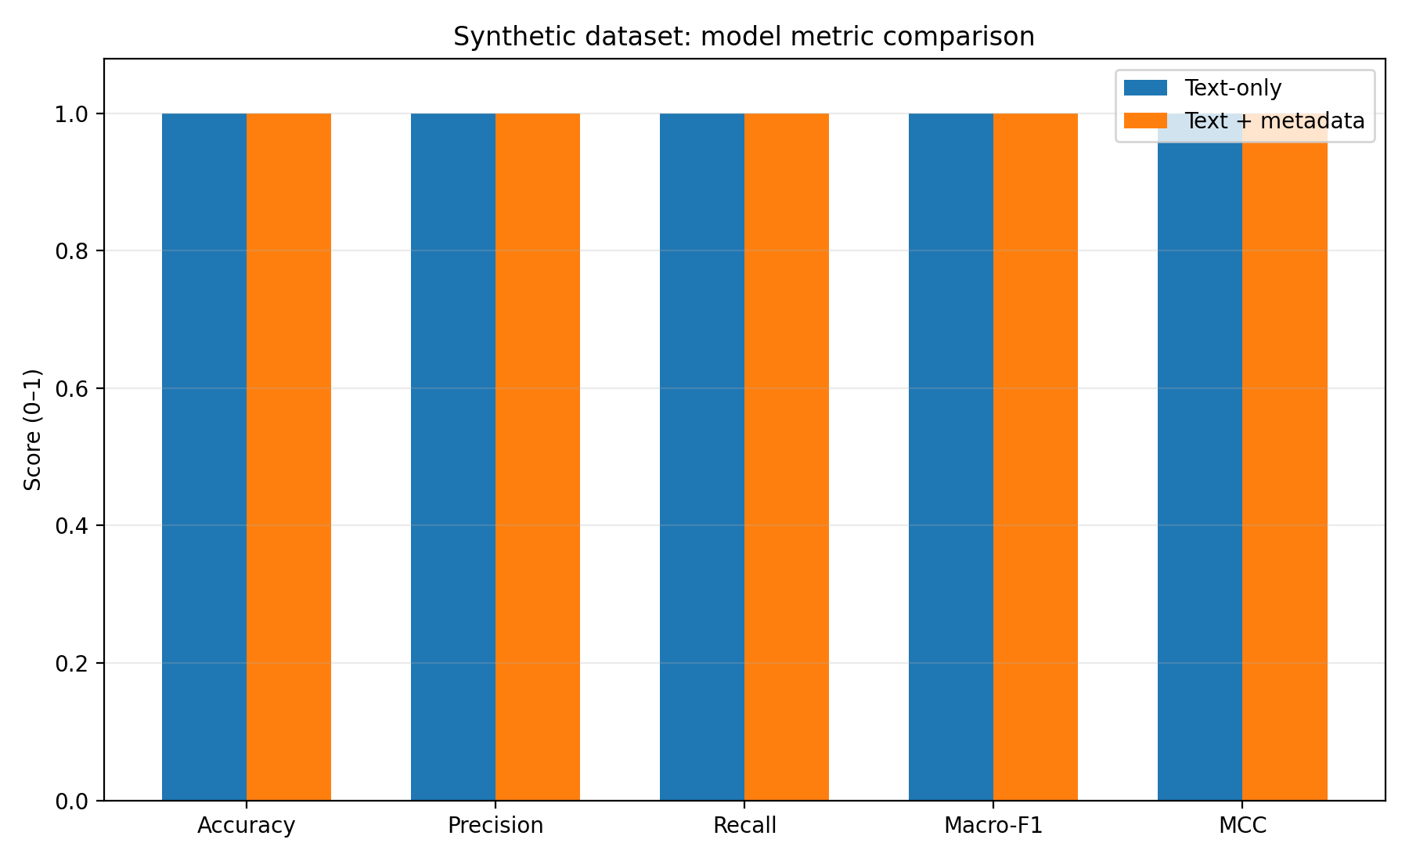
Interpretation: the results show no measured improvement from metadata on this synthetic test set. Perfect scores suggest that the synthetic examples may contain highly separable class patterns. These results should not be interpreted as evidence of equivalent performance on real-world reviews.

3. Published research for context
The following figures are transcribed from a published study evaluating BERT and DeBERTa across several review datasets. They are included as literature context and were not generated by the project’s implementation.
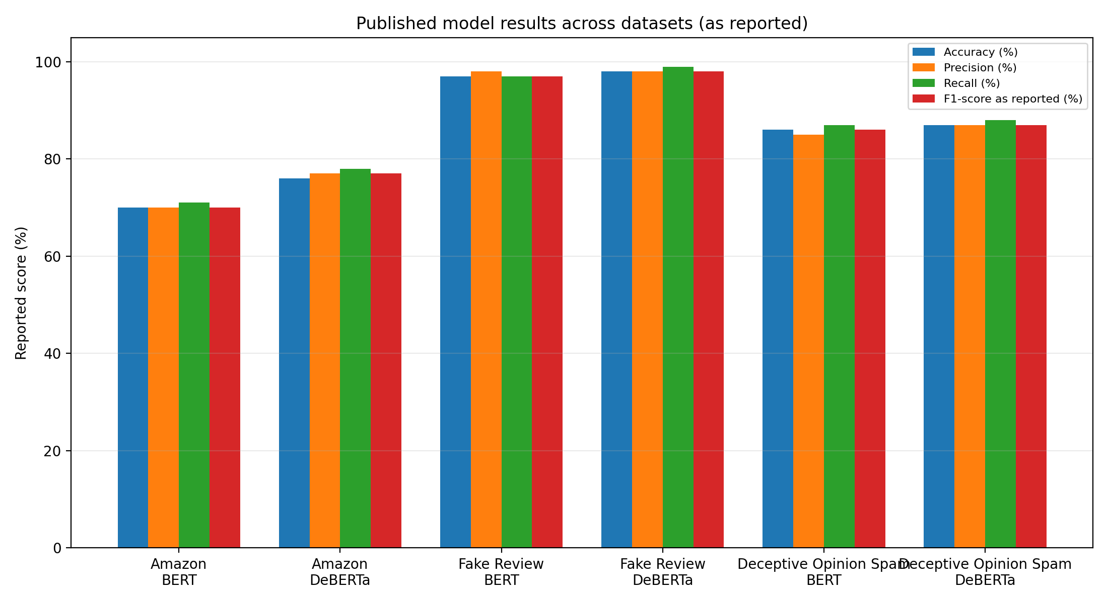
Source: “High performance fake review detection using pretrained DeBERTa optimized with Monarch Butterfly paradigm,” Scientific Reports, Table 5. https://pmc.ncbi.nlm.nih.gov/articles/PMC11876299/
The source table reports an F1-score but does not identify it as macro-F1, and it does not report MCC in the cited table. These values are therefore not inferred or fabricated.

4. Interpretation and limitations
The synthetic experiment and the published study use different datasets, model architectures, and evaluation protocols. Their scores should not be treated as a controlled head-to-head comparison. The project results indicate that the current synthetic dataset is too easy to distinguish for testing whether metadata provides a meaningful benefit.
A stronger next experiment would evaluate both project models on the same independently labelled real-review dataset, using identical stratified splits or cross-validation folds, and report all five metrics for each model.

5. Conclusion
On the available synthetic experiment, both model configurations reached perfect scores, so no incremental benefit from metadata was observed. Published literature provides context on how results vary by dataset and model. Further validation on independently labelled real-world reviews is required before making claims about real-world effectiveness.

References
1. High performance fake review detection using pretrained DeBERTa optimized with Monarch Butterfly paradigm. Scientific Reports. https://pmc.ncbi.nlm.nih.gov/articles/PMC11876299/
2. Soldner, F., Kleinberg, B., & Johnson, S. D. (2022). Confounds and overestimations in fake review detection: Experimentally controlling for product-ownership and data-origin. PLOS ONE, 17(12), e0277869. https://doi.org/10.1371/journal.pone.0277869

