**PROJECT 1:**

Deploying a web server in Windows instance

Task 1:Create a windows instance using AMI :Windows 2012 R2 base

Task 2:Launch the Windows instance using RDP

Task 3:Install IIS web server using Powershell ISE

Note:Simply copy the command below and paste in the powershell ISE to install the IIS web server.

!!!!Powershell is case sensitive.

Install-WindowsFeature -name Web-Server -IncludeManagementTools

Task 4:Verify successful installation of IIS Web Server

Note :You should be able to see the Internet Information Services Web page when you paste the public IP

into the browser.

Step1: Instance Creation

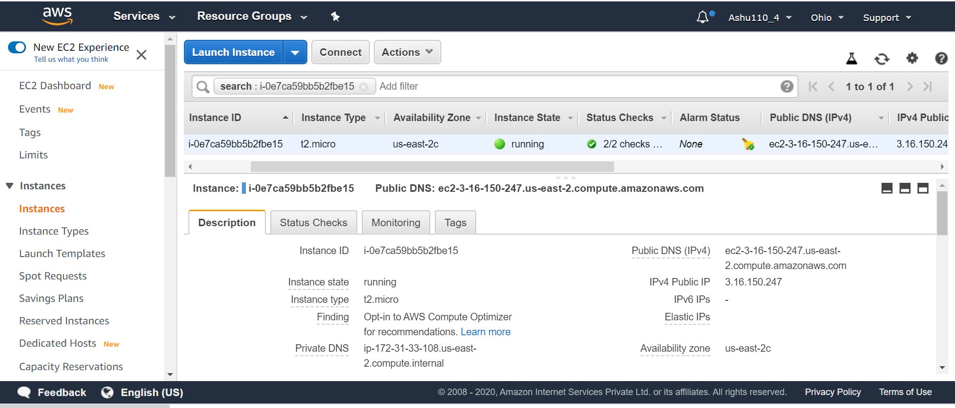

Step 2: instance connected

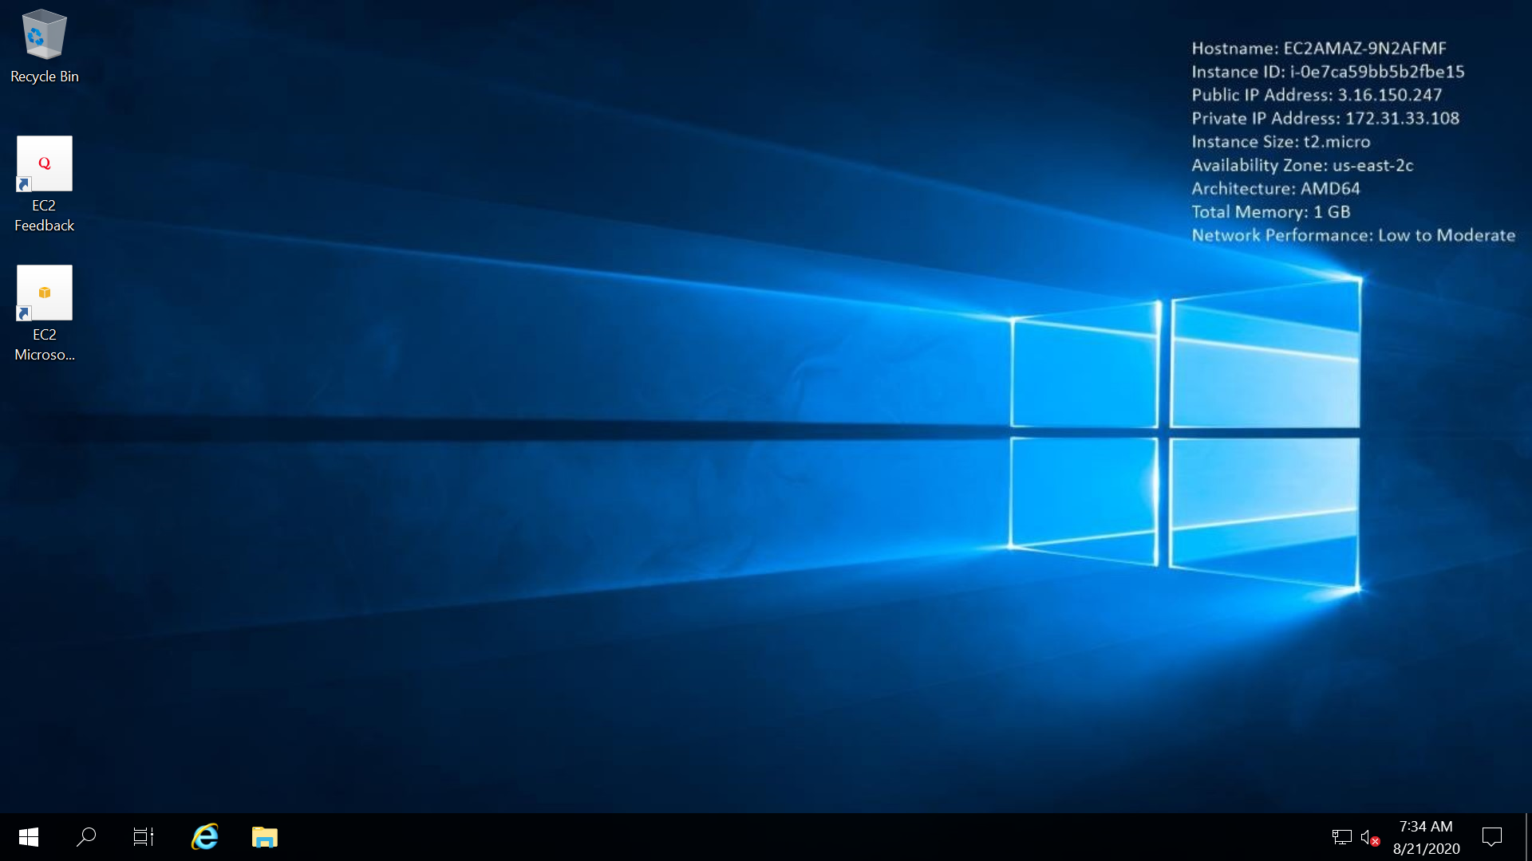

Step3: Web server installation

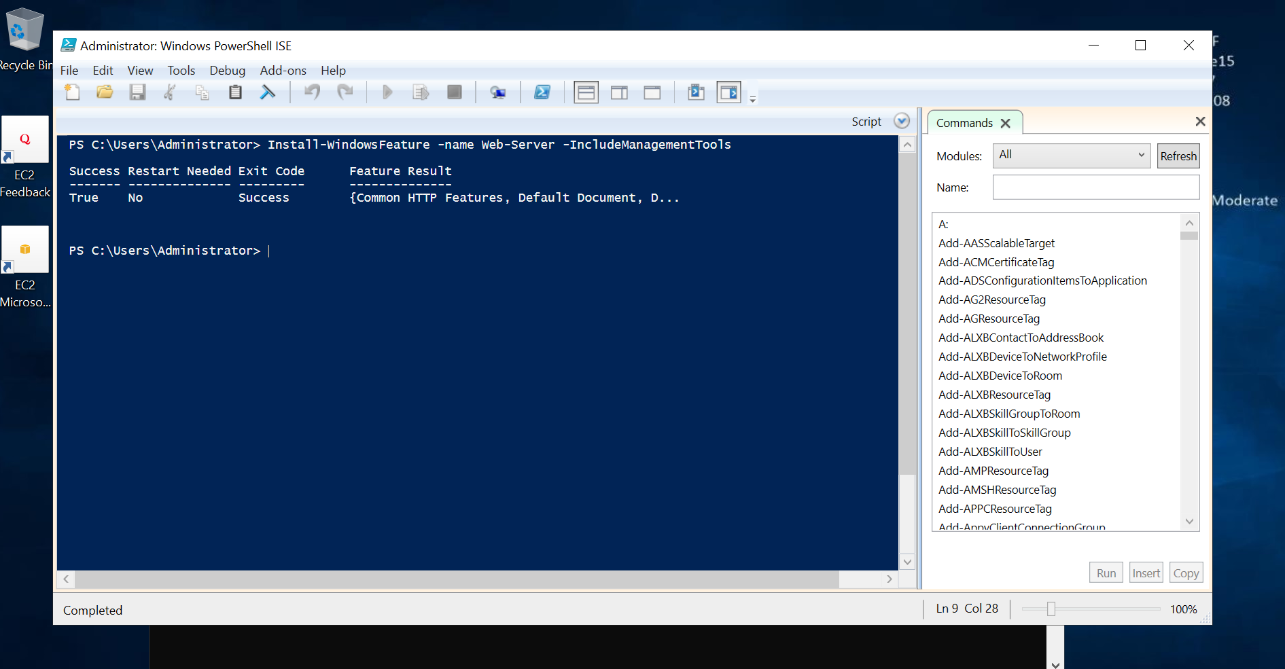

Step 4:Web server access

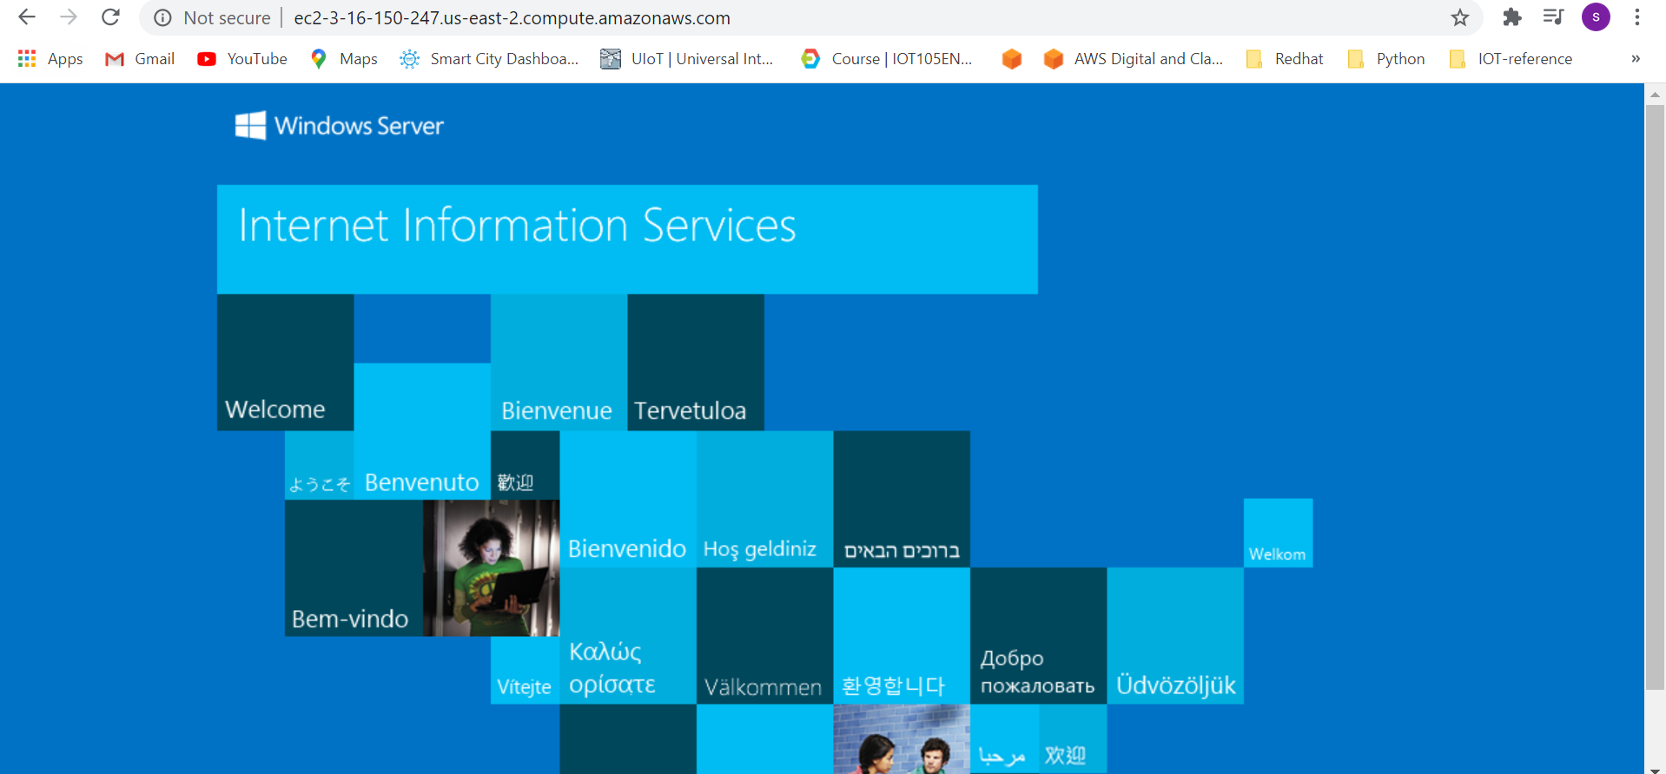

Step 5: instance termination

