**PROJECT 2:**

Deploying a web server in Windows instance

Task 1:Create a windows instance using AMI :Ubuntu Server 18.04 LTS (HVM)

Task 2:Download and install MobaXterm Portable Edition

Task 2:Launch the Ubuntu instance using SSH

Note:Username is ubuntu

Task 3:Install ngnix web server using bash

Note:Simply copy the command below and paste in the bash to install the ngnix web server.

sudo apt-get -y update

sudo apt-get -y install nginx

Task 4:Verify successful installation of ngnix

Note :You should be able to see the Welcome to ngnix Web page when you paste the public IP into the

browser.

Step1: Instance Creation

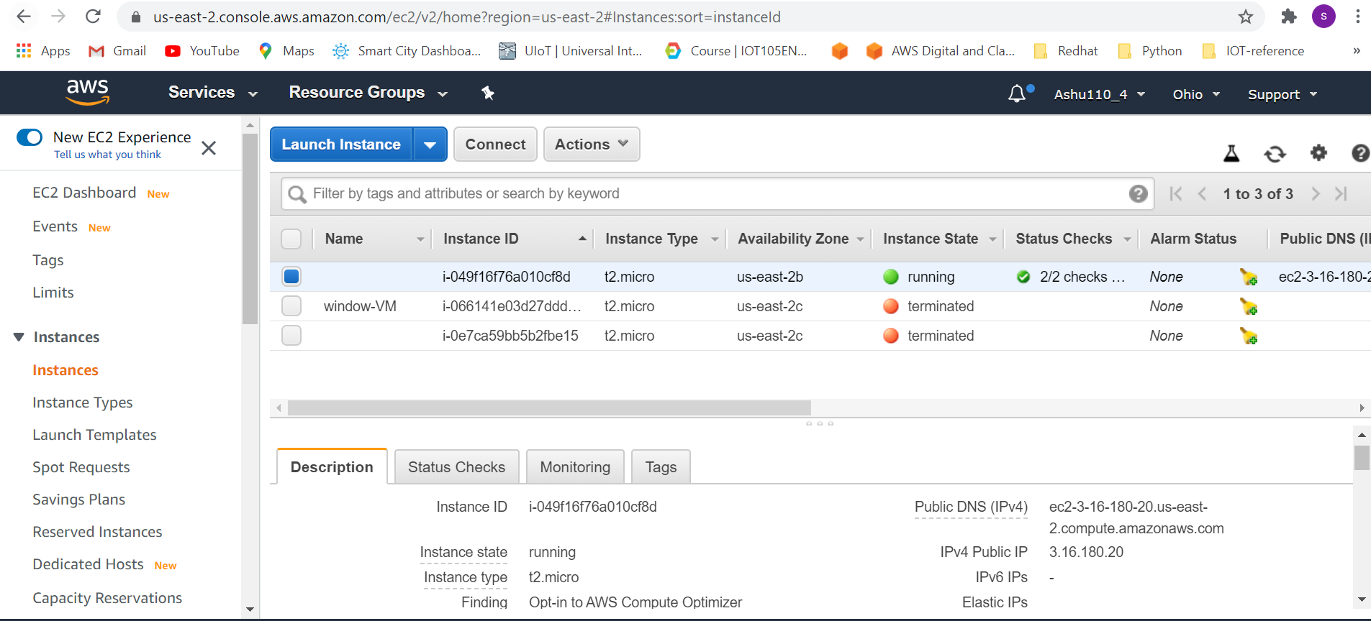

Step 2: instance connected via mobaxterm

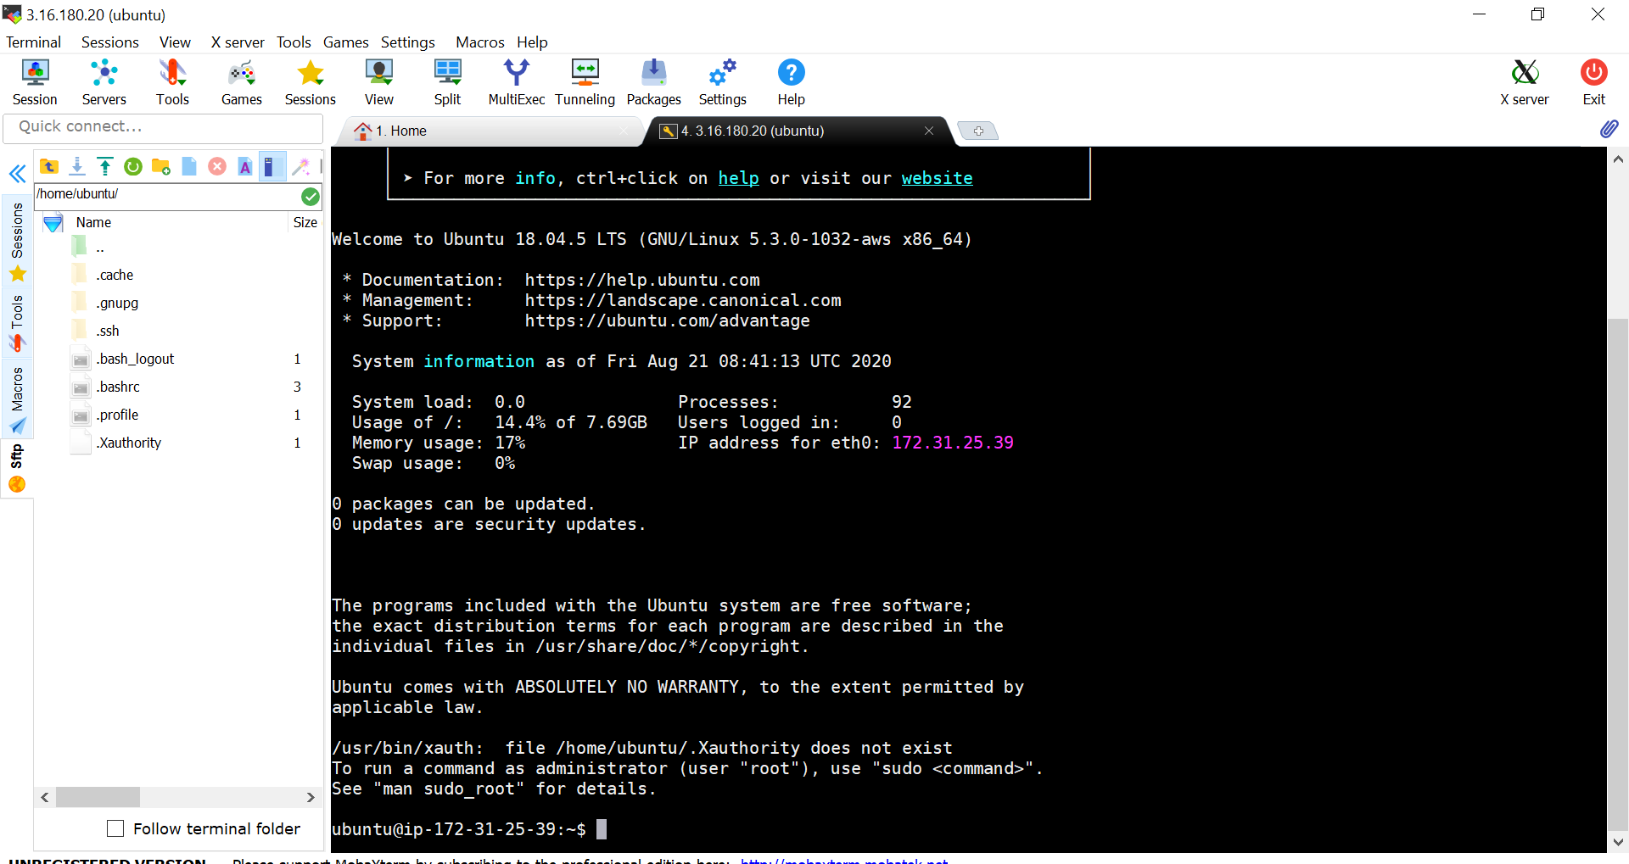

Step3: Web server[nginx] installation

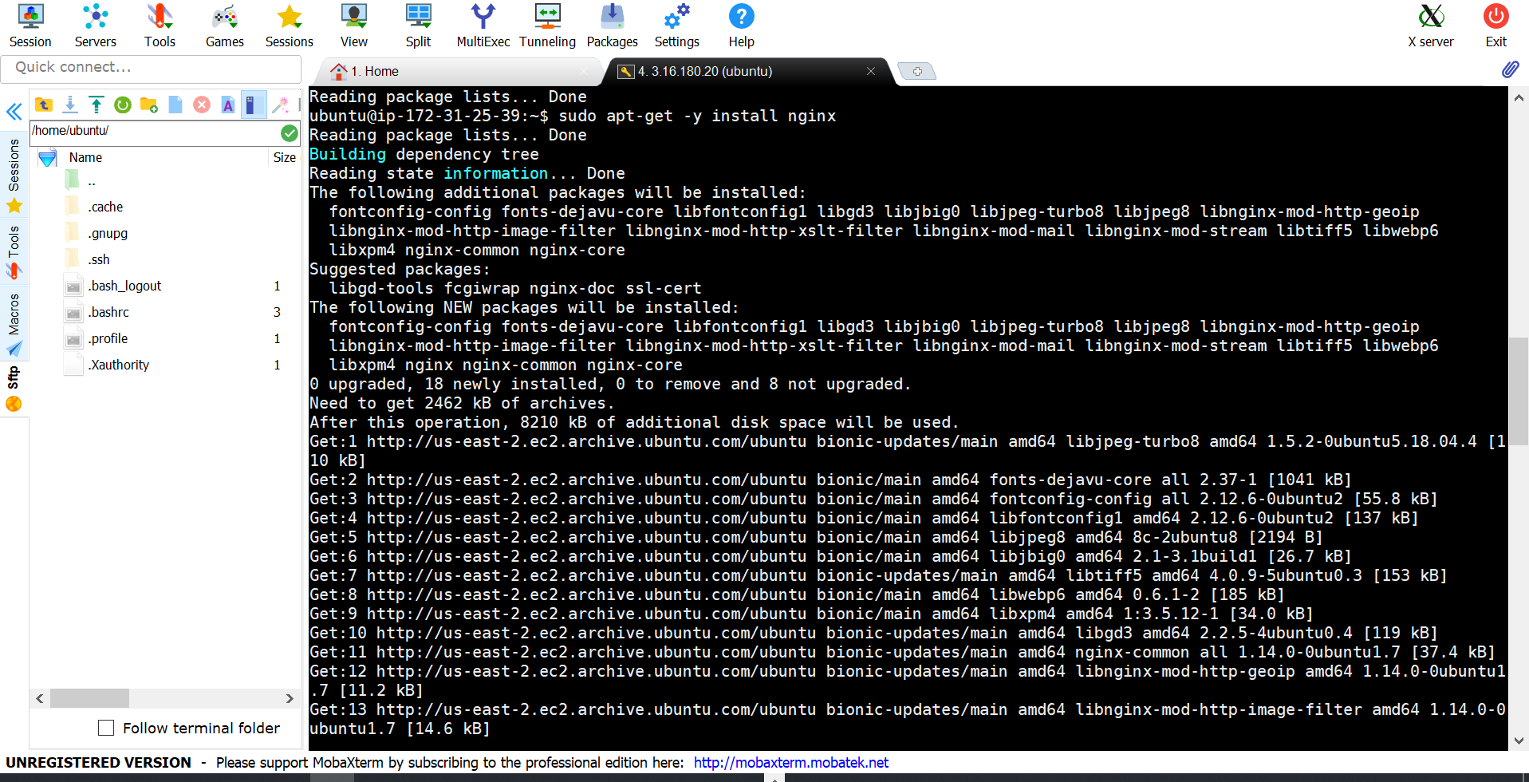

Step 4:Web server access

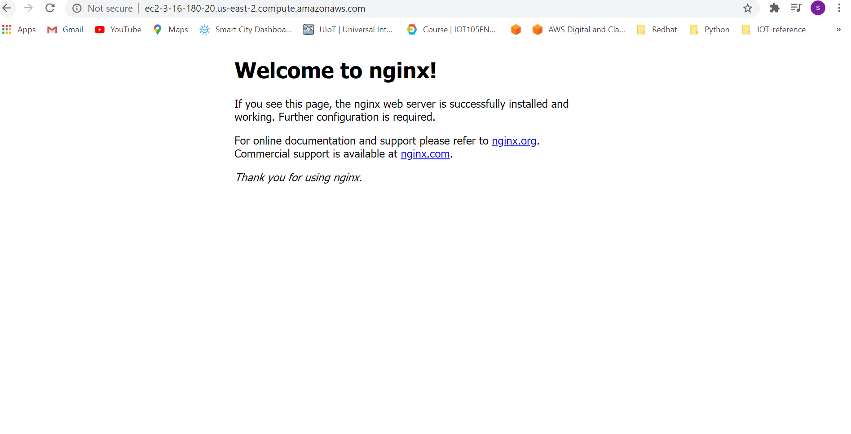

Step 5: instance termination

