One-way ANOVA

What is this test for?

The one-way analysis of variance (ANOVA) is used to determine whether there are any statistically significant differences between the means of three or more independent (unrelated) groups. This guide will provide a brief introduction to the one-way ANOVA, including the assumptions of the test and when you should use this test. If you are familiar with the one-way ANOVA, you can skip this guide and go straight to how to run this test in SPSS Statistics by clicking [here](https://statistics.laerd.com/spss-tutorials/one-way-anova-using-spss-statistics.php).

What does this test do?

The one-way ANOVA compares the means between the groups you are interested in and determines whether any of those means are statistically significantly different from each other. Specifically, it tests the null hypothesis:

ne-way ANOVA Null Hypothesis

where *µ* = group mean and *k* = number of groups. If, however, the one-way ANOVA returns a statistically significant result, we accept the alternative hypothesis (HA), which is that there are at least two group means that are statistically significantly different from each other.

At this point, it is important to realize that the one-way ANOVA is an **omnibus** test statistic and cannot tell you which specific groups were statistically significantly different from each other, only that at least two groups were. To determine which specific groups differed from each other, you need to use a **post hoc test**. Post hoc tests are described later in this guide.

When might you need to use this test?

If you are dealing with individuals, you are likely to encounter this situation using two different types of study design:

One study design is to recruit a group of individuals and then randomly split this group into three or more smaller groups (i.e., each participant is allocated to one, and only one, group). You then get each group to undertake different tasks (or put them under different conditions) and measure the outcome/response on the same dependent variable. For example, a researcher wishes to know whether different pacing strategies affect the time to complete a marathon. The researcher randomly assigns a group of volunteers to either a group that (a) starts slow and then increases their speed, (b) starts fast and slows down or (c) runs at a steady pace throughout. The time to complete the marathon is the outcome (dependent) variable. This study design is illustrated schematically in the diagram below:

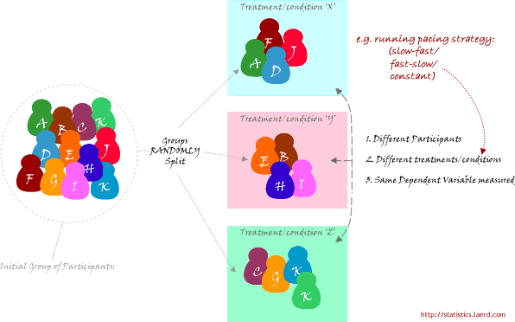

When might you need to use this test? (cont...)

A second study design is to recruit a group of individuals and then split them into groups based on some independent variable. Again, each individual will be assigned to one group only. This independent variable is sometimes called an attribute independent variable because you are splitting the group based on some attribute that they possess (e.g., their level of education; every individual has a level of education, even if it is "none"). Each group is then measured on the same dependent variable having undergone the same task or condition (or none at all). For example, a researcher is interested in determining whether there are differences in leg strength between amateur, semi-professional and professional rugby players. The force/strength measured on an isokinetic machine is the dependent variable. This type of study design is illustrated schematically in the Figure below:

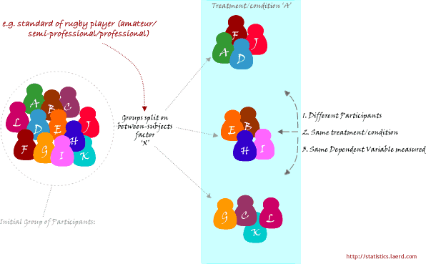

Why not compare groups with multiple t-tests?

Every time you conduct a t-test there is a chance that you will make a Type I error. This error is usually 5%. By running two t-tests on the same data you will have increased your chance of "making a mistake" to 10%. The formula for determining the new error rate for multiple t-tests is not as simple as multiplying 5% by the number of tests. However, if you are only making a few multiple comparisons, the results are very similar if you do. As such, three t-tests would be 15% (actually, 14.3%) and so on. These are unacceptable errors. An ANOVA controls for these errors so that the Type I error remains at 5% and you can be more confident that any statistically significant result you find is not just running lots of tests.

What assumptions does the test make?

There are three main assumptions, listed here:

1. The dependent variable is normally distributed in each group that is being compared in the one-way ANOVA (technically, it is the residuals that need to be normally distributed, but the results will be the same). So, for example, if we were comparing three groups (e.g., amateur, semi-professional and professional rugby players) on their leg strength, their leg strength values (dependent variable) would have to be normally distributed for the amateur group of players, normally distributed for the semi-professionals and normally distributed for the professional players.
2. There is homogeneity of variances. This means that the population variances in each group are equal.
3. Independence of observations. This is mostly a study design issue and, as such, you will need to determine whether you believe it is possible that your observations are not independent based on your study design (e.g., group work/families/etc).

What happens if my data fail these assumptions?

1. The one-way ANOVA is considered a robust test against the normality assumption. This means that it tolerates violations to its normality assumption rather well. As regards the normality of group data, the one-way ANOVA can tolerate data that is non-normal (skewed or kurtotic distributions) with only a small effect on the Type I error rate. However, platykurtosis can have a profound effect when your group sizes are small. This leaves you with two options: (1) transform your data using various algorithms so that the shape of your distributions become normally distributed or (2) choose the nonparametric Kruskal-Wallis H Test which does not require the assumption of normality.
2. There are two tests that you can run that are applicable when the assumption of homogeneity of variances has been violated: (1) Welch or (2) Brown and Forsythe test. Alternatively, you could run a Kruskal-Wallis H Test. For most situations it has been shown that the Welch test is best.
3. A lack of independence of cases has been stated as the most serious assumption to fail. Often, there is little you can do that offers a good solution to this problem.

How do I report the results of a one-way ANOVA?

You will have calculated the following results or obtained them from SPSS Statistics:

Structure of results:

|  |  |  |  |  |  |
| --- | --- | --- | --- | --- | --- |
| *Source* | *SS* | *df* | *MS* | *F* | *Sig.* |
| Between | SSb | k-1 | MSb | MSb/MSw | *p* value |
| Within | SSw | N-k | MSw |  |  |
| Total | SSb + SSw | N-1 |  |  |  |

An example:

|  |  |  |  |  |  |
| --- | --- | --- | --- | --- | --- |
| *Source* | *SS* | *df* | *MS* | *F* | *Sig.* |
| Between | 91.476 | 2 | 45.733 | 4.467 | .021 |
| Within | 276.400 | 27 | 10.237 |  |  |
| Total | 367.867 | 29 |  |  |  |

You will want to report this as follows:

There was a statistically significant difference between groups as determined by one-way ANOVA (*F*(2,27) = 4.467, *p* = .021). This is all you will need to write for the one-way ANOVA per se. However, in reality you will probably also want to report means ± standard deviations for your groups, as well as follow up a statistically significant result with a post hoc test. If you use SPSS Statistics, these descriptive statistics will be reported in the output along with the result from the one-way ANOVA. The general form of writing the result of a one-way ANOVA is as follows:

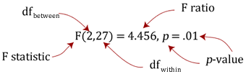

where df = degrees of freedom.

You should not report the result as "significant difference", but instead report it as "statistically significant difference". This is because your decision as to whether the result is significant or not should not be based solely on your statistical test. Therefore, to indicate to readers that this "significance" is a statistical one, include this is your sentence.

## What are post hoc tests?

Recall from earlier that the ANOVA test tells you whether you have an overall difference between your groups, but it does not tell you which specific groups differed – post hoc tests do. Because post hoc tests are run to confirm where the differences occurred between groups, they should only be run when you have a shown an overall statistically significant difference in group means (i.e., a statistically significant one-way ANOVA result). Post hoc tests attempt to control the experiment-wise error rate (usually alpha = 0.05) in the same manner that the one-way ANOVA is used instead of multiple t-tests. Post hoc tests are termed a posteriori tests; that is, performed after the event (the event in this case being a study).