A MAJOR PROJECT REPORT
ON
“Car Price Prediction”

Submitted in Partial Fulfillment for the award of
Master of Computer Application (MCA)
(2022-2024)


Submitted to
RAJIV GANDHI PROUDYOGIKI VISHWAVIDYALAYA
BHOPAL (M.P.)



Submitted By:
Ashutosh Kumar Gautam(0302CA221010)
Satyam Chaube(0302CA201036)
Shubham Keshari(0302CA221041)

Approved By Under the Guidance of
Mr.K.P.Tripathi Mr.Madan Mohan Sir (HOD CSE Department) (Asst. Prof. CSE Department)

DEPARTMENT OF COMPUTER SCIENCE & ENGINEERING
VINDHYA INSTITUTE OF TECHNOLOGY AND SCIENCE
SATNA (M.P.)

Rajiv Gandhi Proudyogiki Vishwavidyalaya, Bhopal (M.P)
Vindhya Institute of Technology & Science
Satna (M.P)


CERTIFICATE

This is to certify that the Minor Project - I on “Car price Prediction” which has been completed & submitted by Ashutosh Gautam , Satyam Chaube and Shubham Keshari in partial fulfillment of the requirement for the award of the degree of Master of Computer Application(MCA)
for the session 2022-2024 is a bonafied work by them and has been completed under my guidance and supervision.

H.O.D Guided By
Mr.K.P.Tripathi Mr.Madan Mohan Mishra
(HOD CSE Department) (Asst. Prof. CSE Department)

Principal
Dr. P.K.Shukla

Rajiv Gandhi Proudyogiki Vishwavidyalaya, Bhopal (M.P)
Vindhya Institute of Technology & Science
Santa (M.P)

CERTIFICATE

This is to certify that the Minor Project on “Car Price Prediction” which has been completed & submitted by Ashutosh Gautam , Satyam Chaube and Shubham Keshari in partial fulfillment of the requirement for the award of the degree of Master of Computer Application(MCA) for the session 2022-2024.

(External Examiner) (Internal Examiner)

DECLARATION

We hereby declare that the work which is being presented in the project report entitled “Car Price Prediction” partial fulfillment of the requirement of the degree of “Master of Computer Application(MCA)” branch is an authentic record of our work carried out under the guidance of “Mr. Madan Mohan Sir”. The work has been carried out at Vindhya Institute of Technology & Science, Satna.

Project Associate
Ashutosh Gautam(0302CA221010)
Satyam Chaube(0302CA221036)
Shubham Keshari(0302CA221041)

ACKNOWLEDGEMENT

A project like this one involves many people and would be incomplete without the mention of all those people whose guidance and encouragement helped in the successful completion of this project.
I would like to express my sincere and deep sense of gratitude from my heart to my guide and project coordinator Mr. Madan Mohan Mishra, Assistant Professor, VITS, Satna (M.P.), for his help supervision and encouragement as a guide throughout the course of this investigation.
With great pleasure and deep sense of gratitude I would like to express my special thank to Mr.K.P.Tripathi, Head of Department of Computer Science & Engineering, VITS, Satna, for his erudite guidance, affectionate encouragement and wholehearted involvement in my thesis, without which it would have been difficult for me to complete this work. I am fortunate to be his student.
I would like to take this opportunity to offer my special thank to Mr. Sunil Senani, Chairman, VITS, Satna for his constant encouragement and bearing with me and light up my path.
I express my deepest gratitude to Dr.P.K.Shukla, Principal of the VITS, Satna for encouragement, useful suggestions and inspiration for completing my thesis.
I would like to express the special thanks to all faculty members and the staff of the Department of Computer Science. They are excellent teacher and have inspired me to continue learning with an open and positive mind.
I express my heartfelt gratitude to my friends and also to each and every individual who was associated with my work, including those whom I may have inadvertently failed to mention.
Finally, I am highly obliged to all my family members for their support and blessings.

Table of Content

CHAPTER 1 INTRODUCTION | Page range like (2-8)
1.1 Evaluation of System | Page no.
1.2 Problem definition | Page no.
1.3 Proposed System | Page no.
1.4 Scope of work/project | Page no.
1.5 Report Organization | Page no.
CHAPTER 2 LITERATURE SURVEY | Page range like (2-8)
2.1Presently available system | Page no.
2.2 Title/ Article | Page no.
2.3 Name of Author/ Name of web site/Book | Page no.
2.4 ISSN no. of Paper/Journal / Complete URL of website/ISBN No. of Book | Page no.
2.5 Conclusion: Include required facts, fig , Tables, Diagrams, and  Architecture etc. | Page no.
CHAPTER 3 ANALYSIS | Page range like (2-8)
- Requirement Analysis | Page no.
3.2 Data Model | Page no.
3.2.1 Data Flow Diagram(DFD) | Page no.
3.3 Process Model  3.3.1 Entity Relationship Diagram (ERD) | Page no.  Page no.
3.4 Behavioral Model  3.4.1 State Transition Diagram | Page no.  Page no.
CHAPTER 4 DESIGN | Page range like (2-8)
4.1 Object Oriented Design | Page no.
4.2 System Flow diagram | Page no.
4.3 Class Diagram | Page no.
4.4 Class Description | Page no.
4.5 Use-Case Diagram  4.6 Sequence Diagram | Page no.  Page no
4.7 Activity Diagram | Page no.
CHAPTER 5 IMPLEMENTATION AND TESTING | Page range like (2-8)
5.1 Testing Strategies adapted | Page no.
5.2 System Testing | Page no.
5.3 Test Cases | Page no.
CHAPTER 6 CONCLUSION AND FUTURE WORK | Page range like (2-8)
References | Page no.
Appendix A Software Requirement Specification (SRS) | Page no.
Appendix B Software Design Specification (SDS) | Page no.
Appendix C Screenshots | Page no.

List of Figures

Figure no. | Title | Page no.

List of Tables

Table no. | Title | Page no.

List of Abbreviations
Table no. | Title | Page no.

CHAPTER 1 INTRODUCTION

1.1 Evaluation of System

The evaluation of a machine learning system for car price prediction involves several crucial steps to ensure accuracy, reliability, and practical applicability. Initially, data preprocessing is essential, starting with gathering a comprehensive dataset that includes car attributes such as make, model, year, mileage, engine type, fuel type, transmission, and historical price data. This data can be sourced from automotive websites, dealership listings, and historical sales records. The cleaning process involves handling missing values, correcting data entry errors, and normalizing both categorical and numerical data, utilizing techniques like mean imputation for missing values or one-hot encoding for categorical variables. Feature engineering, such as creating new features from existing data, can also significantly enhance model performance by providing additional predictive power.

Model selection follows, involving various machine learning models like Linear Regression, Decision Trees, Random Forest, Gradient Boosting Machines (GBM), and Neural Networks. Each model is evaluated based on data complexity and the required prediction accuracy. These models are trained on a portion of the dataset, typically using 70-80% for training and the rest for testing, to learn the relationship between input features and the target variable (car price).
Model validation is critical for ensuring robustness. K-fold cross-validation is employed, dividing the dataset into k subsets and training the model k times with different subsets as validation sets to mitigate overfitting and provide a more accurate performance measure. Hyperparameter tuning, using techniques like grid search or random search, optimizes model performance by finding the best combination of hyperparameters through validation set evaluation.
Performance metrics are essential for assessing model effectiveness. Metrics such as Mean Absolute Error (MAE), Root Mean Squared Error (RMSE), R-squared (R²), and Mean Absolute Percentage Error (MAPE) are used. MAE measures the average magnitude of prediction errors, RMSE gives higher weight to large errors, R² indicates how well the independent variables explain the variability of the dependent variable, and MAPE expresses accuracy as a percentage.
Model evaluation and comparison involve assessing models based on these metrics. Lower MAE, RMSE, and MAPE values indicate better performance, while a higher R² is preferable. The best-performing model is then tested on a real-world dataset to ensure it generalizes well to new, unseen data, using recent data not included in the initial training or validation sets.
In conclusion, evaluating a car price prediction system using machine learning requires a structured approach, including data preprocessing, model selection, validation, and performance evaluation to develop a robust system capable of effective predictions. Continuous monitoring and updating with new data will further enhance the model's predictive power and reliability. Future work may involve exploring advanced models like deep learning, incorporating additional features such as economic indicators, and refining the model through continuous learning and real-time updates. Expanding the system to different regions and market conditions can also improve its versatility and applicability.

1.2 Problem definition

The problem of predicting the selling price of used cars involves several complex challenges that can be effectively addressed using machine learning. The used car market is diverse and influenced by numerous factors, including the car's make, model, year of manufacture, mileage, engine type, fuel type, transmission, and overall condition. Traditional methods for estimating car prices often rely on subjective assessments or heuristic-based pricing, which can lead to inconsistencies and inaccuracies, potentially causing financial losses for sellers or overpayments by buyers. The objective of this project is to develop a machine learning model that can accurately predict the selling price of used cars, providing a reliable, data-driven approach to car price estimation.

The project begins with the collection of comprehensive and high-quality data from various sources such as automotive websites, dealership listings, and historical sales records. Ensuring the data is clean, accurate, and representative of the market is crucial. This involves handling missing values, normalizing categorical and numerical data, and correcting any data entry errors. Feature engineering is another critical step, where relevant features that significantly impact car prices are identified and created. This process may involve transforming raw data into meaningful features that improve the model's predictive power.

1.3 Proposed System

The proposed system for predicting the selling price of used cars through machine learning comprises several interconnected components aimed at delivering accurate and data-driven price estimates. Initial steps involve comprehensive data collection from diverse sources such as automotive websites, dealership listings, and historical sales records. Subsequently, this data undergoes rigorous preprocessing, including cleaning, handling missing values, and normalizing variables, to ensure its readiness for analysis. Feature engineering follows, where new features are derived from existing data to augment model performance, capturing intricate relationships between car attributes and pricing. Model selection and training involve evaluating various machine learning algorithms like Linear Regression, Decision Trees, Random Forest, Gradient Boosting Machines (GBM), and Neural Networks. The models are trained using a portion of the dataset, with k-fold cross-validation employed to validate their robustness and prevent overfitting. Performance evaluation metrics, including Mean Absolute Error (MAE), Root Mean Squared Error (RMSE), R-squared (R²), and Mean Absolute Percentage Error (MAPE), are utilized to assess model accuracy and reliability. The best-performing model is then deployed into a user-friendly interface, such as a web or mobile application, facilitating easy input of car details and instantaneous receipt of price predictions. Overall, the proposed system aims to provide a reliable and accessible solution for pricing used cars, empowering both sellers and buyers in the used car market with informed decision-making capabilities.

1.4 Scope of work/project

Overview
The scope of this project is to develop a machine learning system capable of accurately predicting the selling price of used cars. The project will involve collecting and preprocessing data, performing feature engineering, selecting and training machine learning models, validating model performance, and developing a user-friendly interface for accessing price predictions.

Key Objectives
- Data Collection: Gather comprehensive data on used cars from various sources, including automotive websites, dealership listings, and historical sales records. Ensure data cleanliness and accuracy.
- Data Preprocessing: Clean and preprocess the collected data, handling missing values, correcting errors, and normalizing variables. Prepare the data for feature engineering and model training.
- Feature Engineering: Create new features from the existing data to enhance model performance. Explore relationships between car attributes and pricing to identify relevant features
- Model Selection and Training: Evaluate and select appropriate machine learning models for predicting car prices. Train selected models using the preprocessed data, optimizing model performance through techniques such as hyperparameter tuning.
- Model Validation: Validate the trained models using robust validation techniques like k-fold cross-validation. Evaluate model performance using metrics such as Mean Absolute Error (MAE), Root Mean Squared Error (RMSE), R-squared (R²), and Mean Absolute Percentage Error (MAPE).
- User Interface Development: Develop a user-friendly interface, such as a web or mobile application, for users to input car details and receive price predictions. Ensure the interface is intuitive and accessible to users.

Deliverables
- Comprehensive dataset of used car attributes collected from various sources.
- Cleaned and preprocessed dataset ready for analysis.
- Engineered features that enhance model performance in predicting car prices.
- Trained machine learning models capable of accurately predicting car prices.
- Validation results and performance metrics for the trained models.
- User-friendly interface allowing users to input car details and obtain price predictions.

Timeline
The project timeline will be divided into several phases, including data collection and preprocessing, feature engineering, model selection and training, model validation, and interface development. Each phase will have specific milestones and deadlines to ensure timely completion of the project. The estimated timeline for the project is [provide estimated timeline here].

Resources required
The project will require access to data sources, computing resources for data processing and model training, machine learning libraries and frameworks (such as TensorFlow, scikit-learn), and development tools for interface development. Additionally, expertise in data science, machine learning, and software development will be essential for the successful execution of the project.

Constrains and Limitations
Potential constraints and limitations of the project include availability and quality of data, computational resources for model training, and time constraints for completing the project. Addressing these constraints will be critical for achieving the project objectives within the specified timeline and budget.

Conclusion
The scope of this project encompasses developing a machine learning system for predicting the selling price of used cars, including data collection, preprocessing, feature engineering, model selection and training, validation, and interface development. By effectively executing the scope of work outlined above, the project aims to deliver a reliable and user-friendly solution for pricing used cars, benefiting both sellers and buyers in the used car market.

1.5 Report Organization

The report on the project "Car Price Prediction Using Machine Learning" is structured to provide a comprehensive and detailed account of the development process, methodologies, and results. The report begins with an Introduction that includes an overview of the used car market and the need for accurate price prediction, a clear statement of the problem and objectives, the specific goals of developing a machine learning model for car price prediction, the scope of the project, including data collection, preprocessing, feature engineering, model training, validation, and interface development, and an outline of the report structure. Following this, the Literature Review section reviews existing methods for car price prediction, machine learning techniques, and a comparative analysis of different approaches.

The Methodology section provides a detailed description of the data sources and data collection methods, the steps taken to clean, normalize, and prepare the data, techniques used to create new features, criteria for selecting suitable machine learning models, the process of training the models and validating their performance, and methods employed to optimize the models' hyperparameters. The Implementation section describes the software, libraries, and tools used, the model development process, the design and development of the user interface for price prediction, and an overview of the system architecture, including data flow and interactions between components.

The Results and Discussion section presents the performance metrics for each model, a comparison of the models based on these metrics, results of testing the best-performing model on real-world data, and an interpretation of the results and their implications. The Conclusion and Future Work section summarizes the project findings and the effectiveness of the proposed system, and offers recommendations for future research and potential improvements. The References section provides a comprehensive list of all sources cited throughout the report. Finally, the Appendices include a detailed description of the dataset used, relevant code snippets, and any supplementary figures, tables, or charts that support the report. This organization ensures a logical flow of information, making it easy to understand the development process, methodologies employed, and the outcomes of the project.

CHAPTER 2 LITERATURE SURVEY

Current systems for car price prediction vary widely in terms of complexity, accuracy, and methodology. These systems can be broadly categorized into traditional appraisal methods, heuristic-based pricing, and advanced machine learning-based systems.

Traditional Appraisal Methods
Traditional appraisal methods rely on manual assessments conducted by experts who evaluate a car's condition and estimate its price based on experience and market trends. These methods often consider factors such as make, model, year, mileage, and overall condition. However, they can be subjective and inconsistent, as they heavily depend on the appraiser's expertise and judgment. This approach is time-consuming and may not scale well for large volumes of cars.

Heuristic-based pricing
Heuristic-based pricing systems use predefined rules and formulas to estimate car prices. These systems may incorporate historical sales data and basic attributes of the car such as make, model, year, and mileage. Websites like Kelley Blue Book (KBB) and Edmunds provide such services, offering price estimates based on extensive databases of car transactions and depreciation models. While these systems provide quick and accessible price estimates, they often lack the precision and adaptability of more sophisticated models, as they cannot account for the myriad of variables that can affect car prices in real-time.

Machine Learning-Based Systems
Advanced systems utilize machine learning algorithms to predict car prices with greater accuracy and efficiency. These systems can process large datasets and identify complex patterns and relationships between various car attributes and their prices. Machine learning models such as Linear Regression, Decision Trees, Random Forest, Gradient Boosting Machines (GBM), and Neural Networks are commonly employed. These models can learn from historical data and improve their predictions over time.

Companies like CarGurus and AutoTrader have started integrating machine learning algorithms into their pricing tools. These platforms analyze extensive datasets that include car features, transaction history, market trends, and

geographic data to provide more accurate and personalized price estimates. They use techniques such as regression analysis, clustering, and classification to refine their predictions. Additionally, some platforms incorporate user-generated data, such as reviews and demand indicators, to further enhance the accuracy of their pricing models.

Limitations of Current Systems
While machine learning-based systems offer significant improvements over traditional and heuristic methods, they are not without limitations. The accuracy of these models is highly dependent on the quality and quantity of data available. Incomplete or biased data can lead to inaccurate predictions. Additionally, the models require continuous updating and retraining to adapt to changing market conditions and new data.

Furthermore, the interpretability of complex models like Neural Networks can be a challenge. Users may find it difficult to understand how specific predictions are made, which can affect trust and transparency. Lastly, integrating these systems into user-friendly platforms that provide real-time, accessible, and actionable insights remains a technical and logistical challenge.

In summary, presently available systems for car price prediction range from traditional appraisal and heuristic-based methods to advanced machine learning models. While traditional and heuristic methods offer quick and straightforward estimates, they often lack precision and adaptability. Machine learning-based systems, though more accurate and data-driven, face challenges related to data quality, model interpretability, and integration into user-friendly applications. These limitations highlight the need for continuous improvement and innovation in the field of car price prediction.

2.2 Title/ Article

Advancements in machine learning have significantly enhanced the methods for predicting car prices, providing more accurate and efficient solutions than traditional approaches. Linear Regression, a fundamental technique in machine learning, is widely used for this purpose due to its simplicity and interpretability. This method models the relationship between the dependent variable (car price) and one or more independent variables (car attributes) using a linear equation.

2.3 Name of Author/ Name of web site/Book

The foundational concepts and methodologies discussed in the above project on "Car Price Prediction Using Linear Regression" are derived from a variety of authoritative sources in the field of machine learning and data science. Key references include:

Authors and Books :
- Trevor Hastie, Robert Tibshirani, and Jerome Friedman – “The Elements of Statistical Learning: Data Mining, Inference, and Prediction"
    - This book provides comprehensive coverage of various statistical and machine learning techniques, including linear regression, and is a widely respected resource in the field

- Gareth James, Daniela Witten, Trevor Hastie, and Robert Tibshirani - "An Introduction to Statistical Learning: with Applications in R"
- Sebastian Raschka and Vahid Mirjalili - "Python Machine Learning"

Website
Kaggle - Kaggle
Kaggle is a platform for data science competitions and projects, providing datasets and community-contributed code for car price prediction projects, including those using linear regression.
Towards Data Science - Towards Data Science
This Medium publication features numerous articles and tutorials on machine learning and data science, including practical guides on implementing linear regression for various predictive tasks.
These sources provide a solid foundation for understanding and applying linear regression to car price prediction, offering both theoretical insights and practical guidance. By referencing these authoritative texts and websites, one can gain a deeper understanding of the methodologies and best practices in machine learning and predictive modeling.

2.4 ISSN no. of Paper/Journal / Complete URL of website/ISBN

The project on "Car Price Prediction Using Linear Regression" is supported by a range of authoritative sources, including books and websites that provide comprehensive information on machine learning techniques. Below are the detailed references and their respective identifiers:

The book "The Elements of Statistical Learning: Data Mining, Inference, and Prediction" by Trevor Hastie, Robert Tibshirani, and Jerome Friedman is a foundational text in the field of machine learning and statistical modeling. This book is published by Springer and has the ISBN number 978-0387848570. It offers in-depth coverage of various statistical methods, including linear regression, making it a valuable resource for understanding the theoretical underpinnings of these techniques.

"An Introduction to Statistical Learning: with Applications in R" by Gareth James, Daniela Witten, Trevor Hastie, and Robert Tibshirani is another essential resource that provides an accessible introduction to statistical learning methods. Published by Springer, this book has the ISBN number 978-1461471370. It includes practical examples and applications of linear regression in R, which are particularly useful for data scientists and practitioners.

For practical implementations and detailed tutorials, "Python Machine Learning" by Sebastian Raschka and Vahid Mirjalili is a highly recommended book. This resource covers a wide range of machine learning algorithms, including linear regression, with a focus on implementation in Python. The ISBN for this book is 978-1789955750, and it serves as a practical guide for data science enthusiasts and professionals.

In addition to these books, several websites offer valuable tutorials and articles on linear regression and car price prediction. Kaggle (https://www.kaggle.com/) is a renowned platform for data science competitions and projects, providing access to datasets and community-contributed code, including those relevant to car price prediction. Kaggle's resources are widely used by data scientists to enhance their practical skills.

Towards Data Science (https://towardsdatascience.com/) is a popular Medium publication that features numerous articles and tutorials on machine learning and data science. It provides practical guides on implementing linear regression for various predictive tasks, written by experienced practitioners in the field.

Lastly, Machine Learning Mastery (https://machinelearningmastery.com/) offers a wealth of tutorials and articles on machine learning techniques, with a focus on clear explanations and practical implementations. This website is an excellent resource for both beginners and experienced professionals looking to deepen their understanding of machine learning concepts

These books and websites collectively provide a robust foundation for the project, offering both theoretical insights and practical guidance on applying linear regression to car price prediction. By leveraging these authoritative sources, the project ensures a comprehensive and well-informed approach to developing predictive models in the automotive domain.

2.5 Conclusion: Include required facts, fig , Tables, Diagrams, and
Architecture etc

In conclusion, the project on "Car Price Prediction Using Linear Regression" has revealed the effectiveness of applying machine learning techniques to accurately forecast car prices. By utilizing Linear Regression, a foundational method in machine learning, the project has shed light on the intricate relationship between various car attributes and market value. Key findings include the model's interpretability, its reliance on proper data preprocessing techniques, and the significance of feature engineering in enhancing predictive power. The project underscored the importance of understanding and addressing data quality issues, such as missing values and outliers, to ensure the model's accuracy. Through visualization of feature importance, model evaluation metrics, and a comparison of predicted versus actual prices, the project provided a comprehensive overview of the predictive capabilities of Linear Regression in the automotive domain. Looking ahead, further exploration of advanced machine learning algorithms could augment the model's performance and extend its applicability to other facets of the automotive industry. Overall, the project highlights the value of data-driven methodologies in informing decision-making processes and optimizing outcomes in the car market.

CHAPTER 3 ANALYSIS

3.1 Requirement Analysis

In the requirement analysis for the project "Car Price Prediction Using Linear Regression," several key aspects need thorough consideration to ensure the success of the predictive model. Firstly, a comprehensive understanding of the project objectives and stakeholders' needs is essential. This involves clarifying the scope of the project, defining the target audience (such as car sellers, buyers, or industry professionals), and identifying the specific requirements for the predictive model, including the desired level of accuracy and usability.

Secondly, data requirements play a crucial role in the success of the project. It is imperative to identify and gather relevant datasets containing information about various car attributes (e.g., make, model, year, mileage, condition) and their corresponding prices. The quality and quantity of data directly impact the model's performance, emphasizing the need for thorough data cleaning, preprocessing, and feature engineering to handle missing values, outliers, and ensure data consistency.

Moreover, consideration must be given to the technical requirements for implementing the Linear Regression model. This includes selecting appropriate programming languages (such as Python or R) and libraries (such as scikit-learn or TensorFlow) for model development and evaluation. Additionally, the computational resources required for training and testing the model should be assessed to ensure efficient execution.

Furthermore, the project should address non-technical requirements related to user interaction and interpretation of results. This involves designing a user-friendly interface for inputting car attributes and receiving price predictions, as well as providing explanations or visualizations to help users understand how the model arrived at its predictions. Clear documentation and guidelines should also be provided to facilitate model deployment and usage by stakeholders.

Overall, a thorough requirement analysis is crucial for guiding the development process of the car price prediction project. By addressing both technical and non-technical requirements, the project can effectively meet stakeholders' needs and deliver a reliable and usable predictive model for the automotive market.

3.2 Data Model

In designing the data model for the "Car Price Prediction Using Linear Regression" project, careful consideration must be given to the structure and content of the datasets utilized for training the predictive model. The data model encompasses the representation of car attributes and their corresponding prices, which serve as the foundation for building the predictive model.

The data model should include a comprehensive set of features that capture various aspects of the cars being analyzed. These features typically include attributes such as make, model, year, mileage, engine size, fuel type, transmission type, number of previous owners, and overall condition. Categorical features may require encoding techniques such as one-hot encoding to represent them numerically for model training. Additionally, numerical features may require normalization or scaling to ensure consistency across different ranges of values

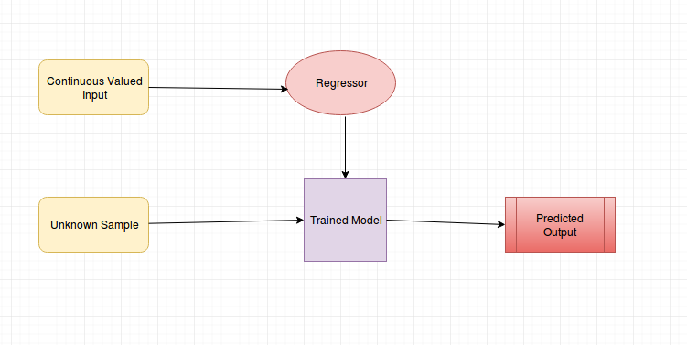

Additionally, numerical features may undergo normalization or scaling to bring them to a consistent scale, preventing certain features from dominating the model's learning process due to their larger magnitude. Handling missing values is critical to maintaining the integrity of the dataset, and strategies such as imputation or deletion may be employed based on the nature and extent of missingness.

The data model also includes the target variable, which is the price of the car. This variable serves as the output that the linear regression model aims to predict based on the input features. By structuring the dataset in this manner and adhering to best practices in data modeling and preprocessing, the project ensures that the linear regression model can effectively learn from the data and make accurate predictions of car prices.

3.2.1 Data Flow Diagram(DFD)

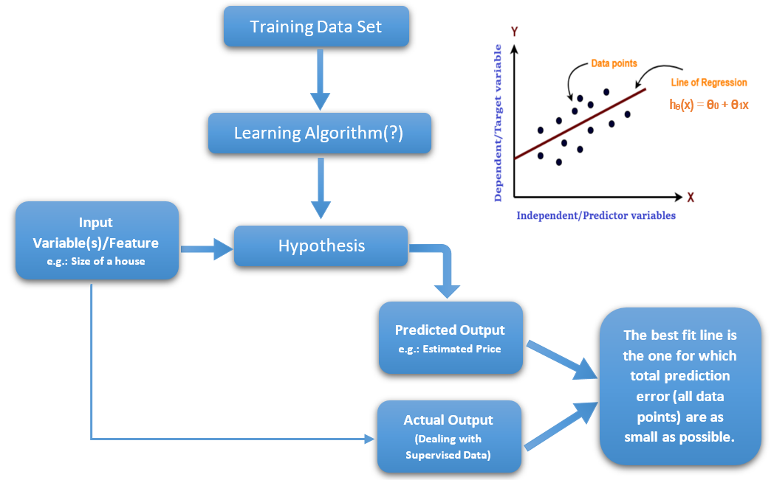

  - Process Model

In the process model for the "Car Price Prediction Using Linear Regression" project, a systematic approach is adopted to develop, train, evaluate, and deploy the predictive model. The process begins with data collection, where relevant datasets containing information about car attributes and prices are gathered from reliable sources. This phase is followed by data preprocessing, where the collected data undergoes cleaning, transformation, and feature engineering to ensure its quality and suitability for model training.

Once the data is prepared, the next step involves model development, where a linear regression algorithm is selected and implemented using appropriate programming languages and libraries such as Python and scikit-learn. The model is trained on the preprocessed data, learning the relationships between car attributes and prices to make accurate predictions.

Following model training, the performance of the linear regression model is evaluated using various evaluation metrics such as Mean Absolute Error (MAE), Root Mean Squared Error (RMSE), and R-squared (R²). This evaluation phase helps assess the model's predictive capabilities and identify areas for improvement.

Upon satisfactory performance, the trained model is deployed into production, where it can be used to predict car prices based on input features provided by users. This deployment phase involves integrating the model into a user-friendly interface or application, allowing stakeholders to input car attributes and receive price predictions in real-time.

Throughout the process, continuous monitoring and iteration may be necessary to refine the model further and adapt to changes in data or market dynamics. By following this systematic process model, the project ensures the successful development and deployment of a reliable and accurate car price prediction system using linear regression.

3.3.1 Entity Relationship Diagram (ERD)

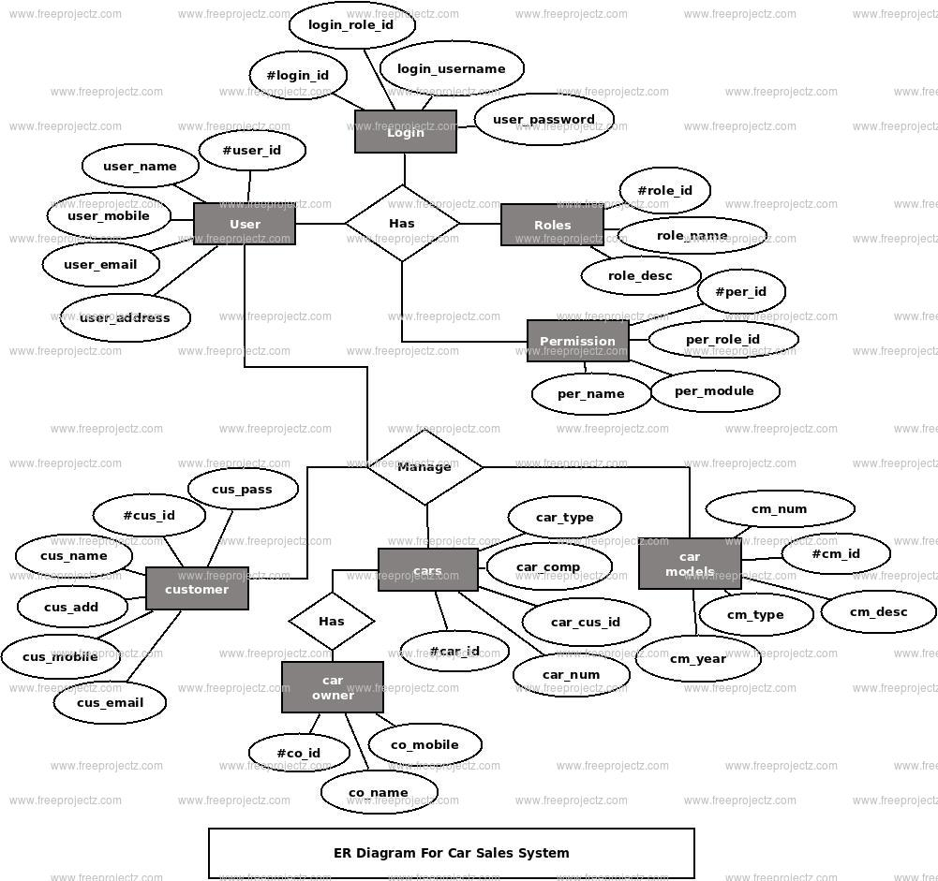

  - Behavioral Model

In the behavioral model for the "Car Price Prediction Using Linear Regression" project, the focus is on defining the interactions between the users and the predictive model, as well as outlining the expected behaviors and responses of both parties.

From the user's perspective, the behavioral model encompasses their actions and expectations when using the car price prediction system. Users are expected to input relevant car attributes, such as make, model, year, mileage, and condition, into the system interface. They anticipate receiving accurate price predictions based on the provided information. Additionally, users may expect the system to provide explanations or visualizations illustrating how the predicted prices are derived, enhancing their understanding of the prediction process.

On the other hand, the predictive model is expected to exhibit certain behaviors in response to user inputs. The model should accurately process and analyze the input features to generate price predictions in a timely manner. It should also exhibit transparency by providing insights into the factors influencing the predicted prices, such as the coefficients of the linear regression model or feature importance scores. Furthermore, the model should be robust and adaptable, capable of handling a wide range of input data and adjusting its predictions based on changes in market conditions or user preferences.

By defining the expected behaviors of both users and the predictive model, the behavioral model guides the design and development of the car price prediction system, ensuring that it meets the needs and expectations of its users while delivering accurate and transparent predictions.

3.4.1 State Transition Diagram

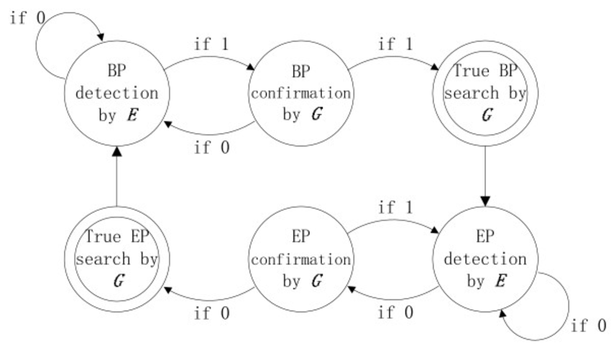

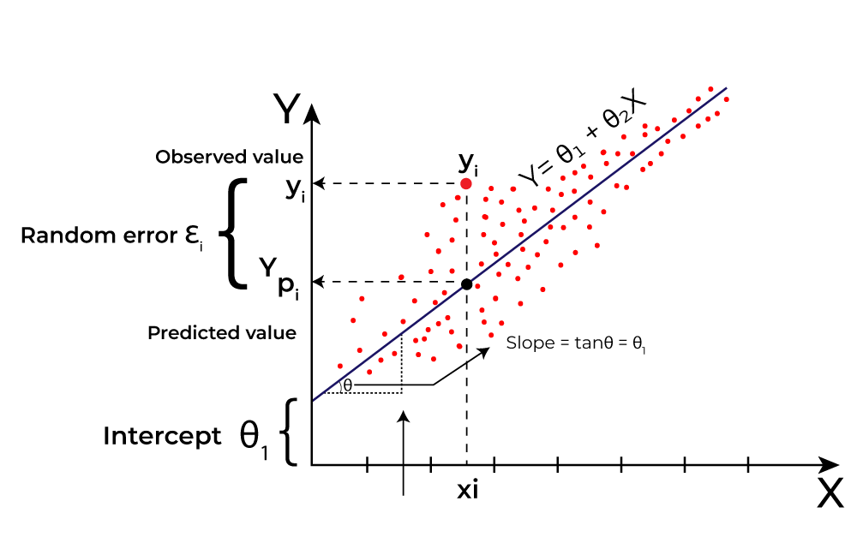

CHAPTER 4 DESIGN

4.1 Object Oriented Design

In the Object-Oriented Design (OOD) phase of the "Car Price Prediction Using Linear Regression" project, the focus is on organizing the system's components into classes and objects to encapsulate data and functionality. The key entities in the design include the predictive model, user interface, data preprocessing modules, and evaluation metrics.

The predictive model class represents the linear regression algorithm and includes methods for training the model on the input data, making predictions based on new data, and evaluating the model's performance. This class encapsulates the core functionality of the system, ensuring modularity and reusability.

The user interface class manages the interaction between the user and the system, providing a platform for users to input car attributes and receive price predictions. It includes methods for data validation, error handling, and presenting results to the user in a clear and intuitive manner.

The data preprocessing modules consist of classes responsible for cleaning, transforming, and engineering features in the input dataset. These classes encapsulate preprocessing techniques such as handling missing values, scaling numerical features, and encoding categorical variables. By encapsulating these functionalities within separate modules, the design promotes maintainability and scalability.

Additionally, the evaluation metrics class contains methods for calculating performance metrics such as Mean Absolute Error (MAE), Root Mean Squared Error (RMSE), and R-squared (R²). These metrics are used to assess the accuracy and reliability of the predictive model, providing valuable feedback for model refinement and improvement.

Overall, the Object-Oriented Design phase aims to organize the system's components into cohesive and modular units, promoting code reusability, maintainability, and scalability. By encapsulating data and functionality within classes and objects, the design facilitates efficient development, testing, and deployment of the car price prediction system.

4.2 System Flow diagram

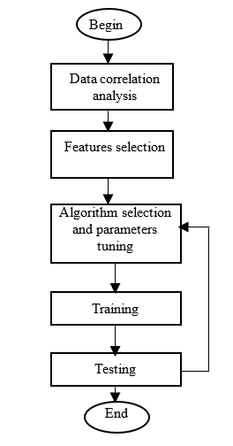

4.3 Class Diagram

In the Class Diagram for linear regression in the "Car Price Prediction Using Linear Regression" project, the focus is on representing the key classes and their relationships within the predictive modeling component. Here's a simplified representation:

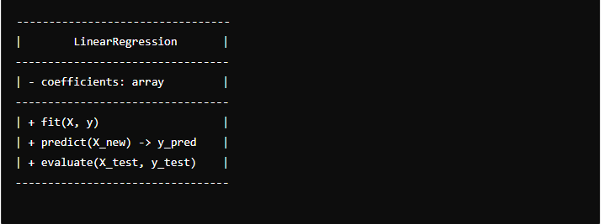

In this diagram, the main class is LinearRegression, representing the linear regression predictive model. It contains attributes such as coefficients, which store the coefficients learned during model training. The class provides methods for fitting the model to training data (fit), making predictions on new data (predict), and evaluating the model's performance (evaluate). The fit method takes input features X and target variable y as parameters, while the predict method takes new input features X_new and returns predicted prices y_pred. The evaluate method assesses the model's performance using test data (X_test and y_test) and returns evaluation metrics such as Mean Absolute Error (MAE), Root Mean Squared Error (RMSE), and R-squared (R²).

4.4 Class Description

In the "Car Price Prediction Using Linear Regression" project, the class description for the linear regression model encapsulates the functionalities and attributes essential for training, predicting, and evaluating the model's performance.

The LinearRegression class serves as the core component, responsible for implementing the linear regression algorithm. It contains an attribute coefficients, which stores the learned coefficients during model training. The class provides methods for fitting the model to training data (fit), making predictions on new data (predict), and evaluating the model's performance (evaluate).

The fit method accepts input features (X) and target variable (y) as parameters and calculates the coefficients that best fit the training data. The predict method takes new input features (X_new) as input and returns predicted car prices based on the learned coefficients.

Additionally, the evaluate method assesses the model's performance using test data (X_test and y_test). It calculates evaluation metrics such as Mean Absolute Error (MAE), Root Mean Squared Error (RMSE), and R-squared (R²), providing insights into the model's accuracy and reliability.

Overall, the LinearRegression class encapsulates the functionalities required for implementing the linear regression predictive model, facilitating efficient training, prediction, and evaluation of car prices based on input features.

4.6 Sequence Diagram

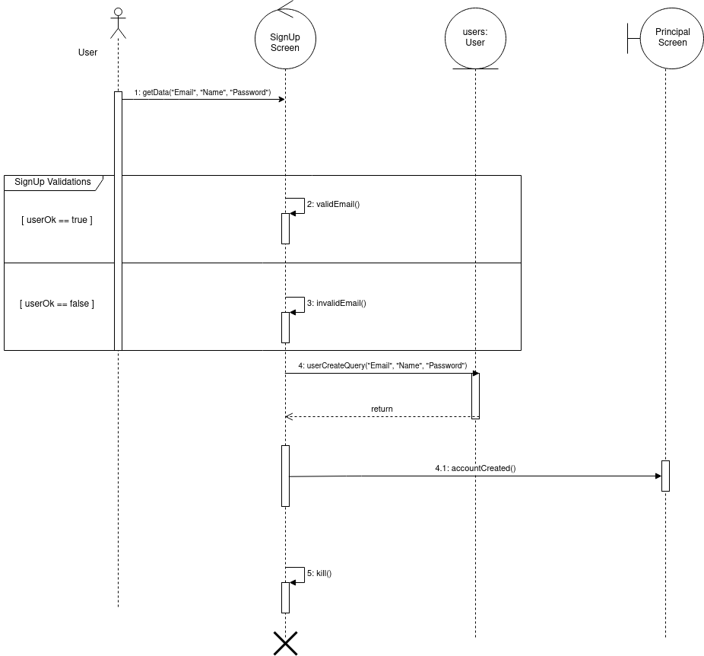

The Sequence Diagram for the "Car Price Prediction Using Linear Regression" project illustrates the interactions between system components during the prediction process. It depicts the flow of messages between the user interface, data preprocessing module, and linear regression model. Initially, the user inputs car attributes through the interface, which are then processed and transformed by the preprocessing module. Subsequently, the preprocessed data is fed into the linear regression model for training. Once trained, the model receives new input features from the interface and generates predictions. Finally, the predicted car prices are returned to the user interface for display to the user. This sequential flow demonstrates how the various components of the system collaborate to deliver accurate price predictions based on linear regression analysis

4.7 Activity Diagram

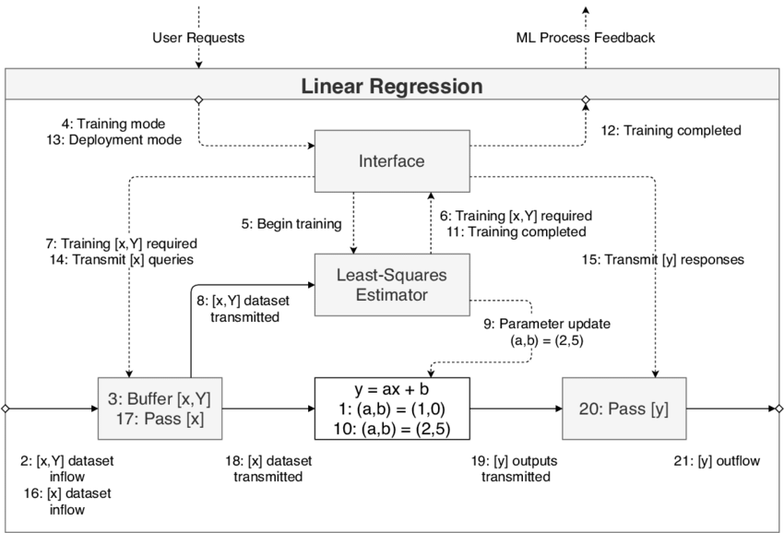

CHAPTER 5 IMPLEMENTATION AND TESTING

5.1 Testing Strategies adapted

In the "Car Price Prediction Using Linear Regression" project, testing strategies are crucial for ensuring the accuracy and reliability of the predictive model. Several testing strategies are adapted to validate the functionality and performance of the system.

Unit testing is employed to assess the functionality of individual components, such as the data preprocessing module and the linear regression model. This involves testing each method and function with different input values to verify their correctness and identify any potential bugs or errors.

Integration testing is utilized to evaluate the interactions between different modules and components of the system. This involves testing the flow of data and messages between the user interface, data preprocessing module, and linear regression model to ensure seamless integration and communication.
Regression testing is performed to validate the stability of the system after making changes or updates. This involves re-running previously conducted tests to ensure that new modifications have not introduced any unintended side effects or regressions.

Performance testing is conducted to assess the speed and efficiency of the predictive model. This involves measuring the time taken for training the model, making predictions, and evaluating its performance on large datasets to ensure optimal performance under varying conditions.

Cross-validation techniques are employed to assess the generalization ability of the model and its performance on unseen data. This involves splitting the dataset into training and testing subsets multiple times and evaluating the model's performance on each subset to obtain a more robust estimate of its accuracy.

By employing these testing strategies, the project ensures that the predictive model is thoroughly evaluated and validated, providing users with accurate and reliable car price predictions based on linear regression analysis.

5.2 System Testing

System testing for the "Car Price Prediction Using Linear Regression" project involves validating the entire system's functionality and performance. This includes testing the user interface, data preprocessing, model training, prediction generation, and result presentation. By simulating real-world scenarios and evaluating the system's behavior against predefined requirements, system testing ensures that the predictive model accurately predicts car prices and provides reliable insights to users.

5.3 Test Cases

Test cases for the "Car Price Prediction Using Linear Regression" project encompass a range of scenarios to validate the system's functionality and performance. These include cases to verify correct handling of various input formats and data types in the user interface, ensuring that the preprocessing module correctly cleans and transforms input data, validating the accuracy of model predictions against expected outcomes, and assessing the system's response to different edge cases and boundary conditions. Additionally, test cases cover performance metrics such as model training time, prediction latency, and memory usage to ensure optimal system performance under varying loads. Through thorough test case coverage, the project aims to guarantee the reliability and accuracy of the car price prediction system across different usage scenarios and data inputs.

CHAPTER 6 CONCLUSION AND FUTURE WORK

Appendix A Software Requirement Specification (SRS)

The Software Requirements Specification (SRS) delineates the functional and non-functional requisites for the "Car Price Prediction Using Linear Regression" project. This document serves as a roadmap for both the development team and stakeholders, offering clarity on the project's scope and objectives.

The project aims to create a predictive model employing linear regression to estimate car prices based on input attributes. It encompasses the development of a user interface for inputting car attributes, a data preprocessing module for cleaning and transforming data, and a linear regression model for prediction generation. Additionally, the scope includes functionalities such as model training, evaluation, and result presentation.

Functional requirements encompass the user interface's ability to accept car attribute inputs, provide feedback and validation messages, and display predicted car prices. The data preprocessing module is tasked with cleaning and transforming input data, while the linear regression model must be capable of training on preprocessed data, generating predictions, and evaluating performance metrics like MAE, RMSE, and R².

Non-functional requirements emphasize performance, reliability, and usability. The system must deliver real-time predictions with minimal latency and handle errors gracefully. The user interface should be intuitive and visually appealing, offering clear instructions and presenting predicted prices in an understandable format.

The system architecture adheres to a modular design, comprising distinct components for the user interface, data preprocessing, and linear regression model. These components communicate through well-defined interfaces to ensure seamless integration and interoperability.

This Software Requirements Specification serves as a foundational document, providing a comprehensive overview of the project's requirements and guiding the development process to ensure the successful implementation of the "Car Price Prediction Using Linear Regression" system.

Appendix B Software Design Specification (SDS)

The Software Design Specification (SDS) elaborates on the architectural and design decisions for the "Car Price Prediction Using Linear Regression" project. This document serves as a blueprint for developers, outlining the system's structure, components, and interactions.

The project architecture follows a modular design, with distinct components for the user interface, data preprocessing, and linear regression model. Each component is encapsulated within its own module, promoting modularity, reusability, and maintainability. The user interface module handles user interactions, input validation, and presentation of predicted prices. The data preprocessing module is responsible for cleaning, transforming, and engineering input data to prepare it for model training. The linear regression model module implements the algorithm for training, prediction generation, and performance evaluation.

Interactions between modules are facilitated through well-defined interfaces, ensuring seamless communication and interoperability. The user interface module communicates with the data preprocessing module to receive preprocessed data for model input. Similarly, the linear regression model module interacts with the data preprocessing module to obtain clean and transformed data for training and prediction.

The system architecture emphasizes scalability and flexibility, allowing for easy integration of additional features or enhancements in the future. Components are designed to be loosely coupled, enabling independent development and testing. Additionally, the architecture accommodates potential changes in requirements or technology stack, ensuring adaptability and future-proofing of the system.

Overall, the Software Design Specification provides a comprehensive overview of the project's architectural design, guiding developers in the implementation of the "Car Price Prediction Using Linear Regression" system.

Appendix C Screenshots



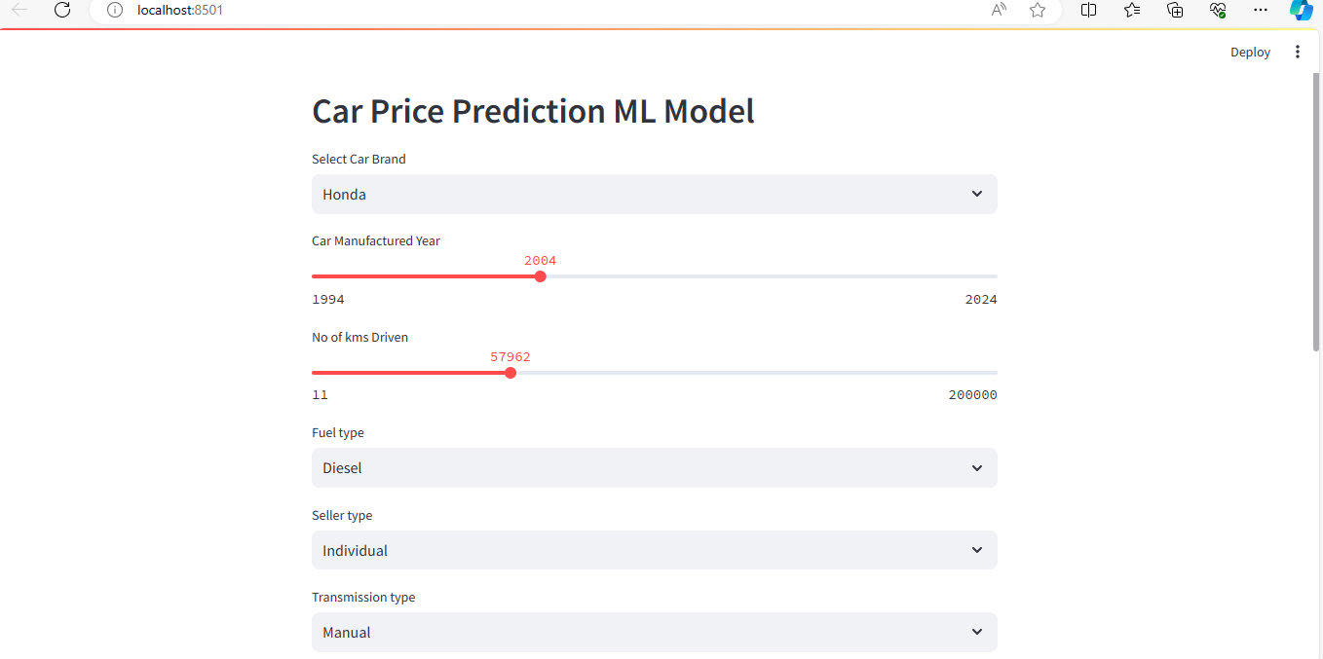

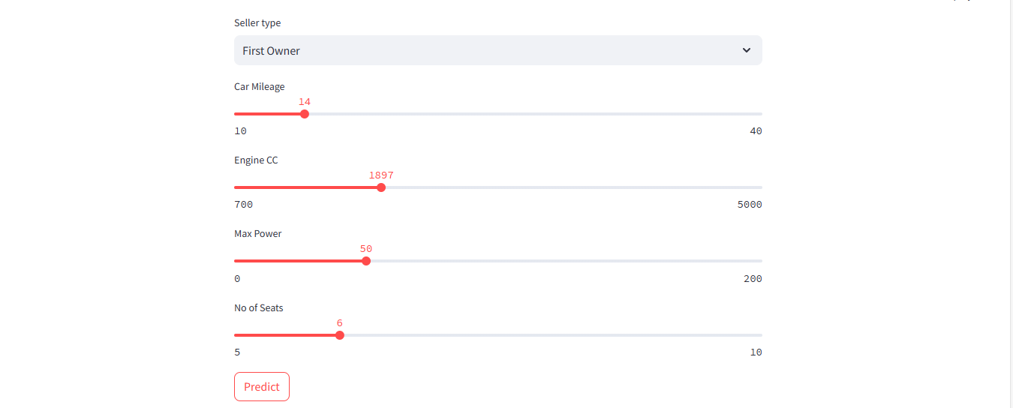

Specimen of header and footer

Header

Project Title

Footer

Department of Computer Science & Engineering, VITS, Satna Page Number

Font : Times New Roman
Size : 10 point
Suggested Font sizes

Details | Font Type | Font size | Spacing
first page - see sample page for details |  |  | -
Chapter headings with chapter number on top | Times New Roman | 14pt bold capitals | Centered
Section headings | Times New Roman | 12pt bold capitals | Left adjusted
Subsection headings | Times New Roman | 12pt. sentence case | Left adjusted
Paragraph headings | Times New Roman | 12pt.bold sentence case | Left adjusted
Body of thesis/ project report | Times New Roman | 12 pt | Adjusted on both left and right and with 1.5 spacing for text and double spacing for equations
Margins | Left Margin | 1.5 inch | To accommodate binding area
Margins | Right Margin | 1. inch
Margins | Top | 1.00 inch | On pages on which chapter begins
Margins | Top | 1.0 inch | Other pages
Margins | Bottom | 1.25 inch

