Nainital Lake

Nainital, Uttarakhand, 263002, India
29.3869° N, 79.4598° E
Area = 0.23 sq. km
Number of Bots required = 4
Total Approximated time = 23 hours
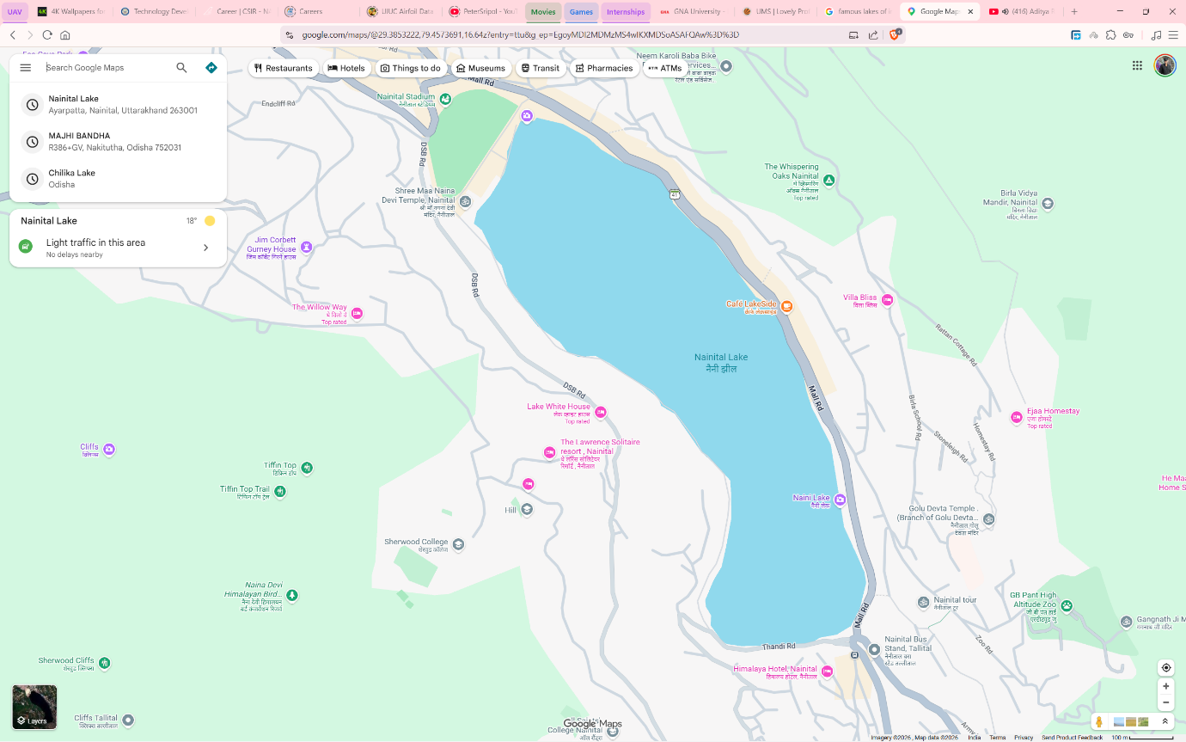
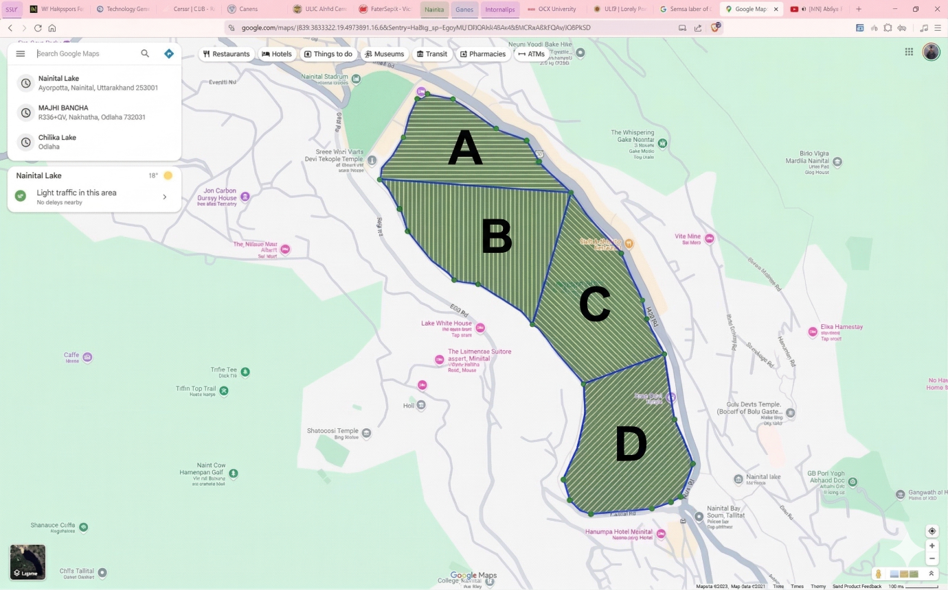

Lonar Lake
Lonar, Buldhana District, Maharashtra,443302, India
19.9764° N, 76.5083° E
Area = 0.23 sq. km
Number of Bots required = 5
Total Approximated time = 42 hours

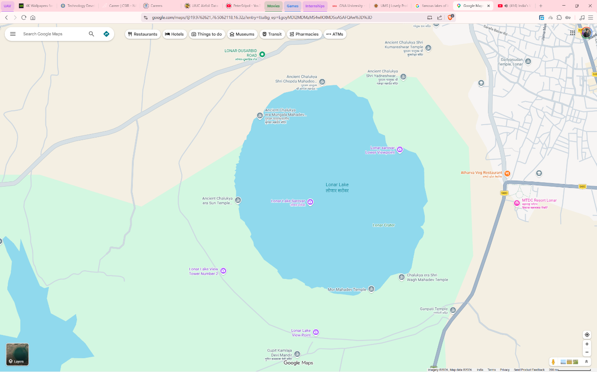
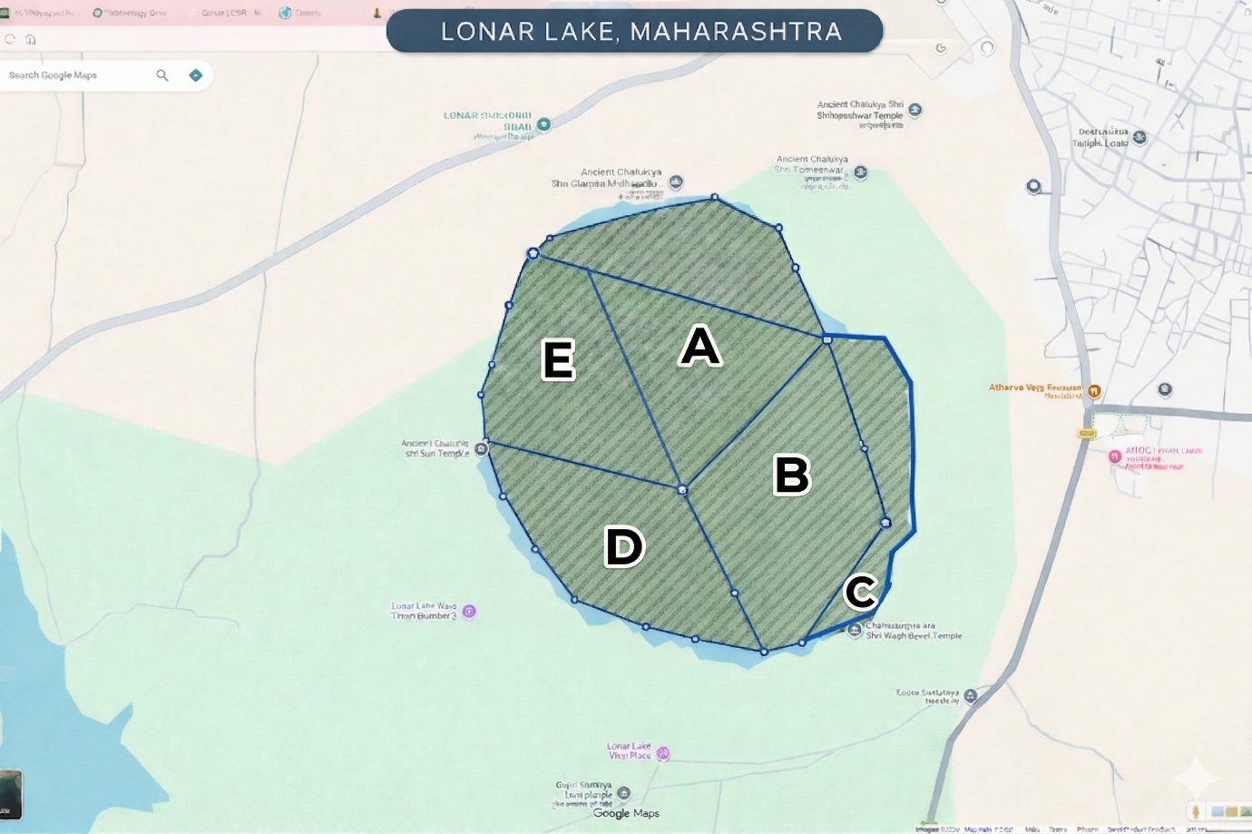

Nakki Lake
Nakki Lake, Mount Abu, Rajasthan 307501, India
24.5945° N, 72.7062° E
Area = 0.49 sq. km
Number of Bots required = 10
Total Approximated time = 21 hours
