

NAME:- ASHU PAL

BRANCH:- CSE

ROLL NO:- 2021A1R116

COURSE NAME:- PYTHON

COURSE CODE:- COM-501

SUBMITTED TO:- ANNU SONANIA MAM

ASSIGNMENT NO:- 01

**ATM Application**

**TESTCASE :**

**\*\*\*welcome to the ATM\*\*\***

* **User (**minimum 5 user **)**
* **Admin**(1 admin**)**
* **Creat account (**for user only**)**

**-------------------------------------------------------------------**

**USER :**

1. **User id and password**

**(**More than 3 times if I enter wrong User id and password account should be lock.)--optional for extra marks

* **Cash deposit(maximum deposit limit 1L)**

User id and password

**(**More than 3 times if I enter wrong User id and password account should be lock.)

1. If i want to deposit 20k mean I want denomination.[100,200,500,2000]

**[**500*2=1000]

[2000*5=10000]

Total deposit=11k

* **Cash withdraw(maximum withdraw limit 50k)**

User id and password

**(**More than 3 times if I enter wrong User id and password account should be lock.)

1. If i want to withdraw 20k mean I want denomination.[100,200,500,2000]

[500*2=1000]

[2000*5=10000]

Total withdraw=11**k**

* **Check balance**

User id and password

**(**More than 3 times if I enter wrong User id and password account should be lock.)

(No denomination for balance)

* **Change user name or password**

current password - new password

**ADMIN:**

**1.User id and password**

**(**More than 3 times if I enter wrong User id and password account should be lock.)--optional for extra marks.

* **Total balance**(maximum balance should be up to 3L)

With denomination[100,200,500,2000]

I.e(for example)

[500*2=1000]

[2000*5=10000]

Total balance=11k

* **Cash deposit**(maximum cash deposit should be 3L)

With denomination[100,200,500,2000]

* **Notification ( if balance is less than 75k )**

Note :

* use 100 to 5L in Admin
* Denomination must
* For every user should be maintain at least 5k minimum balance in their account.
* Calculation must be perfect (I.e if total balance is 5L mean if any user withdraw 50k in their account and then if I check balance in admin balance should be reduce.

**Mark allocation:**

1. Clear and proper menu ----20m
2. Proper denomination with calculation ----30m
3. Proper balance and deposit calculation between user and admin ----30m
4. More than 3 time if I enter wrong user name and password account should be lock -----10

**SOLUTION:-**

CODE:-

users = {

    "user1": {"password": "pass1", "balance": 1000},

    "user2": {"password": "pass2", "balance": 1000},

    "user3": {"password": "pass3", "balance": 1000},

    "user4": {"password": "pass4", "balance": 1000},

    "user5": {"password": "pass5", "balance": 1000},

}

admin = {"password": "adminpass", "balance": 75000}

def lock_account(account_type):

    print(f"Account locked due to multiple failed login attempts. Contact the {account_type}.")

    exit()

def user_login():

    attempts = 0

    while attempts < 3:

        username = input("Enter User ID: ")

        password = input("Enter Password: ")

        if username in users and users[username]["password"] == password:

            return username

        else:

            print("Invalid User ID or Password. Try again.")

            attempts += 1

    lock_account("user")

def admin_login():

    attempts = 0

    while attempts < 3:

        password = input("Enter Admin Password: ")

        if admin["password"] == password:

            return True

        else:

            print("Invalid Admin Password. Try again.")

            attempts += 1

    lock_account("admin")

def create_user_account():

    new_username = input("Enter a new username: ")

    new_password = input("Enter a password for the new account: ")

    users[new_username] = {"password": new_password, "balance": 0}

    print("Account created successfully!")

def cash_deposit(username):

    max_deposit = 100000

    denomination = [100, 200, 500, 2000]

    total_deposit = 0

    while True:

        amount = int(input("Enter the deposit amount: "))

        if amount <= max_deposit - total_deposit:

            total_deposit += amount

            for denom in denomination:

                count = amount // denom

                if count > 0:

                    print(f"[{denom}*{count}] = {denom * count}")

                amount %= denom

            users[username]["balance"] += total_deposit

            print(f"Total deposit = {total_deposit}")

            break

        else:

            print("Exceeded maximum deposit limit. Try again.")

def cash_withdraw(username):

    max_withdraw = 50000

    denomination = [100, 200, 500, 2000]

    while True:

        amount = int(input("Enter the withdraw amount: "))

        if amount <= max_withdraw and amount <= users[username]["balance"]:

            withdrawn_amount = 0

            for denom in denomination:

                count = amount // denom

                if count > 0:

                    print(f"[{denom}*{count}] = {denom * count}")

                    withdrawn_amount += denom * count

                amount %= denom

            users[username]["balance"] -= withdrawn_amount

            print(f"Total withdraw = {withdrawn_amount}")

            break

        else:

            print("Invalid amount or exceeded maximum withdraw limit. Try again.")

def check_balance(username):

    balance = users[username]["balance"]

    print(f"Account balance: {balance}")

def change_password(username):

    current_password = input("Enter current password: ")

    if current_password == users[username]["password"]:

        new_password = input("Enter new password: ")

        users[username]["password"] = new_password

        print("Password changed successfully.")

    else:

        print("Invalid password. Password change failed.")

def admin_total_balance():

    total_balance = admin["balance"]

    print(f"Admin's total balance: {total_balance}")

def admin_cash_deposit():

    max_deposit = 300000

    denomination = [100, 200, 500, 2000]

    total_deposit = 0

    while True:

        amount = int(input("Enter the deposit amount: "))

        if amount <= max_deposit - total_deposit:

            total_deposit += amount

            for denom in denomination:

                count = amount // denom

                if count > 0:

                    print(f"[{denom}*{count}] = {denom * count}")

                amount %= denom

            admin["balance"] += total_deposit

            print(f"Total deposit = {total_deposit}")

            break

        else:

            print("Exceeded maximum deposit limit. Try again.")

while True:

    print("*** Welcome to the ATM ***")

    account_type = input("Are you a User or an Admin? (user/admin/exit): ").lower()

    if account_type == "exit":

        print("Thank you. Goodbye!")

        break

    elif account_type == "user":

        username = user_login()

        while True:

            print("\nUser Options:")

            print("1. Cash Deposit")

            print("2. Cash Withdraw")

            print("3. Check Balance")

            print("4. Change Password")

            print("5. Create an Account")

            print("6. Switch to Admin")

            print("7. Exit")

            option = input("Enter option (1/2/3/4/5/6/7): ")

            if option == "1":

                cash_deposit(username)

            elif option == "2":

                cash_withdraw(username)

            elif option == "3":

                check_balance(username)

            elif option == "4":

                change_password(username)

            elif option == "5":

                create_user_account()

            elif option == "6":

                break

            elif option == "7":

                print("Thank you for using the ATM. Goodbye!")

                exit()

            else:

                print("Invalid option. Please try again.")

    elif account_type == "admin":

        if admin_login():

            while True:

                print("\nAdmin Options:")

                print("1. Admin's Total Balance")

                print("2. Admin Cash Deposit")

                print("3. Switch to User")

                print("4. Exit")

                option = input("Enter option (1/2/3/4): ")

                if option == "1":

                    admin_total_balance()

                elif option == "2":

                    admin_cash_deposit()

                elif option == "3":

                    break

                elif option == "4":

                    print("Thank you, Admin. Goodbye!")

                    exit()

                else:

                    print("Invalid option. Please try again.")

    else:

        print("Invalid account type. Please enter 'user', 'admin', or 'exit'.")

**OUTPUTS:-**

1. Clear and proper menu:-

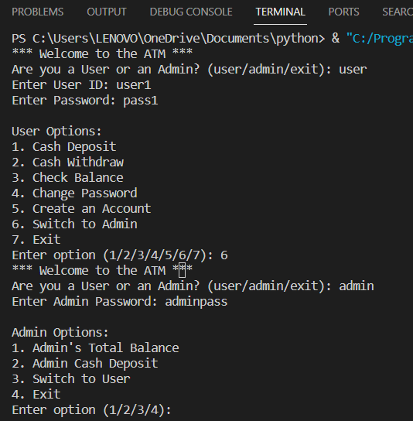

1. More than 3 time if I enter wrong user name and password account should be lock.

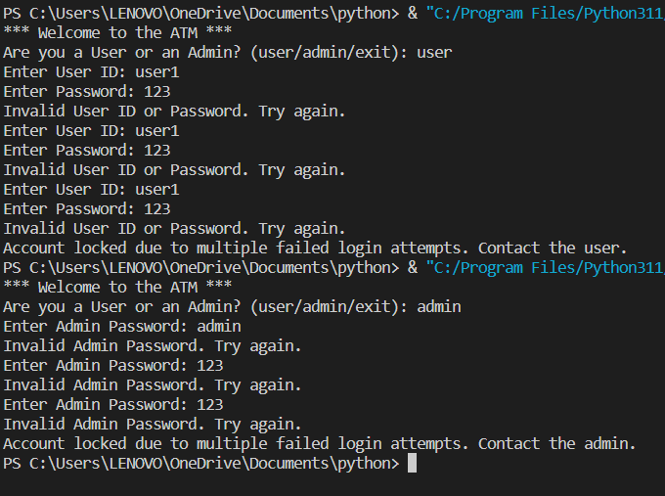

1. Proper balance and deposit calculation and Proper denomination with calculation

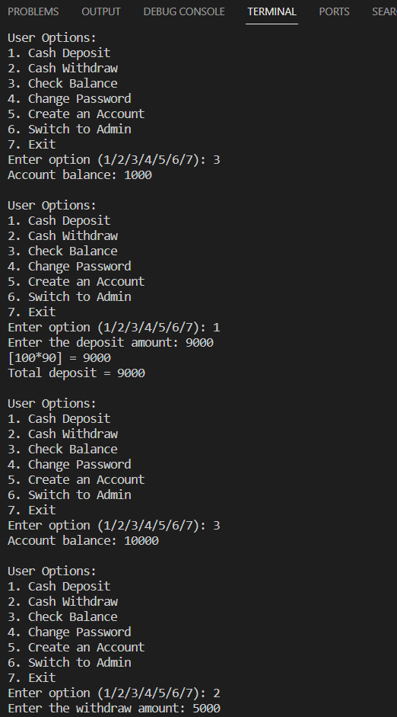

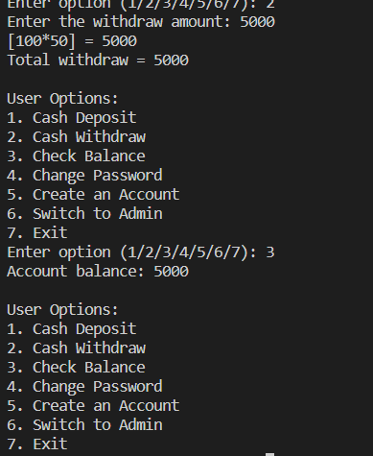

1. Change Password:-

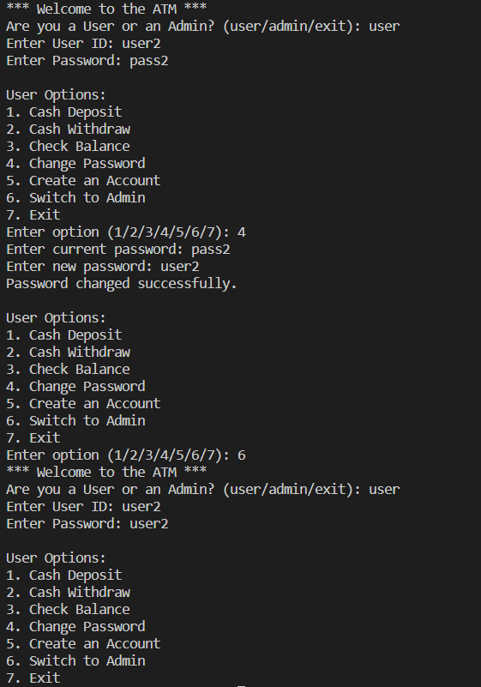

1. Create Account (for users only):-

