**Work-Extracting PDF data into excel sheet using Apache POI**

**1.**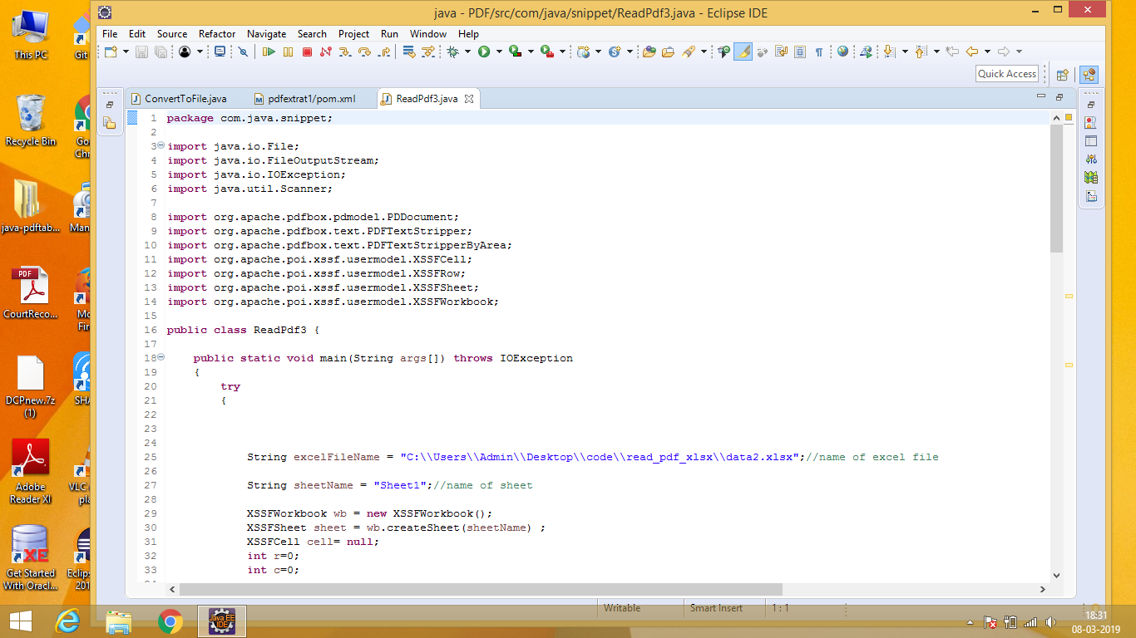

**2.**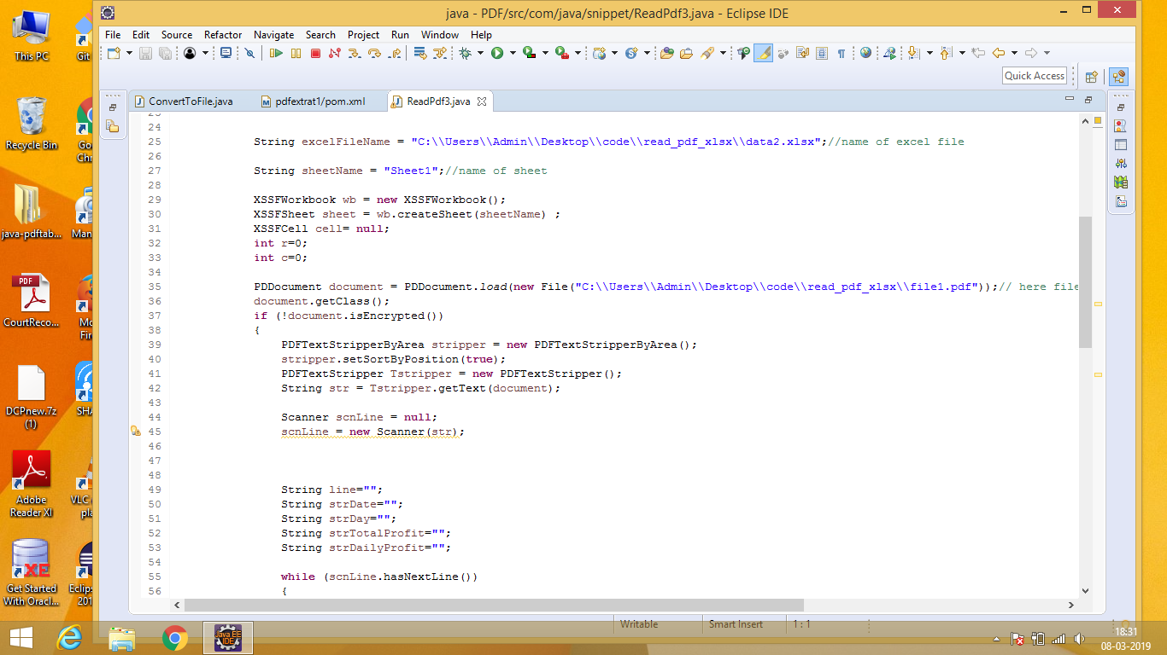

**3.**

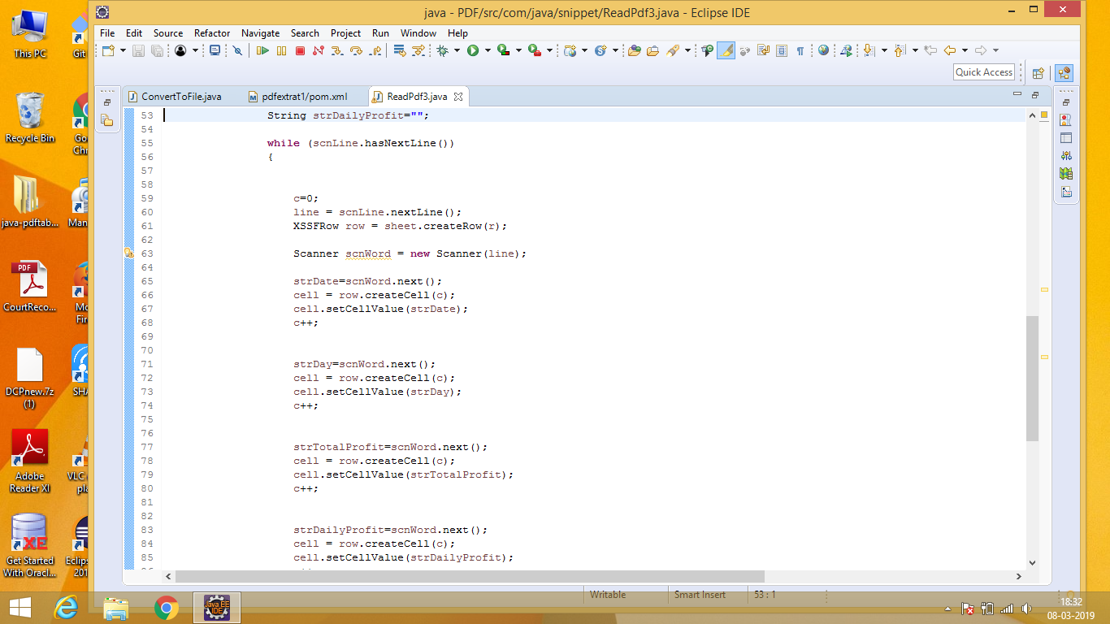

**4.**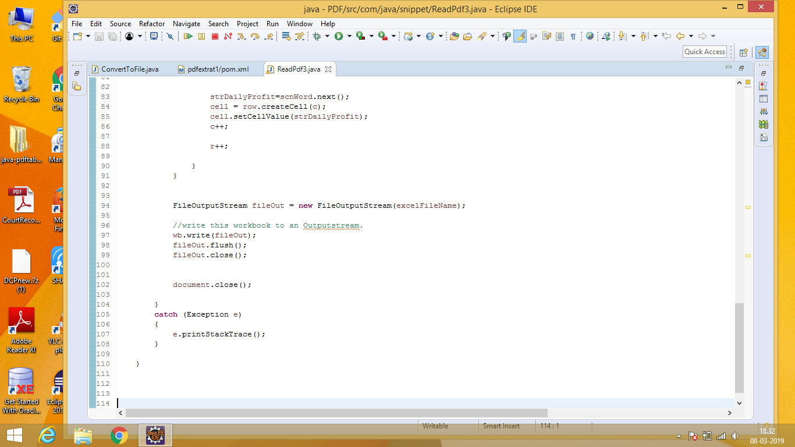

**5.**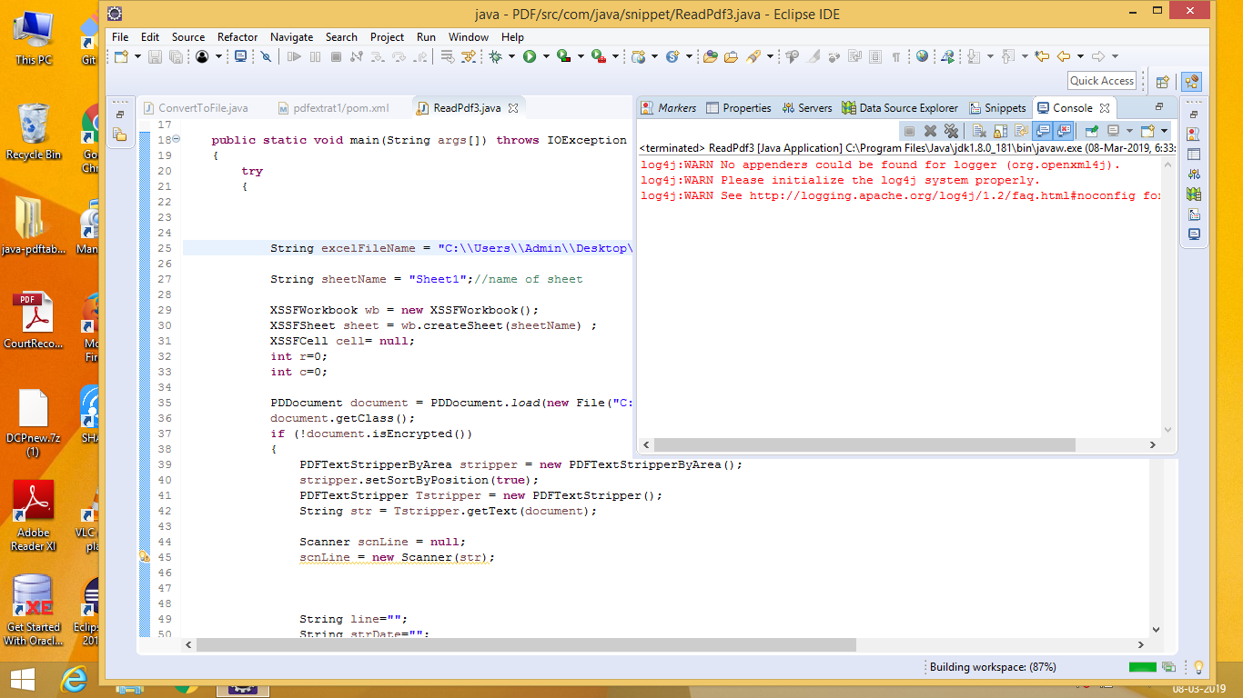

1. **This is input for our pdf to excel sheet convertor**

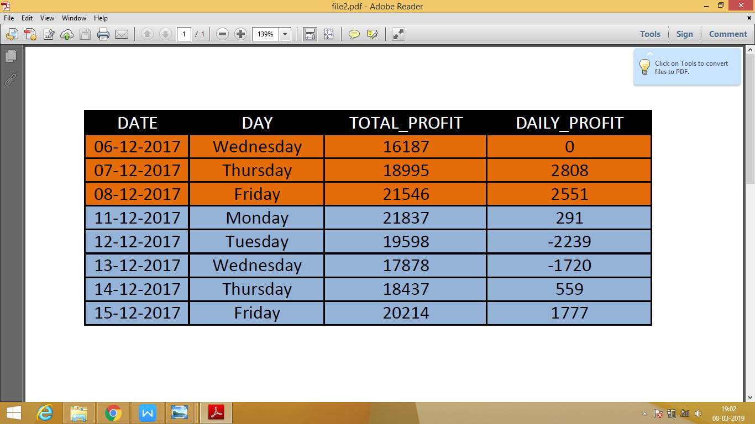

**7. Output for the given input pdf through apache POI**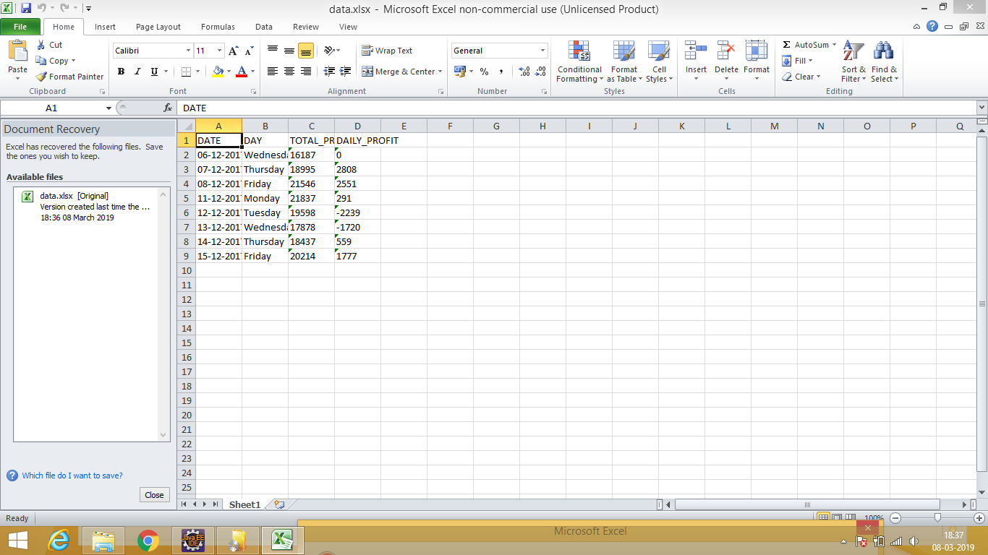

**Status:-** As you can see the above output in Excel sheet, it is extracting PDF data from folder location and into excel sheet in sheet 1. It is only working for one pdf if we try to add multiple pdf then it stop working, so we re working on Apache POI with Apache tikka.